**SRS Document – LinkedIn Mobile Automation**



**Software Requirements Specification**

**Version 1.0**

**Sep 17, 2025**

**1. Purpose of the Document**

This document defines the requirements for automating key workflows of the LinkedIn mobile app. It serves as a reference for testers, developers, and stakeholders to understand the modules and their automated validation.

**2. Project Overview**

The project focuses on critical LinkedIn mobile app workflows including authentication, profile management, networking, feed interactions, and messaging. Automation will be performed using Appium, TestNG, and Java.

**3. Modules**

**3.1 Login & Logout**

Allows users to log in with valid/invalid credentials and log out. Ensures correct navigation to the home feed after login.

**Login**: Allows users to securely log in with valid credentials. Ensures error messages appear for invalid login attempts.

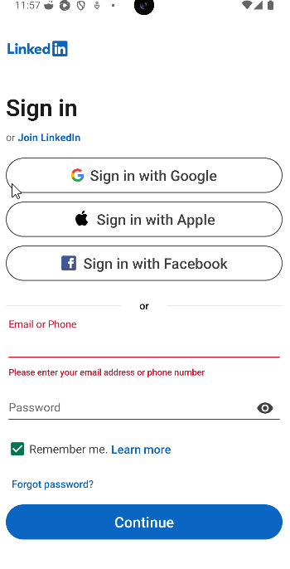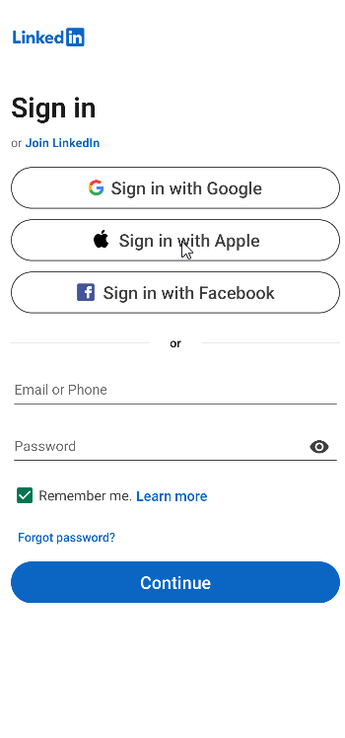

**Logou**t: Provides the option to safely log out of the account. Ensures session termination and navigation back to the login screen.

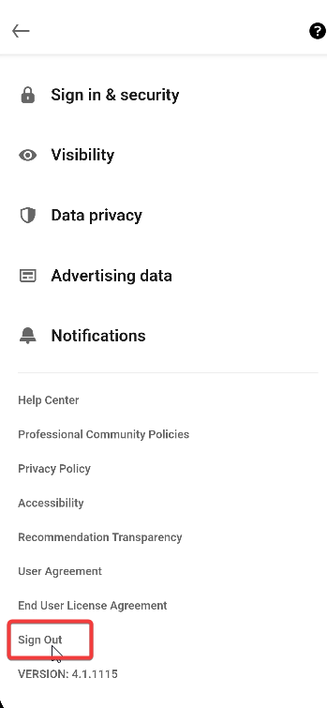

**3.2 Profile Management**

Enables access to all profile-related features. Supports seamless management of user details within the app.

**3.3 View & Edit Profile**

Allows users to view their profile information and make edits. Ensures changes are saved and reflected immediately.

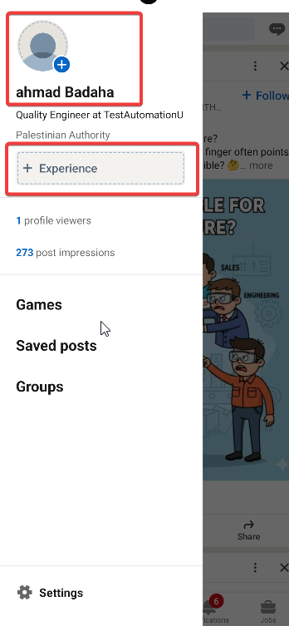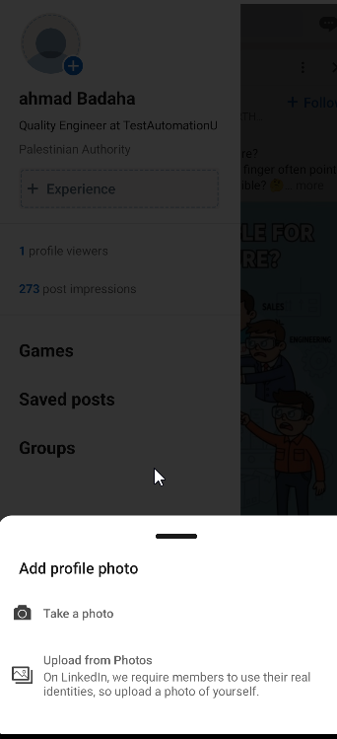

**3.4 Upload Profile Picture**

Supports updating the profile picture using device gallery or direct file upload. Verifies the new image appears correctly on the profile.



**3.5 Add/Remove Experience or Education**

Enables adding new work or educational entries and removing outdated ones. Ensures updates are accurately reflected on the profile.

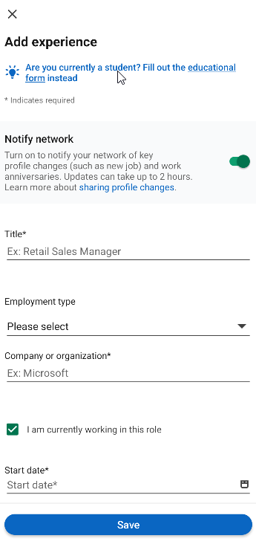

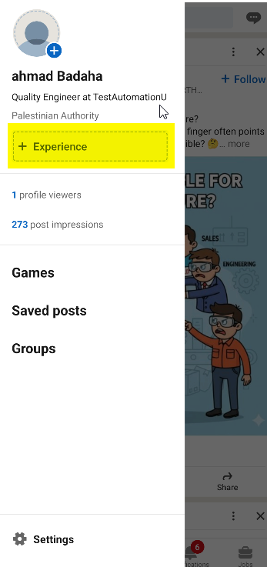

**3.6 Search & Networking**

Allows searching for people by name, company, or keywords. Helps users find potential connections within the LinkedIn network.

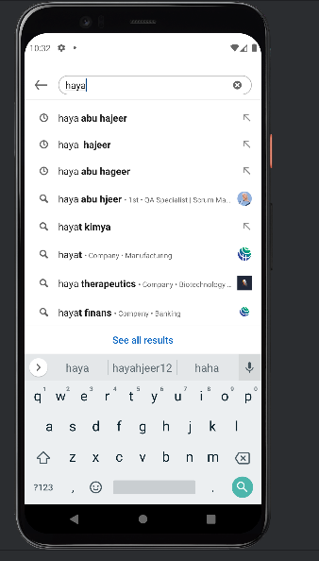

**3.7 Send Connection Request**

Supports sending connection requests to other LinkedIn users. Verifies that the request status is correctly updated as “Pending.”

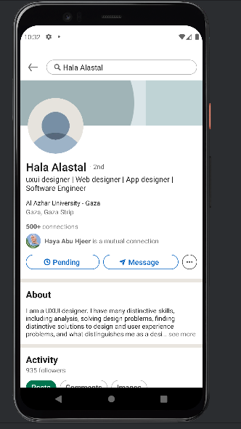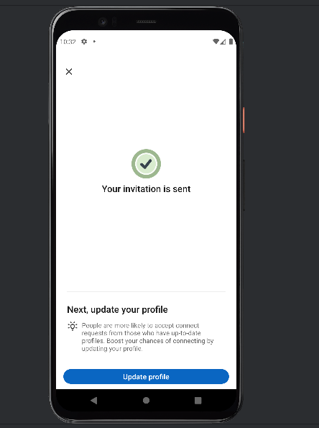

**3.8 Accept Connection Request**

Allows accepting incoming connection requests. Ensures the connection is added to the user’s network successfully.

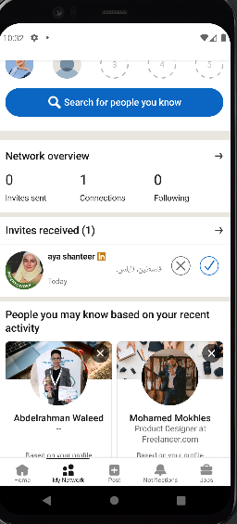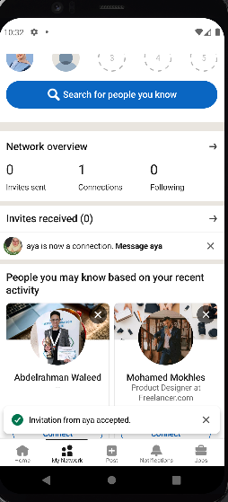

**3.9 Feed & Posts**  
Provides access to the LinkedIn feed to view posts from connections and pages. Ensures the feed loads dynamically as the user scrolls.

* **3.9.1** The user can view the latest posts along with all post details, including timestamp, text content, any attached media, like count, comment count, and share count

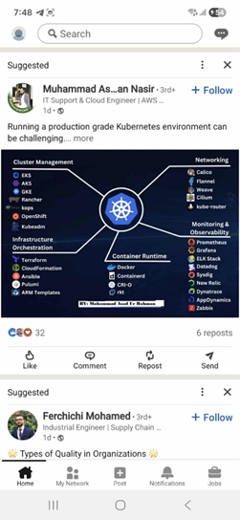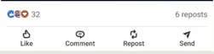

**3.10 Like, Comment, Share a Post**

Enables interacting with posts via likes, comments, and shares. Ensures interactions are correctly displayed and logged.

1. **Like**

* **3.10.1:**User can react to a post with one of the following reactions: Like, Celebrate, Support, Love, Insightful, Funny.
* **3.10.2:** User can remove their reaction from the post.
* **3.10.3:** Like counter updates instantly.

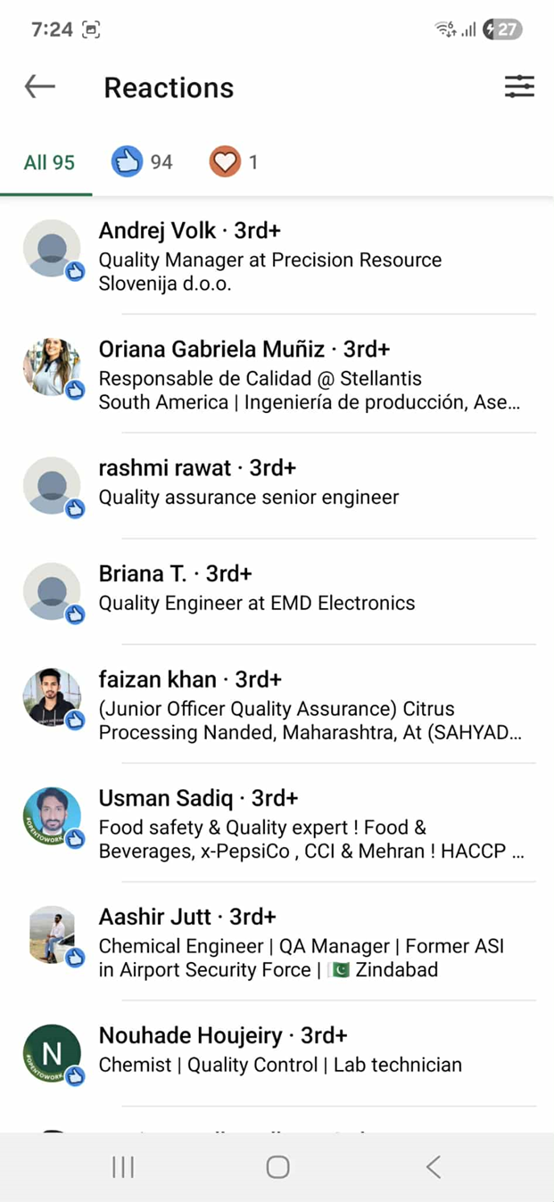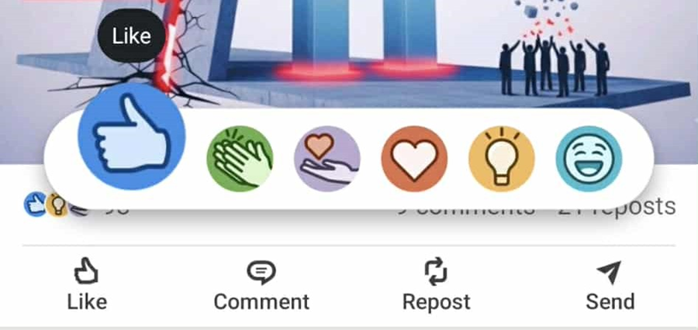

1. **Comment**

* **3.10.4:** User can add a text comment to any post.
* **3.10.5:** User can edit or delete their comments.
* **3.10.6:** the User can not add a an empty comment to any post.

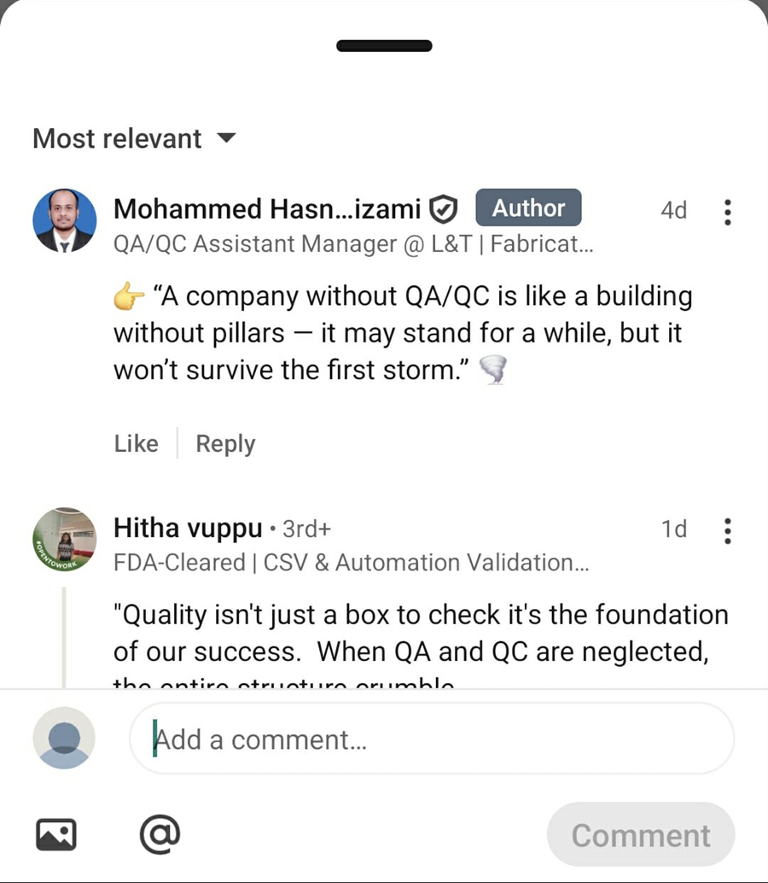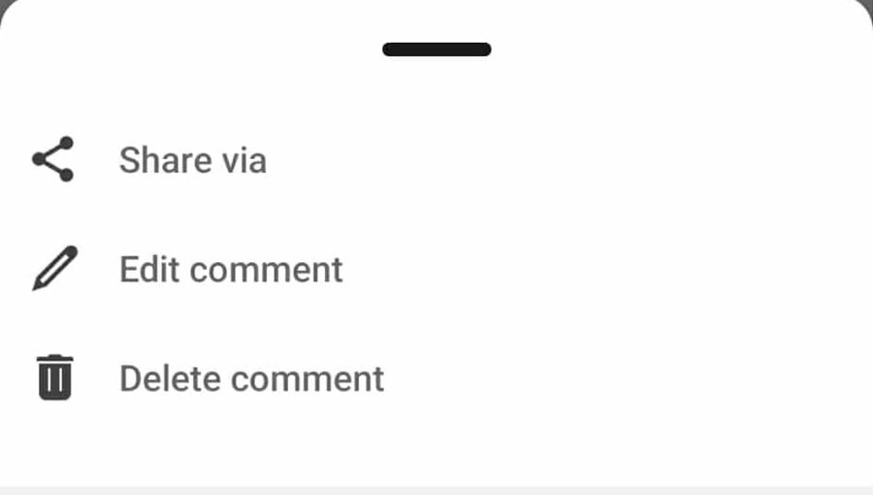

1. **Repost**

* **3.10.7:** User can repost a post directly to their feed (with optional comment).
* **3.10.8**: User can not repost the same post twice.

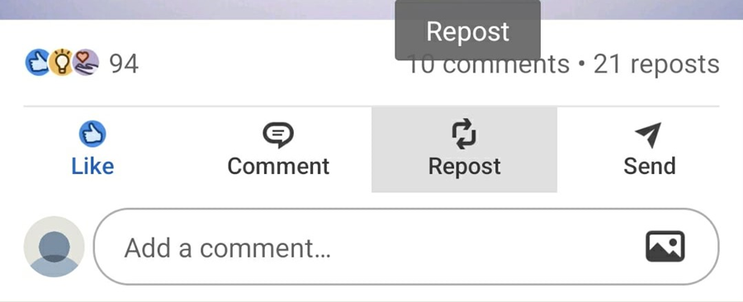

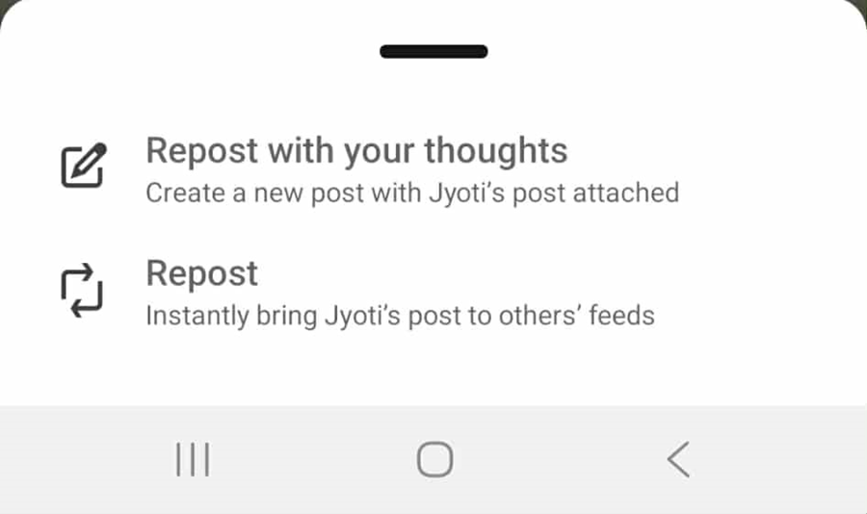

1. **Share**

* **3.10.9**: User can send a post directly to one or more connections through private messages (DM).

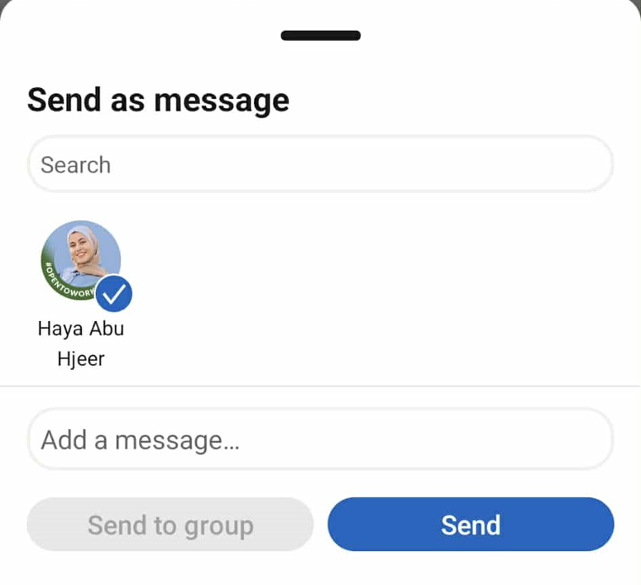

**3.11 Create a Post**

Supports creating new posts with text, images, or hashtags. Verifies that the post appears in the feed immediately after publishing.

* **3.11.1**: User can create a text post up to 3000 characters.
* **3.11.2:** User can select privacy level: Public, Connections only.

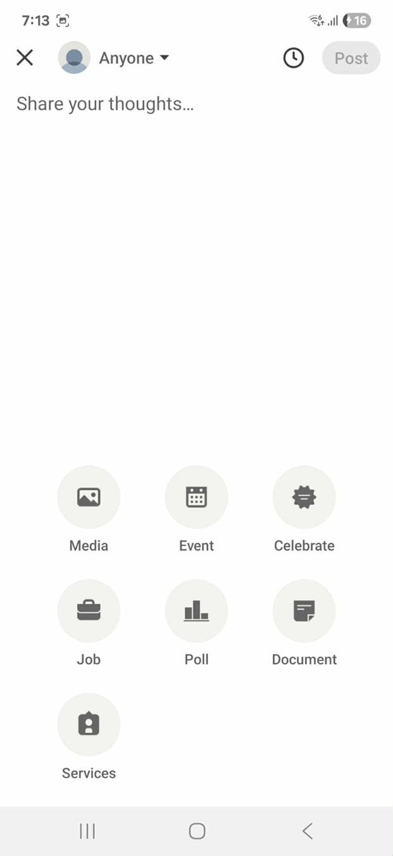

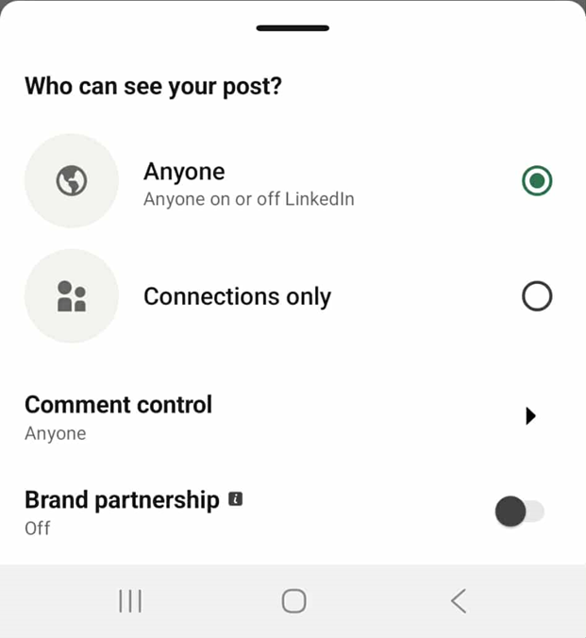

**3.12 Messaging**

Provides access to LinkedIn messages to communicate with connections. Supports reading and organizing conversations efficiently.

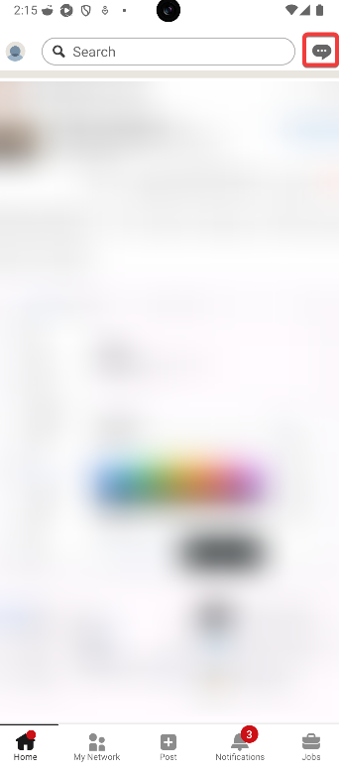

**3.13 Send/Receive a Message to/ from a Connection**

Allows sending text messages to existing connections. Verifies that messages are delivered and visible in the conversation thread.Supports receiving messages from connections. Ensures messages are correctly displayed and notifications are received in real-time

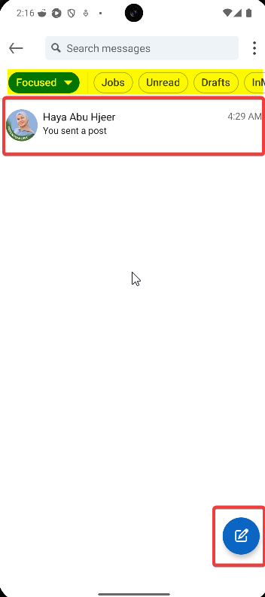 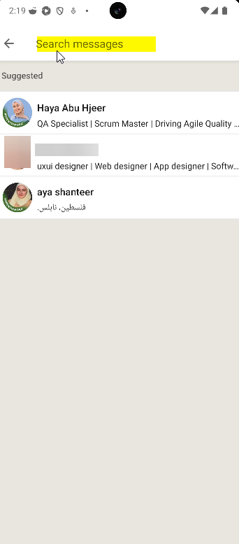

**4. Test Environment**

Tools: Appium, TestNG, Java

Platforms: Android 12+

Accounts: Predefined LinkedIn test accounts

**5. Notes & Assumptions**

Real-time notifications may have delays; tests will include waits/retries.

Profile picture uploads require device gallery or direct file input support.

Messaging tests require at least 2 accounts to validate sending and receiving.