This is on the first page!

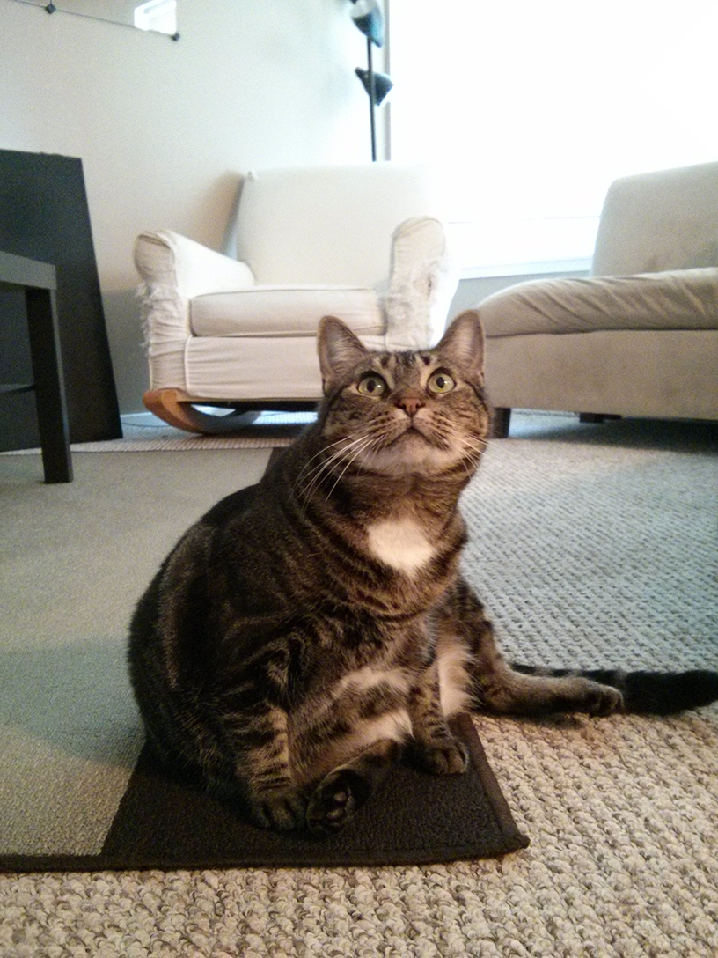

This is on the second page!