PLACEMENT RECOMMENDATION SYSTEM

ER Diagram:

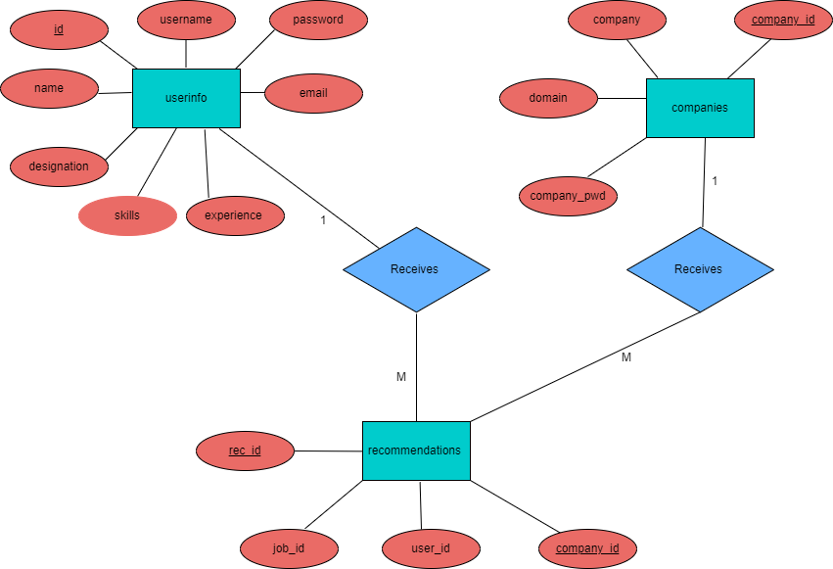

DATA DICTIONARY:

1) userinfo table:

Table Name | userinfo
Description | Stores information about users who have signed up for the platform.

Sr. No | Field Name | Data Type | Constraints | Description
1 | id | INTEGER | PRIMARY KEY | Unique identifier for each user
2 | username | VARCHAR | UNIQUE,NOT NULL | Username of the user
3 | password | VARCHAR | NOT NULL | Hashed password of the user
4 | name | VARCHAR | NOT NULL | Name of the user
5 | email | VARCHAR | UNIQUE,NOT NULL | Email of the user
6 | experience | INTEGER | NOT NULL | Experience of the user (in years)
7 | designation | VARCHAR | NOT NULL | Designation of the user
8 | skills | TEXT | NOT NULL | Skills possessed by the user

2) companies table:

Table Name | companies
Description | Contains details about registered companies on the platform.

Sr. No | Field Name | Data Type | Constraints | Description
1 | company_id | INTEGER | PRIMARY KEY | Unimeaningque identifier for each  company
2 | company_pwd | VARCHAR |  | Password of the company for authentication
3 | company | VARCHAR |  | Name of the company
4 | domain | VARCHAR |  | The company’s official website

3) recommendations table:

Table Name | recommendations
Description | Maintains a record of job recommendations made to users.

Sr. No | Field Name | Data Type | Constraints | Description
1 | rec_id | INTEGER | PRIMARY KEY | Unique identifier for each  recommendation
2 | user_id | INTEGER | NOT NULL | Foreign key referencing userinfo table
3 | job_id | INTEGER | NOT NULL | Identifier of the recommended job
4 | company_id | INTEGER | NOT NULL | Foreign key referencing companies  table

- Use Case Diagram:

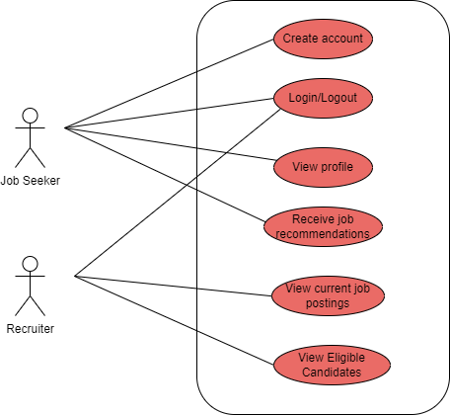

- Class Diagram:

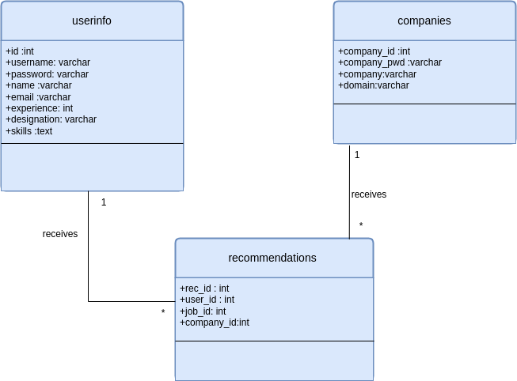

- Activity Diagram (for Job Seeker):

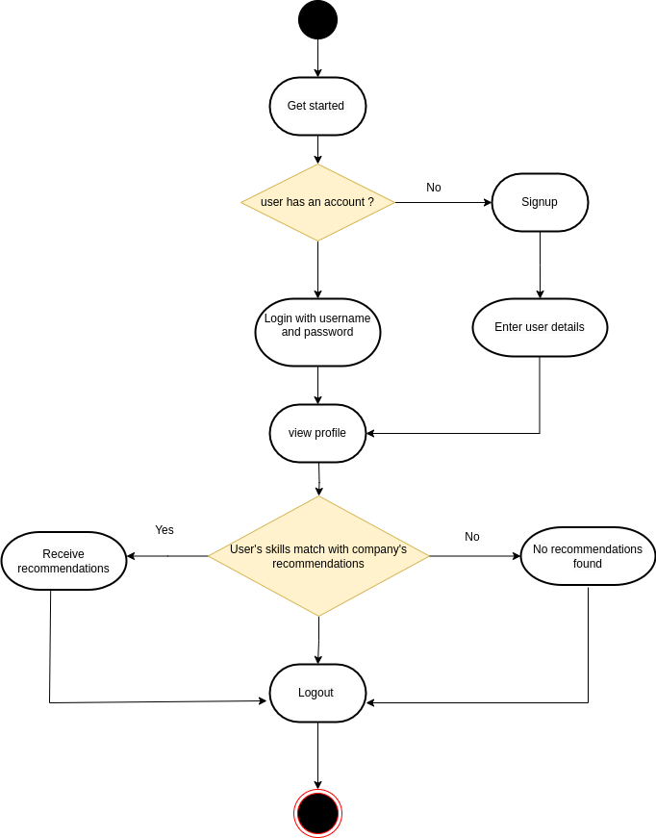
- Activity Diagram (for Recruiter):

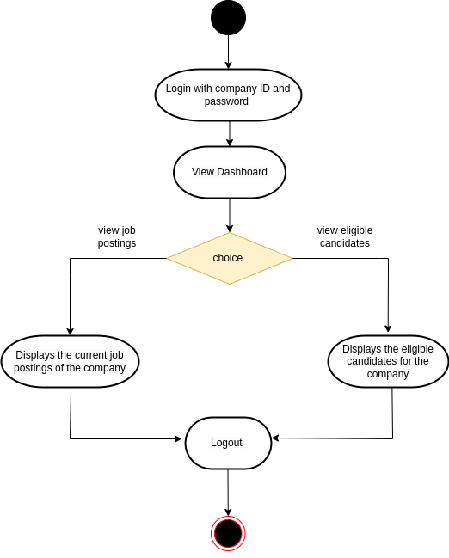
- Sequence Diagram (for Job Seeker):

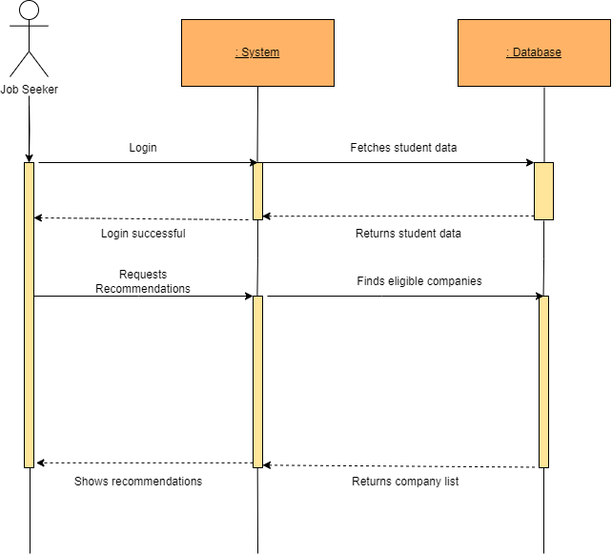

- Sequence Diagram (for Recruiter):

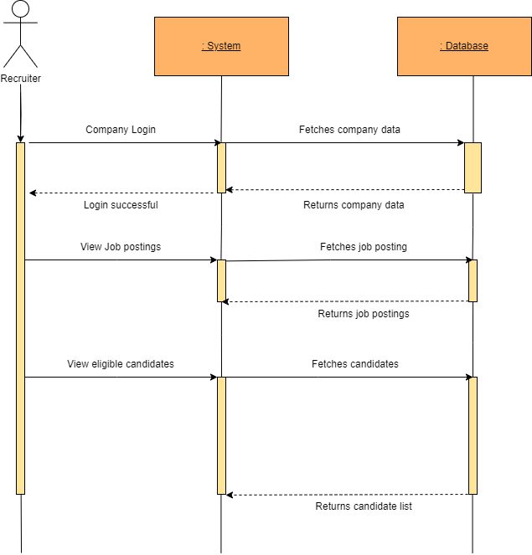
- Collaboration Diagram (for Job Seeker):

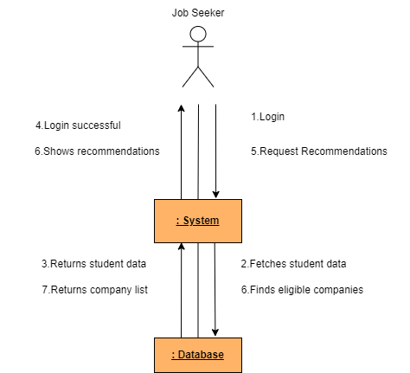

- Collaboration Diagram (for Recruiter):

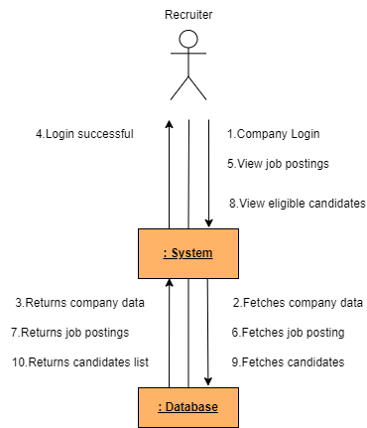
- Deployment Diagram:

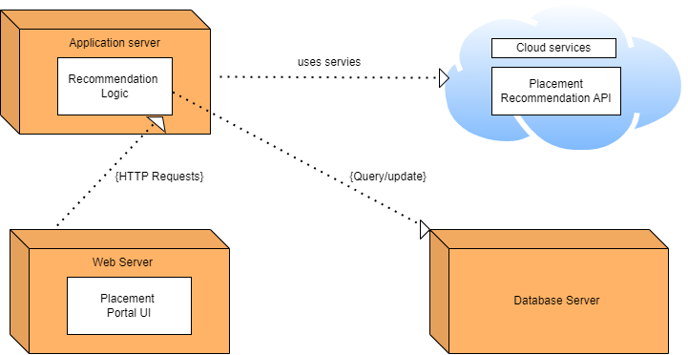

- Component Diagram:

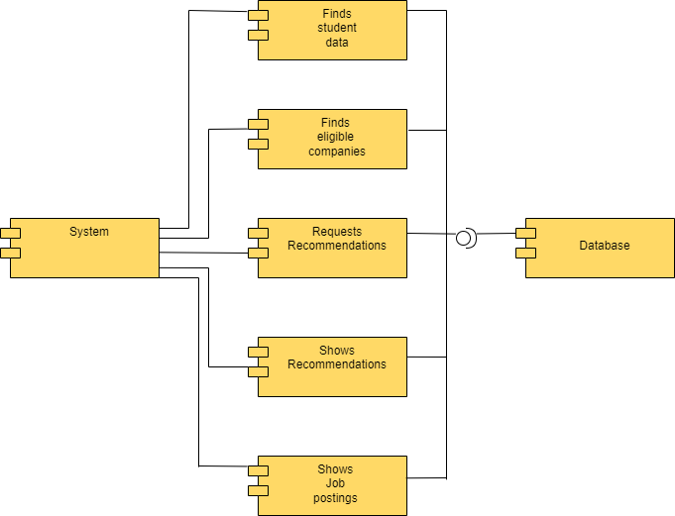

TEST CASES:

- Job Seeker:

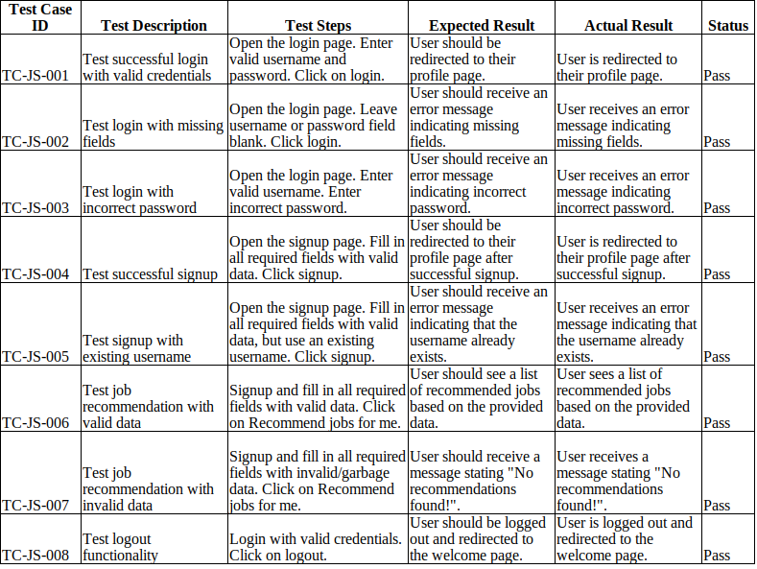

- Recruiter:

