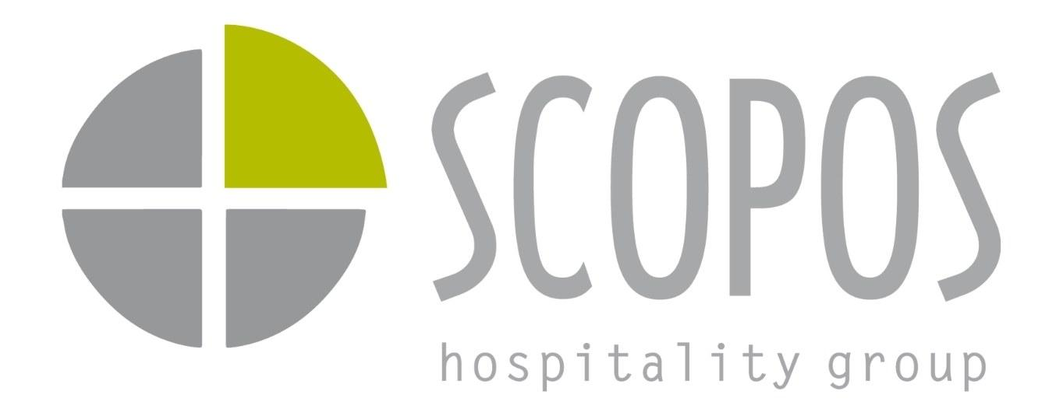
Manager Guide
◎ Why This Exists ◇ What This Is Not ◈ What It Does ▣ Two Pillars ▶ How To Use ⚑ Deficiency Plan △ Promotion Readiness ★ Core Principle ◉ Manager Responsibility ◆ Strategic Outcomes
Evaluation Forms
Interior Designer Construction Administrator
© 2025 SCOPOS Hospitality Group
Skill & Performance System v1.0

 Internal Operating Framework

Skill & Performance System
A structured, role-based competency model that replaces informal evaluations with clarity, development paths, and operational excellence.

Foundation

Why This Exists
As SCOPOS grows, we must ensure that authority aligns with demonstrated capability, promotions reflect readiness, technical standards remain high, client trust is protected, and margin and delivery quality scale with revenue.
This system replaces informal or personality-based evaluations with a structured, role-based competency model.
The goal is not evaluation for its own sake.
The goal is operational excellence and professional growth.

🎯

Authority Alignment
Ensure authority matches demonstrated capability — not tenure or personality.

📈

Promotion Readiness
Promotions are unlocked by meeting defined criteria, not negotiated through advocacy.

🛡

Client Trust
Protect client relationships by ensuring only qualified team members hold authority.

⚙

Scalable Quality
Margin and delivery quality must scale with revenue as the organization grows.

Clarity

What This System Is Not

✗ This System Is Not
- A disciplinary tool
- A comparison scoreboard
- A mechanism to make anyone "look bad"
- A way to justify compensation freezes
- A replacement for leadership judgment

✓ This System Is
- A development engine
- A clarity framework
- A structured growth path
- A fairness guarantee
- A leadership support tool
Skill gaps are normal. Every professional has them.
This framework simply makes them visible and correctable.
Visibility enables growth.

Purpose

What This System Is Designed To Do

🔍

Identify Gaps Early
Surface skill gaps before they impact delivery or client relationships.

📋

Clarify Expectations
Define exactly what each role requires at every performance level.

⚖

Align Authority
Match decision-making power with demonstrated capability.

📝

Development Plans
Create structured, measurable improvement paths for every team member.

🤝

Protect Outcomes
Safeguard delivery quality and client confidence at every stage.

🏆

Objective Promotion
Clear, measurable criteria that remove ambiguity and politics.
The intent is development and clarity — not criticism.

Framework

The Two Pillars of Evaluation
Every evaluation is built on two complementary components, each serving a distinct purpose.

1

Role-Based Skill Competency
70% of evaluation weight

Each position has a defined skill matrix, observable performance levels (1–5), minimum stability thresholds, and senior-track thresholds. Skills are tied directly to the responsibilities of the role.
- Designers are evaluated on documentation and meeting discipline
- CAs are evaluated on technical authority and code literacy
- PMs are evaluated on ownership and coordination
Evaluation is role-specific — not generic.

2

Core Values Alignment
30% of evaluation weight

Core values reflect how work is executed. Values do not override skill gaps. Skills determine role readiness. Values determine trust and leadership suitability.
Both matter. They serve different purposes.

Judgment
Communication
Impact
Curiosity
Innovation Courage
Passion
Integrity
Selflessness

Guidance

How Managers Should Use This Tool

✓ Managers Should
- Conduct structured quarterly evaluations
- Identify areas below stability threshold
- Trigger Deficiency Correction Plans when required
- Align authority with demonstrated capability
- Guide development conversations

✗ Managers Should Avoid
- Inflating scores to avoid difficult conversations
- Using the form as a surprise mechanism
- Completing reviews without prior discussion
- Treating the form as a compliance exercise
The value is in the conversation and follow-through.

Correction

The Deficiency Correction Plan
When a skill falls below threshold, the system triggers a structured correction process. This is structured coaching — not punishment. The objective is measurable growth within 30–60 days.

1

Gap Identification
System automatically flags skills below stability threshold and identifies the specific gap.

2

Root Cause Classification
Manager determines whether the gap is experience-based, training-based, or a role-fit concern.

3

Defined Corrective Actions
Specific, actionable steps are documented with clear ownership and expectations.

4

Measurable Target
A specific skill level target is set with a 30-day checkpoint for progress review.

5

Timeline & Accountability
Follow-up date locked in. Authority temporarily aligned to current demonstrated capability.

6

Review & Reassess
If gap persists across multiple cycles, role fit must be evaluated. Not everyone fits every role long-term — that is normal in scaling organizations.

Advancement

Promotion Readiness

Promotions are unlocked — not negotiated.
Each role has defined skill thresholds, required stability levels, and senior-track criteria. This ensures fairness and protects team morale.

✓

Majority at Target Level
Most required skills must be at the defined target level for the next role.

⊘

No Critical Gaps
No skill can be below the minimum threshold for the target position.

↻

Consistent Performance
Sustained performance across multiple evaluation cycles, not a single snapshot.

⚑

No Disqualifiers
Universal disqualifiers (integrity, repeated deficiencies) automatically block promotion.

Philosophy

The Most Important Principle

This system exists to build people.
It creates clear expectations, clear feedback, clear development paths, and clear promotion criteria. It removes ambiguity and politics.
When skill gaps are identified early and addressed intentionally:

💪

Confidence Increases
Team members know exactly where they stand and what to work on.

📊

Performance Improves
Targeted development produces faster, more meaningful growth.

⬇

Leadership Load Decreases
Self-sufficient team members reduce the need for constant oversight.

🚀

Individuals Grow Faster
Structured paths accelerate professional development.
This is a development engine, not a grading system.

Accountability

Manager Responsibility
This system only works if managers treat it as a growth tool, not an administrative task. Managers are accountable for:

⊙

Scoring Honestly
Accurate ratings protect the integrity of the entire system.

💬

Coaching Intentionally
Development conversations backed by data and followed by action.

✓

Following Through
Development plans require consistent follow-up and accountability.

⚖

Aligning Authority
Match responsibilities to demonstrated skill levels.

♥

Reinforcing Culture
Values alignment alongside technical competence.

↻

Quarterly Cadence
Consistent, predictable evaluation cycles build trust.

Impact

Strategic Outcomes
When used correctly, this system drives measurable organizational improvement.

📐

Elevate Standards
Technical excellence across all roles

↓

Reduce Rework
Fewer escalations and corrections

🤝

Client Confidence
Trust built through consistent delivery

👥

Promotable Leaders
Clear pipeline of ready talent

💰

Protect Margin
Quality delivery at scale

🏗

Reduce Dependency
Operator-grade capability org-wide

This is how SCOPOS builds operator-grade capability across the organization.
A development engine that transforms individual growth into organizational strength — one evaluation cycle at a time.
© 2025 SCOPOS Hospitality Group. All Rights Reserved. Skill & Performance System · scoposhospitalitygroup.com

