Software Requirements Specification
for
Fishing Quota Management System
Version 1.0 approved
Prepared by <author>
02/05/2023
Table of Contents
Table of Contents ii
Revision History ii
1. Introduction 3
1.1 Purpose 3
1.2 Document Conventions 3
1.3 Intended Audience and Reading Suggestions 3
1.4 Product Scope 3
2. Overall Description 4
2.1 Product Perspective 4
2.2 Product Functions 4
2.3 User Classes and Characteristics 4
2.4 Operating Environment 4
2.5 Design and Implementation Constraints 5
2.6 User Documentation 5
2.7 Assumptions and Dependencies 5
3. External Interface Requirements 5
3.1 User Interfaces 5
3.2 Hardware Interfaces 6
3.3 Software Interfaces 6
3.4 Communications Interfaces 6
4. System Features 6
4.1 User Management 6
4.2 Boat Management 6
4.3 Catch Tracking 7
4.4 Quota Monitoring 7
4.5 Real-time Update 7
4.6 Report 7
5. Other Nonfunctional Requirements 7
5.1 Performance Requirements 7
5.2 Safety Requirements 7
5.3 Security Requirements 8
5.4 Software Quality Attributes 8
5.5 Business Rules 8
6. Other Requirements 9
6.1 Database Requirement 9
6.2 Legel Requirement 9
6.3 Re-use Objectives for Projects 9
ERD 10

Appendix A: Glossary 7
Appendix B: Analysis Models 7
Appendix C: To Be Determined List 7

Revision History
Date | Description | Version
02/05/2023 | Initial version of the SRS for The Fishing Quota Management System. | 1.0

Introduction

Purpose
This document specifies the requirements for the Fishing Quota Management System. The system is designed to manage fishing quotas for UK fishing vessels, allowing for the allocation of quotas to individual vessels or fleets. The system will allow users to add new boats to the fleet, track the fish caught by each boat, and display quota reports. The purpose of this document is to outline the functional and non-functional requirements for the system and provide guidance for its development.

Document Conventions
This document follows standard conventions for software requirements specification documents. Requirements are listed in a numbered format and are categorized as functional or non-functional requirements. Priority levels are assigned to requirements to indicate their relative importance. Any special formatting or highlighting is used only for emphasis and is not a formal convention.

Intended Audience and Reading Suggestions
This document is intended for developers, project managers, and other stakeholders involved in the development of the Fishing Quota Management System. It provides a comprehensive overview of the system's requirements, including functional and non-functional requirements, and outlines the scope of the project. The document is organized into sections to make it easy to navigate and to allow readers to focus on the areas most relevant to their roles.

For developers, the document provides detailed information on the functional and non-functional requirements for the system, including any dependencies or constraints. Project managers can use the document to manage the project's scope and ensure that the requirements are being met. Other stakeholders, such as users or testers, can use the document to gain an understanding of the system's capabilities and limitations.

It is recommended that readers start with the overview sections to gain a high-level understanding of the system and then proceed to the detailed requirements sections for a more in-depth analysis.

Product Scope
The Fishing Quota Management System is designed to manage fishing quotas for UK fishing vessels. The system will allow users to add new boats to the fleet and track the fish caught by each boat. The system will also provide quota reports to allow users to monitor the total weight of fish caught by the fleet for each species versus the quota.

The system will be developed as a desktop application using C# and SQL Server. It will consist of several forms, including login and signup forms, as well as forms for adding and managing boats and displaying quota reports. The system will be designed to ensure that no mandatory fields are left null, and users will be prompted with error messages if they enter incorrect inputs.

The Fishing Quota Management System is intended to be a comprehensive system for managing fishing quotas, with features that allow for the addition of new boats and the tracking of fish caught by each boat. The system will provide real-time updates on quotas and allow users to monitor the progress of their quotas throughout the fishing season.

Overall Description

Product Perspective
The Fishing Quota Management System is a new, self-contained product designed to manage fishing quotas for UK fishing vessels. It is not part of an existing system or product family. The system will be a standalone application that will interface with external databases and systems as necessary.

Product Functions
The Fishing Quota Management System will perform the following functions:

- Allow users to create and manage accounts
- Allow users to add new boats to the fleet
- Allow users to track the fish caught by each boat
- Provide quota reports to allow users to monitor the total weight of fish caught by the fleet for each species versus the quota
- Alert users when their quota is close to being reached or has been reached
- Display real-time updates on quotas and allow users to monitor the progress of their quotas throughout the fishing season

User Classes and Characteristics
The Fishing Quota Management System will be used by the following user classes:

- Fishing vessel owners and operators
- Fishing fleet managers
- Government regulators and officials responsible for monitoring fishing quotas

Users are expected to have basic computer skills, including familiarity with desktop applications and internet browsers. They should also have a working knowledge of fishing and fishing quotas.

Operating Environment
The Fishing Quota Management System will be developed as a desktop application using C# and SQL Server. It will be compatible with the following operating systems:

- Windows 10
- Windows 8.1
- Windows 8
- Windows 7

The system requires no internet connection to access external databases and systems.

Design and Implementation Constraints
The following constraints will apply to the design and implementation of the Fishing Quota Management System:

- The system must be designed to ensure that no mandatory fields are left null, and users will be prompted with error messages if they enter incorrect inputs.
- The system must comply with relevant UK fishing regulations and laws.
- The system must be designed to be user-friendly and intuitive, with clear instructions and prompts.
- The system must be designed to handle large amounts of data efficiently and accurately.

User Documentation
This SRS documentation will be delivered with all the relevant details of the program in PDF format.

Assumptions and Dependencies
The following assumptions and dependencies will apply to the development of the Fishing Quota Management System:

- The system will interface with external databases and systems as necessary to access fishing quota information and other relevant data.
- Users will have a basic understanding of fishing and fishing quotas.
- The system will comply with relevant UK fishing regulations and law.

External Interface Requirements

User Interfaces
The Fishing Quota Management System will have a user-friendly and intuitive interface to ensure ease of use for its users. The following are the logical characteristics of each interface between the software product and the users:

- Login and Signup Forms: The system will provide a login and signup form for users to create and manage their accounts. The form will require users to provide their username and password to access the system.

- Fleet Management Form: This form will allow users to add new boats to the fleet, update boat information, and delete boats. Users will be able to view a list of all boats in the fleet and their associated information.

- Catch Tracking Form: This form will allow users to track the fish caught by each boat. Users will be able to select a boat from the fleet and input the weight and species of fish caught. The system will validate the input and provide error messages for incorrect data.

- Quota Reports Form: This form will provide quota reports to allow users to monitor the total weight of fish caught by the fleet for each species versus the quota. Users will be able to view reports for individual boats or the entire fleet.

Hardware Interfaces
The Fishing Quota Management System is a desktop application and will be installed on the user's local machine. It will not require any specialized hardware interfaces.

Software Interfaces
The Fishing Quota Management System will interface with external databases and systems to access fishing quota information and other relevant data. The following software interfaces will be used:

- SQL Server: The system will use SQL Server to store and manage fishing quota data.

- .NET Framework: The system will be developed using the .NET Framework, which will provide a programming environment for developing and running software applications.

Communications Interfaces
The Fishing Quota Management System will not require any communication interfaces as it will be a standalone desktop application and will not communicate with any external systems over a network

System Features

User Management
The Fishing Quota Management System will allow users to create and manage their accounts. Users will be required to provide their full name, username, email, phone number, password and name of the pet to create an account. The system will store the user information in a secure database and allow users to log in to their accounts with their email and password. Users will also be able to reset their passwords if they forget them using username and pet name.

Boat Management
The system will allow users to add new boats to the fleet and manage the boats in their fleet. Users will be able to enter boat information such as the boat id, boat name, license number, and type of species a boat can store. The system will store this information in a secure database and allow users to edit or delete boat information as needed.

Catch Tracking
The Fishing Quota Management System will allow users to track the fish caught by each boat in their fleet. Users will be able to enter information about the catch, including the species caught, the weight, and the boat which caught the species. The system will store this information in a secure database and allow users to view catch information for each boat in their fleet. Users can update the information at any time.

Quota Monitoring
The system will provide quota reports to allow users to monitor the total weight of fish caught by the fleet for each species versus the quota. Users will be able to view quota information by species, fleet. The system will display the quota status, indicating whether the quota has been reached or has or has not been reached.

Real-time Updates
The system will display real-time updates on quotas and allow users to monitor the progress of their quotas throughout the fishing season. Users will be able to view the catch information for each boat in their fleet and see how it contributes to the overall quota status. The system will update quota information in real time and display the updated status to users immediately.

Reporting
The Fishing Quota Management System will provide a report to help users monitor and analyze their quota data. Users will be able to go through the reports on catch data by species, and fleet. The system will also provide reports on quota usage, including the total weight of fish caught, the remaining quota, the quota limit, and the quota status.

Other Nonfunctional Requirements

Performance Requirements
- The system should be responsive and provide a smooth user experience.
- The system should be able to handle multiple requests simultaneously without any significant delay.
- The system should be able to handle large amounts of data without slowing down.

Safety Requirements
- The system should not allow any unauthorized access or data breaches.
- The system should not allow any invalid or incorrect data to be stored or processed.

Security Requirements
- The system should have user authentication and authorization mechanisms to ensure that only authorized users have access to the system.
- The system should encrypt sensitive data such as user passwords to protect them from unauthorized access.

Software Quality Attributes
- The system should be easy to use and navigate for users with different levels of technical expertise.
- The system should be scalable and flexible, allowing for future updates and modifications.
- The system should be maintainable and modular, allowing for easy troubleshooting and bug fixing.
- The system should be reliable and accurate, providing correct and accurate data and results.
- The system should be compatible with different operating environments like Windows 10, and Windows 11.
- The system should be efficient and optimized, reducing resource utilization and energy consumption.

Business Rules
- Only authorized users can access the Fishing Fleet Management System.
- Users can add new boats to the fleet, view the available boats, and add the fish caught by each boat.
- Authorized users have full access to the system and can add, modify, or delete their own account, boats, catches, and view quotas.
- When adding a new boat, the user must enter all required information, including the name, license number, maximum load size, and the number of species the boat can store. The user should also be able to select an existing boat from the fleet.
- Each boat can store a minimum of 2 and a maximum of 4 species of fish.
- The system should validate the inputs entered by the user and display an error message if any mandatory fields are left blank or if the user enters incorrect data types.
- The system should display a quota report that shows the total weight caught by the fleet for each fish species versus the quota.
- The user should be able to select an option to display any weight in either kilograms or tons.
- The system should use the License numbering format allowed: L XXX, LL XXX, L XX, LL XX, where L is a letter and X is a number.
- If the license numbering format is invalid, the system must display an error message.
- The system should display the quota status (limit reached or limit not reached yet) for each fish species.
- The system should not allow the user to add or update the caught species if the limit has been reached.
- The system should maintain a record of all catches made by each boat, including the species caught, weight, and catch date.

Other Requirements

Database Requirements
- The Fishing Fleet Management System should have a secure and reliable database to store all the data.
- The database should be able to handle large amounts of data and have a fast response time.
- The database should be designed to maintain data integrity and consistency.
- The database should be able to perform backup and restore operations.

Legal Requirements
- The Fishing Fleet Management System should comply with all relevant data protection and privacy laws, such as GDPR and CCPA.
- The system should comply with all relevant fishing regulations and laws.
- The system should not allow any illegal activities, such as overfishing, to take place.

Reuse Objectives for the Project
- The system should be designed to be reusable for future projects and enhancements.
- The system should be modular and well-documented to facilitate future maintenance and modifications.
Appendix A: Glossary
- GDPR: General Data Protection Regulation
- CCPA: California Consumer Privacy Act
Appendix B: Analysis Models
- Entity-relationship diagram to show the relationships between different entities in the system.
Appendix C: To Be Determined List
- Any references to external APIs that may be used in the system.
- Any additional features or requirements that may be added during the development process.

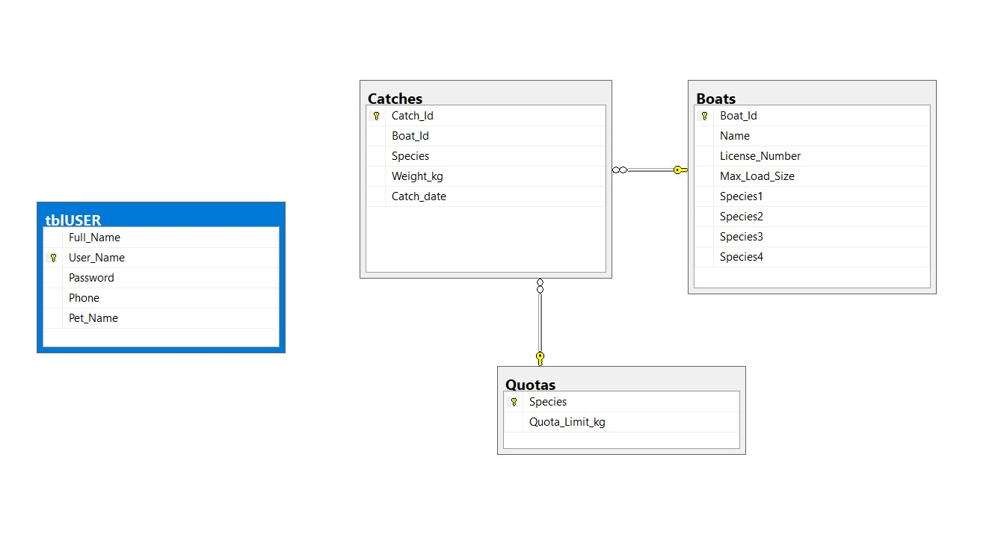
Entity-Relationship Diagram

