CREDIT_CARD

1. Find the total amount spent by each customer.

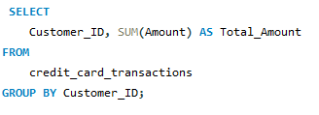

Ans:

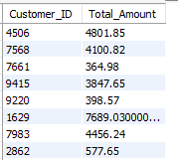

1. Get the top 5 locations with the highest number of transactions.

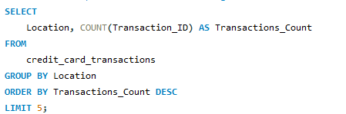

ANS:

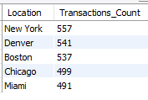

1. List all fraudulent transactions above $1000.

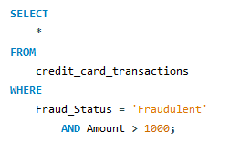

Ans:

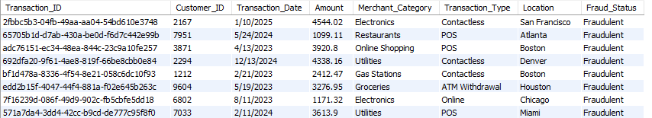

4 Count the number of transactions for each merchant category.

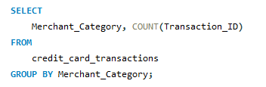

Ans

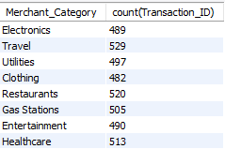

1. Find the average transaction amount for online purchases.

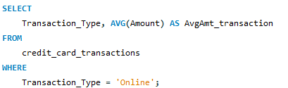

Ans:



1. Identify the customer who has made the highest number of transactions.

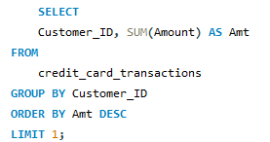

Ans:



1. Retrieve all transactions made in "New York" in the last year.

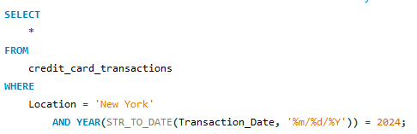

Ans:

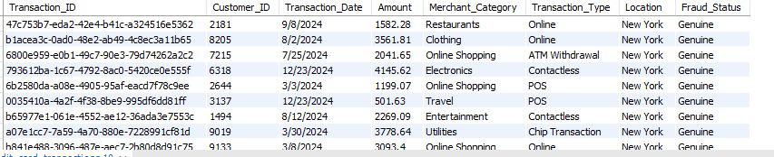

1. Identify the top 3 customers who spent the most in the last year.

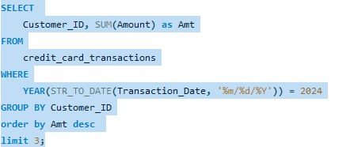

Ans:

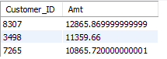

1. Find the most frequently used transaction type.

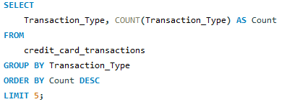

Ans:

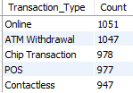

1. Retrieve all transactions where the amount is higher than the average transaction amount.

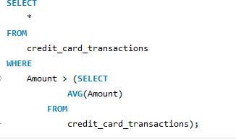

Ans:

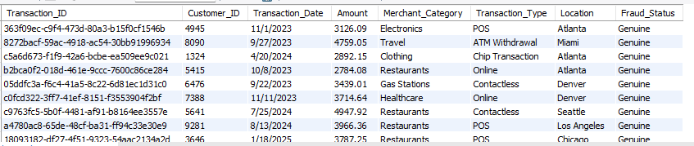

1. Find the month with the highest total transaction amount.

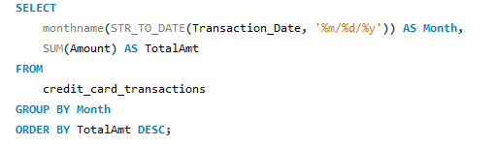

Ans:

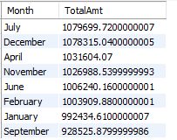

1. Count the number of fraudulent transactions per location.

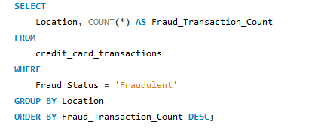

Ans:

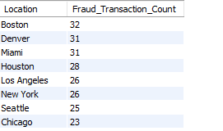

12.Get the total amount spent per customer in each merchant category.

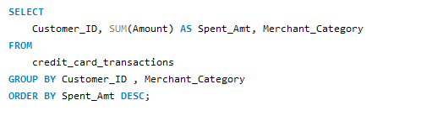

Ans:

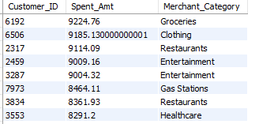

1. List customers who have made transactions in more than 3 different locations.

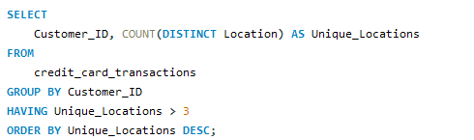

Ans:

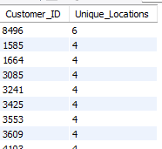

1. Find the percentage of fraudulent transactions for each transaction type.

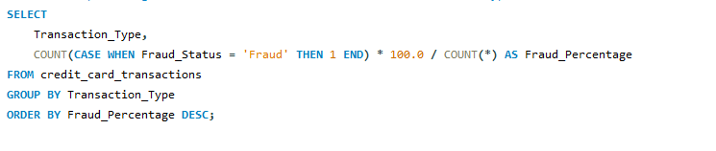

Ans

