Task:-
Task was to store artifacts into nexus repo with help of python script. In this case there were four artifacts generated two were docker images and two were zap reports, Docker images were already stored on ACR thus zap test reports were stored in the nexu repo.

Steps:-
Install nexus repository manager in your machine.
https://youtu.be/K6rR-gdsFc8?si=a3HCWt445tEI70r4
By default nexus repo will run on local host 8081.

2. Configure Nexus Repository Manager:
After installation, you'll need to configure Nexus Repository Manager:
- Access Nexus Repository Manager: Navigate to the URL where Nexus Repository Manager is hosted (e.g., http://localhost:8081).
- Log in: Log in using the default credentials (admin/admin123) or the credentials you specified during installation.
- Set up a Repository: Create a repository to store your artifacts. Since you're dealing with text files, you can create a raw repository. Go to Repositories and click on Create repository, then choose Raw (hosted).
- Configure Repository: Follow the prompts to configure your repository. Ensure you provide a repository name. You can leave other settings as default for now
.

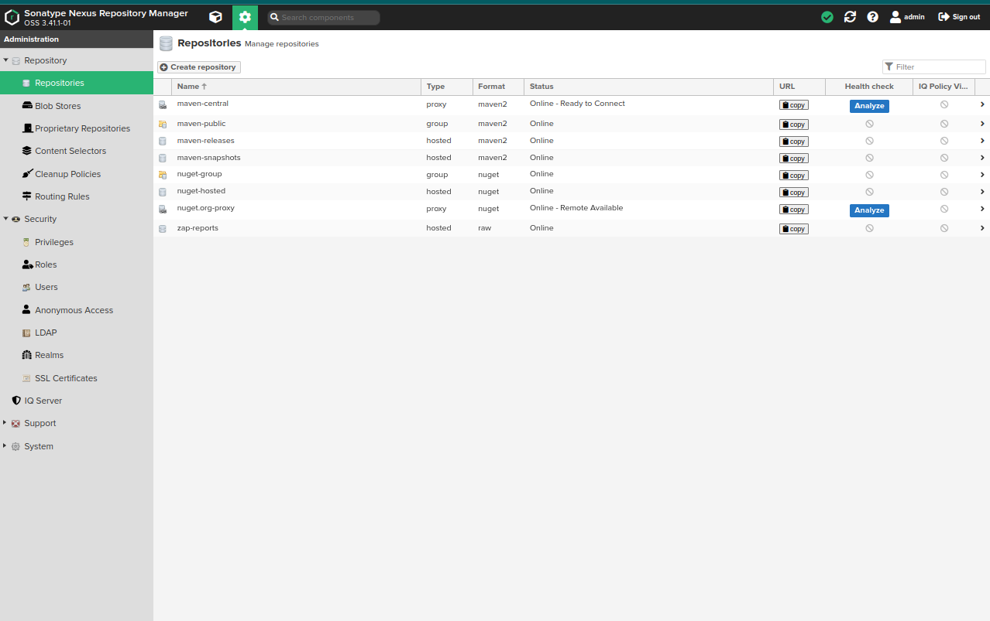
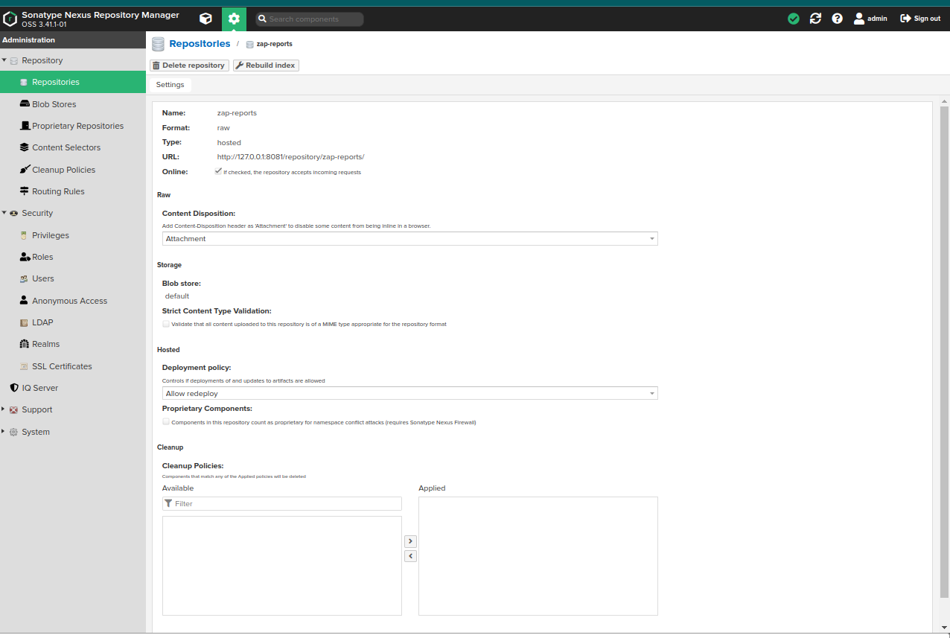
After that make a directory named nexus and in that directory paste both the .txt files related to zap testing and make a file name nexus.py and paste the below script
import os
import requests
# Get the current directory
current_directory = os.getcwd()

# Define the directory path relative to the current directory
directory_path = os.path.join(current_directory, 'packages/raw/')

# Define the parameters
params = (
('repository', 'hosted-raw'), # Repository name
)

# Define the files to upload
files = {
'raw.asset1': ('zap-alerts.txt', open('zap-alerts.txt', 'rb')), # Adjust file name and path accordingly
'raw.asset2': ('zap-alerts-world.txt', open('zap-alerts-world.txt', 'rb')), # Adjust file name and path accordingly
}

# Define additional data
data = {
'raw.directory': directory_path, # Adjust directory path if necessary
'raw.asset1.filename': 'zap-alerts.txt', # Adjust file name accordingly
'raw.asset2.filename': 'zap-alerts-world.txt', # Adjust file name accordingly
}

# Make the POST request
response = requests.post('http://localhost:8081/service/rest/v1/components?repository=zap-reports', params=params, files=files, data=data, auth=('admin', '12345678')) //adjust your credentials

# Check the response status code
if response.status_code == 204:
print("Files uploaded successfully!")
else:
print(f"Failed to upload files. Status code: {response.status_code}")

After that run python3 nexus.py command in terminal
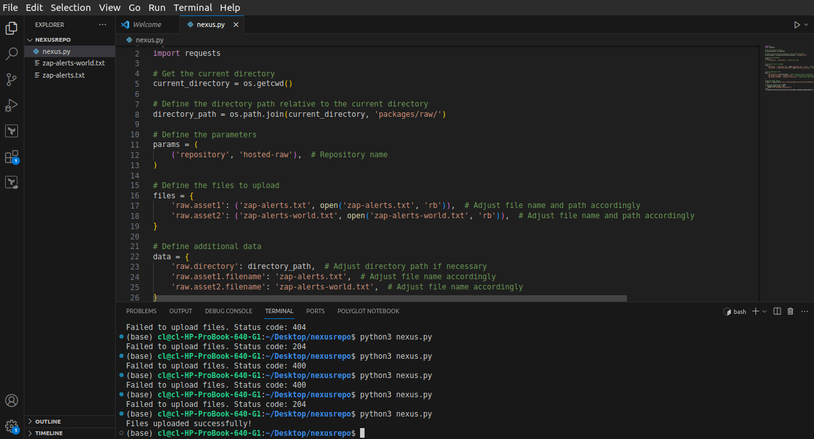
You can validate the files in the nexus repository
