# Power Electronics

# Flyback Converter Simulation

# Name: Abakah Alexander Abeiku

# **Section 1 - Results**

## **Flyback Converter – Unity Ratio.**

**Calculating frequency and duty cycle**

Freq = ${Vo^2(1 - d)^2}/{Prated*L}$ = **46.154kH**

1 = $d/{(1 -d)}$; d = **0.5**

Simulation results when RL is set to 24 ohms :

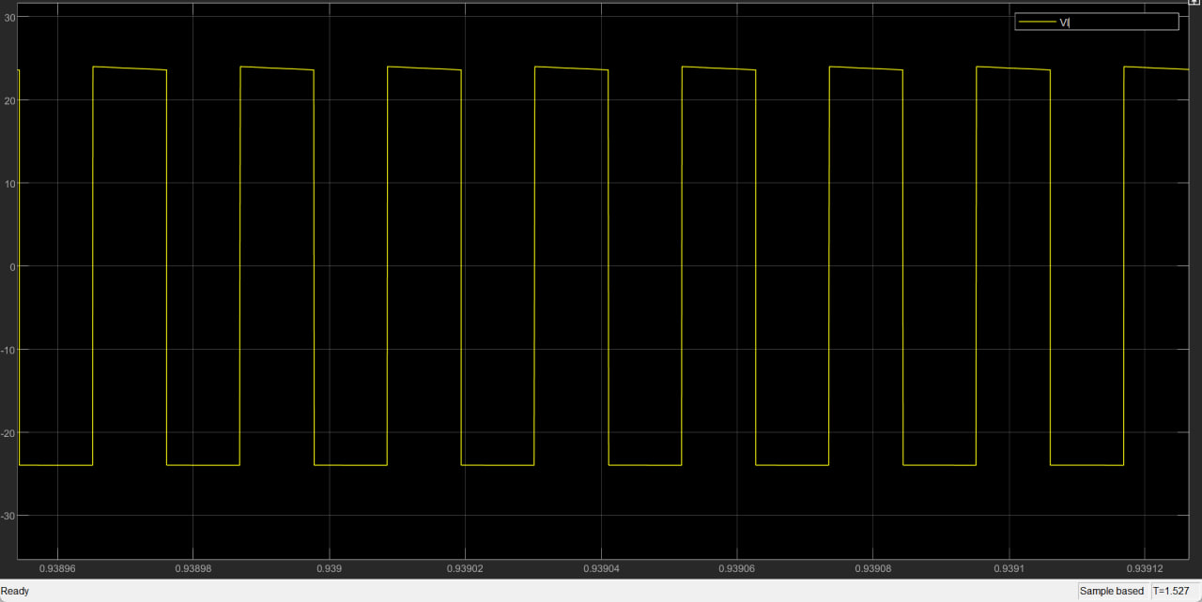

Primary Inductor voltage waveform

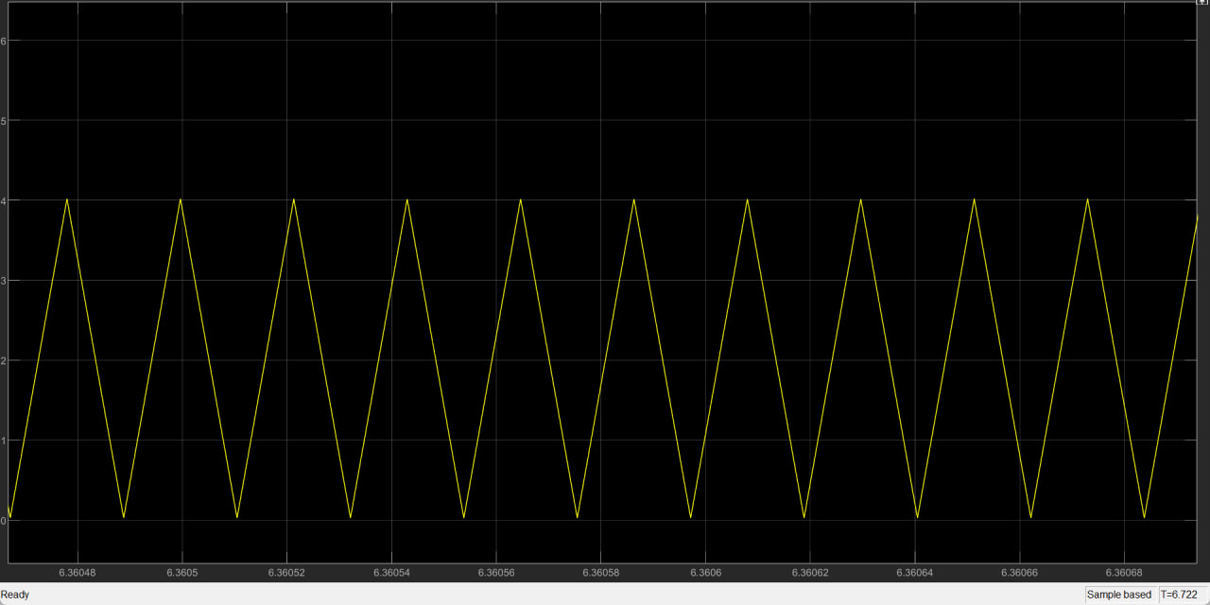

Inductor current waveform

**Simulation results when the single inductor is replaced with a double wounded inductor**

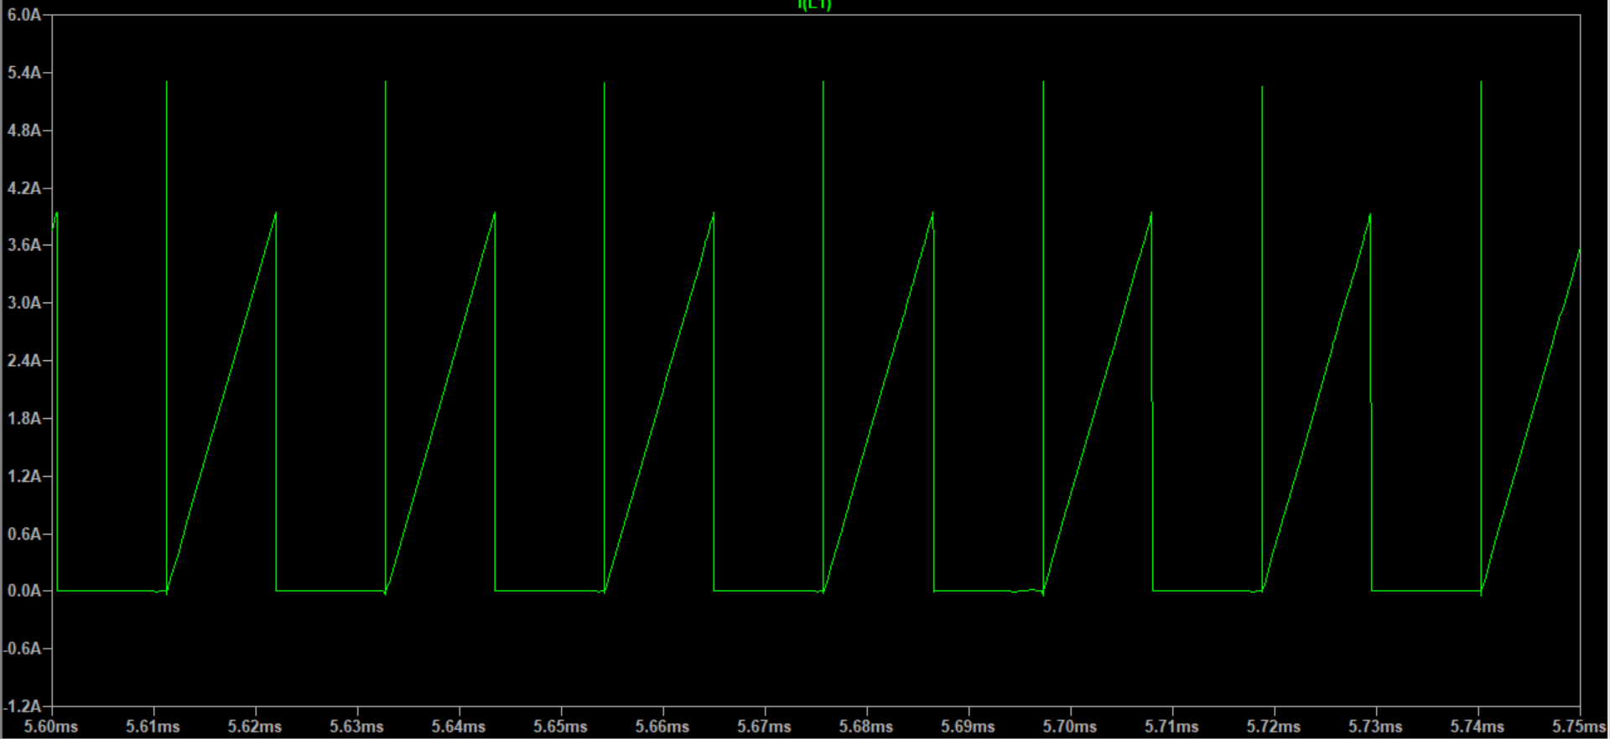

Primary Inductor current waveform

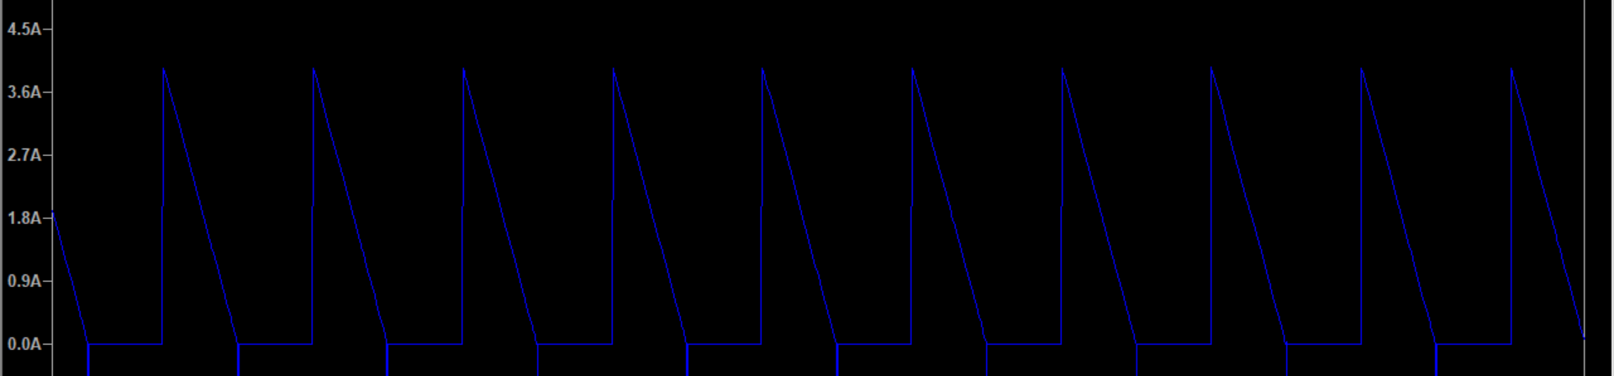

Secondary Inductor current waveform

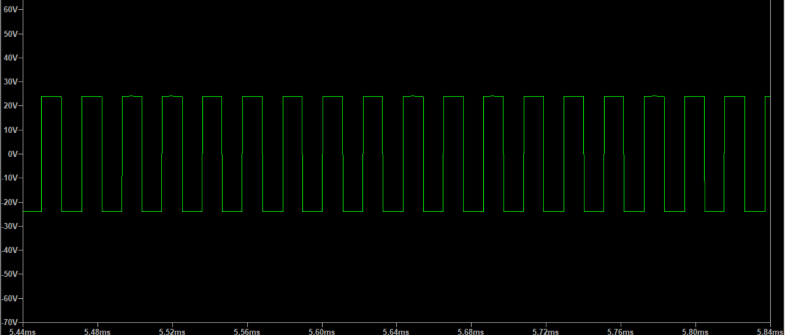

Secondary Inductor voltage waveform

**Calculating the resistance to give rated output power**

Rated output current = $\frac{48W}{24V}$ = 2A

Load resistance to give rated output power = $\frac{24}{2}$ = 12Ω

Simulation results when RL is set to 12Ω :

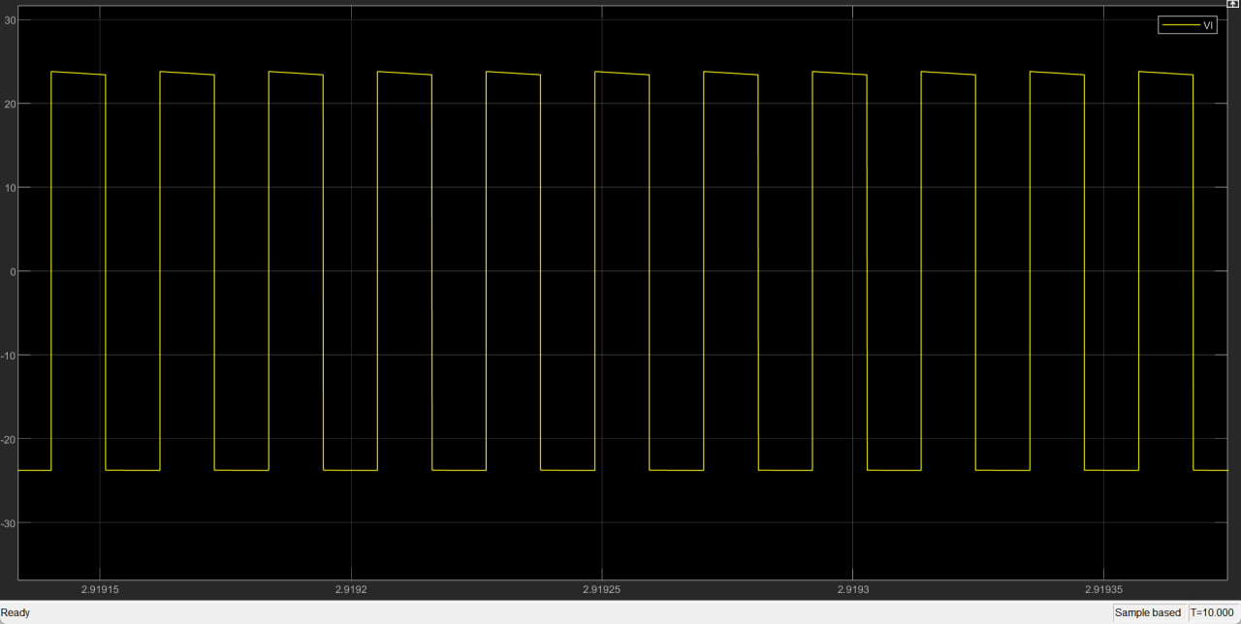

Inductor output voltage waveform (VL)

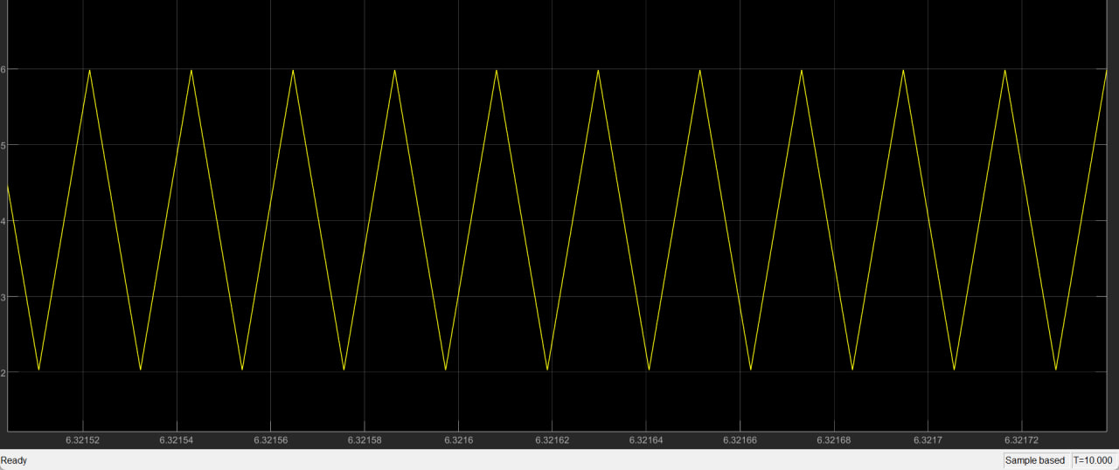

Inductor current waveform (IL)

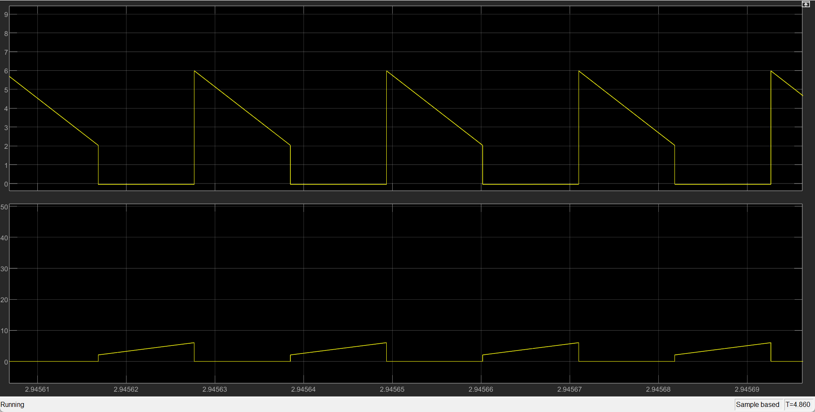

MOSFET(lower waveform) and Diode(upper waveform) current waveform.

## **Fly Back Converter - Step down.**

**Calculating frequency and duty cycle.**

Freq = ${Vo^2(1 - d)^2}/{Prated*L}$ = 29.538kH.

${16}/{24}$ = $d/{(1 -d)}$; d = 0.4

**Calculating the value of RL to give half the rated power at the output.**

output current = $\frac{24W}{16V}$ = 1.5A

Load resistance to give half the rated output power = $\frac{16}{1.5}$ = 10.667Ω.

Simulation results when RL is set to 10.6667 Ω :

**Calculating the value of RL for rated output power.**

output current = $\frac{48W}{16V}$ = 3A

Load resistance to give half the rated output power = $\frac{16}{3}$ = 5.333Ω.

Simulation results when RL is set to 5.333Ω

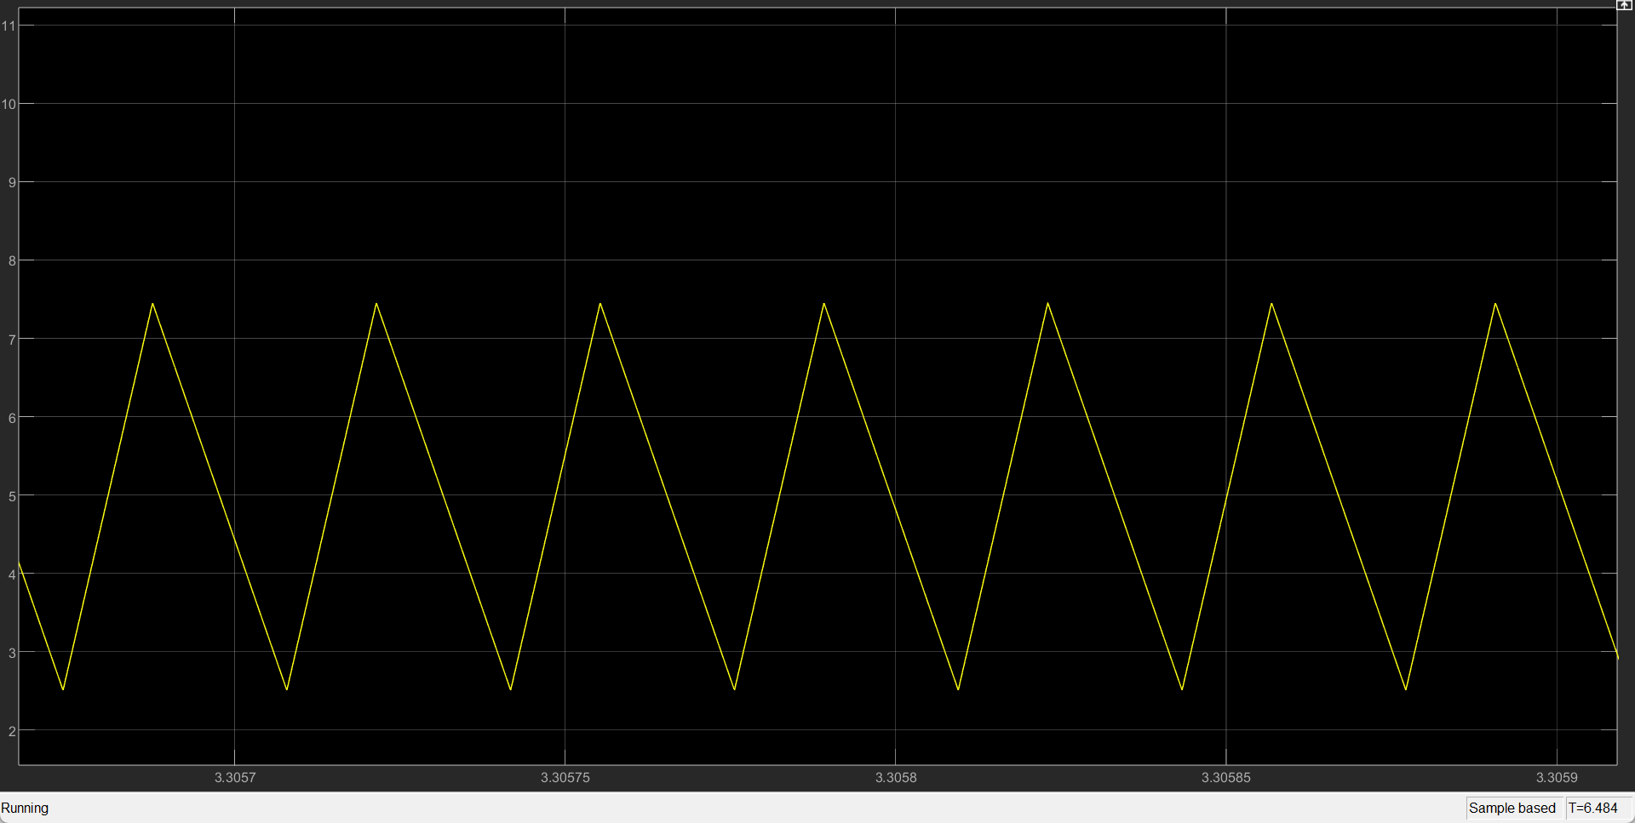

Inductor current waveform (IL)

## **Flyback converter - Step Up**

**Calculating frequency and duty cycle**

Freq = ${Vo^2(1 - d)^2}/{Prated*L}$ = 66.462kH

$\frac{3}{2}$ = $d/{(1 -d)}$; d = 0.6

**Calculating the value of RL for half rated power at the output.**

output current = $\frac{24W}{36V}$ = $\frac{2}{3}$ A

Load resistance to give half the rated output power = $\frac{36}{\frac{2}{3}}$ = 54Ω.

Simulation results when RL is set to 54 Ω :

**Calculating the resistance to give rated output power**

Rated output current = $\frac{48W}{36V}$ = $\frac{4}{3}$ A

Load resistance to give rated output power = $\frac{36}{\frac{4}{3}}$ = 27Ω

Results when RL is set to 27Ω

# **Section 2 – Calculation.**

## **Flyback converter - Unity ratio.**

**Calculating efficiency of the converter(non-isolated)**

**When RL  is set to 24Ω:**

Recorded output(load) current = 0.9982A

Recorded output(load) voltage = 23.96v

Recorded input current = 1.75A

Input voltage = 24v

Efficiency = $\frac{0.9982 × 23.96}{1.75 × 24}$ $×$ 100 = 56.94%

**When RL is set to 12Ω(full load):**

Recorded output(load) current = 1.98A

Recorded output(load) voltage = 23.76v

Recorded input current = 3.087A

Input voltage = 24v

Efficiency = $\frac{1.98 × 23.76}{3.087 × 24}$ $×$ 100 = 63.5%

**Calculating mean diode current and comparing with the measured value**

**Full Load**

Mean diode current = $\frac{48W}{24V}$ = 2A

Recorded mean diode current = 1.635A

**Half load**

Mean diode current = $\frac{24W}{24V}$ = 1A

Recorded mean diode current = 1.034A

**Calculating theoretical value of ∆IL and comparing it to the measured value of ∆IL from the inductor current waveform**

∆IL = = = 4.0A

Recorded value of ∆IL  from the inductor current waveform for both full load and half load conditions = 3.9886A

## **Flyback converter - Step down.**

**Calculating efficiency of the converter(non-isolated)**

**When RL  is set to 10.6667Ω(half load):**

Recorded output(load) current = 1.498A

Recorded output(load) voltage = 15.98v

Recorded input current = 2.106A

Input voltage = 24v

Efficiency = $\frac{1.498 × 15.98}{2.106 × 24}$ $×$ 100 = 47.36%

**When RL is set to 5.333Ω(full load):**

Recorded output(load) current = 2.969A

Recorded output(load) voltage = 15.84v

Recorded input current = 3.473A

Input voltage = 24v

Efficiency = $\frac{2.969 × 15.84}{3.743 × 24}$ $×$ 100 = 56.422%

**Calculating mean diode current and comparing with the measured value**

**Full Load**

Mean diode current = $\frac{48W}{16V}$ = 3A

Recorded mean diode current = 2.768A

**Half load**

Mean diode current = $\frac{24W}{16V}$ = 1.5A

Recorded mean diode current = 1.209A

**Calculating theoretical value of ∆IL and comparing it to the measured value of ∆IL from the inductor current waveform**

∆IL = = = 5.0A

Recorded value of ∆IL  from the inductor current waveform for both full load and half load conditions = 4.9997A

# **Section 3 – Discussion.**

## **Flyback converter - Unity ratio.**

**Single wound mode**

* HALF LOAD

The measured value of voltage, Vo, was found to be 23.92 V, which exhibits a small deviation of only 0.08 V from the expected theoretical value of 24 V. It is noteworthy that theII waveform precisely aligns with the discontinuous current threshold.

* FULL LOAD

The measured value of voltage, Vo, was determined to be 23.75 V, revealing a discrepancy of 0.25 V in comparison to the theoretical value. This difference is notable as it exceeds the voltage deviation observed at half load.

**Double wound mode**

The high frequency damped oscillations during transistor turn-on in an isolated flyback converter are caused by parasitic Cgd and leakage inductance of the double wound inductor. Pre-turn-on oscillations, on the other hand, are influenced by parasitic capacitances and the magnetizing inductance. During transistor turn-off, a significant portion of the energy stored in the primary winding transfers to the secondary winding, but some energy remains due to imperfect magnetic coupling between the coils. The primary inductance comprises two series inductors: the main coupling inductance and the leakage inductance, which accounts for a small percentage of the overall primary inductance. When the MOSFET turns off, the uncoupled energy is rapidly released, creating resonance with the MOSFET drain-source capacitance. The small value of the leakage inductance relative to the overall primary inductance results in a high resonant frequency.

* The presence of leakage inductance in the double-wound inductor of an isolated converter resulted in more pronounced glitches in the inductor voltage waveform compared to a non-isolated flyback converter. Leakage inductance in a transformer can give rise to voltage spikes or glitches during switching transitions. Specifically, when the switch is turned off, the energy stored in the leakage inductance generates a voltage spike across the primary winding. This spike, in turn, causes larger glitches in the inductor voltage waveform in comparison to non-isolated converters that lack transformers.
* The converter’s major sources of power loss include
* switching Losses which occurs during the switching transitions of the main switch (The MOSFET).
* conduction losses which occur due to the resistance of the diode and the MOSFET.
* and losses in the transformer (in the case of the double wounded inductor) in the form of copper and core losses

## **Flyback converter - Step down.**

* At half the rated power, the inductor current waveform is exactly at the discontinuous current threshold. The measured value for output voltage, 15.95, differs from the theoretical 16V by 0.05V.

The measured output voltage value, 15.85, differs from the theoretical 16V by 0.15V. The calculated and measured values for ∆IL are the same. The measured and calculated values for the mean diode, and transistor currents are approximately the same.

* The inductor current waveform also showed the trough just touching zero before the cycle restarted, thus the inductor current was at the threshold between continuous and discontinuous current.

## **Flyback converter - Step up.**

The measured value for output voltage at full load, 35.87, differs from the theoretical 36V by 0.13V. The measured value for output voltage at half load, 35.64, differs from the theoretical 36V by 0.36Vs.

The main distinction between a two-winding inductor and a transformer lies in the manner in which energy flows and is stored. In a transformer, energy is directly transferred from the primary winding to the secondary winding through magnetic coupling. On the other hand, in a two-winding inductor, energy is primarily stored and released within the inductor itself. The inductor operates in a discontinuous mode, where energy is stored in the magnetic field during the "on" period of the switching cycle and released to the load during the "off" period. To enhance the energy storage capacity, an air gap is deliberately introduced into the core structure.

Bifilar windings are employed to minimize leakage inductance. Without bifilar winding, the leakage inductance would be significantly higher, resulting in increased voltage spikes in the waveforms.