These are the pictures showing how the application of infocus studio works,it shows how you register, login then place an order.

Registering in infocus studio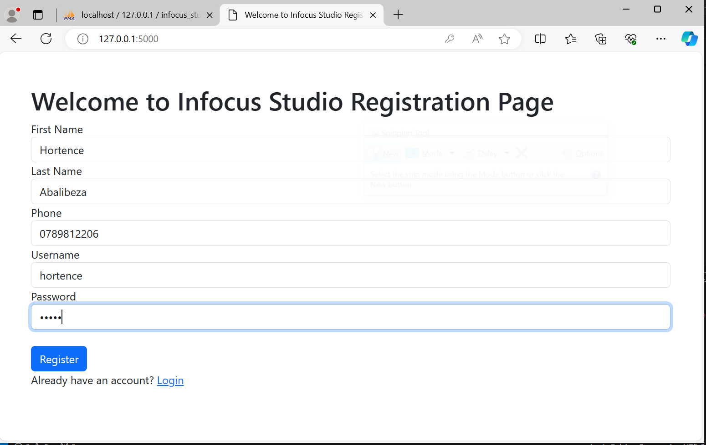

Login with username and password I have created

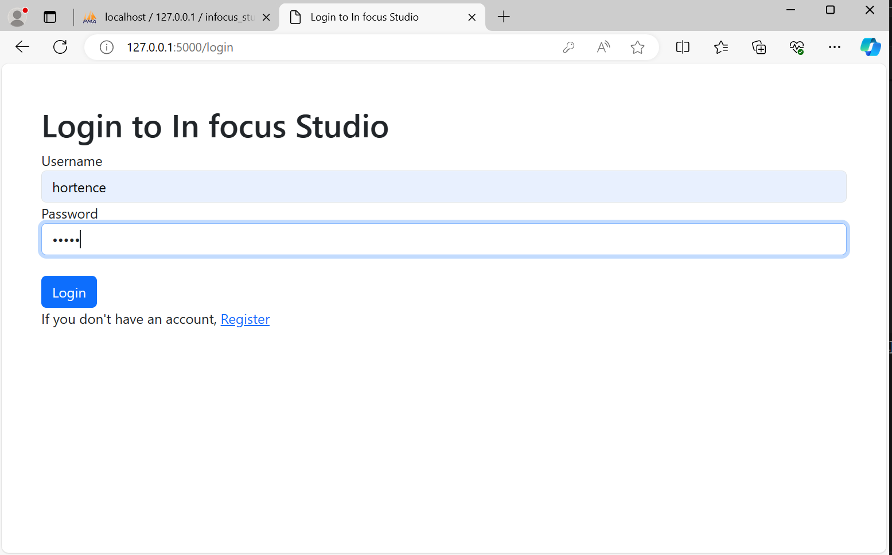

Dashboard after logging in

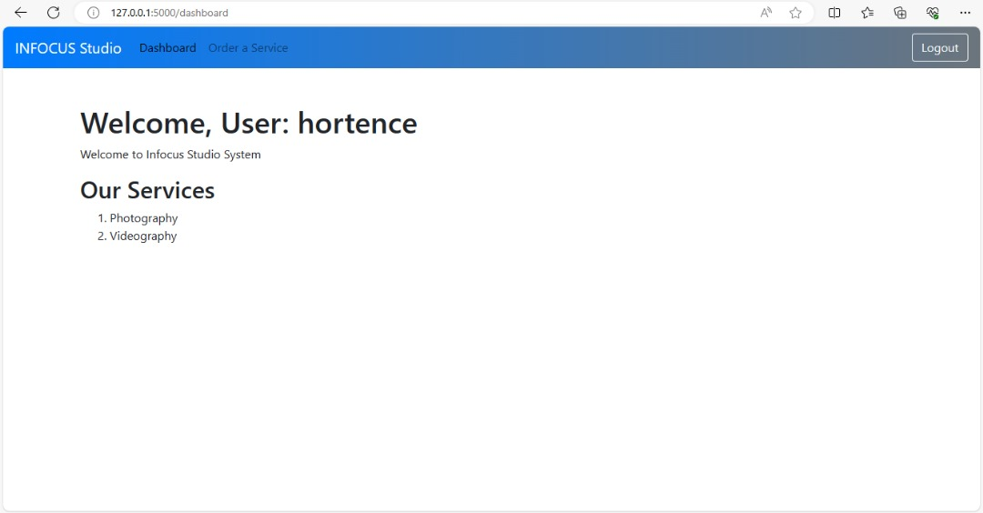

Placing an order of photograpy

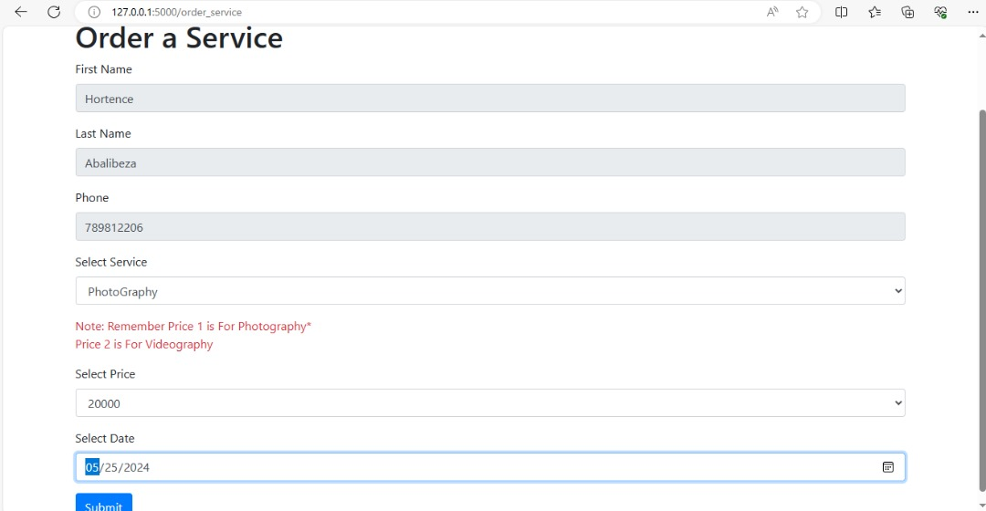

Order was sent successfully

