Retiring a User Created Coach – Without Losing Them
If you’ve ever created your own coach, later retired them, and ended up losing that coach, than this guide is for you.
There are actually two separate bugs stacked on top of each other here: one we built a real fix for, and one that’s on EA’s side and can only be worked around. This guide covers both, plus the exact order of steps that avoids all of it.
⚠️ Back up your save first
Copy your save file somewhere safe before doing anything below. The tool itself is careful about this, but back up anyway — same rule as any save-editing tool.

The two bugs, in plain terms

Bug #1: the "erase my coach" bug — we CAN fix this
The problem: if you create your own coach and later retire them, the game can wipe that coach out and lock you out of ever selecting that team again.
The fix: before retiring a created coach, flip one setting on them (called IsCreated) to false. Do this once, right before you retire them, and the lockout doesn’t happen.
What this does NOT touch
There’s a different setting called IsUserControlled — that tracks which team(s) you’re actually playing as (you can legitimately control more than one team in a dynasty). This tool never changes that setting, only IsCreated.
That distinction matters: an earlier, incorrect version of this kind of fix touched both settings, and touching IsUserControlled causes a different lockout when you try to switch back to your own team.

Bug #2: the "my team disappeared" bug — this one is on EA
What you’ll see: you switch which team you’re controlling (or create a new coach for a second team), open the Members tab, and your other team just isn’t there anymore. Looks like you got kicked out or lost the team entirely.
What’s actually happening: nothing. Your team is still yours, your data is completely fine — the Members tab is just showing you an outdated list. It only fixes itself after you fully save, quit out, and reload the dynasty.
We checked this carefully: the save file itself never changes when this happens, only the on-screen list does. That means this is a bug in the game’s own code, not something a save editor could ever fix. The closest thing to a "fix" is:
Save, quit, and reload whenever the Members tab looks wrong.
Because of this bug, the Members tab can’t be trusted in the moment — it might be lying to you about who’s still on your team list. The steps below are specifically ordered to dodge this, even the parts that look unnecessary. Skipping or reordering them is what leads to actually losing a team, not just having it look wrong temporarily.

Running the fix (for Bug #1)

The easy way — just run the .bat file
Double-click "Fix Coach Flag.bat". It walks you through everything — checking you have Node.js, installing what it needs the first time, asking for your save file, showing you your coaches, and asking which one to protect.
It automatically makes a backup of your save first (saved right next to your original, named yoursave-backup), then updates your actual save file in place. You don’t need to rename or move anything afterward — just load your save normally. If anything goes wrong, your backup is right there.
Note
It only keeps the most recent backup — move the old one somewhere else first if you want to keep more than one.
You can also drag your save file directly onto the .bat file’s icon instead of typing the path when it asks.

The manual way (if the .bat doesn’t work for you, or you want more control)
You’ll need Node.js installed, and your game’s schema folder (a folder with a .gz file in it, usually named something like 472_0.gz).
Open a command prompt in this folder and run once:
npm install madden-franchise

node fix-coach-flags.mjs "path\to\your\save" "path\to\schema\folder" --list

node fix-coach-flags.mjs "path\to\your\save" "path\to\schema\folder" --protect 433 --out "path\to\new-savefile"
(replace 433 with your coach’s actual row number)

node fix-coach-flags.mjs "path\to\your\save" "path\to\schema\folder" --restore-control 433 --out "path\to\new-save-file"
Use your judgment with this one — it’s a fix for an already-broken situation, not the preventive step above.

The full safe procedure (handles both bugs)
Follow these in order, even the parts that seem unnecessary.
- Run the tool (above) on your save, before touching anything else in-game. This protects your current coach so retiring them later won’t erase them.
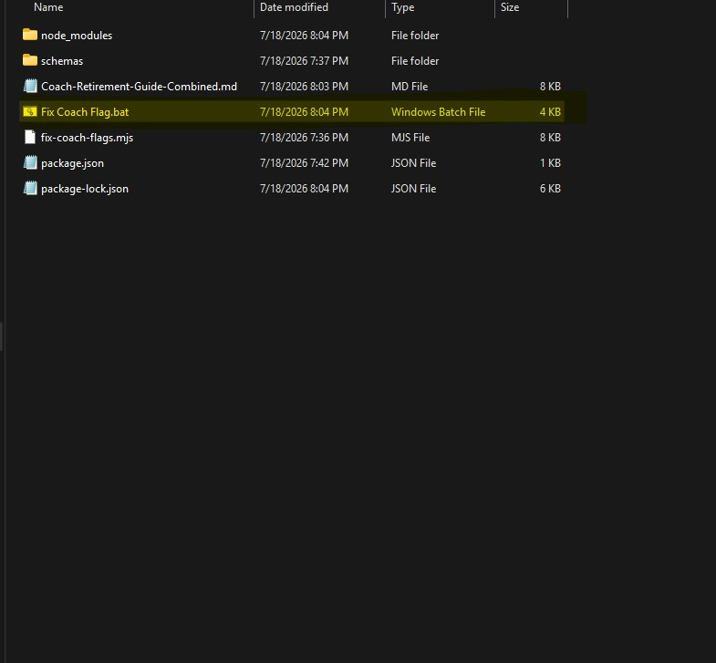
- In the Members tab, choose Create a New Character. Pick a new team and take over as their head coach. The game loads you into that new team.
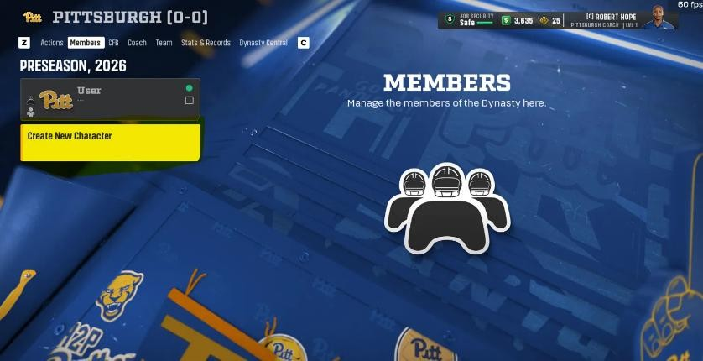
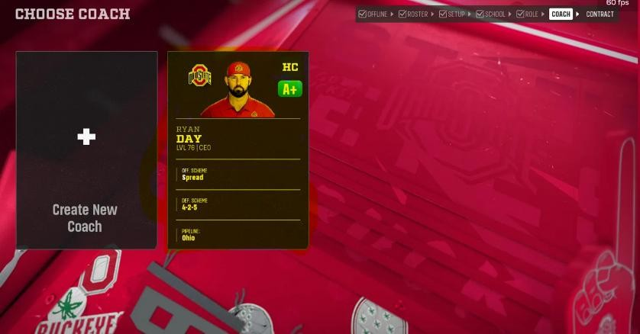
Check Members again — you’ll probably see only that new team, and your original team missing entirely. This is Bug #2. Don’t panic, don’t try to fix anything here. Just move on.
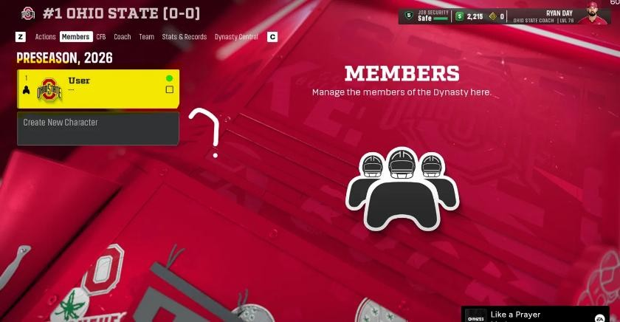
- Save the file, fully exit the dynasty, and reload it. This is the only thing that resets the Members tab back to reality.
After reloading, you’ll land back on your original team’s screen — but Members will now show the opposite problem: your original team missing, even though your original team is what’s on screen. Still Bug #2, still nothing wrong, still don’t panic.
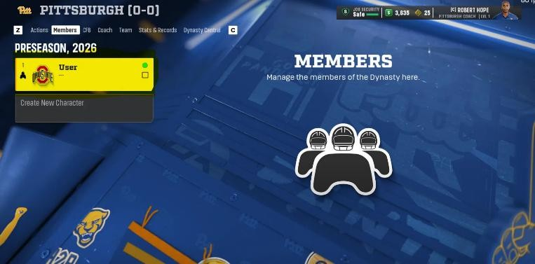
- In Members, click your other (new) team and choose Make Dynasty Owner.
Do NOT click "Switch to this Character" or "Make Commissioner"
That’s a different action, and using it here causes yet another problem. You only want to hand off ownership, not switch who you’re playing as.
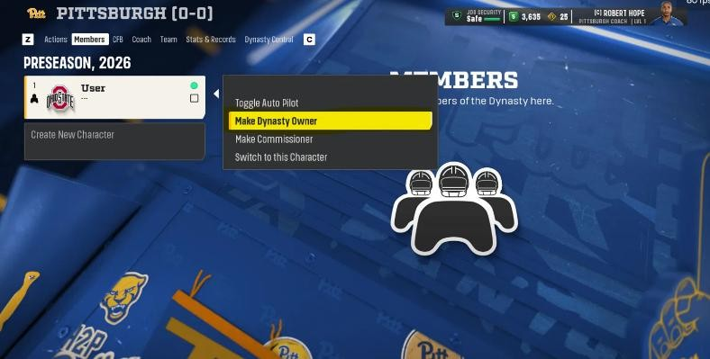
Now go to Dynasty Central → Retire. The game will warn you that retiring a created coach erases them — that warning is generic and always shows up, but because of Step 1, it won’t actually happen.
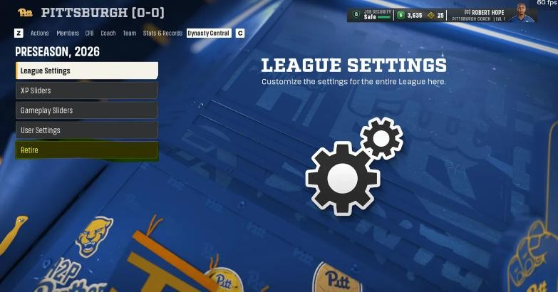
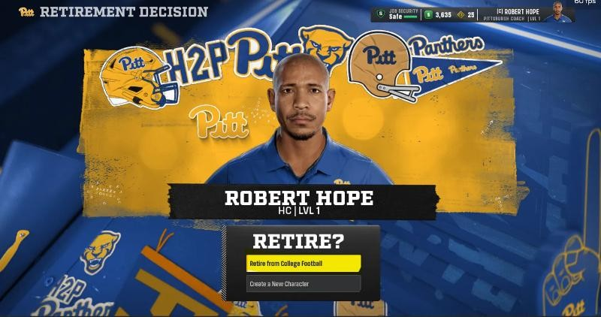
- Retiring takes you to your second team automatically. Go back to Members, choose Create a New Character again, but pick your original team and Head Coach. Instead of a blank "create new" slot or a different coach, your original coach should still be sitting right there in the list — pick them (don’t make a new one) to go back to controlling your original team with your original coach intact.
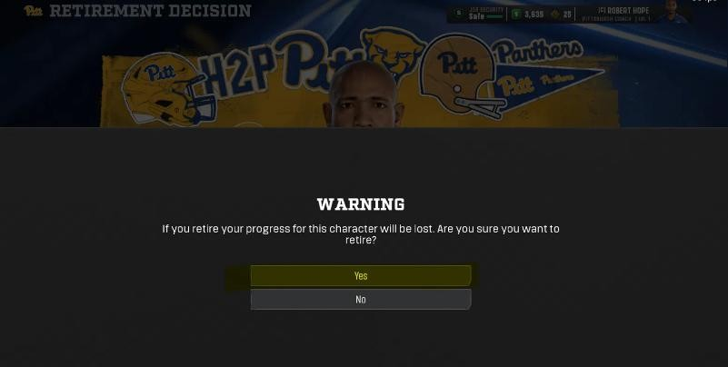
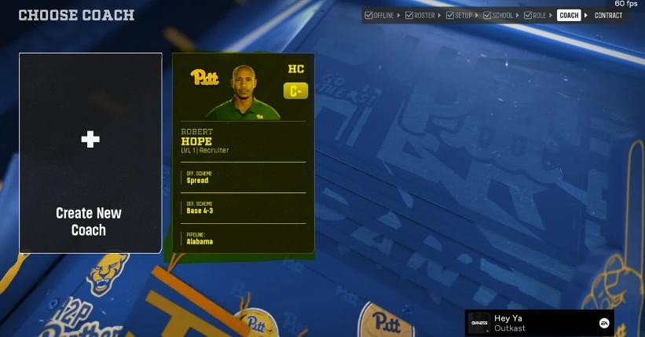
- To fully clean up and hand the second team back to its normal AI coach: repeat the dance in reverse — switch dynasty ownership back to your original team, then retire the second team’s coach. Since you never created a character for that one (you took over their existing coach in Step 2), there’s nothing to protect — their coach just stays in place like a normal AI retirement.
The one-sentence version
Protect first → create a character on a second team → hand dynasty ownership to that second team (never retire while you’re still the owner) → retire your original coach → create a character back on your original team and pick your original coach from the list → hand ownership back and retire the second team’s coach → whenever Members looks wrong, save-quit-reload before you trust it again.

Always double-check in-game
After running the tool and going through these steps, confirm things look right in-game before you keep playing. Same rule as any save-editing tool: trust, but verify.

Found a problem?
Post about it in the Discord — screenshots of what the tool printed, next to what you saw in-game, help a lot.

