Alex Banning

March 5th, 2020

HW6 Pictures

1. $v0 after recursive subroutine

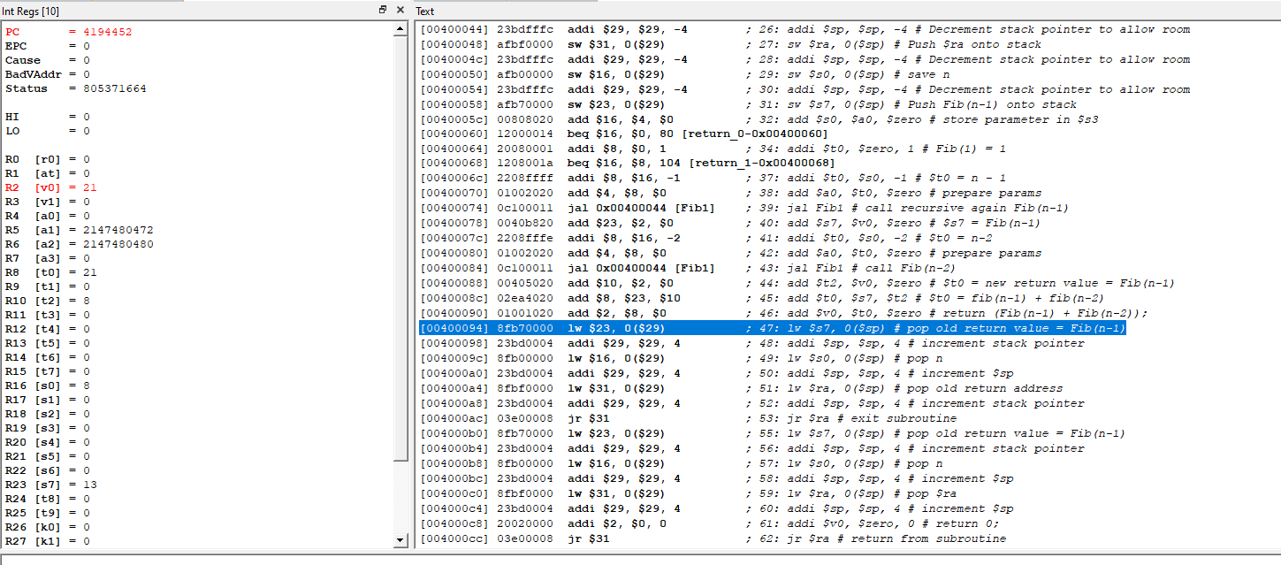

1. 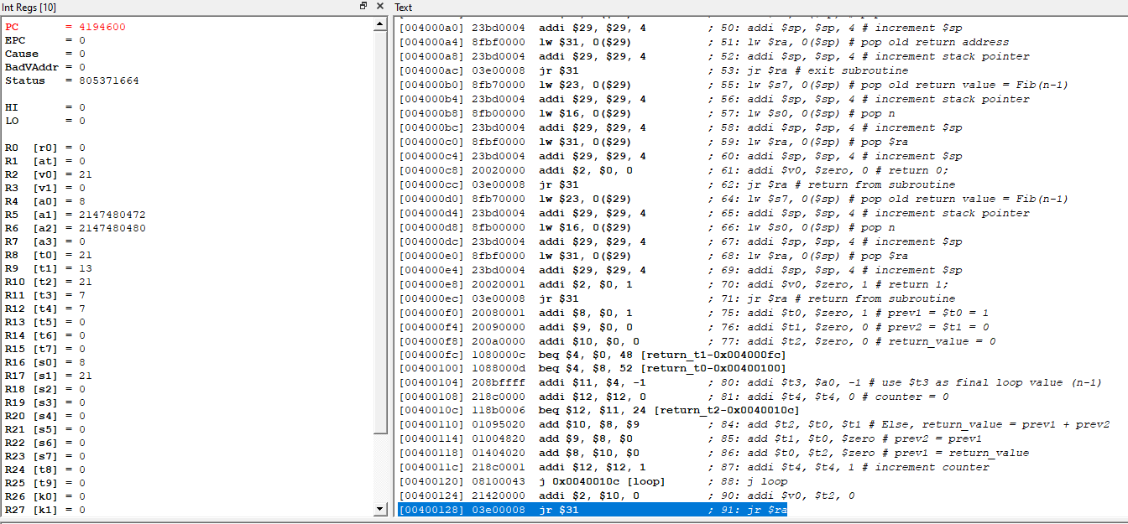$v0 after iterative subroutine