**Project**

Title

**Beauty Salon and spa Management program**

Course

**CIS 18A**

Section

**25664**

Due Date

**July 25, 2019**

Author

**Abanob Wahba**

**Table of contents**

**1)Introduction and summary**

**2)Checklist all the required concepts included in the program**

**3) input and output**

**4)Flowchart (for better quality picture please look in flowchart folder for the pdf)**

**5)****pseudocode**

* **Introduction and summary**

The program is a Beauty Salon and spa Management program. The program will be used in the management level in the beauty salon and spa; that is, only the managers will be the one to operate the program. All the other staff are assumed to be the ones attending to the clients and the manager is the overall head.

The program will serve various purposes such as keeping records of all the employees both in part time basis and in full time basis. All the employees are paid depending on the hours worked. This brought about inheritance because we had the super-class which is an `Employee` class then the sub-classes which were the `fullTimeEmployee` class and the `partTimeEmployee` class. The program stores these records in `ArrayList` so that later the manager can use the information stored in the program to make decisions that will help to improve the business performance.

The program will also allow that manager to add the various services offered in the beauty and define the prices of a given service according to age of the customers. The program splits a service into two i.e. underage clients and the adult’s clients where they will have different prices. When a customer is to be services, his/her age and name is taken then the program itself will decide the category of cost that the client will fall into and save the record for later reference. The programs categorize the client that are below the age of 18 as underage and those that have 18 years and above are categorized as adults. Here in the services we have the implementation of an interface which has the blueprint of how each service should be. It majorly has a method `calculatePrice` which calculates the price of the service.

Since the beauty salon pays employees depending on the number of hours worked, the full time employees have a fixed number of working hours and therefore their pay will always be constant but for the part time employees, the manager will have to record the number of hours he/she has worked. The recorded hours will help later in deciding what amount of salary that the employee will be paid.

The program produces report of all the clients served including details such as their name, service that they were offered and the amount of money that they paid for that service, all the full time employees plus the amount of salary that they should be paid and also the part time employees and the amount of salary that they should be paid. The report is produced by looping through that `Arraylist` that was created when the program was beginning and filled with record when the user adds a client into the program.

The program runs in a command line interface and the user of the program will have to perform action by selecting options. The initial menu items are held in a string array and looping is used to display the options in the screen. The program uses a range base loop to Display the options in the screen. The user of the program will have to enter the option and press enter then the next menu with the relevant instruction will appear. The program will use if statement or the switch statement to validate which action to perform according to the user input i.e. some menus have been implemented using if statement and some using switch statement. The user should follow the instruction so that the program should function without errors.

* **Checklist**

|  |  |
| --- | --- |
| **Concept** | **Location In Code** |
| Inheritance | ParTimeEmployee.java (Line 1)  FullTimeEmployee.java (Line1) |
| Arrays | Dashboard.java (Line 6, 95) |
| ArrayList | DashBoard.java(Line 10,13,14,16) |
| Range Based Loop | Dashboard.java (Line 32, 97) |
| For loop | Dashboard.java (Line 149) |
| Interface | PartTimeEmployee.java( Line 1)  FullTimeEmployee.java (Line 1)  EmployeePayment.java |
| Constructors | PartTimeEmployee.java( Line 3)  FullTimeEmployee.java (Line 4) |
| Methods | Dasboard.java(Line 28, 69, 94)  PartTimeEmployee.java( Line 12)  FullTimeEmployee.java (Line 10) |
| If Statement | Dashboard.java (Line 81, 103)  Services.java (Line 28) |
| Switch statement | Dashboard.java (Line 37) |
| Data Types | Employee.java (Line 2, 3) |
| Variables | Dashboard.java (Line 16)  Services.java (Line 2) |
| Class | Dashboard.java  Services.java  Employee.java  FullTimeEmployee.java  PartTimeEmployee.java |
| Objects | Dashboard.java (Line 111, 127) |
| Operators | PartTimeEmployee.java (Line 13) |
| Control access | Dashboard.java (Line 6)  Services.java (Line 2)  Employee.java (Line 3)  FullTimeEmployee.java (Line 2)  PartTimeEmployee.java (Line 2) |
| Import packages | Dashboard.java (Line 1,2,3) |

* **input and output**

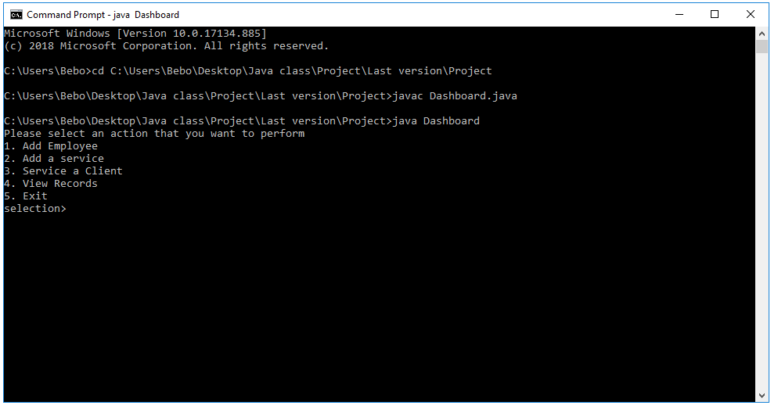

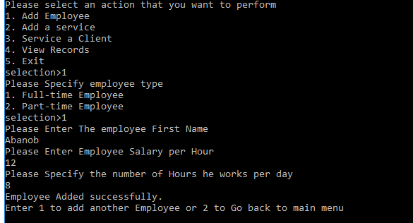

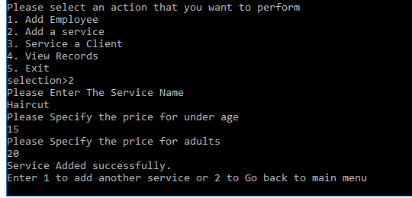

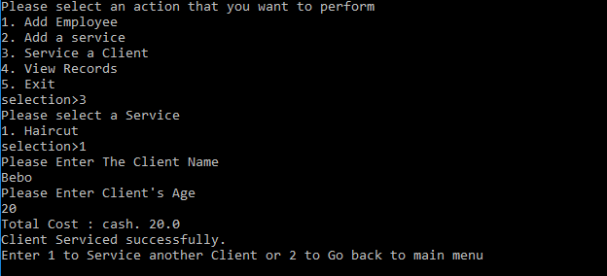

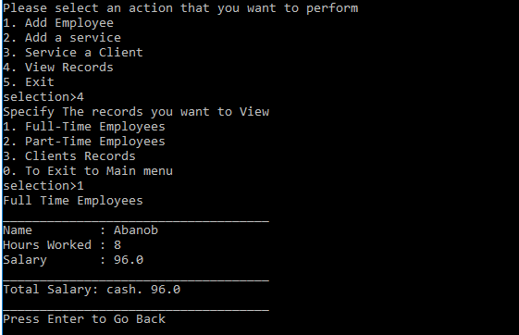

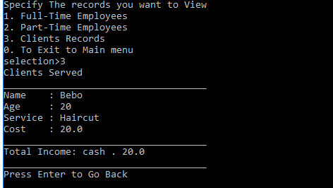

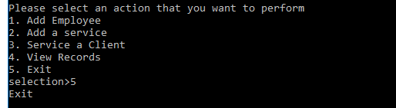

* **Flowchart for better quality please open the flowchart folder look at the pdf file**

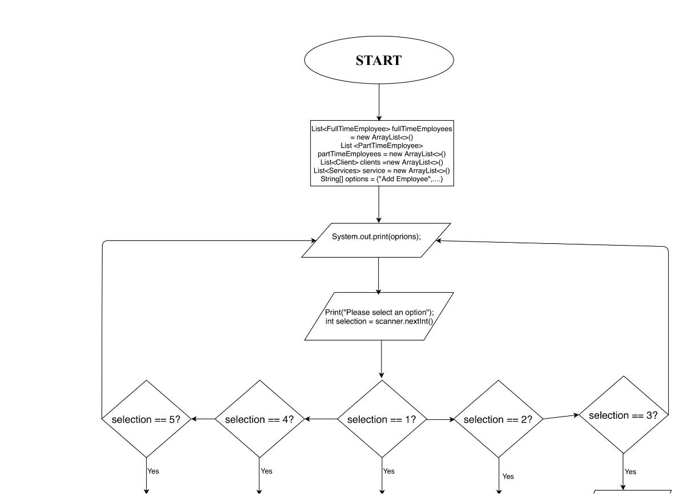

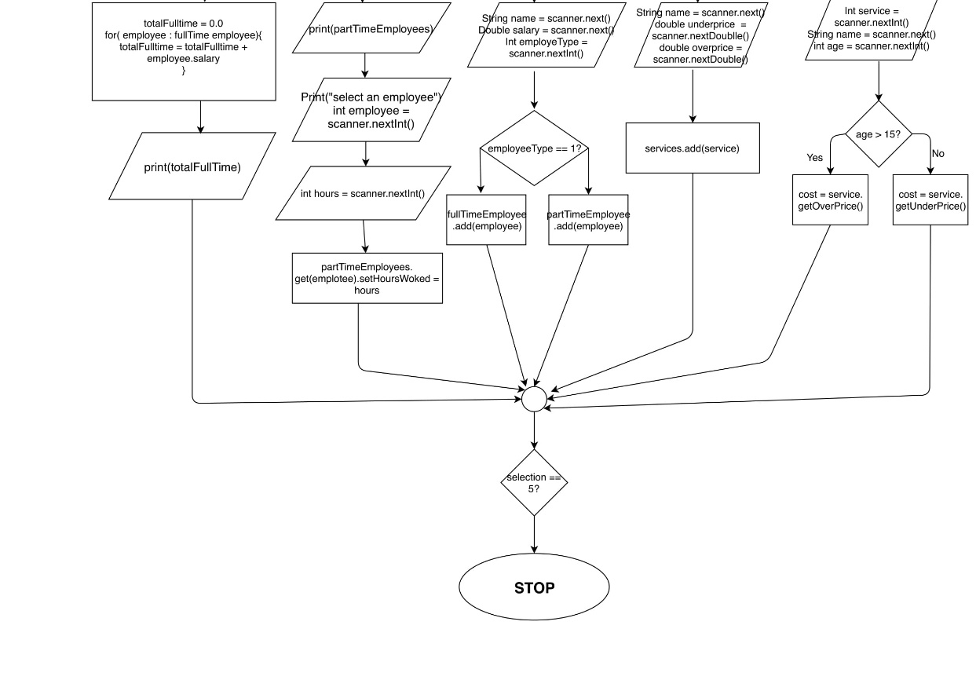

**Pseudocode**

Create an array with all the option in the menu

Initialize arraylist to hold part time employees

Initialize arraylist to hold full time employees

Initialize arraylist to hold client served

Function mainfuction(){

Call the dashboard function

}

Function dashboarrd(){

Loop through the list with option menu to display all option

Prompt the user to enter an option

Check the option enter to determine the function to call

If option is 1

Then call function to add employee

Else if option is 2

Then call function to add service

Else if option is 3

Then call function to service a client

Else if option is 4

Then call function to record part timer worked hours

Else if option is 5

Then call function to view records

Else

Exit the program

}

Function addEmployee(){

prompt the user to select if the employee is a part time or full time employee

Prompt the user to enter Employee name and the salary per hour

Print a success message to the user

Provide user with option to either go back to main menu or add another employee

}

Function addService(){

Prompt the user to enter the service name

Prompt the user to enter the price for those clients under the age of sixteen

Prompt the user to enter price for those clients above age 16

Print a success message to the user

Provide user with option to either go back to main menu or add another service

}

Function serviceClient(){

Check first if the arraylist of services offered has values

If arraylist has no value

Then exit back to main menu

Else

Prompt user to Select the service the client wants

Prompt user to Enter client name and the age

Save the client details into the arraylist

Print a success message to the user

Provide user with option to either go back to main menu or Serve another client.

}

Function recordPartTime(){

Check first if the list of part time employees has items

If the arraylist has not value:

Then exit back to main menu

Else:

Provide the user with options of all the employees

Prompt the user to select an employee

Prompt the user to enter the number of hours

Print a success message to the user

Provide user with option to either go back to main menu or continue recording.

}

Function viewRecord(){

Provide the user with the options of either to view partitme employee,

full time employess or list of the client

If option is full time employees

Then loop through array list for the part time employees

Print the employees names and salary

Calculate subtotal and print

Else if option is part time employees

Then loop through array list for the fulltime employees

Print the employees names and salary

Calculate subtotal and print

Else if option is clients

Then loop through array list for the clirnt

Print the employees names, service they recieved and cost

Calculate subtotal and print

}