**Software Requirements Specification**

**for**

solofit (diet application)

## Version 1.0

**Faculty of Computers and Information in Assiut**

**Prepared by:**

Mina Milad Tawadros Gamal Mahmoud Khalid Abanoub Zakaria

Hossam Abdel Hakeem Abanoub Mousa

Hossam Eldein Mohamed Kyrollos Mi

**Supervisor:**

Dr. Taiseer Hassan Abdel-Hamid Sulaiman

Dr. Mostafa Abobakr Abdelmajed Salem

**Table of Contents**

**Table of** Contents

**Revision History**

**1. Introduction**

1.1 Purpose

1.2 Definitions, acronyms, and abbreviations

1.3 Product Scope

1.4 Actors

1.5 References

**2. Overall Description**

2.1 Product Perspective

2.2 Product Functions

2.3 User Classes and Characteristics

2.4 Operating Environment

2.5 Design and Implementation Constraints

2.6 Assumptions and Dependencies

**3. External Interface Requirements**

3.1 User Interfaces

3.2 Hardware Interfaces

3.3 Software Interfaces

3.4 Communications Interfaces

**4. System Features**

4.1 System Feature 1

4.2 System Feature 2 (and so on)

**5. Other Nonfunctional Requirements**

5.1 Performance Requirements

5.2 Safety Requirements

5.3 Security Requirements

5.4 Software Quality Attributes

5.5 Business Rules

**6. Other Requirements**

**Appendix A: Glossary**

**Appendix B: Analysis Models**

**Appendix C: To Be Determined List**

# Introduction

The following section provides an overview of the software requirements specifications (SRS) for the Solofit Software App.

## Purpose

The purpose of this document is to give a detailed description of both functional and non- functional requirements Solofit Software App.

It will illustrate the purpose and the scope for the development of system.

This document is primarily intended to be proposed to a customer for its approval and a reference for developing the first version of the system for the development team.

## Definitions, acronyms, and abbreviations

|  |  |
| --- | --- |
| Term | Definition |
| Solofit | The mobile application name. |
| BMI | Body mass index (BMI) is a measure of body fat based on height and weight that applies to adult men and women. |
| BMR | The basal metabolic rate (BMR) is the amount of energy needed while resting in a temperate environment when the digestive system is inactive. |
| TDEE | Total Daily Energy Expenditure: is an estimation of how many calories you burn per day when exercise is taken into account. |

## Product Scope

The “Solofit” is a mobile application which helps people to track their meals, put a diet plan for gaining or losing weight or maintain weigh in efficient way with macro calculation.

Tracking food and your macro, carb and calorie intake will help you to reach your weight and health goals.

The app can automatically count calories by taking food photos! Calorie counting should be as simple, fun, and easy as taking a picture of your food. Solofit can tell you the calories in your food just by analysing your food photos. It can recognize thousands of food categories including staples such as fruits, vegetables, meats, grains, beverages

How It Works:

* + 1. Snap a picture of your food
    2. Solofit analyses your food photo and suggests what the food might be
    3. Confirm the food to log your calories!

## Actors

|  |  |
| --- | --- |
| **System user** | Someone who use the application. |

## References

#### <https://en.wikipedia.org/wiki/Body_mass_index> <https://www.egyfitness.com/tdeecalculator/> <https://steelfitusa.com/blogs/health-and-wellness/calculate-tdee>

# Overall Description

## Product Perspective

**Keeping fit** is engaging your body in activities that maintain it in good condition in terms of health as well as physical appearance.

Ways to keep fit include eating healthy food, exercising, and avoiding harmful substances in the body.

###### How to stay fit and healthy?

If you are trying to be more physically active, up your daily steps, or burn more calories, fitness apps can help you on your way. Our project will help you to stay fit and healthy.

###### Play games and sports!

When the body is active, it can metabolize well and keep in good shape. Sports and games allow the body to use op energy, increase blood circulation and eliminate harmful fats in the body. So, one of function in our app is It shows you sports exercises correctly with pictures and videos, and you can also communicate with more than one nutrition doctor and a fitness doctor

###### Eat healthy foods!

What we choose to eat plays a very major role in our fitness. Proper food selection leads to eating healthy. Some of the best foods to eat to remain fit are vitamins found in vegetables and fruits, proteins found in whole grains and lean meat. Eat foods that have less oil, since too much oil can increase cholesterol levels which is harmful to the body, our app was made to help you to calculate carbohydrates, protein, and fats in food by taking pictures of the food and calculating it. **Exercise regularly!**

Keeping fit goes hand in hand with exercising. Take at least thirty minutes a day to do some exercises. You can choose to go to the gym or do it at the comfort of your home, so another function of our app is you can choose any hour in your day and app will notification you every day at this time.

**Calculating calories for the body** Calculating calories for the body by entering your height, age and weight, after that the program will automatically calculate what is the number of calories that your body needs daily

## Product Functions

* + - user will be able to calculate his daily needs to gain or loss or maintain weight.
    - User will be able to calculate carbohydrates, protein, fats and calories in food.
    - User will be able to shows sports exercises correctly with pictures and videos.

For more details see the System Features section

## User Classes and Characteristics

Users of the system should be able to follow a healthy, safe and healthy diet if he is fat, he can lose weight or if he is thin ,help in determining the appropriate healthy body for you, in addition to the image processing feature, which will calculate the percentage of protein and carbohydrates in the food through a clear picture of the meal that he will eat and will receive a notification if this meal will exceed the allowable amount according to the schedule In addition to some gymnastics

## Operating Environment

Operating environment for the solo fit application is as listed below.

* + - distributed database
    - client/server system
    - Operating system: Android.
    - database: Firebase

## Design and Implementation Constraints

The mobile must have a good quality Camera so that the application is constrained by Camera’ quality

The Internet connection is also a constraint for the application. Since the application fetches data from the database over the Internet, it is crucial that there is an Internet connection for the application to function.

## Assumptions and Dependencies

One assumption about the product is that it will always be used on mobile phones that have enough performance. If the phone does not have enough hardware resources available for the application, for example the users might have allocated them with other applications, there may be scenarios where the application does not work as intended or even at all.

Another assumption is that the Camera components in all phones work in the same way. If the phones have

# External Interface Requirements

* 1. **External interface Requirements**

This section provides a detailed description of all inputs into and outputs from the system. It also gives a description of the hardware, software and communication interfaces and provides basic prototypes of the user interface.

* + 1. **User interfaces**

At figure 1, the user can select his/her gender and input his/her data to calculate his/her calories. Then, the user will show the Calculated Calories, and the basic meals on his/her day, At figure 2. At figure 3, the user can select any type of foods to add them to his/her meal.

The user can select item in two ways: first, by select the item from the available options, second, by capture his/her meal, figure 4.

Figure 5 and 6, show the selected items and Calories gained based on the previous selection. The user can select the number of selected items, food serving and show its calories,

At figure 7.

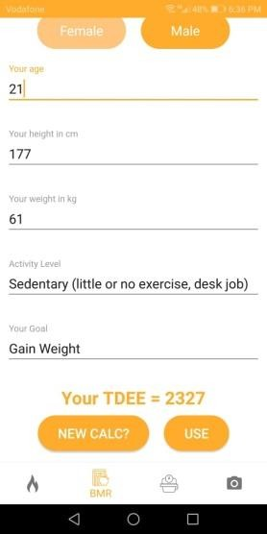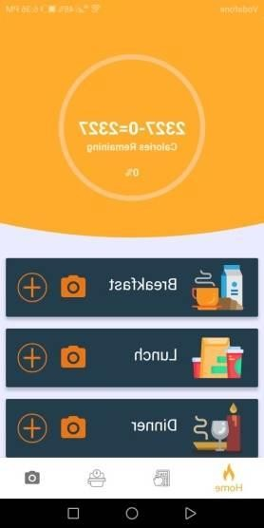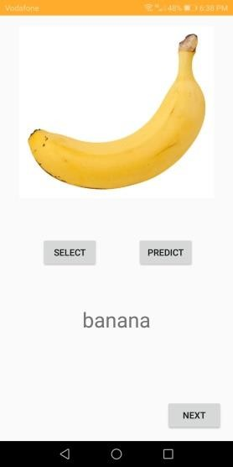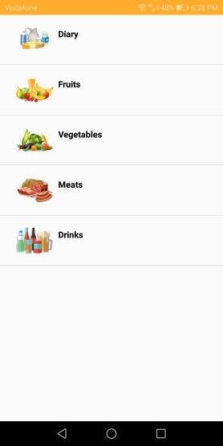

**Figure 1 Figure 2 Figure3 Figure4**

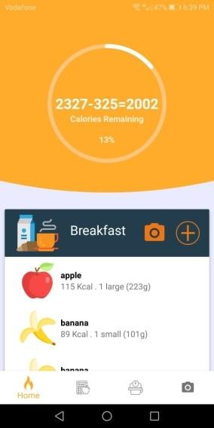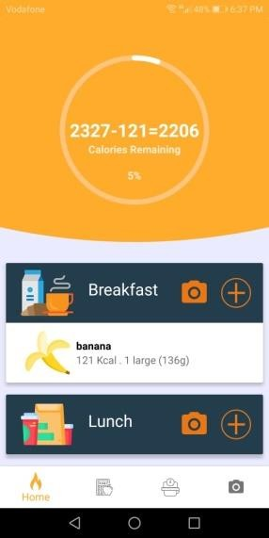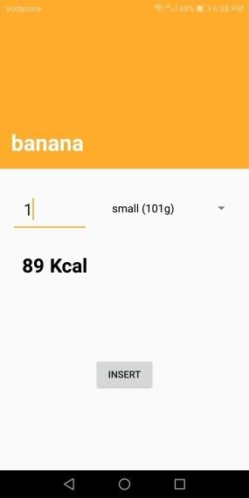

**Figure 5 Figure 6 Figure 7**

* + 1. **Hardware interfaces**

Since the mobile application have not any designated hardware, it does not have any direct hardware interfaces. The camera is managed by mobile phone operating system.

* + 1. **Software interfaces**

The mobile application communicates with the API to get information

about food, and its nutrition facts, the communication between the Application and the API consists of operation concerning only reading data about foods including food servings.

* + 1. **Communications interfaces**

The communication between the different parts of the system is important since they depend on each other. However, in what way the communication is achieved is not important for the system and is therefore handled by the underlying operating systems for both the mobile application and the web portal.

# System Features

#### **Authorization**

User create Account using Firebase Email and password Authentication

Users enter his/her Email and Password to the application to create new account Then User Login using this account to enter to the system

**Calculate BMI**

Users enter his weight and height to the application

The application calculate his/her BMI using equation BMI = weight(Kg) / Height(m2) The results indicate his/her body mass index

Display the result to the user

|  |  |  |  |  |
| --- | --- | --- | --- | --- |
|  |  | | | |
| **Category** | **BMI (kg/m2)** | | **BMI Prime** | |
| **from** | **to** | **from** | **to** |
| Very severely underweight |  | 15 |  | 0.60 |
| Severely underweight | 15 | 16 | 0.60 | 0.64 |
| Underweight | 16 | 18.5 | 0.64 | 0.74 |
| Normal (healthy weight) | 18.5 | 25 | 0.74 | 1.0 |
| Overweight | 25 | 30 | 1.0 | 1.2 |
| Obese Class I (Moderately obese) | 30 | 35 | 1.2 | 1.4 |
| Obese Class II (Severely obese) | 35 | 40 | 1.4 | 1.6 |
| Obese Class III (Very severely obese) | 40 |  | 1.6 |  |

**Calculate BMR**

The basal metabolic rate (BMR) is the amount of energy needed while resting in a temperate environment when the digestive system is inactive.

Users enter his age, gender, height and weight to the application The application calculates his/her BMR using equation

BMR = 10*weight + 6.25*height – 5*age + 5 for men

161

women

BMR = 10*weight + 6.25*height – 5*age - for

**Calculate TDEE**

Your Total Daily Energy Expenditure (TDEE) is an estimation of how many calories you burn per day when exercise is taken into account. It is calculated by first figuring out your Basal Metabolic Rate, then multiplying that value by an activity multiplier.

To calculate your approximate TDEE, simply multiply these activity factors by your BMR:

* + - * Sedentary (little to no exercise + work a desk job) = 1.2
      * Lightly Active (light exercise 1-3 days / week) = 1.375
      * Moderately Active (moderate exercise 3-5 days / week) = 1.55
      * Very Active (heavy exercise 6-7 days / week) = 1.725
      * Extremely Active (very heavy exercise, hard labor job, training 2x / day) = 1.9

Then Manipulating TDEE for Muscle Gain and Fat Loss or maintain your current weight

1. If you aim to [lose weight,](https://www.iifym.com/macro-calculator/macronutrients/essential-dieting-tips-for-bodybuilding-and-weight-loss/) then you need to ensure that you are eating less energy, than you are burning over a sustained period of time.
2. If on the other hand, you are trying to gain weight, then you need to eat more energy than you burn over time.
3. Finally, if you want to maintain your current weight, then the amount of energy you consume, should match the amount of energy burned over time.

Users enter his age, gender, height, and weight to the application

The application calculates the TDEE and display the calories needed per day depending on the user inputs and his/her goal (gain – maintain – loss) weight then display the result to the user.

**Food Image Classification**

Classifies food images provided by the user Provides the user with the correct food image label Ask the user if the label is correct or not

Sends the user’s feedback to the model in order to make it more efficient

**Food Properties**

Sends the food name to the API (or get all foods) Gets the food nutrition facts from API

Display the nutrition facts of the desired serving to the user Ask the user if he want to add the food to his/her diet

**User’s Data Analysis**

Analysis the user’s data stored in the user’s database

Provide easy visualization to the user showing the user’s food consumption Provide the user with the history of his/her previous weights

**Selfie Storage**

The user can take selfie to his body and stored these photos to storage for long term preservation

User can observe his/her body changes by observing these photos

**Workout (Fitness and Exercise)**

The application provide user with some workouts (exercises) to burn calories and gain muscles.

1. **Other Nonfunctional Requirements**
   1. **Performance Requirements**

The system should be fast enough to handle all the processes at no time system should not crash.

Event response time, screen refresh time, should be reduced to minimum time

* 1. **Safety Requirements**

The system shouldn’t give the customers any bad advices that can lead to healthy problem, shouldn’t give the customers bad calculation that can lead to healthy problem like giving bad information for diabetic person about glucose percentage in a food

The system should keep the information of the users secrete

## Security Requirements

The system should not give the customers any bad advices that can lead to healthy problem, shouldn’t give the customers bad calculation that

can lead to healthy problem like giving bad information for diabetic person about glucose percentage in a food

The system should keep the information of the users secrete