Sales Data:

1.Customers :

attributes:

• CustomerID

• FirstName

• LastName

• Email

• RegistrationDate

2.ShoppingCarts

attributes:

• CartID

• CustomerID

• DateCreated

• LastUpdated

3.Orders

attributes:

• OrderID

• CustomerID

• OrderDate

• TotalAmount

• Status

4.OrderItems

attributes:

• OrderItemID

• OrderID

• ProductID

• Quantity

• SubTotal

5.Products

attributes:

• ProductID

• ProductName

• Description

• UnitPrice

• QuantityInStock

6.Inventory_Stock

attributes:

• StockID

• ProductID

• QuantityInStock

• ReorderLevel

3.ERD-Mapping:

• ERD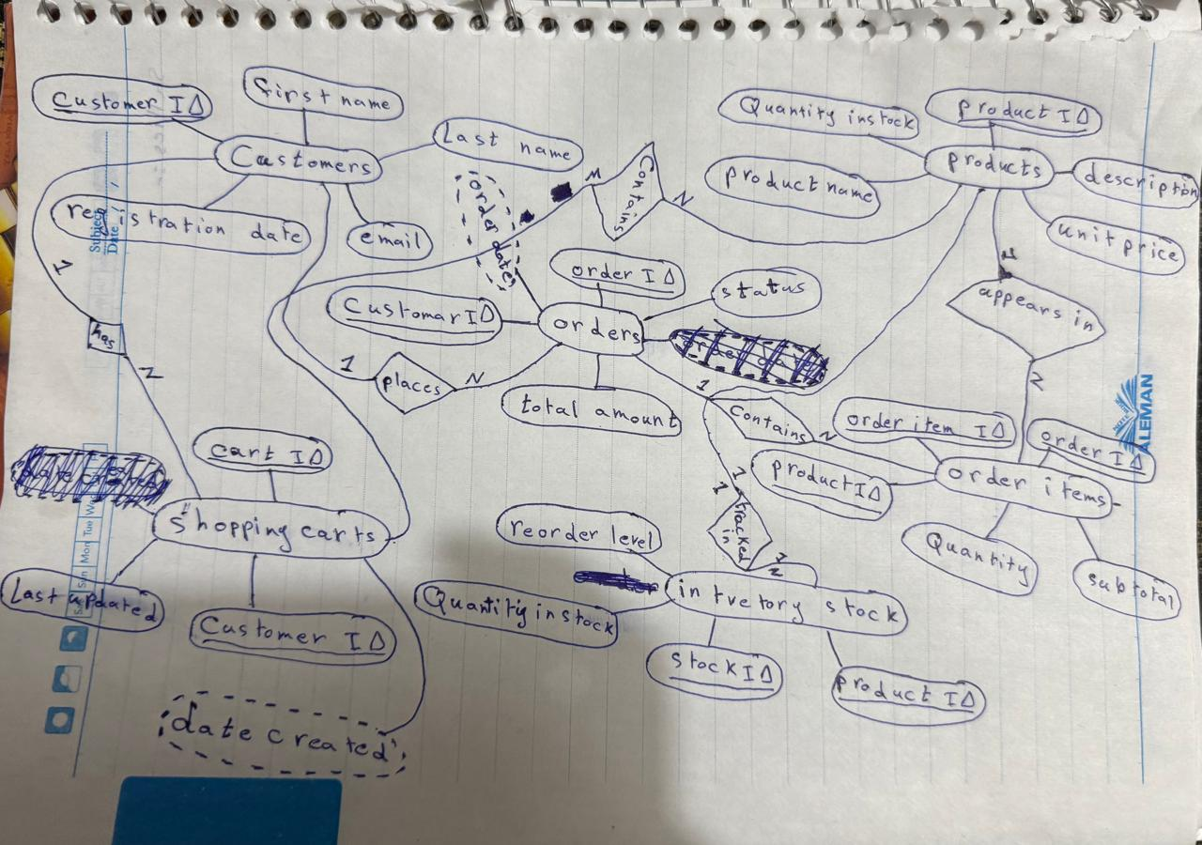

• Mapping :

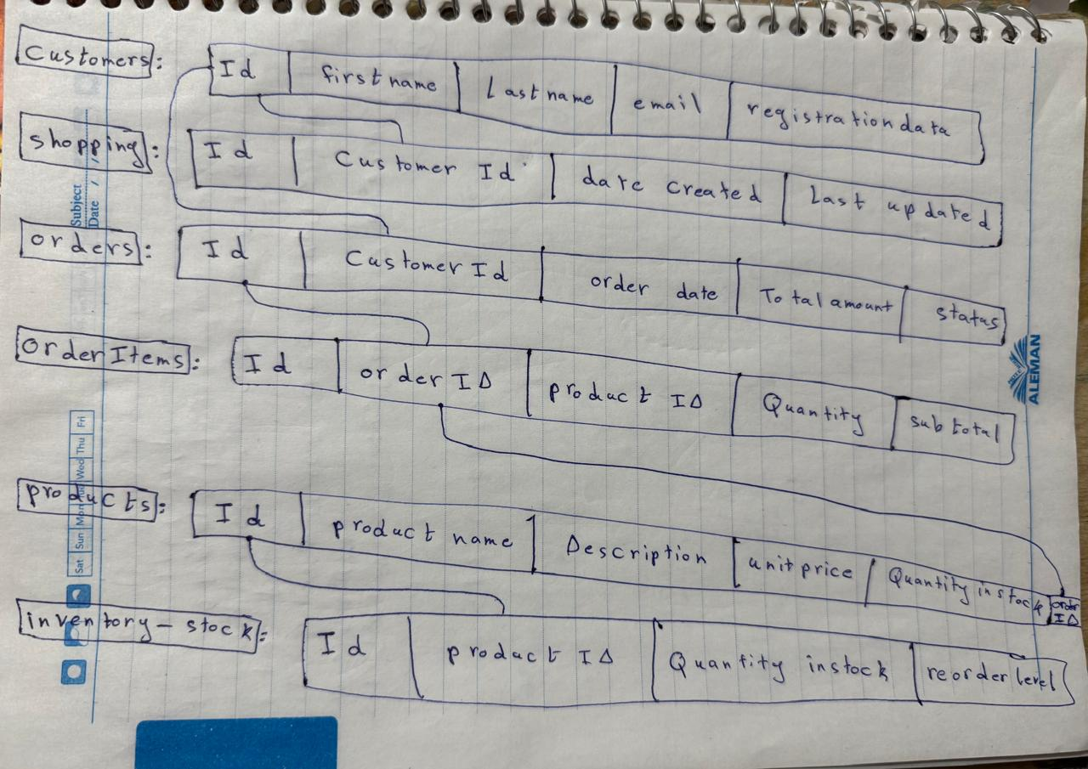

• Normalization:

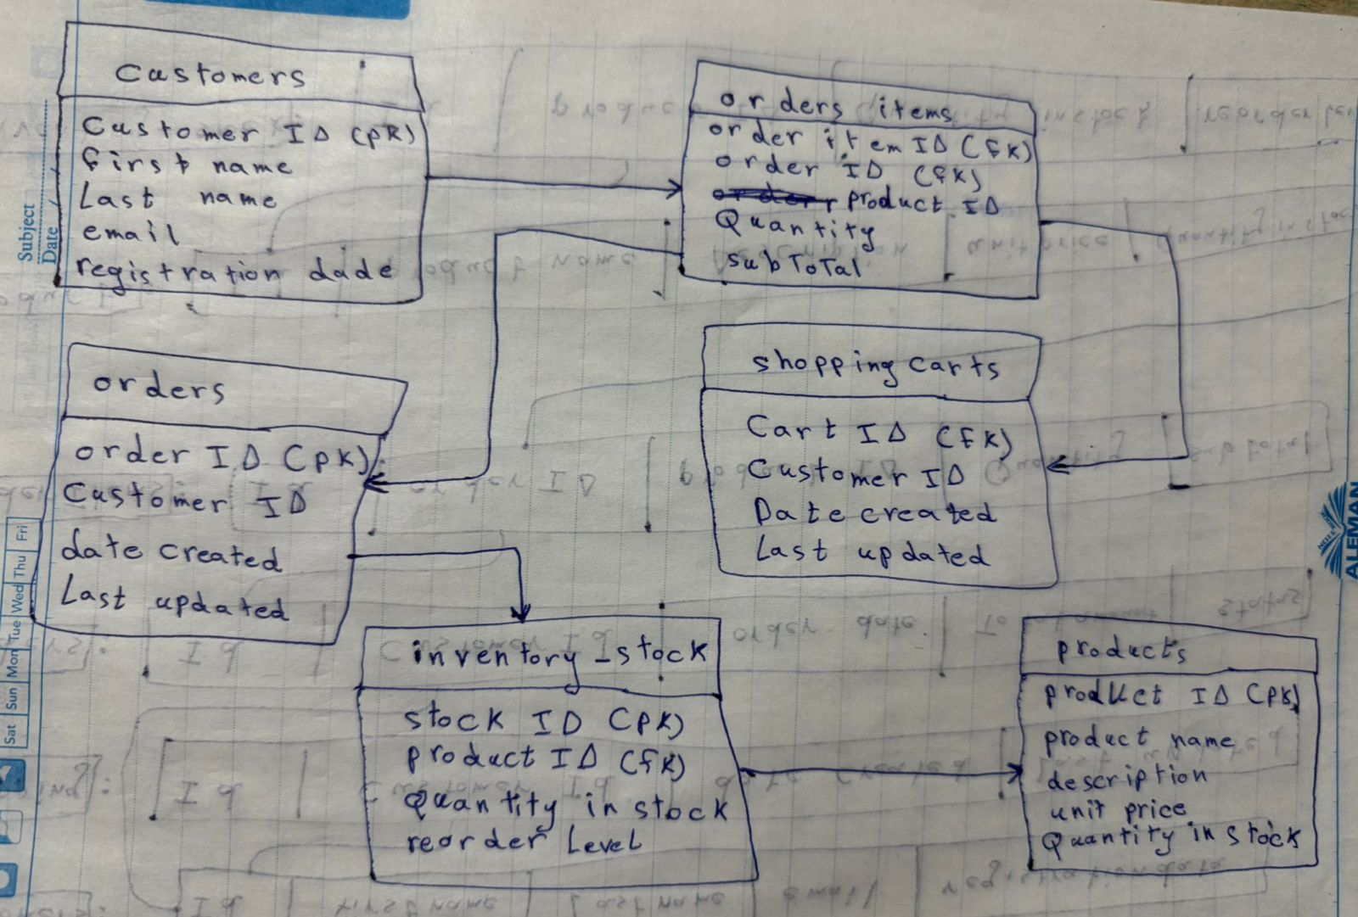

• question 4/5:

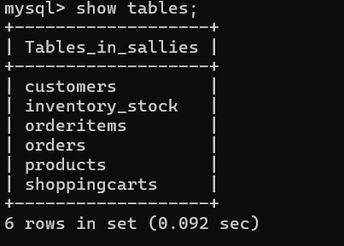

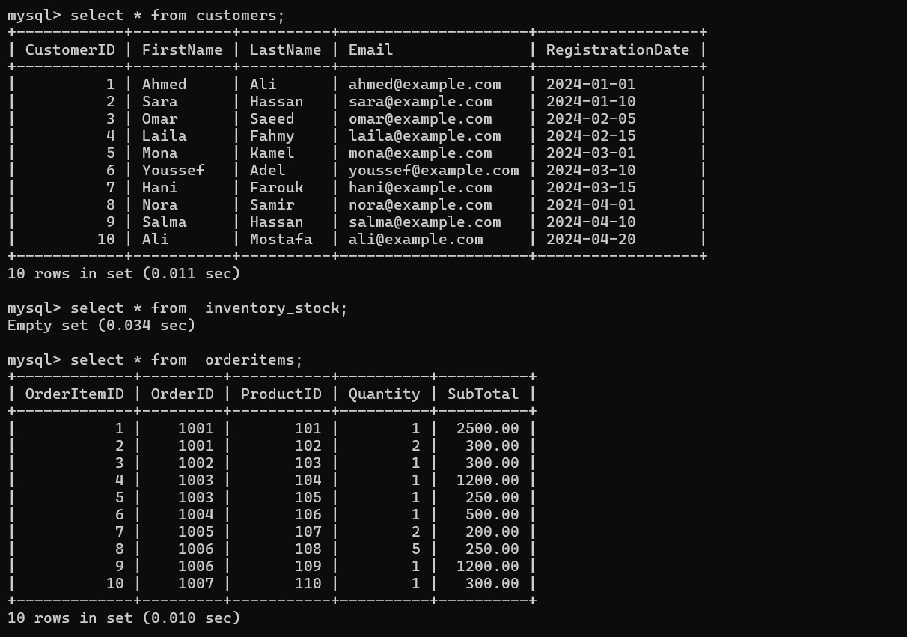

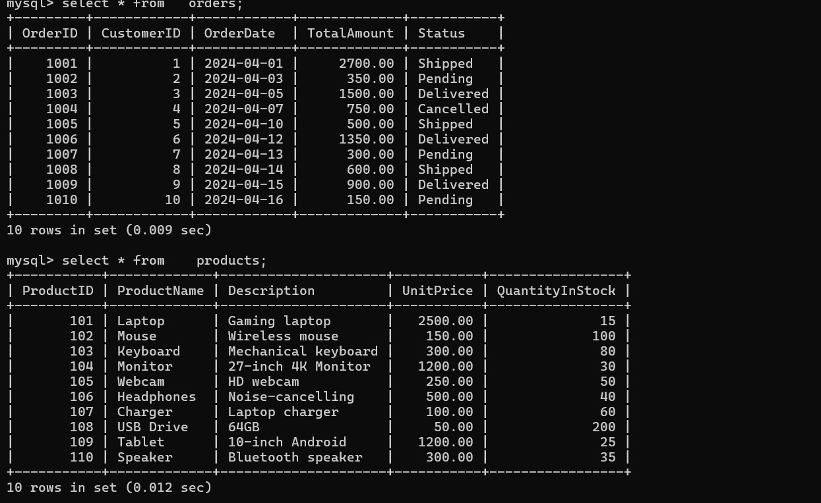

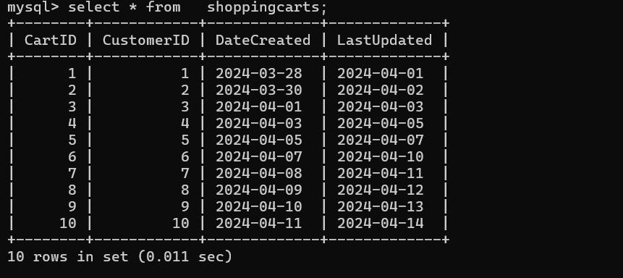

• question 6:

