SAP ERP (System Application Programming) is an enterprise software to **manage business operations and customer relations**. It is designed to **manage and integrate core business processes across various department within an organisation**. SAP ERP has ability to provide real-time information which facilitates quick decision-making.

The major types are Technical and functional modules.

**Technical Modules:**

* **SAP ABAP -**Advanced Business Application Programming
* **SAP Basis**

**Functional Modules:**

* **GRC-Governance, Risk and Compliance**
* **FI** - Financial Accounting
* **CO** - Controlling
* **MM** - Materials Management
* **SD** - Sales and Distribution
* **PP** - Production Planning
* **QM** - Quality Management
* **PM** - Plant Maintenance
* **HCM** (or **HR**) - Human Capital Management
* **PS** - Project System
* **WM** - Warehouse Management
* **CS** - Customer Service
* **EHS** - Environment, Health & Safety

**Clients In SAP:**

Client is a **Customer** in SAP. We can say that each customer maps to one client. Within one SAP instance, a number of Clients can be created. No need to install separate software’s for each and every customer. It provides isolation, one client cannot see the data of another client.We can create up to 1000 clients ranging from 000 to 999.

A client is a separate entity within an SAP system that contains its own master data, transactional data and user profiles.

**Master data or business data:** Data that is required by the business to perform business operations. E.g. Information about customers, employees, products, etc.

**Transactional data:** Data that is created and changed on a day-to-day basis due to business operations is known as transactional data. E.g. purchase orders, sales orders, service requests, etc.

**User master data:** User data of a particular user in an SAP system. E.g. Name, E-mail, Language as well as parameters, authorisation and user groups

There are default clients in SAP

They are

* Client 000 − SAP main admin client
* Client 001 − Copy of Client 000 which is created during the installation of the system.
* Client 066 is used by EWA (Early Watch Alerts), for system monitoring and performance analysis.

**Why are they used?**

* Default clients exist in SAP systems to provide a foundation for system setup, configuration, and maintenance.
* Provide environments that can be copied or customized based on organizational needs
* Performs system health checks.

**T codes in SAP:**

* SAP Transaction Codes (T-Codes) are shortcuts that allow users to access specific functions in the SAP GUI ) without navigating through multiple menus. Each transaction code corresponds to a predefined program or function, making navigation within SAP faster and more efficient.
* It is usually a 4- to 20-character alphanumeric shortcut.

**Users:**

|  |  |  |
| --- | --- | --- |
| USERS | USE | DIFFERENCE |
| Dialog User | Used for day-to-day users to perform business transactions | Authentication needed,  interactive logon,  checks password expiration  and multiple logins. |
| System User | Used for System-to-System Communication | No human interaction.  used for background processing,  cannot log in via SAP GUI. |
| Communication User | Used for Communication between Different Systems | No interactive logon, used for external RFC calls and system communication. |
| Service User | Used for guest/Anonymous | Authentication needed,  Limited authorisations,  allows multiple logins,  password changes by admin only. |
| Reference User | used for authorization of administration. | No direct logon,  used to assign additional authorizations to other users. |

Default users in SAP:

* SAP*
* DDIC
* EARLYWATCH
* TMSADM
* SAPCPIC

**Purposes:**

SAP*:

* After installation, SAP needs a way to log in before custom users/roles are created that allows initial access to configure the system.
* If admin accounts are locked or passwords lost, default users (like SAP*) can serve as a fallback.
* **000/001** Client Created during installation with master password.

DDIC (Data Dictionary):

* Technical user uses for system upgrades, support packs, ABAP Dictionary maintenance, and TMS configuration required for SAP updates.

EARLYWATCH:

* Used by SAP’s EarlyWatch service for system monitoring and performance analysis.
* Client 066 is reserved for early watch.

TMS-ADM:

* Transport Management System is SAP's framework for managing development/transport requests across systems.
* Used for automated RFC communications between SAP systems in a landscape.
* Required to execute imports/exports via transaction **STMS** (transport of changes).

SAPCPIC:

* SAPCPIC is a legacy technical user in SAP systems, primarily used for CPI-C (Common Programming Interface for Communications) connections.
* CPI-C was an older protocol for system-to-system communication (predecessor to modern RFC).
* Used for older versions and some interfaces rely on it

**APPLICATION CHANGE MANAGEMENT:**

An **Application Change Management Process** is a structured and systematic approach for managing all the changes made to an application or software system throughout its lifecycle. This process aims to ensure that changes are implemented in a controlled, predictable, and auditable manner, minimizing risks and maximizing benefits.

At its core, it involves a series of defined steps and responsibilities for:

* **Identifying the need for a change:** This could arise from bug fixes, new features, enhancements, security vulnerabilities, performance improvements, or business requirements.
* **Submitting a change request:** A formal request outlining the proposed change, its purpose, scope, and potential impact.
* **Evaluating and assessing the change:** Analyzing the technical feasibility, potential risks, resource requirements, and impact on other parts of the application and related systems.
* **Planning the change:** Defining the detailed steps for implementation, including timelines, responsibilities, testing strategies, and rollback plans.
* **Approving the change:** Obtaining necessary authorizations from relevant stakeholders (technical leads, business owners, change advisory boards).
* **Implementing the change:** Executing the planned changes in the development, testing, and eventually production environments.
* **Testing the change:** Thoroughly verifying that the implemented change functions as expected and hasn't introduced any new issues.
* **Deploying the change to production:** Migrating the tested changes to the live environment.
* **Monitoring and validating the change:** Observing the production environment after deployment to ensure stability and that the intended benefits are realized.
* **Documenting the change:** Recording all aspects of the change, including the request, plan, implementation steps, test results, and deployment details.
* **Reviewing and closing the change:** Assessing the success of the change and formally closing the change request.

* Production environments are live systems that users and the business rely on. Changes made without proper planning and testing can lead to unexpected errors, system failures, and prolonged downtime, causing significant business impact, financial losses, and reputational damage. A change management process ensures changes are thoroughly **tested in non-production** environments before deployment, reducing the likelihood of such disruptions.
* The change management process involves various stakeholders, including developers, testers, operations teams, and business users. A formal process ensures clear communication channels, defined responsibilities, and better collaboration throughout the change lifecycle.

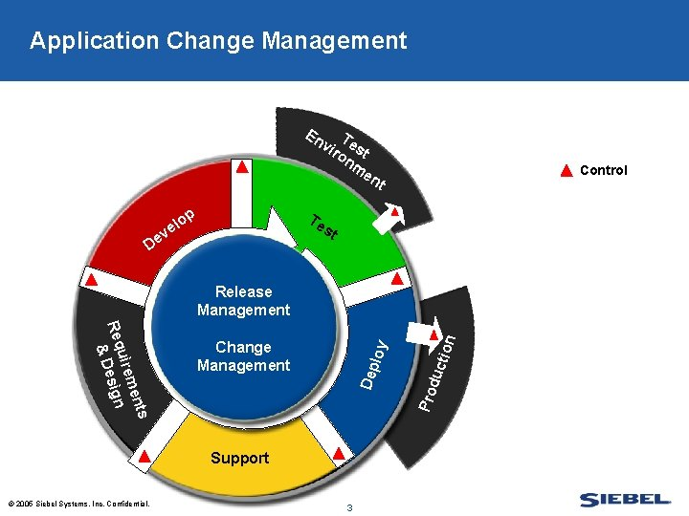

3-system landscape in SAP that facilitate change management process

**Development (DEV) System:** This is where all the initial configuration, customization, and development activities take place. *Consultants and developers make changes to the system based on business requirements*. It often has multiple clients for different development and testing purposes (e.g., a customizing client, a development client, a unit test client).

**Quality Assurance (QAS) System:** Once changes are developed and unit-tested in the DEV system, they are transported to the QAS system. This system is a near-replica of the production environment and is used for integration testing, user acceptance testing (UAT), and regression testing. *The goal is to identify and resolve any issues before changes are moved to the live production system.*

**Production (PRD) System:** This is the live, operational SAP system that end-users use to conduct daily business processes. It contains the actual business data and should be a stable and secure environment. *Direct changes are generally prohibited in the PRD system to maintain its integrity*.

**Advantages:**

* Keeps development, testing, and live operations distinct, preventing accidental production errors.
* Enforces a structured flow for changes (DEV - QAS - PRD).
* Production remains stable because changes are tested thoroughly beforehand.
* Dedicated testing in QAS leads to more reliable deployments.
* Supports teamwork between development, testing, and business teams.
* Provides a clear history of changes which is easy to audit.