Face Recognition Using MATLAB

Date
12/13/2024
Subject
Technologie & Multimedia
Teacher Name
Nada Farhani

Marzougui
Adam

Part I:
Introduction
Introduction

Face recognition is one of the most important applications in computer vision, used in security systems, authentication processes, and multimedia technologies. This project demonstrates face detection and recognition using MATLAB.
The idea of using artificial intelligence and image processing in security attracted me to explore face recognition. It aligns with the current technological trend and practical applications in real life.
This project focuses on detecting and recognizing faces in an image using MATLAB’s built-in tools and functions

Part II:
Theoretical Part

1. Introduction to the Program:
The face recognition program is a MATLAB-based application designed to detect and annotate human faces in digital images. It leverages advanced image processing techniques and the Haar Cascade algorithm to identify face regions and highlight them for visualization. The program is intended to demonstrate the principles of face detection and image processing in multimedia technology.
2. The Main Functions of the Program
The main functions of the program are its conceptual roles and objectives. These functions drive the overall workflow:
- Image insertion:
The program begins by loading a digital image. This step ensures that the data is prepared for analysis.
- Face Detection:
This is the critical phase where the program scans the image to identify regions that match the characteristics of human faces. It relies on mathematical models trained to recognize patterns like eyes, nose, and mouth.
- Annotation:
Once the faces are detected, the program highlights these regions by adding bounding boxes or labels, making them easily identifiable.
- Visualization:
The final output presents the processed image with detected faces alongside the original image for comparison. This step ensures clarity in the results.

3. Role of the Haar Cascade Algorithm
The Haar Cascade algorithm is central to the detection process.
What is the Haar Cascade Algorithm?
It is a machine-learning-based method for detecting objects in an image.

Part III:
Practical Part

The code source:
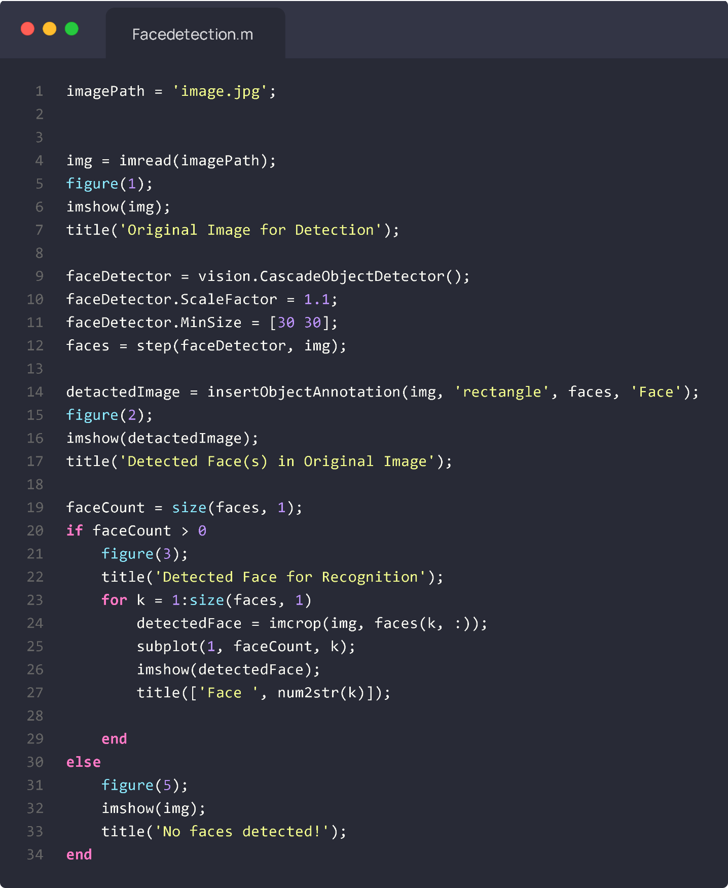

1. Image Acquisition:

Role: Specify the image file for processing.
This line defines the path to the image you want to analyze.
Role: Load the image into MATLAB.
Reads the specified image and converts it into a matrix (img) for processing.
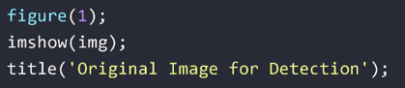
Role: Display the original image.
Opens a figure window, displays the image, and adds a title for clarity.
2. Initialize the Face Detector:
Role: Create the face detector.
Initializes an object detector based on the Haar Cascade algorithm for face detection.
Role: Adjust the scaling factor for detection.
Determines how much the image scales between detection steps, balancing speed and accuracy.

Role: Define the minimum size of faces to detect.
Prevents the detector from recognizing very small regions as faces.
3.Detect Faces:

Role: Detect faces in the image.
The “step” function applies the detector to the image and returns bounding
box coordinates for each detected face.
4.Annotate and Display detected Faces:
Role: Add bounding boxes and labels to detected faces.
Overlays rectangles on the image where faces are detected, labeling them as "Face."
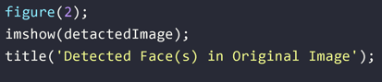
Role: Display the annotated image.
Shows the image with bounding boxes and labels to indicate detected faces.
5.Count the Detected Faces:
Role: Count the number of detected faces.
Calculates the number of rows in “faces”, which corresponds to the number of detected bounding boxes.

Role: Check if faces are detected.
Proceeds to crop and display detected faces if “faceCount” is greater than zero.
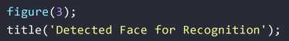
Role: Open a new figure for cropped faces.
Prepares to display all cropped faces in one figure using subplots.
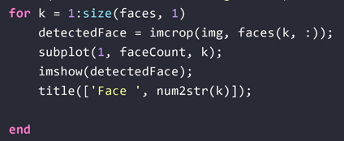
Role: Extract and display each detected face.
- “imcrop”: Extracts a sub-image of the face using bounding box coordinates.
- “subplot”: Arranges multiple cropped faces in a single figure.
- “imshow”: Displays the cropped face.
- “title”: Adds labels like "Face 1," "Face 2," etc., for each subplot.
7. Handle Cases with No Faces Detected:
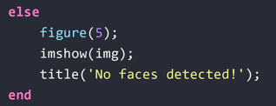
Role: Display a message if no faces are detected.

xxxxxxxx

Conclusion
In this project, we successfully demonstrated the ability to detect and
recognize faces in digital images using MATLAB. By utilizing the Haar
Cascade algorithm and leveraging MATLAB's built-in tools like
“vision.CascadeObjectDetector”, we effectively analyzed images to locate
faces and process them for recognition.
The project highlighted key concepts in image processing, such as
feature extraction, bounding box annotation, and face cropping. Through
careful configuration and optimization, we ensured the program could detect
faces with precision, maintaining the original image quality and size.
This work not only showcases the practical application of image
processing and computer vision but also bridges theoretical knowledge
with real-world problem-solving. It reflects the power of automation and
AI in modern multimedia technologies.

