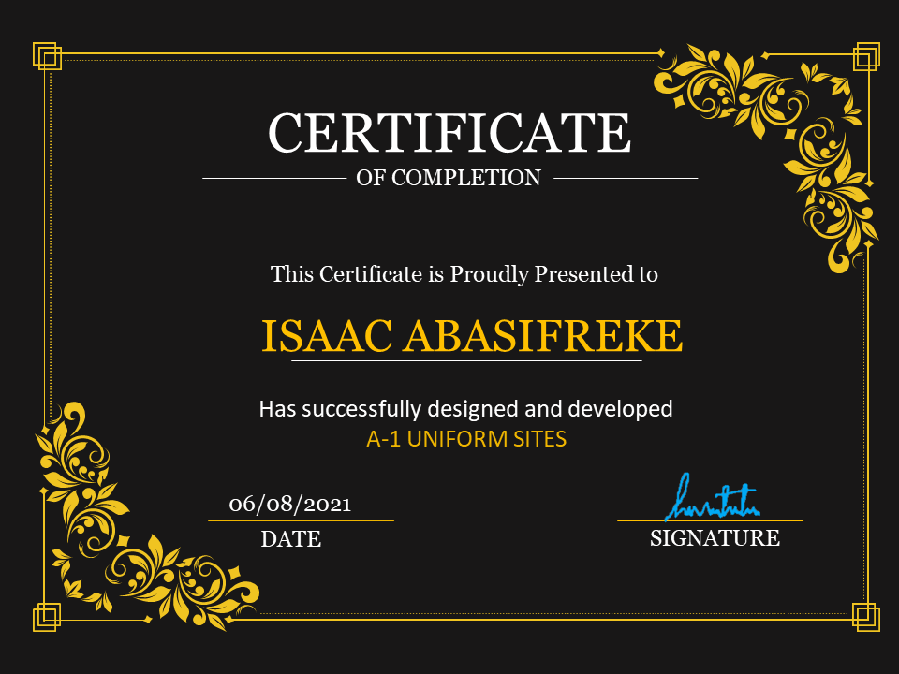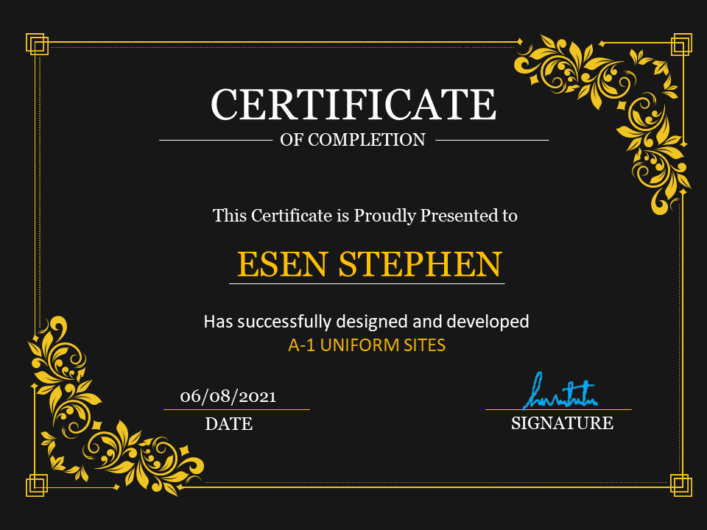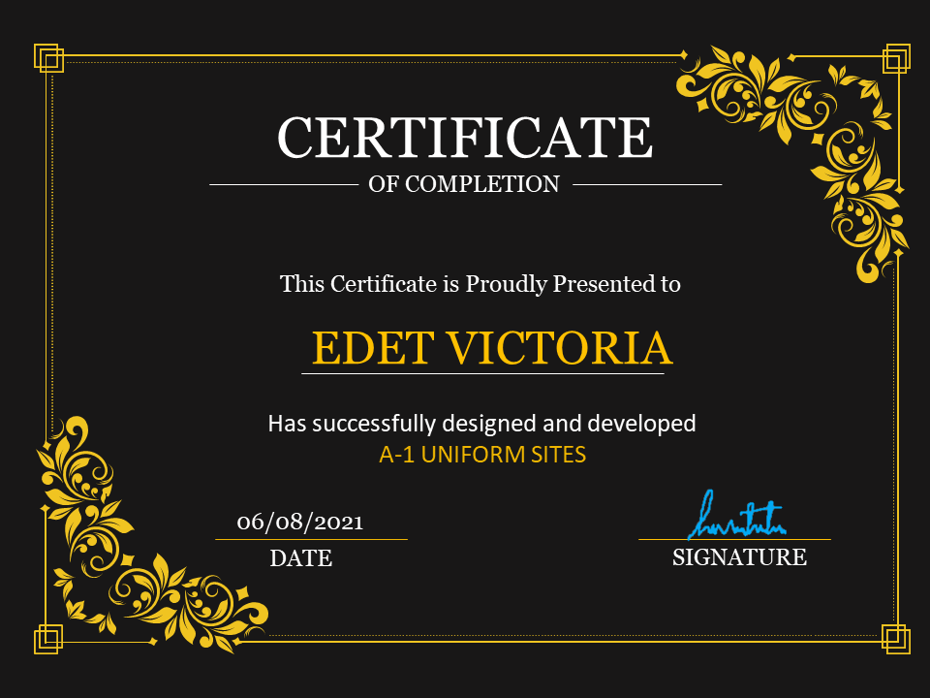

Problem Statement

A-1 uniforms was founded in 2016 and since then they have been one of the leading **Uniform Manufacturers in the country.** they supply many schools in country and they give them the best uniforms. They supply affordable school uniforms for girls and boys. When clients come, they cater to client’s vision.

As a team of professionals, they understand what clients want and deliver the best results.

At A-1 uniform designs are innovative and there are always fresh and new ideas for each and every client. The textiles are of excellent quality and they make each uniform according to the size requirements given. The fit is ingenious and they provide with the best. A-1 uniform is a part of a continuous strategic process of creative inputs from experts in the field. They consider each client differently and ensure the satisfaction with the end results. Each client is given the uttermost importance.

Project Objective

**Hardware**

* A minimum computer system that will help you access all the tools in the courses is a Pentium 166 or better
* 64 Megabytes of RAM or better
* Core i3 or higher
* 1gb ram or higher
* 50gb hard disk space
* Cd rom or dvd-rom drive

**Software**

* Notepad/HTML editor
* Dreamweaver
* IE 5.0/ Netscape 6.0
* Windows 8, 10 or higher
* Html 5 and JavaScript supporting browsers

1.Enable customers choose wonderful outfit for themselves

2.Bing out the beauty in our customers

3.Promote our goods and services

Case Study

A-1 Uniforms is the best uniform making company in Uyo, Nigeria, and has been in the business of garment manufacturing for over 7 Years.

We have grown over the years to become one of the foremost garment manufacturers in Nigeria through the cultivation of a culture of quality

and constantly improving our garment production Process.

A-1 Uniforms has become a household name in the areas of School uniforms, Professional wear, Robes, Boiler suits, and Academic gown.

We also manufacture accessories such as ties and logo.

Uniforms says a lot when it comes to maintaining a consistent, professional image for employees and students

which creates the difference in your business from the competition

Uniforms make a positive impact and we are what customers expect.

The Web Application will be a single page application which will make it easy for users to navigate and use.

Acknowledgement

I would like to acknowledge those who gave me moral support and helped me to make sure this project becomes a reality.

I would also like to thank the e-project team at the head office for helping me. Also, to the members of staff that Aptech uyo for giving me support and the requirement needed to achieve this goal.

Also, to my team members for giving their time, money, attention and devotion in the achievement of the singular goal.

Synopsis

A-1 uniforms is a Web Application that online market place for customers to view various designs of clothing and place orders for their different product which they desire.

A-1 uniforms is beneficial in the following ways.

1. Allows users to view the various items that can be delivered to them
2. Allows users communicate directly to the company through phone numbers or email.
3. Allows the users to know the location of the company through current geolocation.
4. Allows the site to be visible appealing.

Scope of work

The home page includes About us, Contact us, Products.

The products section contains a drop-down menu that shows the various product the company specialises on.

Each of the product pages gives a detailed image report on the available stock of products.

The Contact and About us page give detailed explanation on the aim and goals together with how the company can be reached or located.

Architecture and Design of the System



 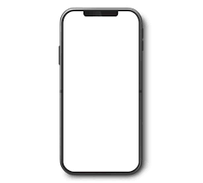

Submission Checklist

|  |  |  |  |  |  |
| --- | --- | --- | --- | --- | --- |
| S/N | PARTICULAR | YES | NO | NA | COMMENTS |
| 1 | Is the application user friendly? | yes |  |  |  |
| 2 | Are all the users able to view images and links? | yes |  |  |  |
| 3 | Is the website launching well in the browser? | yes |  |  |  |
| 4 | Are the navigation bar working correctly with the corresponding products? | yes |  |  |  |
| 5 | Is the web page taking too long to long? | no |  |  |  |
| 6 | Is the JavaScript working correctly? | yes |  |  |  |

USER GUIDE

The following steps will guide you on how to use and understand the website (A-1 UNIFORMS)

- The name of the site is “A-1 UNIFORMS”.

- The website is an offline version, so you don’t have to use internet connection.

- You don’t need a server view the site.

DEVELOPER GUIDE

A-1 Uniforms is an offline uniform platform where you can view the products of the company. To open A-1 Uniforms, open the file called index.html with any of your preferred browser. This program is fully customizable.

How To use A-1 UNIFORMS

- Open index.html on your browser to get into the site.

- On the home page there are four Menus (Home, About Us, Products, Contact Us, Feedback).

- The “Products” has Ten (10) drop-down menu (Shirt, Short, Logo, P.T.Short, P.T.Pants, Tie, Socks, Belt, Frocks, P.T.Shirts).

About Us

In the about page, you would see all the information that has to do with us

Contact Us

This page contains the details on how to reach us, and it also contains a form you can use as a feedback to get in touch with us.

DATA FLOW DIAGRAM

System

Product Details

User

FLOW CHART

