# **DECLARATION**

We ………………………. hereby declare that this Project “SMART HOME CONTROL SYSTEM ” submitted in partial fulfillment of the requirement for the Advanced Diploma in ELECTRONICS AND TELECOMMUNICATION TECHNOLY, at KIGALI INDEPENDENT UNIVERSITY , is our original work and has not previously been submitted elsewhere. Also, we declare that a complete list of references is provided indicating all the sources of information quoted or cited.

NAME 1

Signature………………………….

Date……. /………/……………….

NAME 2

Signature………………………….

Date……. /………./…………..

# **CERTIFICATION**

This is to certify that the Project work entitled “Smart home automation “is submitted by …………… …………………. in partial fulfillment of the requirement for the award of the degree Electrical and Electronic engineering department in Electronics and telecommunication technology is a record of work carried out by him under my guidance.

Supervisor: …………………………….

Signature …………………………...

Date : …... /…... / 2021

Head of department of Electrical and Electronics Engineering

…………………………….

Signature …………………………...

Date : …... /…... / 2021

# **DEDICATION**

We dedicate this work to our beloved parents, brothers and sisters who may see this work as a fruitful result of their support, encouragement and love. Who have always been by our side in time of need, since we started our academic study till today. Finally, we dedicate it to all our classmates for the part they played in our studies during those long and exciting years.

# **ACKNOWLEDGEMENTS**

Our first gratitude, appreciation and thanks goes to the Almighty God, who guided us through this journey that was not easy.

We express our deepest thanks to Electrical and Electronics Engineering department for taking part in useful decision and giving necessary advices and guidance and arrange all facilities to make life easier. I choose this moment to acknowledge their contribution gratefully.

It is our radiant sentimental to place on record our best regards, deepest sense of gratitude toour supervisor ……………………………… for his careful and precious guidance which were extremely valuable for our study both theoretically and practically, for his technical, wise advice, inspiration, motivation and guidance support during the elaboration of this project.

We highly express our thanks and gratitude for ULK administration and others staffs for their great help. Moreover, we express and appreciate our school practice supervisor for his help, advice throughout our teaching practice.

We wish to express our sincere thanks to ULK for giving us the opportunity of making practice exercises to the department of Electrical and Electronics Technology especially option of Electronics and Telecommunication.

# **ABSTRACT**

 In these days, there is a problem to control our home remotely in case of outside such as turn on or off lights, electrical devices as TV, air condition, open or close the doors, etc., the study offers a solution to develop Smart Home Automation System using Internet of Things (IoT). The proposed model of Smart Home Automation control elements of your home environment such as lighting, heating and air conditioning, using any smart phone or computer through particular web application. The main objective of the study is to improve safety, security, expand usability and make life easier for people of all abilities. Smart home automation provides high degree of security and safety and energy saving. With smart home automation your home is in the palm of your hands where ever you are at any time.

**TABLE OF CONTENTS**

**DECLARATION** ii

**CERTIFICATION** iii

**DEDICATION** iv

**ACKNOWLEDGEMENTS** v

**ABSTRACT** vi

**TABLE OF FIGURES** viii

**LIST OF ABBREVIATIONS** xi

**CHAPTER ONE: INTRODUCTION** 13

1.1 General background 13

1.2 Problem statement 13

1.3 Objectives 13

1.3.1 Main objective 13

1.3.2 Specific objectives 14

1.4 Scope of project 14

1.5 Project organization 14

**CHAPTER TWO: LITERATURE REVIEW** 15

2.1 INTRODUCTION 15

2.2 ELECTRONIC AND ELECTRICAL ELEMENTS INCLUDED IN OUR CIRCUIT 15

2.2.1 ESP8266 15

2.2.1.2 The specification 16

2.2.1.3 APPLICATIONS (Gillott, 2005) 18

2.2.2 RELAY MODULE 18

2.2.2.1 SPECIFICATIONS 19

2.2.2.2 8 CHANNEL RELAY MODULE INPUTS 19

2.2.2.4 8 CHANNEL RELAY MODULE TESTING SET UP 20

2.2.2.5 APPLICATIONS OF 8 CHANNEL RELAY MODULE 20

2.2.2.6 ADVANTAGES OF 8 CHANNEL RELAY MODULES 21

2.2.3 LAP TOP 21

2.2.4 INCANDESCENT LAMP 21

2.2.5 CIRCUIT BREAKER 23

2.2.5.1 Function of circuit breaker 23

2.2.5.2 Characteristics of circuit breaker 23

2.2.5.3 Types of circuit breaker 24

**CHAPTER THREE: METHODOLOGY** 25

3.1 Introduction 25

3.2 Methodology 25

3.2.1 Observation 25

3.2.2 Documentation 25

3.3 Softwares used 26

3.3.1 Arduino IDE 26

3.3.2 Sublime text editor 26

3.3.3 XAMPP 26

3.3.4 Browsers 27

3.4 Programming languages 27

3.4.1 HTML 27

3.4.2 CSS 28

3.4.3 Java script 28

3.4.4 PHP 28

3.4.5 SQL 29

3.5 FLOW CHART 29

3.5.2 USER SIDE FLOW CHART 31

3.5.2.1 USER SIDE FLOW CHART DESCRIPTION 31

# **TABLE OF FIGURES**

Figure 1: ESP8266 (Kolban, 2016) 15

Figure 4:ESP8266 PIN DEFINITION (Kolban, 2016) 16

Figure 6: Relay board 8 channels (Handson, 2016) 18

Figure 7: Laptop (Shneiderman, 2003) 20

Figure 8: Incandescent lamp (Karlicek, 2016) 21

Figure 9: Circuit breaker (Prévé, 2013) 22

Figure 13: popular web browsers 26

Figure 10: Flow chart of admin 29

Figure 11: flow chart of admin 30

# **LIST OF ABBREVIATIONS**

**AC**: Alternating current

**API**: application programming interface

**ASCII**: American Standard Code for Information Interchange

**AVR:** Automatic Voltage Regulation

**CRT**: Cathode Ray Tube

**CSS**: Cascading style sheet

**dB**: decibel

**DC**: Direct current

**GPRS**: General Packet Radio Service

**HTML**: Hypertext markup language

**I2C**: inter-integrated circuit

**IC**: integrated circuit

**ICSP**: in circuit serial programming

**ICT**: Information Communication and Technology

**IDE**: Integrated Development Environment

**IoT**: Internet of things

**ULK**: KIGALI INDEPENDENT UNIVERSITY

**LCD**: Liquid Crystal Display

**LPG**: liquefied petroleum gas

**MHz**: Megahertz

**MS**: Microsoft

**NTC**: Negative temperature coefficient

**PC**: Personal Computer

**PCB**: Printed Circuit Board

**Ppm**: parts per million

**PWM**: Pulse Width Modulation

**RAM**: Random access memory

**RDMS**: Relational Database Management Systems

**ROM**: Read Only Memory

**SDA**: Serial data

**SIM**: subscriber identity module

**SMS**: Short Message Service

**SQL**: Structured Query Language

**TTL**: transistor transistor logic

**UART**: Universal asynchronous receiver transmitter

**USA**: United States of America

**USB**: Universal Serial Bus

**VCC**: Voltage common collector

**VDC**: Direct Current voltage

**XAMPP**: Cross-platform, Apache server, MariaDB, PHP and Perl

# **CHAPTER ONE: INTRODUCTION**

## General background

In 1752, Benjamin Franklin ran his famous kite experiment that sparked the discovery of electricity. As a prominent American scientist and one of America’s founding fathers, Franklin tied a key to a kite string during a thunderstorm and proved that static electricity and lightning were one and the same thing. Following this historic result, people were eager to try to harness the power of electricity for the primary goal of lighting their homes in a cheap and safe way instead of oil and gas lamps which were flammable and dangerous. This revolutionized the world in a lot of different ways since then people have improved the technology leading to industrial revolutions and many more, as technology develops people always try to find a way of making life more efficient and simple using technology.

Due to people working for many hours and having a busy schedule, smart devices started to be invented in order to improve people’s standards of living and also providing and efficient, easy and time saving ways of doing things, this is where this project comes in hand in providing an easy, secure and effective way of controlling your loads using Internet of things (IoT) where ever you are in the world.

## Problem statement

As people tend to spend more time on works and other things they tend to forget to turn ON or OFF their load and usually remember when they are far from where they can be operated, and also some loads need to be controlled at specific times when the owner is also far for example at works, all there resulted to wastage of electric power and poor production efficiency, there was also another problem mostly faced by the old and disabled people moving around to control their loads.

## Objectives

### Main objective

The main objectives of this project is to Design and SMART HOME CONTROL SYSTEM.

### Specific objectives

The specific objectives of this project are:

1. To build a circuit that controlls the home loads (lights, socket outlets, and many more) by communicating with our web application.
2. To build web application where users will be able to control their loads using a smart phone, computer wherever they are as long as they have access to the internet.

## Scope of project

This project is limited to users whose homes can have access to internet since the project uses a Wi-Fi shield, and also accessing the web application requires internet, this project is also designed for controlling a maximum of eight loads, but this can be eliminated by using a microcontroller with increased out puts.

## Project organization

This report discusses the design and implementation of Smart home control system. It is subdivided into five chapters the first chapter is the Introduction, the second chapter is the literature review, the third chapter is Methodology, the fourth chapter is presentation and result analysis and the fifth chapter is Conclusion, summary and recommendations

# **CHAPTER TWO: LITERATURE REVIEW**

## INTRODUCTION

This chapter consists of the discussion about the basics of electronic elements and electrical devices that are joined together in order to achieve the desired result during the design and implementation of our project. Although there are several electronic and electrical elements and devices, this chapter will focus on those which are included with smart home as the purpose of our project (American 's new future, 2001)

## ELECTRONIC AND ELECTRICAL ELEMENTS INCLUDED IN OUR CIRCUIT

An electronic component is any basic used to affect electrons or their associated fields. Whereas electrical element is conceptual abstraction representing, idealized electrical component. Such as, WIFI Arduino ESP8266, 8 channels relay module, wireless router, circuit breaker, incandescent lamps, and computer (Nelkin, Body bazzar, 2001)

### ESP8266

The esp8266 is the name of microcontroller designed by espressif system , Espressif system is a Chinese company based out of Shanghai . (Kolban, 2016)

The esp8266 advertises itself as it is a self-contained Wi-Fi networking solution. It is self as a bridge from existing to Wi-Fi and it is also capable of running self-contained application. The volume of esp8266 didn’t start until 2014 which means in the scheme of things this is a new bland entry in the line-up processors. A couple of years after Ic production, 3rd party OEMs are taking these Ic chips and building “breakout boards” for them. They are very tiny and virtually impossible for hobbyists to attach wires to allow them to be plugged into breadboards Thankfully, these OEMs bulk purchase the ICs, design Basic circuits, design printed circuit boards and construct pre-made boards with the ICs reattached Immediately ready for our use (Kolban, 2016)

There are a variety of board styles available. The two that we focused on have been given the names ESP-1 and ESP-12. It is important to note that there is only one ESP8266 processor and it is this processor that is found on ALL breakout boards. What distinguishes one board from another is the number of GPIO pins exposed, the amount of flash memory provided, the style of connector pins and various other considerations related to construction. From a programming perspective, they are all the same (Kolban, 2016)

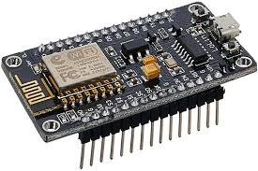

Figure 1: ESP8266 (Kolban, 2016)

#### The specification

When we approach a new electronics device, we like to know about its specification. Here bellow are table show us some details points:

Table 1:ESP8266 SPECIFICATION (Kolban, 2016)

|  |  |
| --- | --- |
| Voltage | 3.3v |
| Current consumption | 10uA – 170Ma |
| Flash memory attachable | 16MB max (512K normal) |
| Processor | Ten silica L106 32 bit |
| Processor speed | 80-160MHz |
| RAM | 32K + 80K |
| GPIOs | 17 (multiplexed with other functions) |
| Analog to Digital | 1 input with 1024 step resolution |
| 802.11 support | b/g/n/d/e/i/k/r |
| Maximum concurrent TCP connections | 5 |

The question of determining how long an ESP8266 can run on batteries is an interesting one. The current consumption is far from constant. When transmitting at full power, it can consume 170mA but when in a deep sleep, it only needs 10uA. That is quite a difference. This means that the run time of an ESP8266 on a fixed current reservoir is not just a function of time but also of what it is doing during that time and that is a function of the program deployed upon it (Kolban, 2016)

The ESP8266 is designed to be used with a partner memory module and this is most commonly flash memory. Most of the modules come with some flash associated with them. Realize that flash has a finite number of erases per page before something fails. They are rated at about 10,000 erases. This is not normally an issue for configuration change writes or daily log writes but if your application is continually writing new data extremely fast, then this may be an issue and your flash memory will fail (Kolban, 2016)

This module comes with a built in USB connector and a rich assortment of pin-outs. It is also immediately breadboard friendly (Kolban, 2016)

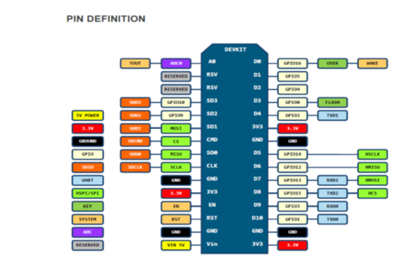

Figure 4:ESP8266 PIN DEFINITION (Kolban, 2016)

#### APPLICATIONS (Gillott, 2005)

Major Fields of ESP8266 applications to Internet-of-Things include:

• Home Appliances

• Home Automation

• Smart Plug and lights

• Mesh Network

• Industrial Wireless Control

• Baby Monitors

• IP Cameras

• Sensor Networks

• Wearable Electronics

### RELAY MODULE

This is a LOW Level 5V 8-channel relay interface board, and each channel needs a 15-20mA driver current. It can be used to control various appliances and equipment with large current. It is equipped with high-current relays that work under AC250V 10A or DC30V 10A. It has a standard interface that can be controlled directly by microcontroller. This module is optically isolated from high voltage side for safety requirement and also prevent ground loop when interface to microcontroller (www.handsontec.com, 2017)



Figure 6: Relay board 8 channels (Handson, 2016)

#### 2.2.2.1 SPECIFICATIONS

* Relay Maximum output: DC 30V/10A, AC 250V/10A.
* 8 Channel Relay Module with Opto-coupler. LOW Level Trigger expansion board, which is compatible with Arduino control board.
* Standard interface that can be controlled directly by microcontroller (8051, AVR, *PIC, DSP, ARM, ARM, MSP430, TTL logic).
* Relay of high quality low noise relays SPDT. A common terminal, a normally open, one normally closed terminal.
* Opto-Coupler isolation, for high voltage safety and prevent ground loop with microcontroller ; Module Board: 138 x 56 mm. (Handson, 2016)

#### 2.2.2.2 8 CHANNEL RELAY MODULE INPUTS

### 

VCC: Connected to positive supply voltage (supply power according to relay voltage)

GND: Connected to supply ground, IN1: Signal triggering terminal 1 of relay module, IN2: Signal triggering terminal 2 of relay module , IN3: Signal triggering terminal 3 of relay module, IN4: Signal triggering terminal 4 of relay module , IN5: Signal triggering terminal 5 of relay module , IN6: Signal triggering terminal 6 of relay module ,

IN7: Signal triggering terminal 7 of relay module and IN8: Signal triggering terminal 8 of relay module (Handson, 2016)

**2.2.2.3 8 CHANNEL RELAY MODULE OUTPUTS**

Each module of the relay has one NC (normally close), one NO (normally open) and one COM (Common) terminal. So there are 8 NC, 8 NO and 8 COM of the channel relay in total. NC stands for the normal close port contact and the state without power. NO stands for the normal open port contact and the state with power. COM means the common port. You can choose NC port or NO port according to whether power or not. (Handson, 2016)

### 2.2.2.4 8 CHANNEL RELAY MODULE TESTING SET UP

When a low level is supplied to signal terminal of the 8-channel relay, the LED at the output terminal will light up. Otherwise, it will turn off. If a periodic high and low level is supplied to the signal terminal, you can see the LED will cycle between on and off. (Handson, 2016)

### 2.2.2.5 APPLICATIONS OF 8 CHANNEL RELAY MODULE

* It can be applied to Arduino and raspberry pi
* Relays are suitable for driving high power electronics devices such as lights, electric fans and air condition.
* A relay can be used to control high voltages with a low voltage by connecting it to an MCU.
* They are also designed to control high voltage AC loads from lower voltage DC control circuitry and they accomplish this by using infrared lights as the “contact” (Handson, 2016)

### 2.2.2.6 ADVANTAGES OF 8 CHANNEL RELAY MODULES

One such advantage of using 8 channel relay module is that they can be switched by a much lower voltage and at a much lower current than most mechanical relays. Also because there are no moving contacts. Solid state relays can be switched much faster and for much longer periods without wearing out (Handson, 2016)

### LAP TOP

A **laptop**, often called a **notebook computer** or just **notebook**, is a small, portable personal computer with a "clamshell" form factor, having, typically, a thin LCD or LED computer screen mounted on the inside of the upper lid of the "clamshell" and an alphanumeric on the inside of the lower lid. The "clamshell" is opened up to use the computer. A standard laptop combines the components, inputs, outputs, and capabilities of a desktop computer, including the display screen, small speakers, a keyboard, hard disk drive, optical disc drive pointing devices (such as a touchpad or track pad), a processor, and memory into a single unit. (Shneiderman, 2003)



Figure 7: Laptop (Shneiderman, 2003)

### INCANDESCENT LAMP

An incandescent light bulb, incandescent lamp or incandescent light globe is an [electric light](https://en.wikipedia.org/wiki/Electric_light) which produces light with a wire filament heated to a high temperature by an electric current passing through it, until it glows .The hot filament is protected from oxidation with a glass or quartz bulb that is filled with inert gas or evacuated. In a [halogen lamp,](https://en.wikipedia.org/wiki/Halogen_lamp) filament evaporation is prevented by chemical processes that redeposit metal vapour onto the filament, extending its life. The light bulb is supplied with electric current by feed-through terminals or wires embedded in the glass. Most bulbs are used in a socket which provides mechanical support and electrical connections (Karlicek, 2016)

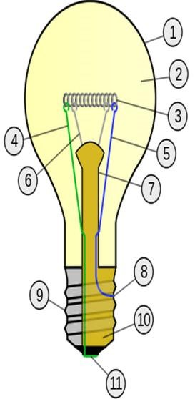

Figure 8: Incandescent lamp (Karlicek, 2016)

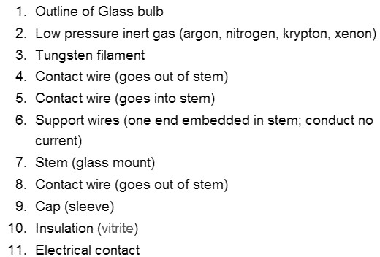

### CIRCUIT BREAKER

A circuit breaker is a type of switch that automatically breaks the circuit and cut off the current when a certain current value is excluded. Unlike a wire fuse that has to be replaced, a circuit breaker can reset and switched on again (Prévé, 2013)

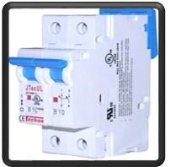

Figure 9: Circuit breaker (Prévé, 2013)

#### 2.2.5.1 Function of circuit breaker

It detects fault condition by interrupting the continuity and is used to determine if there is the fault. It is used to protect the circuit against the damaged caused by over load and short circuit for electrical circuit (Prévé, 2013)

#### 2.2.5.2 Characteristics of circuit breaker

* Voltage classes
* Current rating
* Type of circuit breaker

### 2.2.5.3 Types of circuit breaker

* Low voltage circuit breaker
* Magnetic circuit breaker
* Thermal magnetic circuit breaker Medium voltage circuit breaker

# **CHAPTER THREE: METHODOLOGY**

## 3.1 Introduction

This chapter demonstrates different methods and strategies that were used to conduct this project, we highlighted the methods which are interview, observation method and documentation methods. Furthermore, we reviewed different softwares and programming languages that were also used while designing and implementing this project.

## Methodology

### Observation

Observation, as the name implies, is a way of collecting data through observing. Observation data collection method is classified as a participatory study, because the researcher has to immerse him/herself in the setting where her respondents are, while taking notes and/or recording. The advantages of observation data collection method include direct access to research phenomena, high levels of flexibility in terms of application and generating a permanent record of phenomena to be referred to later. At the same time, observation method is disadvantaged with longer time requirements, high levels of observer bias, and impact of observer on primary data, in a way that presence of observer may influence the behavior of sample group elements.

While collecting the data, it was hard to visit many homes since most of them they like privacy. But we managed to observe starting from our homes and some institutions, we also observed how the business is done on the side of vendors in the business of gas refilling and gas ordering.

### Documentation

This technique is also necessary for getting information and help the researcher also to increase their knowledge so that he can easily solve the problem practically, it permits the researcher to consult books, other previous researchers, class notes, and the internet to find a different definition of words and codes for solving it.

Here we have read many class notes; consult different books from the school even outside the school so that we can easily solve the problems as stated before.

## Softwares used

Application software (app for short) is a program or group of programs designed for end-users to perform specific tasks. While designing and implementing this project we used different kind of softwares like Arduino IDE, Sublime text editor, Xampp and browsers [Chaudhuri.A.(2018].

### Arduino IDE

The Arduino Integrated Development Environment (IDE) is a cross-platform application (for Windows, mac OS, Linux) that is written in functions from C and C++.It is used to write and upload programs to Arduino compatible boards, but also, with the help of third-party cores, other vendor development boards. In this project Arduino IDE was used in writing and upload program to esp8266 [John ,M.(2019)].

### Sublime text editor

Sublime Text is a sophisticated  cross-platform source code editor with a Python application programming interface (API). It natively supports many programming languages and markup languages, and functions can be added by users with plugins, typically community-built and maintained under free-software licenses. This software was used in writing PHP, JavaScript, HTML and CSS codes [Mark,J.(2013)].

### XAMPP

The full form of XAMPP is X stands for Cross-platform, (A) Apache server, (M) MariaDB, (P) PHP and (P) Perl. The Cross-platform usually means that it can run on any computer with any operating system. XAMPP is an open-source software developed by Apache Friends. XAMPP software package contains Apache distributions for Apache server, MariaDB, PHP, and Perl. And it is basically localhost or a local server. This local server works on your own desktop or laptop computer. XAMPP was used test the website before uploading it to the remote web server. XAMPP server software gave us a suitable environment for testing MYSQL, PHP, Apache, and Perl projects on the local computer [SAMUEL,P.(2013)].

### Browsers

A web browser, or simply "browser," is an application used to access and view websites. Common web browsers include Microsoft Internet Explorer, Google Chrome, Mozilla Firefox, and Apple Safari. The primary function of a web browser is to render HTML, the code used to design or " markup " webpages. Each time a browser loads a web page, it processes the HTML, which may include text, links, and references to images and other items, such as cascading style sheets and JavaScript functions. The browser processes these items, then renders them in the browser window. While designing the web application we used many popular web browsers in order ensure browser compatibility [Board.E.(2018)].



Figure 13: popular web browsers

[ Luimes.A.(2018)]

## Programming languages

A programming language is a set of commands, instructions, and other syntax use to create a software program. Languages that programmers use to write code are called "high-level languages." This code can be compiled into a "low-level language," which is recognized directly by the computer hardware [ Edward, D(2014)].

High-level languages are designed to be easy to read and understand. This allows programmers to write source code in a natural fashion, using logical words and symbols. In the design of this project different programming languages were which are Arduino C language, HTML, CSS, PHP, Java script [ Dean. (2019)].

### HTML

Stands for "Hypertext Markup Language." HTML is the language used to create webpages. HTML was invented by Tim Berners-Lee, a physicist at the CERN research institute in Switzerland. He came up with the idea of an Internet-based hypertext system.

Hypertext means a text that contains references (links) to other texts that viewers can access immediately. He published the first version of HTML in 1991, consisting of 18 HTML tags. Since then, each new version of the HTML language came with new tags and attributes (tag modifiers) to the markup [Dean.(2019)].

### CSS

Cascading Style Sheets, fondly referred to as CSS, is a simple design language intended to simplify the process of making web pages presentable.

CSS handles the look and feel part of a web page. Using CSS, you can control the color of the text, the style of fonts, the spacing between paragraphs, how columns are sized and laid out, what background images or colors are used, layout designs, variations in display for different devices and screen sizes as well as a variety of other effects.

CSS is easy to learn and understand but it provides powerful control over the presentation of an HTML document. Most commonly, CSS is combined with the markup languages HTML. CSS has several advantages among them include CSS saves time, Pages load faster, Easy maintenance, Superior styles to HTML, Multiple Device Compatibility, Global web standards [Dean.(2019)].

### Java script

JavaScript is a dynamic computer programming language. It is lightweight and most commonly used as a part of web pages, whose implementations allow client-side script to interact with the user and make dynamic pages. It is an interpreted programming language with object-oriented capabilities.

Java script was used to create and control dynamic website content, i.e. anything that moves, refreshes, or otherwise changes on your screen without requiring you to manually reload a web page. Features like: animated graphics, photo slide shows, autocomplete text suggestions, interactive forms [Dean.(2019)].

### PHP

PHP is a server side scripting language. that is used to develop Static websites or Dynamic websites or Web applications. PHP stands for Hypertext Pre-processor, that earlier stood for Personal Home Pages. PHP scripts can only be interpreted on a server that has PHP installed. PHP is integrated with a number of popular databases, including MySQL, PostgreSQL, Oracle, Sybase, Informix, and Microsoft SQL Server, PHP was used in making logical decisions and connecting the interface with the database through SQL [Williams, E.(2002)].

### SQL

SQL is Structured Query Language, which is a computer language for storing, manipulating and retrieving data stored in a relational database.

SQL is the standard language for Relational Database System. All the Relational Database Management Systems (RDMS) like MySQL, MS Access, Oracle, Sybase, Informix, Postgres and SQL Server use SQL as their standard database language. SQL was used to access data in the relational database management systems, define the data in a database and manipulate that data, create and drop databases and tables, create view, stored procedure, functions in a database [Williams, E .(2002)].

### 3.5 FLOW CHART

A flowchart is a type of diagram that represents a workflow or process. A flowchart can also be defined as a diagrammatic representation of an algorithm, a step-by-step approach to solving a task. The flowchart shows the steps as boxes of various kinds, and their order by connecting the boxes with arrows (https://en.wikipedia.org)

**3.5.1 ADMIN SIDE FLOW CHART**

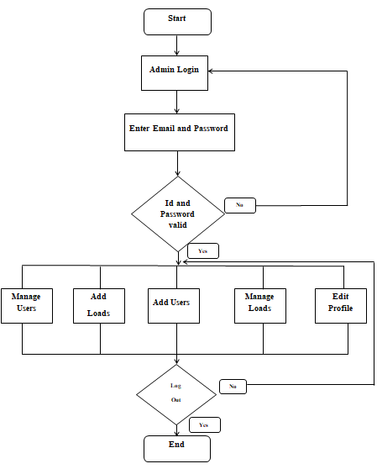

Figure 10: Flow chart of admin

**3.5.1.**1 ADMIN SIDE FLOW CHART DESCRIPTION

Initially the system starts with a page pertaining admin login, if admin enters both collect email id and password then he /she is allowed into the system, when admin could not either enter collect email id or password, the system will bring him/her back to the log in page.so when he/she enters in the system, he/she will be allowed to manage both users, add new loads, add users, manages loads and edit his/her profile as well. And when he/she needs to log out in the system admin flow chart will be end simply the admin will require the collect credentials to be able to do those tasks in the system.

#### 3.5.2 USER SIDE FLOW CHART

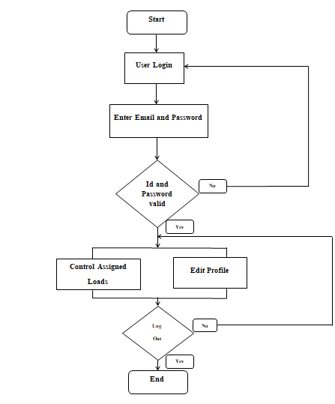

Figure 11: flow chart of admin

##### 3.5.2.1 USER SIDE FLOW CHART DESCRIPTION

Initially the system starts with a page pertaining user login ,if a user enters both collect email id and password then he /she is allowed into the system, when a user could not either enter collect email id or password ,the system will bring him/her back to the log in page.so when he/she enters in the system ,he/she will be allowed to control assigned loads and edit his/her profile as well. And when he/she needs to log out in the system user flow chart will be end simply the user will require the collect credentials to be able to do those tasks in the system.