# **DECLARATION**

We; UWINEZA SUGIRA Peace Clement and NZASABIMANA Jean Baptiste hereby declare that this Project “AUTO-DRIVING LIFTING ROBOT WITH SPEED CONTROL” submitted in partial fulfillment of the requirement for the Advanced Diploma in ELECTRONICS AND TELECOMMUNICATION TECHNOLOGY, at Rwanda Polytechnic-Integrated Polytechnic Regional College-Huye, is our original work and has not previously been submitted elsewhere. Also, we declare that a complete list of references is provided indicating all the sources of information quoted or cited.

Name 1

UWINEZA SUGIRA Peace Clement

Signature………………………….

Date……. /………/……………….

Name 2

NZASABIMANA Jean Baptiste

Signature………………………….

Date……. /………./…………..

# **CERTIFICATION**

This is to certify that the Project work entitled “Auto-driving lifting robot with speed control” Submitted by ………………. Peace Clement and ……………………….in partial fulfillment of the requirement for the award of the degree Electrical and Electronic engineering department in Electronics and telecommunication technology is a record of work carried out by them under my guidance.

Supervisor: ………………………..

Signature …………………………...

Date : …... /…... / 2021

Head of department of Electrical and Electronics Engineering

………………………………………….

Signature …………………………...

Date : …... /…... / 2022

# **DEDICATION**

We dedicate this work to our beloved parents, brothers and sisters who may see this work as a fruitful result of their support, encouragement and love as they have always been by our side in time of need, since we started our academic studies till today. Finally, we dedicate it to all our classmates for the part they played in our studies during those long and exciting years.

# **ACKNOWLEDGEMENTS**

Our first gratitude, appreciation and thanks goes to the Almighty God, who guided us through this journey that was not easy.

We express our deepest thanks to Electrical and Electronics Engineering department for taking part in useful decision and giving necessary advices and guidance and arrange all facilities to make life easier. We choose this moment to acknowledge their contribution gratefully.

It is our radiant sentimental to place on record our best regards, deepest sense of gratitude toour supervisor ……………………… for his careful and precious guidance which was extremely valuable for our study both theoretically and practically. And also, for his technical, wise advice, inspiration, motivation and guidance support during the elaboration of this project.

We highly express our thanks and gratitude for IPRC ………………… administration and others staffs for their great help. Moreover, we express and appreciate our school practice supervisor for his help, advice throughout our teaching practice.

We wish to express our sincere thanks to Rwanda Polytechnic/ IPRC ………………………….. for giving us the opportunity of undertaking practical exercises through the department of Electrical and Electronics Technology especially option of Electronics and Telecommunication.

# **ABSTRACT**

Nowadays smart systems are being used in every aspect of our daily life to improve our standards of living. mainly as industrialization continues to grow, the need of using automated systems to carry out tasks in order to improve the production is at a high demand, using these robots increases the production and precision in the production. self-driving robot is one among the automated systems. Mostly in hazard areas self-driven robots are very needed that why we directed our project in achieving a self-driven robot, this system can be achieved in many different ways but in this project, it was achieved using IR (infrared)sensors to follow a pre-determined line path, adding a mechanical lift to the robot makes it’s uses extend to the packaging process without any human operator to control the motions of the robot , this project report illustrates the steps, materials and components needed to design and implement project.

**TABLE OF CONTENTS**

**DECLARATION** 2

**CERTIFICATION** 3

**DEDICATION** 4

**ACKNOWLEDGEMENTS** 5

**ABSTRACT** 6

**TABLE OF FIGURES** 8

**LIST OF ABBREVIATIONS** 10

**CHAPTER ONE: INTRODUCTION** 11

1.1 General background 11

1.2 Problem statement 11

1.3 Objectives 12

1.3.1 Main objective 12

1.3.2 Specific objectives 12

1.4 Scope of project 12

**CHAPTER TWO: LITERATURE REVIEW** 13

2.1 Introduction 13

2.2 Electronic components 13

2.2.1 Microcontroller 13

2.2.1.1 Arduino uno 13

2.2.2 Sensors 14

2.2.2.1 IR sensor/ infrared sensor 15

2.2.2.2 HC-SR04 Ultrasonic sensor. 18

2.2.3 Actuators 19

2.2.3.1 DC motor 19

2.2.4 Switching devices 21

2.2.4.1 L298N Driver 21

**CHAPTER THREE: METHODOLOGY** 23

3.1 Introduction 23

3.2 Methodology 23

3.2.1 Observation 23

3.2.2 Documentation 23

3.3 Software’s used 24

3.3.1 Arduino IDE 24

**CHAPTER FOUR: PRESENTATION AND IMPLEMENTATION** 25

4.1 Introduction 25

4.2 Block diagram 25

4.2.1 Block diagram description 25

4.2.1.1 Arduino mega 26

2.2.4.2 Infrared sensors 26

2.2.4.3 Ultrasonic sensor 27

4.3 Flow chart 28

4.4 Circuit diagram 29

4.5 working principle 29

4.6 Implementation of the project 30

**CHAPTER FIVE. CONCLUSION, SUMMARY AND RECOMMENDATION** 30

5.1 Conclusion 31

5.2 Recommendation 31

**REFERENCES** 31

**APPENDIES** 33

# **TABLE OF FIGURES**

Figure 1: Arduino mega [4] 14

Figure 2: IR transmitter [5] 16

Figure 3:IR receiver [5] 16

Figure 4:IR sensor obstacle detection [5] 17

Figure 5:Ultrasonic sensor 18

Figure 6: DC electric motor [6] 20

Figure 7:L298N motor driver [8] 21

Figure 10: block diagram 25

Figure 11:IR sensor on a black and white surface 26

Figure 12:IR sensors on different directions 27

Figure 13: flow chart 28

Figure 14: Full circuit diagram 29

Figure 15:Folk lift mounted on the robotic car 30

Figure 16: final implemented project 30

# **LIST OF ABBREVIATIONS**

**AC**: Alternating current

**AVR:** Automatic Voltage Regulation

**dB**: decibel

**DC**: Direct current

**IC**: integrated circuit

**ICSP**: in circuit serial programming

**IDE**: Integrated Development Environment

**IPRC**: Integrated Polytechnic Regional College

**MHz**: Megahertz

**PC**: Personal Computer

**PCB**: Printed Circuit Board

**PWM**: Pulse Width Modulation

**RAM**: Random access memory

**ROM**: Read Only Memory

**RP**: Rwanda Polytechnic

**SMS**: Short Message Service

**SQL**: Structured Query Language

**TTL**: transistor transistor logic

**UART**: Universal asynchronous receiver transmitter

**USB**: Universal Serial Bus

**VCC**: Voltage common collector

**VDC**: Direct Current voltage

# **CHAPTER ONE: INTRODUCTION**

## General background

The history of robots has its origins in the ancient world. During the industrial revolution, humans developed the structural engineering capability to control electricity so that machines could be powered with small motors. Several definitions can be used to define a robot, one of them include “A reprogrammable, multifunctional manipulator designed to move material, parts, tools, or specialized devices through various programmed motions for the performance of a variety of task”

The first uses of modern robots were in factories as industrial robots. These industrial robots were fixed machines capable of manufacturing tasks which allowed production with less human work. Digitally programmed industrial robots with artificial intelligence have been built since the 2000s [1].

**Mostly Robots are used to work in areas that can possess danger to man, to carry out heavy tasks, and also to increase production since they don’t get tired. carrying heavy objects is one of the things that can expose danger to the human life, and also working for a long period of time. That’s why we used a line follower to achieve an automatic control. Generally, a line follower robot is a self-operating mobile machine that follows a line drawn on the floor, the line path can be black or white (inverted). By Adding system to detect the object and a mechanical system to lift the object, an automatic lifting is achieved as a line follower robot follows the line path and place the object to t**he **desired location, and for the speed to vary with the material lifted, a way to control the speed of the robot is also provided and finally an automatic lifting robot with speed control is achieved** [2]**.**

## Problem statement

In the current system in use the operator drives the lift machine, and this system in use presents some problems which include; the operator’s life may be in danger due to accidents that may rise from the falling objects being parked, the operator gets tired and this affects the production in industries, the need of more man labor which increases the production costs.

## Objectives

### Main objective

The main objectives of this project is to Design and implement AUTODRIVING LIFTING ROBOT WITH SPEED CONTROL.

### Specific objectives

The specific objectives of this project are:

1. To build a line follower robotic car that will follow the path predetermined.
2. To build a mechanical system on the robotic car that will be used to lift the objects (folk lift).
3. To build a control system that controls the speed of the robot.

## Scope of project

This project is designed for areas whose floor is not black but have only black as the color of the path, since it uses sensors to follow the black path, any change in the color could result in the malfunction of system. And also the speed isn’t changed automatically, an operator is required to change the speed of the robot. this robot we built is capable of lifting not more than 500 grams. also the existence of other sorts of light as sunlight, can cause interference in detection of reflected light by IR sensors as they normally use light to detect.

# **CHAPTER TWO: LITERATURE REVIEW**

## Introduction

In this chapter we have reviewed different types of components that were used while implementing this project. these components include, Microcontroller, sensors, actuators and switching devices.

## Electronic components

### Microcontroller

A microcontroller is a small computer on a single metal-oxide-semiconductor (MOS) integrated circuit (IC) chip. A microcontroller contains one or more CPUs (processor cores) along with memory and programmable input/output peripherals. While designing and implementing this project we used Arduino uno microcontroller [3].

#### Arduino uno

The **Arduino Mega 2560** is a microcontroller board based on the ATmega2560. It has 54 digital input/output pins (of which 15 can be used as PWM outputs), 16 analog inputs, 4 UARTs (hardware serial ports), a 16 MHz crystal oscillator, a USB connection, a power jack, an ICSP header, and a reset button. It contains everything needed to support the microcontroller; simply connect it to a computer with a USB cable or power it with a AC-to-DC adapter or battery to get started. The Mega 2560 board is compatible with most shields designed for the Uno and the former boards Duemilanove or Diecimila [4].

The arduino mega in this project works as the mind of the whole system as it sends commands to the rest of the system’s components for the operation according to the information read from sensors.

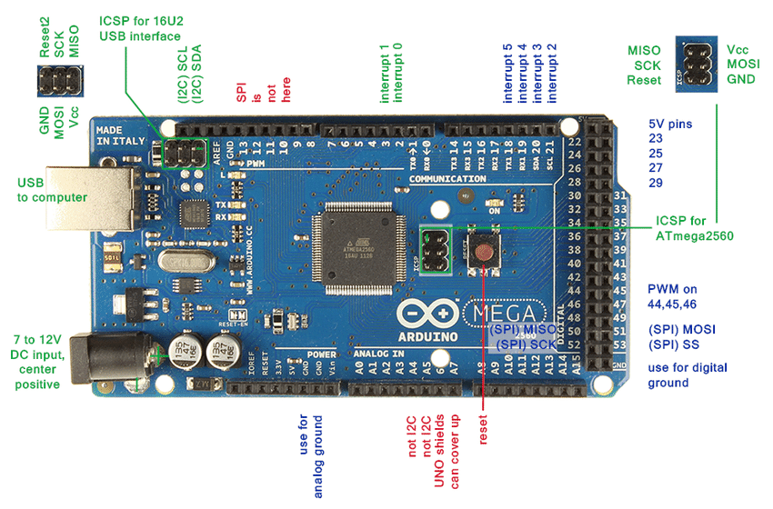

Figure 1: Arduino mega [4]

### Sensors

A sensor is a device that measures physical input from its environment and converts it into data that can be interpreted by either a human or a machine. Most sensors are electronic (the data is converted into electronic data), but some are simpler, such as a glass thermometer, which presents visual data. People use sensors to measure temperature, gauge distance, detect smoke, regulate pressure and a myriad of other uses. There are two types of electronic sensors: analog and digital. Analog sensors convert physical data into an analog signal. While digital sensors are limited to a finite set of possible values.  While designing this project both types of sensors were used, we used IR sensors, ultrasonic sensor [5]

#### IR sensor/ infrared sensor

IR sensor is an electronic device, that emits the light in order to sense some object of the surroundings. An **IR sensor** can measure the heat of an object as well as detects the motion. Usually, in the **infrared spectrum**, all the objects radiate some form of thermal radiation. These types of radiations are invisible to our eyes, but infrared sensor can detect these radiations.

The emitter is simply an IR LED **(Light Emitting Diode)** and the detector is simply an IR photodiode. Photodiode is sensitive to IR light of the same wavelength which is emitted by the IR LED. When IR light falls on the photodiode, the resistances and the output voltages will change in proportion to the magnitude of the IR light received.

There are five basic elements used in a typical infrared detection system: an infrared source, a transmission medium, optical component, infrared detectors or receivers and signal processing. Infrared lasers and Infrared LED’s of specific wavelength used as infrared sources.

The three main types of media used for infrared transmission are vacuum, atmosphere and optical fibers. Optical components are used to focus the infrared radiation or to limit the spectral response [5].

**IR Transmitter or IR LED**

Infrared Transmitter is a light emitting diode (LED) which emits infrared radiations called as IR LED’s. Even though an IR LED looks like a normal LED, the radiation emitted by it is invisible to the human eye.

[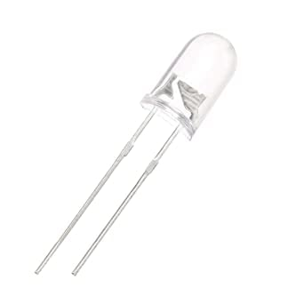](https://robu.in/wp-content/uploads/2020/05/51fibl-5xL._SX342_.jpg)

Figure 2: IR transmitter [5]

**IR Receiver or Photodiode**

Infrared receivers or infrared sensors detect the radiation from an IR transmitter. IR receivers come in the form of photodiodes and phototransistors. Infrared Photodiodes are different from normal photo diodes as they detect only infrared radiation. Below image shows the picture of an IR receiver or a photodiode,

[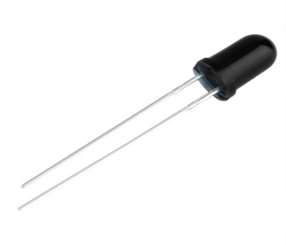](https://robu.in/wp-content/uploads/2020/05/SN-IR-R-0-1-1-800x800-1.jpg)

Figure 3:IR receiver [5]

Different types of IR receivers exist based on the wavelength, voltage, package, etc. When used in an infrared transmitter – receiver combination, the wavelength of the receiver should match with that of the transmitter.

The emitter is an IR LED and the detector is an IR photodiode. The IR photodiode is sensitive to the IR light emitted by an IR LED. The photo-diode’s resistance and output voltage change in proportion to the IR light received. This is the underlying working principle of the IR sensor [5].

[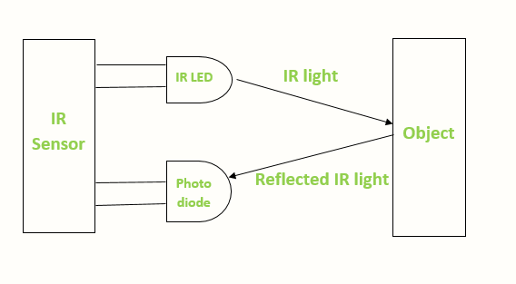](https://robu.in/wp-content/uploads/2020/05/IR-sensor-Working.png)

Figure 4:IR sensor obstacle detection [5]

When the IR transmitter emits radiation, it reaches the object and some of the radiation reflects back to the IR receiver. Based on the intensity of the reception by the IR receiver, the output of the **sensor** defines. As for this project we used the IR sensors to detect the black line drawn on the floor for the robotic car to follow.

**Advantages**

The advantages of IR sensor include the following

* It uses less power
* The detection of motion is possible in the presence or absence of light approximately with equal reliability.
* They do not need contact with the object for detection
* There is no data leakage because of the ray direction
* These sensors are not affected by oxidation & corrosion
* Noise immunity is very strong

**Disadvantages**

The **disadvantages of IR sensor** include the following

* Line of sight is required
* Range is limited
* These can be affected by fog, rain, dust, etc
* Less data transmission rate

#### HC-SR04 Ultrasonic sensor.

HC-SR04 Ultrasonic sensor is a 4 pin module, whose pin names are Vcc, Trigger, Echo and Ground respectively. This sensor is a very popular sensor used in many applications where measuring distance or sensing objects are required. The module has two eyes like projects in the front which forms the Ultrasonic transmitter and Receiver. The sensor works with the simple high school formula that

**Distance = Speed × Time**

The Ultrasonic transmitter transmits an ultrasonic wave, this wave travels in air and when it gets objected by any material it gets reflected back toward the sensor this reflected wave is observed by the Ultrasonic receiver module as shown in the picture below [5]

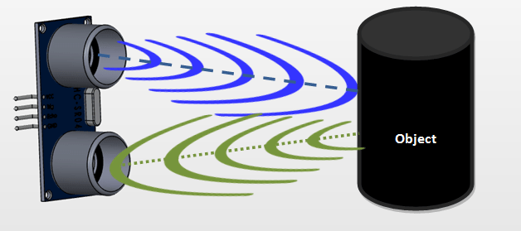

Figure 5:Ultrasonic sensor

To calculate the distance using the above formula, the Speed and time in known. Since universal speed of US wave at room conditions which is 330m/s. The circuitry inbuilt on the module will calculate the time taken for the US wave to come back and turns on the echo pin high for that same particular amount of time, this way we can also know the time taken. the distance is then calculated using a microcontroller or microprocessor.

**Applications**

* Used to avoid and detect obstacles with robots like biped robot, obstacle avoider robot, path finding robot etc.
* Used to measure the distance within a wide range of 2cm to 400cm
* Can be used to map the objects surrounding the sensor by rotating it
* Depth of certain places like wells, pits etc can be measured since the waves can penetrate through water

While implementing our system we added HC-SR04 Ultrasonic sensor for detection of objects to be carried.

### Actuators

An actuator is a component of a machine that is responsible for moving and controlling a mechanism or system, for example by opening a valve. An actuator requires a control signal and a source of energy. The control signal is relatively low energy and may be electric voltage or current, pneumatic, or hydraulic fluid pressure, or even human power. Its main energy source may be an electric current, hydraulic pressure, or pneumatic pressure. When it receives a control signal, an actuator responds by converting the source's energy into mechanical motion, while implementing this project we used motors [6]

#### DC motor

The term ‘DC motor’ is used to refer to any rotary electrical machine that converts direct current electrical energy into mechanical energy. DC motors can vary in size and power from small motors in toys and appliances to large mechanisms that power vehicles, pull elevators and hoists, and drive steel rolling mills. DC motors include two key components: a **stator** and an **armature**. The stator is the stationary part of a motor, while the armature rotates. In a DC motor, the stator provides a rotating magnetic field that drives the armature to rotate.

A simple DC motor uses a stationary set of magnets in the stator, and a coil of wire with a current running through it to generate an electromagnetic field aligned with the center of the coil. One or more windings of insulated wire are wrapped around the core of the motor to concentrate the magnetic field.

The windings of insulated wire are connected to a commutator (a rotary electrical switch), that applies an electrical current to the windings. The commutator allows each armature coil to be energized in turn, creating a steady rotating force (known as torque).

When the coils are turned on and off in sequence, a rotating magnetic field is created that interacts with the differing fields of the stationary magnets in the stator to create torque, which causes it to rotate. These key operating principles of DC motors allow them to convert the electrical energy from direct current into mechanical energy through the rotating movement, which can then be used for the propulsion of objects [6]

Our project involves five DC motors, four motors connected to the robot wheels and one responsible for lifting up or dropping down the folk lift.

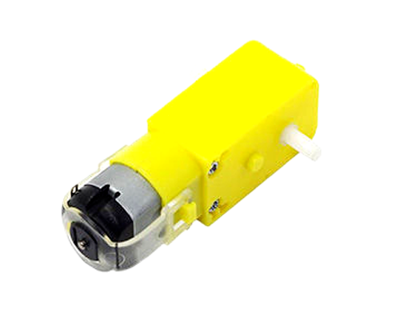

Figure 6: DC electric motor [6]

### Switching devices

switching devices are defined as any devices that open and close electrical circuits. Electrical circuits must form a continuous loop, and a switching device functions like a gate in that loop. A circuit is ON when the switching device is closed, and the circuit is OFF when the switching device is open. In this project we used different kind of switching devices such as limit switch, relay board and selector switch [7]

#### L298N Driver

The L298N is a dual H-Bridge motor driver which allows speed and direction control of two DC motors at the same time. The module can drive DC motors that have voltages between 5 and 35V, with a peak current up to 2A [8].

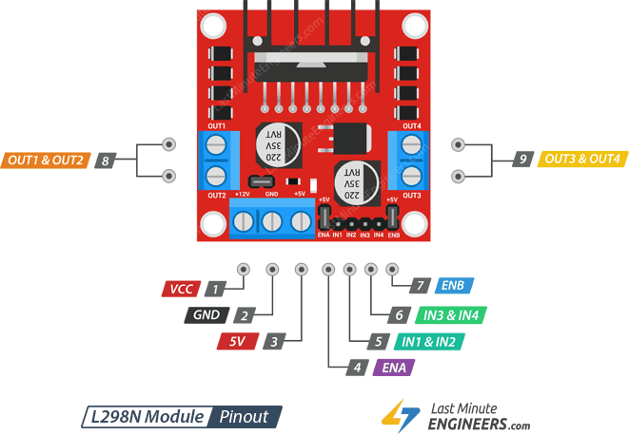

Figure 7:L298N motor driver [8]

VCC  pin supplies power for the motor. It can be anywhere between 5 to 35V. Remember, if the 5V-EN jumper is in place, you need to supply 2 extra volts than motor’s actual voltage requirement, in order to get maximum speed out of your motor.

GND  is a common ground pin.

5V  pin supplies power for the switching logic circuitry inside L298N IC. If the 5V-EN jumper is in place, this pin acts as an output and can be used to power up your Arduino. If the 5V-EN jumper is removed, you need to connect it to the 5V pin on Arduino.

ENA  pins are used to control speed of Motor A. Pulling this pin HIGH (Keeping the jumper in place) will make the Motor A spin, pulling it LOW will make the motor stop. Removing the jumper and connecting this pin to PWM input will let us control the speed of Motor A.

IN1 & IN2  pins are used to control spinning direction of Motor A. When one of them is HIGH and other is LOW, the Motor A will spin. If both the inputs are either HIGH or LOW the Motor A will stop.

IN3 & IN4  pins are used to control spinning direction of Motor B. When one of them is HIGH and other is LOW, the Motor B will spin. If both the inputs are either HIGH or LOW the Motor B will stop.

ENB  pins are used to control speed of Motor B. Pulling this pin HIGH(Keeping the jumper in place) will make the Motor B spin, pulling it LOW will make the motor stop. Removing the jumper and connecting this pin to PWM input will let us control the speed of Motor B.

OUT1 & OUT2 pins are connected to Motor A.

OUT3 & OUT4 pins are connected to Motor B

# **CHAPTER THREE: METHODOLOGY**

## 3.1 Introduction

This chapter demonstrates different methods and strategies that were used to conduct this project, we highlighted the methods which are observation method and documentation methods. Furthermore, we reviewed different software’s and programming languages that were also used while designing and implementing this project.

## Methodology

### Observation

Observation, as the name implies, is a way of collecting data through observing. Observation data collection method is classified as a participatory study, because the researcher has to immerse him/herself in the setting where her respondents are, while taking notes and/or recording. The advantages of observation data collection method include direct access to research phenomena, high levels of flexibility in terms of application and generating a permanent record of phenomena to be referred to later. At the same time, observation method is disadvantaged with longer time requirements, high levels of observer bias, and impact of observer on primary data, in a way that presence of observer may influence the behavior of sample group elements.

### Documentation

is a technique necessary for getting information and help researchers also to increase their knowledge so that they can easily solve the problems practically. it permits the researcher to consult books, other previous researchers, class notes, and the internet to find a different definition of words and codes for solving it.

Here we have read many class notes; consulted different books from the school, even outside the school so that we can easily solve the problems as stated before.

## Software’s used

Application software (app for short) is a program or group of programs designed for end-users to perform specific tasks. While designing and implementing this project we used different kind of software’s like Arduino IDE and fritzing.

### Arduino IDE

The Arduino Integrated Development Environment (IDE) is a cross-platform application (for Windows, mac OS, Linux) that is written in functions from C and C++.It is used to write and upload programs to Arduino compatible boards, but also, with the help of third-party cores, other vendor development boards. In this project Arduino IDE was used in writing and upload program to Arduino Uno [3].

# **CHAPTER FOUR: PRESENTATION AND IMPLEMENTATION**

## Introduction

Using the components and software’s discussed, an auto-driving lifting robot with speed control was designed and implemented.

## Block diagram

**ARDUINO MEGA**

POWER SUPPLY

L298 MOTOR DRIVER

ULTRASONIC

SENSOR

IR SENSOR

**LIFT MECHANISM**

COLOR SENSORS

Figure 10: block diagram

### Block diagram description

The basic block diagram of auto-driving lifting robot with speed control as shown above is composed of different main blocks:

#### 4.2.1.1 Arduino mega

As discussed, the Arduino mega is a micro controller board based on the aTmega328, this microcontroller in the above block diagram, manages the communication between different input and output devices, reads data from the sensors, writes data on the output devices furthermore it makes logical decision based on the input from sensors and also the program written on it.

#### Infrared sensors

Concept of working of line follower is related to light. We use here the behavior of light at black and white surface. When light fall on a white surface it is almost full reflected and in case of black surface light is completely absorbed. This behavior of light is used in building a line follower robot.

[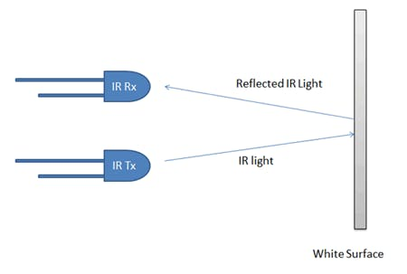](javascript:openLightBox('7a75fcf827',%200);)

[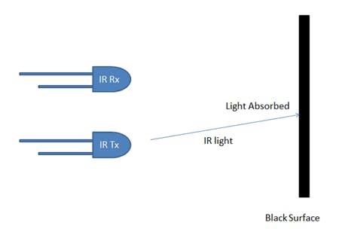](javascript:openLightBox('446cf4ff30',%200);)

Figure 11:IR sensor on a black and white surface

Designing the line follower robot three Infrared sensors were used, these are responsible for sensing the black line and then the microcontroller controls the motors based on the values obtained from the sensors.

/,

**FORWARD**

**Turn left**

**Turn right**

**Stop**

Figure 12:IR sensors on different directions

#### Ultrasonic sensor

The ultrasonic sensor as discussed earlier it  it can be used to measure the distance by the use of sound waves, specifically in this project, this sensor was used to sense if there is an object to carry, and it was also used as an obstacle avoider.

## Flow chart

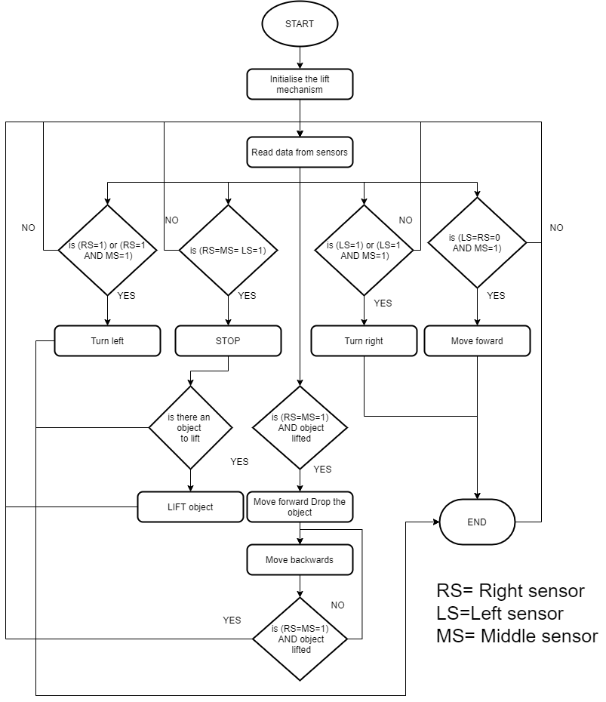

Figure 13: flow chart

## 4.4 Circuit diagram

Figure 14: Full circuit diagram

## 4.5 working principle

When the robot is switched on, it first starts by initializing the lift mechanism, then the microcontroller starts reading the values from the IR sensors, depending on the values obtained from the sensors the microcontroller then commands the robot to stop, move forward, move backwards, turn left or turn right.

When all the three IR sensors are sensing the black line, the robot stops it then checks if there is an object to carry, when there is an object the robot moves forward, moves down the lifting mechanism, picks up the object then follows the line accordingly.

* If the right sensor and the middle sensor are sensing the black line, the robot turns left.
* If the left sensor and the middle sensor are sending the black line, then the robot turns Right.
* If the right sensor and the left sensor are not sensing the black line but the middle sensor is sensing the black line the robot moves forward.
* If the right sensor and the middle sensor senses the black line while the robot has lifted the object, then the robot stops, moves forward, reaches the drop point marked by a black line, drops the object, moves backwards till it senses the black line, and again it starts following the line.

The speed of the robot can be changed by toggling the toggle switch, either to choose high speed or low speed.

## Implementation of the project

While implementing this project, we started by testing component on breadboard then after testing we soldered the whole circuit on PCB after all we mounted the car body with the motors and also mounted the circuit.

Figure 15:Folk lift mounted on the robotic car

Figure 16: final implemented project

# **CHAPTER FIVE. CONCLUSION, SUMMARY AND RECOMMENDATION**

## Conclusion

The project that we have undertaken has helped us gain a better perspective on various aspects related to our course of study as well as practical knowledge on electronic components, we became familiar with software analysis, designing, implementing, testing and maintaining while carrying out this project, we also improved on team working which of course became the pillar to successfully achieving this project. This project can be helpful in packaging in hazard areas since it can work without human intervening.

## Recommendation

1. This project is an implication of our concept in automating, the lifting of loads using a robot, we recommend that this project can be applied more especially in places that are dangerous to humans to work in.
2. This system can be improved by designing a mobile application where it can be controlled remotely
3. This system can also be improved by using QR code reader to read the places where it can exactly place the object.
4. This system can also be improved by adding IoT systems as means for advanced operation and control.

# **REFERENCES**

|  |  |
| --- | --- |
| [1] | J. F. Margaux Baum, "The History of Robots and Robotics," in Hands-On Robotics, New York, United, The Rosen Publishing Group, Inc, , 2017. |
| [2] | S. Block, "Digital control methods for a line following robot," Newyork,USA, diplom.de, 2003, 2003. |
| [3] | R. Kamal, "Microcontrollers: Architecture, Programming, Interfacing and System Design," in Microcontrollers: Architecture, Programming, Interfacing and System Design, Pearson Education India, 2009, 2009. |
| [4] | A. Kurniawan, "Arduino UNO WiFi Development Workshop," in Arduino UNO WiFi Development Workshop, PE Press, 2016. |
| [5] | A. R. John Vetelino, "Introduction to Sensors," CRC Press, 2017, 2017. |
| [6] | C. W. d. Silva, "Sensors and Actuators: Engineering System Instrumentation, Second Edition," in Sensors and Actuators: Engineering System Instrumentation, Second Edition, CRC Press, 2015, 2015. |
| [7] | J. Rupp, "Resistive Switching: Oxide Materials, Mechanisms, Devices and Operations," in Resistive Switching: Oxide Materials, Mechanisms, Devices and Operations, Springer Nature, 2014. |
| [8] | C. W. d. Silva, "Mechatronic Systems: Devices, Design, Control, Operation and Monitoring," in Mechatronic Systems: Devices, Design, Control, Operation and Monitoring, CRC Press, 2007, 2007. |
| [9] | H. E. Marrows, "Transistor Engineering Reference Handbook," in Transistor Engineering Reference Handbook, J.F. Rider, 1956, 2002. |

# **APPENDIES**

APPENDIX ONE

Project codes

int motor_right_a = 2;

int motor_right_b = 3;

int motor_left_a = 5;

int motor_left_b = 4;

int L_S = A3;

int S_S = A2;

int R_S = A1;

int speed_motor_a = 9;

int speed_motor_b = 10;

int trigPin = 11; // Trigger

int echoPin = 12; // Echo

int speed_definer = 6;

long duration, cm, inches;

int lift_motor_a = A5;

int lift_motor_b = A0;

int stop_down = 7;

int stop_up = 8;

int lifted = 0;

void setup()

{

Serial.begin(9600);

pinMode(motor_right_a, OUTPUT);

pinMode(motor_left_a, OUTPUT);

pinMode(motor_right_b, OUTPUT);

pinMode(motor_left_b, OUTPUT);

pinMode(lift_motor_a, OUTPUT);

pinMode(lift_motor_b, OUTPUT);

pinMode(stop_down, INPUT);

pinMode(stop_up, INPUT);

pinMode(speed_motor_a, OUTPUT);

pinMode(speed_motor_b, OUTPUT);

pinMode(speed_definer, INPUT);

pinMode(L_S, INPUT);

pinMode(S_S, INPUT);

pinMode(R_S, INPUT);

pinMode(trigPin, OUTPUT);

pinMode(echoPin, INPUT);

digitalWrite(lift_motor_a, 0);

digitalWrite(lift_motor_b, 0);

up_lift();

}

void loop()

{

if (digitalRead(speed_definer) == HIGH) {

analogWrite(speed_motor_a, 130);

analogWrite(speed_motor_b, 130);

}

else {

analogWrite(speed_motor_a, 100);

analogWrite(speed_motor_b, 100);

}

obstacle();

if (cm < 10) {

Stop();

}

if ((digitalRead(L_S) == 0) && (digitalRead(S_S) == 1) && (digitalRead(R_S) == 0)) {

forword();

}

if ((digitalRead(L_S) == 1) && (digitalRead(S_S) == 1) && (digitalRead(R_S) == 0) && lifted == 1) {

Stop();

delay(1000);

up_in_place();

}

if ((digitalRead(L_S) == 0) && (digitalRead(S_S) == 1) && (digitalRead(R_S) == 1) && lifted == 1 ) {

Stop();

delay(1000);

up_in_place();

}

if ((digitalRead(L_S) == 1) && (digitalRead(S_S) == 1) && (digitalRead(R_S) == 0)) {

turnLeft();

}

if ((digitalRead(L_S) == 1) && (digitalRead(S_S) == 0) && (digitalRead(R_S) == 0)) {

turnLeft();

}

if ((digitalRead(L_S) == 0) && (digitalRead(S_S) == 1) && (digitalRead(R_S) == 1)) {

turnRight();

}

if ((digitalRead(L_S) == 0) && (digitalRead(S_S) == 0) && (digitalRead(R_S) == 1)) {

turnRight();

}

if ((digitalRead(L_S) == 1) && (digitalRead(S_S) == 1) && (digitalRead(R_S) == 1)) { // when the car reaches the stop place

Stop();

delay(2000);

if (cm < 40) {

down_lift();

while (1) {

analogWrite(speed_motor_a, 70);

analogWrite(speed_motor_b, 70);

obstacle();

if (cm < 6) {

Stop();

delay(1000);

up_lift();

delay(1000);

lifted = 1;

forword();

delay(500);

break;

}

else {

forword();

}

}

}

}

}

void forword() {

digitalWrite(motor_left_a, HIGH);

digitalWrite(motor_left_b, LOW);

digitalWrite(motor_right_a, HIGH);

digitalWrite(motor_right_b, LOW);

}

void backward() {

digitalWrite(motor_left_a, LOW);

digitalWrite(motor_left_b, HIGH);

digitalWrite(motor_right_a, LOW);

digitalWrite(motor_right_b, HIGH);

}

void turnRight() {

digitalWrite(motor_left_a, HIGH);

digitalWrite(motor_left_b, LOW);

digitalWrite(motor_right_a, LOW);

digitalWrite(motor_right_b, LOW);

}

void turnLeft() {

digitalWrite(motor_left_a, LOW);

digitalWrite(motor_left_b, LOW);

digitalWrite(motor_right_a, HIGH);

digitalWrite(motor_right_b, LOW);

}

void Stop() {

digitalWrite(motor_left_a, LOW);

digitalWrite(motor_left_b, LOW);

digitalWrite(motor_right_a, LOW);

digitalWrite(motor_right_b, LOW);

}

void obstacle()

{

digitalWrite(trigPin, LOW);

delayMicroseconds(5);

digitalWrite(trigPin, HIGH);

delayMicroseconds(10);

digitalWrite(trigPin, LOW);

duration = pulseIn(echoPin, HIGH);

// Convert the time into a distance

cm = (duration / 2) / 29.1; // Divide by 29.1 or multiply by 0.0343

Serial.println(cm);

}

void down_lift() {

while (1) {

if (digitalRead(stop_down) == HIGH) {

digitalWrite(lift_motor_a, LOW);

digitalWrite(lift_motor_b, LOW);

break;

}

else {

digitalWrite(lift_motor_a, 255);

digitalWrite(lift_motor_b, 0);

}

}

}

void up_lift() {

while (1) {

if (digitalRead(stop_up) == HIGH) {

digitalWrite(lift_motor_a, 0);

digitalWrite(lift_motor_b, 0);

break;

}

else {

digitalWrite(lift_motor_a, 0);

digitalWrite(lift_motor_b, 255);

}

}

}

void up_in_place() {

while (1) {

analogWrite(speed_motor_a, 80);

analogWrite(speed_motor_b, 80);

if ((digitalRead(L_S) == 1) && (digitalRead(S_S) == 1) && (digitalRead(R_S) == 1)) {

Stop();

delay(2000);

down_lift();

delay(2000);

back_line();

break;

}

else {

forword();

}

}

}

void back_line() {

int x = 0;

while (1) {

analogWrite(speed_motor_a, 90);

analogWrite(speed_motor_b, 90);

if (x == 0) {

backward();

delay(1000);

x++;

}

if ((digitalRead(L_S) == 1) || (digitalRead(S_S) == 1) || (digitalRead(R_S) == 1)) {

Stop();

delay(2000);

up_lift();

lifted = 0;

delay(2000);

break;

}

else {

backward();

}

}

}

APPENDIX TWO

PROJECT BUDGET