Modifications

Question 1 & 2) Word frequency and NGRAM based frequency calculation

Answer) in below screen showing code which is calculating word frequency using NGRAM function from TFIDF vector

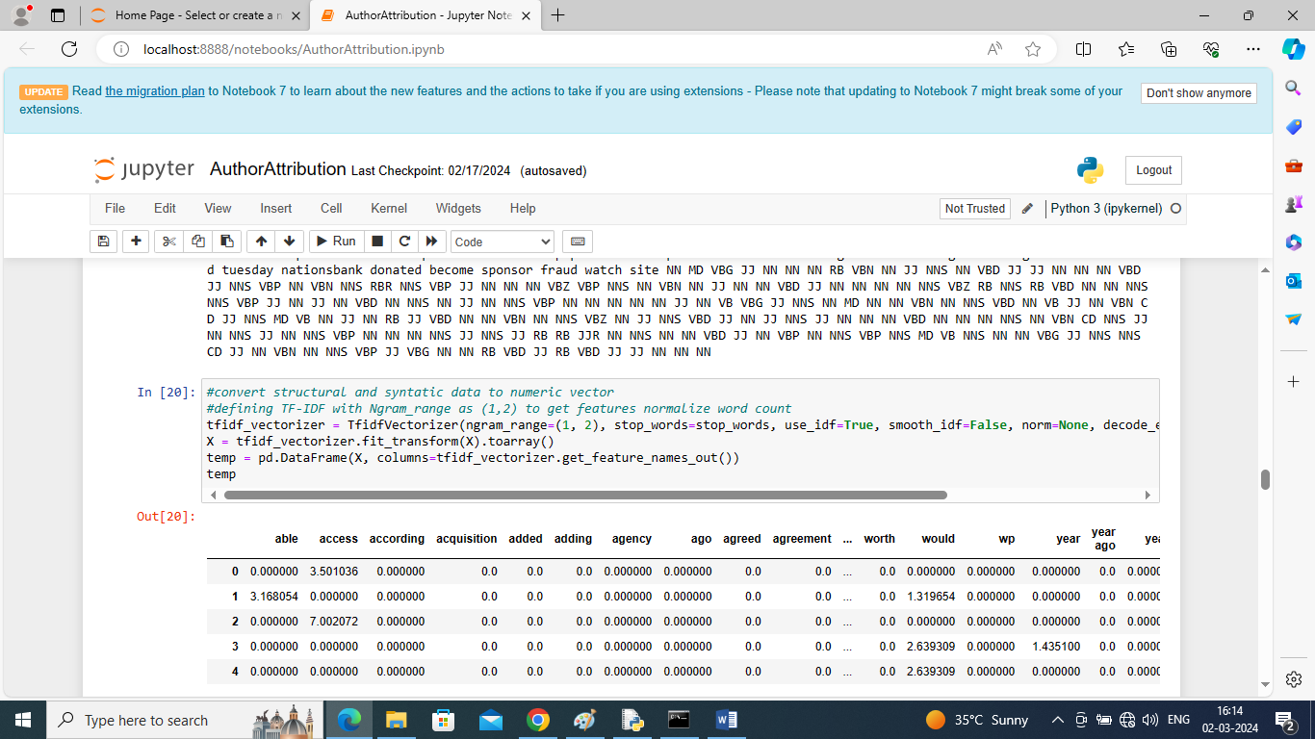

In above screen read blue color comments where you can see we are counting frequency using NGRAM and then displaying words and its frequency in tabular format

Question 3) POS Tagging to analyze text

Answer) in below screen showing code to extract POS information from given text

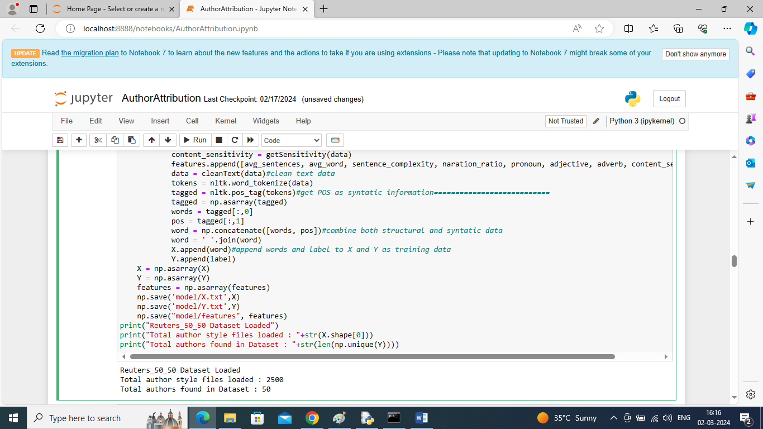

In above screen at blue color ======================= dashed lines you can see where POS tagging extracting from given text data

4) Average length of words and sentences

Answer) in below screen see function calculating average words and sentences

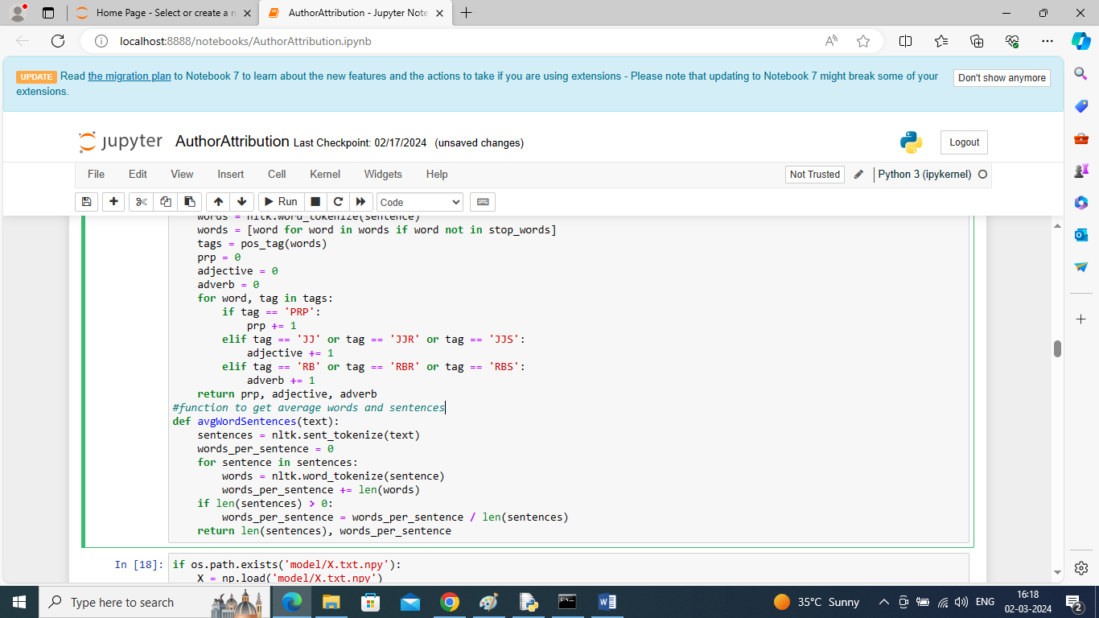

In above screen see function which is finding out average words and sentences

Question 5) TF-IDF scores

Answer) in question 1 and 2 answer already showing TFIDF scores in table format

Question 7 to 13) showing in below screen code

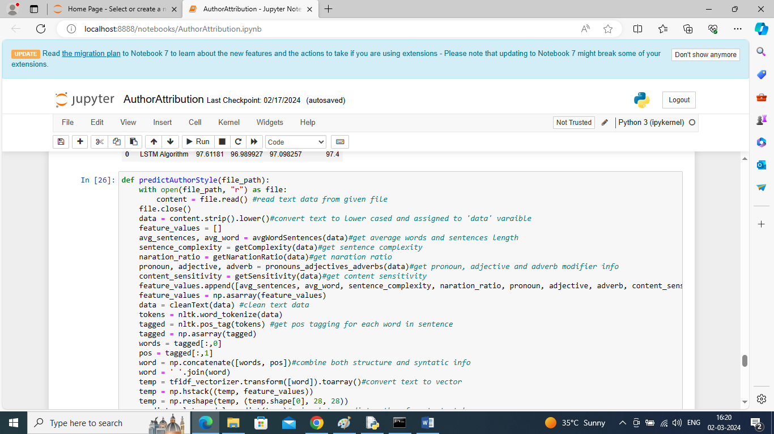

In above screen read blue color comments then you can see calculation of ‘Dialogue Narration Ratio, pronoun, adverb, adjective, content sensitivity’ are extracting from given text data.

After executing above points we are getting below LSTM output

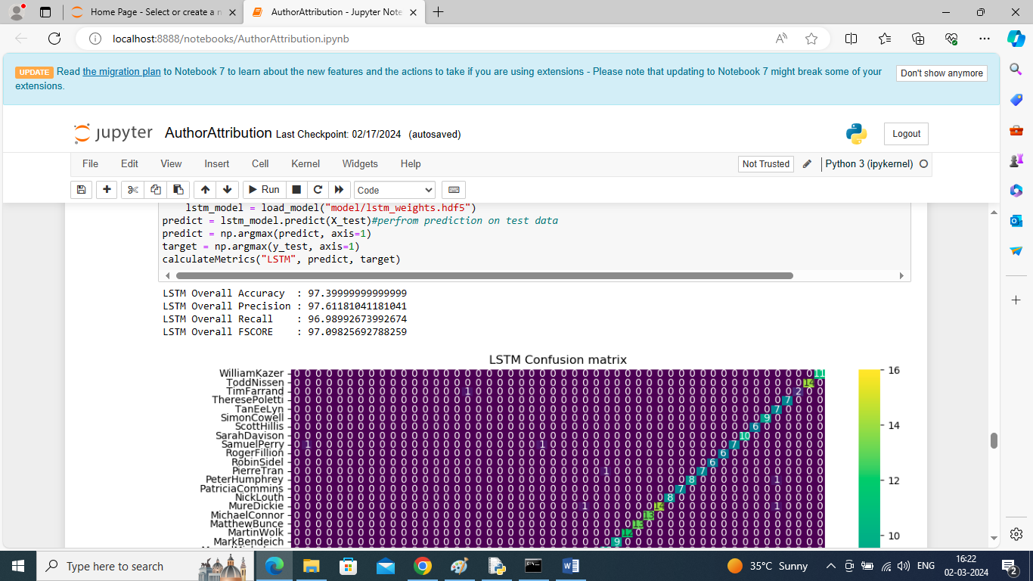

In above screen with all features extraction and training LSTM got 97% accuracy