Motivated Computer Science student seeking an internship opportunity to gain practical experience in software development and improve technical, analytical, and problem-solving skills while contributing to organizational growth.

▼ Experience

Currently Working as a Web Developer in CodeAlpha Company.
Worked on university assignments related to problem solving and software development.

▼ Education



Lahore Garrison University, Lahore

Computer Science (BSCS)
—

5
th Semester CGPA
: 3.00

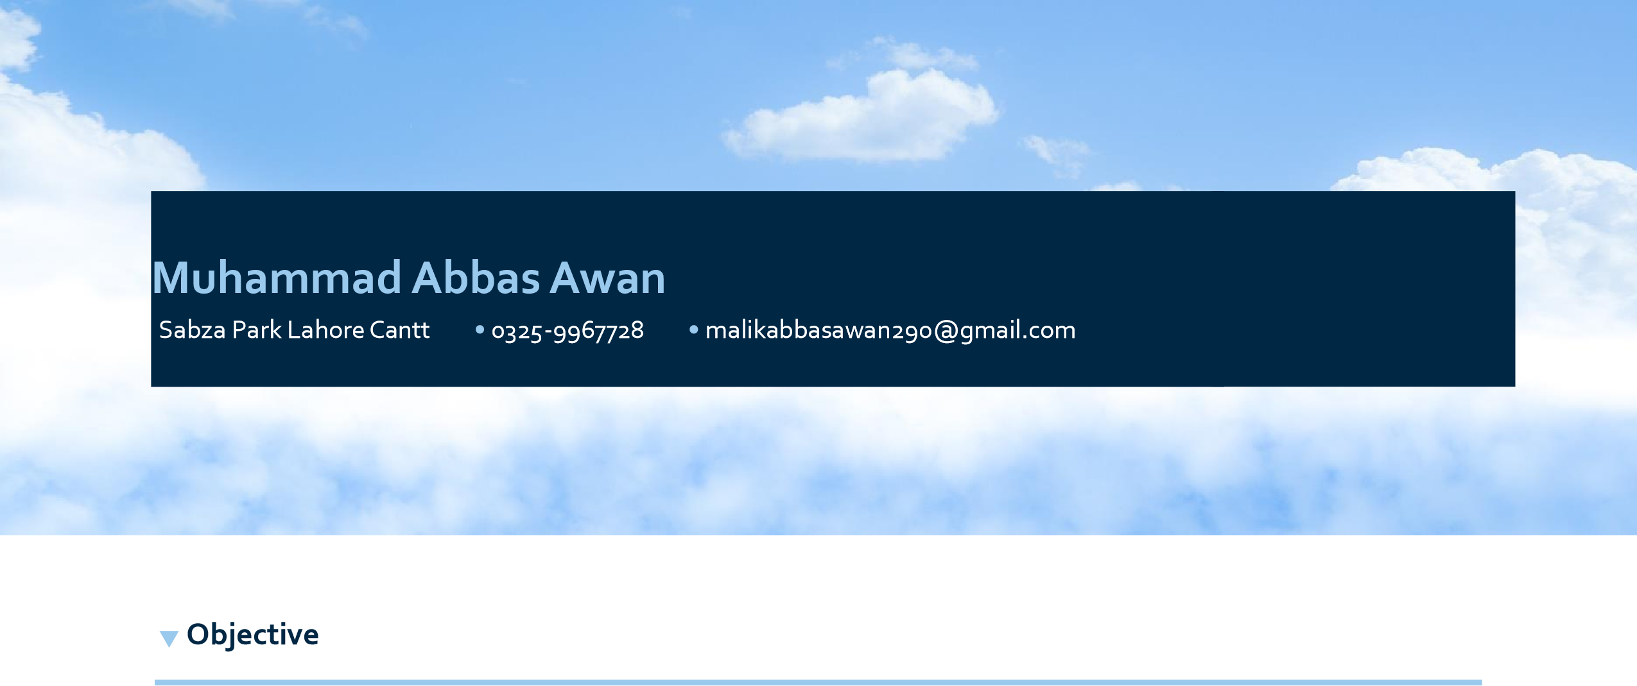
▼ Soft Skills

- Good communication and teamwork skills
- Good presentation and interpersonal skills

▼ Technical Skills

- Database Concepts
- HTML, CSS, Javascript concepts.

▼ References

Available upon request.

