Abbas Rizvi
100746798
SOFE 4790U
Assignment 1: CL-Reddit
https://github.com/Abbas-Rizvi/CL-Reddit

Description
CL-Reddit or more Command Line Reddit, is a sophisticated socket client application written in Java. The application is designed to be a simplified version of the popular social media site reddit.com and provide a more accessible freedom and privacy respecting implementation. The application provides a command line interface for a message board with the ability for users to view and provide feedback on posts created by other clients.
Novel Features
- Creating & Viewing Posts
Similar to the web version of Reddit, CL-Reddit allows users to login to the server and both create and view posts. Users are able to create a post containing a subject and body and post to the server. This request is then forwarded to the database along with the authenticated user credentials and proccessed to be appended to an SQLite table. Users are then able to request a list of posts and display the author, subject, body and score of all posts that have been made.
This ability is limited to only registered users and user authentication is enforced.
- Up-Voting
Building upon the ability to create and view posts, users are also able to up-vote favourable ideas on the server. This is invoked via a menu function being called with the ID of the post to upvote and the server will process the request to the database to have the score incremented.
Features
- Login Authentication & Encryption
The CL-Reddit application provides clients with an interface for registering and logging in to the server. Clients are first provided the option via main menu and upon selection will request username and login to have processed by the server and stored on the user SQLite table.
Authentication is handled with proper security permissions to ensure data is not leaked. All data stored is encrypted using Bcrypt, an OpenBSD based hashing library only storing the hashed version of user passwords.
- SQLite Database
The CL-Reddit application utilizes a SQLite database to provide back-end data handling of both users and posts. This was determined to be a suitable solution due to the lightweight nature of the database and the ability to leverage modularity between the various layers in the application.
The SQLite-JDBC driver is utilized to provide the connection.

Design
The CL-Reddit application functions using primarily 4 java classes, each with it’s own distinct purpose. These classes are as follows:
- FileServer.java
The FileServer.java file is a simple implementation of a multi-threaded server. The file is responsible for opening starting a server socket on a designated port and receiving client connections. These client connections are then run using ServerThreads.
- ServerThread.java
The ServerThread.java file is the main interface the user is making with the server. The thread is responsible for handling input from the client and calling appropriate functions from the connected database.
- FileClient.java
The FileClient.java file serves as the client application. Users are able to run the file and have a connection be formed to the server. Menus and prompts are provided through the server with input being forwarded between the two via BufferedReader and PrintWriter streams. When a function is called a request will be sent to the server to execute the corressponding function enabling processing to the database layer.
- DatabaseConnect.java
DatabaseConnect.java serves as the database connection for the application. The object provides the core methods which interact with the database via SQL commands. Server Threads are able to call the public methods in the desired format and are able to write to and from the database for all login, registration, list and update functions.

Challenges & Testing
Several challenges were encountered with the development of this application. The first major obstacle was in implementing the database connections using the required library files. The file structure had to be modified several times to ensure that SQL connection drivers were being read by the program correctly and are able to be used in creation and updating of databases. In this phase of development, heavy emphasis was placed on testing the core back-end functionalities of the database layer to ensure there were no issues with back-end logic. Additionally, originally GPG key pair verification was planned on being included in to the program and database however issues were encountered in providing a simple method for relaying public keys over PrintWriter stream. This was done using a test file designed to test the return values and updating of files within the databse. See Appendix A for screenshots of test runs.
Other challenges encountered were largely with the connection between the FileClient and ServerThread in regards to printing data back and forth between the two. Originally the plan was focused on developing an entirely server-sided application with the client only being used to pass parameters when requested. After attempting to develop in this manner, issues were encountered in managing program flow with menu options and it was decided to resort to a more active client with corresponding functions to those on the server. This change in strategy also provided the benefit of reducing demand on server slightly.
Appendix A.
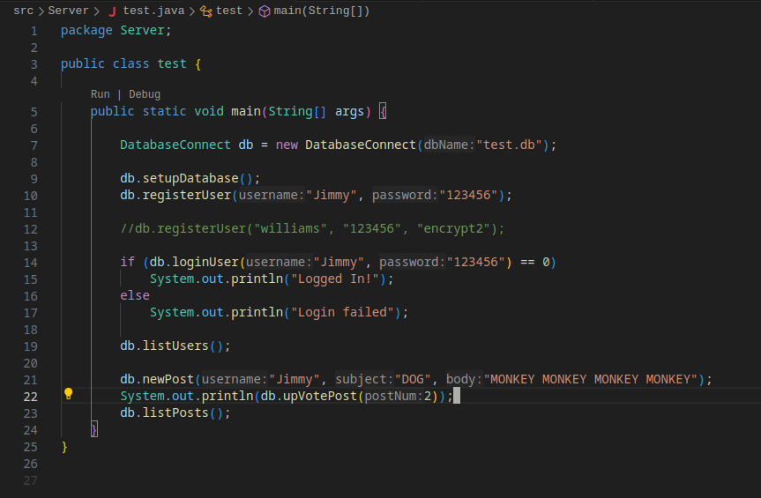

1.0 Test Java File
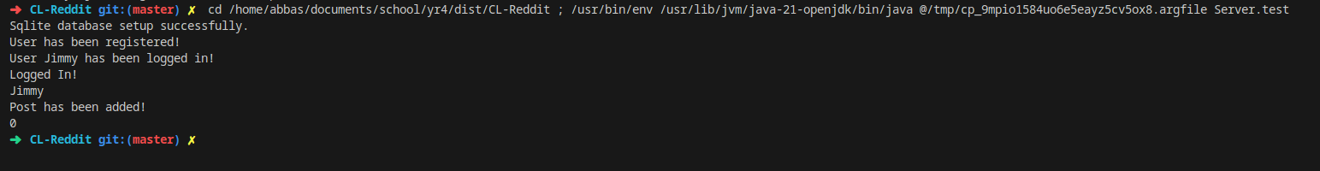
2.0 Command Line Test Response
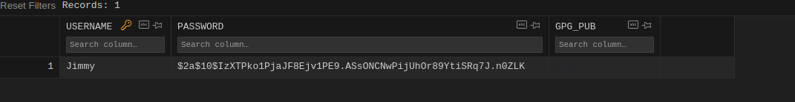
3.0. User Database table after test
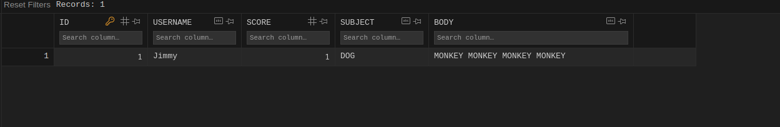
4.0. Post Database table after test

