TimberFrame2D — Software Architecture & Design
This document describes the software architecture of the TimberFrame2D package: how the projects are organised and connected, the data flow through the application, the object-oriented design patterns used, and the major design decisions behind them.

1. Solution structure
The solution is split into seven projects along clear responsibility boundaries. Dependencies flow in one direction only — from presentation down to the domain — so the computational engine has no knowledge of the user interface.
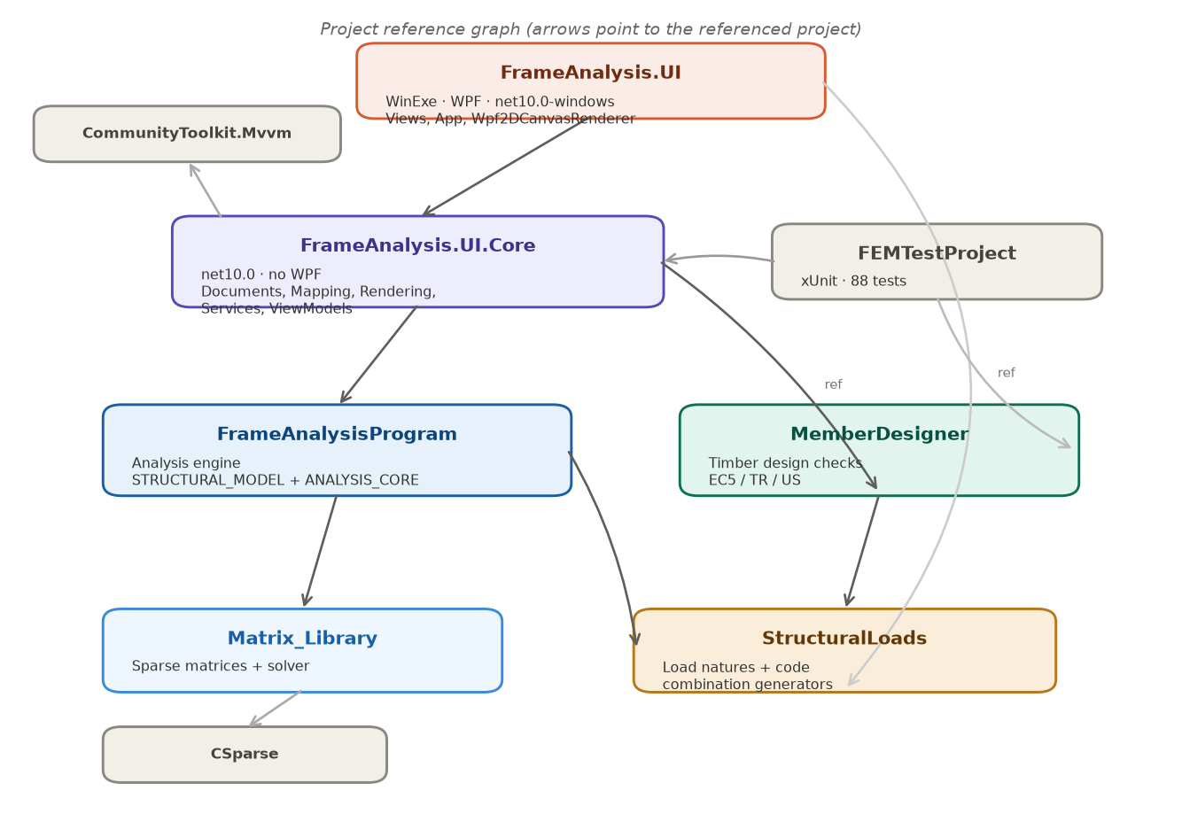
Figure 1 — Project reference graph (arrows point to the referenced project).
Project | Target | Responsibility
Matrix_Library | net10.0 | Sparse matrices and the linear solver (wraps CSparse).
StructuralLoads | net10.0 | Load natures, limit states, and code load-combination generators (ASCE 7 / EN 1990 / TBDY).
FrameAnalysisProgram | net10.0 | The analysis engine: structural model, assembly, solve, and result recovery.
MemberDesigner | net10.0 | Timber member-design checks for EC5, the Turkish code, and US/NDS.
FrameAnalysis.UI.Core | net10.0 (no WPF) | Document model, mappers, scene/rendering abstraction, services, view-models.
FrameAnalysis.UI | net10.0-windows (WPF) | Views, App, and the concrete WPF renderer. The only project that references WPF.
FEMTestProject | net10.0 | xUnit tests (88) covering assembly, elements, recovery, mapping, and design.

FrameAnalysis.UI also references FrameAnalysisProgram and StructuralLoads directly so XAML can bind to domain enums (e.g. MomentRelease, LoadDirection, load nature).

2. Architecture and data flow
The application follows the Model-View-ViewModel (MVVM) pattern. The editable document is the single source of truth; the picture is rebuilt live on every edit, while the analysis and the design checks run on demand, on a background thread.
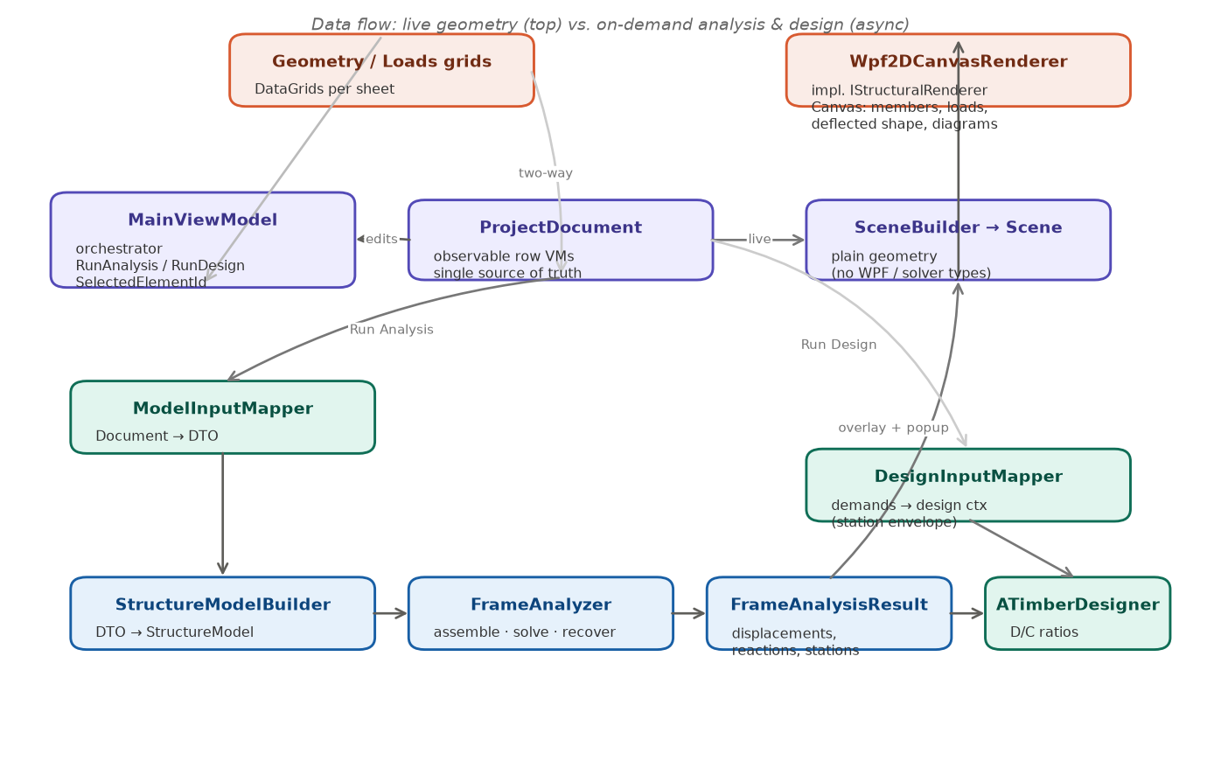
Figure 2 — Data flow: live geometry (top) vs. on-demand analysis and design (async).
Three execution paths share the same document:
- Live geometry — every edit to ProjectDocument raises a change event; MainViewModel rebuilds a Scene through SceneBuilder, and the renderer redraws. No solving occurs.
- On Run Analysis — ModelInputMapper snapshots the document to a plain DTO on the UI thread, then StructureModelBuilder + FrameAnalyzer run on a background thread and return a FrameAnalysisResult. The result feeds the deflected-shape overlay and the diagrams popup.
- On Run Design — DesignInputMapper turns the analysis demands (the per-member station envelope) plus the design settings into a design context that ATimberDesigner checks.
Two boundaries keep the layers decoupled: the mappers (Document ↔ solver DTO) and the Scene (the renderer only ever sees plain geometry — never solver types or WPF types). Swapping the 2D canvas for a 3D renderer means writing a new IStructuralRenderer and a 3D SceneBuilder; nothing upstream changes.

3. Design patterns used
Pattern | Where | Purpose
MVVM | MainViewModel, row VMs (CommunityToolkit.Mvvm) | Separate state/commands from the WPF views; enables testing the UI logic without WPF.
Observer | ProjectDocument : IDocumentChangeNotifier; ObservableObject | One aggregated Changed event drives the live re-render from a single place.
Adapter / Mapper | ModelInputMapper, DesignInputMapper | Translate the UI object model to the solver/design DTOs at a single boundary.
Bridge / isolation | IStructuralRenderer + Scene | Decouple presentation geometry from the drawing technology (2D→3D swap).
Dependency injection / composition | FrameAnalyzer composes its services | Each step (assembly, solve, recovery, validation) is an injected collaborator — testable and replaceable.
Strategy | ILinearSolver; per-code design provider; load-combination generators | Swap the algorithm (solver, design code, combination set) without touching callers.
Template Method / polymorphism | StructuralElement2D ← FrameElement2D, TrussElement2D | Shared element interface; each type supplies its own stiffness/transform.
Interface segregation | ILoad / INodalLoad / IMemberLoad; ITimberDesignCheck | Loads and design checks are small, focused contracts with many implementations.
Factory | TimberDesignCheckInputFactory; AnalysisService.CreateDefault | Build the right per-code check inputs / a fully-wired analyzer.
Service layer (async) | IAnalysisService, IDesignService | Wrap the heavy engine calls behind async, non-crashing services.
Attached behavior | DoubleClickCommand | Bind a double-click to a command inside a DataTemplate (where InputBindings can't).

4. The analysis engine
FrameAnalyzer is an orchestrator built by composition: it holds the DOF numbering, stiffness assembly, load-vector and settlement builders, the linear solver, and the recovery services, plus the model validator. Calling Analyze runs validation, assembles and solves the system, then recovers displacements, reactions, element end-forces, and the per-member station results (section forces + deflected shape).
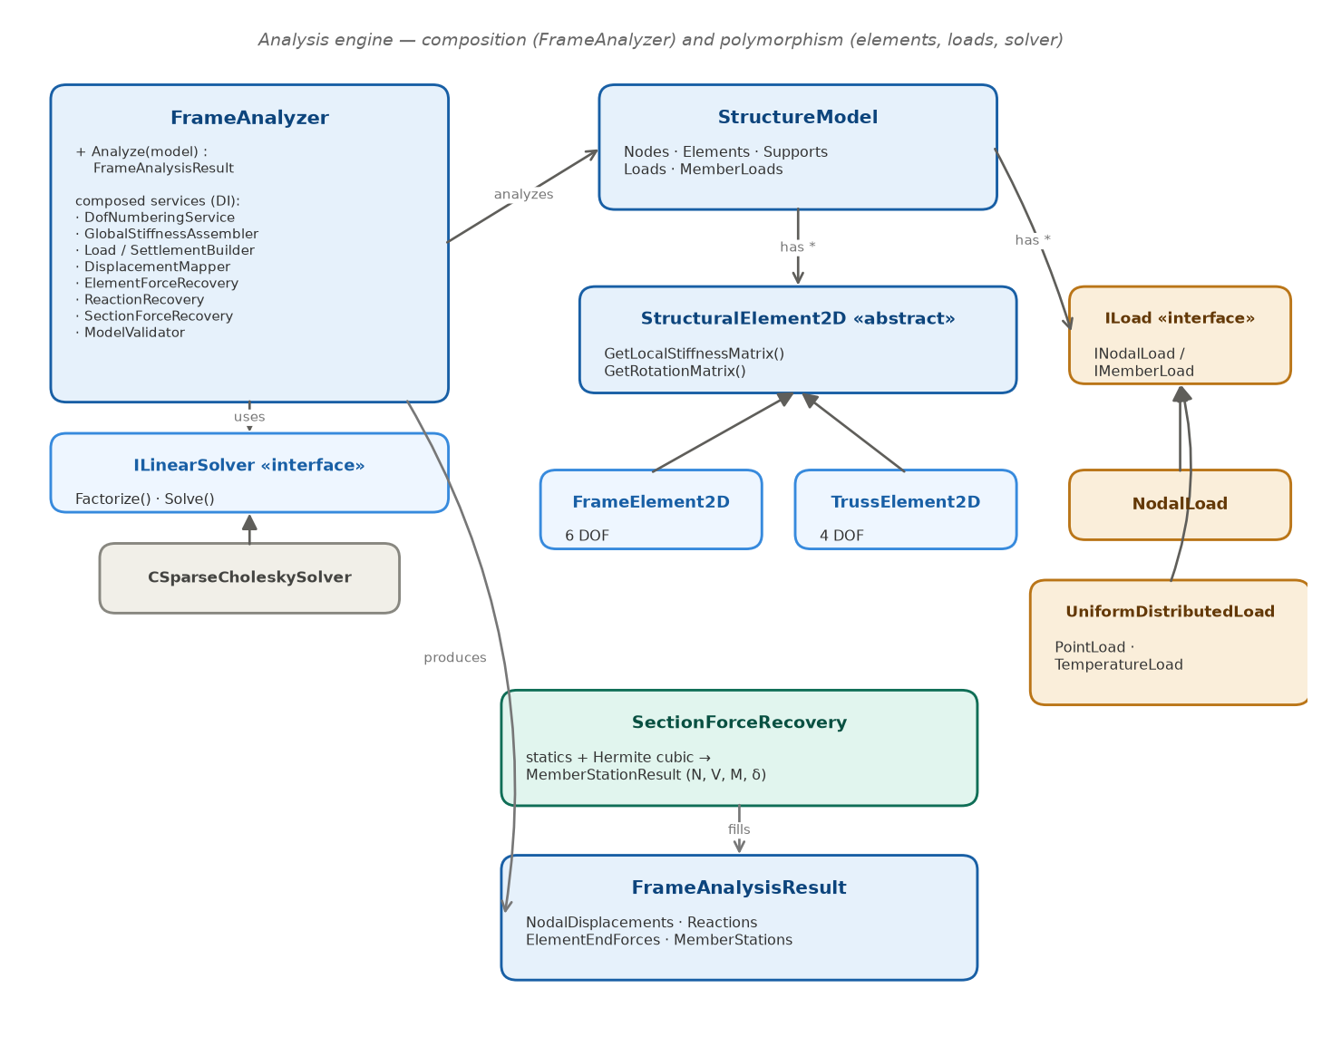
Figure 3 — Analysis engine: composition (FrameAnalyzer) and polymorphism (elements, loads, solver).
- StructureModel aggregates nodes, elements, supports, and loads — a plain object graph.
- StructuralElement2D is the abstract element; FrameElement2D (6 DOF, bending + axial) and TrussElement2D (4 DOF, axial) provide their own stiffness and rotation matrices.
- Loads implement ILoad / INodalLoad / IMemberLoad, so the assembler and recovery treat nodal loads, UDLs, point loads, and temperature loads uniformly.
- ILinearSolver hides the numerical backend (CSparseCholeskySolver), so the solver can be replaced without touching the analyzer.
- SectionForceRecovery samples N, V, M and the Hermite deflected shape at station points and fills FrameAnalysisResult.MemberStations — the single source of truth for the diagrams, the deflected overlay, and the design envelope.

5. The design module
The design module checks each member against a timber code. ATimberDesigner orchestrates the checks: it asks a provider for the per-code set of checks, asks a factory to build their inputs, orders them by their declared dependencies, and runs them (independent checks in parallel). The code (EC5 / TR / US) selects which concrete checks and inputs are used — a Strategy chosen by eTimberCode rather than by subclassing the designer.
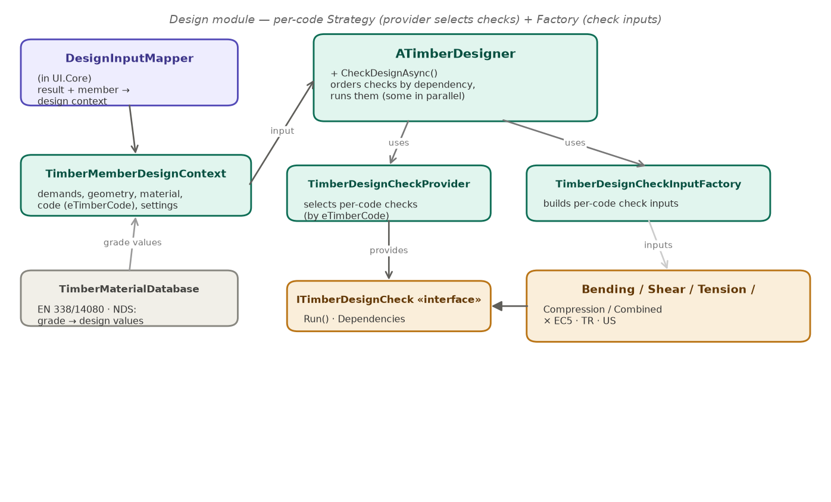
Figure 4 — Design module: per-code Strategy (provider selects checks) + Factory (check inputs).
- DesignInputMapper (in UI.Core) bridges the analysis result + the member parameters into a TimberMemberDesignContext, using the per-member station envelope for the demands.
- TimberMaterialDatabase supplies the published strength values (EN 338 / EN 14080, NDS species + grade) so picking a grade auto-fills the design values.
- Each check (bending, shear, tension, compression, combined) implements ITimberDesignCheck and exists in EC5, TR, and US variants.

6. Major design decisions
Decision | Choice | Rationale
Project split | FrameAnalysis.UI.Core (no WPF) vs FrameAnalysis.UI (WPF) | Makes “no WPF in the model/logic” a compile-time guarantee and lets the tests run the UI logic without WPF.
Source of truth | ProjectDocument (observable VMs); DTO only at the solver boundary | Grids bind to live row VMs; cross-row links are object references, so insert/delete/reorder stay safe.
Renderer input | A plain Scene; no solver or WPF types in the interface | Decouples the drawing technology; a 3D renderer is a new IStructuralRenderer + SceneBuilder.
Live vs on-demand | Geometry re-renders on every edit; analysis/design run on explicit buttons, async | Keeps the UI responsive; heavy work never blocks the UI thread.
Threading | Map document → DTO on the UI thread, then Task.Run the build + solve | The non-thread-safe document is never touched from the background task.
Error handling | Never crash: catch StructuralAnalysisException, surface ValidationMessages | An unstable/under-restrained model is explained, not thrown.
Design-code location | In the design layer (project-level), not global setup | Analysis stays code-agnostic; grade values are code-family specific, so one code per project keeps them coherent.
Identifiers | Implicit, sequential, assigned at export by the mapper | Raw table indices are never exposed; a stale id can’t corrupt the export.
3D readiness | Keep the hidden Z column; the renderer interface enables a UI swap | The solver stays 2D, but the architecture does not block a future 3D view.
Post-processing | Station recovery lives in the engine, on the result | One set of section forces feeds the diagrams, the deflected overlay, and the design envelope.
Deflected shape | Hermite cubic interpolation from the nodal end DOFs | Matches beam theory and needs only the displacements + rotations the solver already returns.
MVVM library | CommunityToolkit.Mvvm | Source-generated ObservableObject / RelayCommand with no WPF dependency.

7. Testing
Correctness is locked by an xUnit suite (88 tests) that verifies stiffness assembly, element behaviour, boundary conditions, and result recovery against closed-form solutions (e.g. cantilever and simply-supported beams), plus the mappers, services, and design checks. A separate verification document compares the program against these reference solutions in detail.

