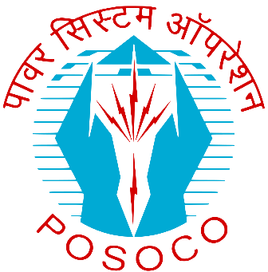

**Power System Development Fund Portal**

This project is in vision to automate the ongoing working of the PSDF department, and facilitate various manually run operations such as DPR submission, TESG Outcome-response, Appraisal Reporting, Monitoring Committee outcomes, payment references etc.

The project has been developed internally at POSOCO-NLDC, and is made public to various entities for the smooth working of PSDF

*Under the keen guidance of*

**Sh. Debasis De**

Executive Director- NDLC

**Sh. S. C. Dambhare**

GM – PSDF

**Sh. Harish Kr. Rathour**

Sr. DGM – IT

**Sh. Abhishek Kr. Gupta**

Sr. DGM – IT

**Sh. T Bheemesh**

Manager – PSDF

*Developer:*

**Sh. Sayed Abbas Haider Abidi**

Assistant manager – IT

*Technical specifications of portal:*

*Framework:* Django

*Database:* MySQL

The following documentation is to provide an insight of how the portal is to be operated, and what is the workflow of the portal regarding a project.

It is to be noted that POSOCO reserves the right to change, modify, add or delete any functionality (hereafter to be referred as module), however and whenever it deems to be.

It is to be noted that there are only three generic users to be in play, namely, Administrator (PSDF sect.), Entity, Auditor.

Modules:

Entity Side:

1. User Registration
2. User