

**Bansilal Ramnath Agarwal Charitable Trust’s**

**Vishwakarma Institute of Technology**

#### (An Autonomous Institute affiliated to Savitribai Phule Pune University)

**COMPUTER NETWORKS LAB ASSIGNMENTS**

|  |  |
| --- | --- |
| **NAME** | **ABBAS MADHVASWALA** |
| **PRN** | **12110285** |
| **DIVISION** | **CS-C** |
| **ROLL.NO** | **13** |
| **BATCH** | **B3** |

**LAB ASSIGNMENT NO : 02**

**PROBLEM STATEMENT**

**Setting up small computer networks and Hands on networking commands:  
Set up a small wired and wireless network of 2 to 4 computers using Hub/Switch/Access point. It includes installation of LAN Cards, Preparation of Cables/ Installation and Configuration of Access Point, Assigning unique IP addresses and use of ping utility. Hands on for network commands - ping, pathping, ipconfig/ifconfig, arp, netstat, nbtstat, nslookup, route, traceroute/tracert, nmap.**

**OUTPUT**

# **PING COMMAND:**

The ping command along with a specific URL or IP address. Your computer sends several packets of information out to that device, and then waits for a response. When it gets the response, the ping tool shows you how long each packet took to make the round trip or tells you there was no reply.

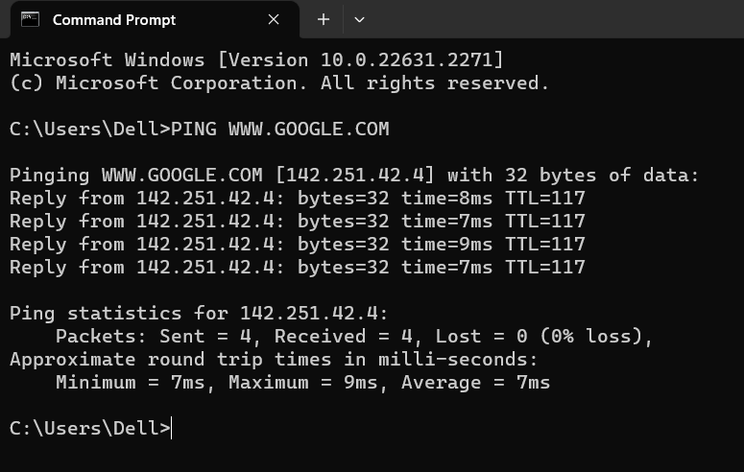

# **PATHPING COMMAND:**

Network troubleshooting tools that are built-in to Windows. It helps you to find the location of a packet loss in a route between you and a host (server, router, website etc).

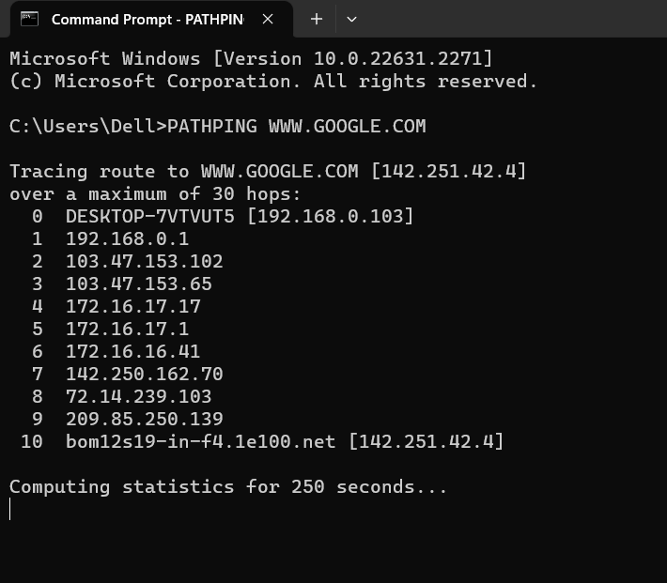

# **IPCONFIG COMMAND:**

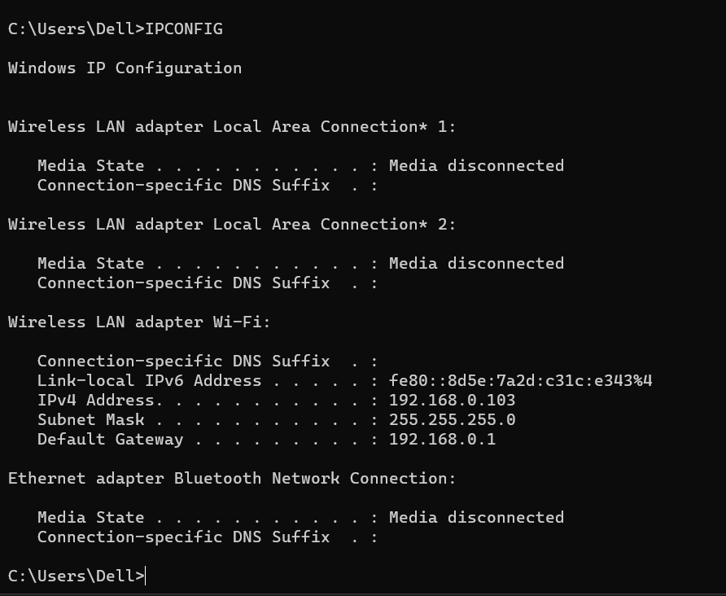Display the current network information for interfaces on the machine

# **ARP COMMAND:**

Arp To view, display, or modify the details/information in an ARP table/cache.

ARP table : Contains dynamic list of IP and MAC addresses of those devices to which your computer has communicated recently in a local network. The purpose of maintaining an ARP table is that when you want to communicate with another device, your device does not need to send the ARP request for the MAC address of that device.

USES:

* **arp -a**: display the ARP table for a particular IP address. It also shows all the entries of the ARP cache or table.
* **arp -d**: This command is used when you want to delete an entry from the ARP table for a particular interface. To delete an entry, write **arp - d** command along with the IP address in a command prompt you want to delete.

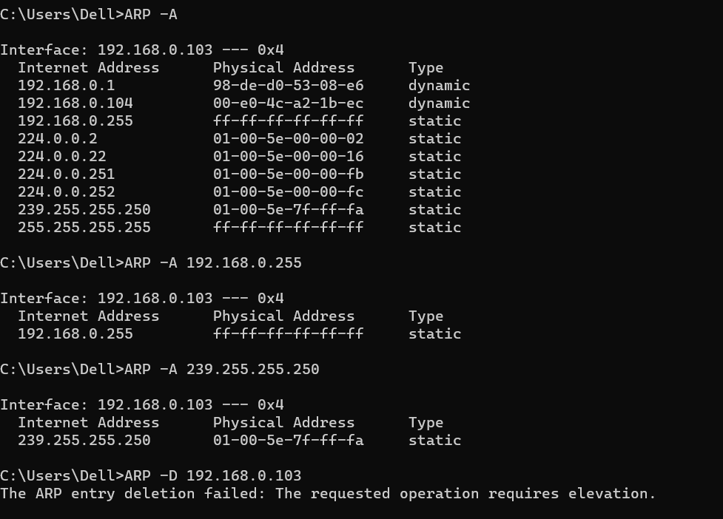

# **NETSTAT COMMAND:**

Netstat command displays various network related information such as network connections, routing tables, interface statistics.

1. **NETSTAT -A** :Show both listening and non-listening sockets.

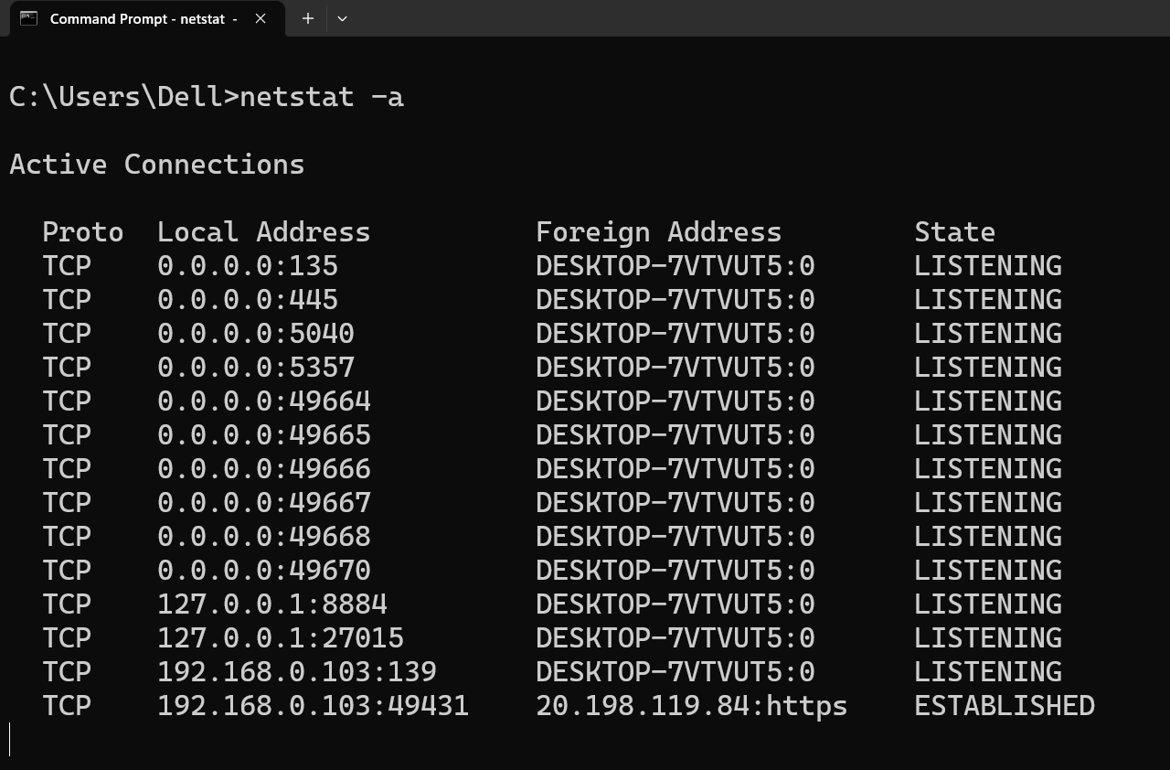

1. **NETSTAT -AT :** Show list of TCP ports.

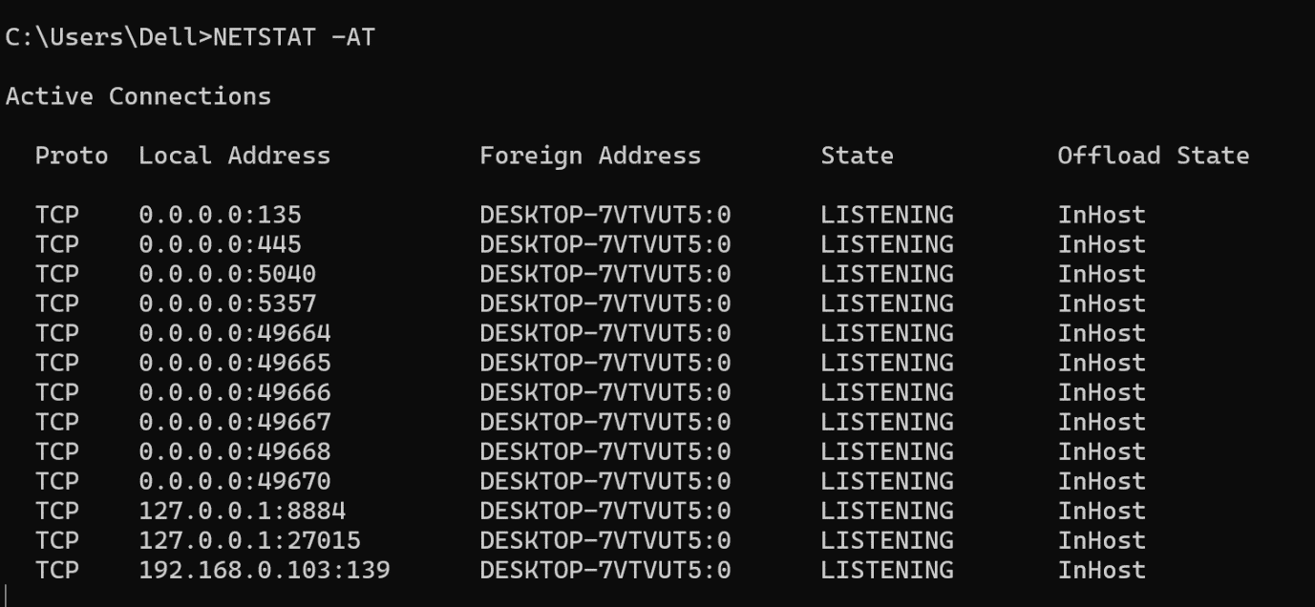

1. 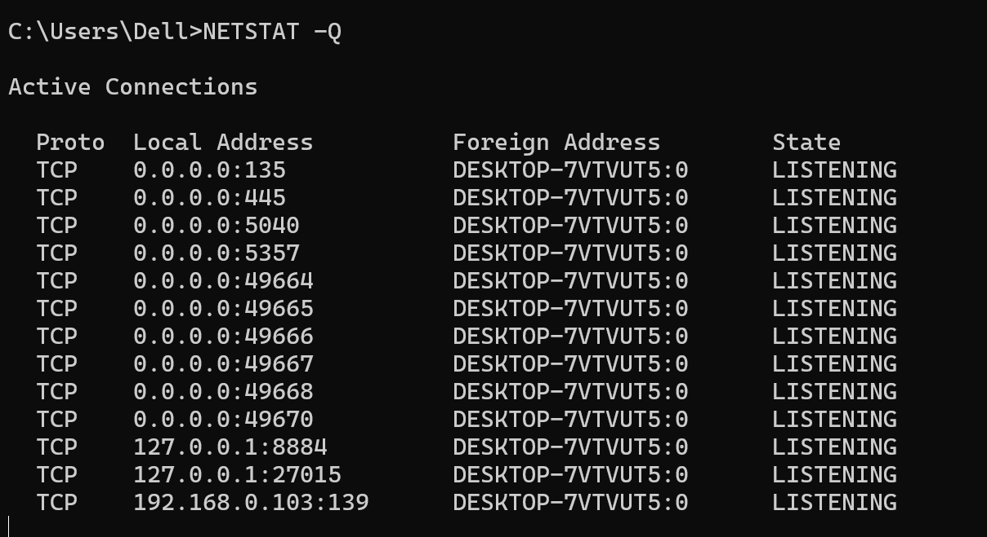**NETSTAT -Q** : Displays all connections, listening ports, and bound.
2. **NETSTAT -E** : Displays Ethernet statistics. This may be combined with the -s option.

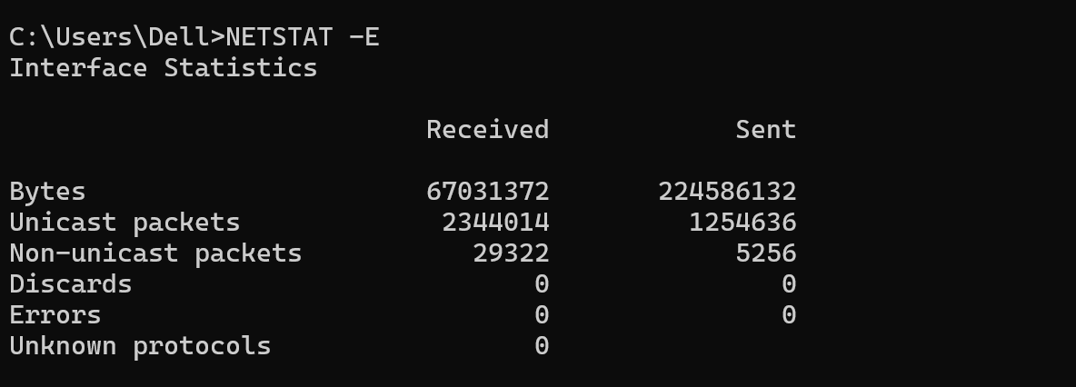

1. 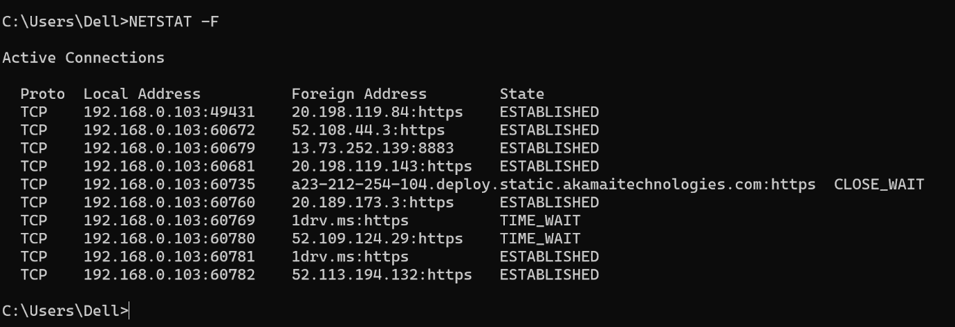**NETSTAT -F** : Displays Fully Qualified Domain Names (FQDN) for foreign addresses.
2. **NETSTAT -O** : Displays the owning process ID associated with each connection.

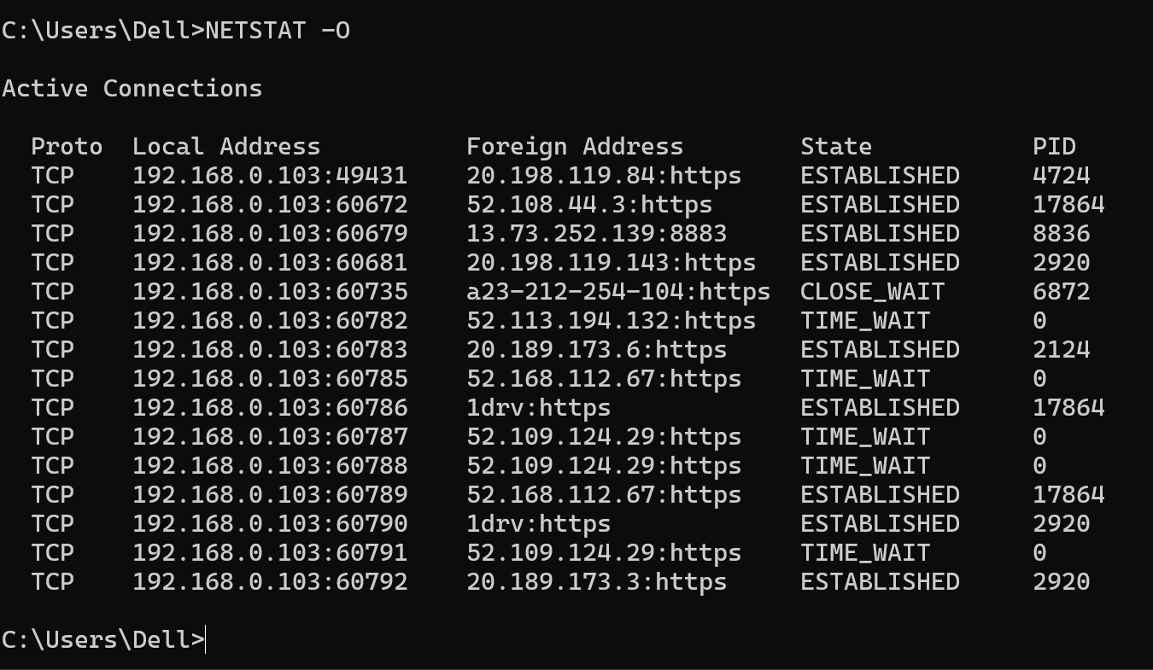

1. **NETSTAT -N** : Displays addresses and port numbers in numerical form.

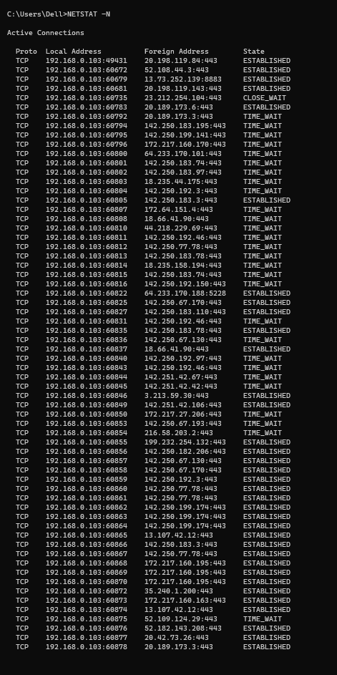

# **NSLOOKUP COMMAND:**

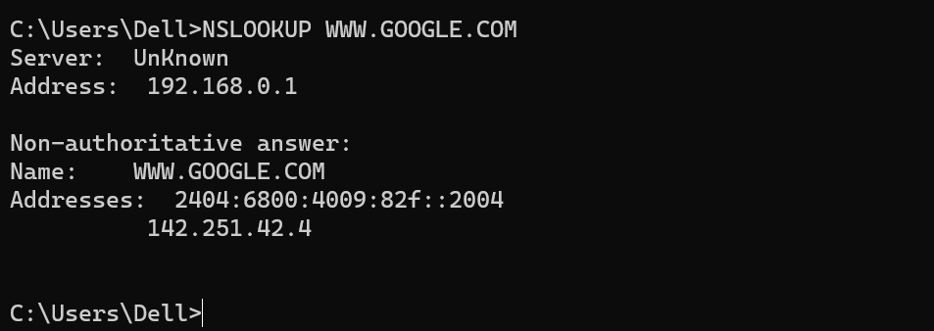Nslookup is the name of a program that lets users enter a host name and find out the corresponding IP address or domain name system ( DNS) record.

# **ROUTEPRINT COMMAND:**

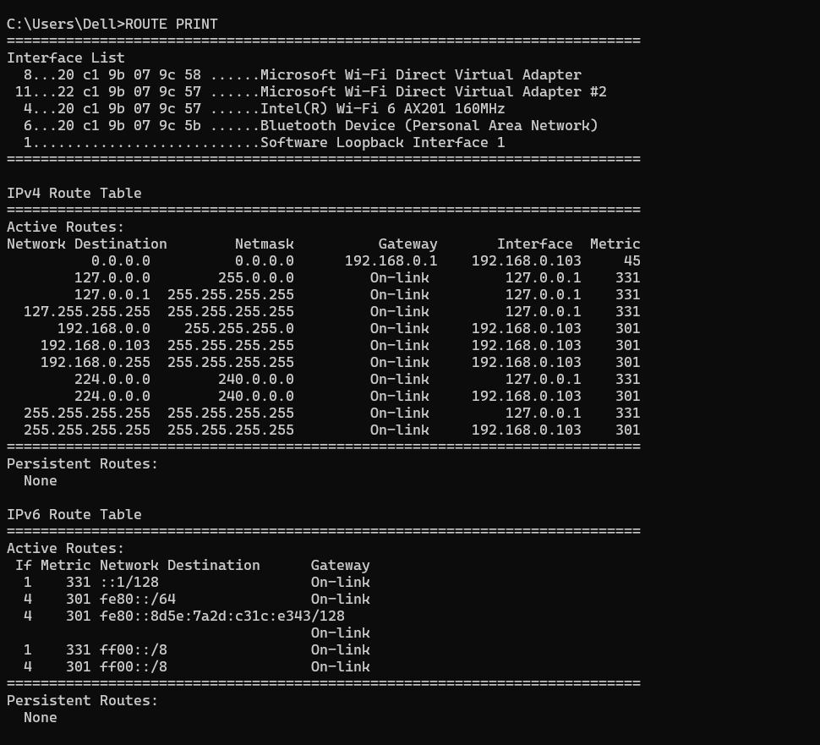To display the IP routing table. To get details of the kernel/IP routing table using ip command.

# **TRACERT COMMAND:**

command that's used to show several details about the path that a packet takes from the computer or device you're on to whatever destination you specify. We have to provide a IP or domain name of any machine.

