**e)**

1)Detailed ERD

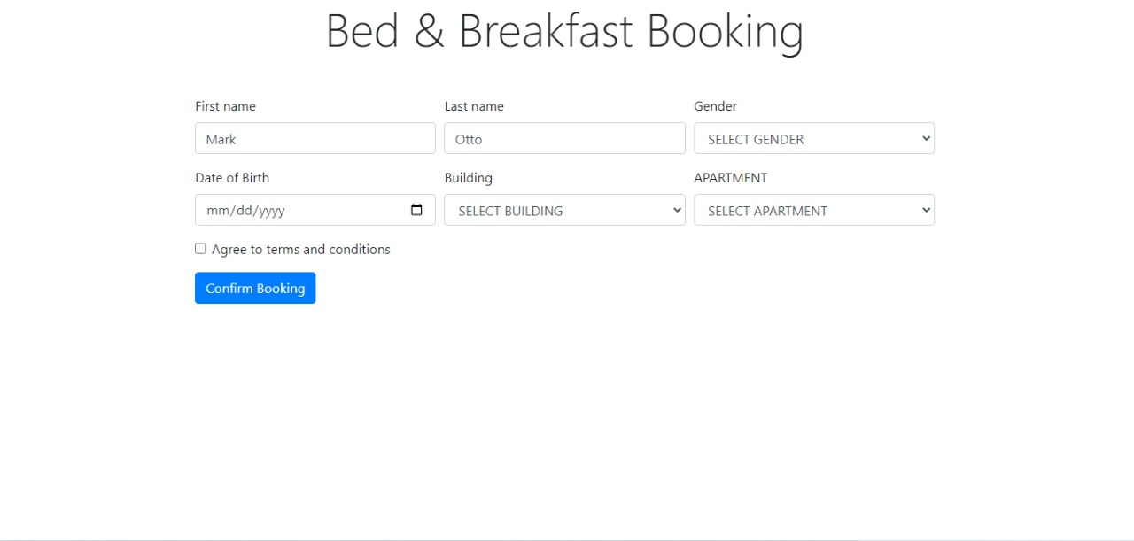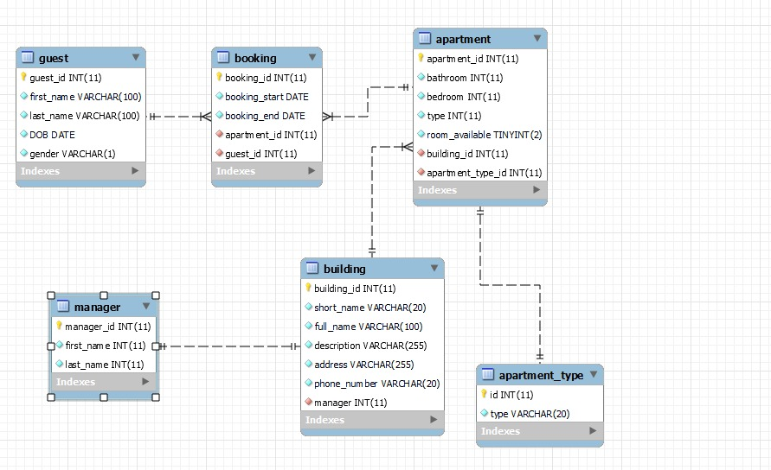2) GUI FOR DATABASE:

**F)**

DETAILED CODE FOR IMPLEMENTATION:

1. Create Table

CREATE TABLE apartment (

  apartment_id int(11) NOT NULL,

  bathroom int(11) NOT NULL,

  bedroom int(11) NOT NULL,

  type int(11) NOT NULL,

  room_available tinyint(2) NOT NULL,

  building_id int(11) NOT NULL,

  PRIMARY KEY (apartment_id),

  FOREIGN KEY (building_id) REFERENCES building(building_id)

)

CREATE TABLE apartment_type (

  id int(11) NOT NULL,

  type varchar(20) NOT NULL,

  PRIMARY KEY (id)

);

CREATE TABLE booking (

  booking_id int(11) NOT NULL,

  booking_start date NOT NULL,

  booking_end date NOT NULL,

  apartment_id int(11) NOT NULL,

  guest_id int(11) NOT NULL,

  PRIMARY KEY (booking_id),

  FOREIGN KEY (apartment_id) REFERENCES apartment(apartment_id),

  FOREIGN KEY (guest_id) REFERENCES guest(guest_id)

);

CREATE TABLE building (

  building_id int(11) NOT NULL,

  short_name varchar(20) NOT NULL,

  full_name varchar(100) NOT NULL,

  description varchar(255) NOT NULL,

  address varchar(255) NOT NULL,

  phone_number varchar(20) NOT NULL,

  manager int(11) NOT NULL,

  PRIMARY KEY (building_id),

  FOREIGN KEY (manager) REFERENCES manager(manager_id)

)

CREATE TABLE guest (

  guest_id int(11) NOT NULL,

  first_name varchar(100) NOT NULL,

  last_name varchar(100) NOT NULL,

  DOB date NOT NULL,

  gender varchar(1) NOT NULL,

  PRIMARY KEY (guest_id),

);

CREATE TABLE manager (

  manager_id int(11) NOT NULL,

  first_name varchar(255) NOT NULL,

  last_name varchar(255) NOT NULL,

  PRIMARY KEY (manager_id),

);

1. Insert Data
2. INSERT INTO apartment (apartment_id, bathroom, bedroom, type, room_available, building_id) VALUES
3. (1, 3, 5, 1, 0, 1);
4. INSERT INTO booking (booking_id, booking_start, booking_end, apartment_id, guest_id) VALUES
5. (1, '2022-11-21', '2022-11-26', 1, 1);
6. INSERT INTO apartment_type (id, type) VALUES
7. (1, 'beach front'),
8. (2, 'city view'),
9. (3, 'ocean view'),
10. (4, 'family apt'),
11. (5, ' luxury'),
12. (6, 'economy');
13. INSERT INTO building (building_id, short_name, full_name, description, address, phone_number, manager) VALUES
14. (1, 'Almas', 'Almas Tower', 'Tallest office building in the city.', 'Jumeirah Lake Towers\r\nDubai, United Arab Emirates', '+971 (0) 4 424 9600', 1);
15. INSERT INTO guest (guest_id, first_name, last_name, DOB, gender) VALUES
16. (1, 'Max', 'Cart', '2022-11-16', 'M');
17. INSERT INTO manager (manager_id, first_name, last_name) VALUES
18. (1, 'John', 'Doe');

3) DELETE DATA

DELETE FROM building WHERE short_name='Almas';

DELETE FROM manager WHERE first_name='John';

4) MODIFY DATA

UPDATE booking

SET booking_start = '2022-11-22'

WHERE booking_id = 1;

UPDATE guest

SET last_name = 'Wood'

WHERE guest_id = 1;

5) RETREIVE DATA

SELECT guest.* FROM guest

INNER JOIN booking ON guest.guest_id = booking.guest_id

INNER JOIN apartment.apartment_id = booking.apartment_id

**Data Visualization**

Link: https://public.tableau.com/app/profile/abdulkareem6008/viz/DataVisualization_16692925553020/Story1?publish=yes

**Booking and customer relation:**

This Booking and customer relation visualization gives us insights that Apartment #-6 generates most of revenue compare others, because our lots of guest choose this apartment. These apartments are near ocean view so ocean side is most popular among others view.

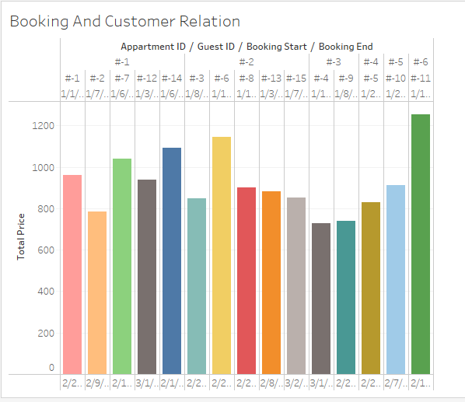

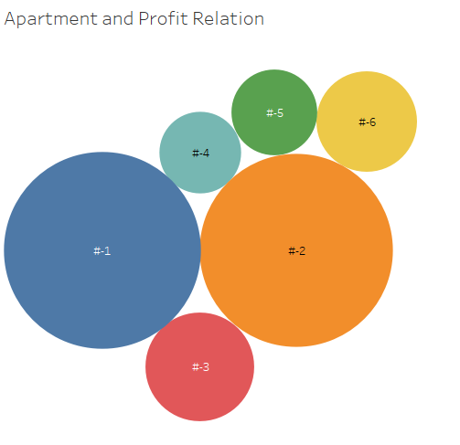

**Apartment and Profit:**

This is bubble graph, which indicate which portion has highest value, in this visualization, every bubble indicate individual apartment apartment #-1 and apartment #-2 has highest profit among others. Because lots of Guest select those apartment.



**Booking and customer relation:**

This visualization describes that which apartment has highest booking as we see this apartment #-1 and apartment #-2 has 5 booking.

