Nerd VPN Installation

Prepare
- Flutter latest version
- Laravel
- Apache
- Mysql
- A Cup of Coffee

Admin Side

Setup
- Run composer install command in web_admin floder
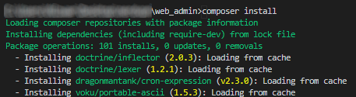
- Change your database informations on web_admin/.env line 7-12
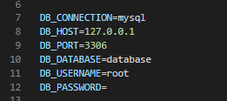
- Migrate database by running php artisan migrate
Instructions Link : https://laravel.com/docs/8.x/migrations#running-migrations
- Create admin account directly from Database panel
- Deploy web_admin on your host
Instructions Link : https://dev.to/asapabedi/deploying-laravel-5-applications-on-shared-hosting-without-the-use-of-ssh--16a6

Mobile Side
You need to follow these instructions step by step or your app will crash and not running!.

Setup
- Run flutter pub get
- Open mobile_app/lib/core/resources/environment.dart, go to line 1 and replace YOUR_HOST_OR_DOMAIN to your deployed web host/domain.
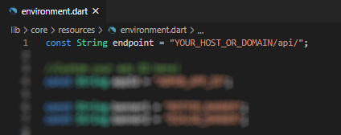

Change Android Package Name
Change your android package name by following these instructions.
Instructions Link : https://medium.com/@skyblazar.cc/how-to-change-the-package-name-of-your-flutter-app-4529e6e6e6fc

Firebase Configuration
Nerd VPN integrated with Analytics and Crashlytics, you need to setup to make your app running by following these instructions (Follow it until step 3 number 2).
Instructions Link : https://firebase.google.com/docs/flutter/setup?platform=android

Admob Configuration
Open mobile_app/android/app/src/main/AndroidManfiest.xml, go to line 18-20, and Enter your app id by replace it on ADMOB_APP_ID
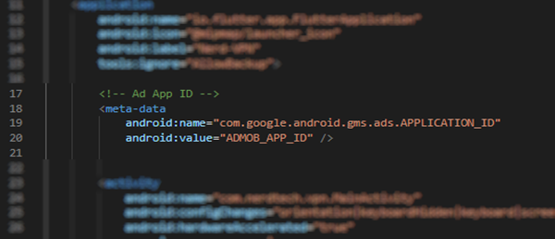
Open mobile_app/lib/core/resources/environment.dart, go to line 4-11, Enter your ads information by replacing each value.
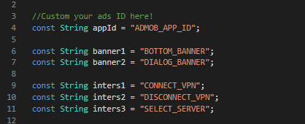

In App Purchase
IAP Feature is automatically active after your App live on Playstore.

Build Release
Follow these instructions to build release.
Instructions Link : https://flutter.dev/docs/deployment/android

Change Icon
- open nerdvpn\mobile_app\assets\icons, replace logo.png with your own Logo
- run flutter pub run flutter_launcher_icons:main command

Rename app
You can simply rename the app by open mobile_app/android/app/src/main/AndroidManfiest.xml, line 14.
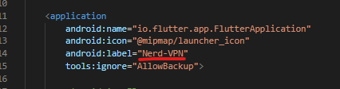

Basic Edit
You can simply edit on each folders in mobile_app/lib/UI/ Folder.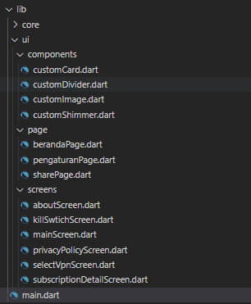
Don’t worry, Everything documented on every lines

Change Package Name
- Open mobile_app/android/ with Android Studio.
- on Project Explorer, click on Gear icon and uncheck Compact Middle Packages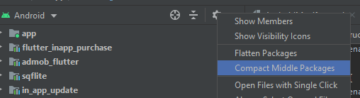
- Select the package you want to rename, and press Shift + F6 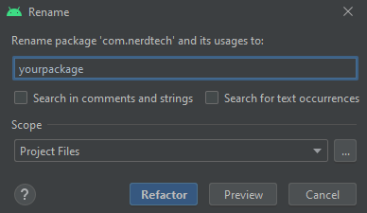
- Click on Refactor
- Open Gradle Scripts > build.gradle (module : app)
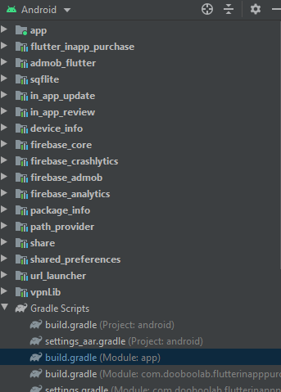
- Goto line 56 and change it with your changed Application ID that you already on step 1-3 above.
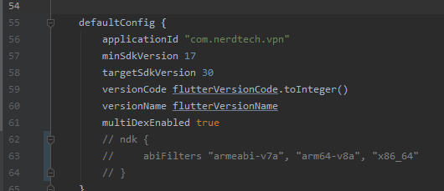

VPN Connection Area
Provide all about “connection” things on vpn, in case if you want to pick the codes to yours.

Prepare
- Copy android/vpnLib into your_project/android
- In your project directory, open settings.gradle and settings_aar.gradle (create it if not exists)
- Add include ':vpnLib' into each settings gradle on the top before or after include ':app'
- Open build.gradle (Module: app)
- add this line into depedencies{ }
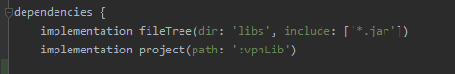
implementation fileTree(dir: 'libs', include: ['*.jar'])
implementation project(path: ':vpnLib')
- Open nerdvpn\mobile_app\android\app\src\main\java\com\nerdtech\vpn\MainActivity.java and copy NerdVPN MainActivity class source code and paste into your project MainActivity
- Open nerdvpn\lib\core\utils, Copy NizVPN.dart to your project.
- And you ready to go!

Do this to Connect / Disconnect
Connect or Disconnect vpn with single line of code!
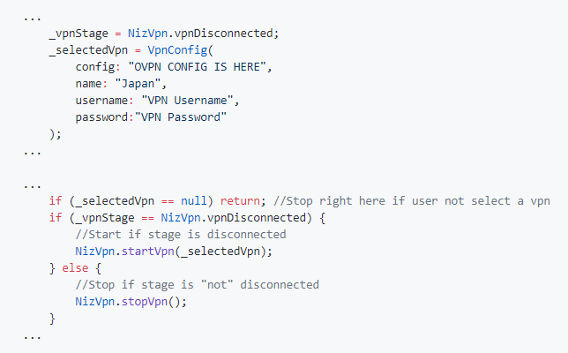

Listen to VPN Stage & Status
Don't forget to listen your vpn stage and status, you can simply show them with this.
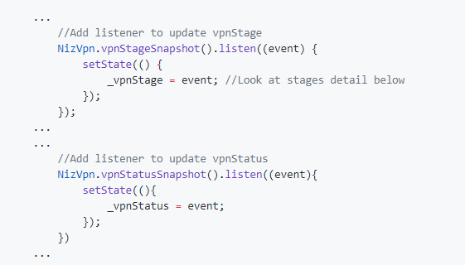

VPN Stages
Let me be clearer, VPN Stage shows the connection indicator when connecting the VPN
