

TITLE : WASTE RADAR FORUM

TEAM MEMBERS
STUDENT NAME | USN | MOBILE NO. | EMAIL
ABBAS HOZEFA | 1DS21CS007 | 7349519551 | abbashozefa@gmail.com
MOHAMMAD ARMAAN | 1DS21CS116 | 9008221224 | armaan02432gmail.com
SANJAL S ERALIL | 1DS21CS189 | 9482682530 | sanjaleralil@gmail.com
SIDHANT BHAT | 1DS21CS210 | 6006823303 | bhat.sid2001@gmail.com

PROJECT START DATE: 04-06-2022
Synopsis submission date :14-06-2022

PROJECT GUIDE NAME:
Prof. SAGARI

ABSTRACT
The project is about designing a website to manage waste in the localities. Our website consists of a front-end and a back-end.
As a Front-end the website consists of a navigation bar which comprises of Home,Survey and Maps as the webpages.The Back-end consists of a server and database management system that enhances the flexibility of the website by storing and retrieving data efficiently when required.

INTRODUCTION
Waste management is intended to reduce adverse effects of waste on human health, the environment, planetary resources and aesthetics.
The aim of waste management is to reduce the dangerous effects of such waste on the environment and human health. A big part of waste management deals with municipal solid waste, which is created by industrial, commercial, and household activity.

REQUIREMENTS
The following components are required for the completion of the project.
* Any Code Editer(for eg. VS code,Atom)
* HTML
* CSS
* JAVASCRIPT.
* REACT.js
* Django(Python framework)
* MySQL
* Web Hosting and Domain name
* API key for google maps

LITERATURE SURVEY
A developer named Aekansh singh had intended on developing a similar forum in 2020.He had used multiple webpages and tools to manage waste on a very large scale.
His work is open to edit on github(https://github.com/AekanshSingh/Website) to help other developers improve and learn the same.

ARCHITECTURAL DESIGN
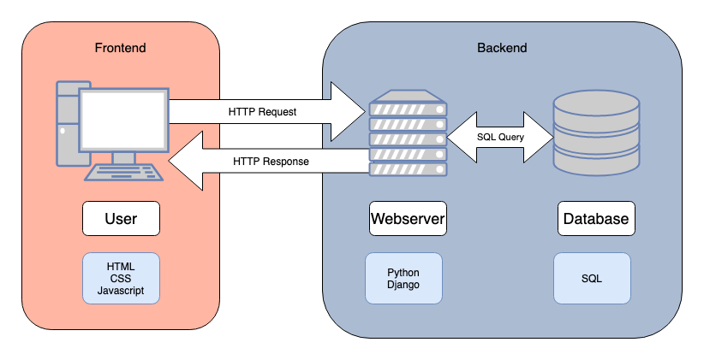

EXPECTED OUTPUT
The website is expected to have a mainpage which gives gives information about the website and blogs about the waste management. The link to secondary webpages could be accessed on the home page by just clicking the buttons on the navigation bar.
CONCLUSION
The project is an effective approach for social and economic benefit of the society by creating an awareness regarding waste management and recycling.
REFERENCE
https://www.google.com
https://www.youtube.com
https://www.w3schools.com
https://www.stackoverflow.com

