Output for the programs
1.
89.76923076923077
87.0
ModeResult(mode=array([86]), count=array([3]))

900.484375
30.008071830759135

Original key list is : ['Aravindh', 'Samitha', 'Tamil']
Original value list is : [1, 49, 59]
Resultant dictionary is : {'Aravindh': 1, 'Samitha': 49, 'Tamil': 59}

2.

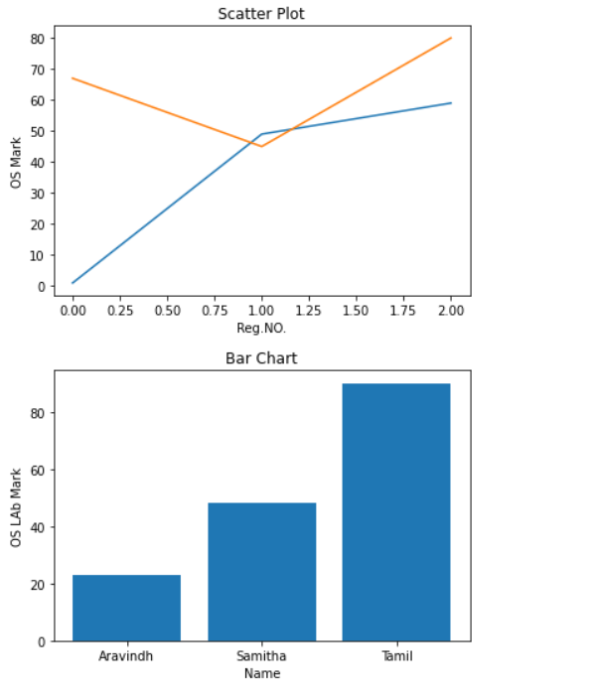
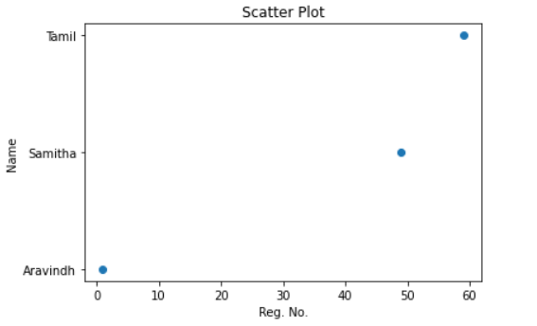

3.

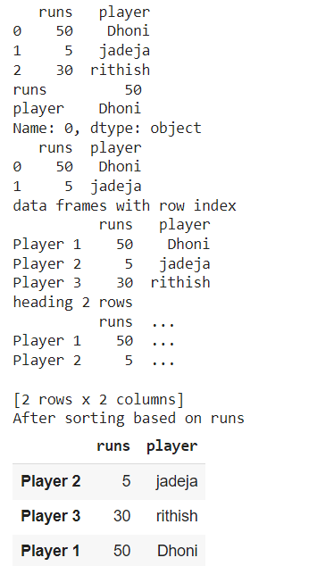

4,
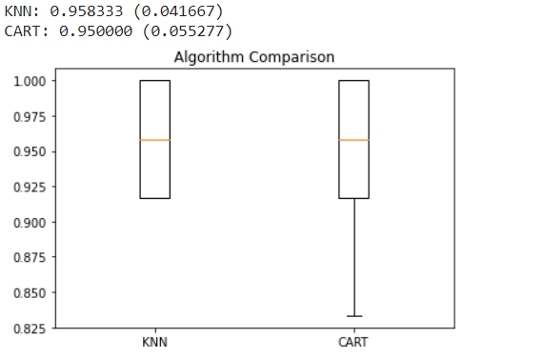

5.
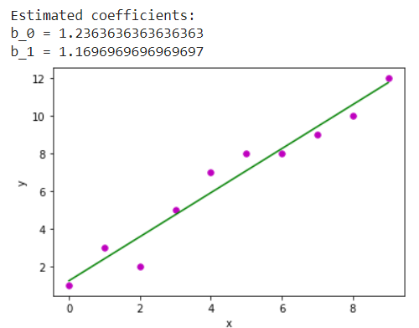
[[2 1]
[1 6]]
6.
Gaussian Naive Bayes model accuracy(in %): 95.0

7. Data :
Pregnancies Glucose BloodPressure SkinThickness Insulin BMI \
0 6 148 72 35 0 33.6
1 1 85 66 29 0 26.6
2 8 183 64 0 0 23.3
3 1 89 66 23 94 28.1
4 0 137 40 35 168 43.1
.. ... ... ... ... ... ...
763 10 101 76 48 180 32.9
764 2 122 70 27 0 36.8
765 5 121 72 23 112 26.2
766 1 126 60 0 0 30.1
767 1 93 70 31 0 30.4

DiabetesPedigreeFunction Age Outcome
0 0.627 50 1
1 0.351 31 0
2 0.672 32 1
3 0.167 21 0
4 2.288 33 1
.. ... ... ...
763 0.171 63 0
764 0.340 27 0
765 0.245 30 0
766 0.349 47 1
767 0.315 23 0

[768 rows x 9 columns]

Code-book :
[[0.75087192 3.27957011 3.31230663 1.20812245 0.51381383 3.80581379
1.24731589 2.33438929 0.1433724 ]
[1.66355377 4.45627591 3.9199151 1.39507971 0.931841 4.40027866
1.66237797 3.48756338 1.51771379]]

Clusters :
[1 0 1 0 1 0 0 0 1 1 0 1 1 1 1 0 1 1 0 1 1 1 1 1 1 1 1 0 1 0 1 1 0 0 1 0 1
1 0 1 0 1 0 1 1 1 0 0 1 0 0 0 0 1 1 0 1 0 1 0 0 1 0 0 1 0 1 1 0 0 1 0 1 0
0 0 0 0 0 0 0 0 0 0 1 0 1 0 1 0 0 0 1 1 0 1 0 0 0 1 1 0 0 0 0 0 0 0 0 0 1
1 0 0 1 1 1 0 0 0 1 0 0 1 0 0 0 0 1 1 1 1 1 0 0 0 0 0 0 0 0 0 0 1 0 0 0 0
1 0 0 0 1 1 1 1 0 0 0 1 1 1 0 0 1 1 0 0 0 0 1 1 0 0 0 1 0 1 1 1 0 0 0 0 0
1 1 1 1 1 0 1 1 1 0 1 0 0 1 1 0 0 0 0 1 0 1 1 0 1 0 0 1 1 1 1 1 0 1 1 1 1
0 1 0 0 0 1 1 0 1 1 0 0 0 1 1 1 1 0 0 0 0 1 0 1 1 1 1 0 0 0 0 0 1 0 0 0 0
1 1 0 0 1 1 0 0 0 0 0 1 0 0 0 1 0 1 0 1 0 1 1 1 1 1 1 1 1 0 0 0 0 1 1 0 1
1 0 1 1 0 1 0 1 0 0 1 0 1 1 0 0 1 0 1 0 0 1 0 1 0 0 0 1 0 0 1 1 1 0 1 0 1
1 0 1 0 1 1 1 0 0 0 0 1 1 0 0 0 0 0 0 0 0 0 1 1 1 1 1 1 1 1 1 1 0 1 0 0 1
1 0 0 0 0 1 0 0 1 0 0 0 0 0 0 0 1 1 1 0 0 1 0 0 1 0 0 0 0 1 0 1 1 0 1 0 1
0 1 1 0 0 1 0 1 1 0 1 0 1 0 0 0 0 1 1 0 1 0 1 0 0 0 0 0 0 1 0 0 0 1 0 0 1
1 1 0 0 0 0 0 0 0 0 0 1 0 0 1 1 1 0 0 0 1 0 0 0 0 1 0 0 0 1 0 1 1 0 0 1 1
0 0 0 0 1 0 1 0 1 0 0 0 1 0 1 0 0 1 1 0 0 0 0 0 0 1 0 0 1 1 0 0 0 0 1 1 1
0 1 0 0 0 1 0 0 0 0 0 0 0 0 0 0 0 0 0 0 0 1 1 1 1 0 0 1 1 0 1 1 0 0 1 0 0
0 0 1 1 0 1 1 0 0 0 0 0 0 1 1 0 0 0 0 0 0 0 1 0 1 1 0 1 0 1 0 1 0 1 0 1 0
1 0 1 1 0 0 1 0 0 0 0 1 1 0 1 0 0 0 0 1 1 0 1 0 0 0 1 0 0 0 1 0 0 0 0 0 0
0 1 0 0 0 0 1 0 0 1 0 0 0 1 0 0 1 1 1 1 0 0 0 0 0 0 1 0 1 1 1 1 1 1 1 1 0
1 1 0 1 1 0 1 1 1 1 1 0 0 0 0 1 0 1 1 0 0 0 0 1 0 1 0 1 0 1 1 0 0 0 0 1 1
0 0 0 0 0 1 0 0 0 1 0 0 1 1 1 0 1 0 0 1 1 0 0 0 0 0 0 1 1 1 0 0 0 0 0 0 1
1 0 0 1 1 1 1 0 1 1 1 0 0 1 1 1 1 1 0 1 0 1 0 1 0 0 1 0]

No.of.diabetic patients : 328
No.of.non-diabetic patients : 440

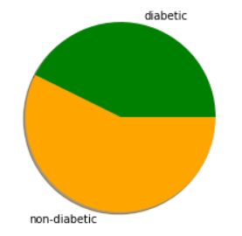

8.
 | Length | Breadth | Type
0 | 18 | 20 | Big
1 | 20 | 20 | Big
2 | 10 | 10 | Normal
3 | 12 | 11 | Normal
4 | 18 | 19 | Big
5 | 11 | 10 | Normal

 | Length | Breadth | Type | Area
0 | 18 | 20 | Big | 360
1 | 20 | 20 | Big | 400
2 | 10 | 10 | Normal | 100
3 | 12 | 11 | Normal | 132
4 | 18 | 19 | Big | 342
5 | 11 | 10 | Normal | 110

 | Machine Learning | ERP | Total grade
0 | 78 | Good | 1
1 | 56 | Good | 2
2 | 87 | Excellent | 0
3 | 91 | Excellent | 0
4 | 45 | Good | 3
5 | 62 | Good | 1

9.

idf values:
are : 1.6931471805599454
bca : 1.2876820724517808
in : 1.6931471805599454
we : 1.2876820724517808

Word indexes:
{'we': 3, 'are': 0, 'in': 2, 'bca': 1}

tf-idf value:
(0, 1) 0.4280460350631185
(0, 2) 0.5628290964997665
(0, 0) 0.5628290964997665
(0, 3) 0.4280460350631185
(1, 1) 1.0
(2, 3) 1.0

tf-idf values in matrix form:
[[0.5628291 0.42804604 0.5628291 0.42804604]
[0. 1. 0. 0. ]
[0. 0. 0. 1. ]]

10.

 | Sentence | label
0 | Ok brokeback mountain is such a horrible movie. | 0
1 | Brokeback Mountain was so awesome. | 1
2 | friday hung out with kelsie and we went and sa... | 0
3 | I am going to start reading the Harry Potter s... | 1
4 | Is it just me, or does Harry Potter suck?... | 0

 | sentence | label
1 | Brokeback Mountain was so awesome. | 1
3 | I am going to start reading the Harry Potter series again because that is one awesome story. | 1
6 | I am going to start reading the Harry Potter series again because that is one awesome story. | 1
9 | So as felicia's mom is cleaning the table, felicia grabs my keys and we dash out like freakin mission impossible. | 1
10 | I love The Da Vinci Code... | 1

 | sentence | label
0 | Ok brokeback mountain is such a horrible movie. | 0
2 | friday hung out with kelsie and we went and saw The Da Vinci Code SUCKED!!!!! | 0
4 | Is it just me, or does Harry Potter suck?... | 0
5 | The Da Vinci Code sucked big time. | 0
7 | For those who are Harry Potter ignorant, the true villains of this movie are awful creatures called dementors. | 0

