DEMOCRATIC AND PEOPLE’S REPUBLIC OF ALGERIA
MINISTRY OF HIGHER EDUCATION AND SCIENTIFIC RESEARCH
HOUARI BOUMEDIENE UNIVERSITY OF SCIENCE AND TECHNOLOGY
DEPARTMENT OF COMPUTER SCIENCE


000

Report on:
Information and Communication Technologies
(TIC)

- Student Name:
Ferhat Omar.

Academic Year: 2025/2026

Table of Contents

1. Introduction 3
2. Definition of TIC 3
3. Importance of TIC 4
4. Technologies Related to TIC 5
4.1 Google Services 5
4.2 Microsoft Tools 5
4.3 Git and GitHub 6
5. TIC in Education and Work 7
6. Advantages and Challenges of TIC 8
7. Conclusion 8

1. Introduction
Information and Communication Technologies (ICT), known in French as Technologies de l’Information et de la Communication (TIC), refer to all technologies used to collect, process, store, and transmit information, as well as to facilitate communication between individuals and organizations. Over the past decades, the rapid development of ICT has profoundly transformed the way people learn, work, and interact. These technologies play a crucial role in education, healthcare, business, administration, and daily life by enabling fast access to information, improving communication efficiency, fostering collaboration, and supporting a wide range of digital services that contribute to social and economic development.

2. Definition of TIC
TIC includes:

- Hardware: computers, smartphones, servers, networks



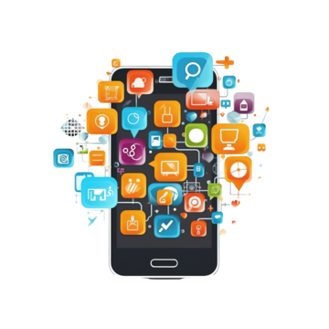
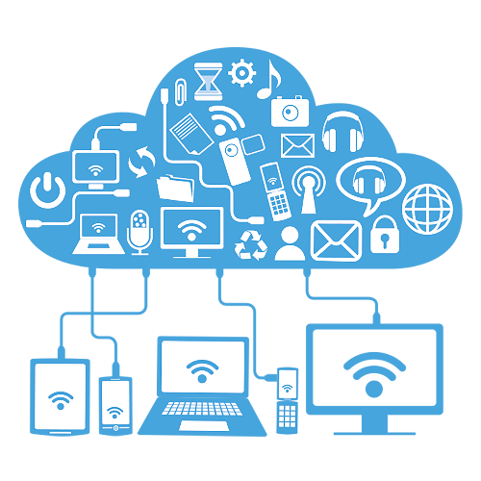
- Software: operating systems, applications, cloud platforms
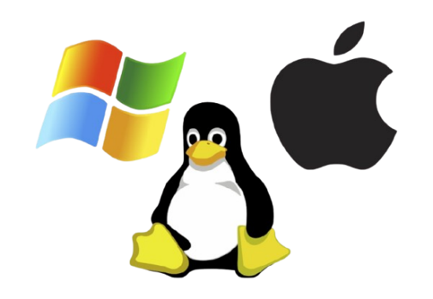


- Communication technologies: internet, email, video conferencing, social networks

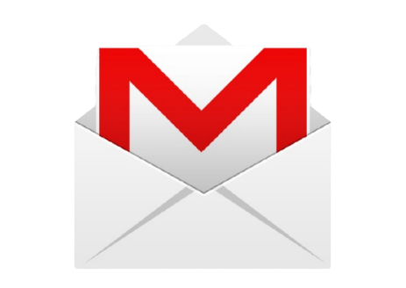

- Information systems: databases, management systems
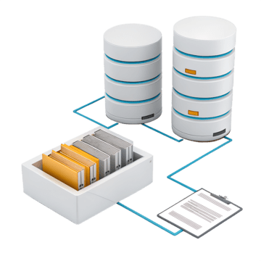
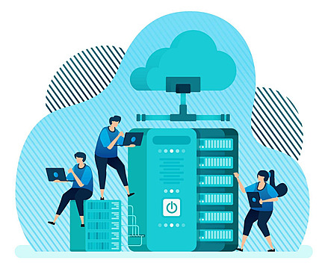

The main objective of TIC is to collect, store, process, transmit, and share information efficiently.

3. Importance of TIC
TIC is essential because it:
- Improves communication and collaboration
- Increases productivity and efficiency
- Supports distance learning and e-learning
- Facilitates digital transformation of organizations
- Enables innovation and access to global information

4. Technologies Related to TIC

4.1 Google Services
Google provides many cloud-based tools widely used in education and professional environments:
- Gmail: email communication
- Google Drive: cloud storage and file sharing
- Google Docs, Sheets, Slides: online office tools for documents, spreadsheets, and presentations
- Google Meet: video conferencing
- Google Forms: data collection and surveys
- Google Classroom: e-learning and course management
Gmail | Google Drive | Google Docs | Google Meet | Google Forms | Google Classroom
 |  |  |  | 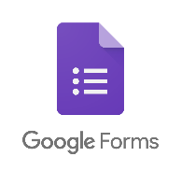 | 

Advantages:
- Free or low-cost
- Real-time collaboration
- Accessible from anywhere with internet

4.2 Microsoft Tools
Microsoft offers powerful software solutions for personal and professional use:
- Microsoft Word: document creation
- Microsoft Excel: data analysis and spreadsheets
- Microsoft PowerPoint: presentations
- Microsoft Outlook: email and calendar
- Microsoft Teams: collaboration and online meetings
- OneDrive: cloud storage
- Windows OS: operating system
Microsoft Word | Microsoft Excel | Microsoft PowerPoint | Microsoft Outlook | Microsoft Teams | OneDrive | Windows OS
Document creation | data analysis and spreadsheets | presentations | Email and calendar | collaboration and online meetings | Cloud storage | Operating system
 |  |  |  | 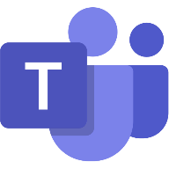 | 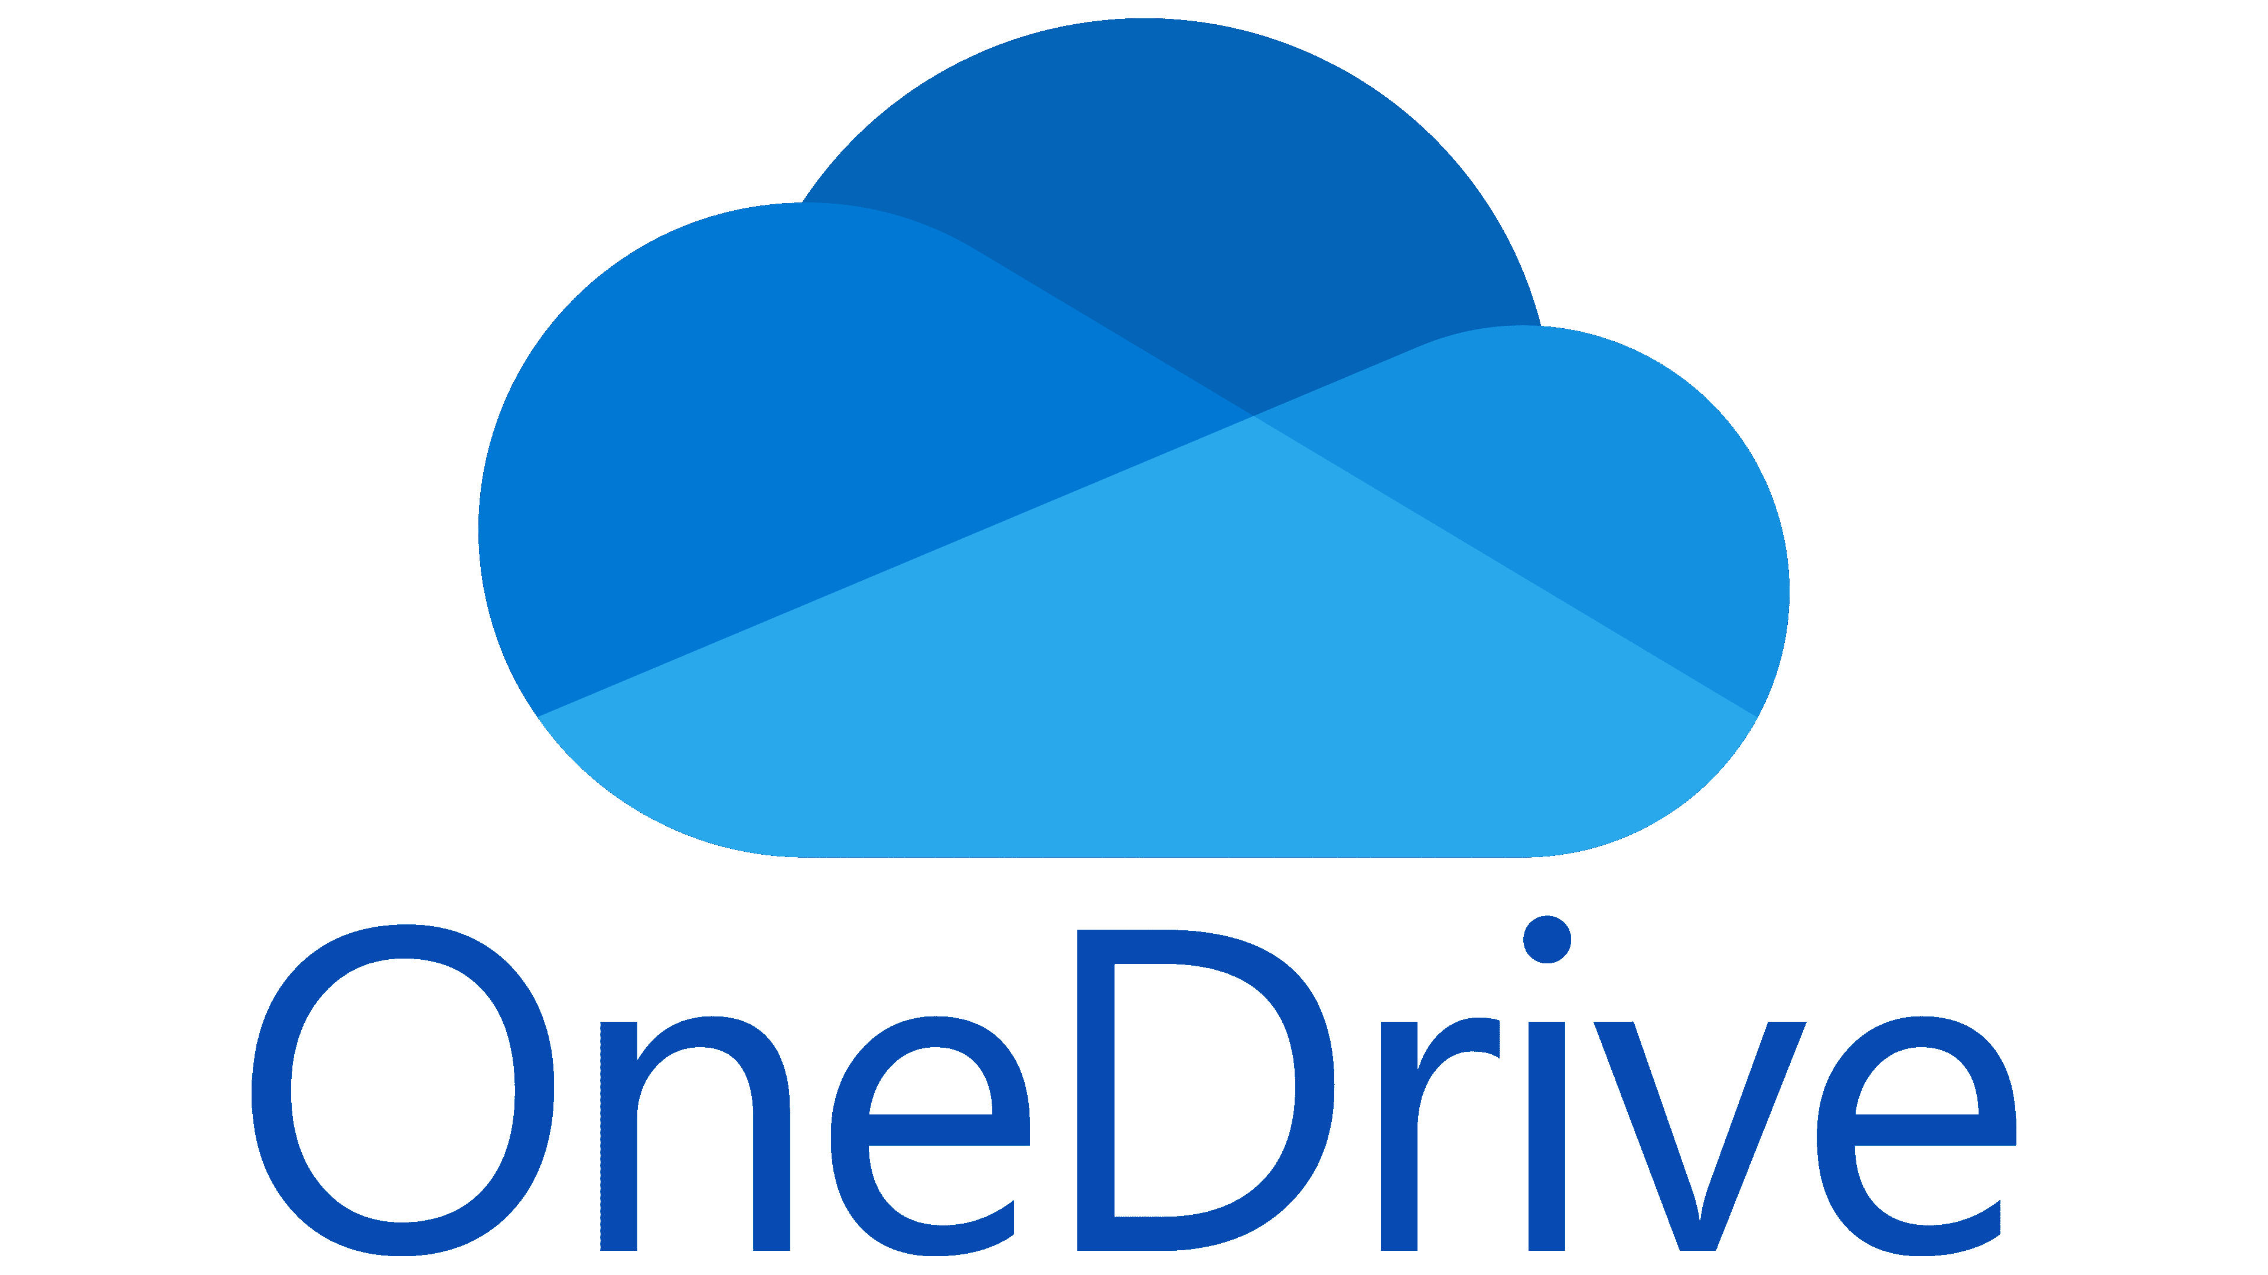 | 

Advantages:
- Professional standard
- Advanced features
- Widely used in companies and institutions

4.3 Git and GitHub
Git
- A version control system
- Allows tracking changes in files (especially code)
- Enables multiple developers to work on the same project
Key features:
- Version history
- Branching and merging
- Backup of work
GitHub
- A web platform that hosts Git repositories
- Used for collaboration and project sharing
Main uses:
- Store and manage code
- Team collaboration
- Open-source projects
- Project documentation
Benefits:
- Improves teamwork
- Prevents data loss
- Enhances software development workflow

5. TIC in Education and Work
- Online courses and virtual classrooms
- Remote work and teleconferencing
- Digital documentation and data management
- Research and information access
TIC reduces time, cost, and physical constraints.

6. Advantages and Challenges of TIC
Advantages | Challenges
- Fast communication  - Global connectivity  - Easy access to information  - Automation of tasks | - Cybersecurity risks  - Data privacy issues  - Digital divide (unequal access)  - Dependence on technology

7. Conclusion
Information and Communication Technologies are fundamental in modern society. Tools such as Google services, Microsoft applications, and Git/GitHub have transformed how people learn, work, and collaborate. Mastering TIC is essential for academic success and professional development in the digital age.

