Jordan Balk Schaer – jordan.schaer@gmail.com

**For publication in the *Berkeley Fiction Review***

4,131 words and 11 illustrations.

**The Magbapi Earth Trip!**

***With illustrations by the author***

*You know what to do in case you screw up, right? Just draw everything bigger and darker, then nobody can tell the difference.*

Tom Jackson, high school math teacher, discussing manual graphing techniques

In the novel *Happy Travels* by Penny Rot

*If you had fun, you won.*

Summer camp motto

*The philosophers have only* interpreted *the world in various ways; the point is, to* change *it.*

Karl Marx, the Eleventh Thesis on Feuerbach

**Part One:**

Please meet my character, Filmore Marp, once a baby, born and raised here on Earth with you and me. Which is to say, he is a human being. Human beings do all sorts of things which I’ll get into later which, seem silly to outsiders. Humans speak by waggling around a slick slimy muscle, with little taste-sensing folds, inside an even bigger *differently* slimy fold; they wiggle their fingers and wrists and call it writing; they operate machines like pens and typewriters and computers to pick up the slack (in case you didn’t already know). What else? Lots of human beings like to make and wear hats. Filmore Marp in particular prefers to wear hats that look like these:

*Figure 1.1: 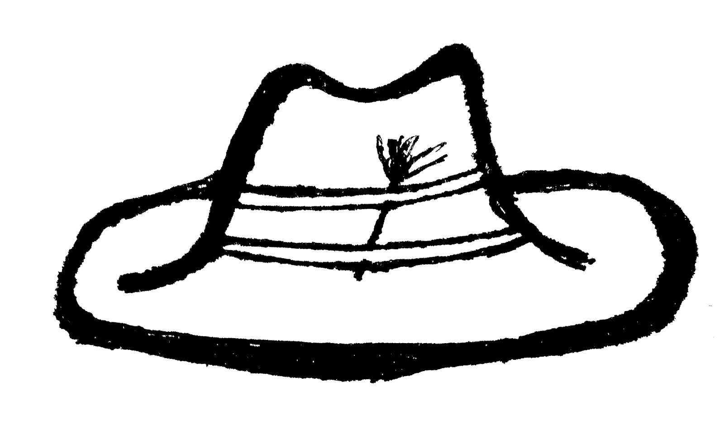*

He wears these all around the clock *and* the solar system; believes they make him look real cool—not to be mistaken with fake cool. Strong words. Most people think hats like these (refer to *f.1.1)* make you look bona-fide loser. Who wants that? Everyone on Earth wants to win. People say strong words are for important people. Many think, some say, Filmore Marp is very unimportant, use his hat as justification for disregarding anything and everything that comes out of Filmore’s mouth fold. Meanwhile Filmore wishes everyone would think the way he does regarding how the world ought to work. If everyone just tried to keep it cool all the time, the world would be a better place. He told this to his friends, relatives, neighbors, customers, and otherwise.

What is cool? Filmore would tell you it means taking what you like, and then making more of it. Not because other people like it, but because you like it, *and* you have a sense of why you like it. It’s knowing how to listen to what others think, and when it’s okay to respond with “fuck you.” If he was still around, he’d tell you if you do that right, you “Win. Really win.” and can change the world.

Consider a species of aliens called the Magbapi (pronounced “mag-bah-pee”), some of whom nabbed Filmore. They wanted to go on a quickie tour of Earth and a local to ask questions about whatever weird stuff they notice. Normally they cycle through a few guides until they get the right fit. Once they find the right one, they look for other locals to tailgate, and there’s their trip. Perhaps Filmore should have known better than to travel with a roving gang of stranger alien types. Most folks don’t listen to people like Filmore, so when the Magbapi willingly digested him, he stayed without protest.

This is what the Magbapi look like:

*Figure 1.2: 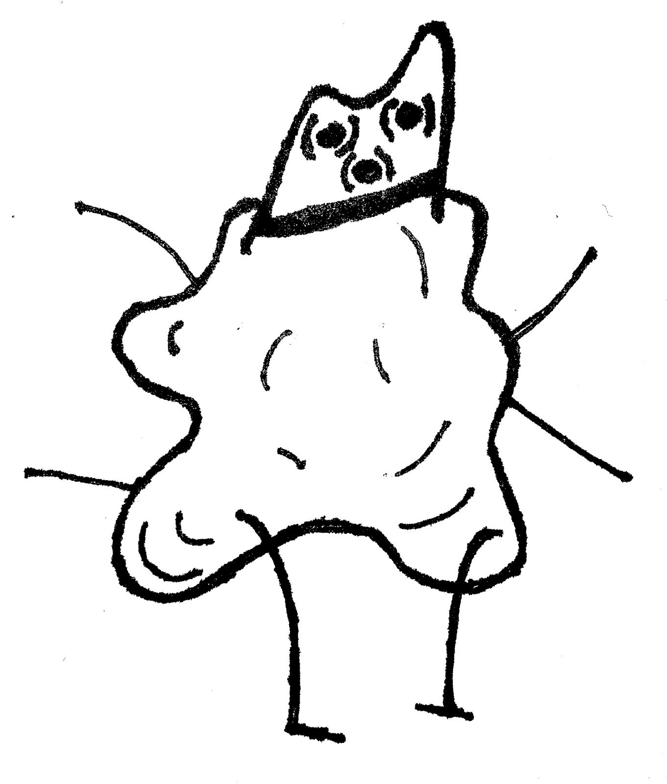*

Pretty normal, nice and perky. Sure they might look creepy or whatever to mouth-and-nose-breathers like you and me, but this particular Magbapi illustrated above, named Clöre, won Queen Milky Way back in 8 and 2008 *in one go*. Obviously, they use a *very* different time system than we do. Apparently perceiving time as a linear progression is “for suckers,” though whether the Magbapi even do insults still remains unclear. It’s hard to suck with so many flaps going. But don’t worry about that, galactic society at large is outside the scope of this story. Stoop close, we are planet-side. (Useful way to spot the Magbapi on Earth—locate an upscale junk reseller with an outstanding cumbersome pile of bathtubs. Nine times out of ten it’s a disguised Magbapi spaceship.) The least important Magbapi are the ones who understand how everything works under-the-hood. They don’t bother going on superfluous extravagant tours of the galaxy. As physical bodies, they are lumps and flaps and appendages, which they use analogous to our hands arms or legs. They have three eyes on top. I suppose we can call this their head. They don’t have many parallel organs; only some corresponding functionalities. Some flaps are for talking and eating and fucking and shitting, and others for functions humans don’t bother, like emitting distinctive electromagnetic signals from select pores, suitable for high-speed internet telecommunication—server ports.

When most people meet Filmore, they don’t like him—he seems so damn unimportant. But don’t believe Filmore Marp is unimportant, oh no. He is a typewriter salesman and he is exactly what the Magbapi are looking for. They swing by in their nifty space shuttle and nab Filmore Marp—ask him questions and whatnot. He’s so unimportant they pick him up, but they don’t pick just *anyone* up. You see the problem? After all, he’s my protagonist. This, in a sense, makes him important. Problems like these, they fold into themselves. *They* become unimportant. Either the problem is solved under-the-hood, and you don’t yet know it… Or you’re dead. *That’s* the way it’s supposed to work. We don’t need to worry about that problem. Here’s the problem we do have: the important and the interesting—they’re not the same thing here on Earth.

Filmore Marp lives in the United States, a country with three hundred million fools, all just like Filmore, more or less—some prettier, some scarier, a few more noble, and plenty more comfortable. What do they all have in common? Every single one believes inside they’re more important than they really are. The United States also has all sorts of laws. Lots of places do. In fact, nowadays it’s much harder to find places without laws. Obey the laws, or else face nasty nasty punishment like taking your things away and locking them in a box, or taking you away and locking you in a box. Depending on what you’re trying to hack, it’s not like the matter falls abstract, only hard to keep total track. Administrative laws can look like this:

*Figure 1.3: 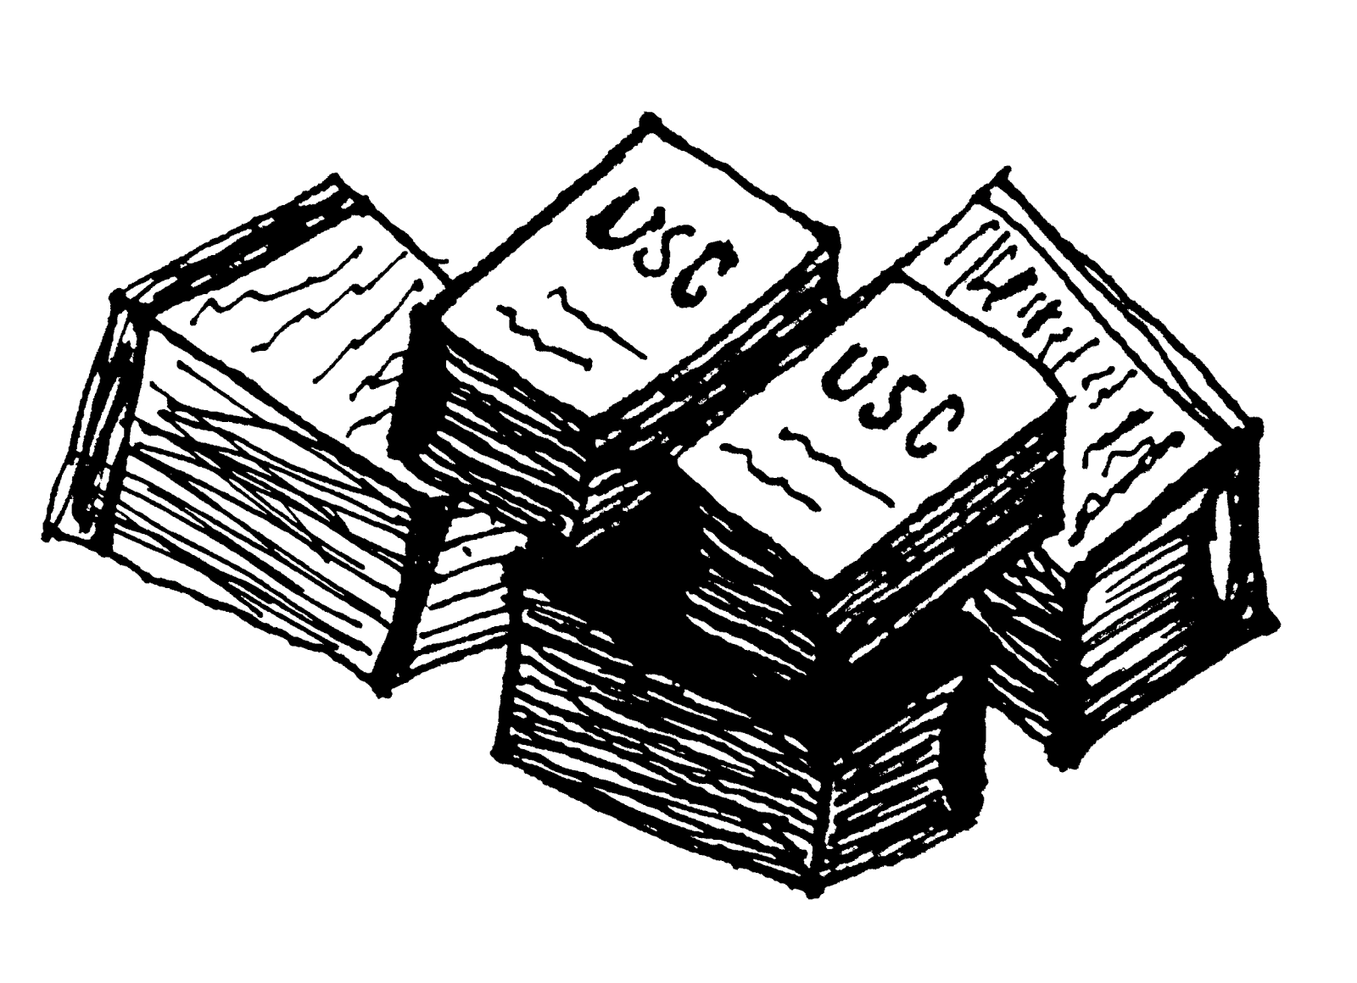*

You can tuck all sorts of mischievous knuckle-dragging nonsense in harmless-looking blocks such as the ones above. But that’s not the real monster. The scary stuff? Consider all things the United States *won’t* write laws for. Sometimes people throw rocks and bricks into the windows of homes and cars and they scream and shout. It is only sometimes frowned upon. Either protest is incriminated as riot, a dangerous thing, or entertained as revelry–perhaps if the local sports team unexpectedly won or lost some big game. Other times, well, some things turns out they implicitly do not want to change, or even discuss. Inequality and injustice makes it easier to make lots of money quickly, which is great if you avoid thinking about the problems. With adequate disruption, the theory goes, they’ll carve a tiny, fleeting concession into their bricks for you and yours. That’s how you change society. Filmore would say the ones who lead social movements are “real cool.” They don’t avoid problems. They solve problems.

**Part Two:**

Next-door to the typewriter store where Filmore works as their sole salesman, there’s this cannabis dispensary and an upscale junk shop. Our Magbapi recreationists decide to tailgate Filmore’s first customer of the day. Bring along Filmore, and see how it goes. Try not to bother whomever, unless of course everything comes to a slam. The Magbapi want to know why not just call it a “store.” That’s what they would call it. The answer leaves their heads spinning (metaphorically speaking—Magbapi ‘heads’ do not spin much at all). One of those concessions made marijuana kind of legal, only if you’re considered sick enough. Laws declared the junk they sold at the other shop next to Filmore’s typewriter front as technically criminal as truly dangerous drugs with long nasty names like methylenedioxypyrovalerone (pronounced “meth-eh-leen-die-oks-ee-pie-roh-vae-lehr-own”) or phencyclidine (pronounced “fen-sie-cleh-deen”) and harmless nicknames like bath salts or molly or horse. Molly, for the most part, is only dangerous when her nasty cousins impersonate and jam up people’s brain-function tragically permanently, which happens every here and there, couple months or so, now and again. Meanwhile, horse has slaughtered countless innocent people, broken far more hearts and souls, continues to do so. Filmore casually enjoys heroin. Hasn’t killed him yet.

The Magbapi like to come to Earth because they don’t understand us; they love to ask questions. Turns out, we love talking about ourselves to aliens if they look cuddly enough. Even if super dangerous. From their perspective, we look like gerbils (perhaps best case scenario—hedgehogs) trapped in glass cages painfully aware of our own planetary imprisonment, scrambling around in the dirt wide-eyed and stupid. The Magbapi say “Happy travels!” as they leave,  bringing Filmore along for a quick joy ride around Saturn, snorting some of his Champagne. (That’s right, snorting. Like I said, the Magbapi are not analogous to humans. They don’t do it like we do.) They collected Filmore Marp’s things, *especially* his drugs. The ones that tried tracking his heroin in their folds became addicted quickly enough. Just like human beings, only worse and faster.

A common trend here on Earth is to get accidentally addicted to painkillers after surgery, eventually move on up to the opiate big leagues. Others just go straight for the heroin. This is what the Magbapi that ate heroin (technically, inserted the heroin into their mouth fold, it’s not exactly what you and I consider “eating”) all looked like after less than a week:

*Figure 2.1: 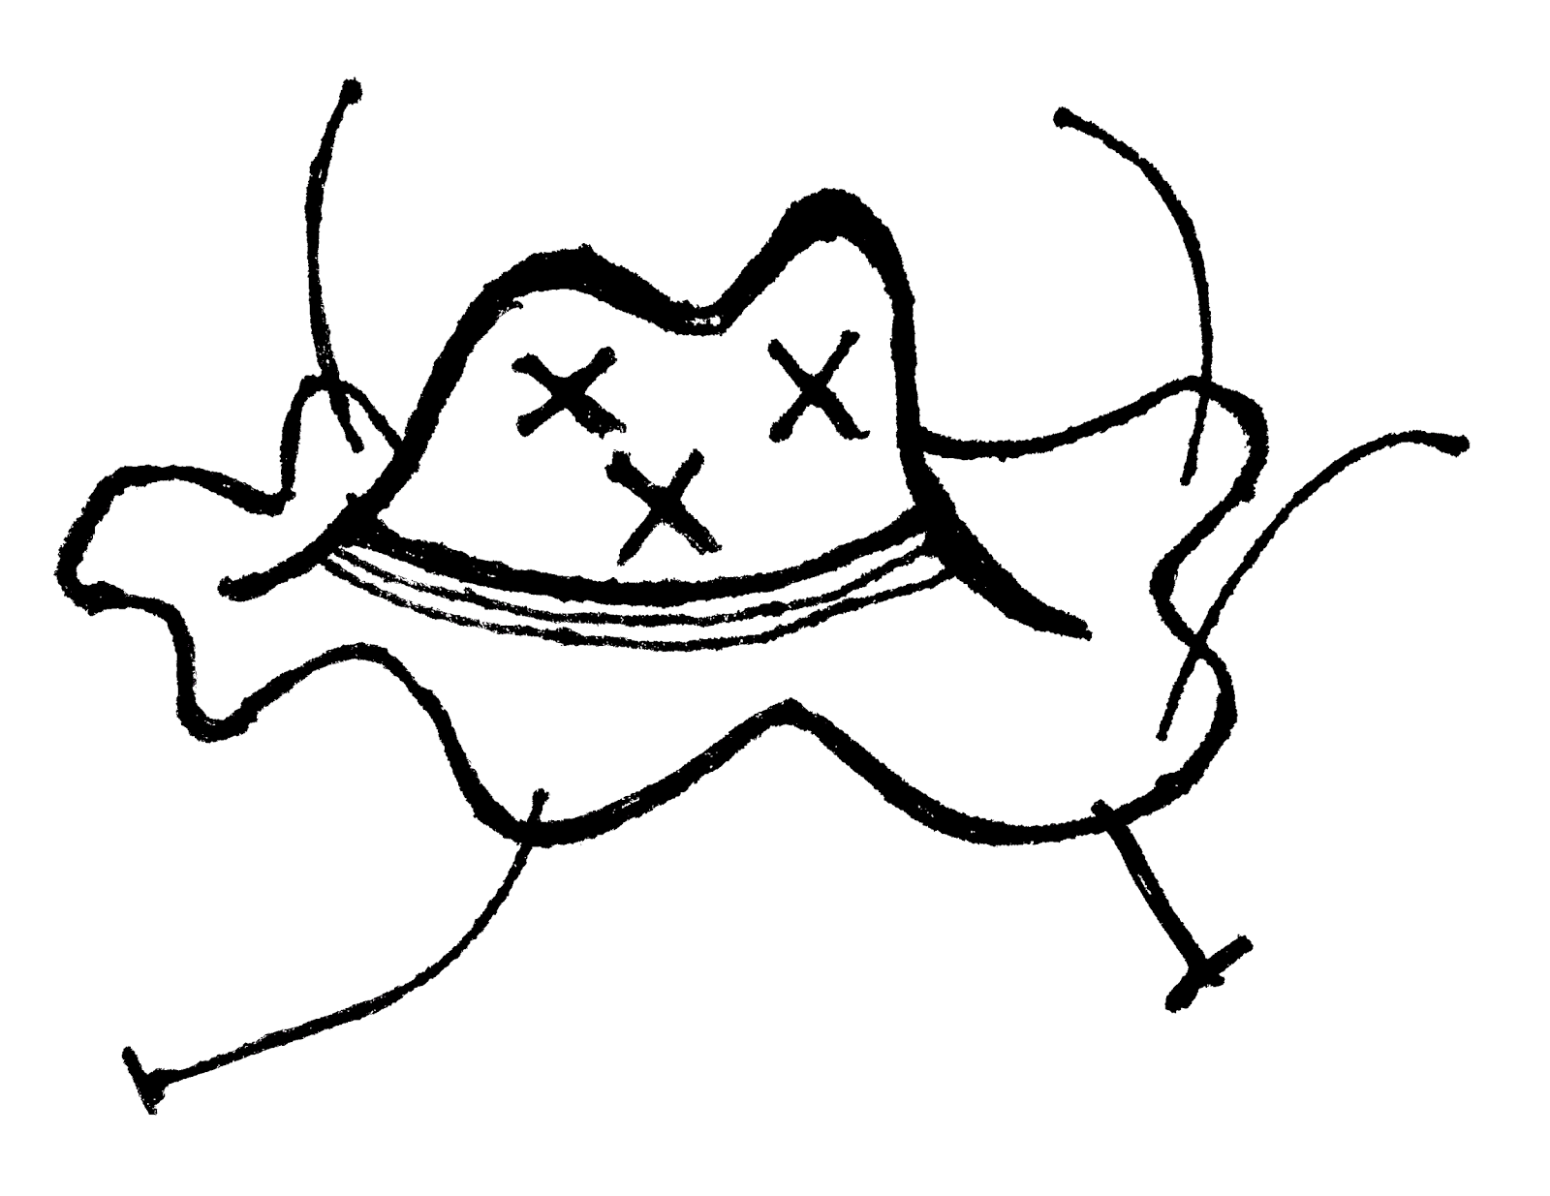*

Notice how they’ve overdosed, and died. You see that? (What you and I would likely consider their-) Eyes are blank, folded inwards. “Phew!” said Filmore Marp, glad he didn’t just kill *all* his new and interesting (-ly shaped) friends who wanted to hear his ideas for how the world ought to work. They discuss ways to make his visions happen. Could have been worse; relieving Filmore. “Why did you just say ‘Phew!’?” One of the Magbapi scratch through his talking flaps; eyes narrowed; their internet telecom pores responding only with reset packets—electro-emotional firewall; starring suddenly sullenly solemnly at his friends, the puddles; shifting saggy weight from appendage to appendage. “Um,” Filmore says. This kind of thing happens, the rest of society doesn’t blink thrice at sadness—so much cool stuff out there to gawk at.

Filmore will be shot in the head and killed abroad in a friendly-fire incident—Rupert, a well-meaning Magbapi, will see Filmore’s hat (refer to *f.1.1)* and will prejudicially presume he must’ve poisoned and murdered a hapless Magbapi (refer to *f.2.1)* for sport and crafted the poor thing – protected by galactic statute – into a hat*.* The blaster bolt will instantly kill Filmore*.* A stupid mistake maybe, but in his defense, Rupert had recently been stationed in the occupation of the planet Paper Stack 16, where the dominant species commonly liked to wear hats that looked like this made from a species named the Kitternull (pronounced “kih-ter-null”)—who were good and friendly and harmed none:

*Figure 2.2: 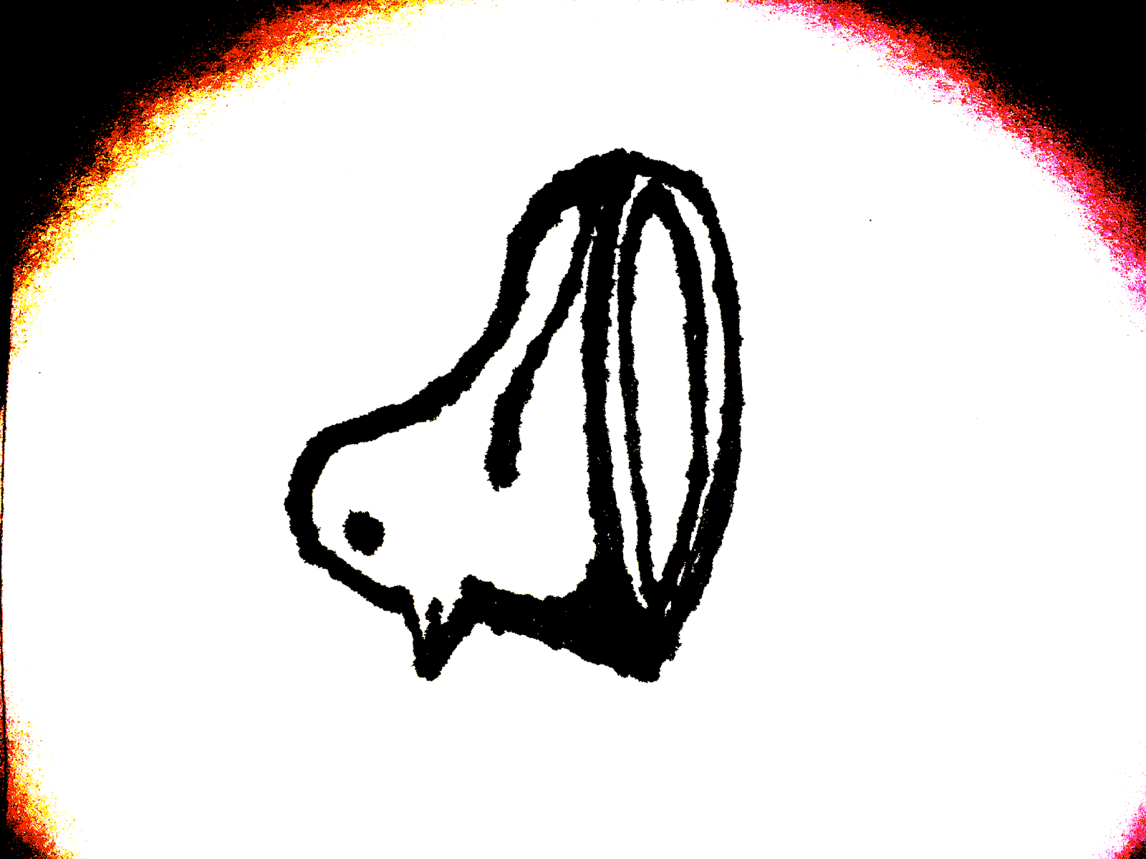*

Which meant they looked like this:

*Figure 2.3: 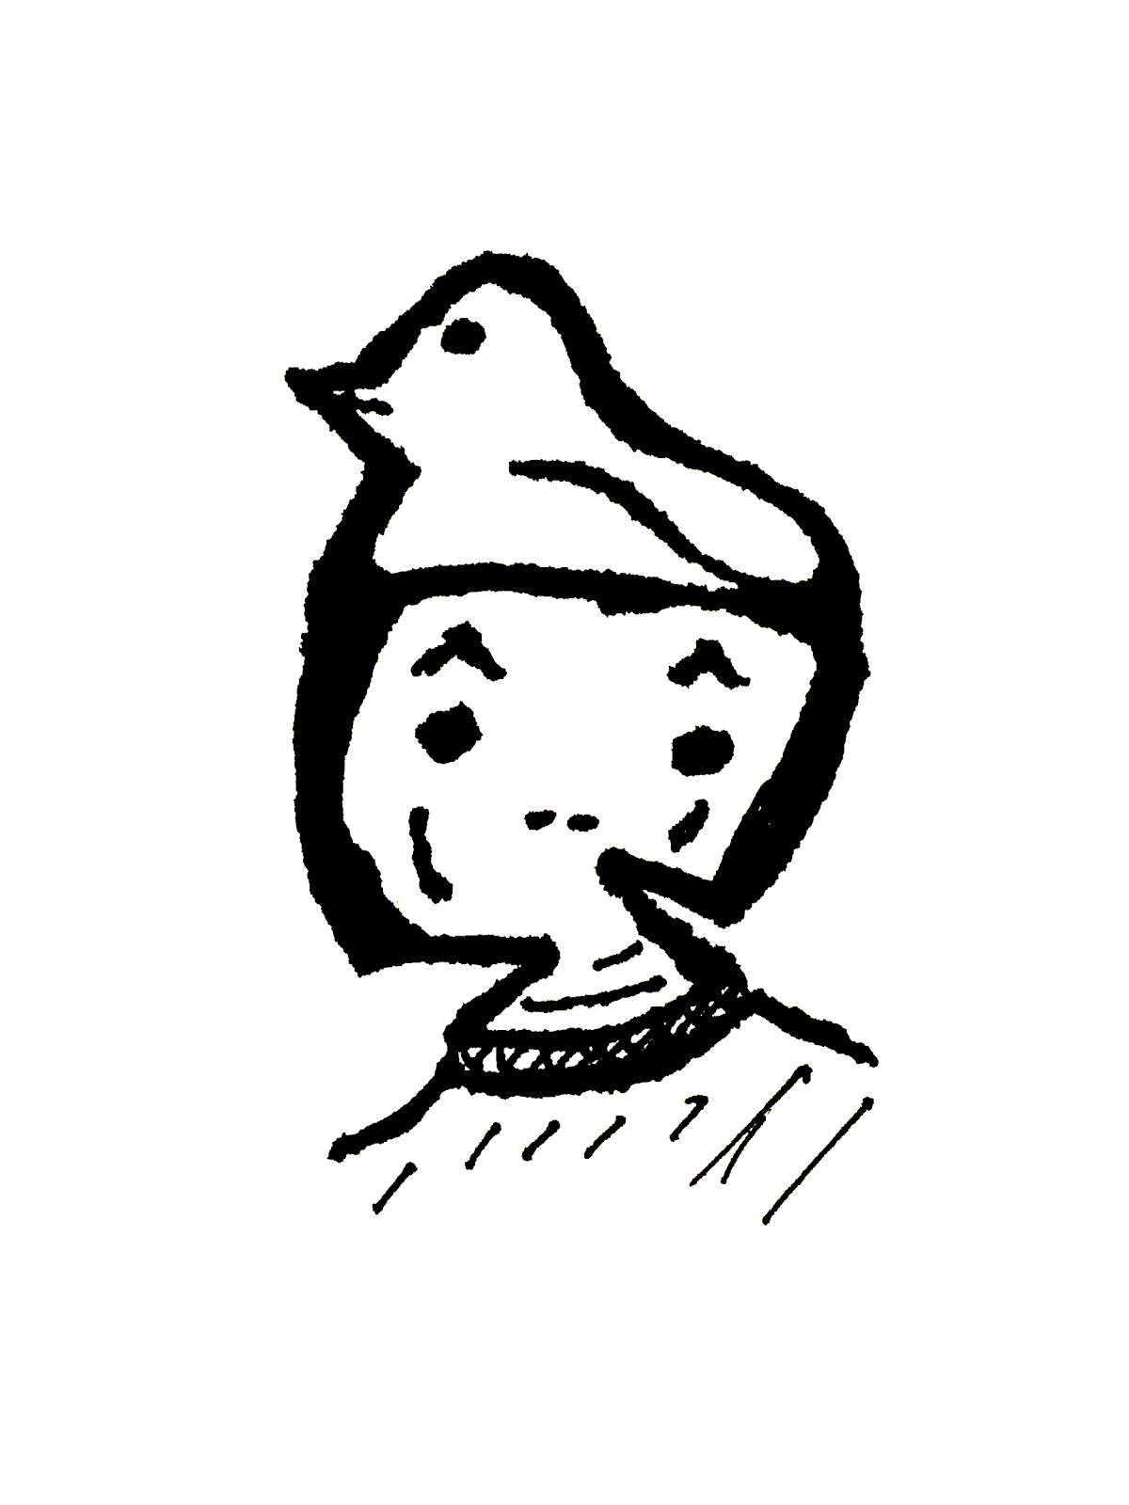*

Quite cool and fashionable, in some circles.

It perturbed Rupert to see Kitternull killed and turned into hats. Rupert departed Paper Stack 16 traumatized, looking for rest and recreation on planet Earth. Human beings aren’t any better in terms of respectful tourism, always presuming the exceptional are excused. Two months after he’d mistakenly blasted Filmore in the head and left his body in a magma den half-way to the Sirius system, Rupert gets bored of Earth. He stumbles limb over limb to the nearest pile of bathtubs, and booze-cruises over to the party hub always tailgating Hailey’s Comet, a place called *Happy Travels.* You can’t point to it with any of your appendages because it’s floating around, and you’re far away so you’ll always be wrong. Management keeps it stealthy up there, so the less advanced can’t/won’t see anything suspicious with their rudimentary telescopes or index fingers; the Magbapi shuttles are fancy and have lots of tricks to get down for good hide and seek. *Happy Travels* has been floating bopping around for millennia—nobody knows who built it. Most folks postulate it must’ve been their mighty ancestors when their kind finally find the galactic gambling haven. When humans progress into massive galactic space travel, they argued it had to have been us because of the illustrations left on the walls. Wrong again.

Some of the Magbapi who live and let live full time aboard *Happy Travels* later on heard about Filmore Marp, and they liked all what he had to say. What did Filmore say real winning looks like? Filmore wasn’t around to remind them, so they started studying and guessing and trying more stuff out to see if they liked it. Their work had gravity to it, and as a result, attracted-gathered a following.

**Part Three:**

Consider Penny Rot. Penny still uses a typewriter to draft her books and essays and stories and occasional letters to lostlorn lovers even though computers are way easier, favored by most everyone for more than twenty years… The Magbapi had trouble finding anyone who still used a typewriter, let alone shops that only sell typewriters, not that they were looking. Penny’s latest novel won her mighty and sought-for status and fame. A nice big audience. Critics praised her voice, style, and emotional weightiness in her storytelling—two stories intertwined in romance and thrill. Half of the novel featured cancer patients enduring treatment, stoically carrying each other through illness and impoverishment. A reflection on the modern day duress of treatable sickness leaving you alive yet miserable. Penniless and prohibitively sore for the rest of your unobstructed days. The other story takes place in the wild. Two wolves, each separated from their pack, follow each other’s paths, but never meet.

Had Rupert not shot Filmore Marp in the head, Filmore would’ve died in his fifties as a result of an aneurysm caused by brain cancer. How do I know this? Filmore and I have a franticly fraught and tenuously tepid relationship. Better wiser older folks have been working on thinking about this problem since long before you and I were bare babies.

Cancer is when a part of your body decides it wants to be bigger and have more things than it needs, jamming up other parts, causing nasty serious problems. Important stuff the body wants to do like eating and sleeping and sharing and fucking and sucking and tugging and lugging and laughing and cradling, enough cancer, which isn’t very much at all, and you can’t do any of it. Cancer keeps you busy wrapped up with dying—forces you and your loved ones to stay conscious through all of being able to do nothing at all. Most everything sucks when you have cancer.

Instead of *that* nasty business, Rupert’s blaster will shoot a hot glob of plasma, scalding its way and leaving a crispy hole through Filmore Marp’s cerebellum across through his grey matter, disintegrating everything in its path. This is what Filmore Marp’s hat will look like after Rubert shoots it:

*Figure 3.1: *

Some studying the matter aboard the *Happy Travels* say this makes Filmore – ultimately everybody – fake cool.

When she was younger, Penny Rot underwent a mastectomy. A surgeon made her breathe special gas out of a tank. Technically, the gas doesn’t make you sleep. You don’t remember any of it, but your body reacts believing it’s dying right there on the operating table. They strap you down because as you lose consciousness, panicky instinct kicks in; muscles struggle against the blank darkness. Given the gas, even the most suicidal push to stay alive. Not asleep but not in pain either, the surgeon cut around Penny Rot’s breast and swished a special kind of knife around inside her chest until they sucked out as much cancer as they could manage, and stitched Penny Rot back together so she doesn’t have any remaining flaps left hanging. The Magbapi asked why she wouldn’t want bonus flaps—they’re so *handy*. After the surgery, Penny’s chest looked like this:

*Figure 3.2: 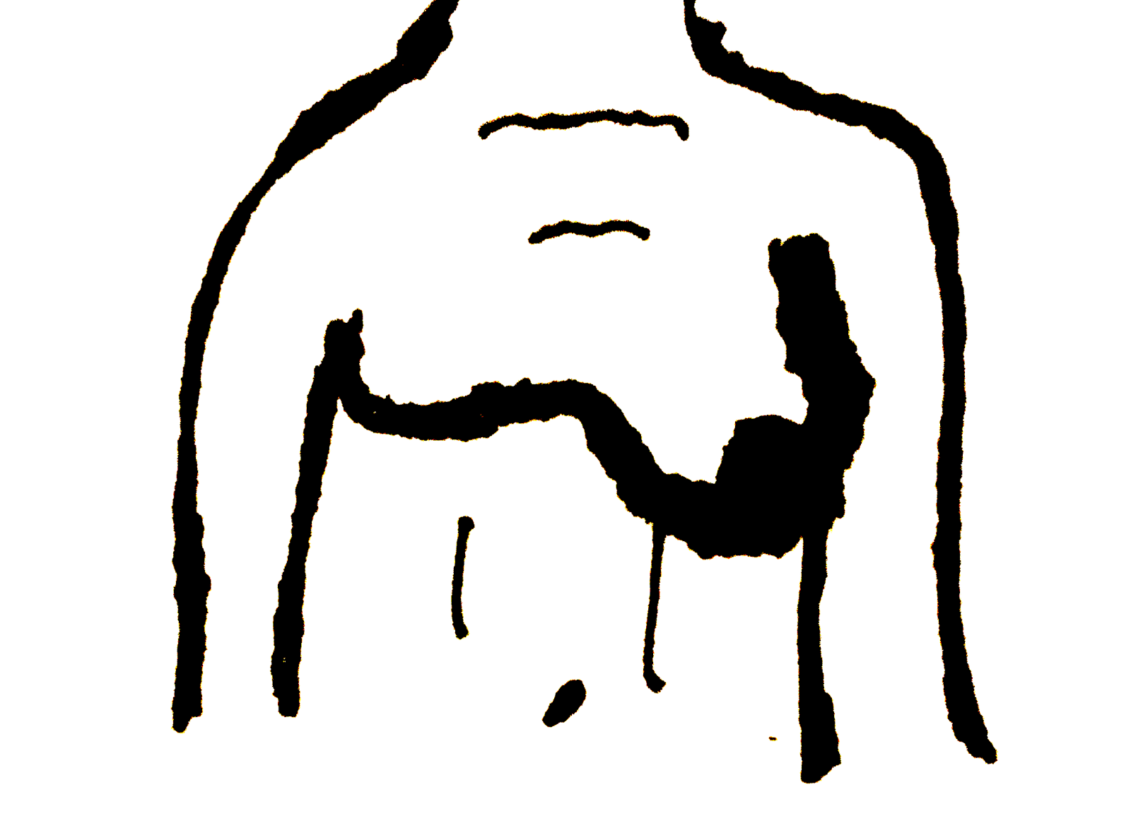*

Made her feel all sorts of embarrassed; embodiment of wobbling. Cancer drained grace from her body. Something from treatment blackened her remaining nipple. Doctors couldn’t-wouldn’t-shouldn’t explain why. A little later her other breast, nipple and all, would go too. She felt better once no longer a “sad potato sack on legs” (her words). After the surgeon finished on her, they returned to their office and wrote a report to the Rot family’s insurance, which then repossessed the family’s home in exchange.

One of the Magbapi asks Filmore if the other humans feel sorry for sick people like Penny Rot. She’s a famous novelist with fans a dime a dozen, plenty of other humans (important and otherwise) recognize Penny on the hometown street kind of famous. She smiles afraid and alone and squiggles a little something on whatever trash they shove in front of her. Sometimes (twice) that trash is toilet paper. Toilet paper is used to wipe away bits of food (after you’ve used your body to suck out lots of nutrients) from your anus.

Her next novel, inspired by cancer, entranced an even wider audience. When time finally came to go outpatient, her characters, smitten with each other, move in together and try to build their lives back. Nothing goes as planned, and then some. The novel becomes iconic for incorporating the narrative about wolves in the forests that never meet.Critics thrilled the world over, earning Penny Rot lifelong credential as an acclaimed novelist. She loved the wide congregation and the small audiences she’d accumulated, each and every one, especially all the cancer patients. Why did they adore Penny so much? Why did they join and stay with her? They joined for stories of empathy and compassion but stayed because they’re/there’s *so much more than that*.

She walks out of the medical office after her mastectomy. No prestige can make her feel any less awkward as she hobbles towards a taxi, alone, all lopsided.

**Part Four:**

A combo of curious, relieved they didn’t crash into Penny dead of smushed cancer (their spaceship does that sometimes, they still holiday when it does accidentally increase preexisting cancer),  and upset about their companions since overdosed super-dead on heroin, some Magbapi ask why make cannabis as bad as the drug that killed their alien friends, not to mention the poor dead humans. Filmore Marp takes the aliens to his typewriter shop. Maybe that’ll show them. Filmore just wants to go home. They park their spaceship nearby; then glob covering the windows, swallowing away the natural light, frightening children walking on the street clinging onto their parent(s)’ hand. The adults glare through the windows and the propped open door, passively mano-a-mano. Filmore Marp shouts through, “They’re only Furbies, don’t worry!” because that’ll assuage them. One human visitor nabs up a Magbapi lined along the closest window display. The perturbed Magbapi pulls its blaster pistol out of a mid-torso fold, and shoots the bandit, leaving a small crispy burnt hole in their arm. They howl and drop the alien. Filmore Marp does his best to triage the wound. They leave to go to the hospital. “Nevermind.” The alien clams. “We’ll ride along with the next one,” received by the others with some clamors of agreement they make with their feet. Another claps, perched on the windowsill. Perhaps Filmore should’ve been more concerned about the trigger-happy aliens, but people don’t seem too concerned with guns these days. Besides, Filmore is already a regular heroin user. Statistically speaking, hard to get much worse. But then again, they say it can always get worse. That’s a law too.

One of Penny Rot’s oncologists prescribed her medical cannabis to cope with the queasy achy unpleasantries of prolonged treatment, despite being declared “technically cancer-free.” Walking out of the dope shop and before the junk shop, Penny Rot sees the typewriter shop. “I have a typewriter!” she says, maybe trying to make cool new friends. “Oh yeah? Does it, uh, does it need anything? I’m a mechanic. For typewriters.” A fib. “I think it’s alright.” She plays with the Qand Jkeys on one of the display models. She leaves. “Happy travels!” one alien glurbles, as sarcastic as *don’t let the door smack you on the way out.* Time to trip through someone’s life.“Thanks little potato sack on legs!” as happy as *I don’t have cancer anymore!*

Penny Rot got her first and only typewriter as a birthday present—a machine well crafted; built to last. The sturdiness of the machine inspired resiliency. Since that day, she needed to become an author. Her family shattered apart only a few months later. Her father, Jim Rot walked in on wife Pauline spread over their marriage bed; the view obscured only by someone else’s butt cheeks. (He didn’t recognize the cheeks.) Jim Rot said nothing but divorced floated away, thinking only of preserving the sanctity of Penny's relationship with her mother. Five years later, over the phone Penny somberly will tell her father that she won’t be calling him any longer. "You've destroyed our family." 'So it goes,' some might say. Penny Rot wrote her first novel with her typewriter and kept it up. Editing was hard and confusing because you never know if your work is good enough. A year and a half into writing intensely, her parents separately saw her struggling and sweating. Jim gifted a box of post-its and pencils; Pauline a bunch of nice red pens bound together with a wearing rubber band, supplies stolen from her office. "I'm unstoppable." Penny smiled to both. Two years later, she'd cleared two boxes of pens, a case of pencils, and a fat stack of light-bright neon sticky notes. Inside her chest, an accumulation of molecules which looked like this:

*Figure 4.1: 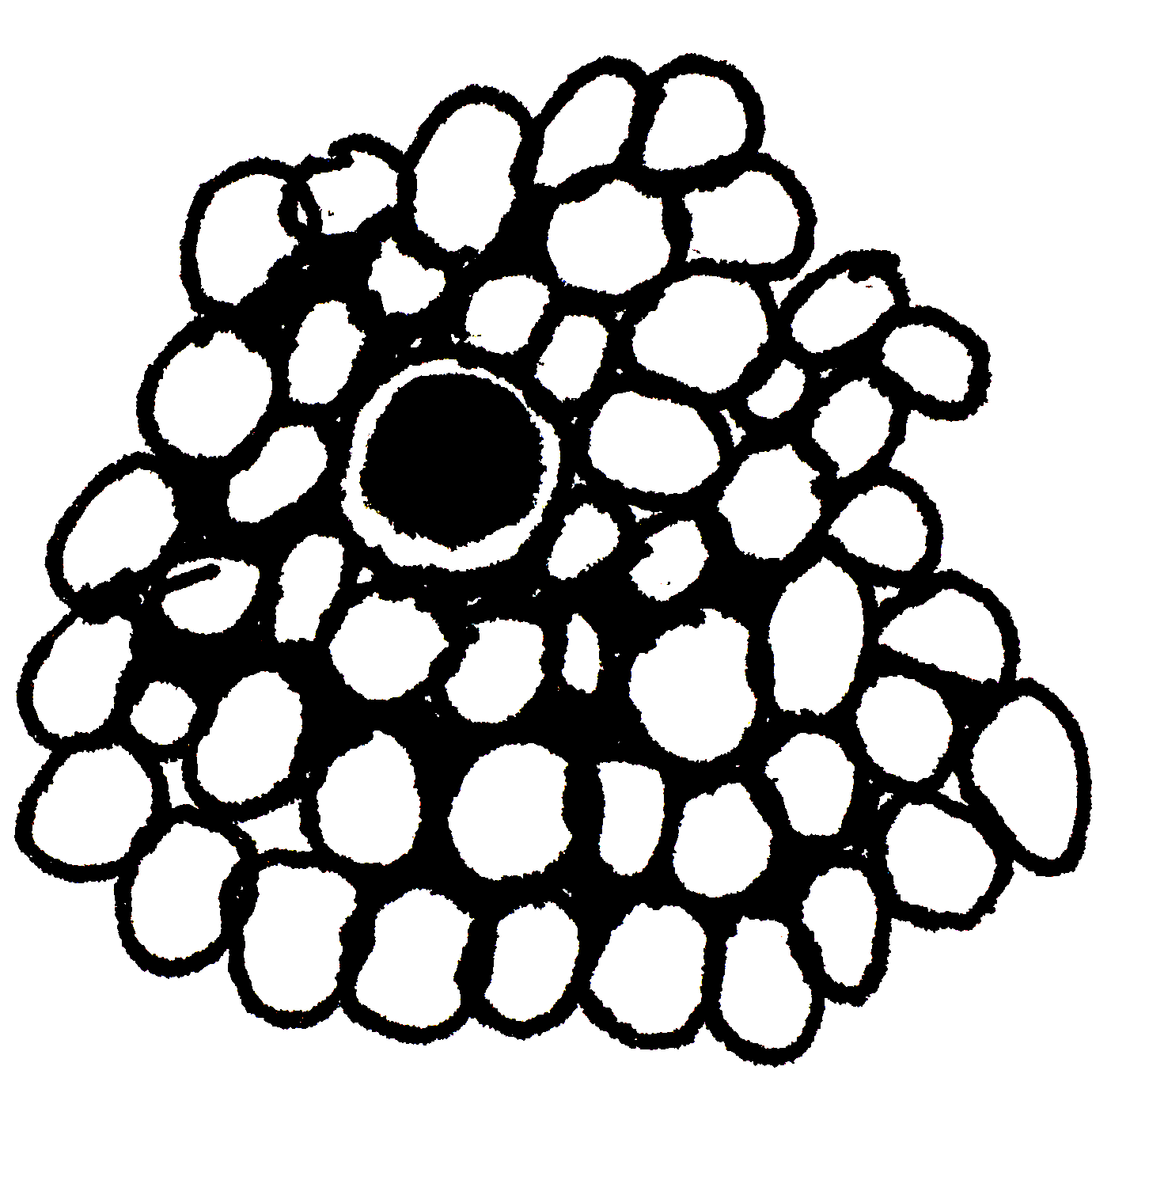*

globbed and piled unwelcome. “Hey! No loitering” her breast said. “Fuck you.” the glob responded, and nuzzled further, deeper, bigger, badder, swoler.

Penny Rot’s first final draft was a cosmic realist novel about an orthodox Jewish neighborhood in Brooklyn, where males are required to wear hats and the partnered females must cover their hair in public or they risk ostracization, banishment, erasure from collective memory. This is a kind of customary law. The protagonist wants to leave her head as is, but her society has other ideas. They try to change each other.

Shabbat, on Friday nights and Saturdays, is sacred. Some of the important male hat-wearers look like this:

*Figure 4.2: 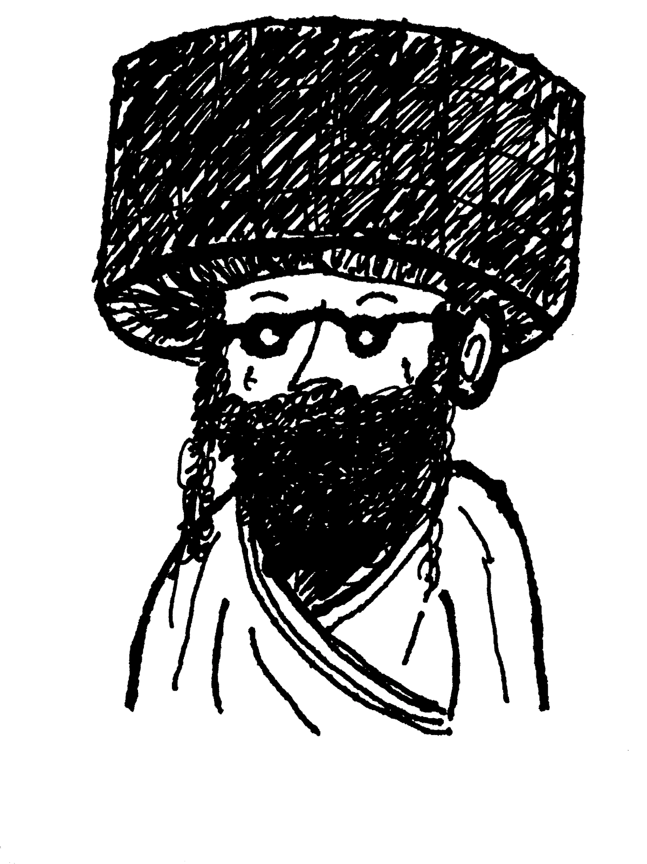*

It’s called a *streimel* (pronounced “shtreh-mil”), and it shows everyone how cool and rich and important and holy Shabbat is, and how wealthy and powerful and important the hat-wearer. Between the options of paying for food for their family for a month and a new *streimel*, sadly sometimes hats win. A *streimel* is crafted out of a formerly living mink, or some other small furry creature, killed, skinned, and carefully sewn into a hat. Some of the rabbis argued against *streimels* as unnecessarily cruel to animals. “Oh, no.” the others said, annoyed and worried sick the pricey hats they’d already purchased could ever be seen as fake-cool.

The blob (refer to *f.3.1)* stayed benign for years, tucked away neatly mostly harmlessly into a fatty fold in her tissue. Penny hobbles wobbles uneven out of Filmore Marp's typewriter shop. “Keep it cool!” he calls after her. “I’ll do my best!” she says back. “That’s all you can do.” He responds, but she’d left and didn’t hear that part.

The Magbapi parked their space ship next door. They leave the shop to go uncloak their spaceship. Why cloak into a pile of bathtubs? What do you want to move all those tubs? That’s a lot of work. Nobody wants to deal with such a pile of ceramic unimportance. Even though, turns out, it’s quite interesting.

In a classroom-learning-for-fun type of thing tucked into a space station locked onto the gravitational pull of Halley’s Comet, some galaxy-weary Magbapi travelers, long since changed for the better, will facilitate a popular and important course on the Filmore Marp approach to cool. In a different class they’ll teach you how to consume heroin safely. Turns out all you have to do is let it soak in your secondary over-folds, and it’s perfectly safe for Magbapi consumption.

Some other travelers inadvertently dramatically advance human space exploration by a few millennia—some hapless trendy salvagers disturb a cloaked spaceship, and when they look around, above the dashboard some lucky duck will find this note written on toilet paper, and hanging by some wire:

*Figure 4.3: *