**Electric Power Markets Spring 2023 ENV 717**

Nicholas School of the Environment Duke University

***Assignment #3***

In this assignment, you will use eGrid and EIA data to create a supply curve for electricity in PJM, and PJM demand data to estimate cost of meeting different demand levels.

*Please include all the graphs and tables into the word document your will submit as a solution to this assignment. Also submit a file with your calculations (excel or python) and a few lines inside those files explaining your approach to find the answers.

1. (25%) Download the file eGRID2020.xls from the [eGRID website](https://www.epa.gov/energy/emissions-generation-resource-integrated-database-egrid) released on 1/27/2022, which contains the most recent data on power generation units for the U.S[1]. Look at the PLNT20 tab and create a subset of power plants that contains only those plants with the following characteristics:

-Column L, Balancing Authority Code, is PJM Interconnection, LLC.

-Column Y, Plant primary fuel category is equal to Coal, Gas, Hydro, or Nuclear.

-Column AA, Plant capacity factor, is 0.1 or greater.

-Column AB, Plant nameplate capacity (MW), is 10 or more.

a. (10%) What is the total installed capacity (in MW) from this subset of plants?

**145,756.10 MW**

**For details, see python code or Excel file in the Github repository of the course.**

b. (15%) Assume a competitive electricity market which has, on the supply side, a number of nuclear, coal-fired, natural gas-fired, and hydropower generators as presented in this subset of plants. Use the information given in columns AB, AJ, AN, AV, Plant nameplate capacity (MW), Plant annual heat input (MMBtu), Plant annual net generation (MWh), Plant annual CO2 equivalent emissions (tons), to build a supply curve or electricity.

Assume the short-run marginal cost of natural-gas-fired and coal-fired generators is the cost of fuel only. Assume the short-run marginal cost of nuclear energy is $9/MWh. Graph the supply curve (aggregated short-run marginal cost) for electricity (at a given hour of the day). Assume the average coal and natural-gas prices for 2021 as reported by EIA in $/MBTU[2].

For this problem assume that there is no tax on CO2 equivalent emissions. This will change in the next assignment. Please copy the graph in your word document and do not forget to insert a title and to label the axes. Please differentiate the nuclear, coal plants, natural gas and hydro plants by graphing them with different colors and markers. Also remember that another way to refer to Million Btu is MMBtu.

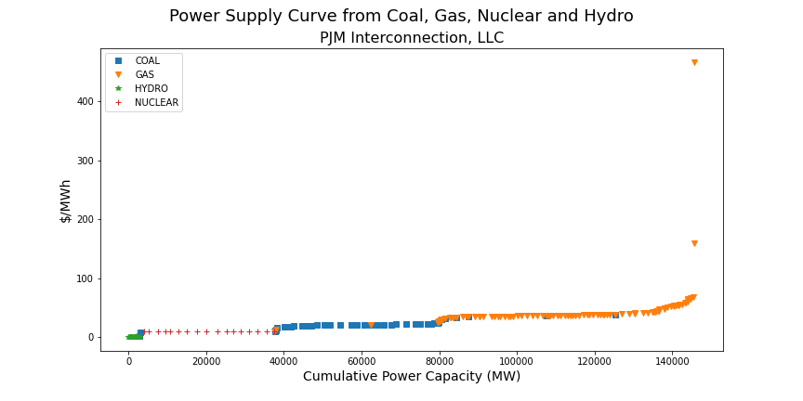

**For details, see python code or Excel file in the Github repository of the course.**

2. (25%) Download year 2022 electricity demand data (bids to buy for the day-ahead market) for PJM from <https://dataminer2.pjm.com/feed/hrl_dmd_bids>. Make sure you select 1/1/2022 (hour 0:00) as start date and 12/31/2022 (hour 23:59) as end date.

a. (10%) Graph the time-series of hourly demand (Include the graph in your word document, with demand in MW in the vertical axis and date in the horizontal axis. Make sure the axes are properly labeled.

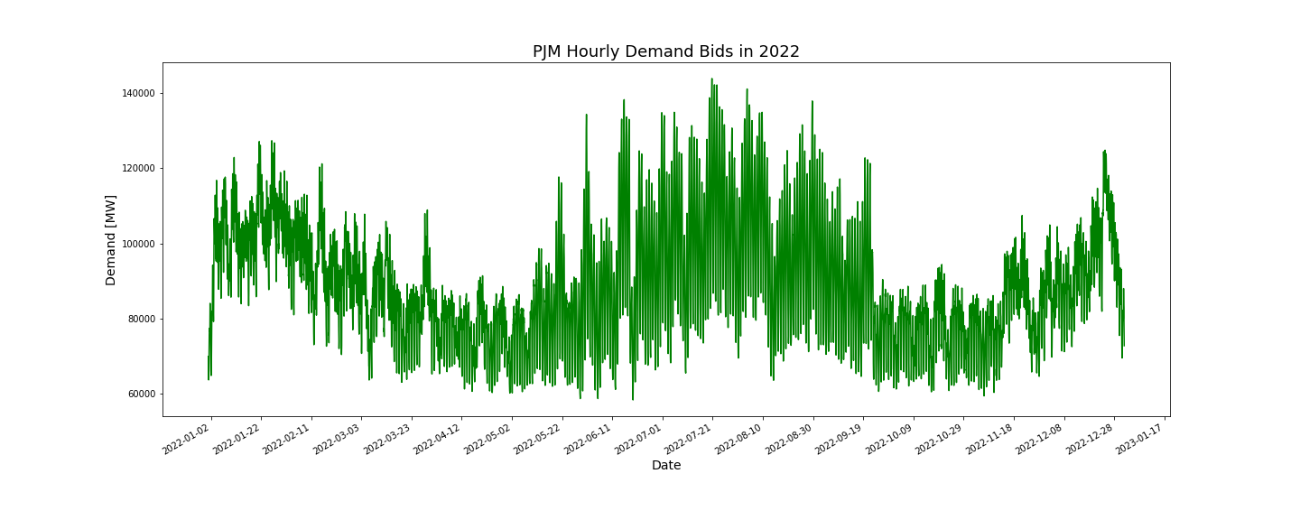

**For details, see python code or Excel file in the Github repository of the course.**

b. (15%) What was the peak demand (in MW) observed in 2022? When did the next 4 highest demands occur in 2022? Fill out the table below.

| Demand | Load (MW) | Date | Time |
| --- | --- | --- | --- |
| Highest Peak | **143864.0** | **2022-07-20** | **16:00** |
| 2nd highest | **143819.0** | **2022-07-20** | **17:00** |
| 3rd Highest | **142681.0** | **2022-07-20** | **15:00** |
| 4th highest | **142190.0** | **2022-07-21** | **16:00** |
| 5th highest | **142138.0** | **2022-07-22** | **16:00** |

**For details, see python code or Excel file in the Github repository of the course.**

3. (25%) Clear the market for a few levels of demand.

a) (15%) Use the demand data found in 2. to find the percentiles 1, 5, 10, 30, 50, 70, 90, 100 for total annual demand. Write down those percentiles in the table below. If you are using excel, the function Percentile will be useful. Percentile (Array, 0.9), where array is the matrix containing all the 8760 values of hourly demand in 2019 gives you the percentile 90%.

Using the supply curve found in 2, find the competitive market-clearing price for different load levels corresponding to each percentile. Use these results to fill out the following table:

| **Demand** | **Demand (MW)** | **Mkt clearing price ($/MWh)** |
| --- | --- | --- |
| **Percentile** |
| 5% | **65,632.85** | **21.43** |
| 10% | **69,010.10** | **22.22** |
| 30% | **79,286.10** | **24.56** |
| 50% | **85,960.50** | **34.34** |
| 70% | **96,233.80** | **35.42** |
| 90% | **112,019.30** | **36.84** |
| 100% | **143,864.00** | **59.64** |

**Calculated percentile using the numpy percentile function.**

**Observed market clearing price for each demand value in the table. Obtain the next price higher than the demand so that all of the demand could be satisfied with the provider of last resort**.

b) (10%) Show graphically, how the market is cleared for an inelastic demand (i.e., in the same graph present both the supply curve and the vertical lines for percentiles of demand 5%, 50%, 90% and 100% in the same graph. Their intersection is the price).

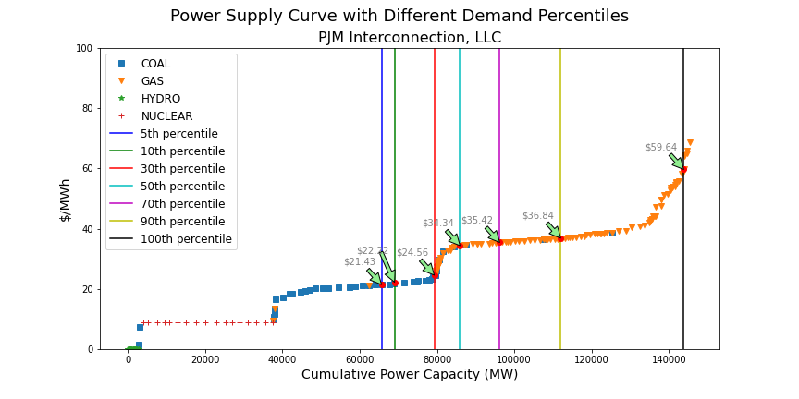

**For details, see python code or Excel file in the Github repository of the course.**

4. (10%) Problem 3.3 from Kirschen and Strbac.

Southern Antartica electrical energy market.

Assuming that all imbalances are settled at the spot market price, calculate the

profit or loss made by each of these participants.

| **Company** | **Contract Type** | **Electricity Purchased (MWh)** | **Electricity Sold (MWh)** | **Price ($/MWh)** | **Expenses ($)** | **Revenue ($)** | **Profit ($)** |
| --- | --- | --- | --- | --- | --- | --- | --- |
| Red (1000MW Max Cap Genco) | Long-term contract |  | 600 | 15 |  | 9,000 |  |
| Red | Futures |  | 200 | 14.75 |  | 2,950 |  |
| Red | Futures |  | 200 | 16 |  | 3,200 |  |
| Red | Futures |  | 200 | 15.50 |  | 3,100 |  |
| Red | Futures | 200 |  | 16 | 3,200 |  |  |
| Red | Put Option |  | **200*(Does Not Exercise)** | **14.75\*** |  |  |  |
| Red | Option Fee |  |  |  | 50 |  |  |
| Red | Generation | 800 |  | 14 | 11,200 |  |  |
| Red | Spot Market | 200 |  | 15.75 | 3,150 |  |  |
| **Red TOTAL** |  | **1,200** | **1,200** |  | **17,600** | **18,250** | **650** |
| Green (800MW Max Cap Genco) | Long-term contract (peak) |  | 500 | 16 |  | 8,000 |  |
| Green | Futures |  | 250 | 15.75 |  | 3,937.50 |  |
| Green | Generation | 770 |  | 14.25 | 10,972.50 |  |  |
| Green | Spot Market |  | 20 | 15.75 |  | 315 |  |
| **Green TOTAL** |  | **770** | **770** |  | **10,972.50** | **12,252,50** | **1,280** |
| Blue (1200MW Retailer) | Long-term contract (peak) | 700 |  | 15.5 | 10,850 |  |  |
| Blue | Futures | 250 |  | 15.75 | 3,937.50 |  |  |
| Blue | Futures | 300 |  | 15 | 4,500 |  |  |
| Blue | Futures |  | 50 | 15.50 |  | 775 |  |
| Blue | Retail |  | 1250 | 16.50 |  | 20,625 |  |
| Blue | Spot Market | 50 |  | 15.75 | 787.50 |  |  |
| **Blue TOTAL** |  | **1300** | **1300** |  | **20,075** | **21,400** | **1,325** |
| Yellow (900MW Retailer) | Long-term contract (peak) | 550 |  | 16.25 | 8,937.50 |  |  |
| Yellow | Futures | 200 |  | 15 | 3,000 |  |  |
| Yellow | Futures | 200 |  | 14.75 | 2,950 |  |  |
| Yellow | Futures | 50 |  | 14.50 | 725 |  |  |
| Yellow | Futures |  | 100 | 14 |  | 1,400 |  |
| Yellow | Call Option | 100 |  | 15.50 | 1,550 |  |  |
| Yellow | Option Fee |  |  |  | 25 |  |  |
| Yellow | Retail |  | 850 | 16.40 |  | 13,940 |  |
| Yellow | Spot Market |  | 150 | 15.75 |  | 2,362.50 |  |
| **Yellow TOTAL** |  | **1100** | **1100** |  | **17,187.50** | **17,702.50** | **515** |
| Magenta (Trading Co) | Futures | 50 |  | 14.50 | 725 |  |  |
| Magenta | Futures | 100 |  | 15 | 1,500 |  |  |
| Magenta | Futures |  | 100 | 15.25 |  | 1,525 |  |
| Magenta | Futures | 50 |  | 14.25 | 712.50 |  |  |
| Magenta | Futures |  | 100 | 17 |  | 1,700 |  |
| **Magenta TOTAL** |  | **200** | **200** |  | **2,937.50** | **3,225** | **287.50** |
| Purple (Trading Co) | Futures |  | 100 | 14.75 |  | 1,475 |  |
| Purple | Futures | 50 |  | 15 | 750 |  |  |
| Purple | Futures |  | 200 | 14.50 |  | 2,900 |  |
| Purple | Futures | 250 |  | 14 | 3,500 |  |  |
| **Purple TOTAL** |  | **300** | **300** |  | **4,250** | **4,375** | **125** |

Total Profits of each company:

| **Company** | **Profit ($)** |
| --- | --- |
| Red | 650 |
| Green | 1,280 |
| Blue | 1,325 |
| Yellow | 515 |
| Magenta | 287.50 |
| Purple | 125 |

5. (15%) Problem 3.4 from Kirschen and Strbac.

The operator of a centralized market for electrical energy has received the bids shown in the table below for the supply of electrical energy during a given period.

**Problem 3.4a: Supply curve**

Building the supply curve requires organizing the generation in merit order (lowest to highest price). The table and the supply curve are presented below.

| Company | Amount (MWh) | Cumulative Electricity Supplied (MWh) | Price ($/MWh) |
| --- | --- | --- | --- |
| **Blue** | **200** | **200** | **10.50** |
| **Red** | **100** | **300** | **12.50** |
| **Blue** | **200** | **500** | **13.00** |
| **Green** | **50** | **550** | **13.50** |
| **Red** | **100** | **650** | **14.00** |
| **Green** | **50** | **700** | **14.50** |
| **Blue** | **100** | **800** | **15.00** |
| **Green** | **50** | **850** | **15.50** |
| **Red** | **50** | **900** | **18.00** |

**Problem 3.4b:**

Assume that this market operates unilaterally, that is, that the demand does not bid and is represented by a forecast. Calculate the market price, the quantity produced by each company and the revenue of each company for each of the following loads: 400MW, 600MW, 875 MW.

Load = 400MW

| Company | Amount (MWh) | Price ($/MWh) |
| --- | --- | --- |
| **Blue** | 200 | 10.50 |
| **Red** | 100 | 12.50 |
| **Blue** | **200 (100/200 MWh supplied)** | **13.00** |
| **Green** | 50 | 13.50 |
| **Red** | 100 | 14.00 |
| **Green** | 50 | 14.50 |
| **Blue** | 100 | 15.00 |
| **Green** | 50 | 15.50 |
| **Red** | 50 | 18.00 |

With a load of 400MW, the **market price is $13/MWh.**

The quantity produced by each company and the revenue of each company:

| Company | Quantity Produced (MWh) | Revenue ($13/MWh) |
| --- | --- | --- |
| **Blue** | **300** | **$3,900** |
| **Red** | **100** | **$1,300** |
| **Green** | **0** | **$0** |

Load = 600MW

| Company | Amount (MWh) | Price ($/MWh) |
| --- | --- | --- |
| **Blue** | 200 | 10.50 |
| **Red** | 100 | 12.50 |
| **Blue** | 200 | 13.00 |
| **Green** | 50 | 13.50 |
| **Red** | **100 (50 of 100 MWh supplied)** | **14.00** |
| **Green** | 50 | 14.50 |
| **Blue** | 100 | 15.00 |
| **Green** | 50 | 15.50 |
| **Red** | 50 | 18.00 |

With a load of 600MW, the **market price is $14/MWh.**

Quantity produced by each company and the revenue of each company:

| Company | Quantity Produced (MWh) | Revenue ($14/MWh) |
| --- | --- | --- |
| **Blue** | **400** | **$5,600** |
| **Red** | **150** | **$2,100** |
| **Green** | **50** | **$700** |

Load = 875MW

| Company | Amount (MWh) | Price ($/MWh) |
| --- | --- | --- |
| **Blue** | 200 | 10.50 |
| **Red** | 100 | 12.50 |
| **Blue** | 200 | 13.00 |
| **Green** | 50 | 13.50 |
| **Red** | 100 | 14.00 |
| **Green** | 50 | 14.50 |
| **Blue** | 100 | 15.00 |
| **Green** | 50 | 15.50 |
| **Red** | **50 (25/50 MWh supplied)** | **18.00** |

With a load of 875MW, the **market price is $18/MWh.**

Quantity produced by each company and the revenue of each company:

| Company | Quantity Produced (MWh) | Revenue ($18/MWh) |
| --- | --- | --- |
| **Blue** | **500** | **$9,000** |
| **Red** | **225** | **$4,050** |
| **Green** | **150** | **$2,700** |

**Problem 3.4c:**

Suppose that instead of being treated as constant, the load is represented by its inverse demand curve, which is assumed to have the following form:

D = L − 4.0·π

where D is the demand, L is the forecasted load and π is the price. Calculate the effect that this price sensitivity of demand has on the market price and the quantity traded.

If Load = 400MW, then Demand = 400 – 4 * 13 (see price obtained from previous question)

Demand = 400 – 52 = 348

**Demand = 348MW**

| Company | Amount (MWh) | Price ($/MWh) |
| --- | --- | --- |
| **Blue** | 200 | 10.50 |
| **Red** | 100 | 12.50 |
| **Blue** | **200 (48/200 MWh supplied)** | **13.00** |
| **Green** | 50 | 13.50 |
| **Red** | 100 | 14.00 |
| **Green** | 50 | 14.50 |
| **Blue** | 100 | 15.00 |
| **Green** | 50 | 15.50 |
| **Red** | 50 | 18.00 |

With a demand of 348MW, the **market price is $13/MWh.**

Quantity produced by each company and the revenue of each company:

| Company | Quantity Produced (MWh) | Revenue ($13/MWh) |
| --- | --- | --- |
| **Blue** | **248** | **$3,224** |
| **Red** | **100** | **$1,300** |
| **Green** | **0** | **$0** |

If Load = 600MW, then Demand = 600 – 4 * 14 (see price obtained from previous question)

Demand = 600 – 56 = 544

Demand = 544MW

With a demand of 544MW, given this market supply curve, the **market price is $13.50/MWh.**

Because this is a shift in price from the previous calculation, we recalculate demand based on this new price.

If Load = 600MW, then Demand = 600 – 4 * 13.4

Demand = 600 – 54 = 546

**Demand = 546MW**

| Company | Amount (MWh) | Price ($/MWh) |
| --- | --- | --- |
| **Blue** | 200 | 10.50 |
| **Red** | 100 | 12.50 |
| **Blue** | 200 | 13.00 |
| **Green** | **50 (46/50 MWh supplied)** | **13.50** |
| **Red** | 100 | 14.00 |
| **Green** | 50 | 14.50 |
| **Blue** | 100 | 15.00 |
| **Green** | 50 | 15.50 |
| **Red** | 50 | 18.00 |

Quantity produced by each company and the revenue of each company:

| Company | Quantity Produced (MWh) | Revenue ($13.50/MWh) |
| --- | --- | --- |
| **Blue** | **400** | **$5,400** |
| **Red** | **100** | **$1,350** |
| **Green** | **46** | **$621** |

If Load = 875MW, then Demand = 875 – 4 * 18 (please see price obtained in question 5b)

Demand = 875 – 72 = 803

Demand = 803MW

With a demand of 803MW, given this market supply curve, the **market price is $15.50/MWh.**

Because this is a shift in price from the previous calculation, we recalculate demand based on this new price.

If Load = 875MW, then Demand = 857 – 4 * 15.5

Demand = 875 – 62 = 813

**Demand = 813MW**

| Company | Amount (MWh) | Price ($/MWh) |
| --- | --- | --- |
| **Blue** | 200 | 10.50 |
| **Red** | 100 | 12.50 |
| **Blue** | 200 | 13.00 |
| **Green** | 50 | 13.50 |
| **Red** | 100 | 14.00 |
| **Green** | 50 | 14.50 |
| **Blue** | 100 | 15.00 |
| **Green** | **50 (13 of 50 MWh supplied)** | **15.50** |
| **Red** | 50 | 18.00 |

With a demand of 803MW, given this market supply curve, the **market price is $15.50/MWh.**

Quantity produced by each company and the revenue of each company:

| Company | Quantity Produced (MWh) | Revenue ($15.50/MWh) |
| --- | --- | --- |
| **Blue** | **500** | **$7,750** |
| **Red** | **200** | **$3,100** |
| **Green** | **113** | **$1,751.50** |

1. The next release scheduled for 2023 will occur after this assignment is designed.
2. From the Electric Power Annual With Data for 2021 | Release Date: November 7, 2022 | Next Release Date: October 2023. Table 7.1. Receipts, Average Cost, and Quality of Fossil Fuels for the Electric Power Industry, <https://www.eia.gov/electricity/annual/html/epa_07_01.html>