CUSTOMER 360
DATA
INTEGRATION
Overview:
A retail business wants to build a unified Customer 360 view by integrating data from multiple sources, including online transactions, in-store purchases, customer service interactions, and loyalty programs. This project uses a mix of fact and dimension tables to ensure a clean, scalable structure
Medallion Architecture
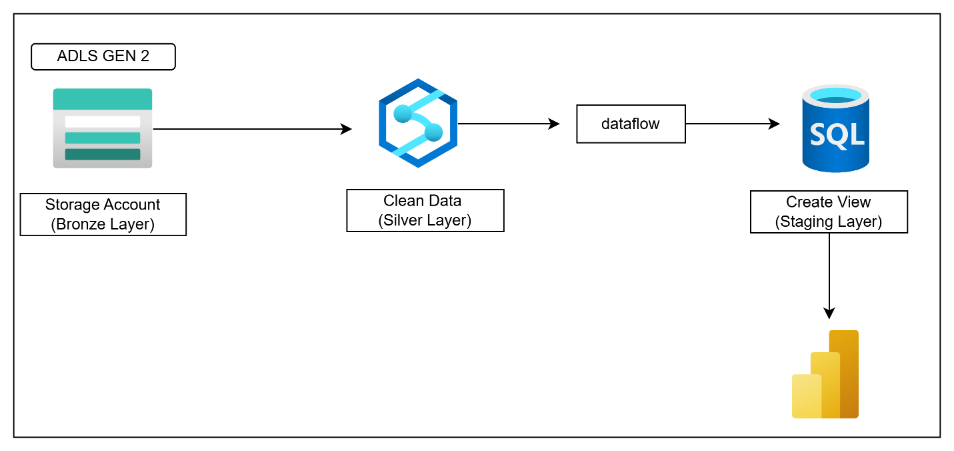
Bronze layer:
Manually uploaded the all the files in the bronze layer (ADLS gen 2)
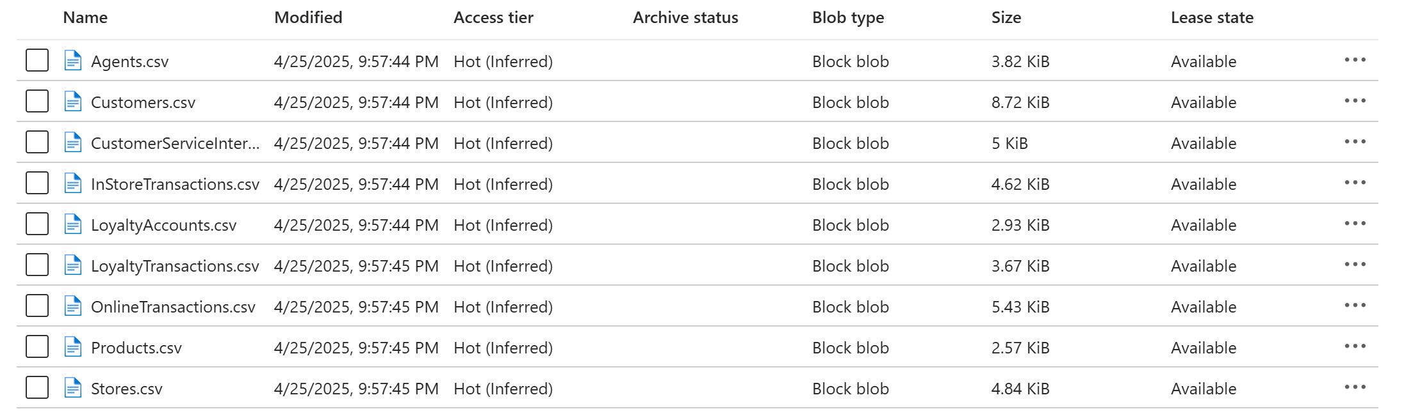
Silver layer:
DATAFLOW TRANSFORMATION
Source: get the data from gen 2
Filter : Pick only the rows that meet a condition.
Aggregate: Summarize data by combining rows.
Cast: Change the type of data in a column.
Sink : Load the data in sql database
Step 1 : For Customer table I used dataflow for cleaning
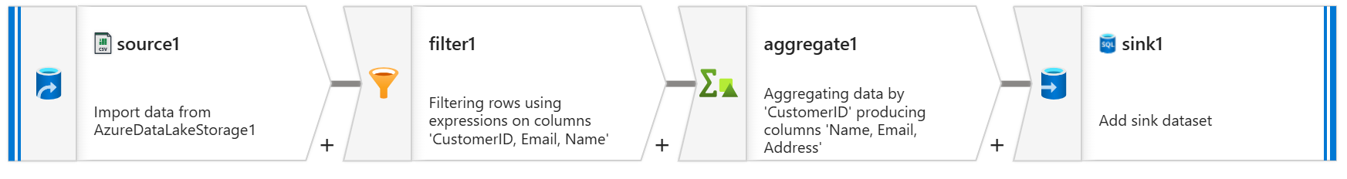
HERE IS THE OUTPUT IN SSMS
CREATE TABLE Customers (
CustomerID INT PRIMARY KEY,
Name VARCHAR(100),
Email VARCHAR(100),
Address VARCHAR(255)
);
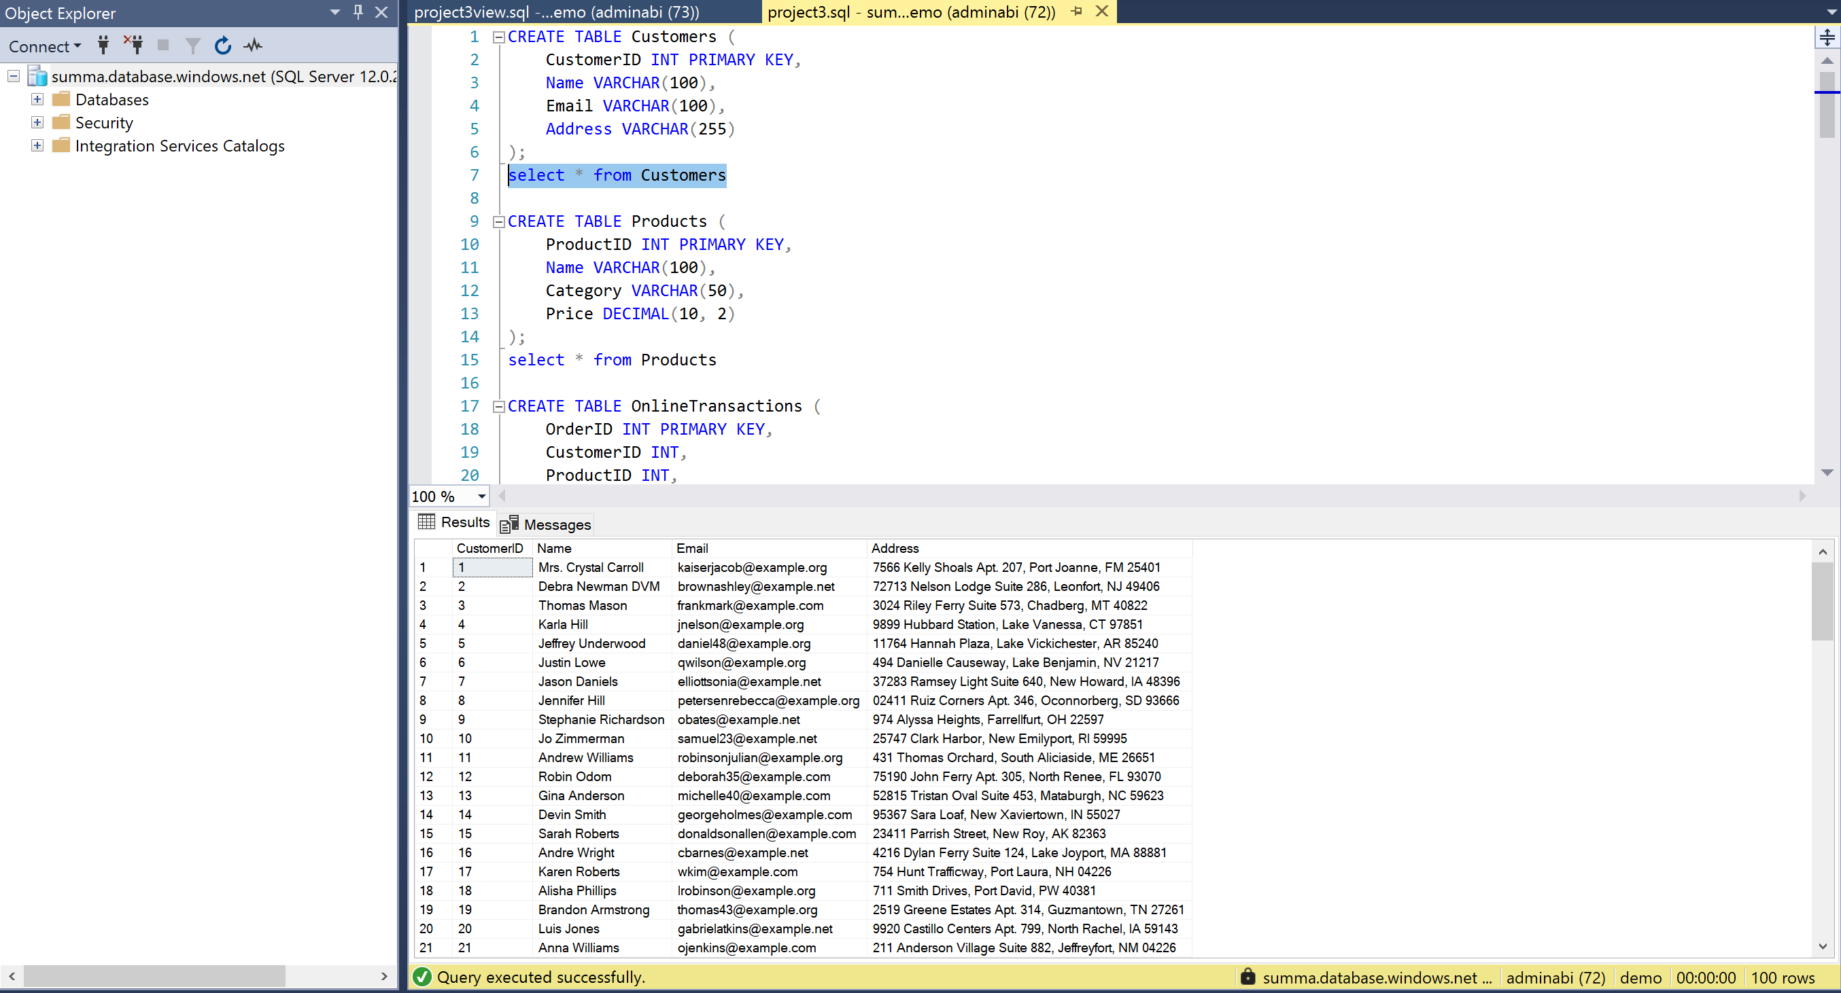
Step 2 : For Products table, used dataflow for cleaning
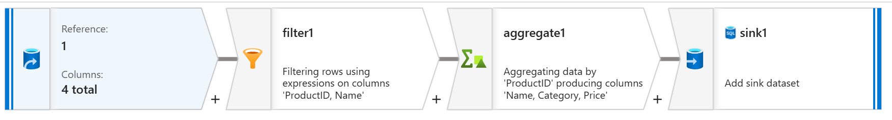
HERE IS THE OUTPUT IN SSMS
CREATE TABLE Products (
ProductID INT PRIMARY KEY,
Name VARCHAR(100),
Category VARCHAR(50),
Price DECIMAL(10, 2)
);
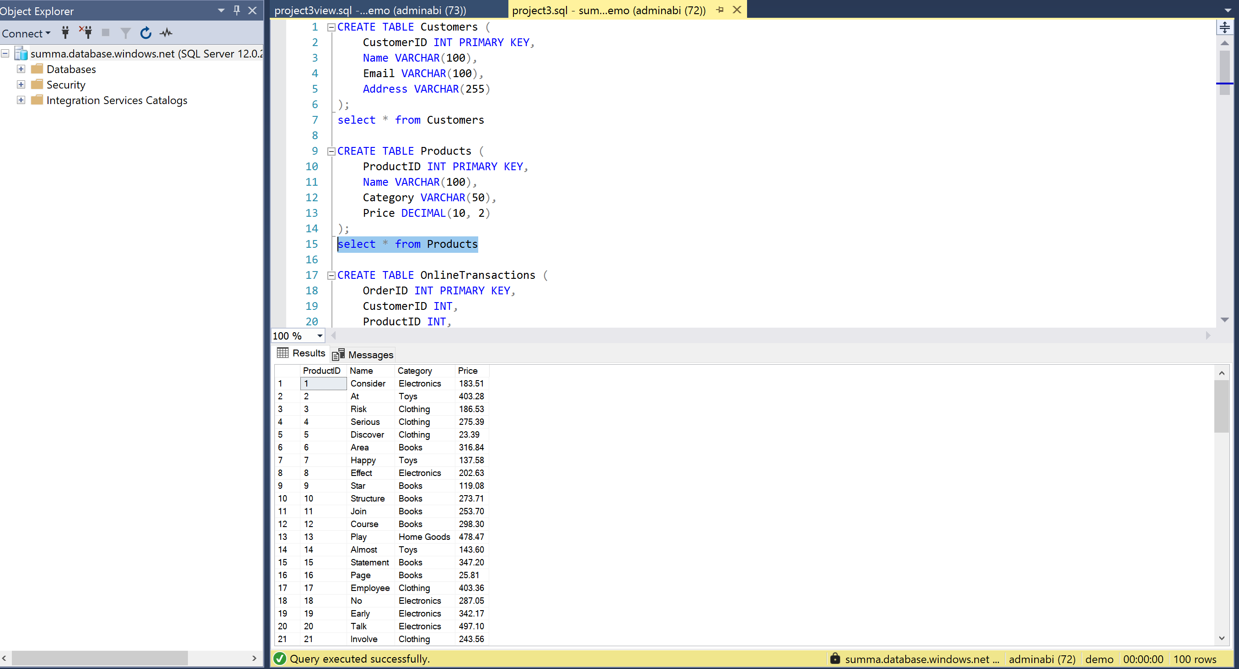

Step 3 : For Stores table, used dataflow for cleaning
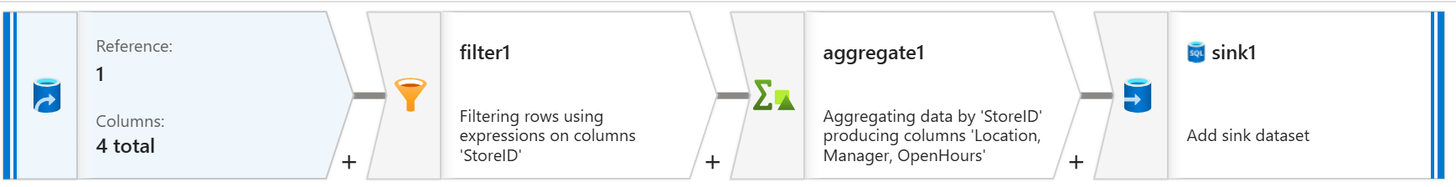
HERE IS THE OUTPUT IN SSMS
CREATE TABLE Stores (
StoreID INT PRIMARY KEY,
Location VARCHAR(100),
Manager VARCHAR(100),
OpenHours VARCHAR(50)
);
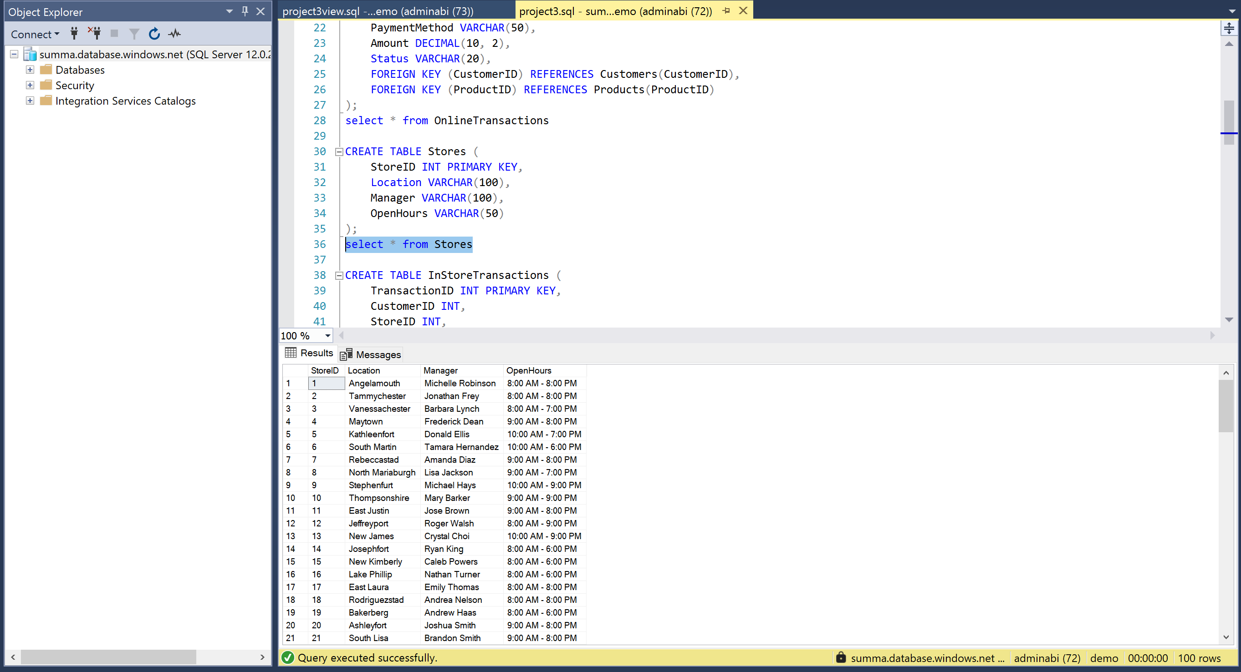

Step 4 : For Customer Service Interactions table, used dataflow for cleaning
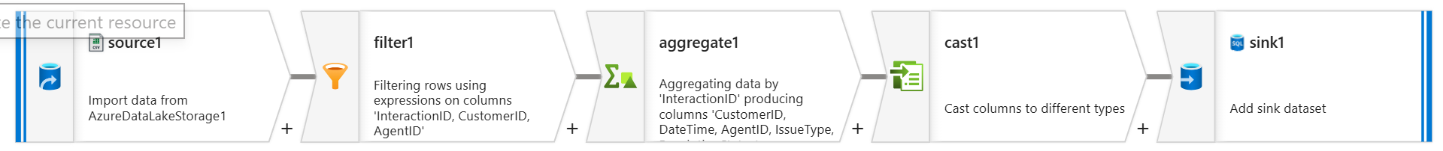
HERE IS THE OUTPUT IN SSMS
CREATE TABLE CustomerServiceInteractions (
InteractionID INT PRIMARY KEY,
CustomerID INT,
DateTime DATETIME,
AgentID INT,
IssueType VARCHAR(50),
ResolutionStatus VARCHAR(50),
FOREIGN KEY (CustomerID) REFERENCES Customers(CustomerID),
FOREIGN KEY (AgentID) REFERENCES Agents(AgentID)
);
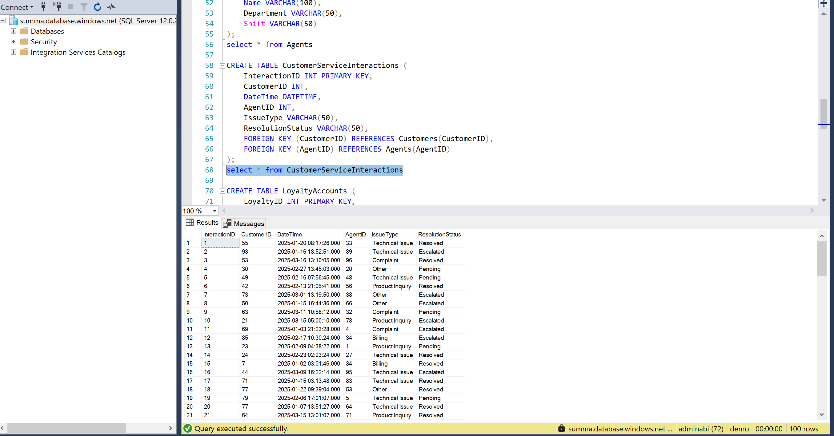

Step 5 : For Online Transactions table, used dataflow for cleaning
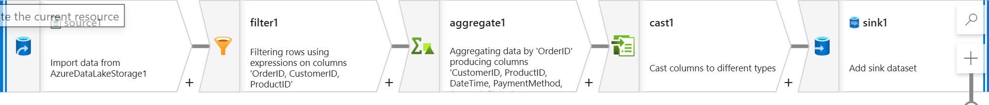
HERE IS THE OUTPUT IN SSMS
CREATE TABLE OnlineTransactions (
OrderID INT PRIMARY KEY,
CustomerID INT,
ProductID INT,
DateTime DATETIME,
PaymentMethod VARCHAR(50),
Amount DECIMAL(10, 2),
Status VARCHAR(20),
FOREIGN KEY (CustomerID) REFERENCES Customers(CustomerID),
FOREIGN KEY (ProductID) REFERENCES Products(ProductID)
);
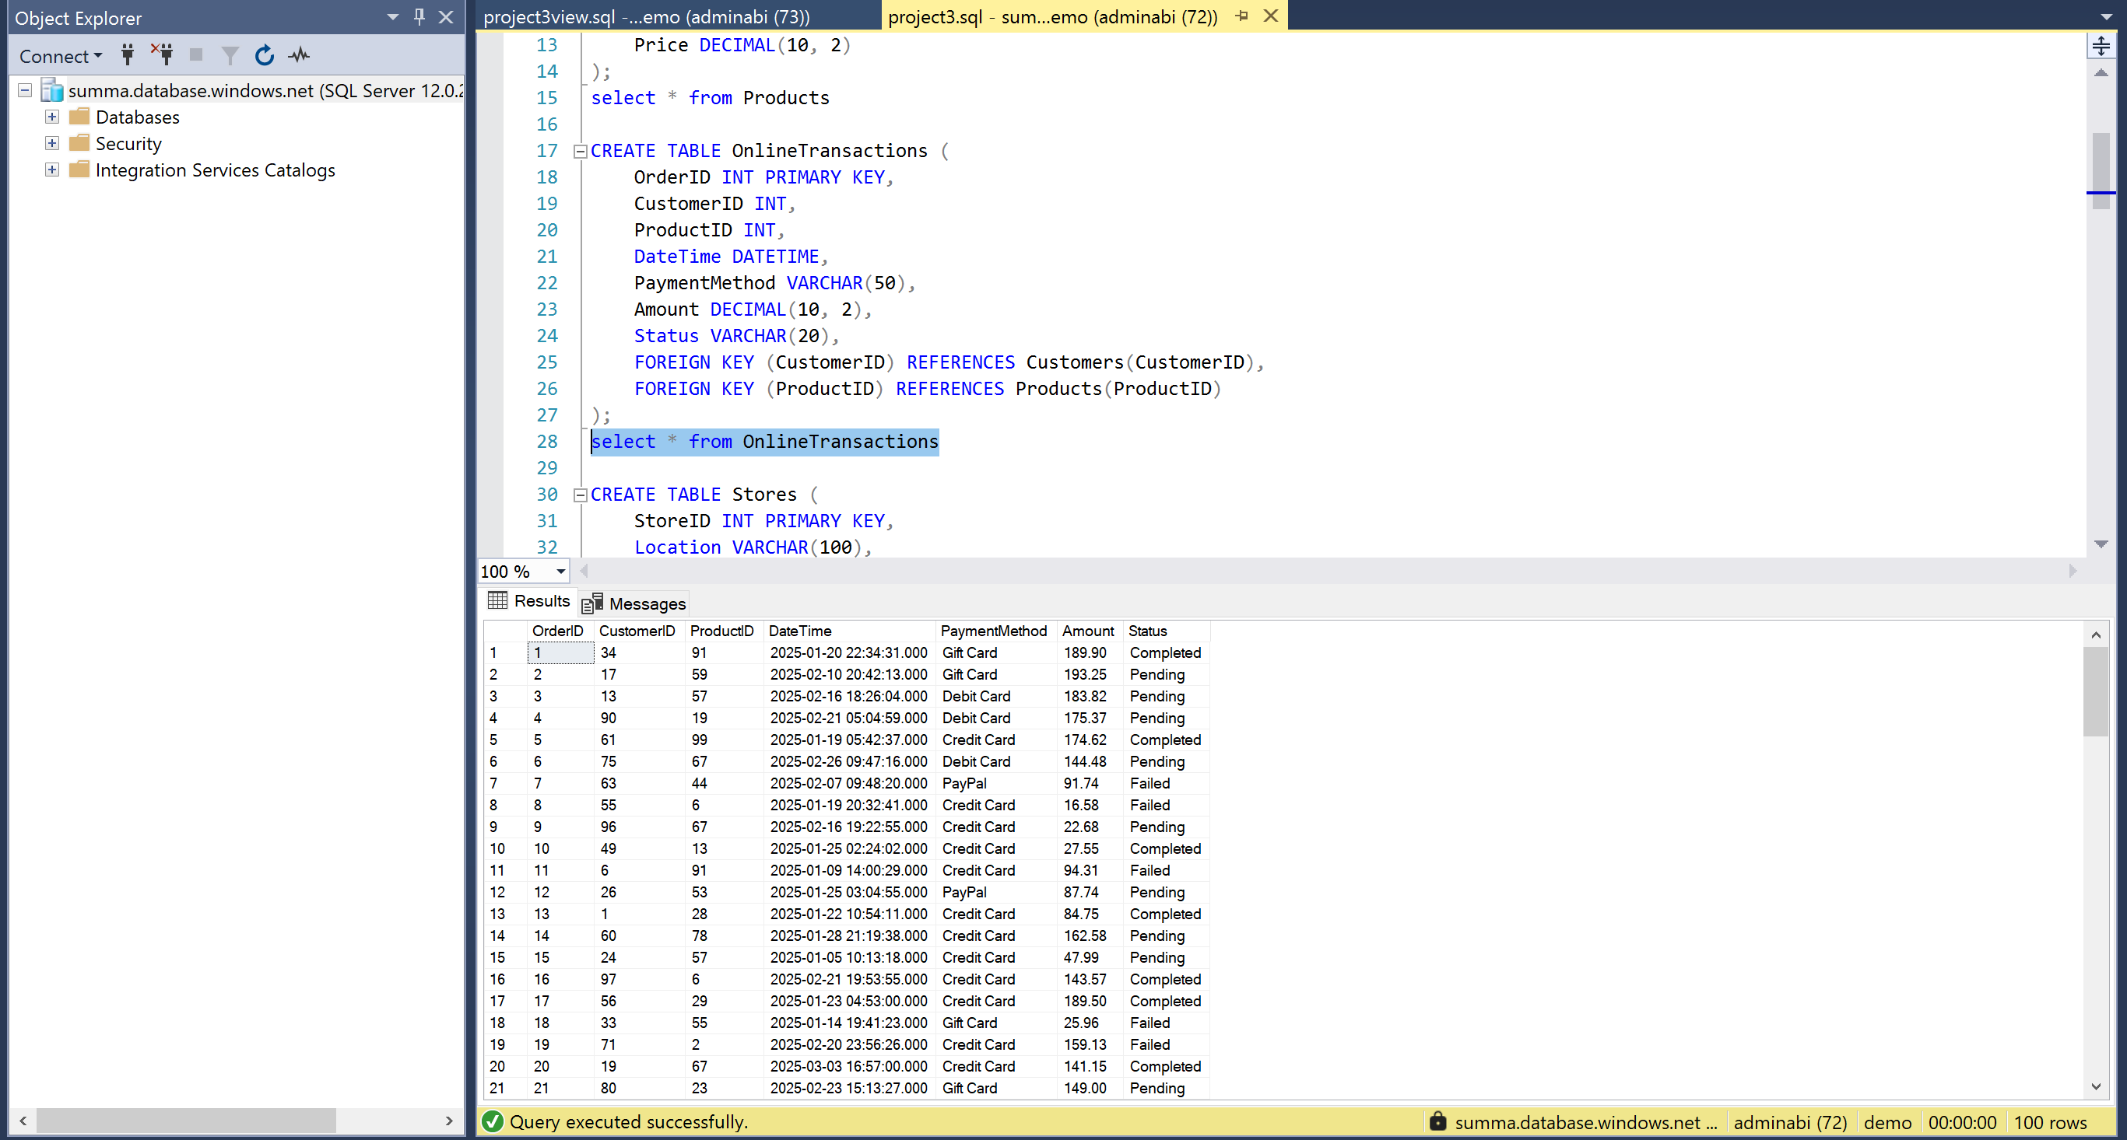

Step 6 : For Loyalty Accounts table, used dataflow for cleaning
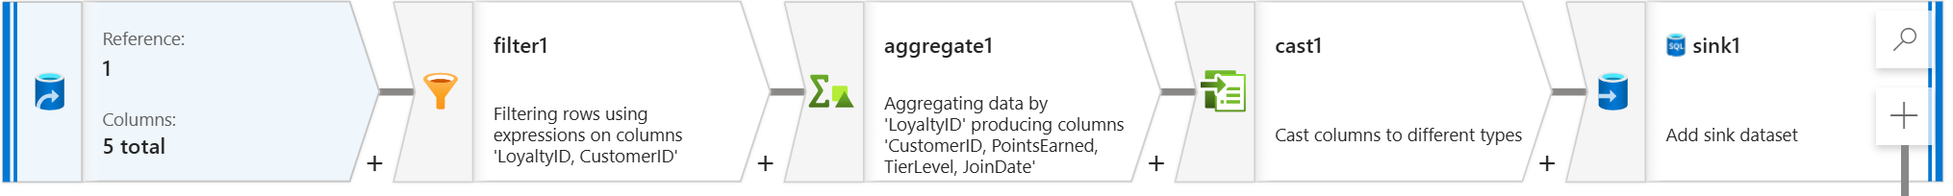
HERE IS THE OUTPUT IN SSMS
CREATE TABLE LoyaltyAccounts (
LoyaltyID INT PRIMARY KEY,
CustomerID INT,
PointsEarned INT,
TierLevel VARCHAR(20),
JoinDate DATE,
FOREIGN KEY (CustomerID) REFERENCES Customers(CustomerID)
);
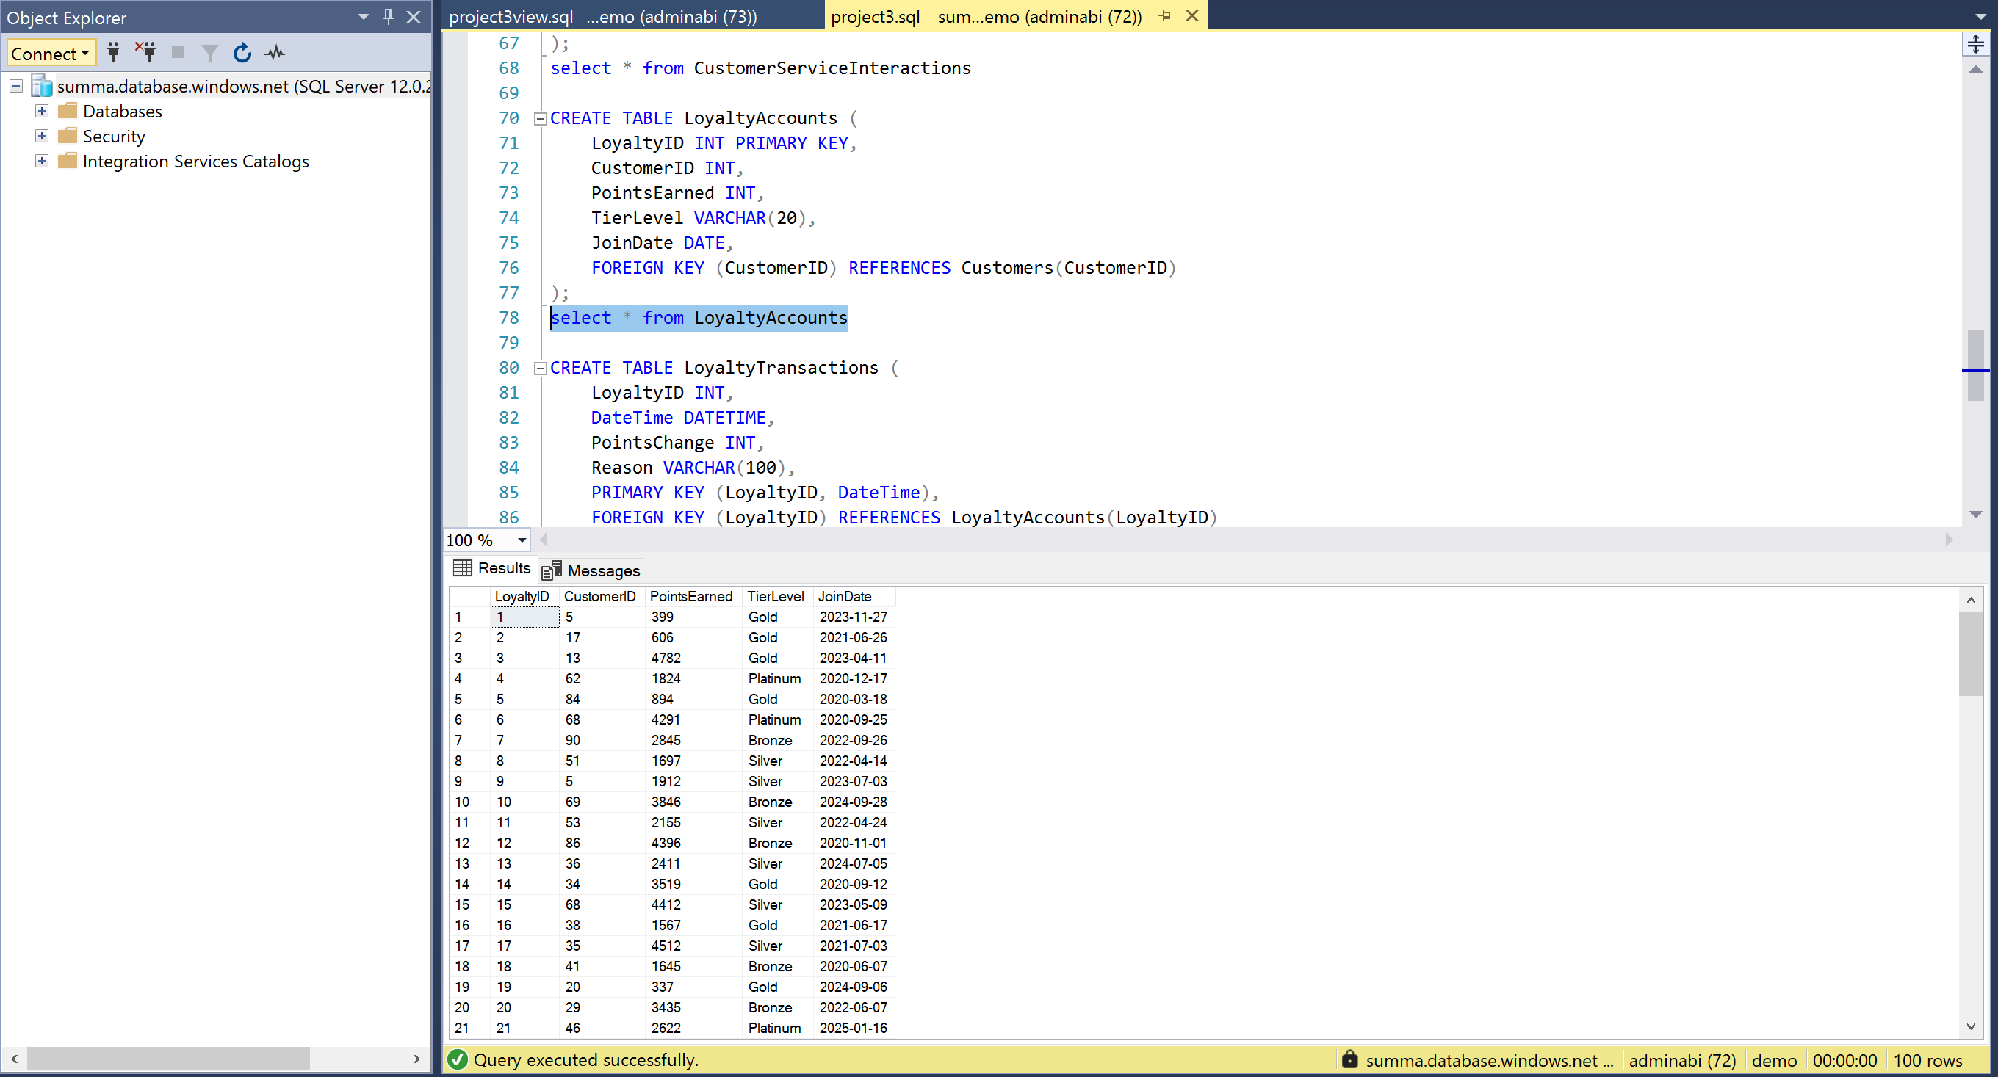

Step 7 : For Loyalty Transactions table, used dataflow for cleaning
HERE IS THE OUTPUT IN SSMS
CREATE TABLE LoyaltyTransactions (
LoyaltyID INT,
DateTime DATETIME,
PointsChange INT,
Reason VARCHAR(100),
PRIMARY KEY (LoyaltyID, DateTime),
FOREIGN KEY (LoyaltyID) REFERENCES LoyaltyAccounts(LoyaltyID)
);
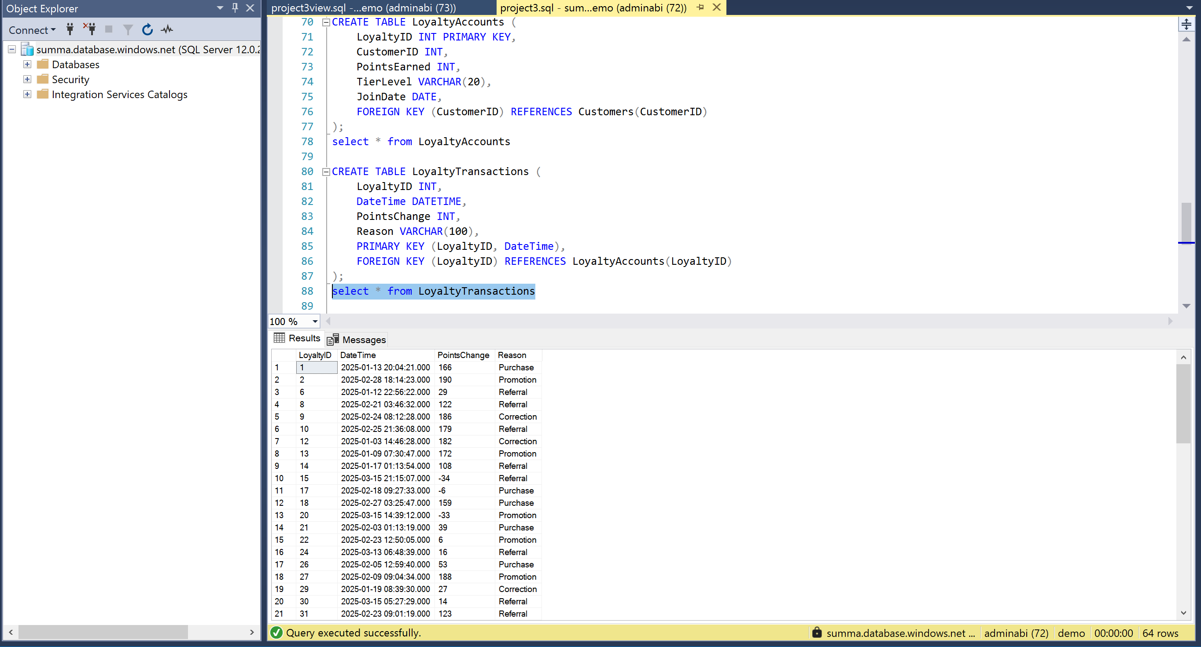

Step 8 : For Agent table, used dataflow for cleaning
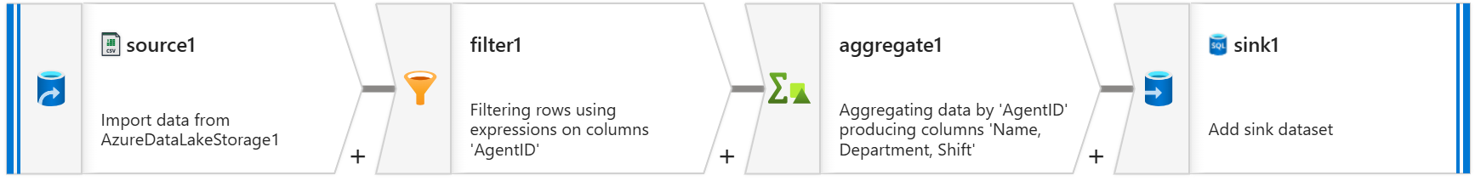
HERE IS THE OUTPUT IN SSMS
CREATE TABLE Agents (
AgentID INT PRIMARY KEY,
Name VARCHAR(100),
Department VARCHAR(50),
Shift VARCHAR(50)
);
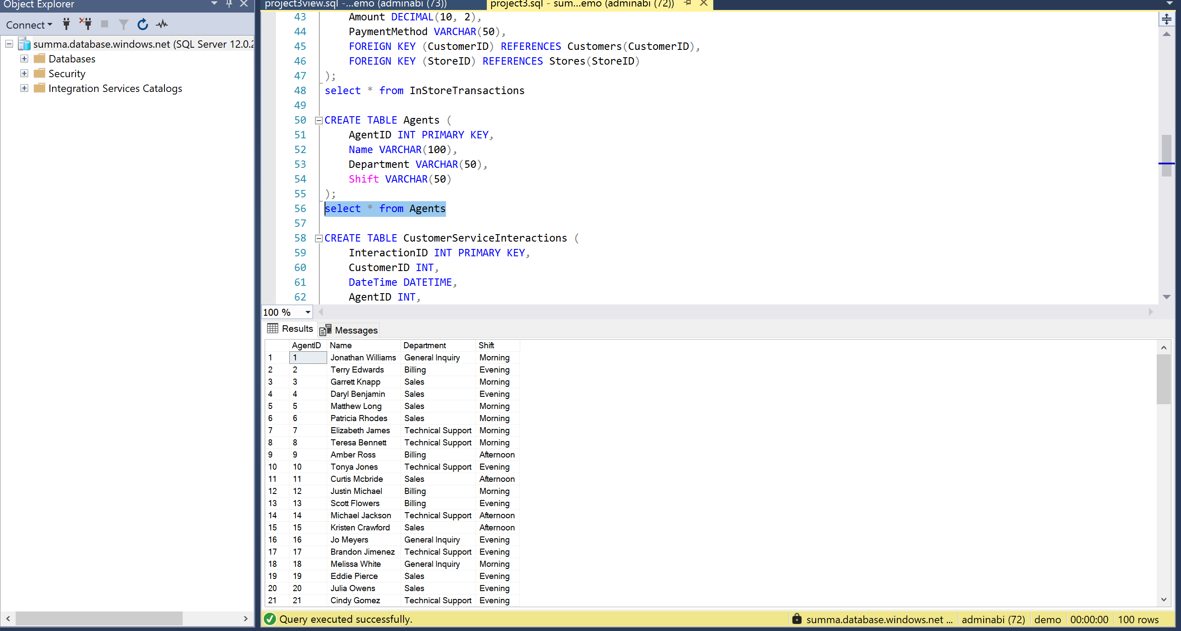

Step 9 : For Instore Transactions table, used dataflow for cleaning
HERE IS THE OUTPUT IN SSMS
CREATE TABLE InStoreTransactions (
TransactionID INT PRIMARY KEY,
CustomerID INT,
StoreID INT,
DateTime DATETIME,
Amount DECIMAL(10, 2),
PaymentMethod VARCHAR(50),
FOREIGN KEY (CustomerID) REFERENCES Customers(CustomerID),
FOREIGN KEY (StoreID) REFERENCES Stores(StoreID)
);
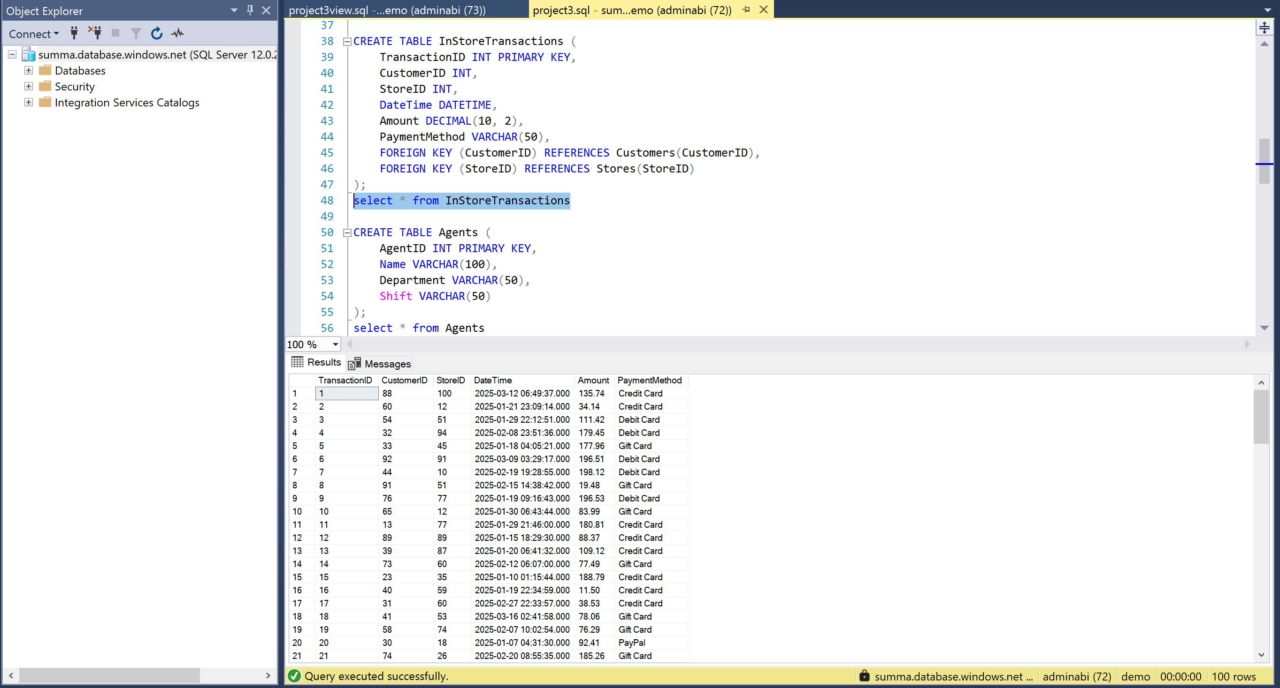
STAGING LAYER :
VIEWS IN TABLES
Created 4 views in all the tables
CREATE VIEW PeakTransactionTimes AS
SELECT
Status,
DayOfWeek,
HourOfDay,
COUNT(*) AS TransactionCount
FROM (
SELECT
'Completed' AS Status,
DATENAME(WEEKDAY, DateTime) AS DayOfWeek,
DATEPART(HOUR, DateTime) AS HourOfDay
FROM InStoreTransactions

UNION ALL

SELECT
'Pending' AS Status,
DATENAME(WEEKDAY, DateTime),
DATEPART(HOUR, DateTime)
FROM OnlineTransactions
) AS CombinedTransactions
GROUP BY
Status,
DayOfWeek,
HourOfDay;
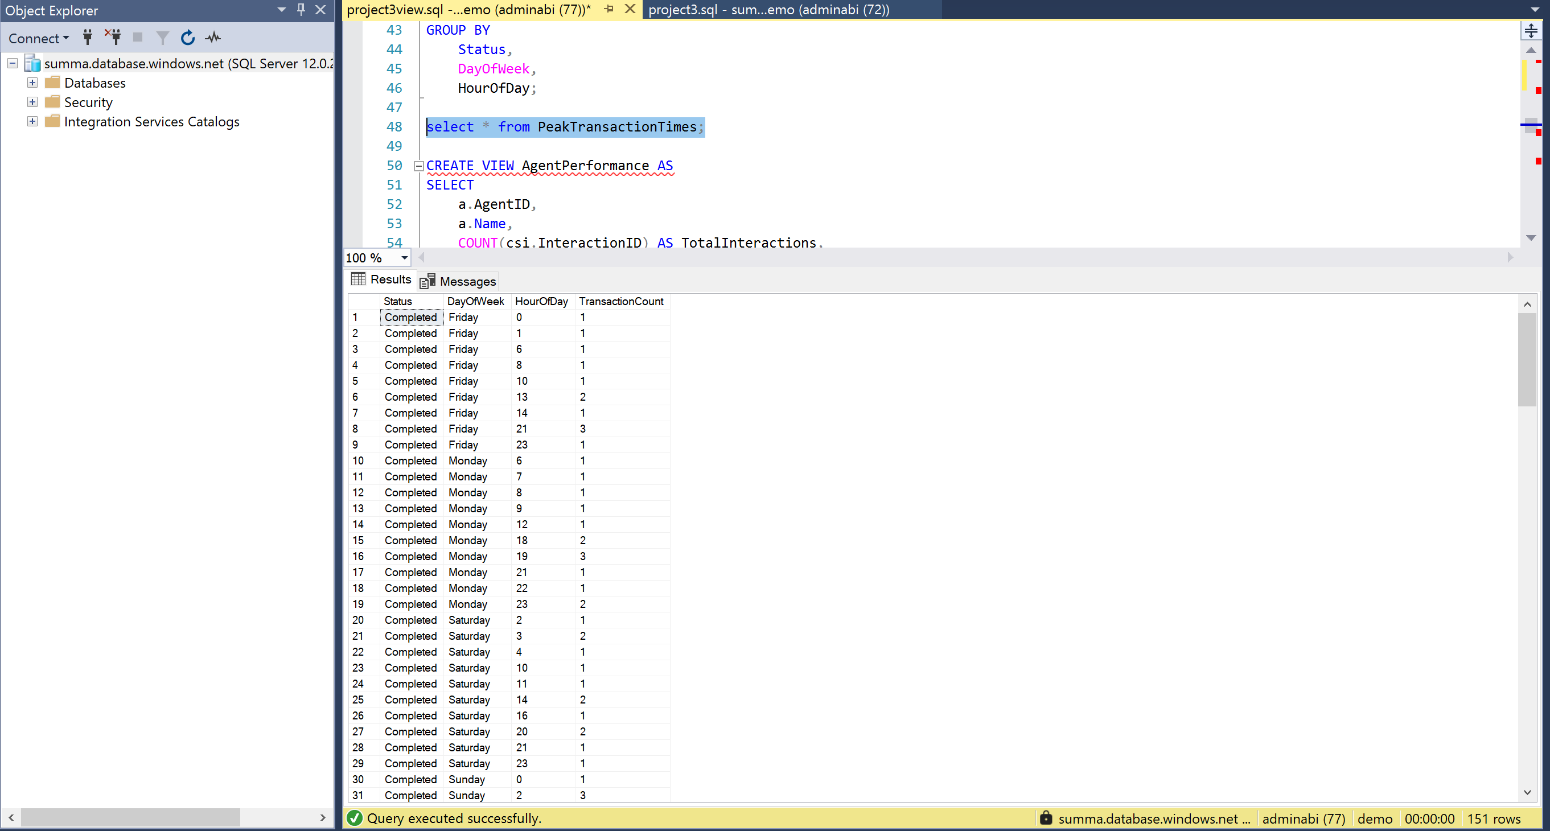

CREATE VIEW AverageOrderValue AS
SELECT
p.Name AS ProductName,
p.Category AS ProductCategory,
COALESCE(s.Location, 'Online') AS StoreLocation,
COUNT(ot.OrderID) AS TotalOrders,
SUM(ot.Amount) AS TotalRevenue,
CASE
WHEN COUNT(ot.OrderID) = 0 THEN 0
ELSE SUM(ot.Amount) / COUNT(ot.OrderID)
END AS AvgOrderValue
FROM OnlineTransactions ot
JOIN Products p ON ot.ProductID = p.ProductID
JOIN Customers c ON ot.CustomerID = c.CustomerID
LEFT JOIN InStoreTransactions ist ON ist.CustomerID = c.CustomerID
LEFT JOIN Stores s ON ist.StoreID = s.StoreID
GROUP BY p.ProductID, p.Name, p.Category, s.Location;
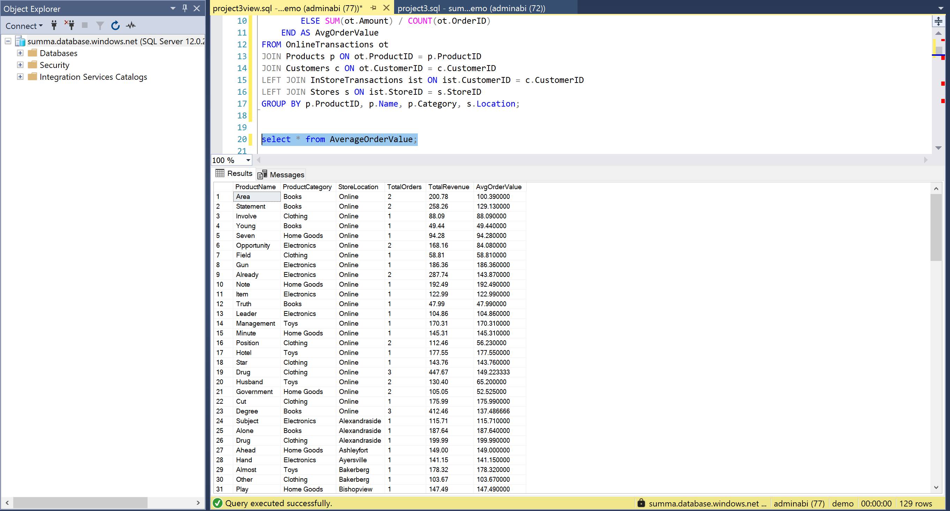
CREATE VIEW AgentPerformance AS
SELECT
a.AgentID,
a.Name,
COUNT(csi.InteractionID) AS TotalInteractions,
SUM(IIF(csi.ResolutionStatus = 'Resolved', 1, 0)) AS ResolvedCount,
SUM(IIF(csi.ResolutionStatus = 'Escalated', 1, 0)) AS EscalatedCount,
SUM(IIF(csi.ResolutionStatus = 'Pending', 1, 0)) AS PendingCount,
AVG(IIF(csi.ResolutionStatus = 'Resolved', 1.0, 0.0)) AS ResolutionSuccessRate
FROM
Agents a
LEFT JOIN
CustomerServiceInteractions csi ON a.AgentID = csi.AgentID
GROUP BY
a.AgentID,
a.Name;
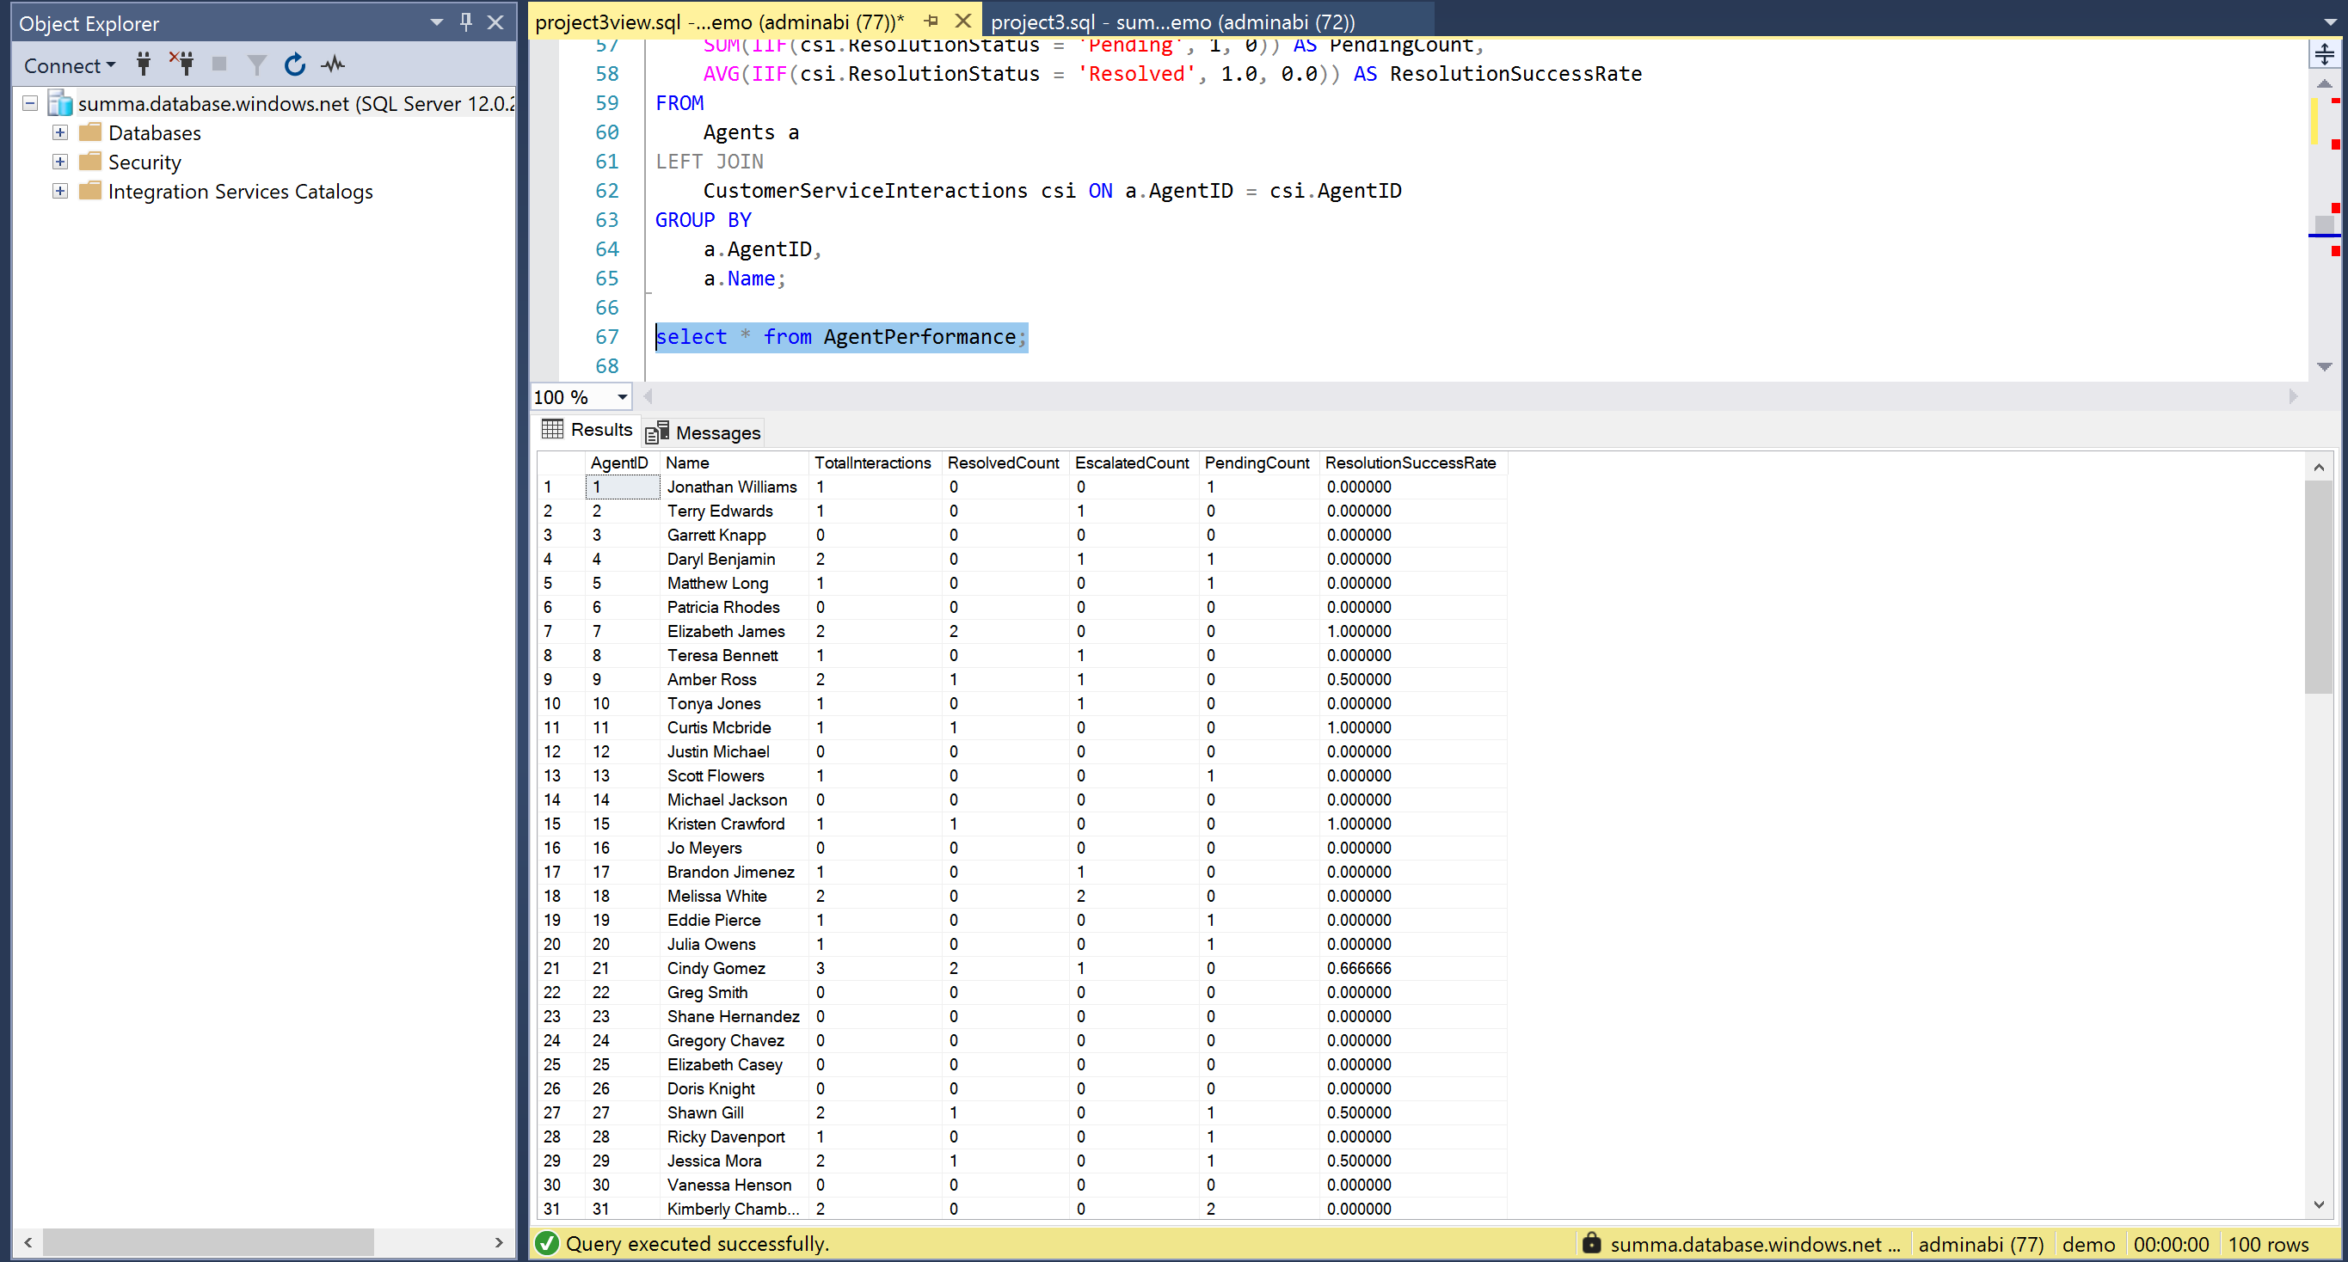
CREATE VIEW CustomerSegments AS
WITH CustomerStats AS (
SELECT
la.CustomerID,
la.TierLevel,
COUNT(lt.DateTime) AS PurchaseFrequency,
SUM(lt.PointsChange) AS TotalPoints
FROM
LoyaltyAccounts la
LEFT JOIN
LoyaltyTransactions lt ON la.LoyaltyID = lt.LoyaltyID
GROUP BY
la.CustomerID,
la.TierLevel
),
TopSpenders AS (
SELECT
CustomerID
FROM (
SELECT
CustomerID,
NTILE(10) OVER (ORDER BY TotalPoints DESC) AS SpendDecile
FROM CustomerStats
) AS Ranked
WHERE SpendDecile = 1 -- Top 10%
)
SELECT
cs.CustomerID,
cs.TierLevel,
cs.TotalPoints,
cs.PurchaseFrequency,
CASE
WHEN cs.CustomerID IN (SELECT CustomerID FROM TopSpenders) THEN 'High-Value Customer'
WHEN cs.PurchaseFrequency = 1 THEN 'One-Time Buyer'
WHEN cs.TierLevel = 'Platinum' OR cs.TierLevel = 'Gold' THEN 'Loyalty Champion'
ELSE 'Regular Customer'
END AS CustomerSegment
FROM
CustomerStats cs;
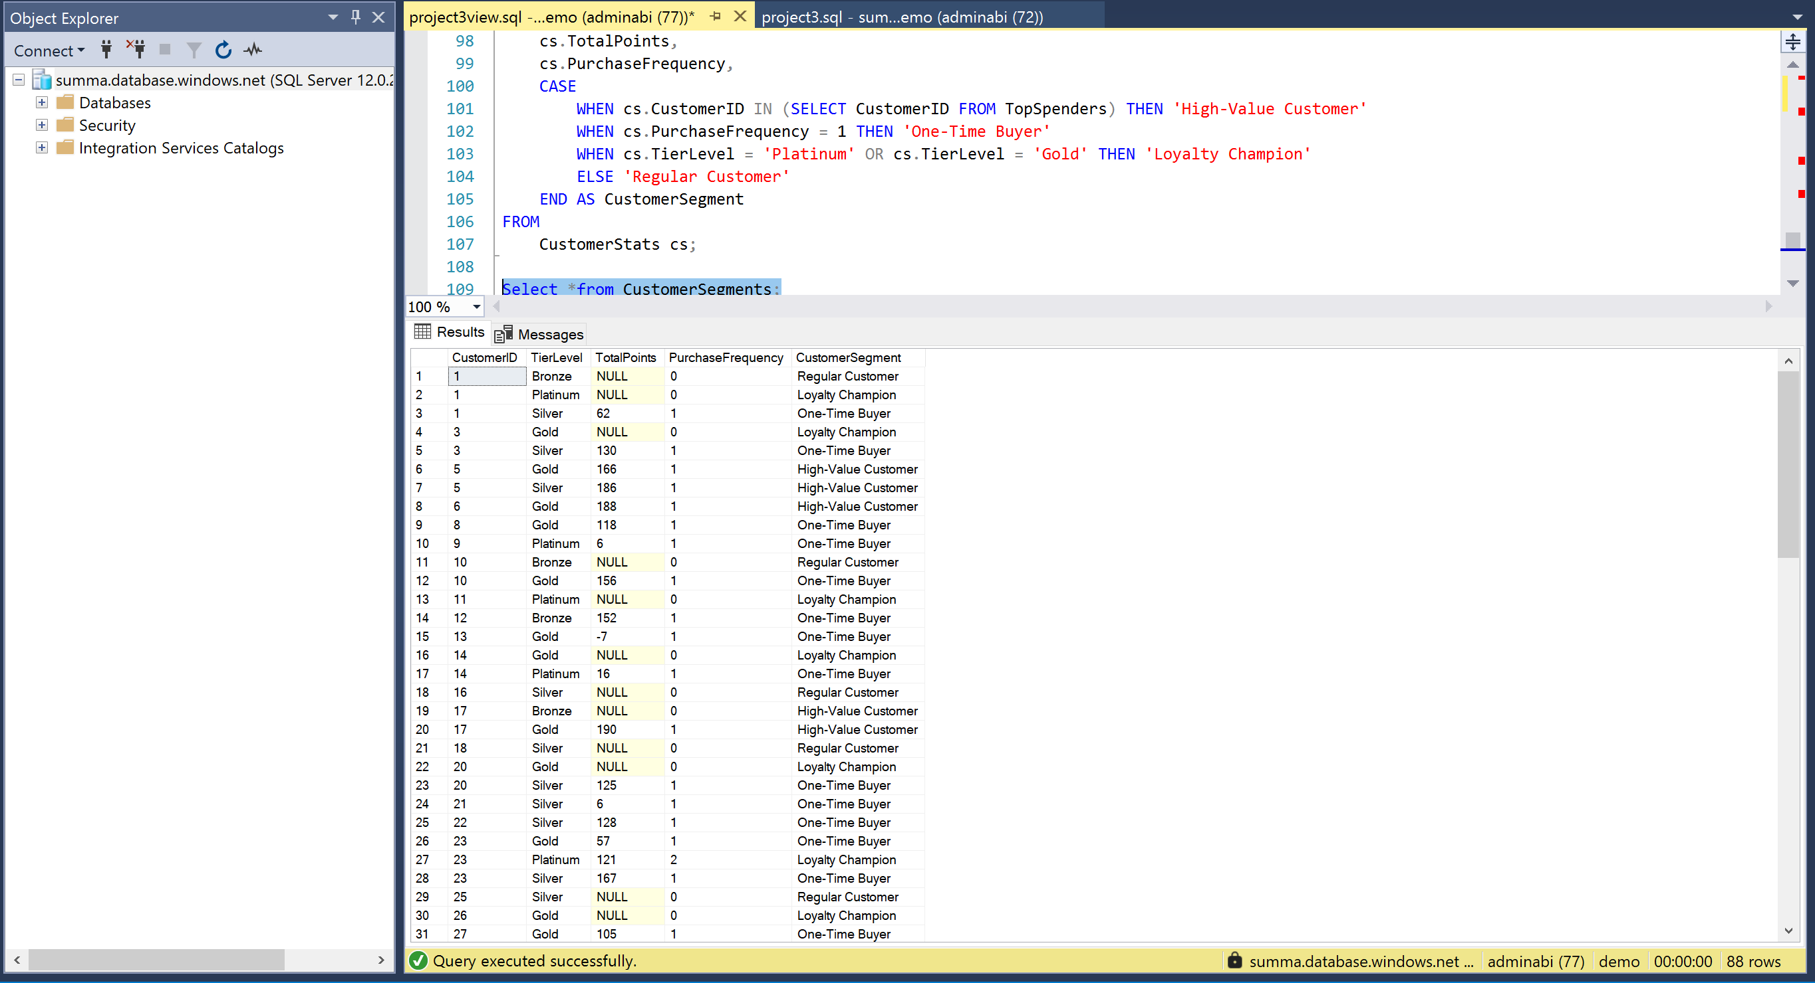
IMPORTED ALL THE VIEW IN POWER BI AND PUBLISHED THE VIEWS IN FABRIC
