SERVERLESS SQL POOL

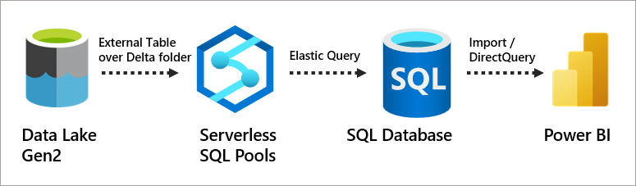

A serverless SQL pool is a feature in Azure Synapse Analytics that allows you to query and analyze data stored in your data lake without needing to set up or manage any servers. Think of it as a tool that lets you run SQL queries on your data directly, without having to move or prepare it first.
Here’s why it’s cool:
- No setup required: You don’t need to worry about infrastructure or servers—it’s all handled for you.
- Pay-as-you-go: You’re only charged for the amount of data your queries process, making it cost-effective.
- Supports multiple formats: It works with data in formats like CSV, Parquet, and JSON.
- On-demand: You can use it whenever you need, without keeping anything running in the background.
It’s great for exploring data, creating reports, or transforming data for further analysis.

Write Query using Synapse Serverless SQL pool

- Read CSV, Parquet and Delta Format files.
Step 1 : To read csv file, go to linked services select the csv file which you want to read
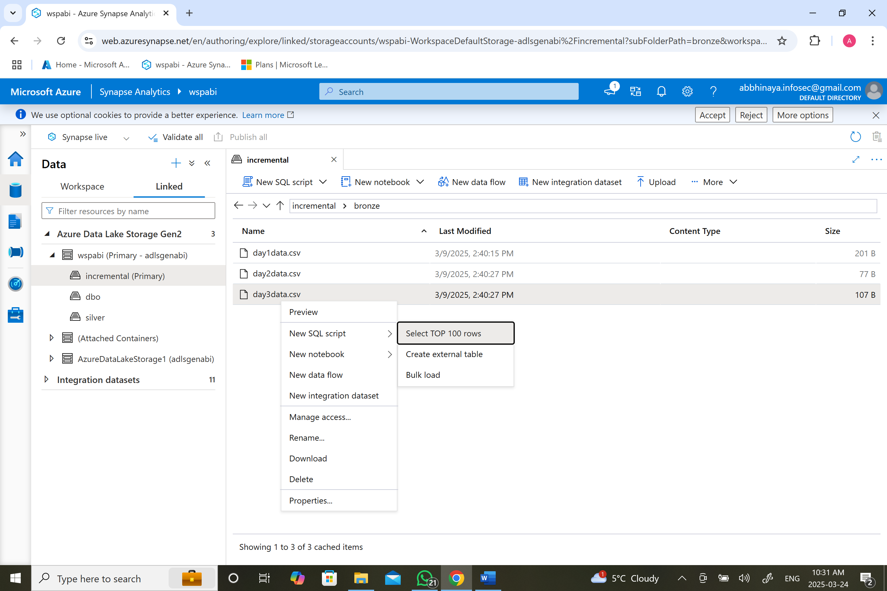

Step 2 : in this query add header_row to display the header row
SELECT
TOP 100 *
FROM
OPENROWSET(
BULK 'https://adlsgenabi.dfs.core.windows.net/incremental/bronze/day3data.csv',
FORMAT = 'CSV',
PARSER_VERSION = '2.0',
HEADER_ROW = True
) AS [result]

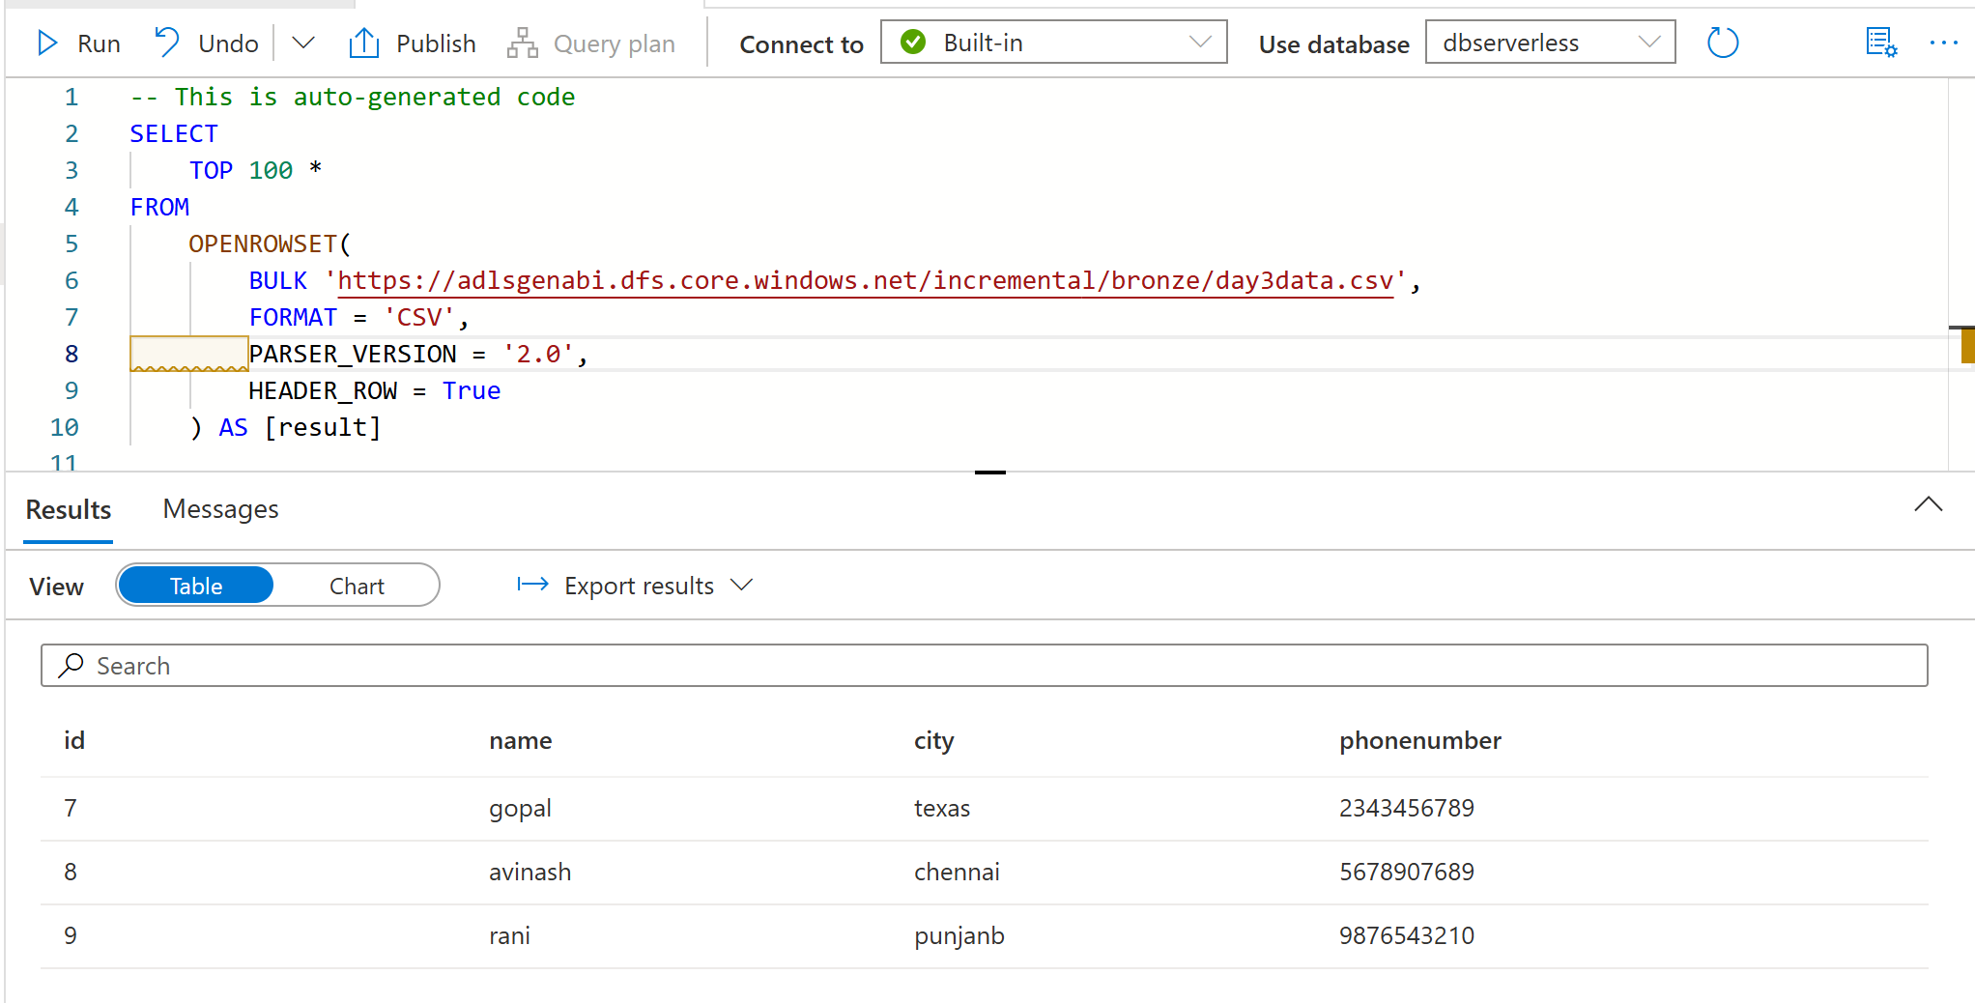
Step 3 : To read the parquet file, do the following steps which have done for csv

SELECT
TOP 100 *
FROM
OPENROWSET(
BULK 'https://adlsgenabi.dfs.core.windows.net/incremental/house-price.parquet',
FORMAT = 'PARQUET',
Header_row = true
) AS [result]

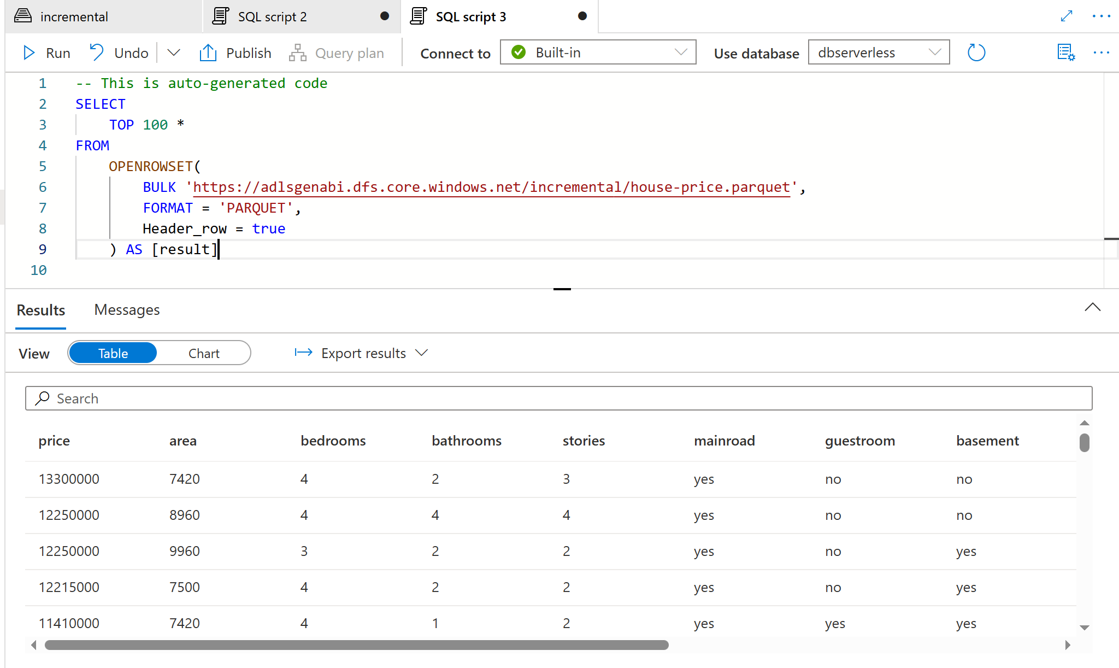
Step 4 : To read the delta file format, do the following as csv and parquet
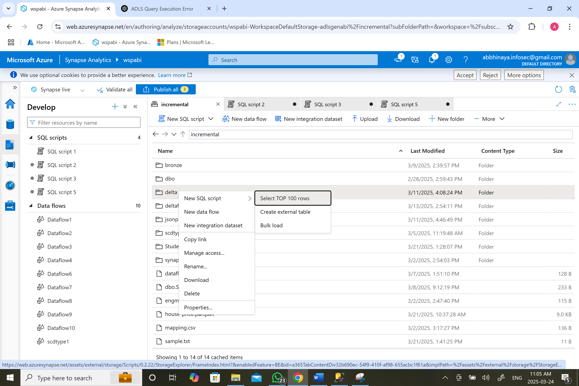
In the click for delta file format
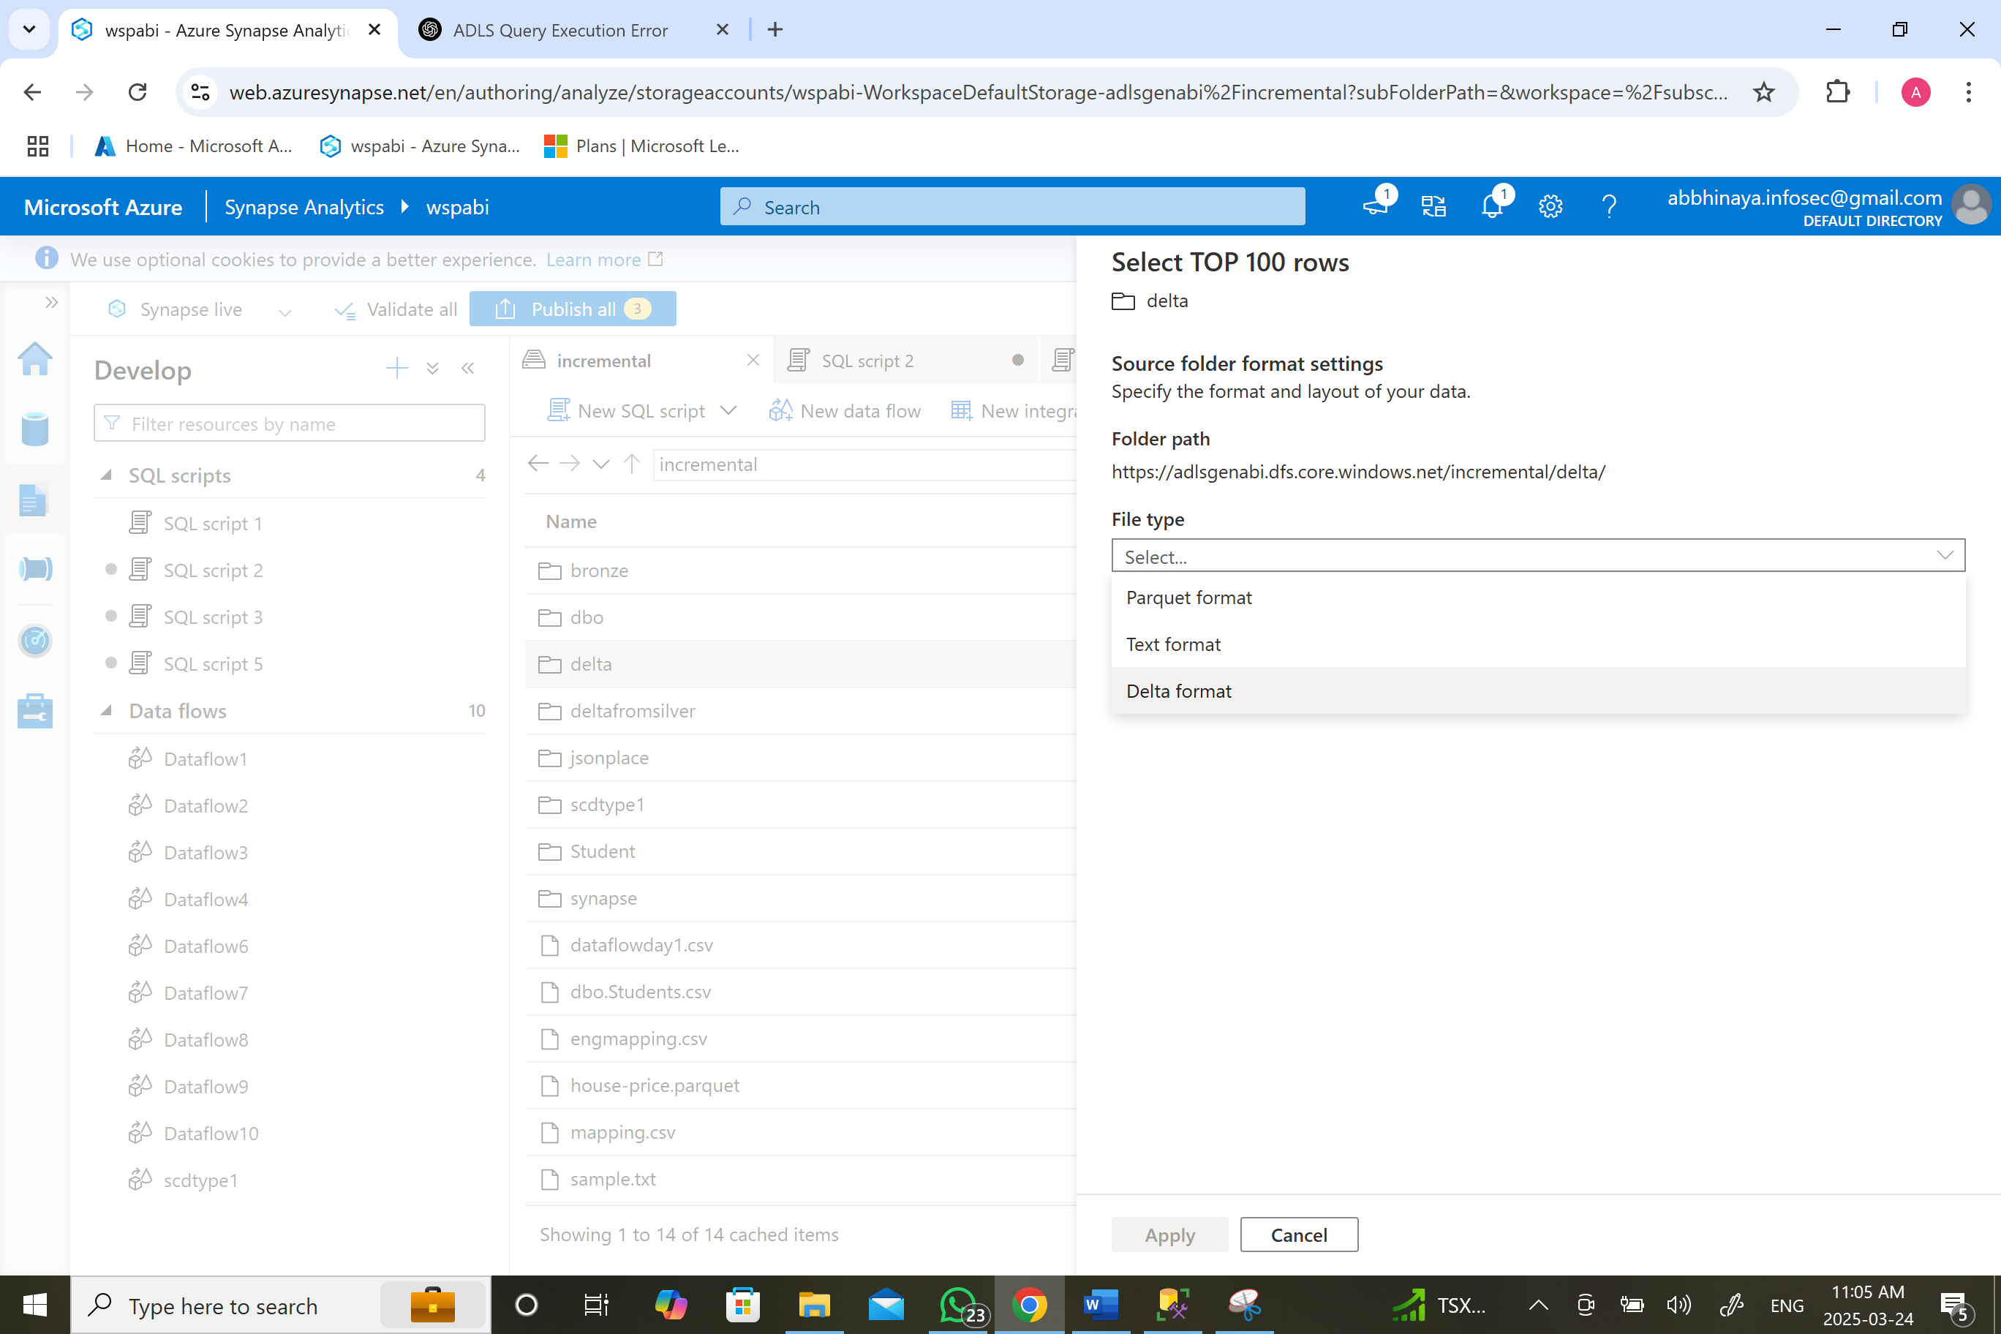

SELECT
TOP 100 *
FROM
OPENROWSET(
BULK 'https://adlsgenabi.dfs.core.windows.net/incremental/delta/',
FORMAT = 'DELTA'
) AS [result]

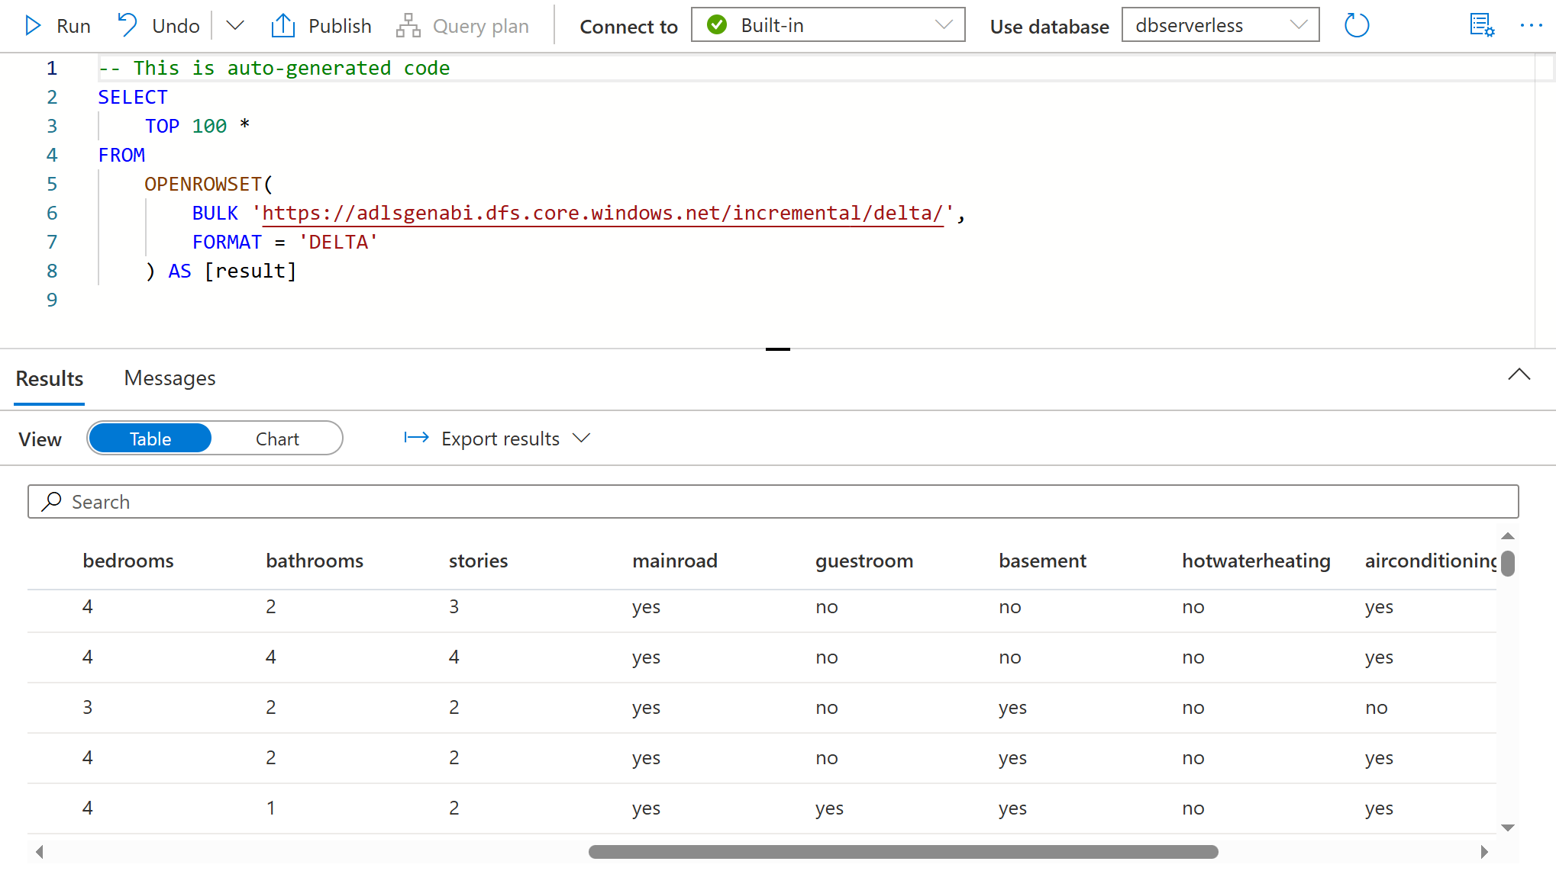

- Use wildcard character to read folder and subfolder data
Step 1 : To read the folder and subfolder data using wildcard characters in CSV file
SELECT
TOP 100 *
FROM
OPENROWSET(
BULK 'https://adlsgenabi.dfs.core.windows.net/incremental/bronze/*',
FORMAT = 'CSV',
PARSER_VERSION = '2.0',
HEADER_ROW = TRUE
) AS [result] ORDER BY 1

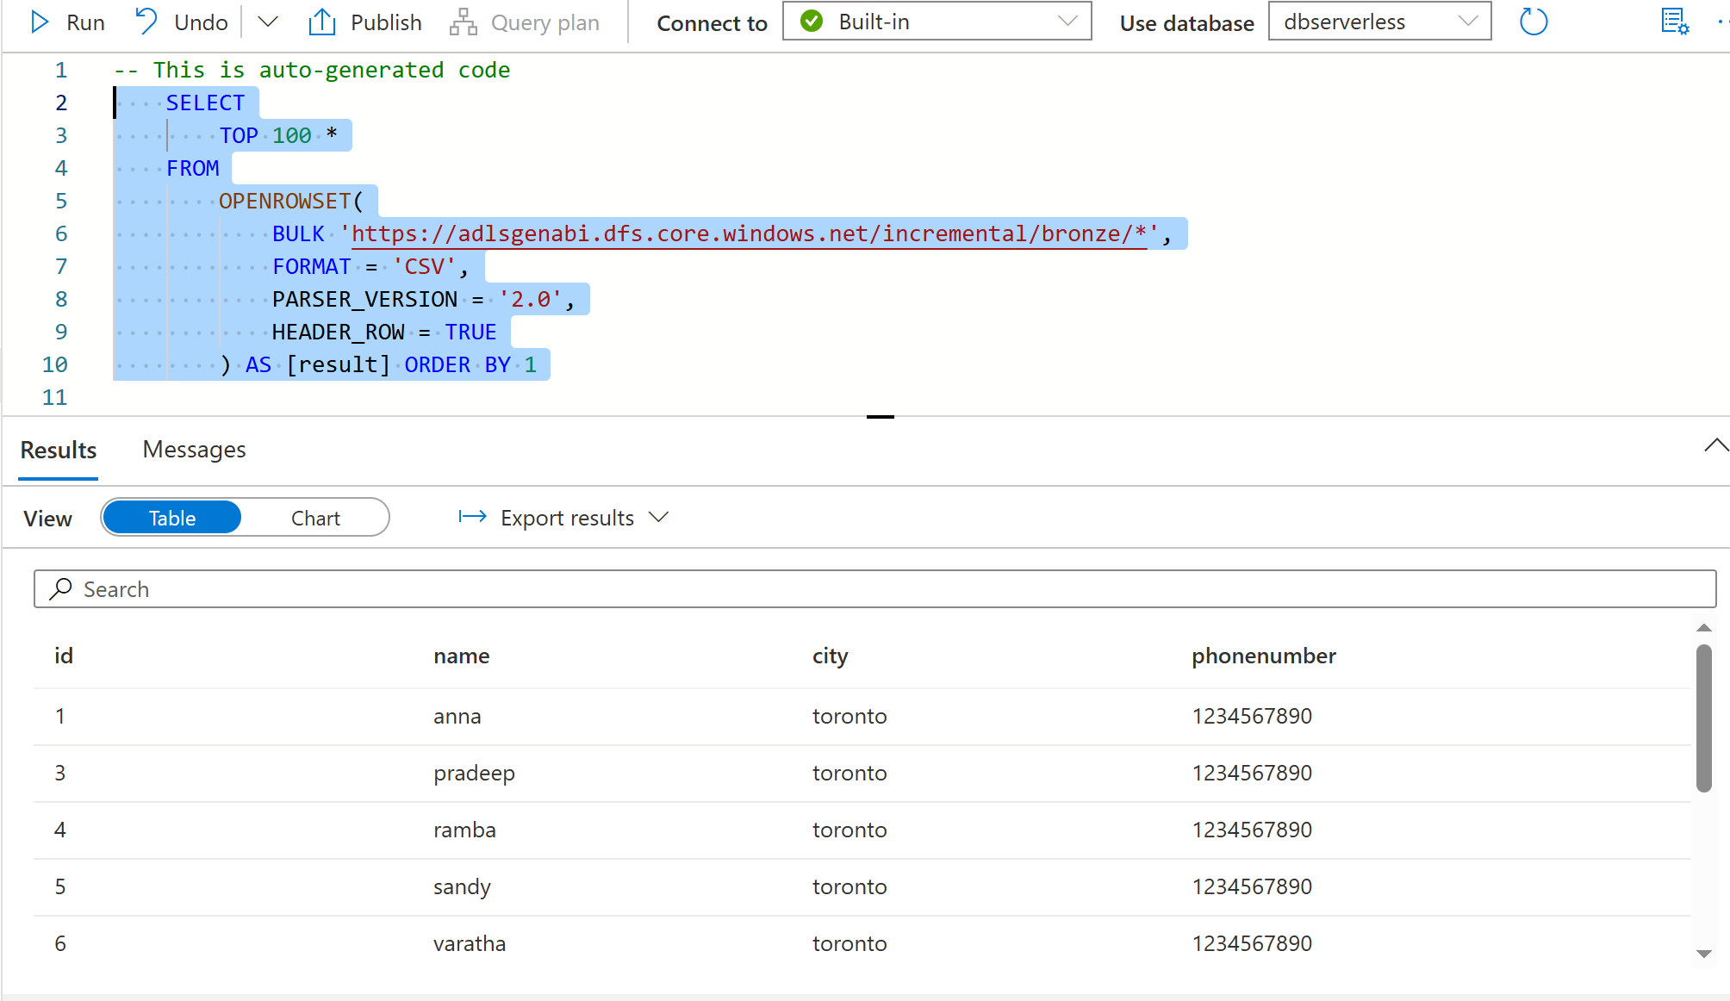

Step 2 : To read the folder and subfolder data using wildcard characters in PARQUET file

SELECT TOP 100 *
FROM OPENROWSET(
BULK 'https://adlsgenabi.dfs.core.windows.net/incremental/parquet/*',
FORMAT = 'parquet'
) AS [result]

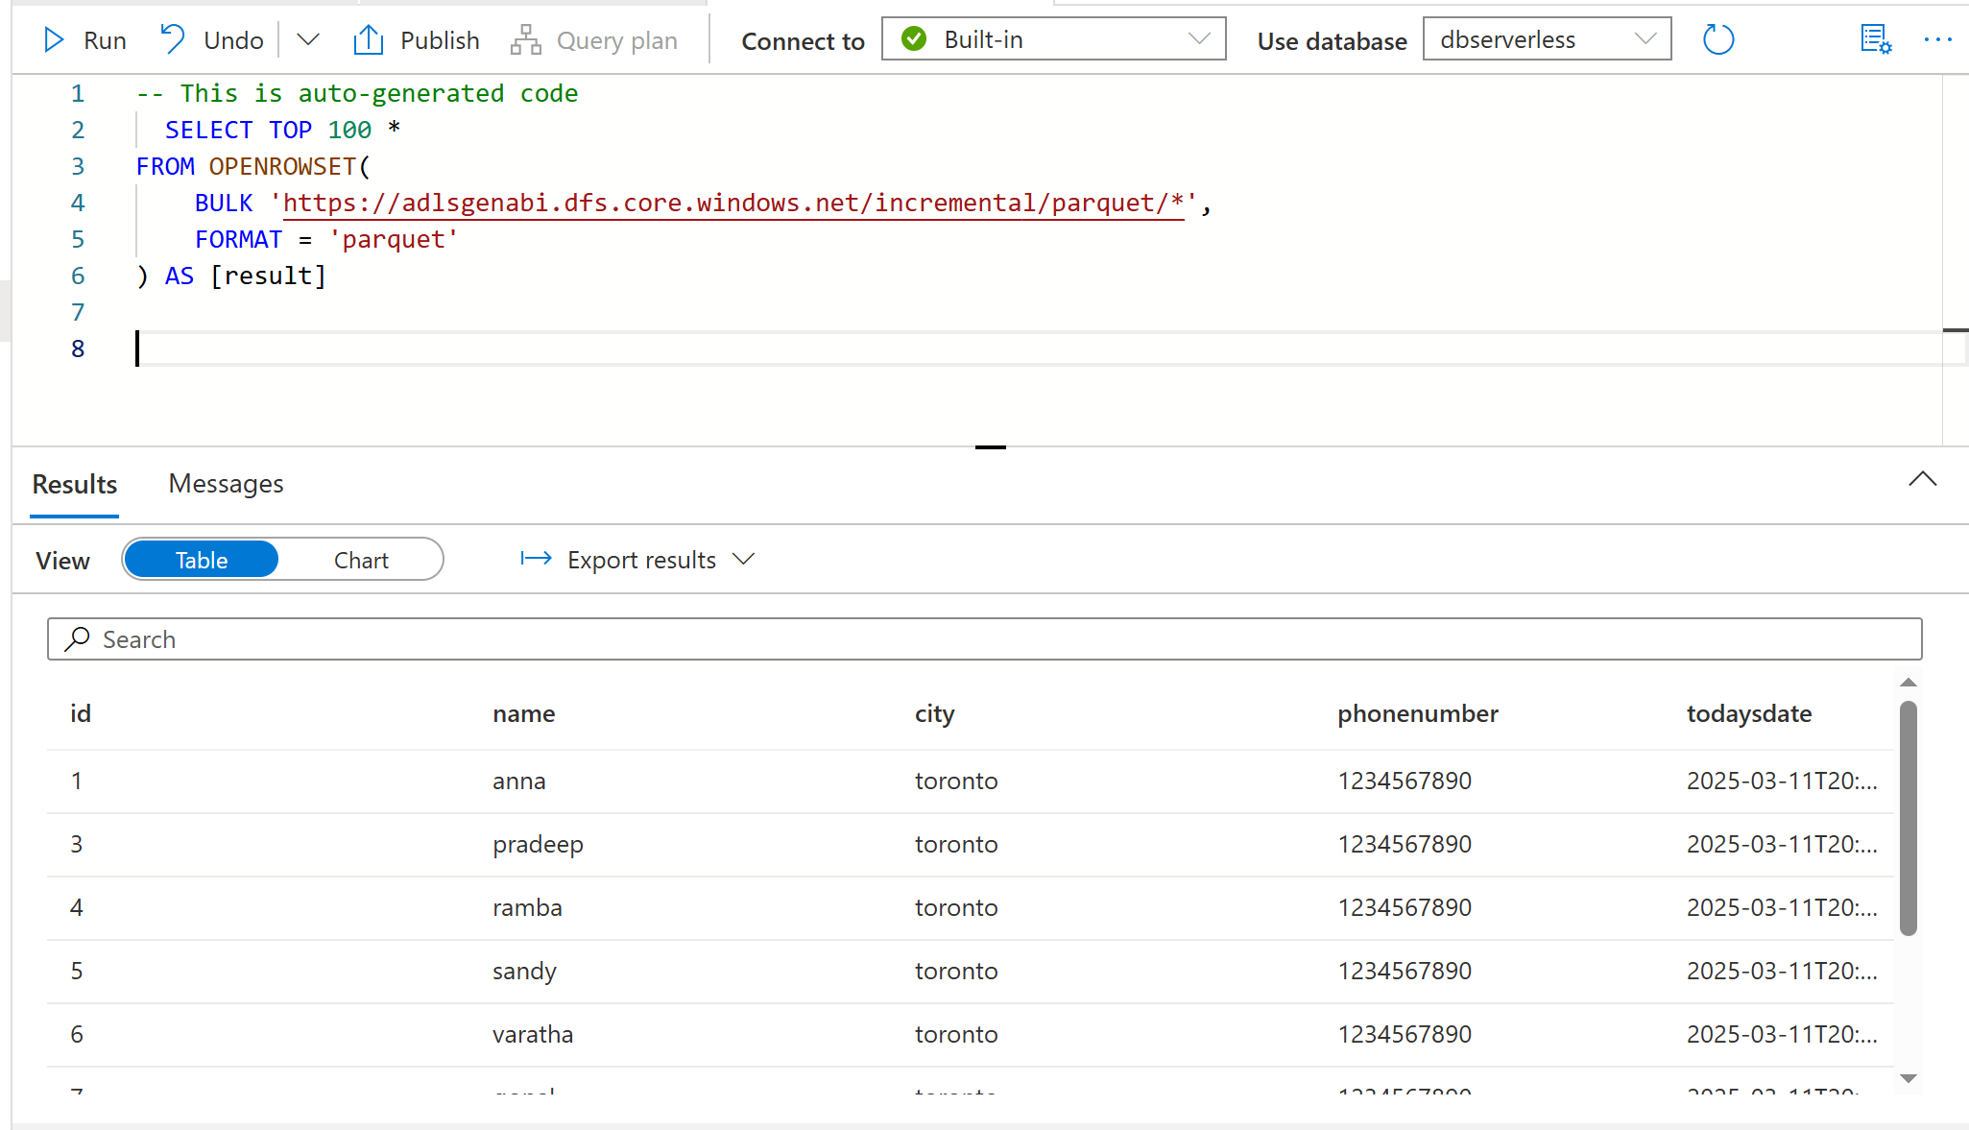
Step 3 : To read the folder and subfolder data using wildcard characters in DELTA file

wildcards (*) are not supported when querying Delta files using OPENROWSET. However, Delta format inherently manages multiple files within a Delta table, so you don’t need wildcards. Instead, you should reference the root directory of the Delta table, and it will automatically read all underlying Parquet files.

SELECT TOP 100 *
FROM OPENROWSET(
BULK 'https://adlsgenabi.dfs.core.windows.net/incremental/delta/',
FORMAT = 'DELTA'
) AS [result]

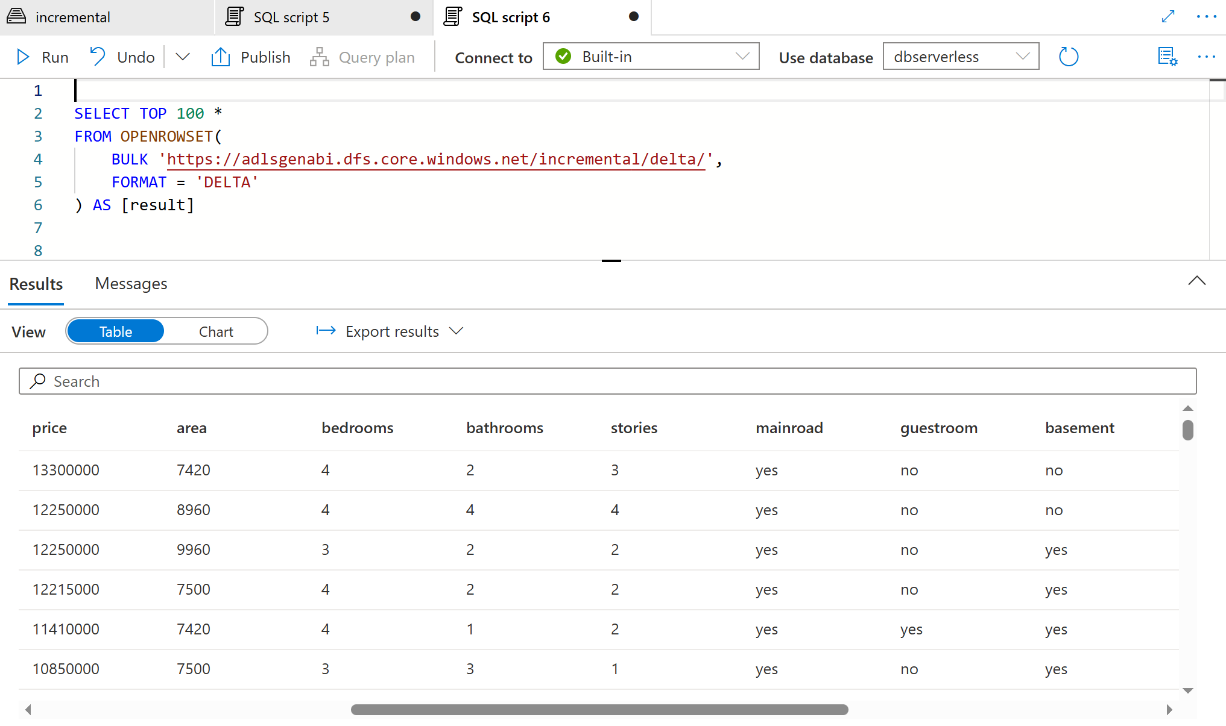

- Use Filename and Filepath to read data along with the file name of each partition.

In Azure Synapse, extracting Filename and Filepath while reading CSV files is not directly supported using OPENROWSET()

TO DO THIS IN PARQUET FILE FORMAT

SELECT
*,
_file_path AS FilePath
FROM OPENROWSET(
BULK 'https://adlsgenabi.dfs.core.windows.net/incremental/parquet/',
FORMAT = 'PARQUET'
)
WITH (
id INT,
name VARCHAR(100),
city VARCHAR(100),
phonenumber VARCHAR(100),
_file_path VARCHAR(8000) -- Explicitly define _file_path
) AS result;

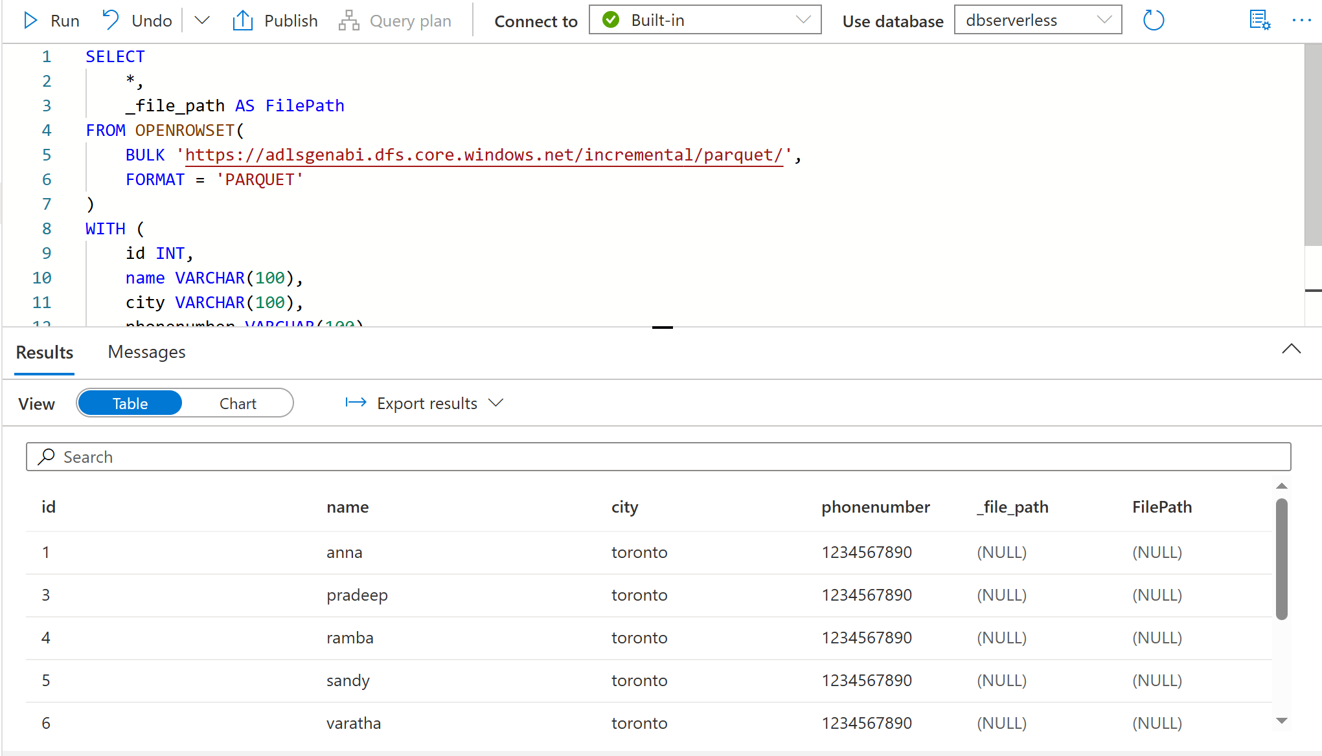

- Create External File Formats: Specify the format for CSV files

Click on the file which you wantnew sql script create external table new external table will be created continue give your external schema and table name open script
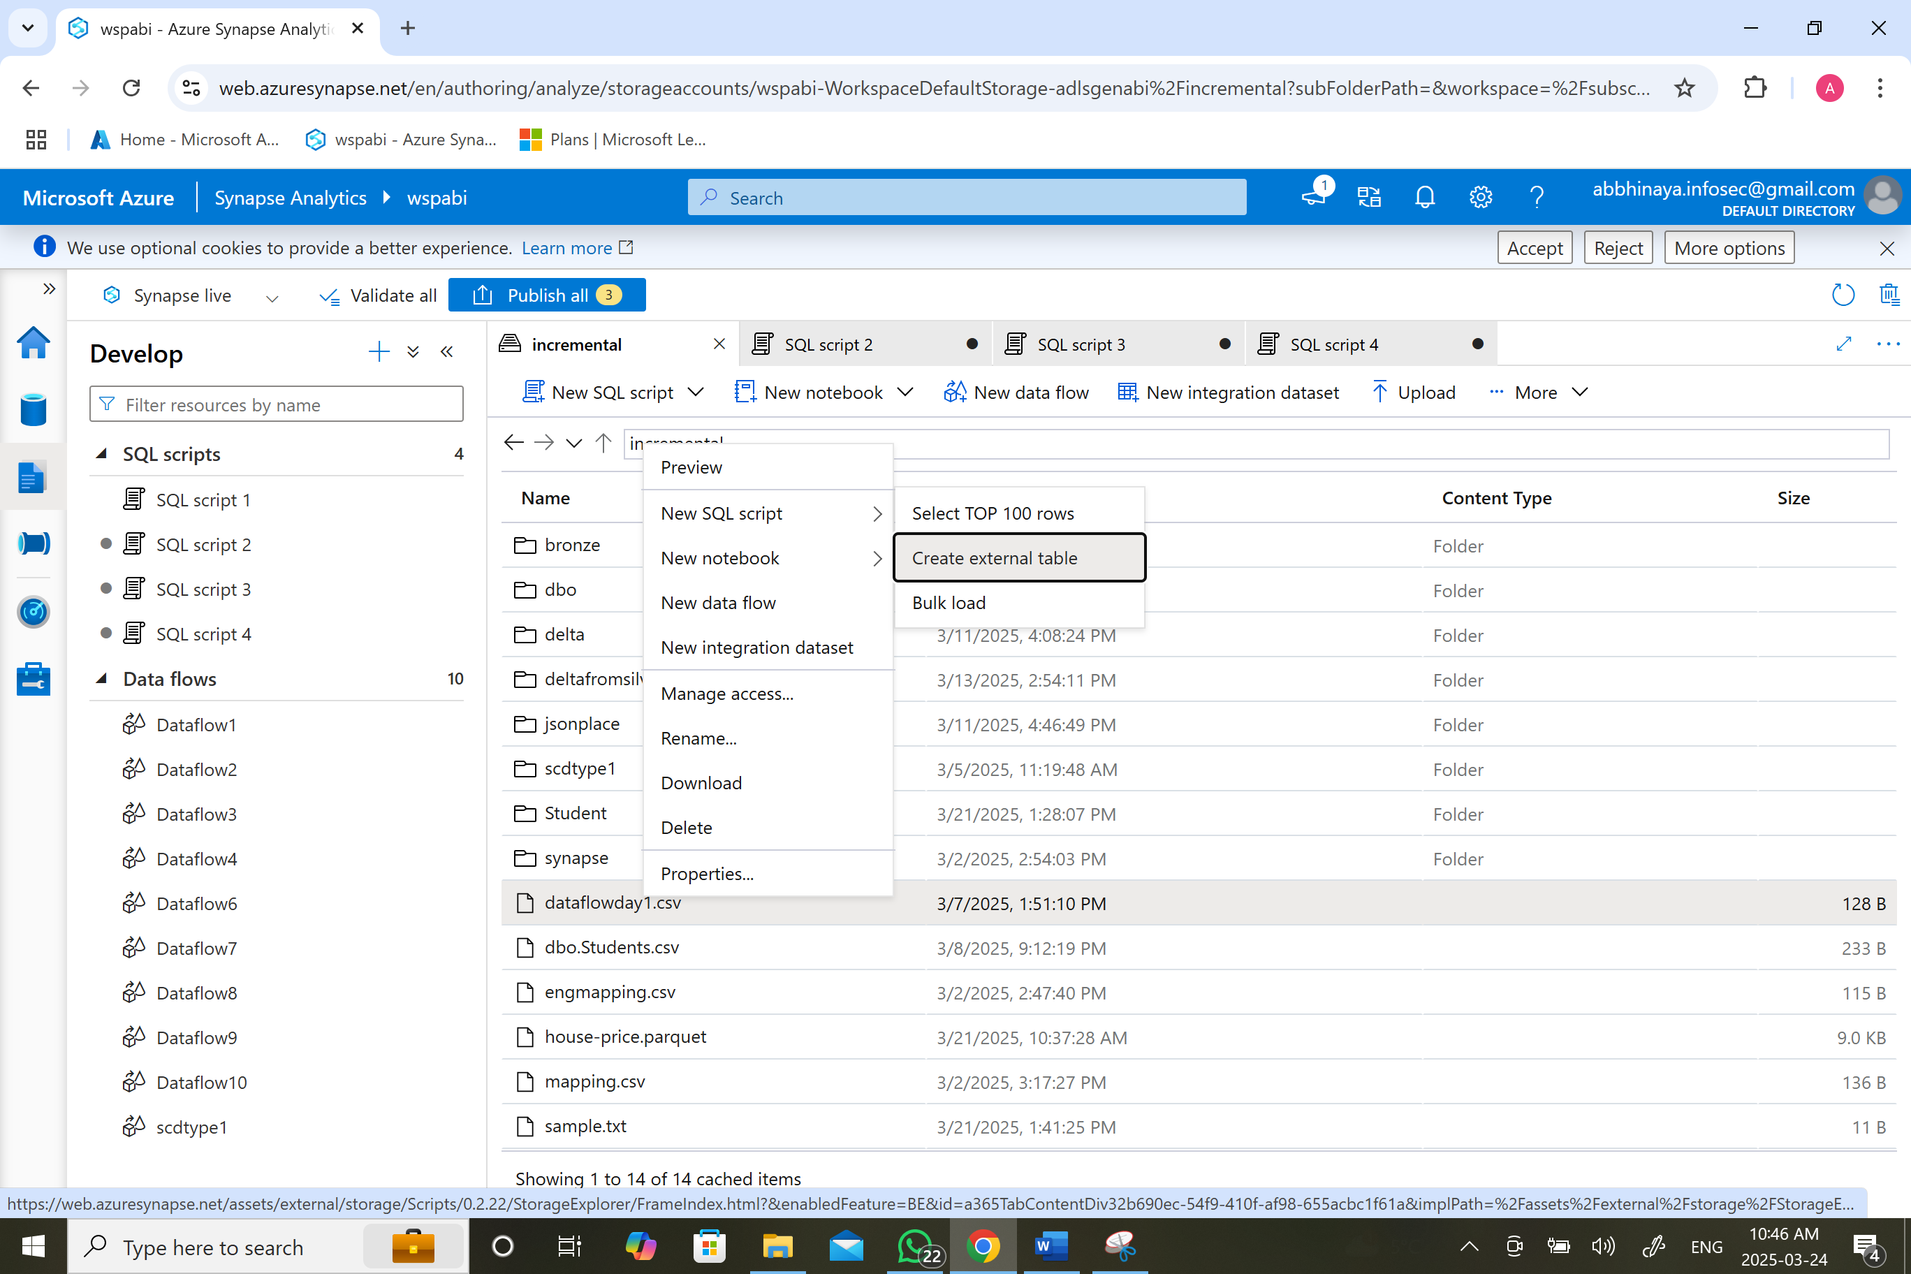
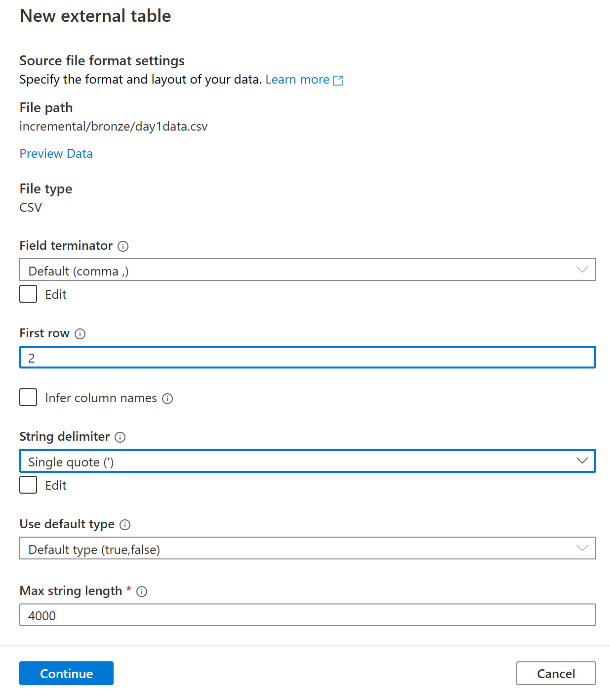

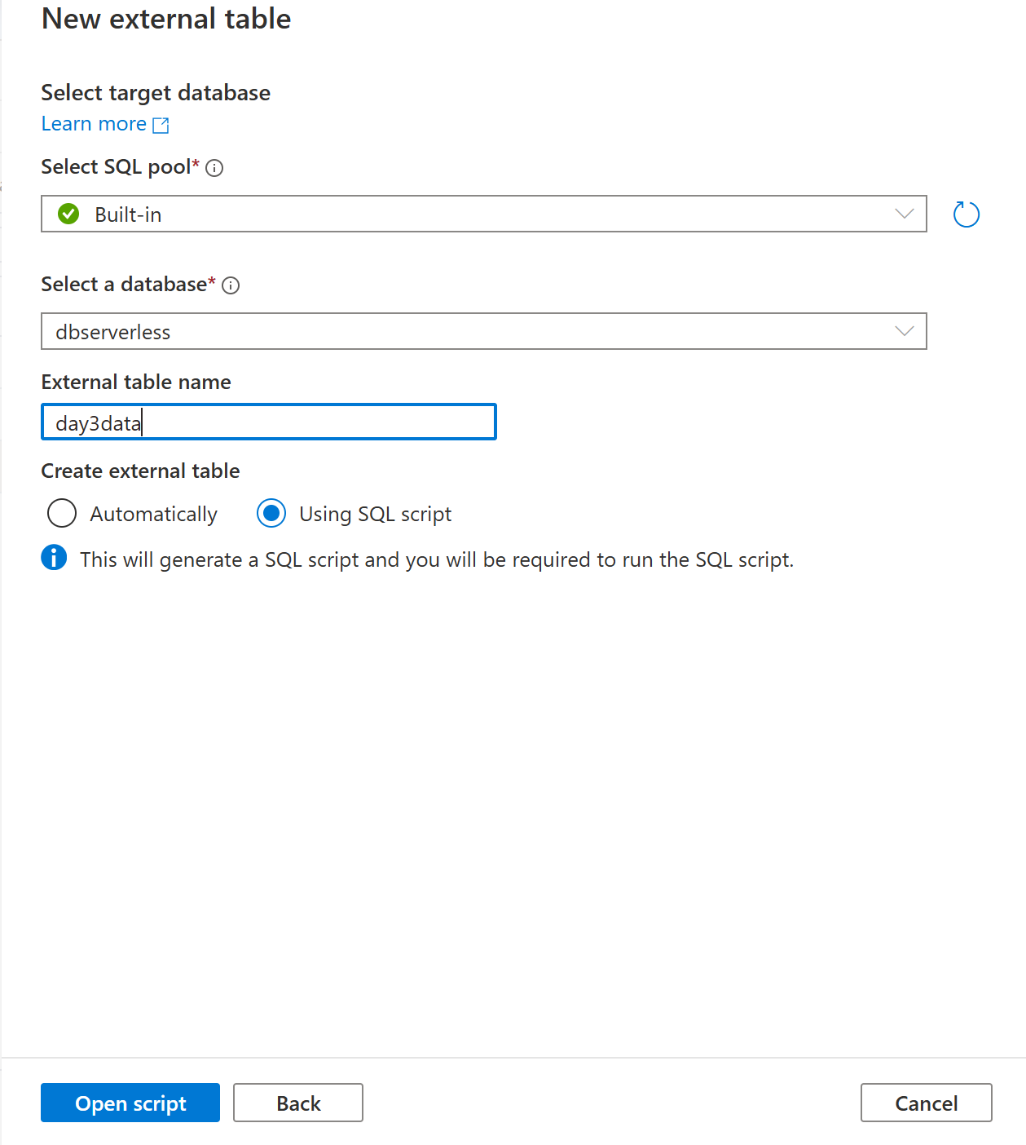
CREATE EXTERNAL DATA SOURCE [day1datasources]
WITH (
LOCATION = 'abfss://incremental@adlsgenabi.dfs.core.windows.net'
)
CREATE EXTERNAL FILE FORMAT [day1datacsv]
WITH ( FORMAT_TYPE = DELIMITEDTEXT ,
FORMAT_OPTIONS (
FIELD_TERMINATOR = ',',
STRING_DELIMITER = '''',
FIRST_ROW = 2,
USE_TYPE_DEFAULT = FALSE,
ENCODING = 'UTF8',
PARSER_VERSION = '2.0'
));
CREATE EXTERNAL TABLE dbo.day1data (
ID nvarchar(4000),
NAME nvarchar(4000),
CITY nvarchar(4000),
PHONENUMBER nvarchar(4000)
)
WITH (
LOCATION = 'bronze/day1data.csv',
DATA_SOURCE = [day1datasources],
FILE_FORMAT = [day1datacsv]
)
GO

SELECT TOP 100 * FROM dbo.day1data
GO

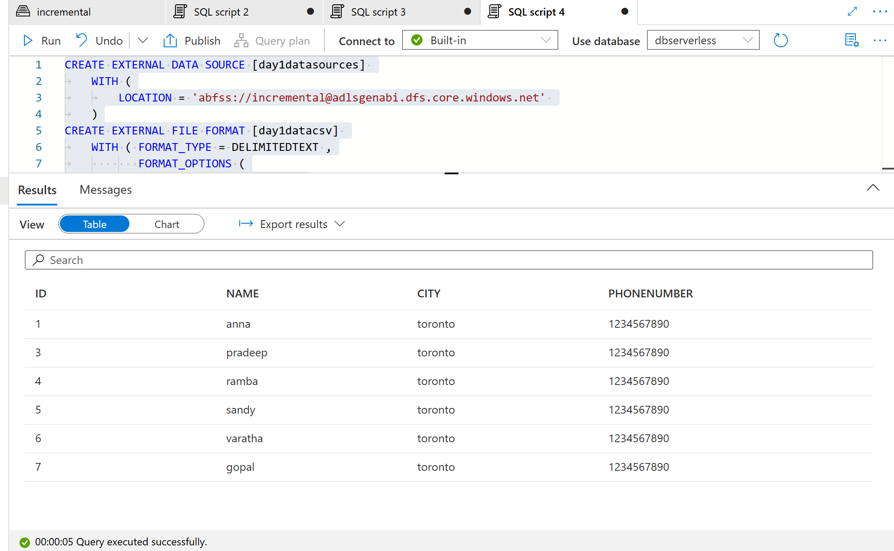

- Create External File Formats: Specify the format for Parquet files.
Click on the file which you wantnew sql script create external table new external table will be created continue give your external schema and table name open script

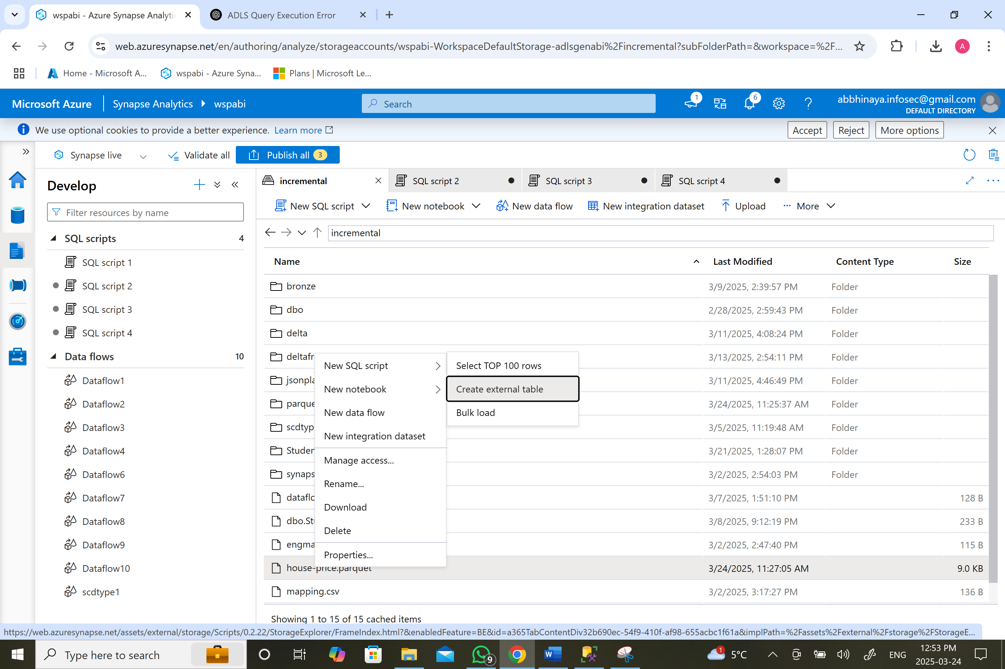
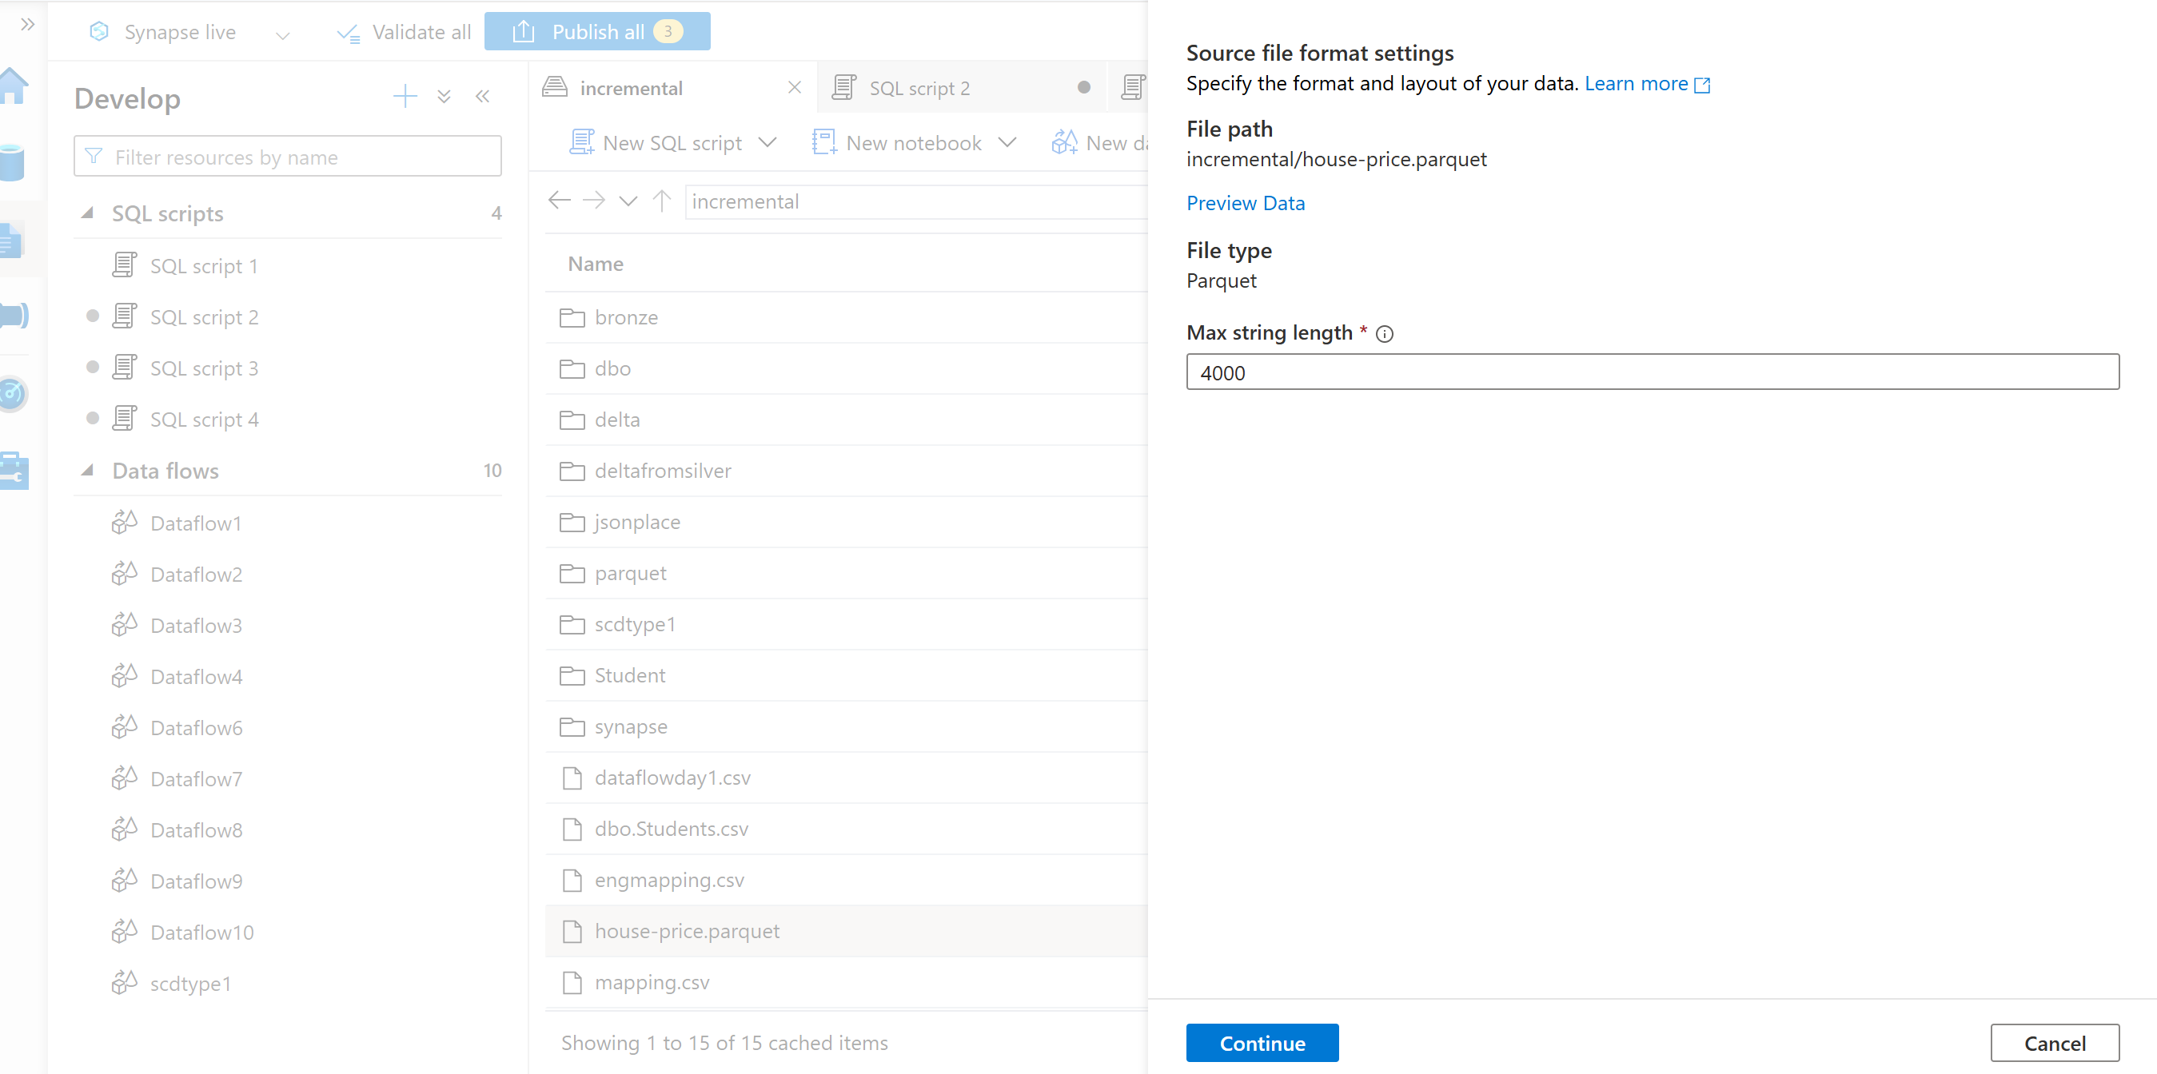
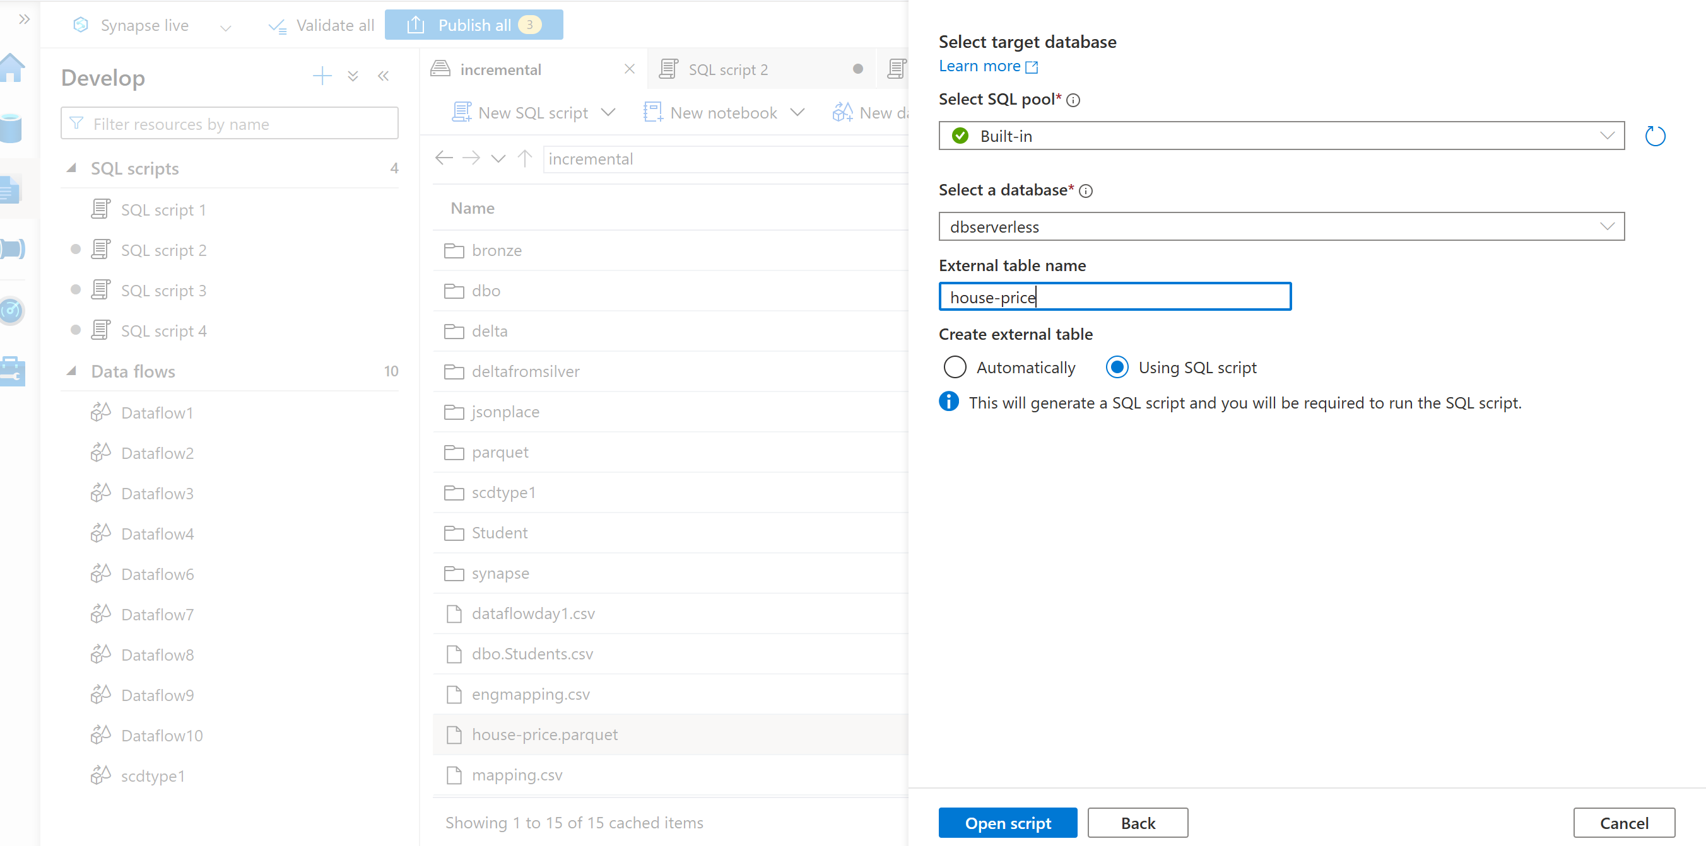

IF NOT EXISTS (SELECT * FROM sys.external_file_formats WHERE name = 'SynapseParquetFormat')
CREATE EXTERNAL FILE FORMAT [SynapseParquetFormat]
WITH ( FORMAT_TYPE = PARQUET)
GO

IF NOT EXISTS (SELECT * FROM sys.external_data_sources WHERE name = 'incremental_adlsgenabi_dfs_core_windows_net')
CREATE EXTERNAL DATA SOURCE [incremental_adlsgenabi_dfs_core_windows_net]
WITH (
LOCATION = 'abfss://incremental@adlsgenabi.dfs.core.windows.net'
)
GO

CREATE EXTERNAL TABLE dbo.stu (
[id] smallint,
[name] nvarchar(4000),
[city] nvarchar(4000),
[phonenumber] int,
[todaysdate] datetime2(7)
)
WITH (
LOCATION = 'parquet/stu.parquet',
DATA_SOURCE = [incremental_adlsgenabi_dfs_core_windows_net],
FILE_FORMAT = [SynapseParquetFormat]
)
GO

SELECT TOP 100 * FROM dbo.stu
GO

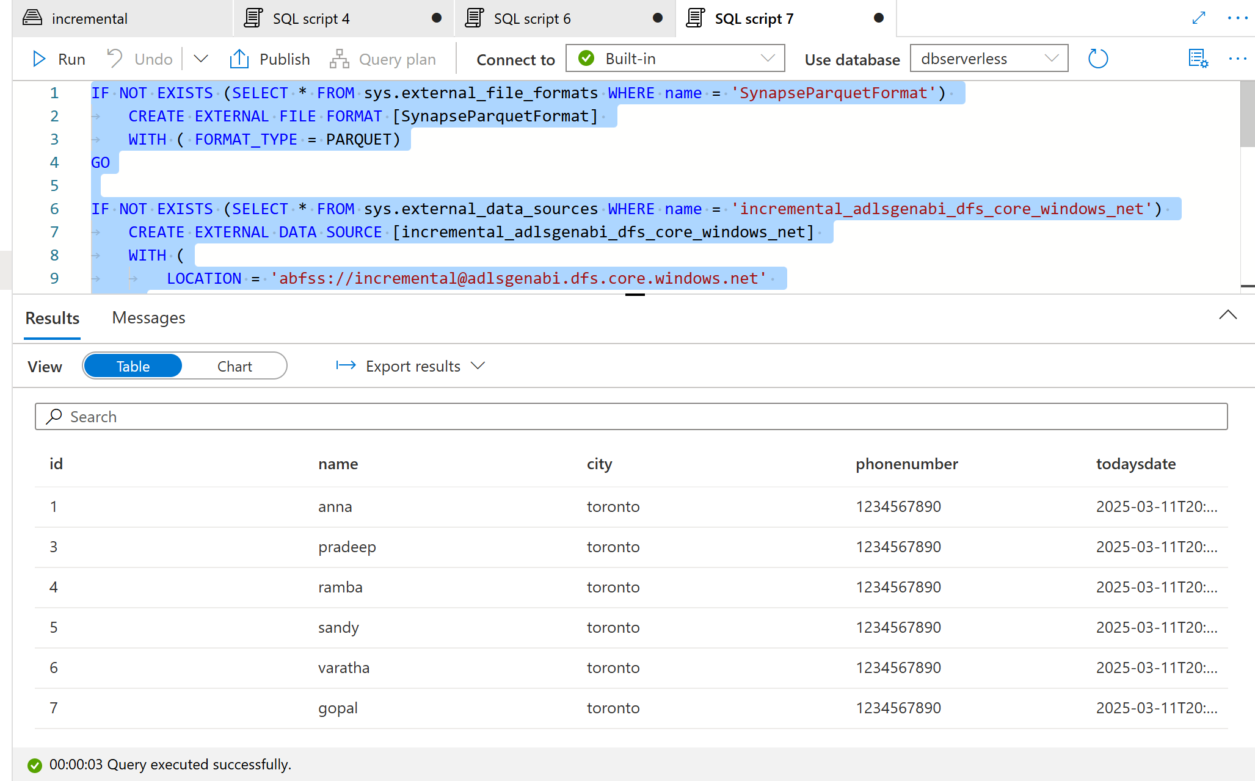

- Create External File Formats: Specify the format for Delta files.
Click on the file which you wantnew sql script create external table new external table will be created continue give your external schema and table name open script
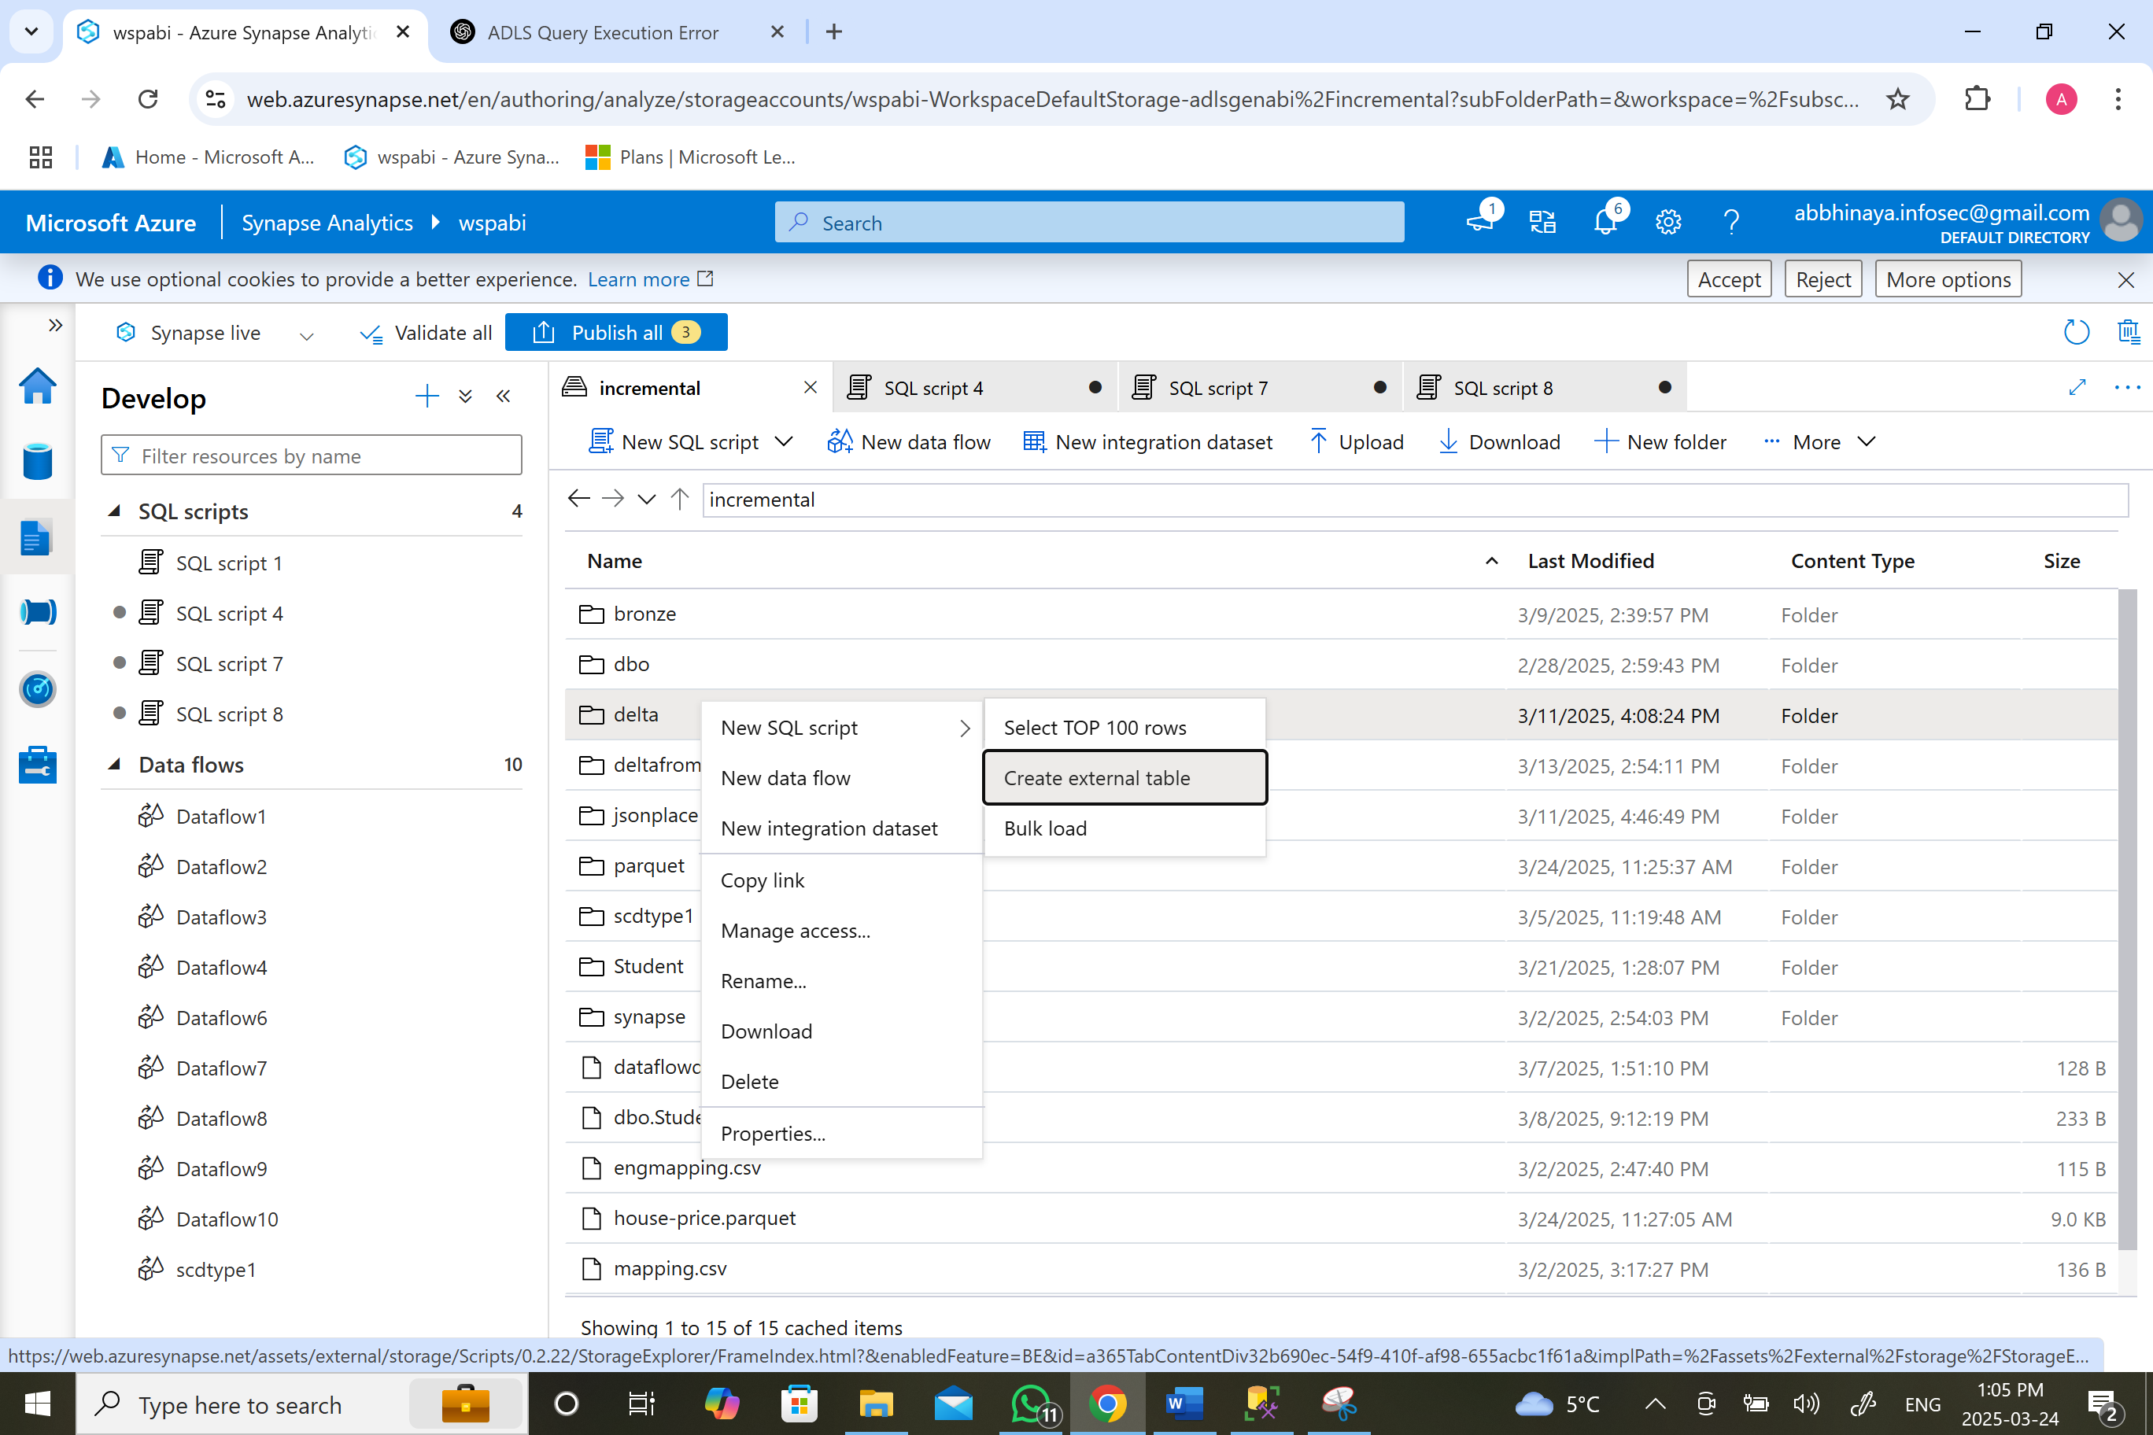
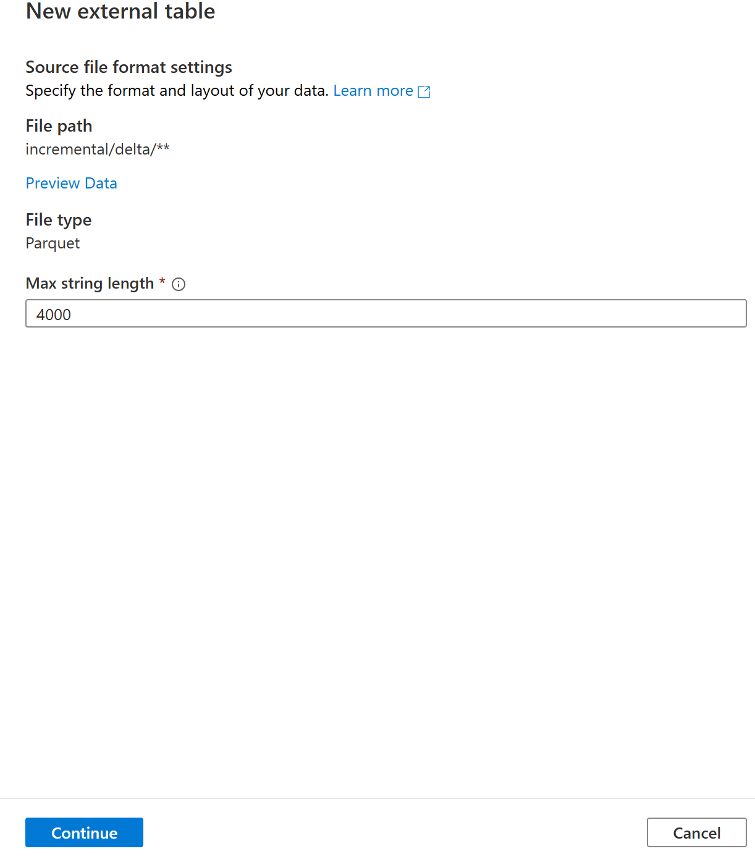
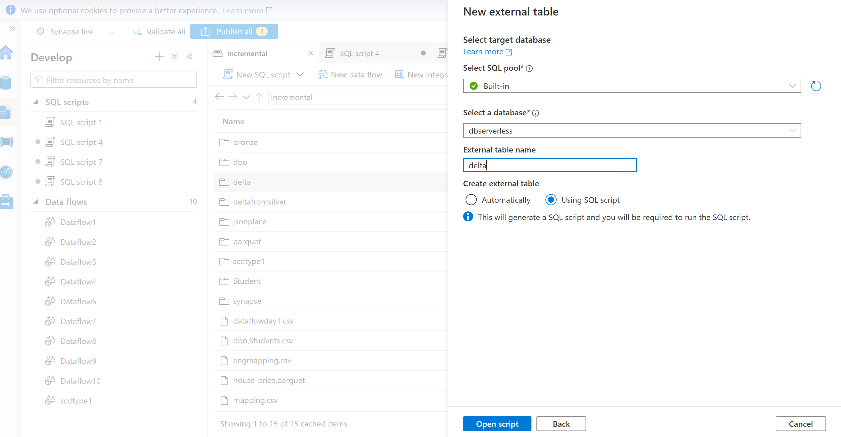
IF NOT EXISTS (SELECT * FROM sys.external_file_formats WHERE name = 'SynapseParquetFormat')
CREATE EXTERNAL FILE FORMAT [SynapseParquetFormat]
WITH ( FORMAT_TYPE = PARQUET)
GO

IF NOT EXISTS (SELECT * FROM sys.external_data_sources WHERE name = 'incremental_adlsgenabi_dfs_core_windows_net')
CREATE EXTERNAL DATA SOURCE [incremental_adlsgenabi_dfs_core_windows_net]
WITH (
LOCATION = 'abfss://incremental@adlsgenabi.dfs.core.windows.net'
)
GO

CREATE EXTERNAL TABLE dbo.delta (
[id] smallint,
[name] nvarchar(4000),
[city] nvarchar(4000),
[phonenumber] int,
[todaysdate] datetime2(7)
)
WITH (
LOCATION = 'delta/**',
DATA_SOURCE = [incremental_adlsgenabi_dfs_core_windows_net],
FILE_FORMAT = [SynapseParquetFormat]
)
GO

SELECT TOP 100 * FROM dbo.delta
GO
