Data Pipeline for Customer Account Analysis
Objective:
The project aims to design and implement a robust data pipeline for processing customer account data. This includes copying data from a backend team's storage account, performing necessary transformations using Databricks, and upserting (inserting or updating) data from a file stored in Azure Data Lake Storage ADLS GOLD Storage into a dedicated SQL pool table in Azure Synapse Analytics. The pipeline aims to ensure efficient, accurate, and scalable data processing to support downstream analytics and reporting needs.
Architecture Diagram :
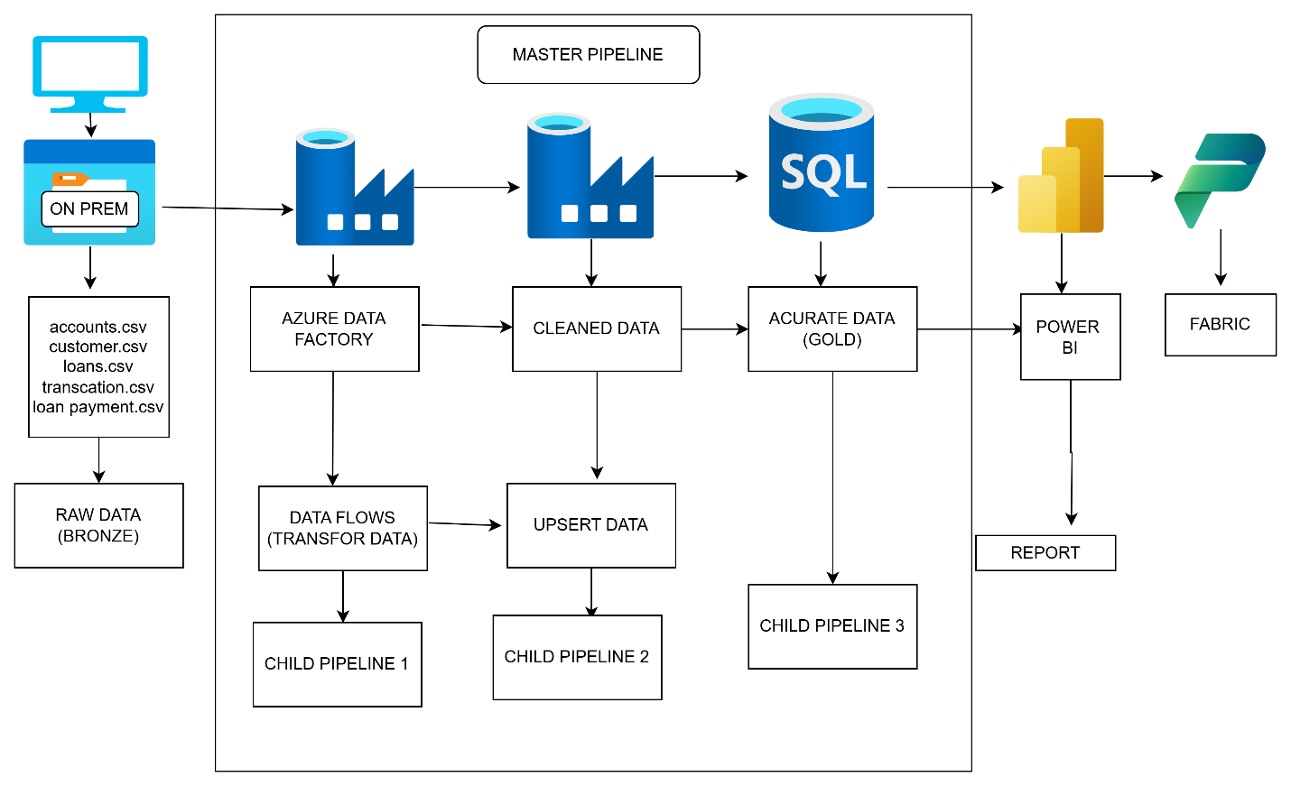

STEPS TO CREATE DATA INGESTION
BRONZE LAYER
Step 1 : to create self hosted IR download and register for it

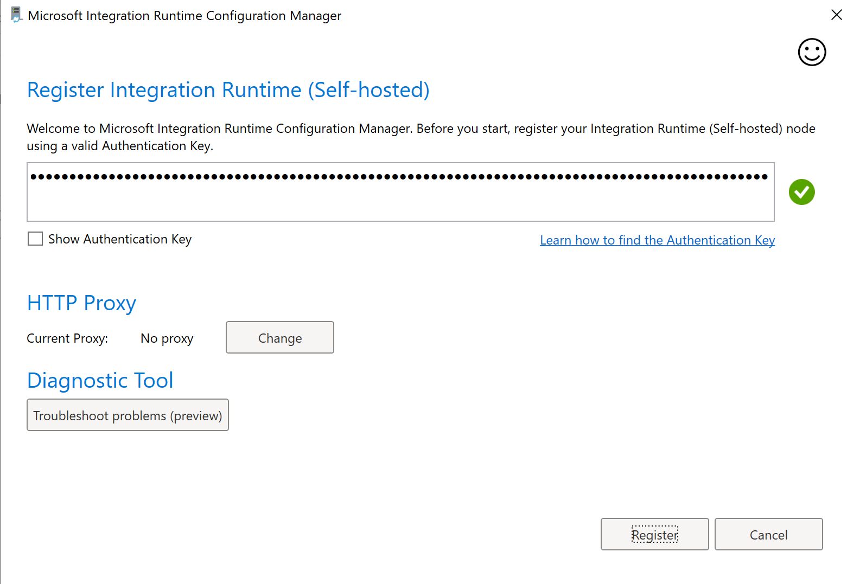
Step 2 : create linked services
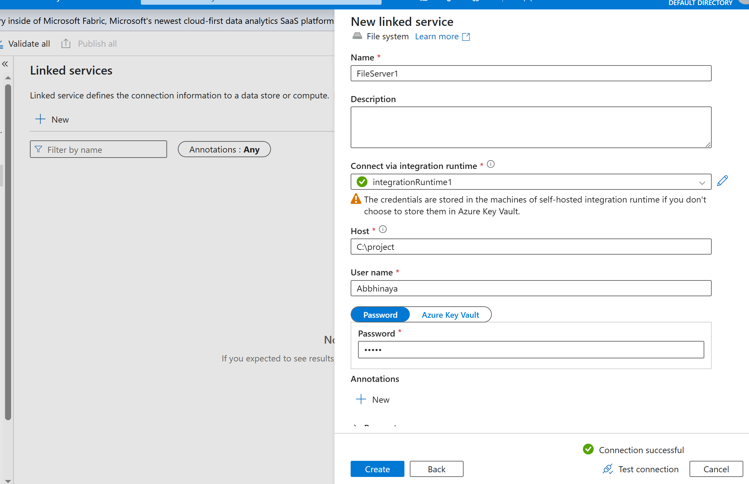
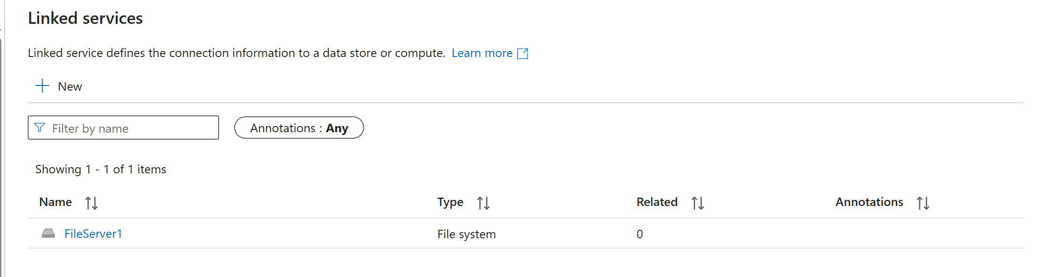
Step 3 : create for each activity to load all the 5 files dynamically
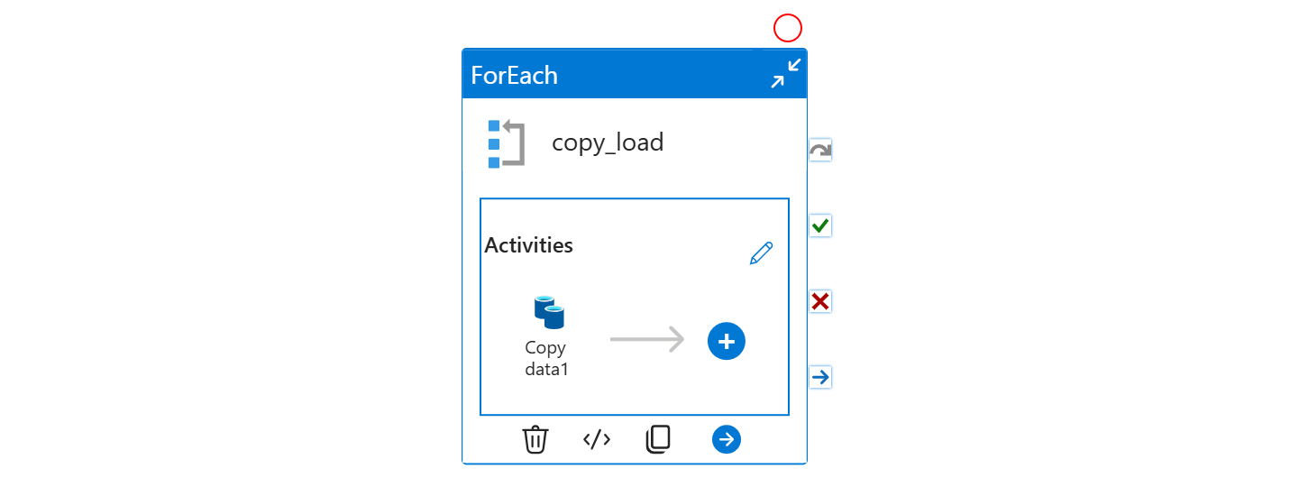
Step 4 : pass the files I array
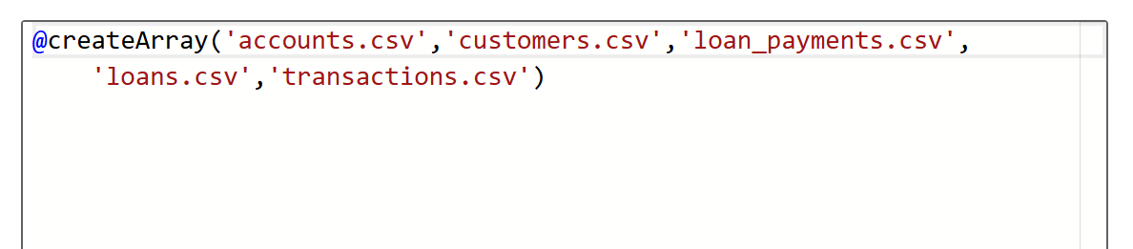
Step 5 : create a copy date inside the for each and in source select for file system pass the value dynamically
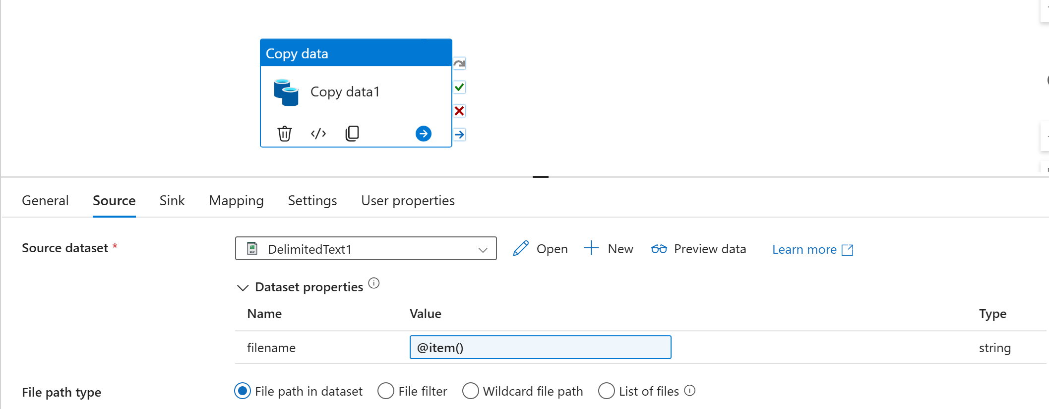
Step 6 : in sink load the data In gen2 bronze container pass the file dynamically to load the file
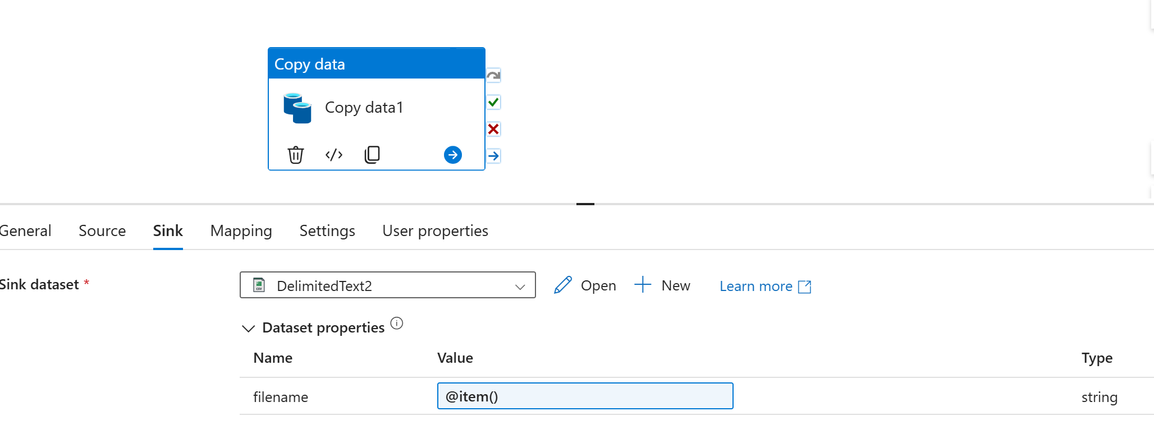
Run the pipeline
Data is loaded in the bronze container
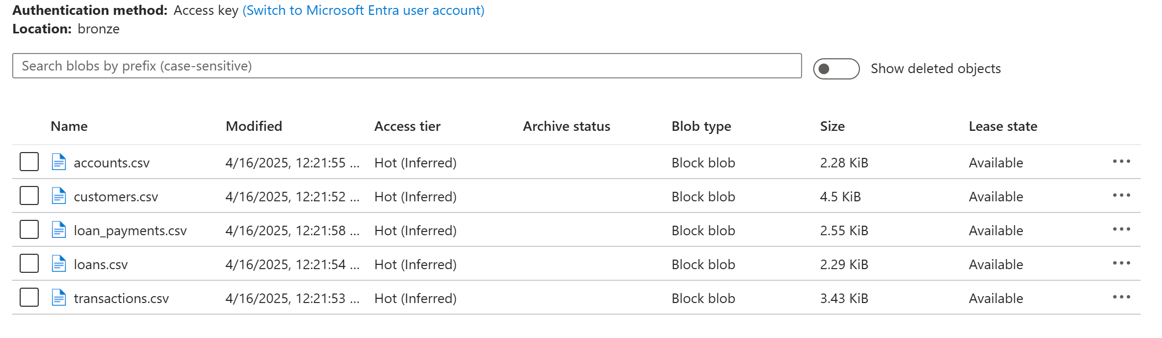
SILVER LAYER
STEPS TO USE DATAFLOWS TO REMOVE THE DUPLICATES
Account and Loans file do this same
In a data flow, the Filter transformation is used to eliminate rows containing null values or irrelevant data based on defined conditions.
Step 1 : in sources create a new linked services (bronze)
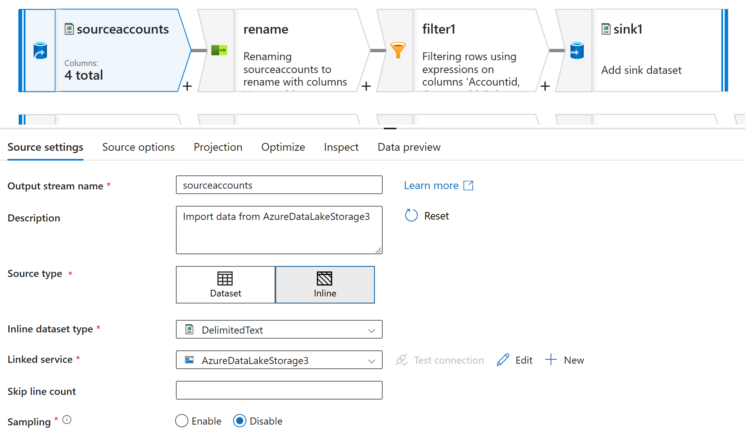
Step 2 : click the select (rename) change the column name
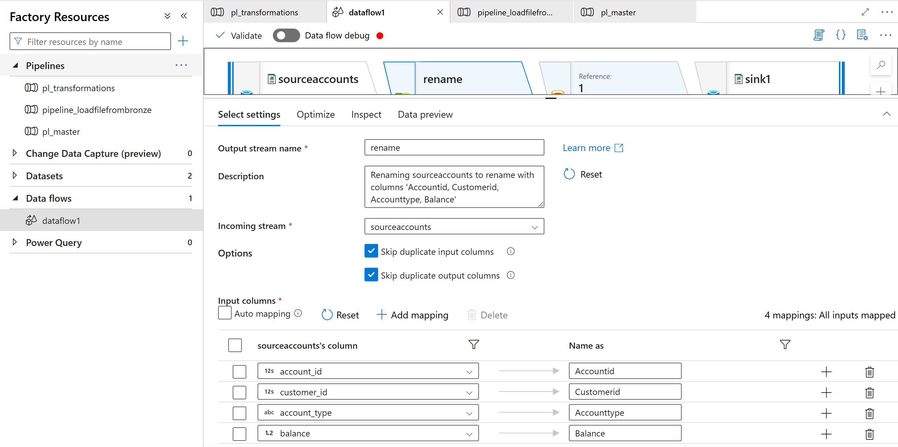
Step 3 : click the filter transformation to remove the null for the accounted and customerid
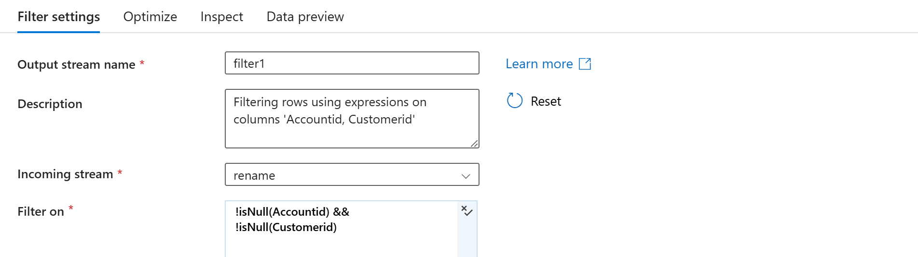
Step 4 : in sink give file name option and file name
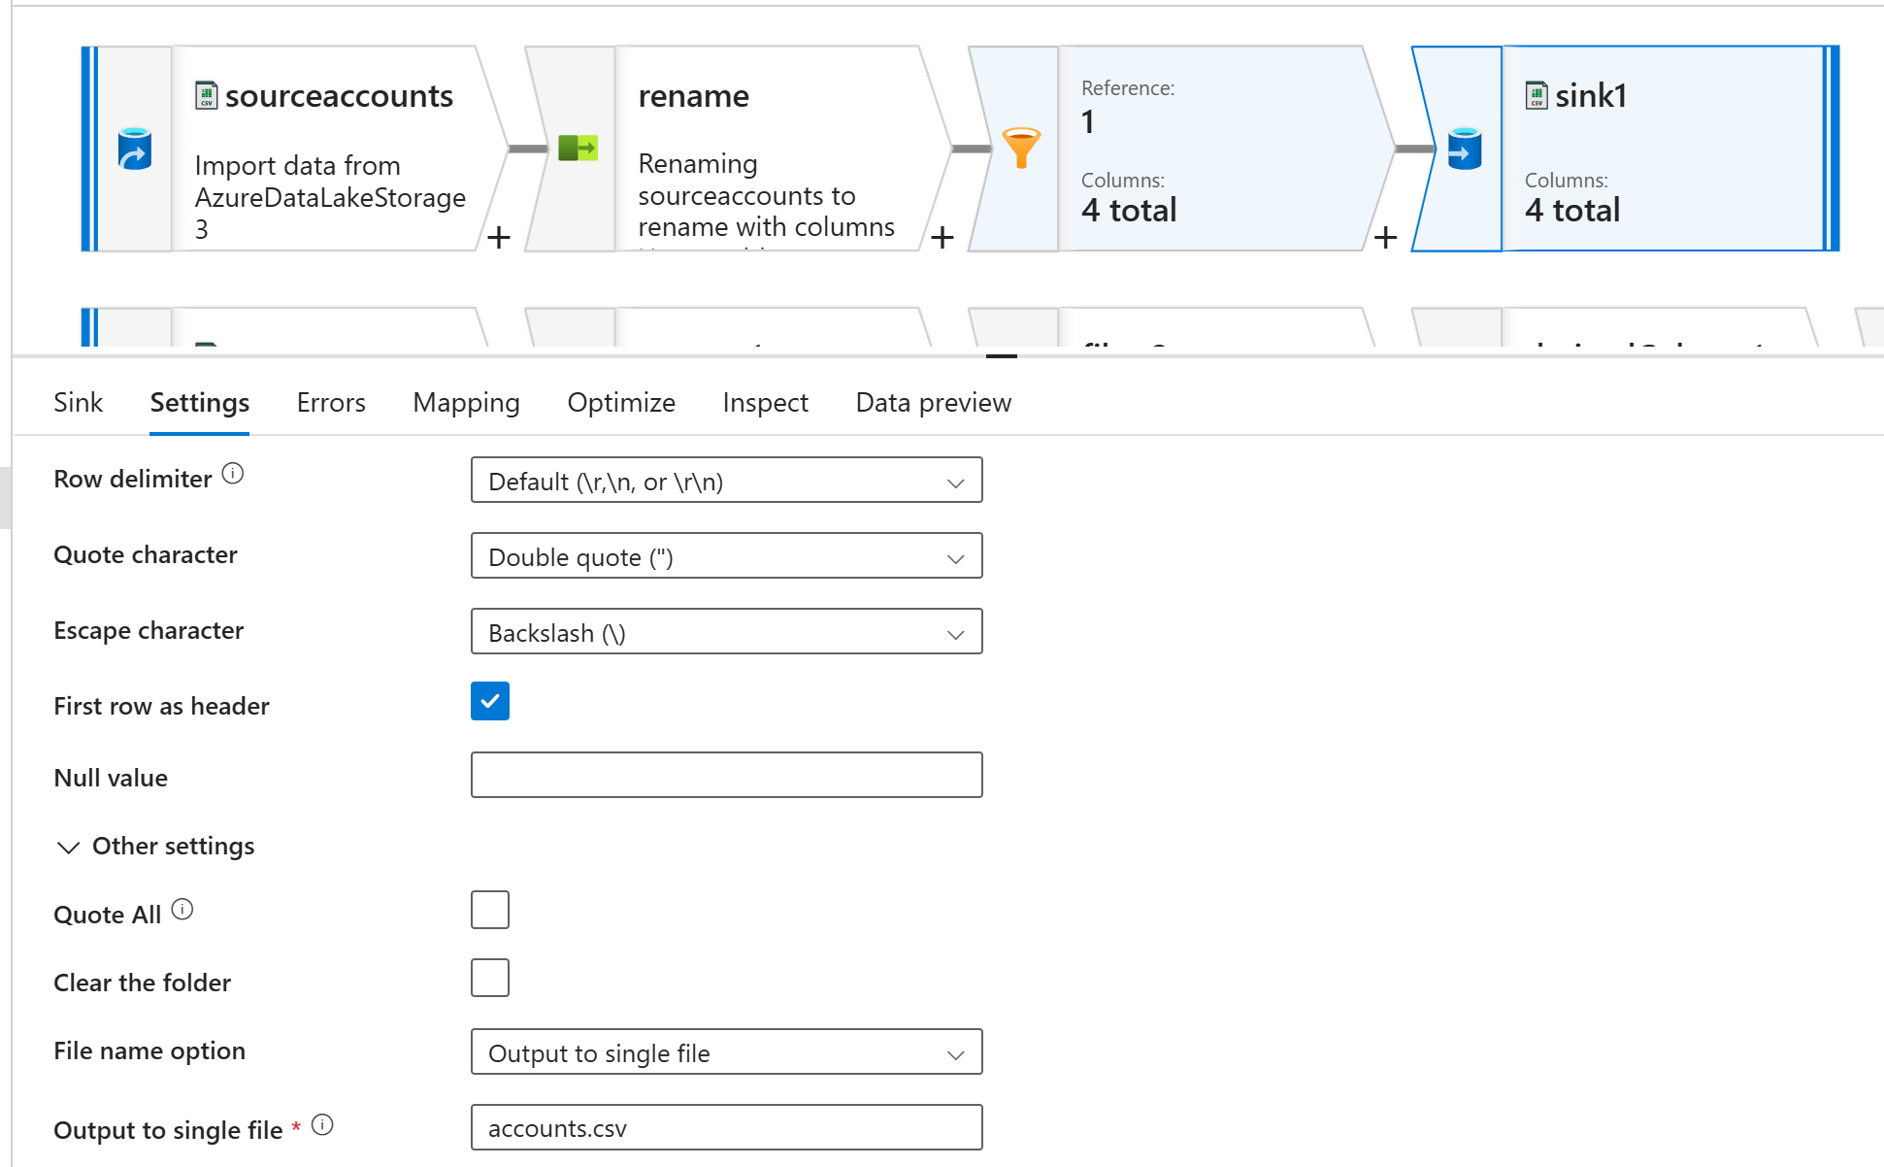
For Customer create a transformation
This data flow pipeline is designed to extract data from various sources, apply a series of transformations, and load the cleaned and enriched data into a designated sink. The primary goal of this pipeline is to ensure data consistency by converting null values to the string "Unknown" where applicable. Below is a breakdown of each step involved in the pipeline:

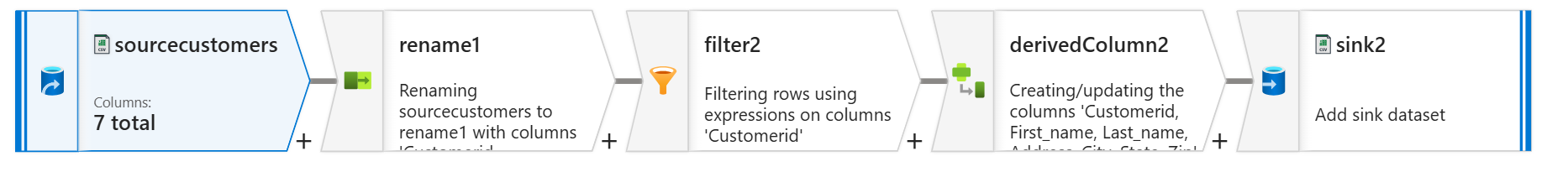
Step 1 : in sources add existing adls
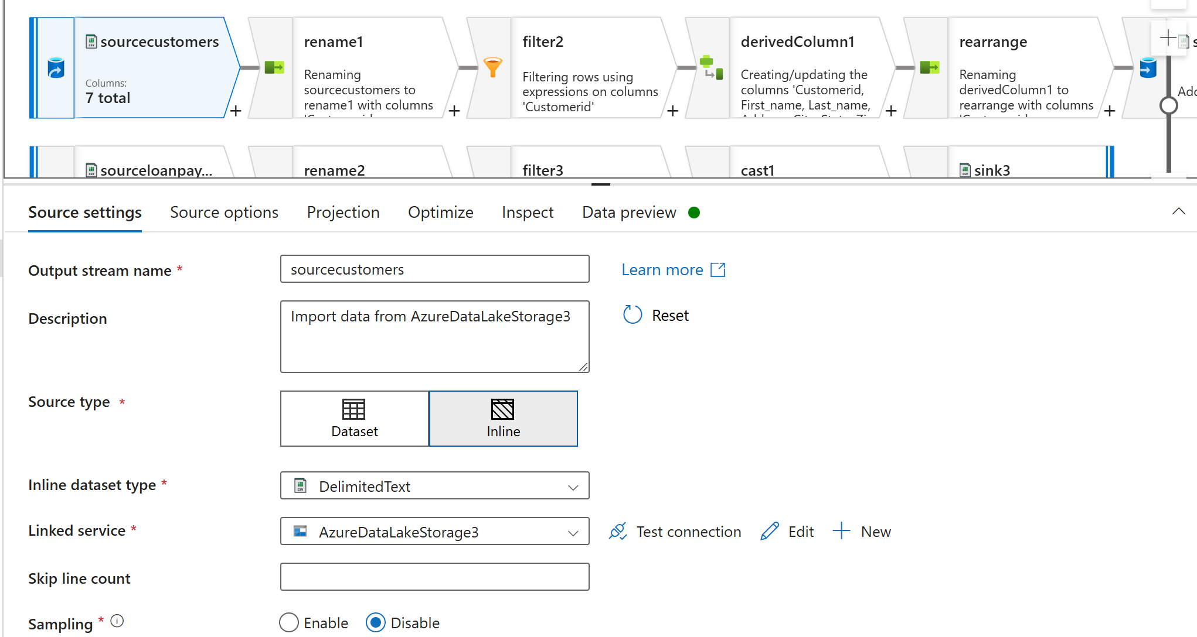
Step 2 : rename the column name
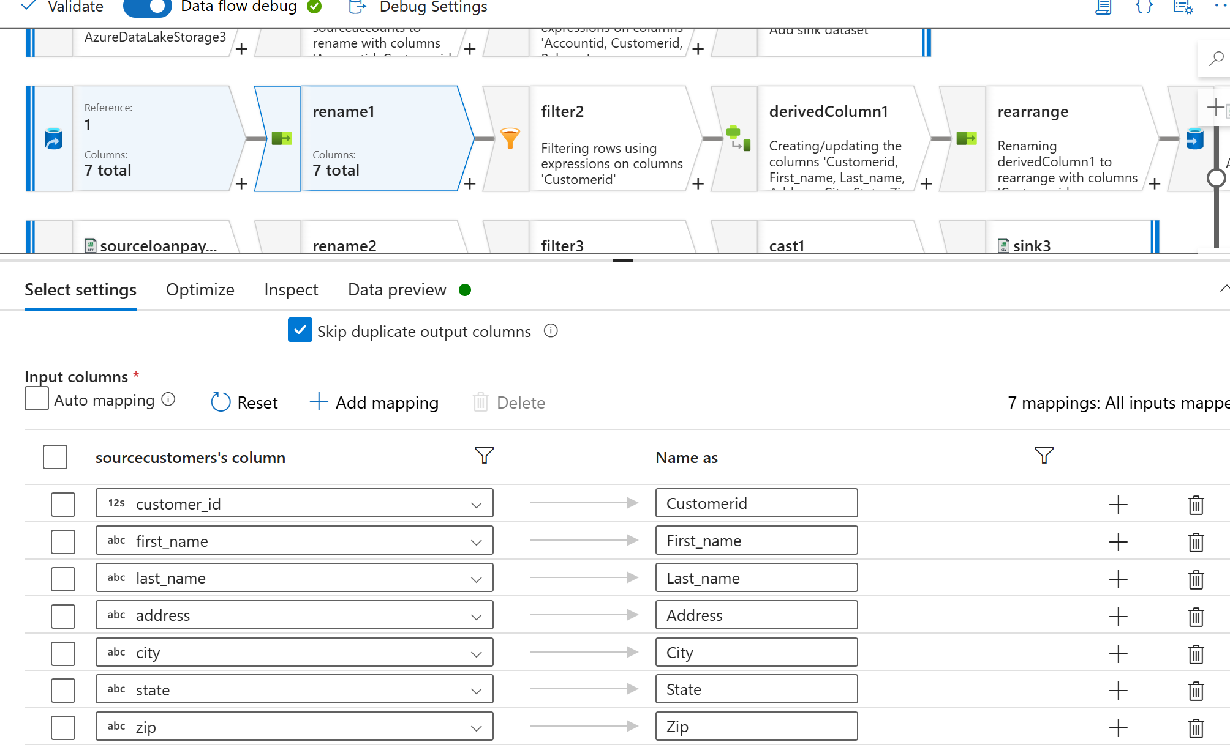
Step 3 : check for the null value
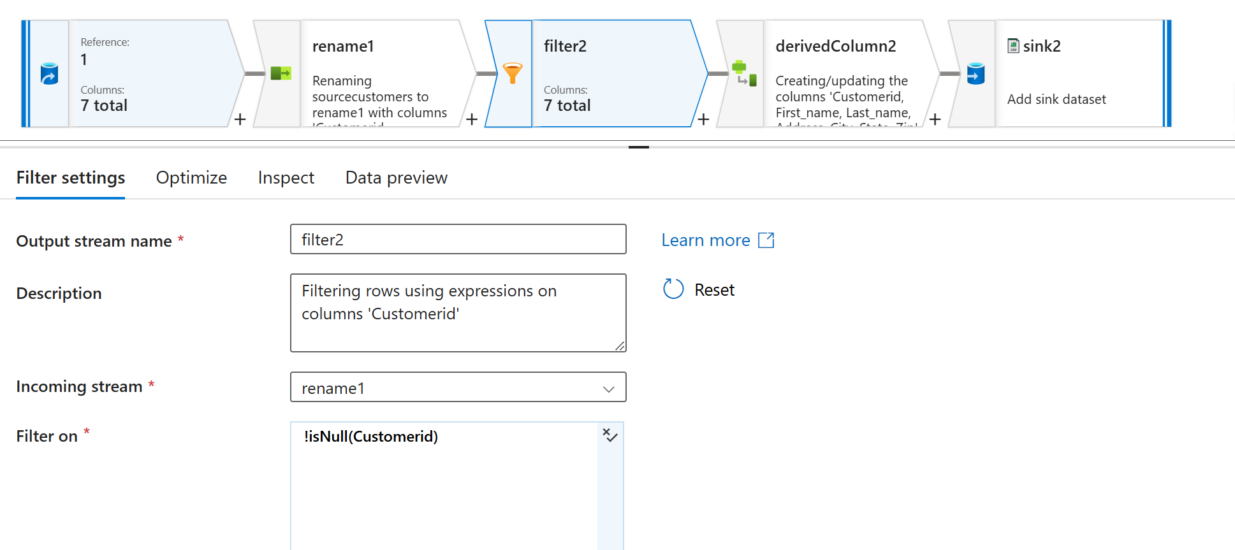
Step 5 : Derived column is used to change the null into unknown
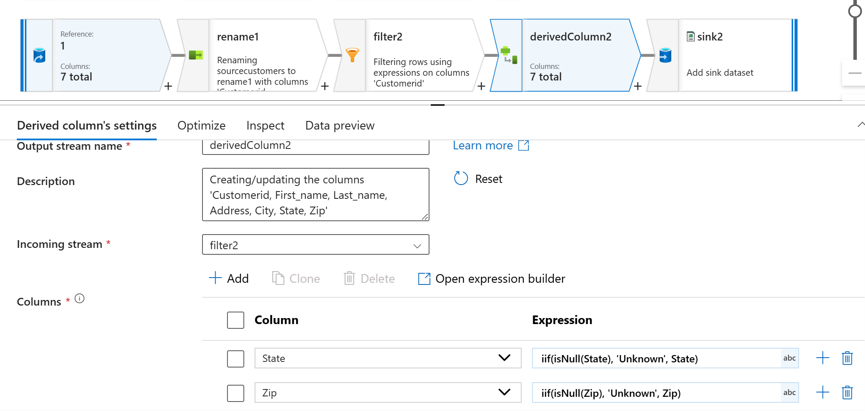
Step 6 : sink in the silver layer
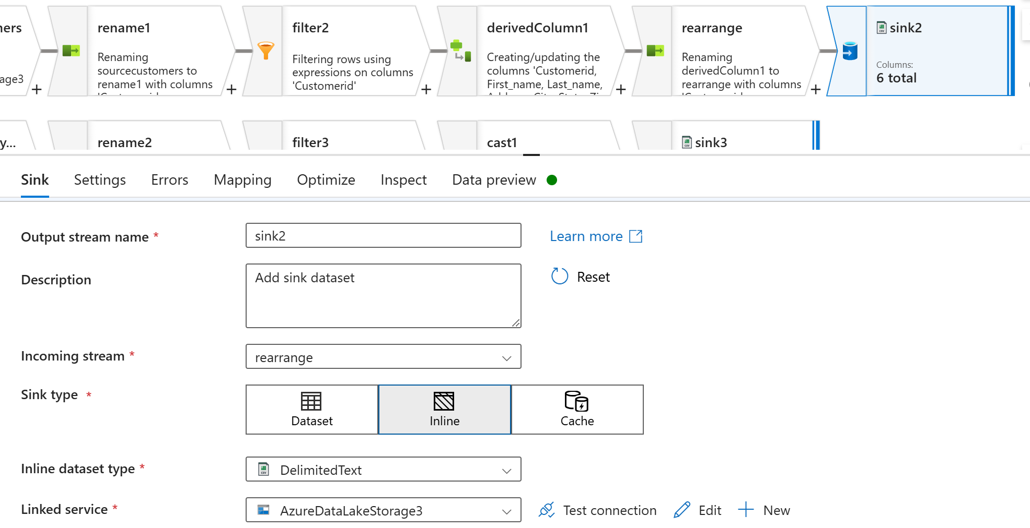
For loadpayments and transcations
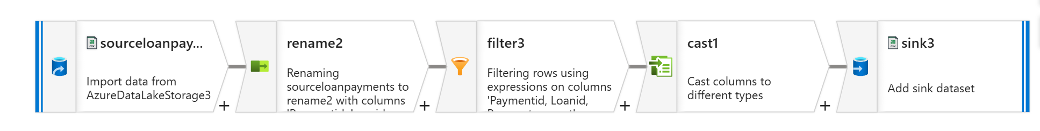
Step 1 : do the same step for the first 3 transformations
Step 2 : search for cast and do this below thing
The Cast transformation was used to convert the PaymentDate column into the DateTime format, ensuring consistency and enabling accurate time-based operations and storage in the sink
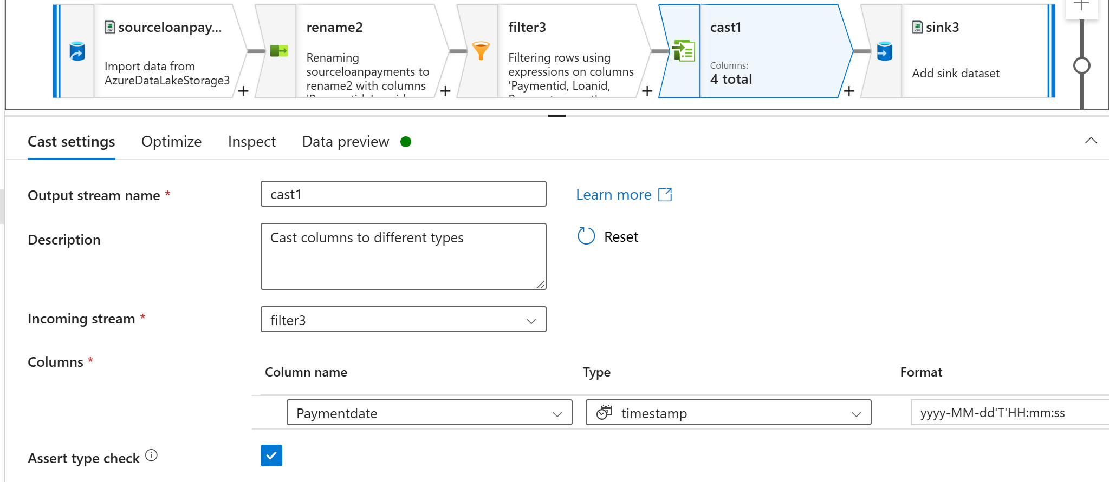
Step 3 : do sink same as all the sink
HERE IS THE SILVER LAYER IN ADLS GEN 2
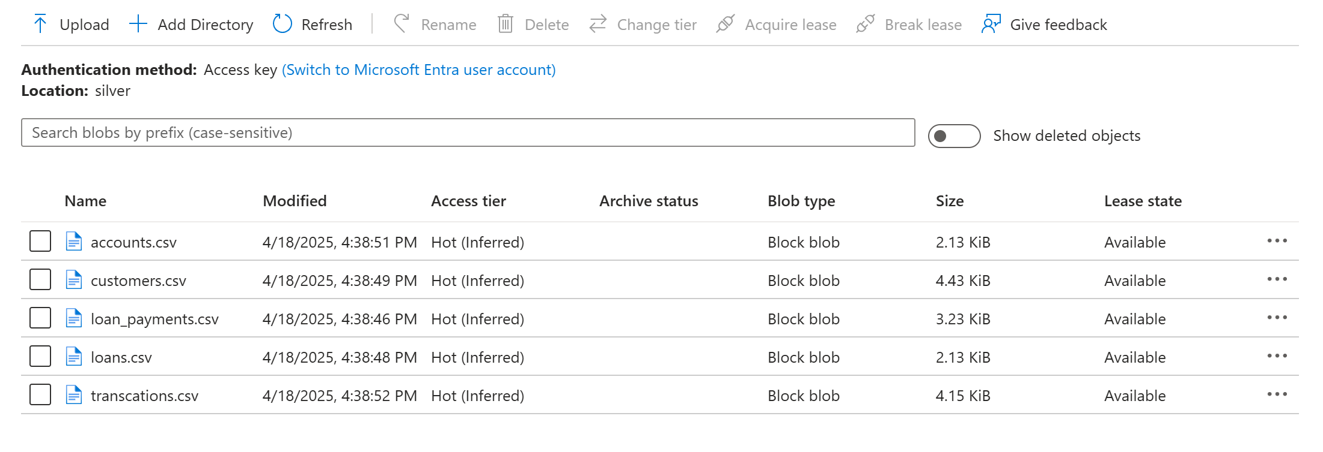
GOLD LAYER
The final output is written to a SQL Database, which serves as the Gold layer. This layer contains well-structured, business-ready data designed for downstream analytics, dashboards, and reporting tools.
SCDTYPE 1 TABLES
SCD Type 1 is used when we only want to keep the most up-to-date information. When something changes, it replaces the old data with the new data and doesn’t store any old information.
Hash Key is a unique code (like a fingerprint) created by combining important columns (e.g., name, email, address) into one value using a hash function.
ACCOUNTS TABLE
create table accounts_scdtype1
(
Accountid int,
Customerid int,
Accounttype varchar(100),
Balance decimal,
Createdby Varchar(100),
Createddate datetime,
Updateby Varchar(100),
Updatedate datetime,
Hashkey bigint
)
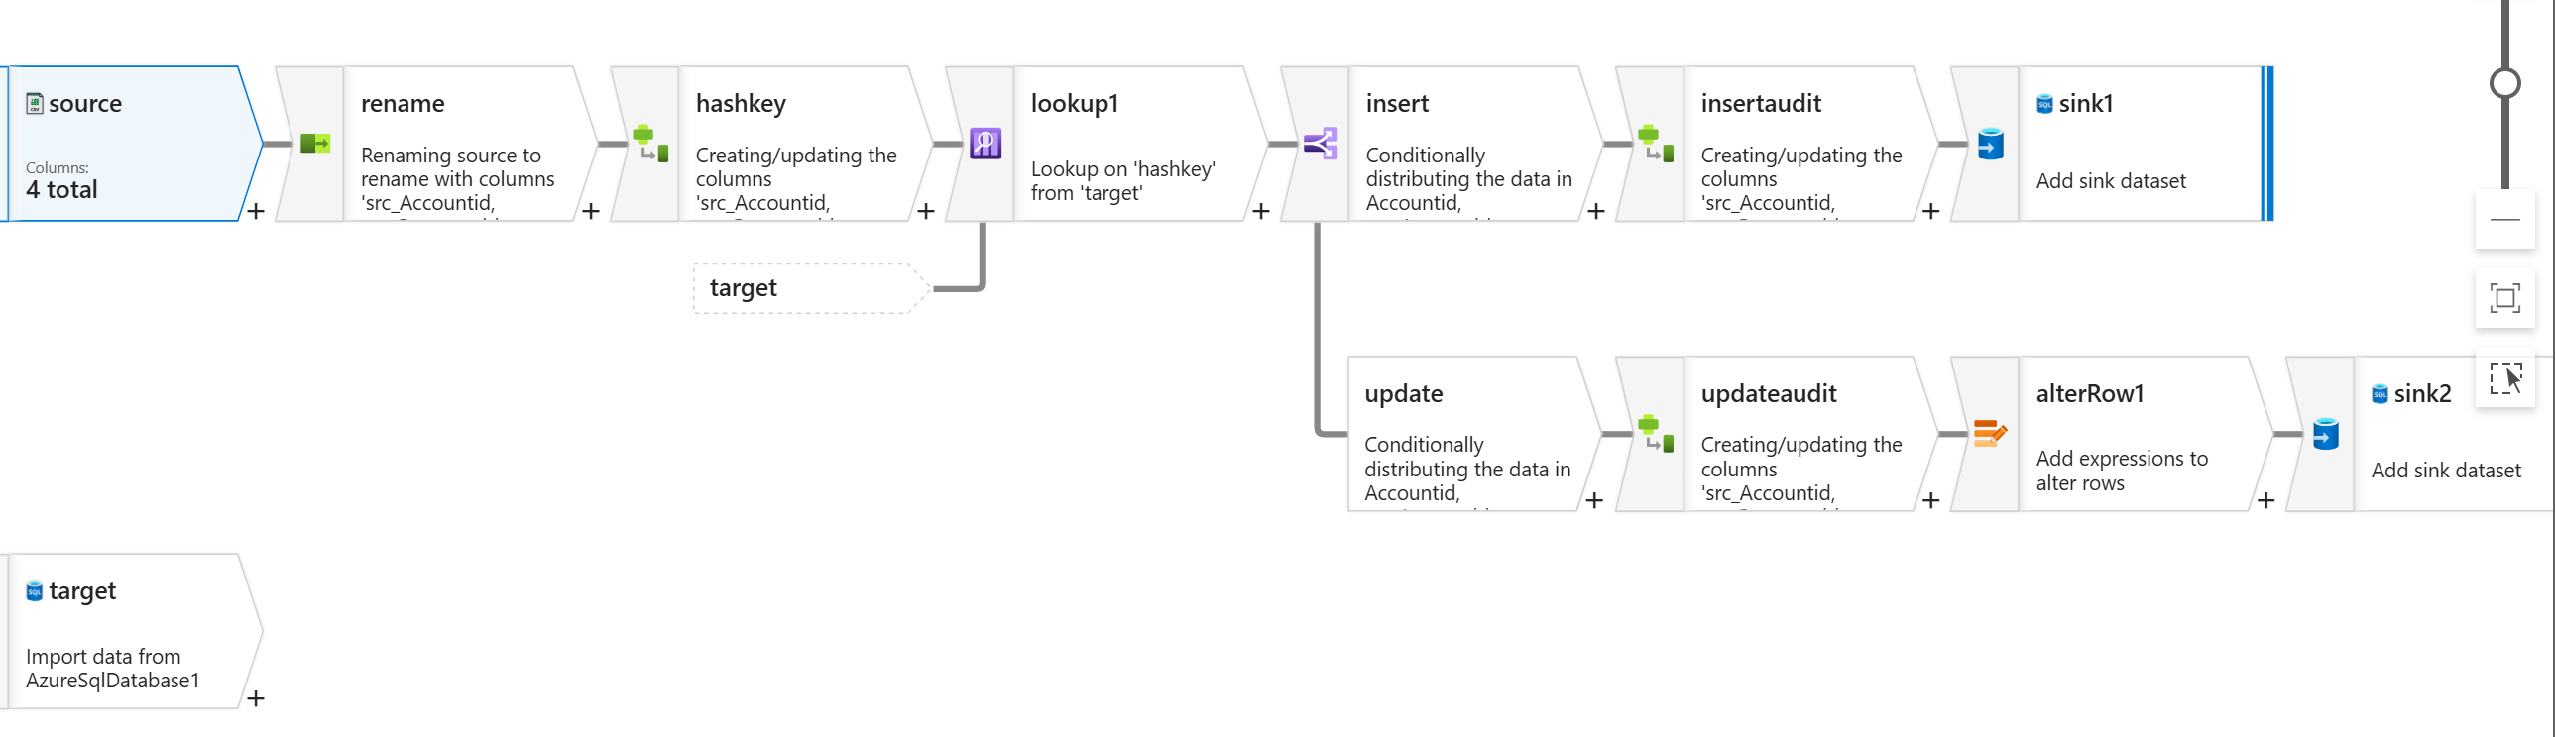
STEP 1 : My source is gen2 storage account which silver layer
In sources setting source type click for inline inline data type change into delimited text and in linked services
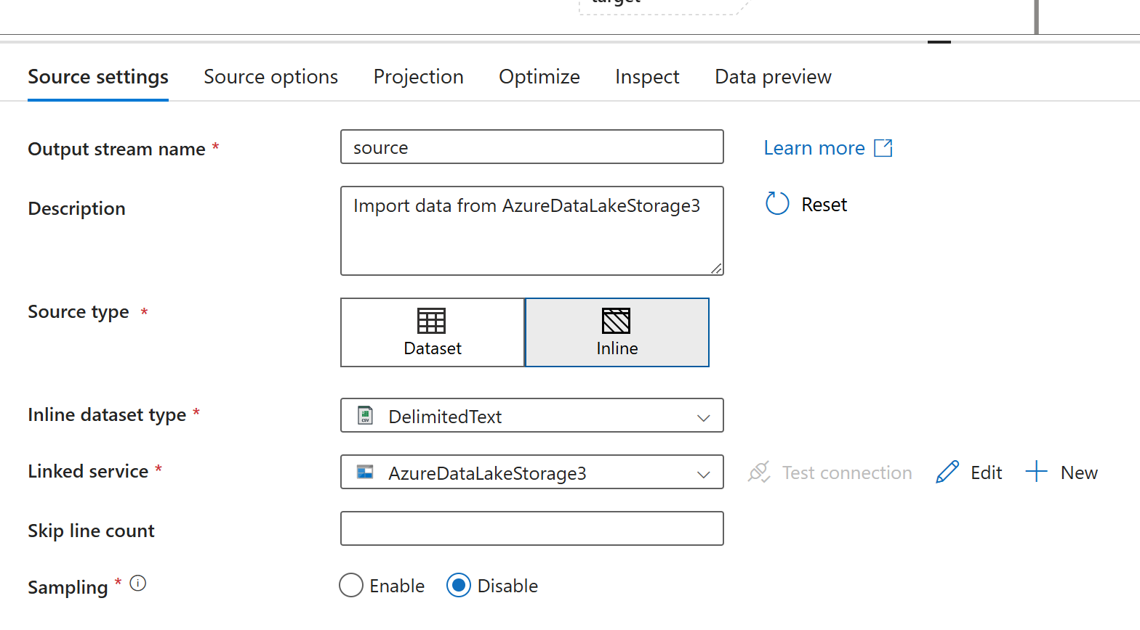
STEP 2 : in source options I gave my file path where my files are located
STEP 5: In source options check first row as header

STEP 3: In projection click on import the schema
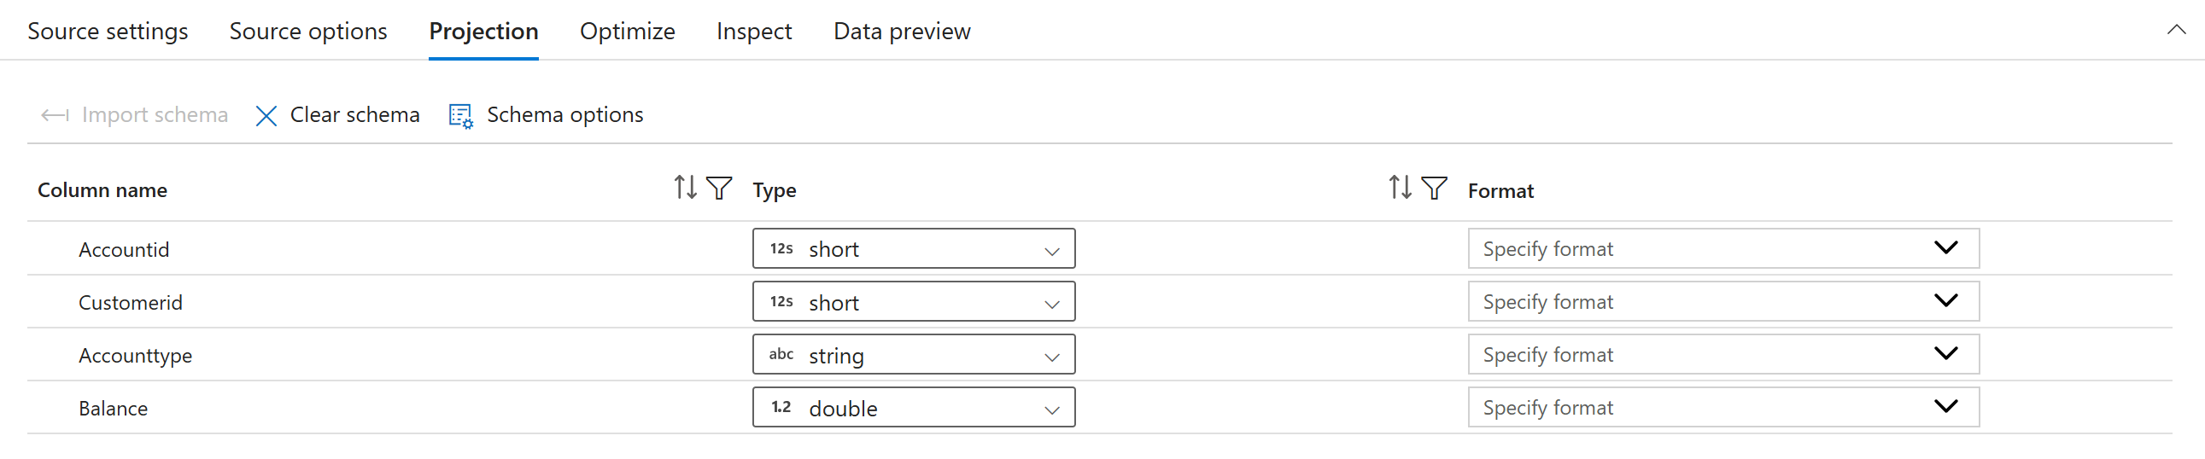
STEP 4 : Click on data preview you will get column
STEP 5 : In select transformation I wanna rename the column name by doing this step
Concat(‘src_’,$$)
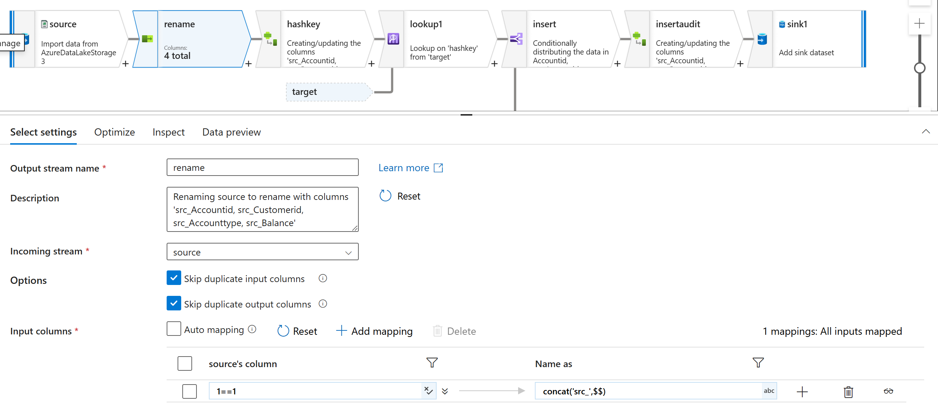
STEP 6 : click on preview data and refresh (column name changed)
STEP 7 : By clicking + in the select(rename) Im gonna start new transformation called drivedcolumn
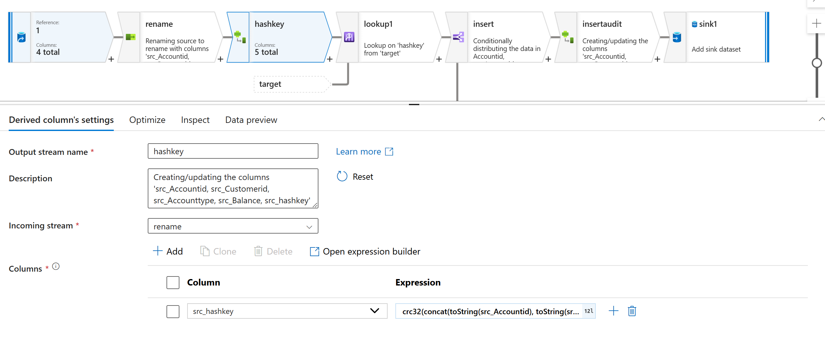
STEP 8 : in derived column , have to create a new column (hashkey) and use concat expressions
crc32(concat(toString(src_Accountid), toString(src_Customerid),src_Accounttype, toString(src_Balance)))
STEP 9 : I wanna add my target (sink)
In source setting source type inline inline dataset type sql db
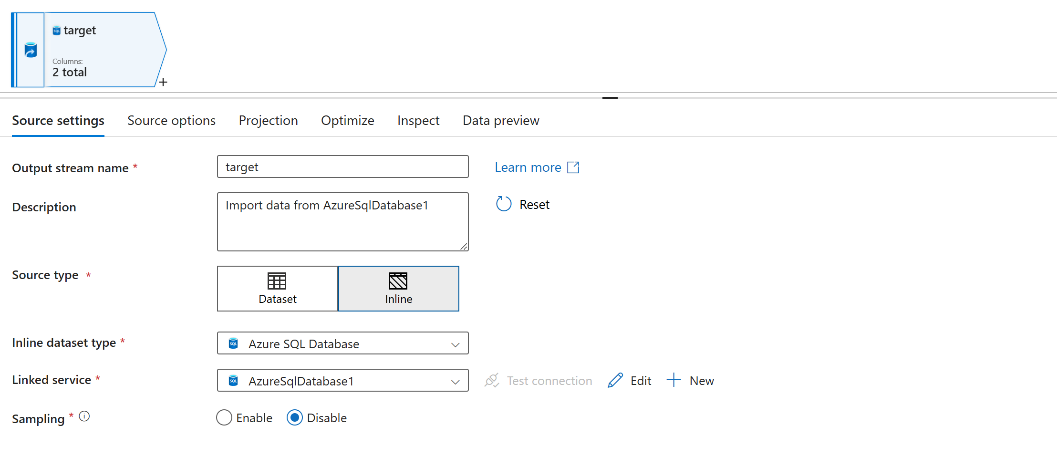
STEP 10 : I wanna compare this 2 column whether this is existing or not
select Accountid, Hashkey from accounts_scdtype1
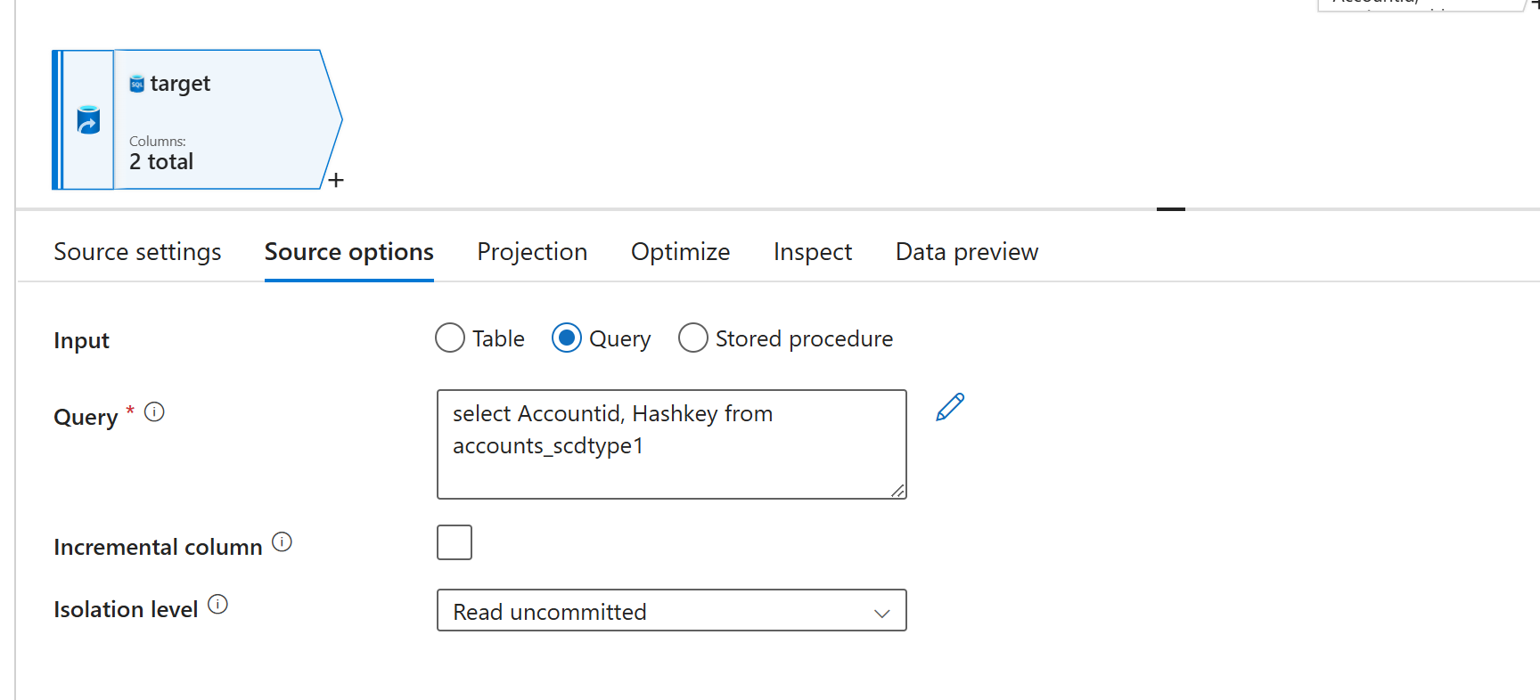
STEP 11 : click on projection click on import schema
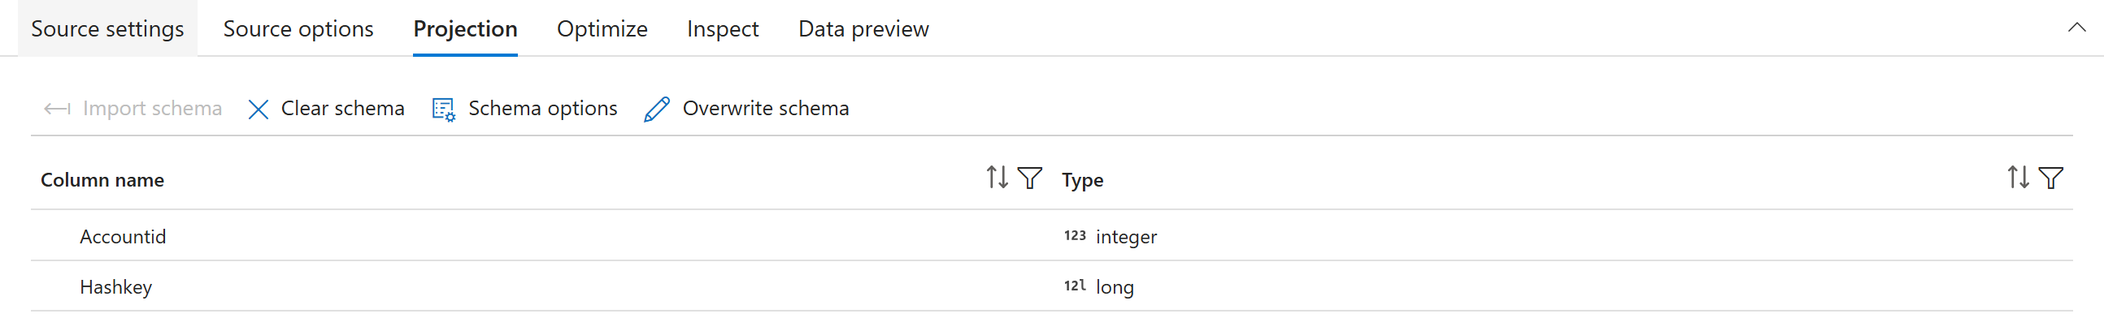
STEP 12: By clicking + in the derived(hashkey) start new transformation called lookup
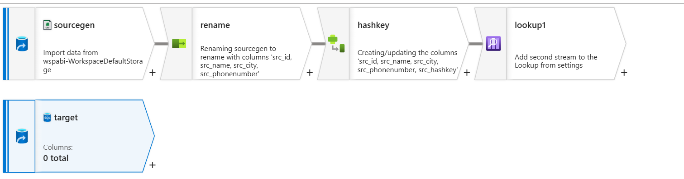
STEP 13 : select lookup transformation
Used a lookup to match conditions, where the left side referred to the target column and the right side referred to the source column.
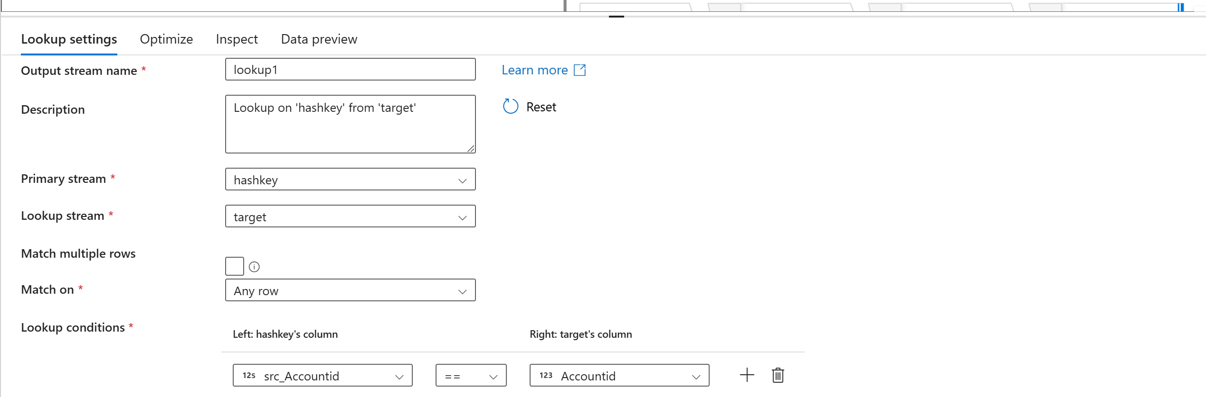
STEP 14 : in data preview data will be displayed
STEP 15 : By clicking + in the lookup start new transformation called conditional split

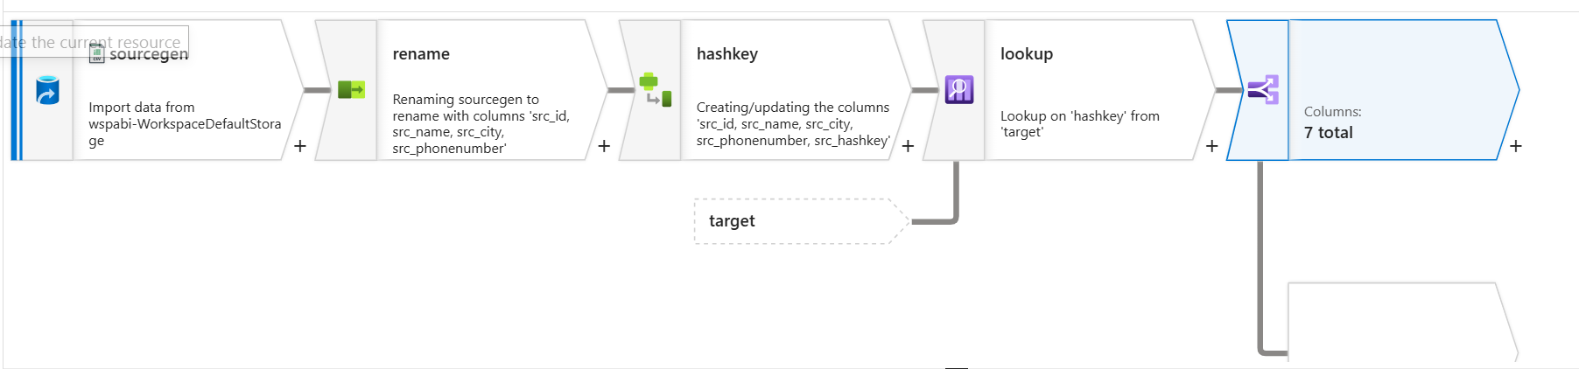
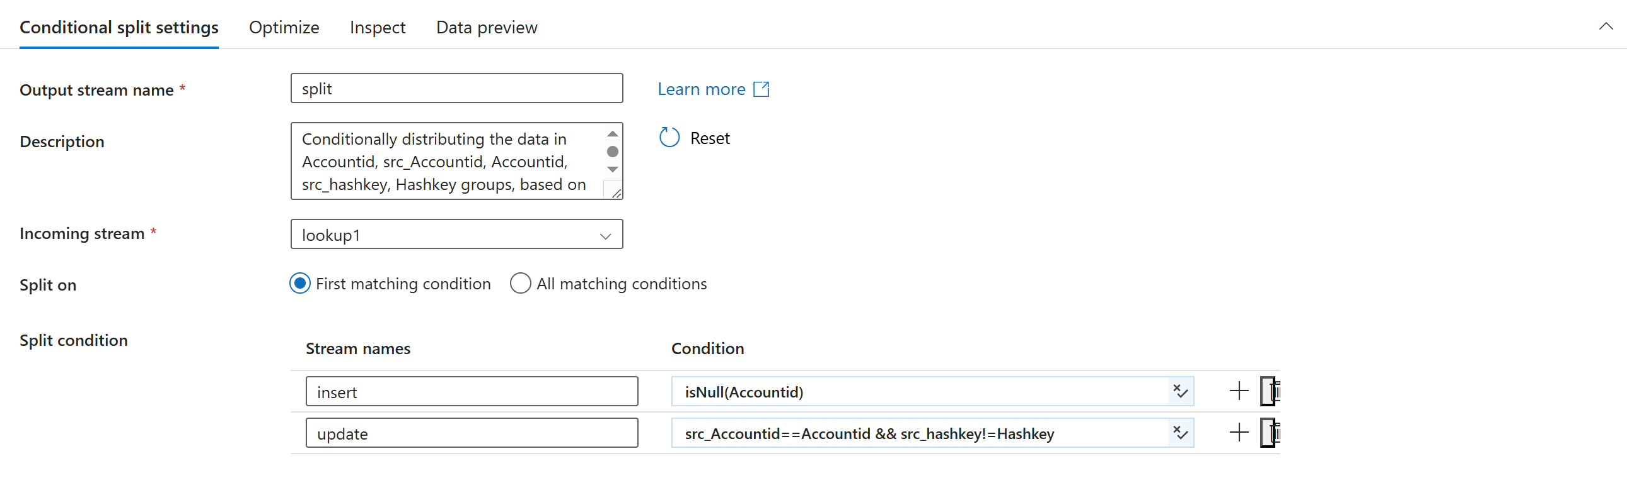
isNull(Accounttid)
If the custid is not null consider this as a existing record and update this
Hashkey is already generated and it will generate another hashkey use the below code code
src_Accountid==Accountid && src_hashkey!=Hashkey

STEP 16 : By clicking + in the update Im gonna start new transformation called derived column (to update audit column)

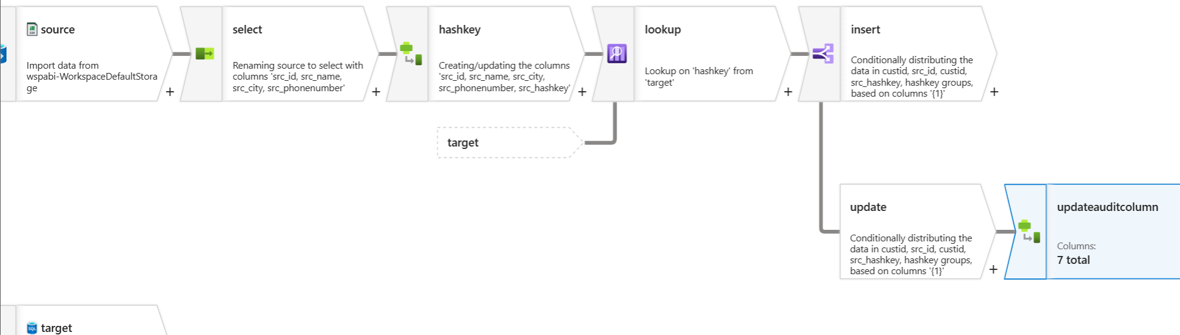
STEP 17 : I wanna update audit column (src_updateby, src_updatedate)
Add new columns
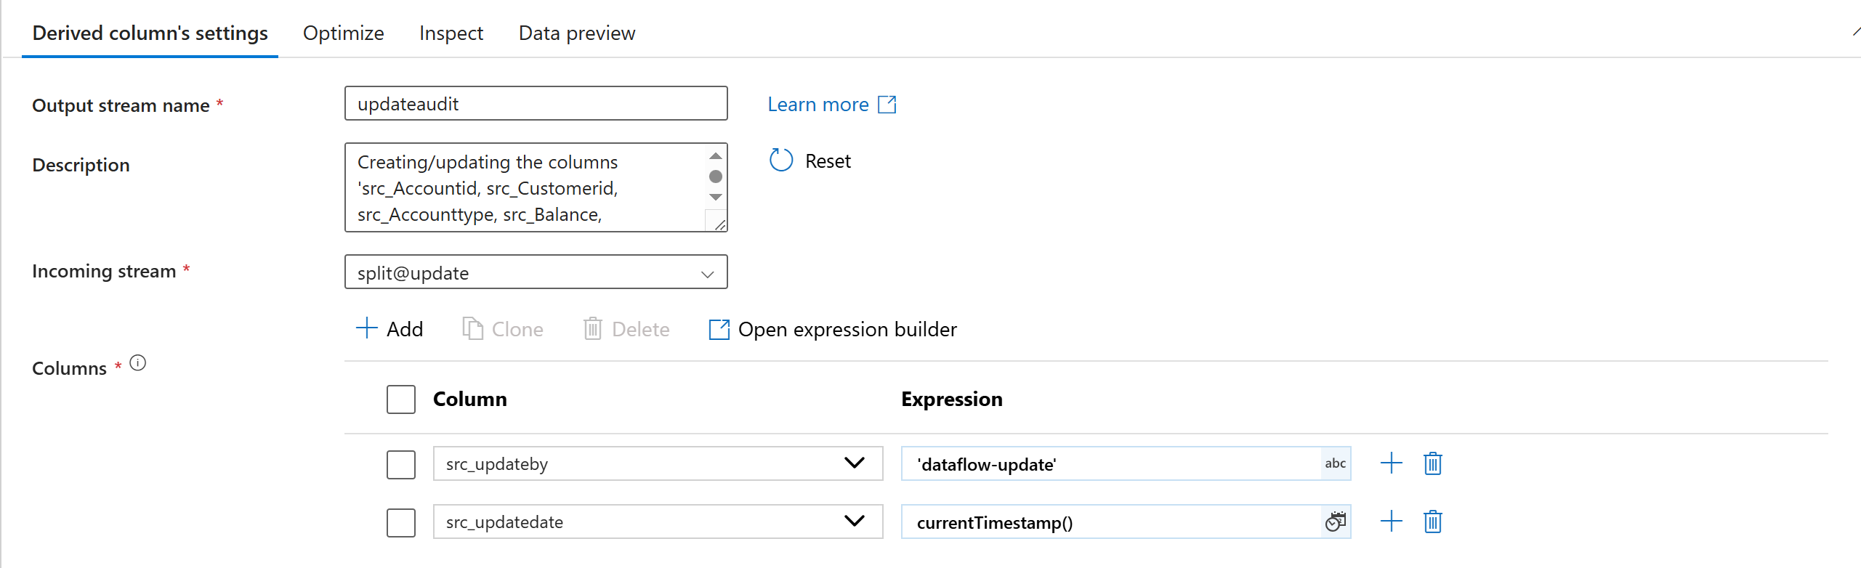
STEP 18 : By clicking + in the derivedcolumn Im gonna start new transformation called alter row
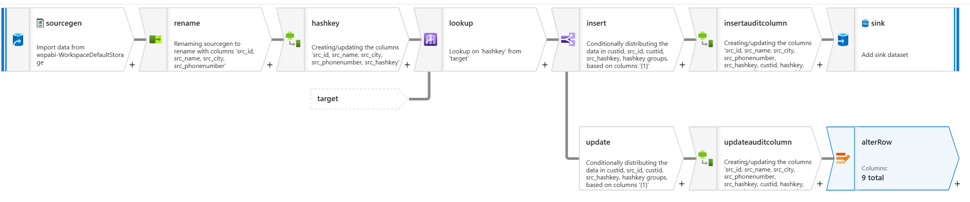
STEP 19 : Permission to modify the data
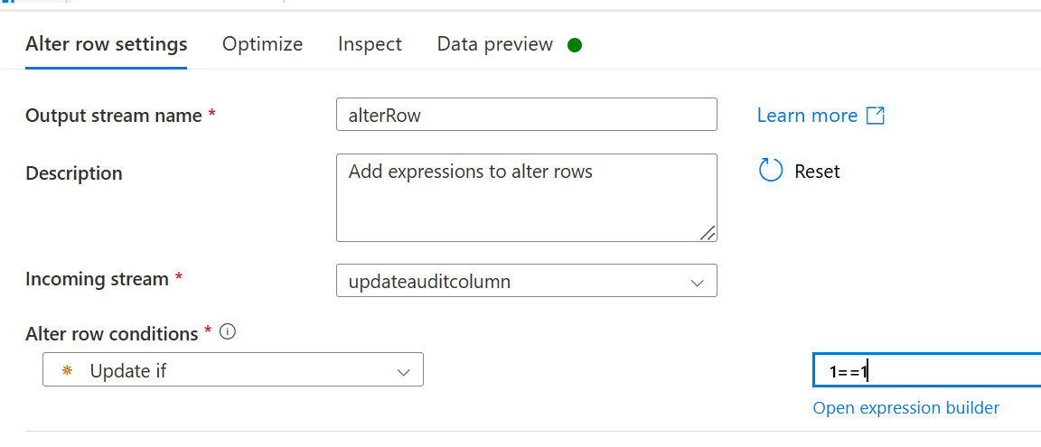
Updateif 1==1
STEP 20 : By clicking + in the alterrow Im gonna start new transformation called sink

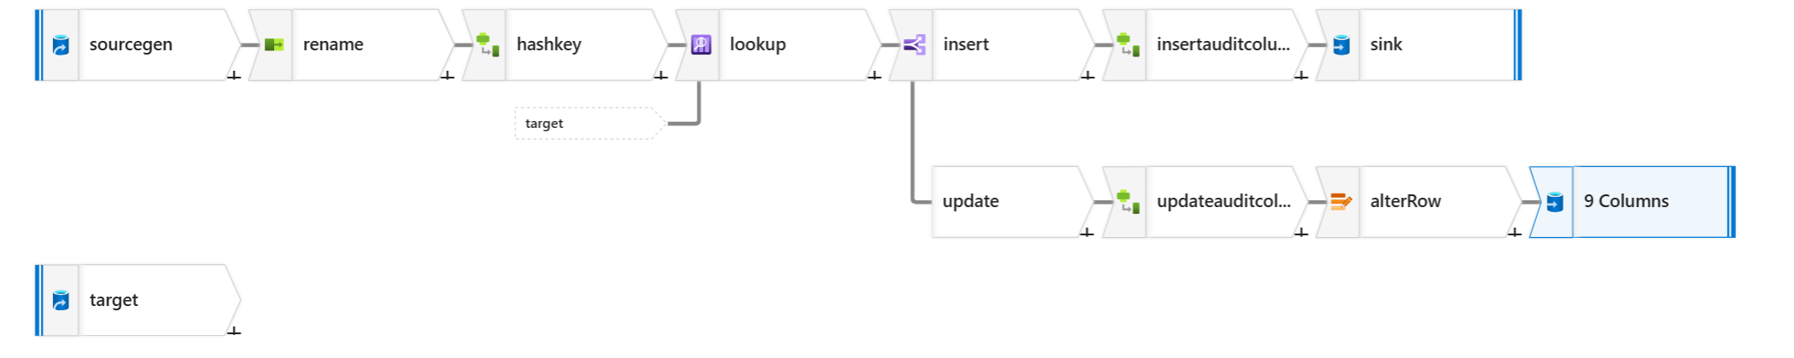
STEP 21 : sink as sql database
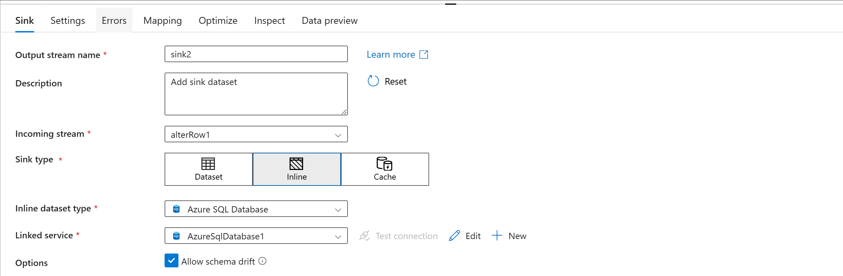
STEP 22 : in setting give schema and table name
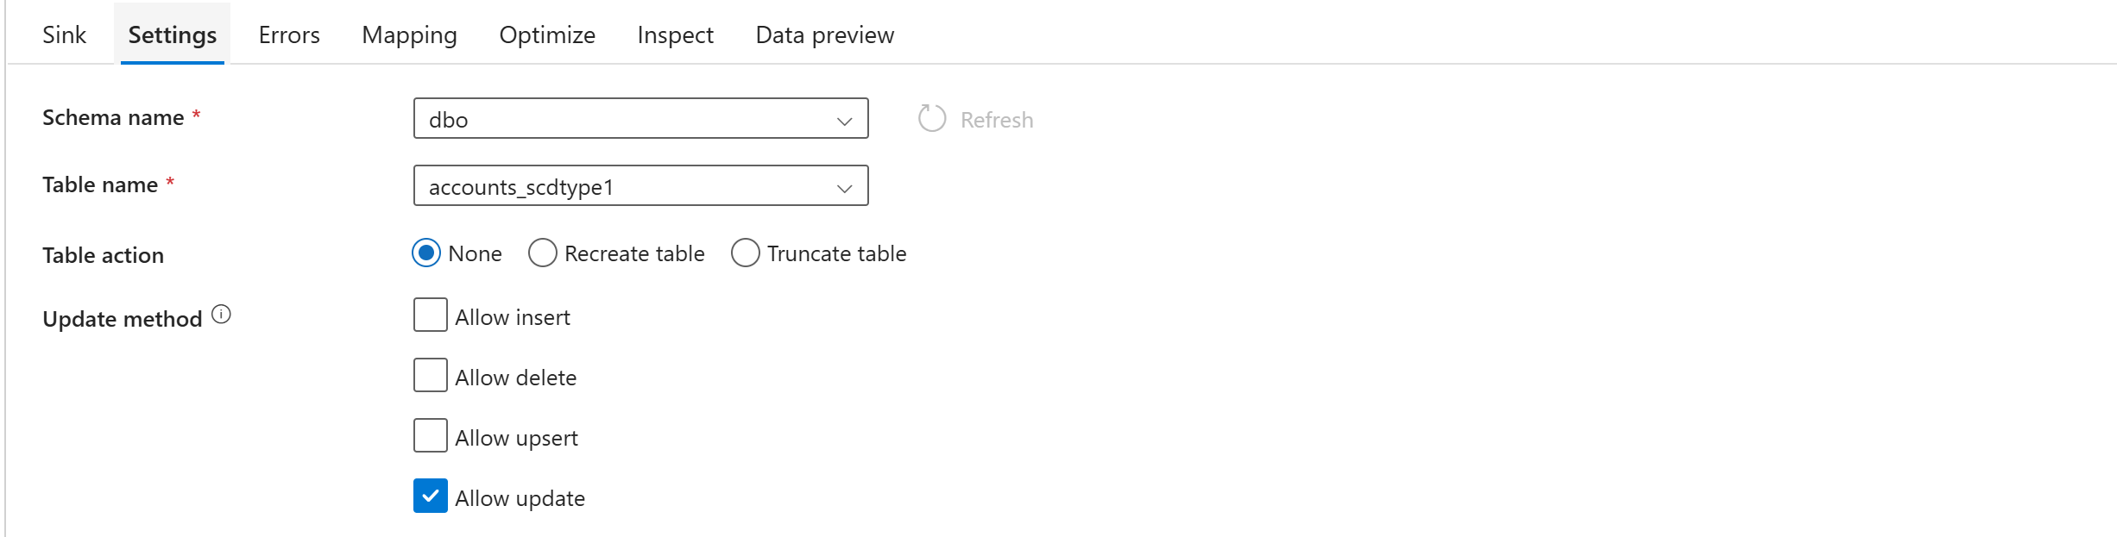
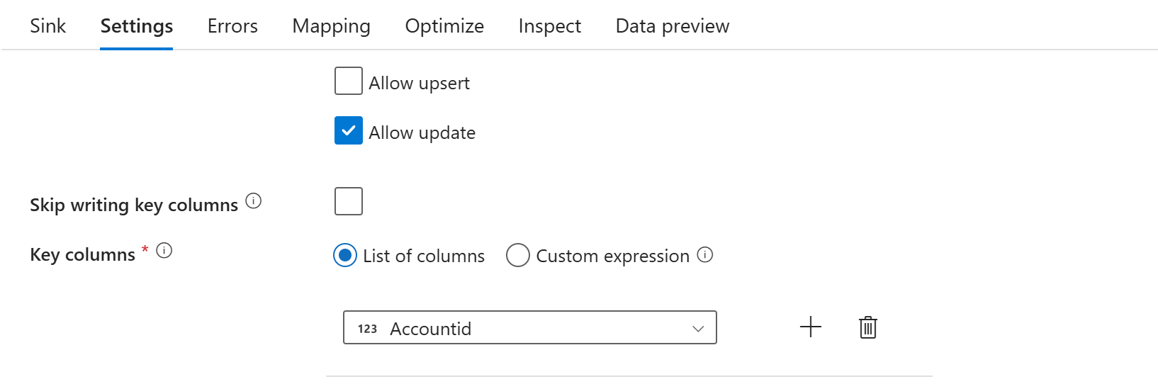

STEP 23 : in mapping uncheck auto mapping click on importschema and click reset
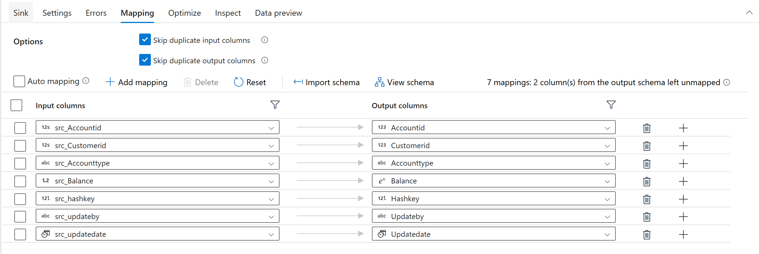

STEP 24 : By clicking + in the insert Im gonna start new transformation called derived column(insertaudit)
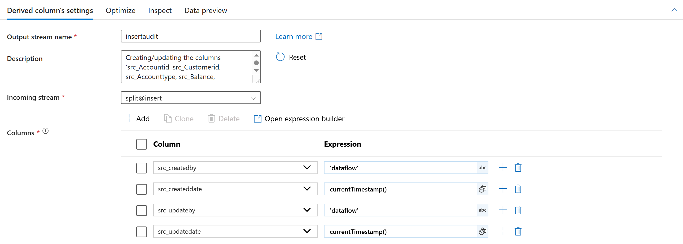
STEP 25 : By clicking + in the derived column (insert audit column) add new transformation called sink
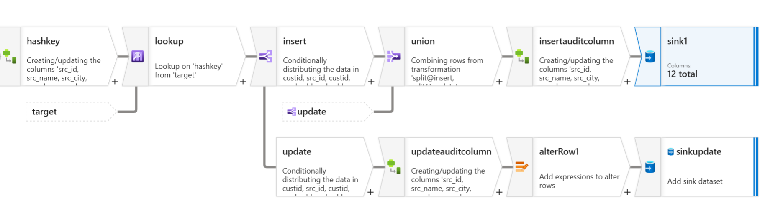
STEP 26 : In sink sink type click inline inline dataset type click sqldb
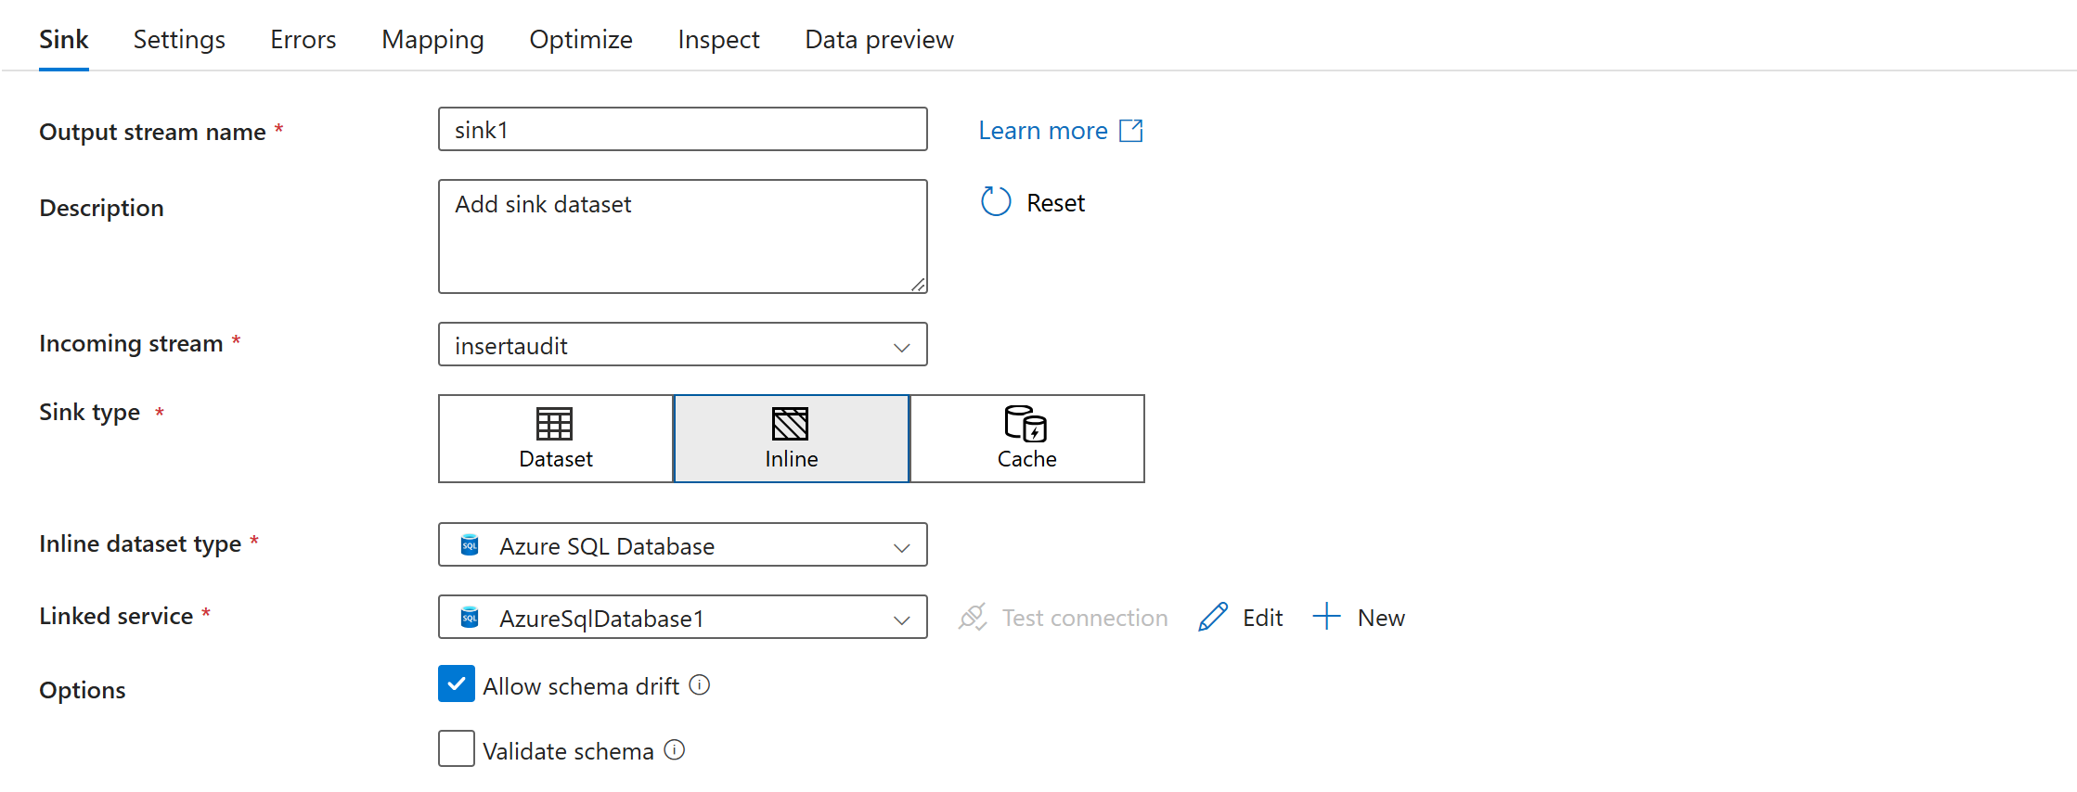

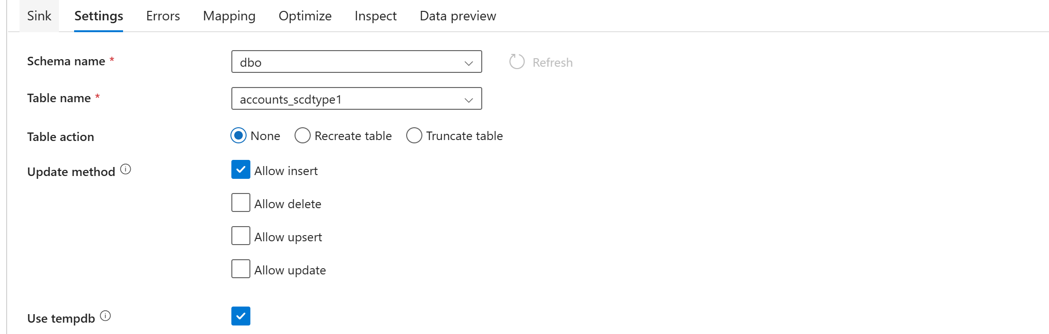
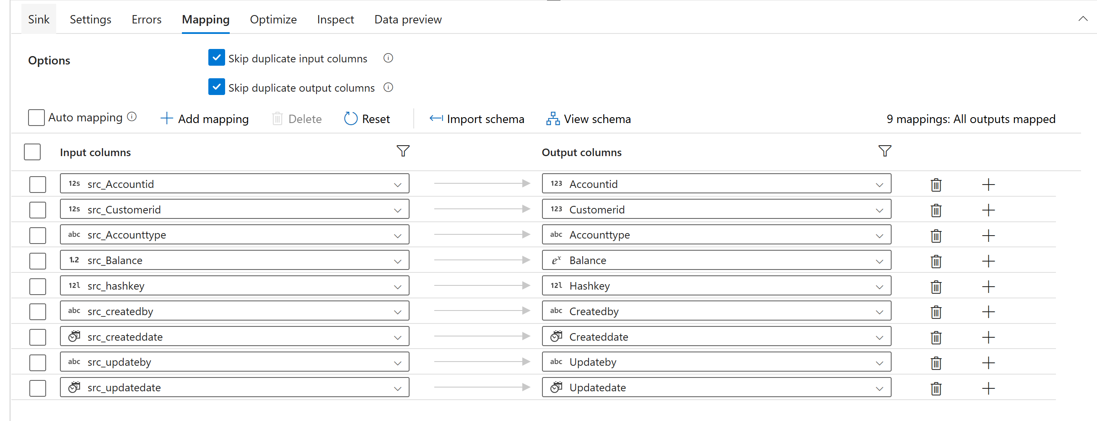
STEP 27 : publish
USED THIS SAME LOGIC FOR CUSTOMERS AND LOANPAYMENT
GOLD LAYER ACCOUNTS, CUSTOMERS AND LOADPAYMENT SCD TYPE 1
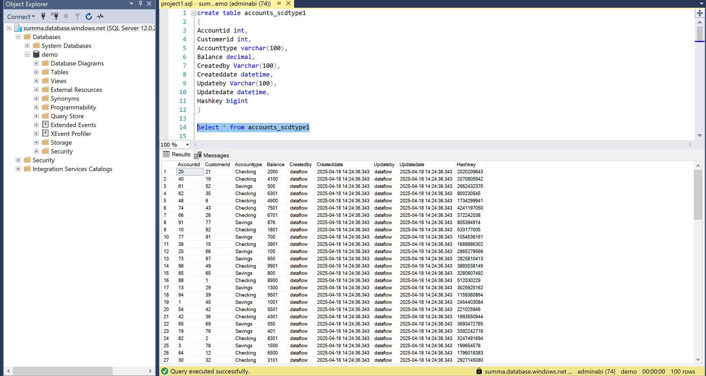
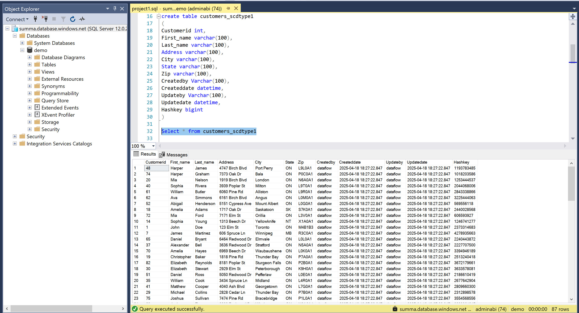
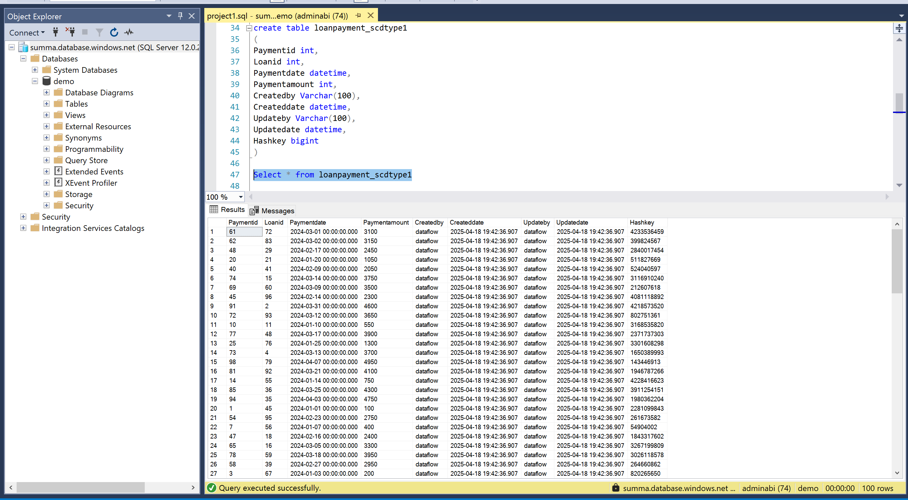
SCD TYPE 2
SCD Type 2 is a way to keep track of changes in your data over time—like keeping an entire history of changes instead of just the latest update.
LOANS TABLE
create table loan_scdtype2
(Loanid int,
Customerid int,
Loanamount int,
Interestrate int,
Loanterm int,
Createdby varchar(100),
Createddate datetime,
Updateby varchar(100),
Updatedate datetime,
Hashkey bigint,
Isactive int)
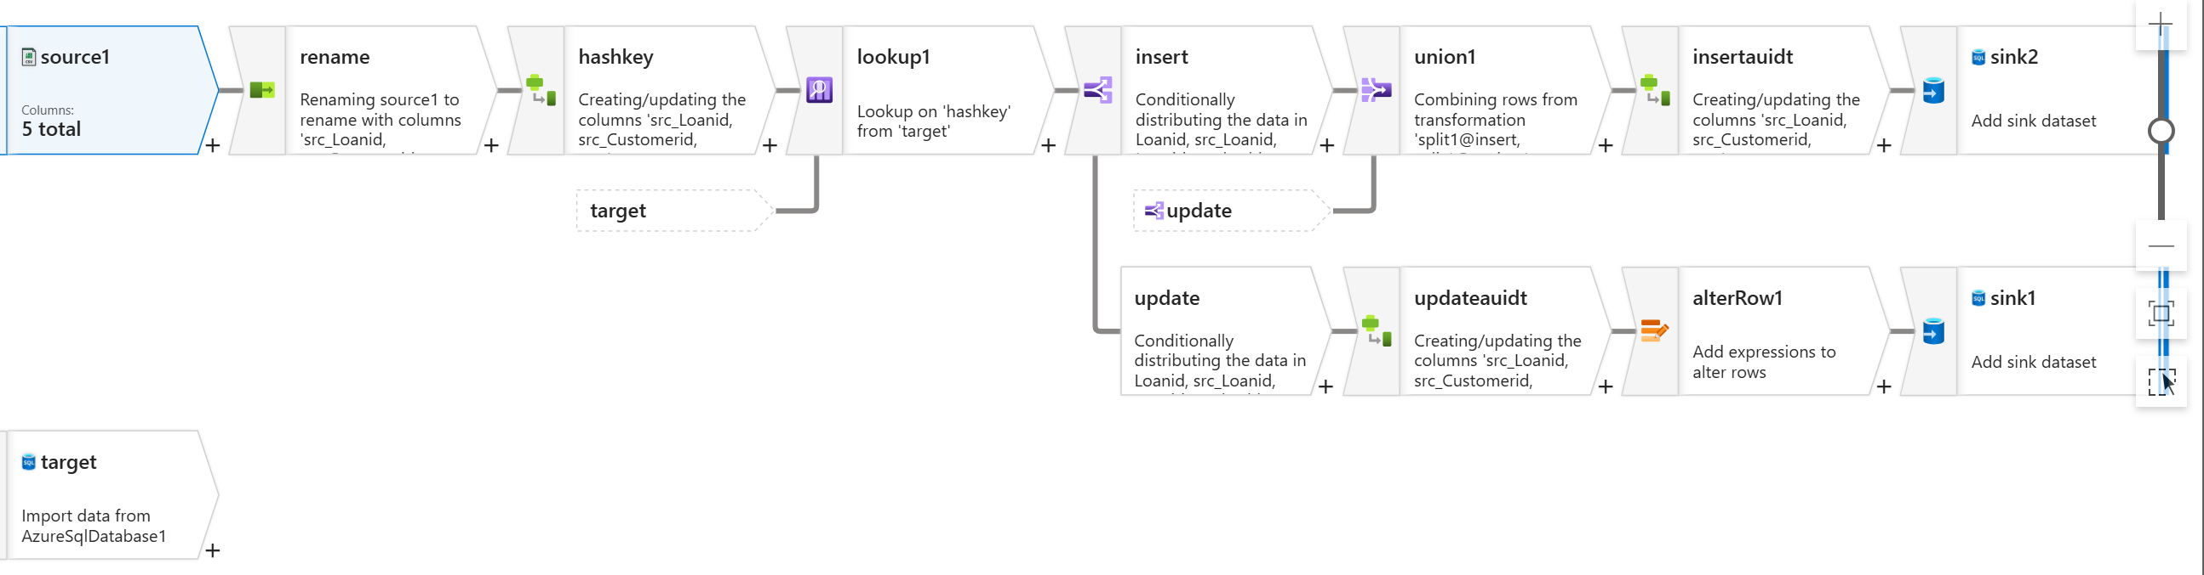
STEP 1 : My source is gen2 storage account which silver layer
In sources setting source type click for inline inline data type change into delimited text and in linked services

STEP 2 : in source options I gave my file path where my files are located 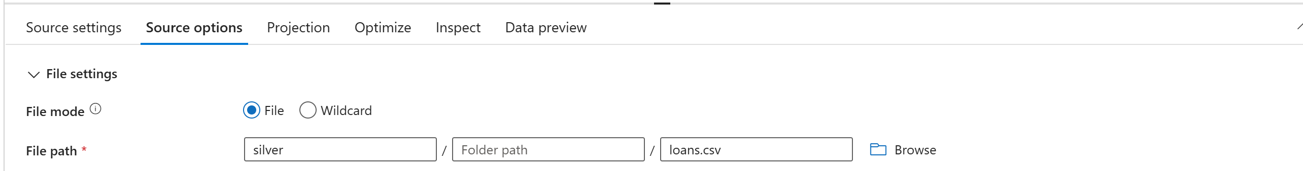
STEP 5: In source options check first row as header

STEP 3: In projection click on import the schema
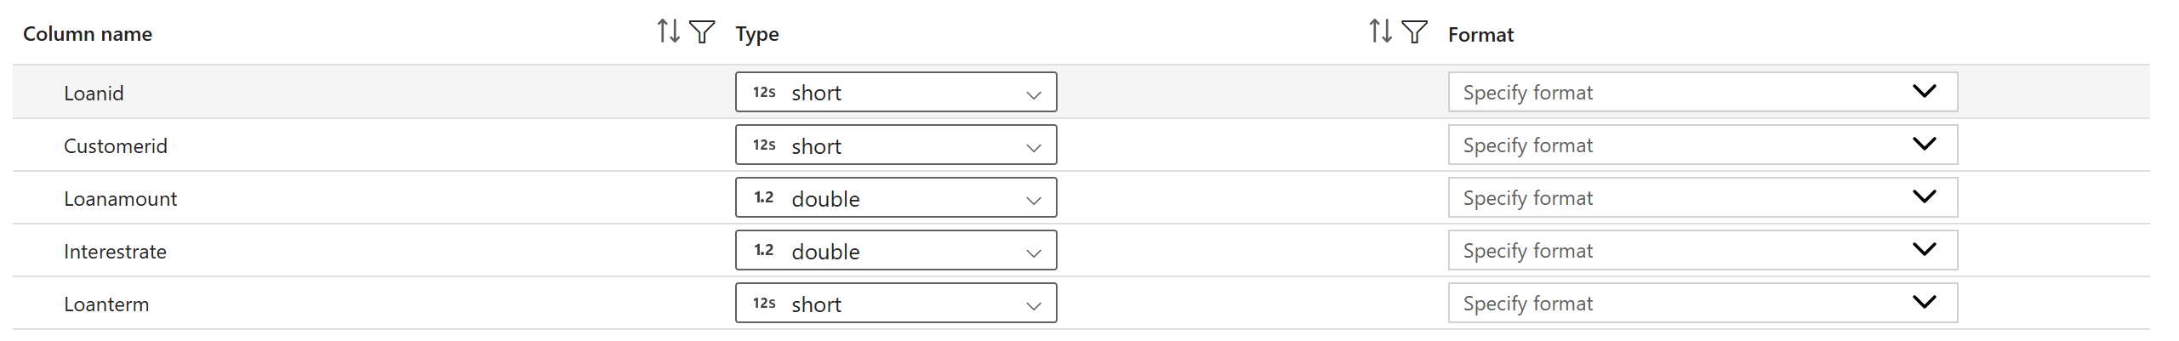
STEP 4 : Click on data preview you will get column
STEP 5 : In select transformation I wanna rename the column name by doing this step
Concat(‘src_’,$$)

STEP 6 : click on preview data and refresh (column name changed)
STEP 7 : By clicking + in the select(rename) Im gonna start new transformation called drivedcolumn
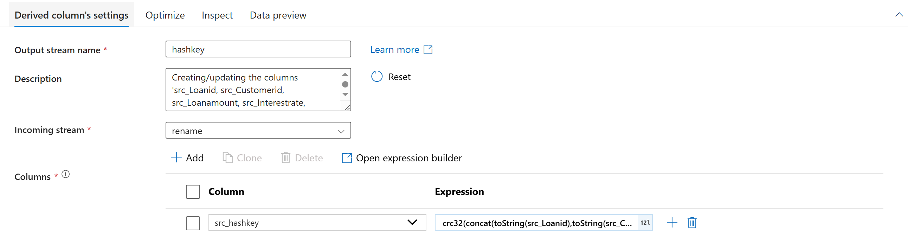
STEP 8 : in derived column , have to create a new column (hashkey) and use concat expressions
crc32(concat(toString(src_Loanid),toString(src_Customerid),toString(src_Loanamount),toString(src_Interestrate),toString(src_Loanterm)))

STEP 9 : I wanna add my target (sink)
In source setting source type inline inline dataset type sql db

STEP 10 : I wanna compare this 2 column whether this is existing or not
select Loanid,Hashkey from loan_scdtype2 where Isactive=1
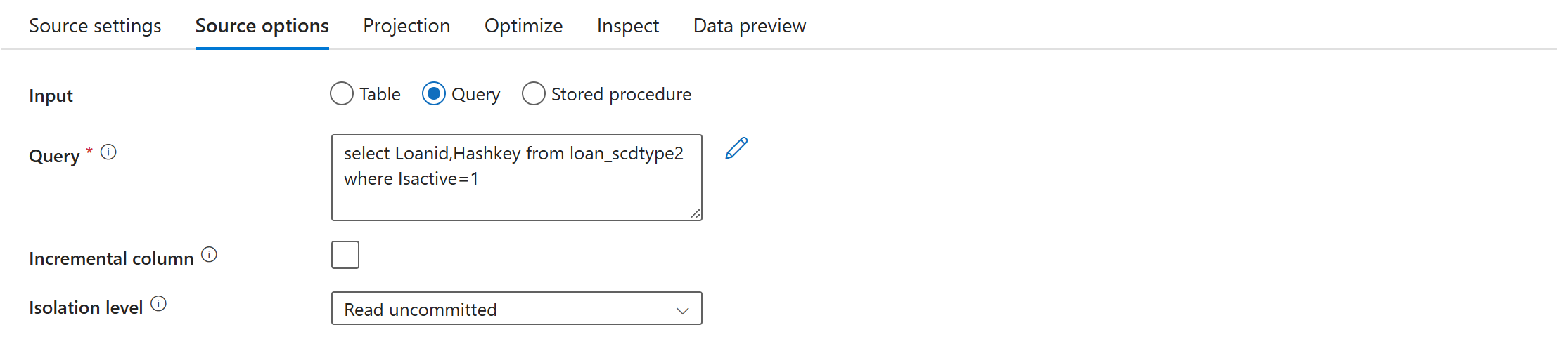
STEP 11 : click on projection click on import schema
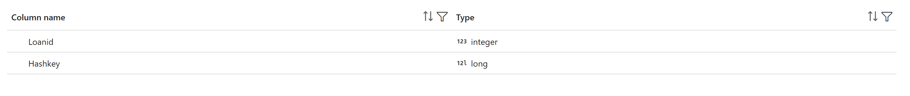
STEP 12: By clicking + in the derived(hashkey) start new transformation called lookup

STEP 13 : select lookup transformation
Used a lookup to match conditions, where the left side referred to the target column and the right side referred to the source column.
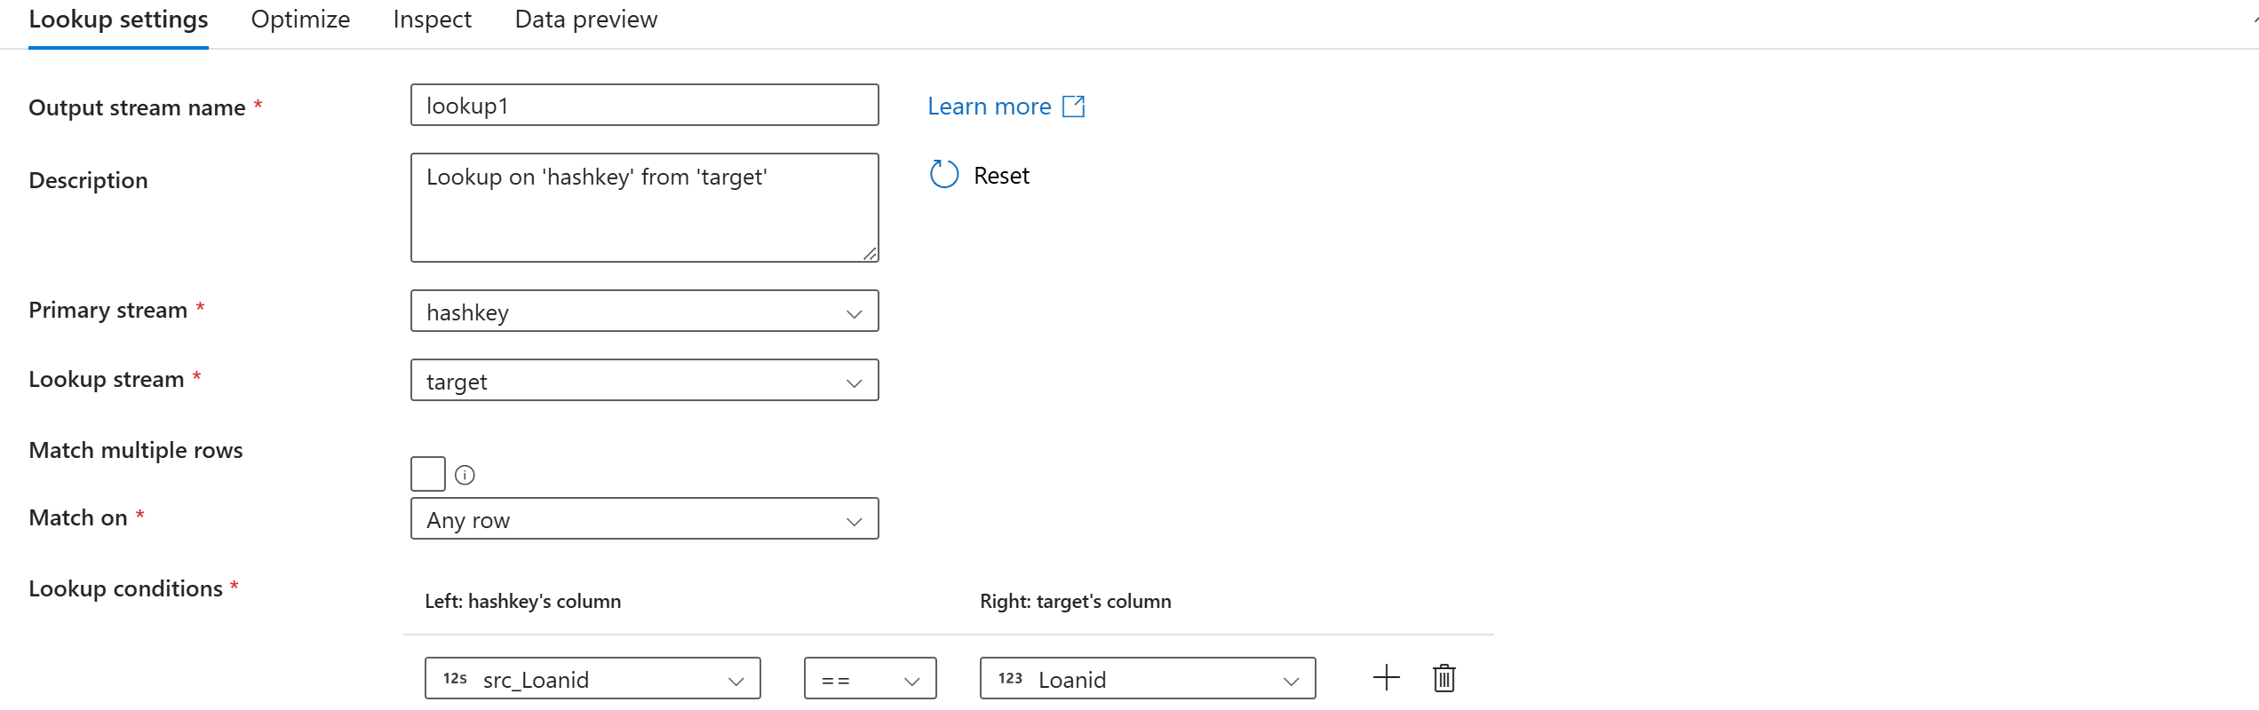
STEP 14 : in data preview data will be displayed
STEP 15 : By clicking + in the lookup start new transformation called conditional split


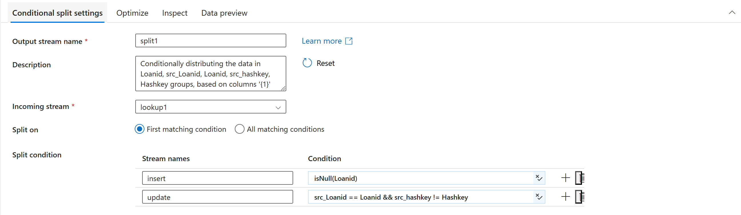
isNull(Accounttid)
If the custid is not null consider this as a existing record and update this
Hashkey is already generated and it will generate another hashkey use the below code code
src_Accountid==Accountid && src_hashkey!=Hashkey

STEP 16 : By clicking + in the update Im gonna start new transformation called derived column (to update audit column)


STEP 17 : I wanna update audit column (src_updateby, src_updatedate,src_isactive)
Add new columns
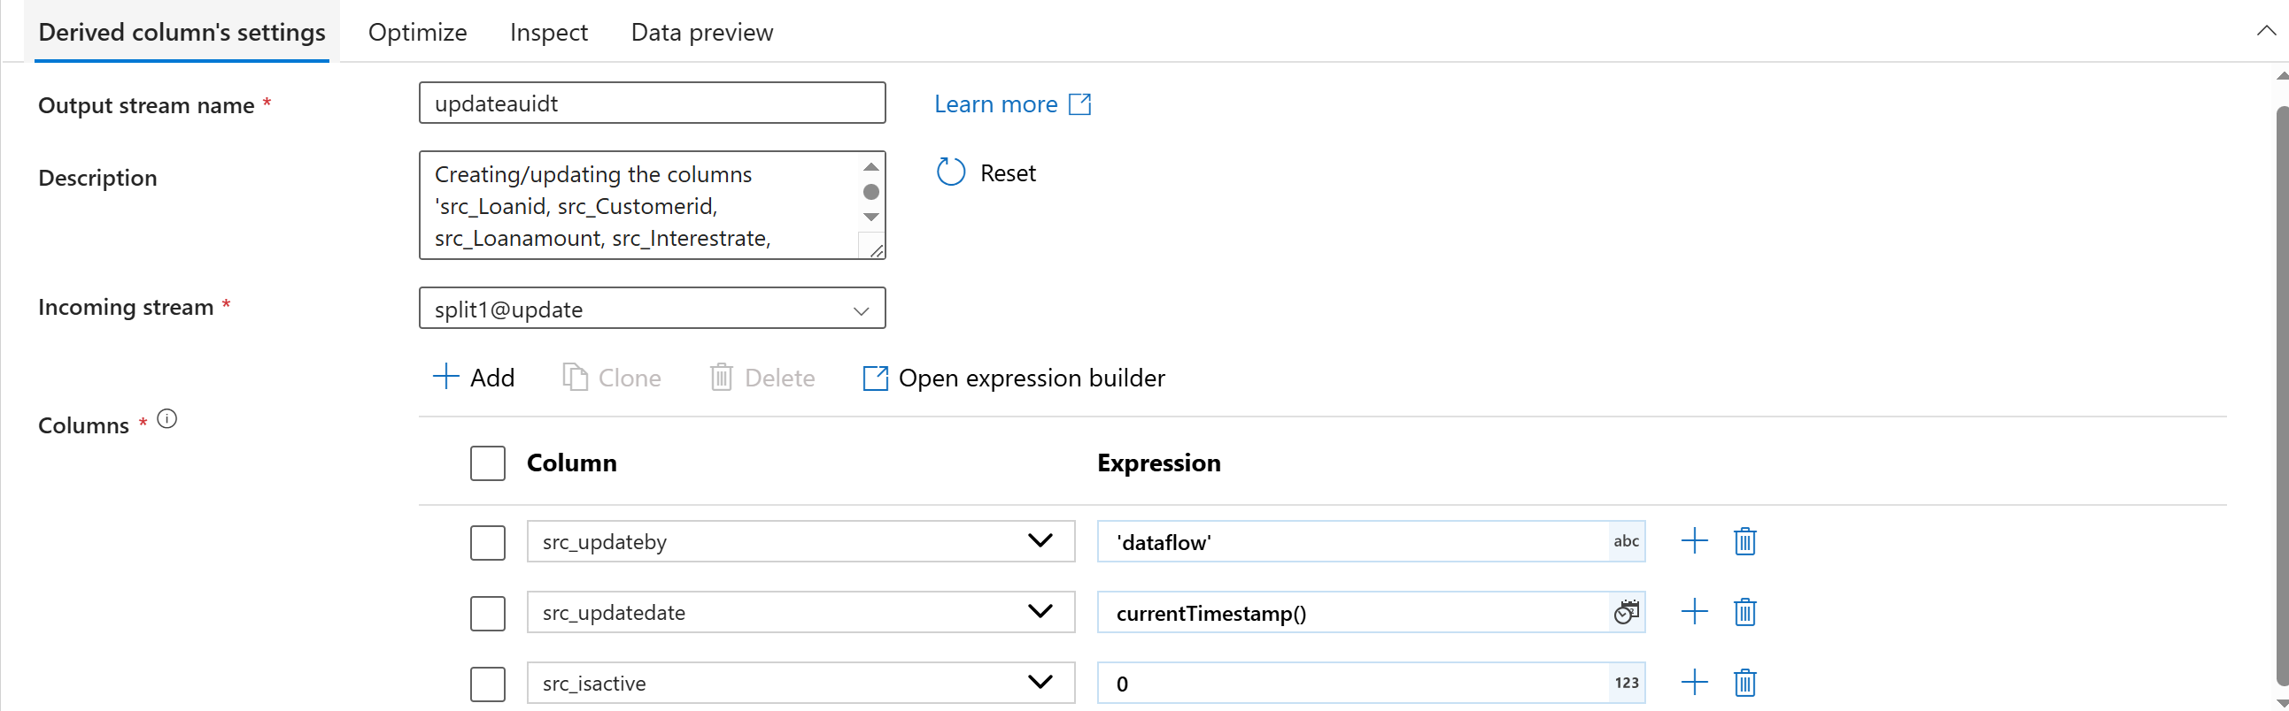
STEP 18 : By clicking + in the derivedcolumn Im gonna start new transformation called alter row

STEP 19 : Permission to modify the data
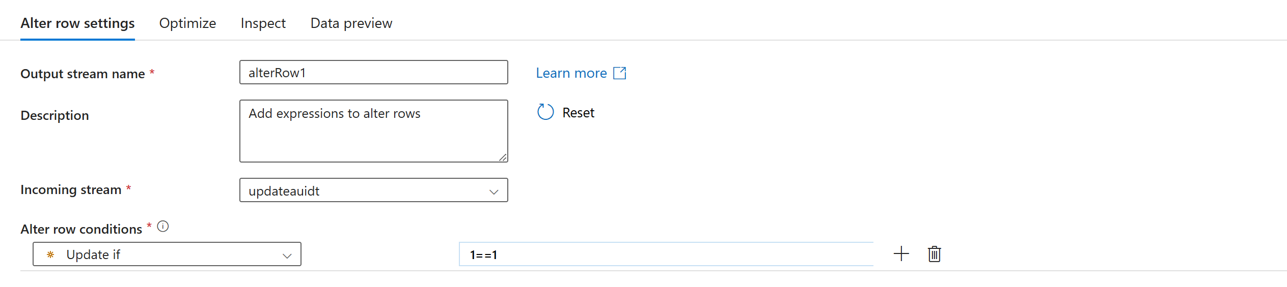
Updateif 1==1
STEP 20 : By clicking + in the alterrow Im gonna start new transformation called sink


STEP 21 : sink as sql database

STEP 22 : in setting give schema and table name
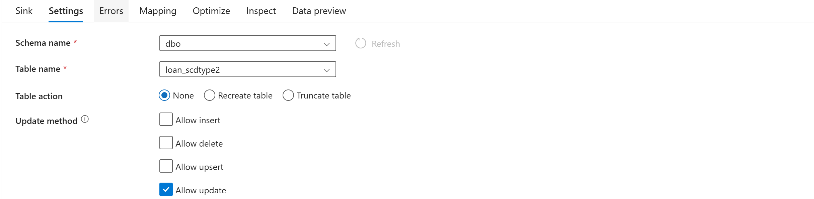


STEP 23 : in mapping uncheck auto mapping click on importschema and click reset
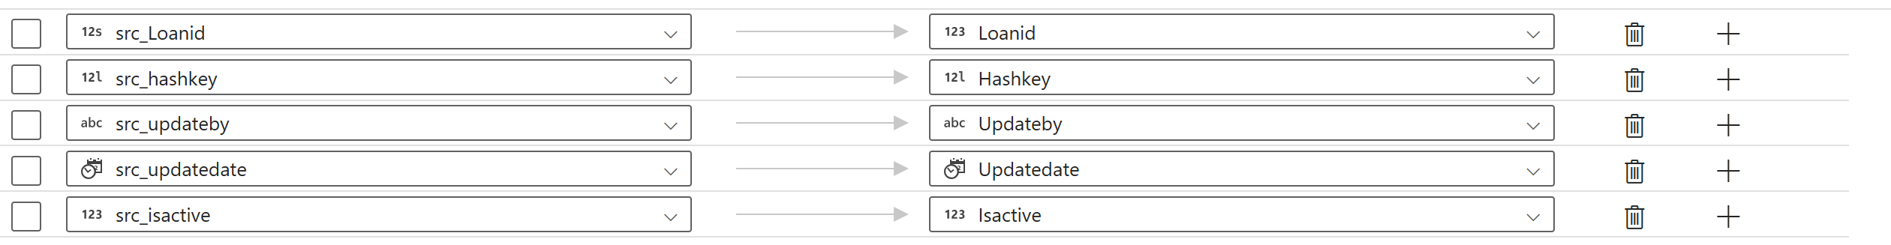
Step 24 : By clicking + in the insert, im gonna start new transformation called union
The Union transformation is used to combine data from two or more sources into one single output.

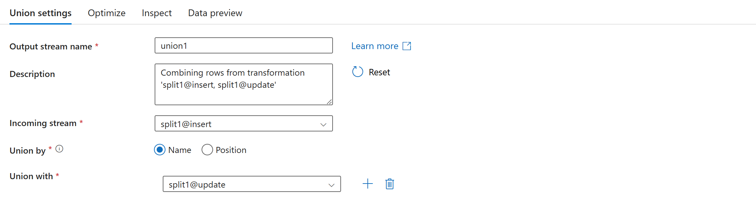

STEP 25 : By clicking + in the insert Im gonna start new transformation called derived column(insertaudit)
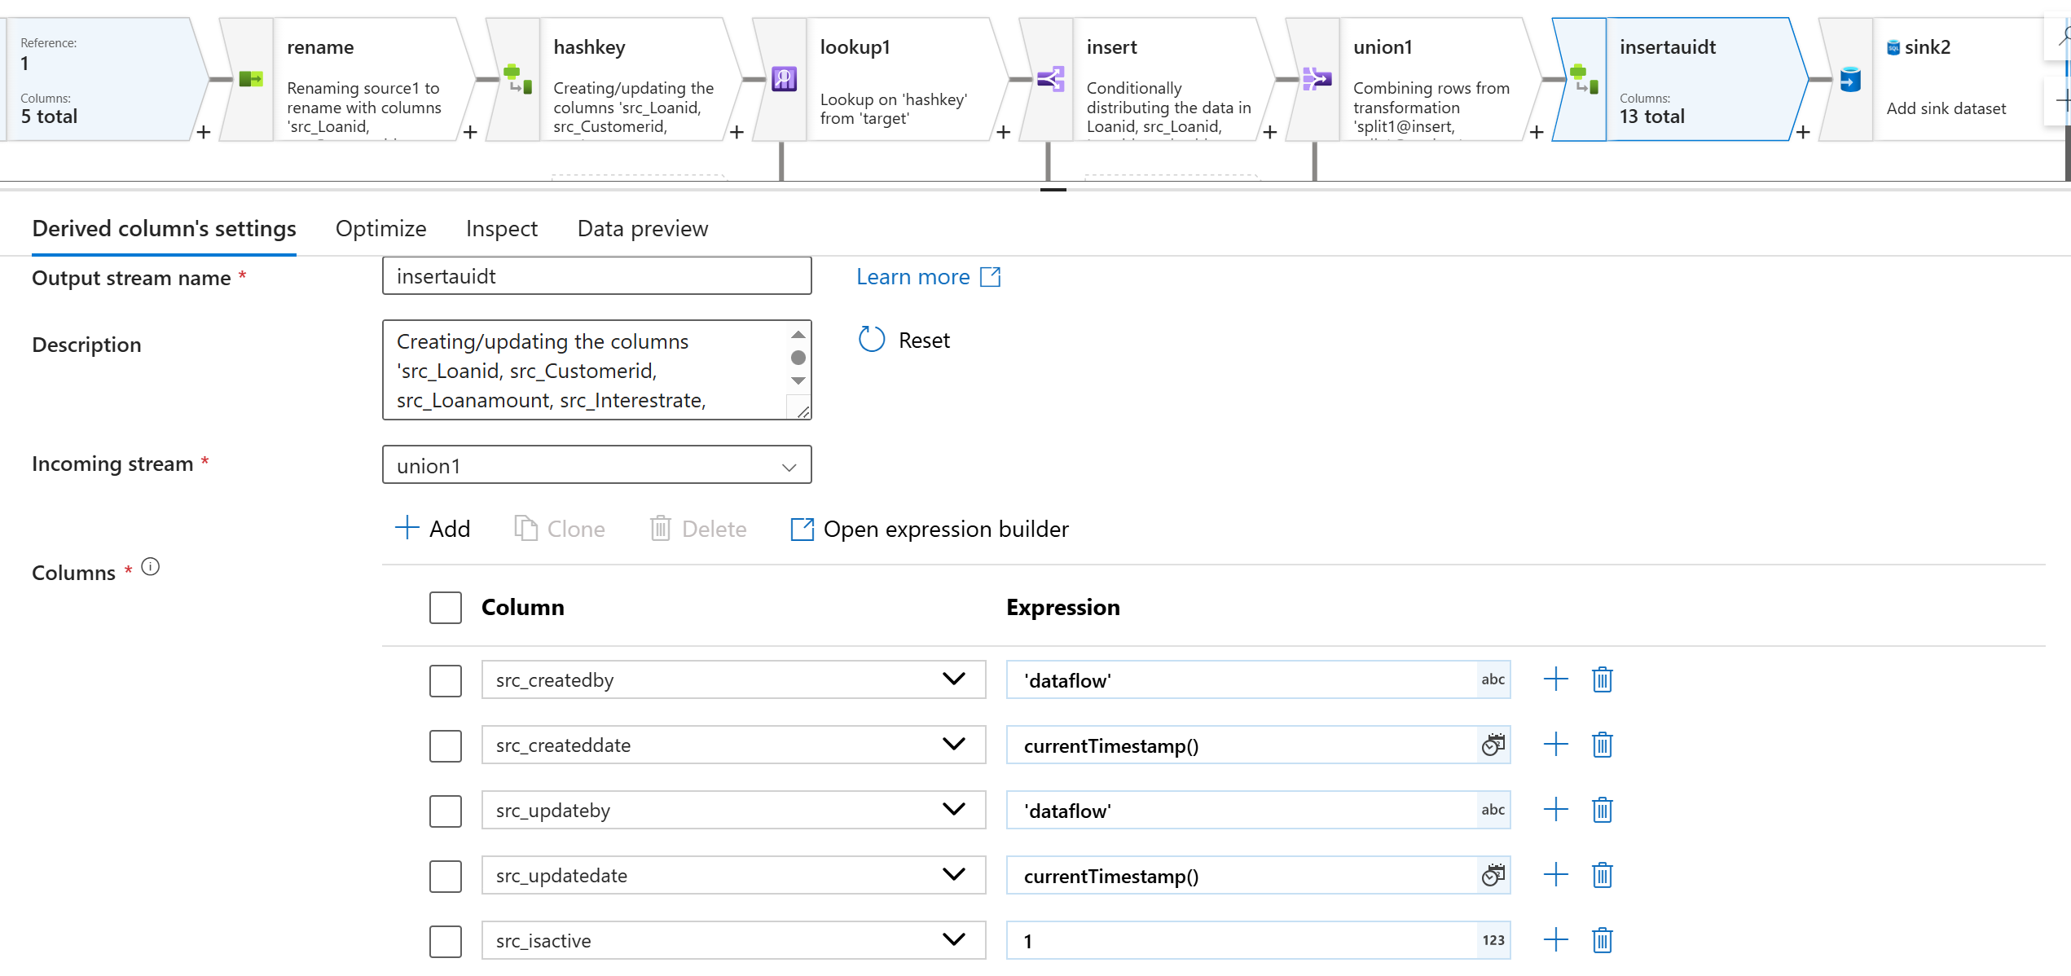
STEP 26 : By clicking + in the derived column (insert audit column) add new transformation called sink

STEP 27 : In sink sink type click inline inline dataset type click sqldb


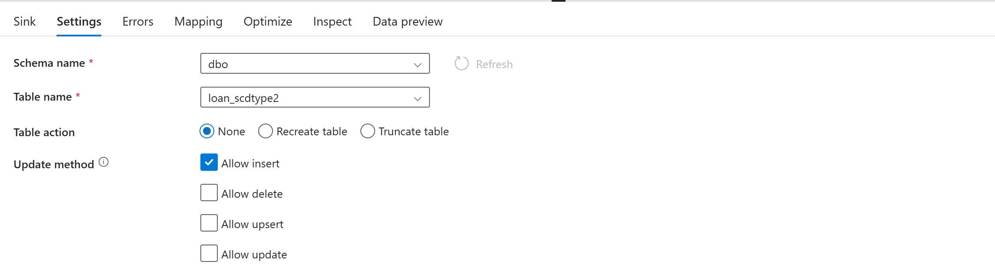
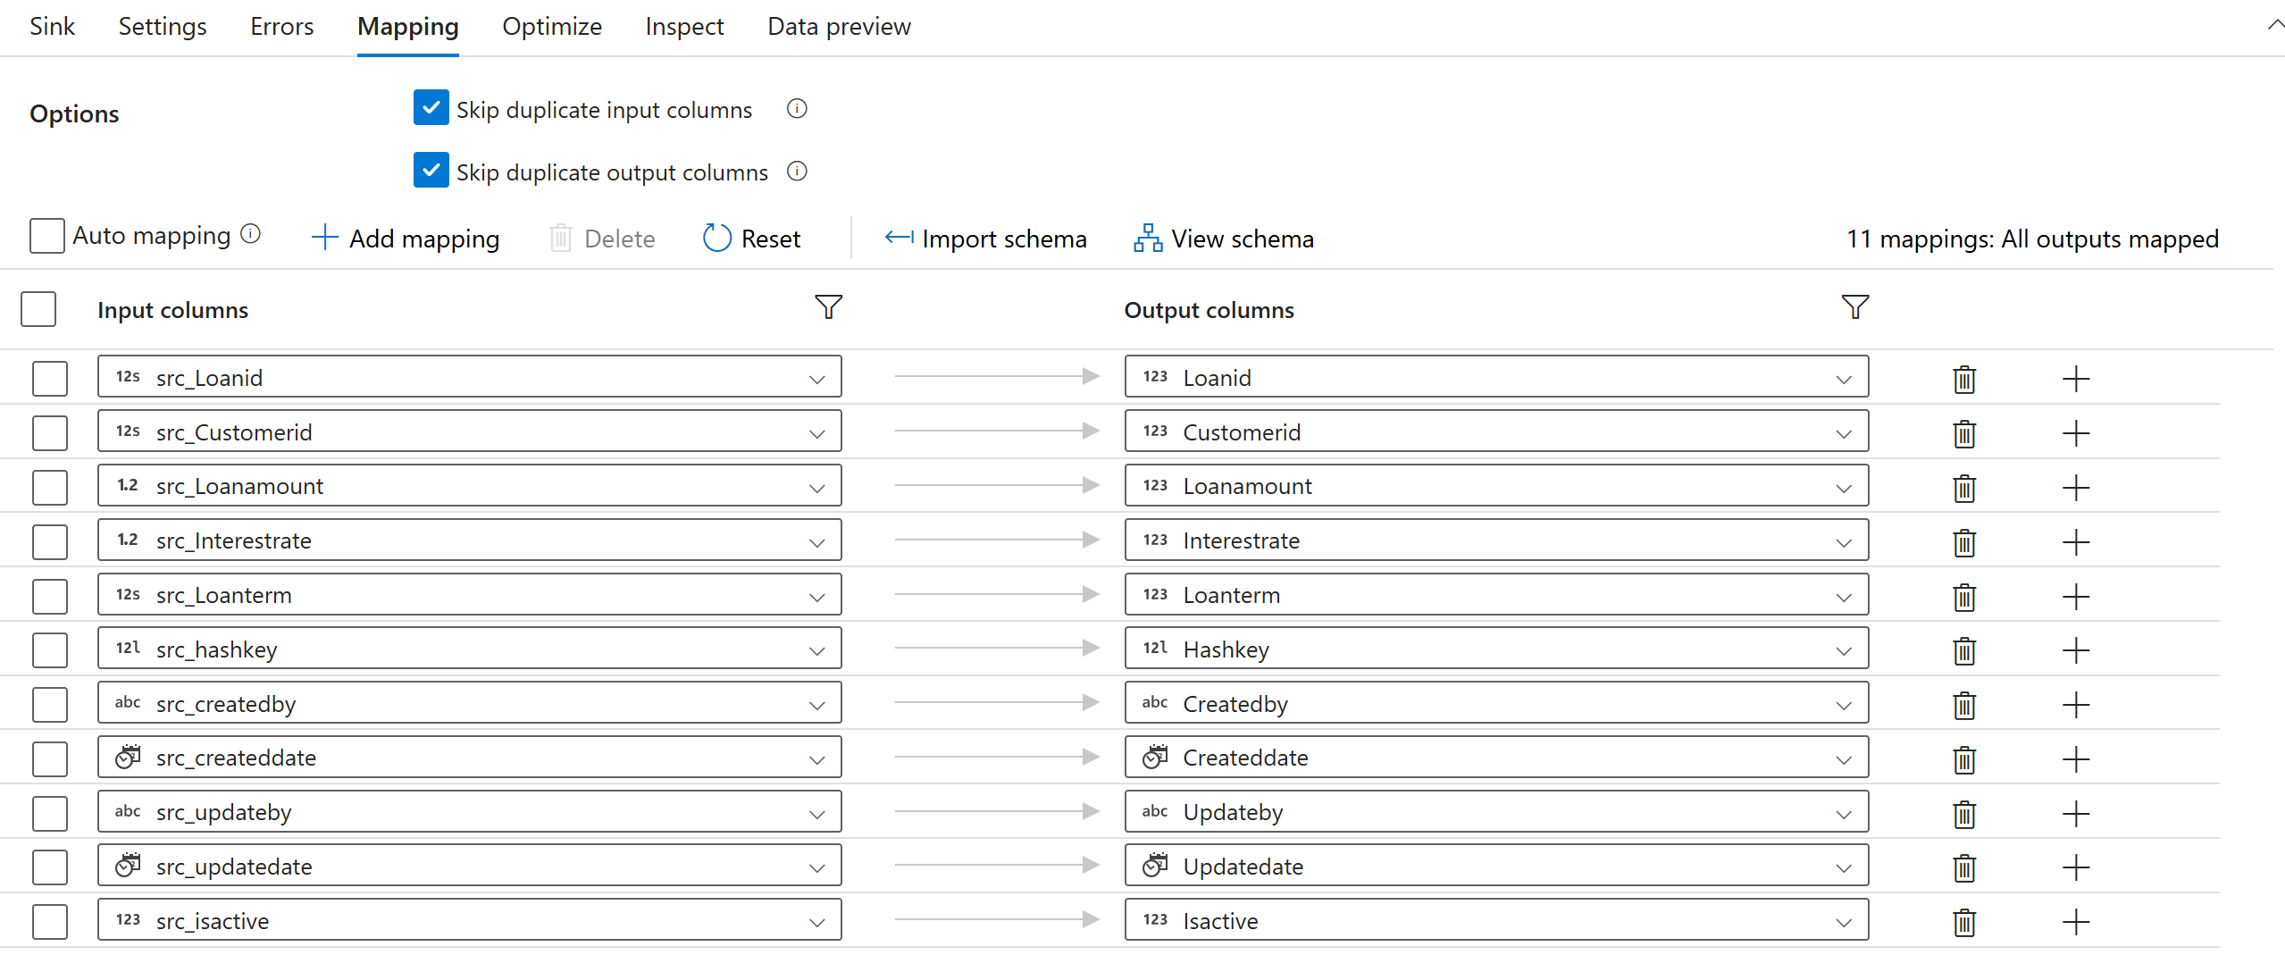
STEP 28 : publish
USED THIS SAME LOGIC FOR CUSTOMERS AND LOANPAYMENT
GOLD LAYER ACCOUNTS TRANSCATIONS SCD TYPE 2
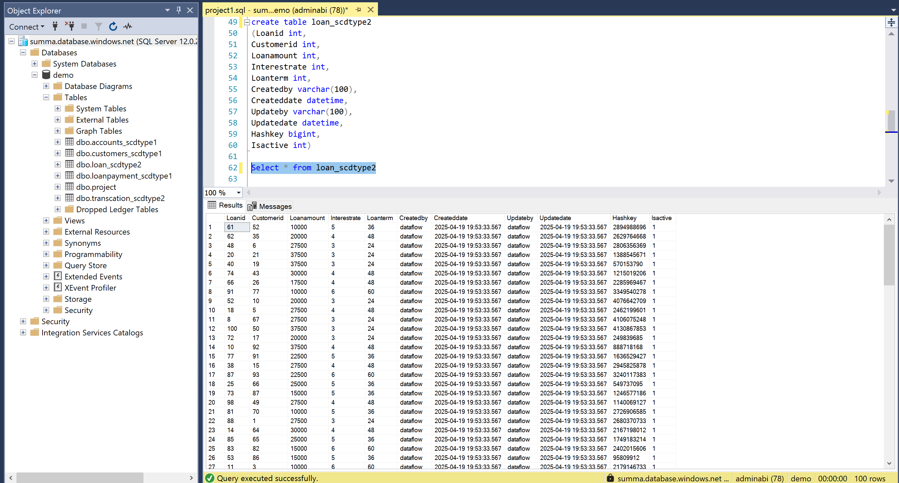
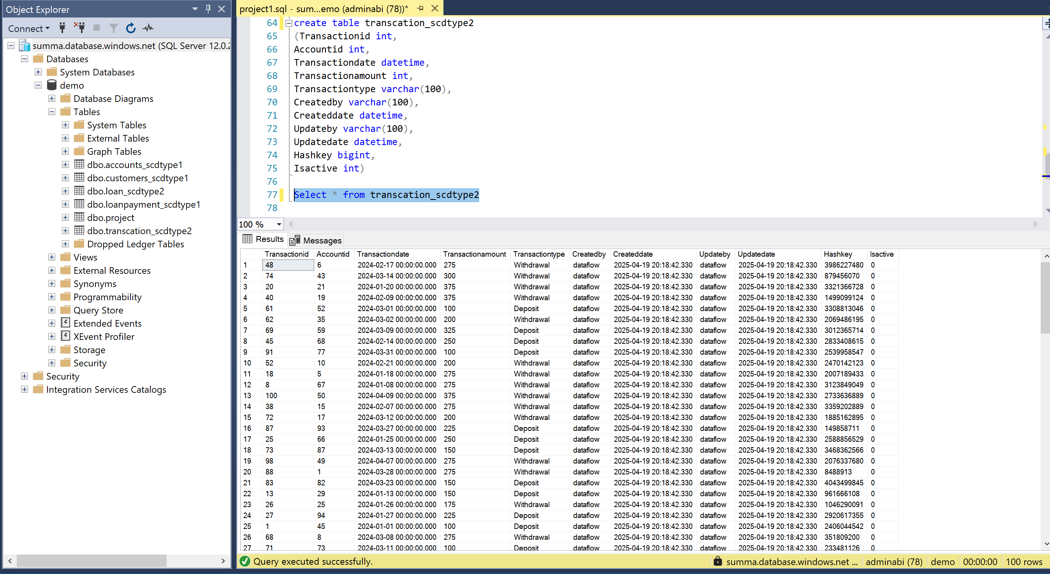

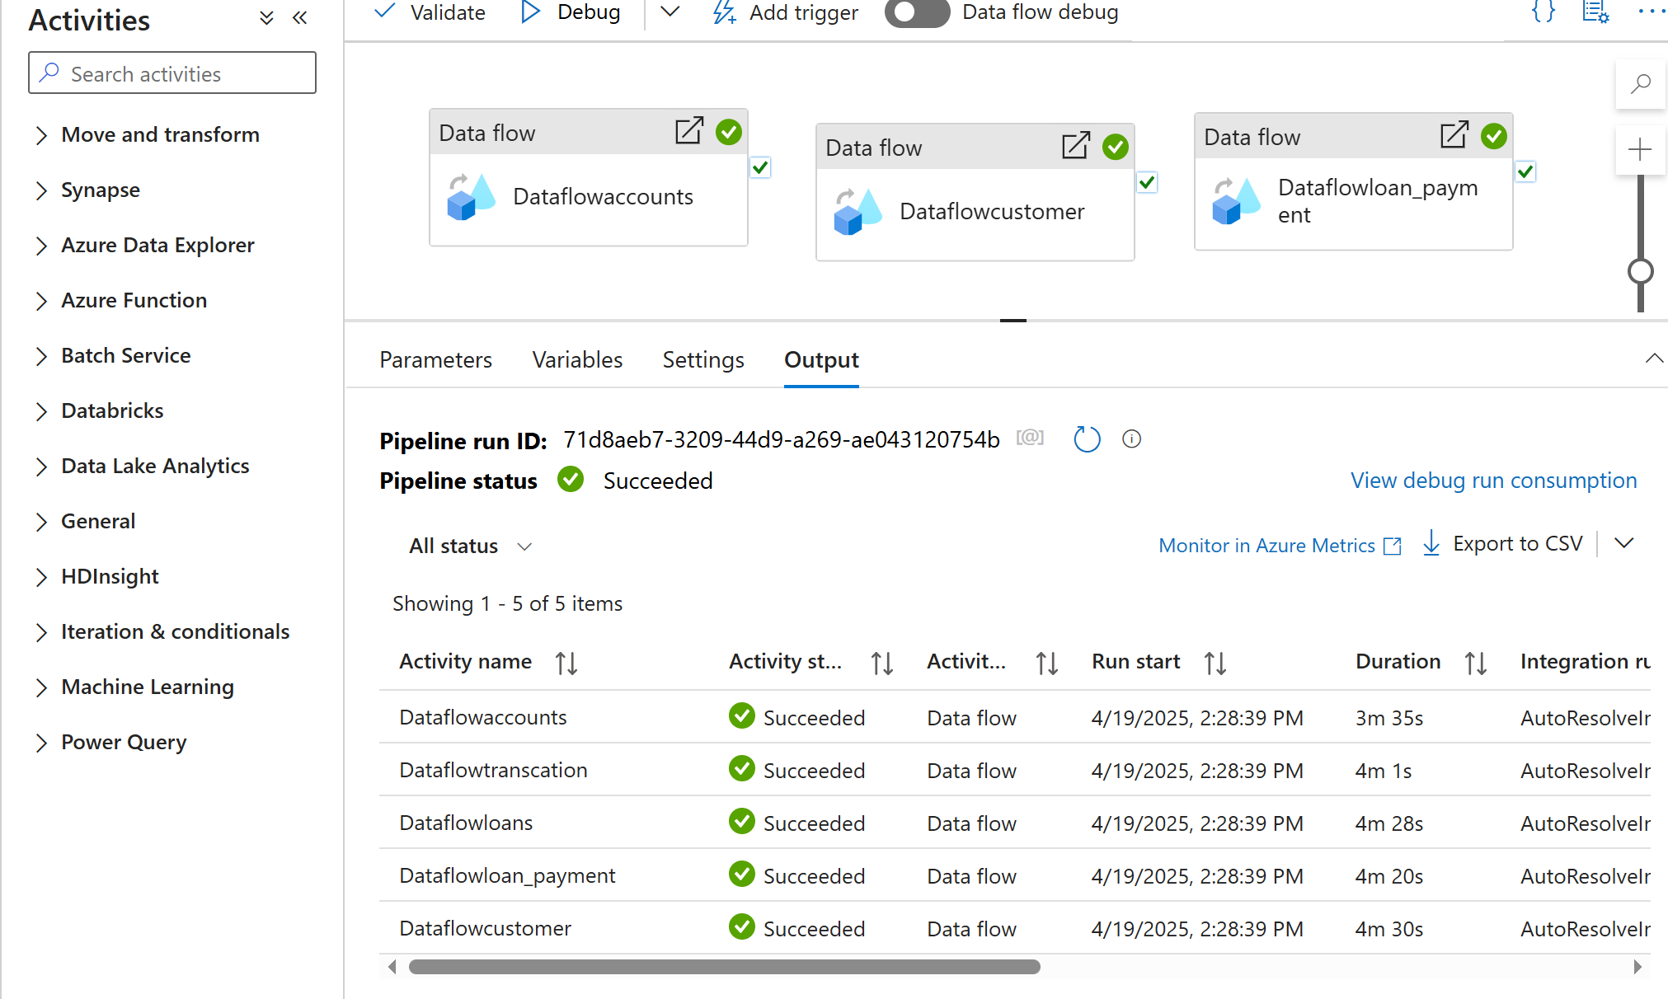
MASTER PIPELINE
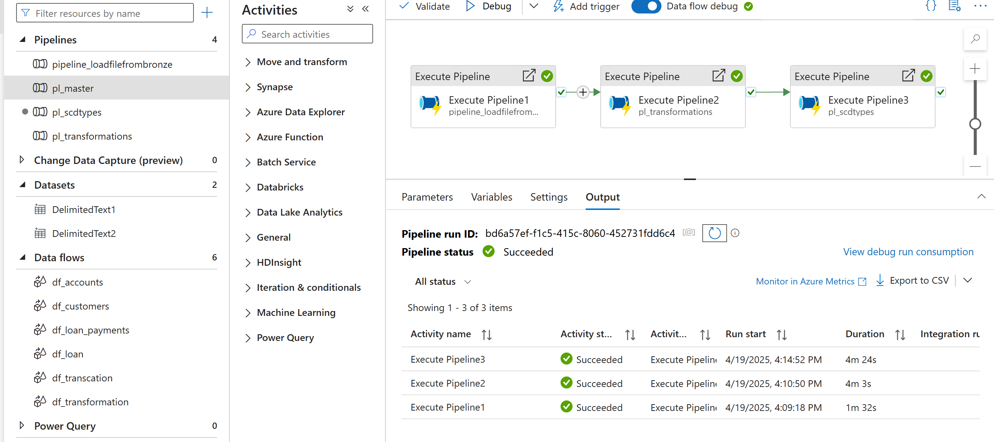
PUBLISHED MY REPORTS IN THE FABRIC WORKSPACE
