MIGRATE AZURE DATA FACTORY INTO AZURE SYNAPSE

METHOD 1 :
Created pipeline in adf click on export template 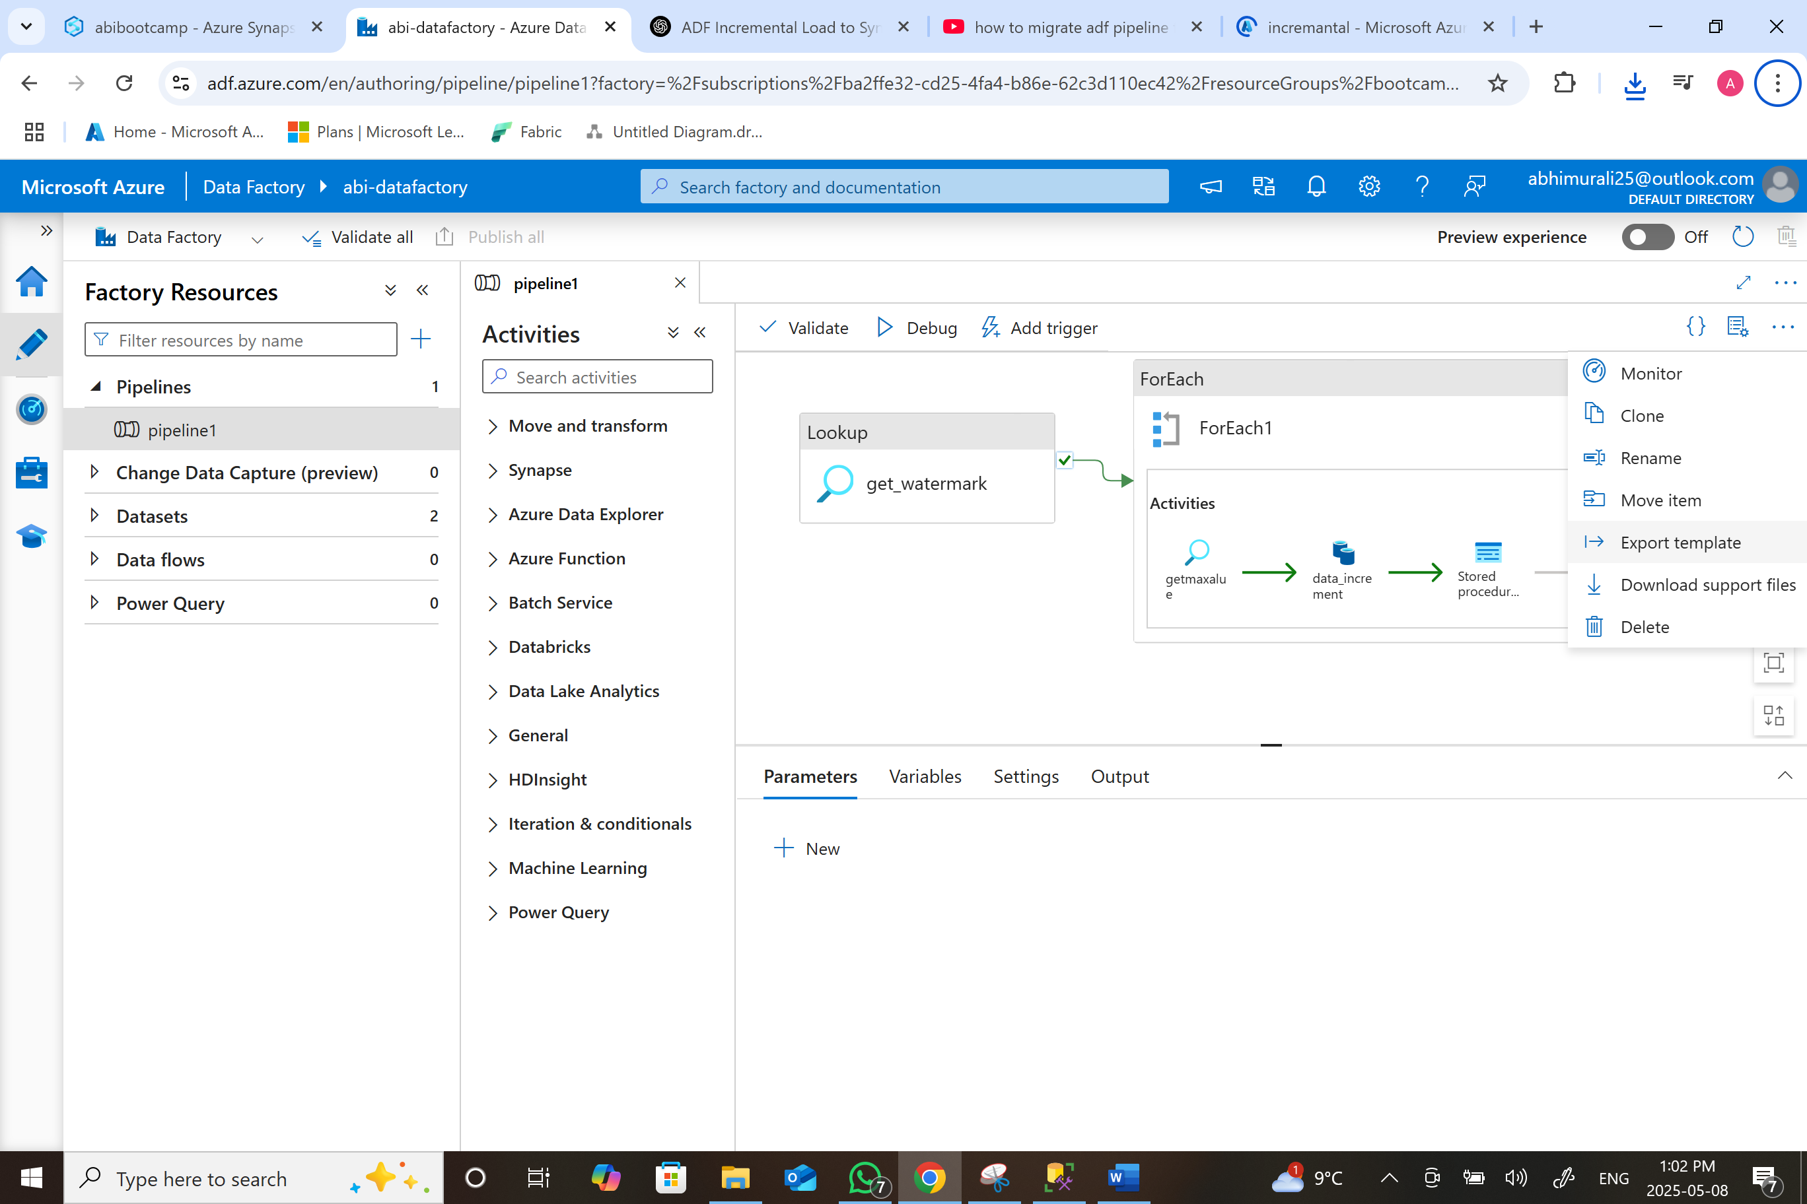
Zip file will download in your local machine
Go to synapse workspace integrate click + icon import from pipeline template

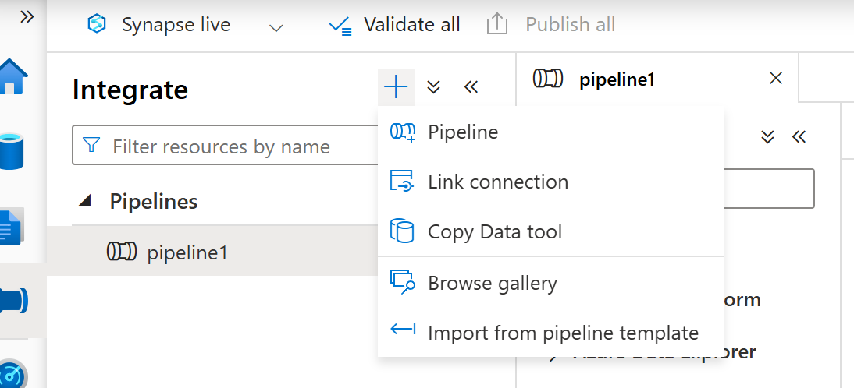
Fill the linked services details
Source : I used sql so I gave sql server
Sink : gen 2
Click on open pipeline
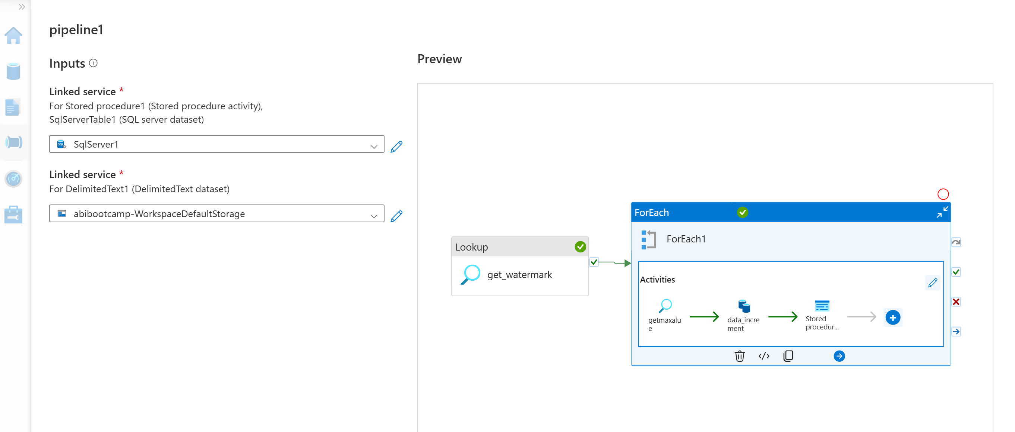
Same pipeline run in synapse and it went well
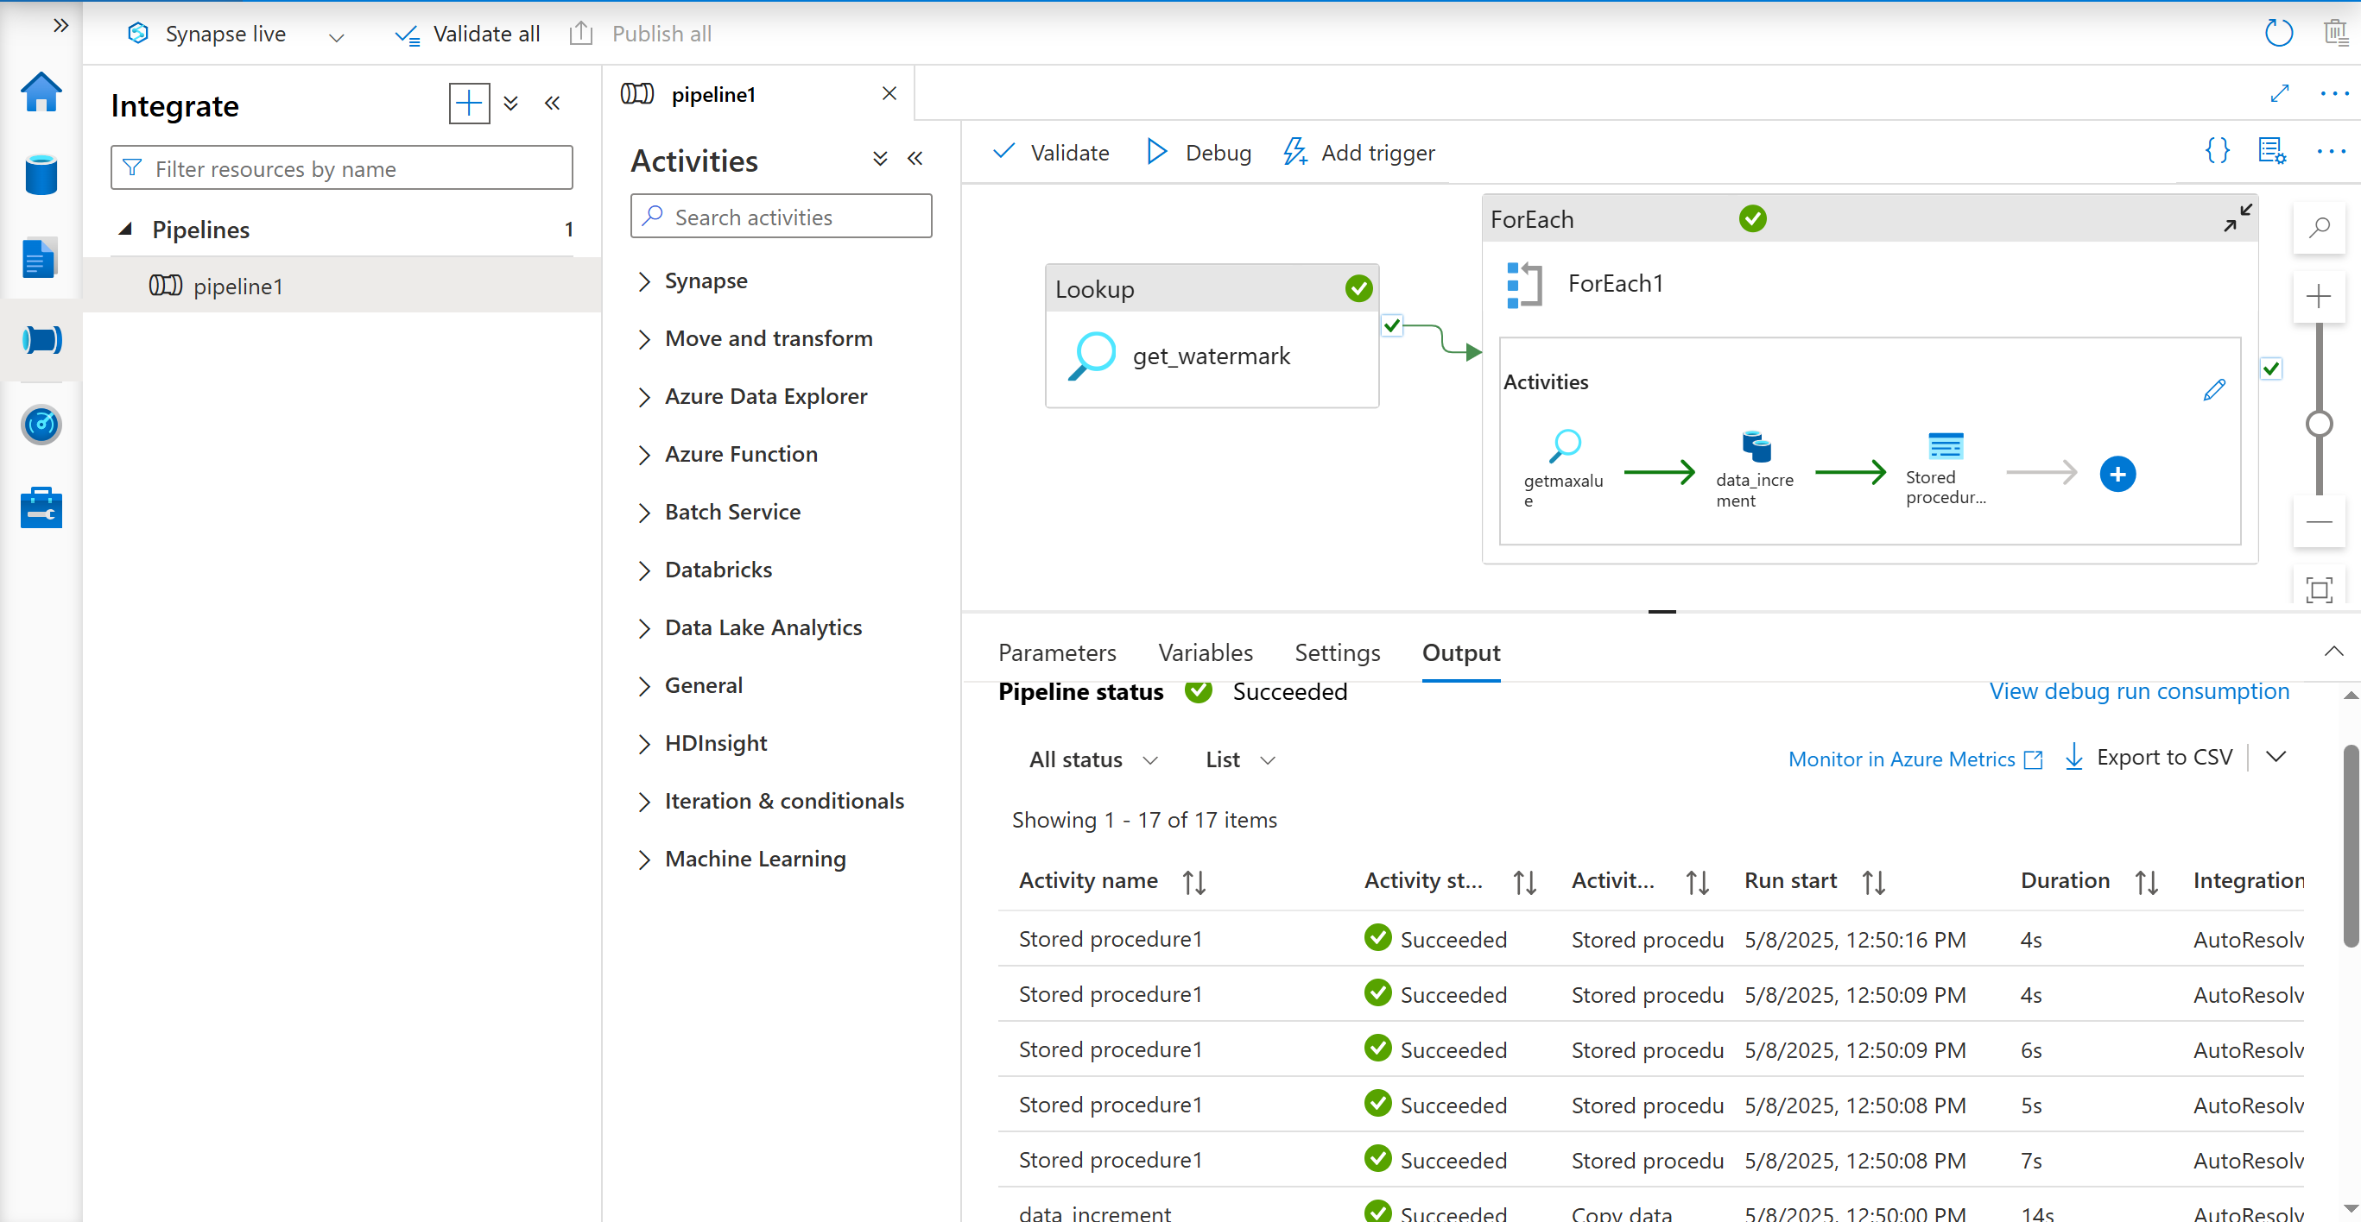
Gen 2
11 : 54 ran in adf
12 : 50 ran in synapse
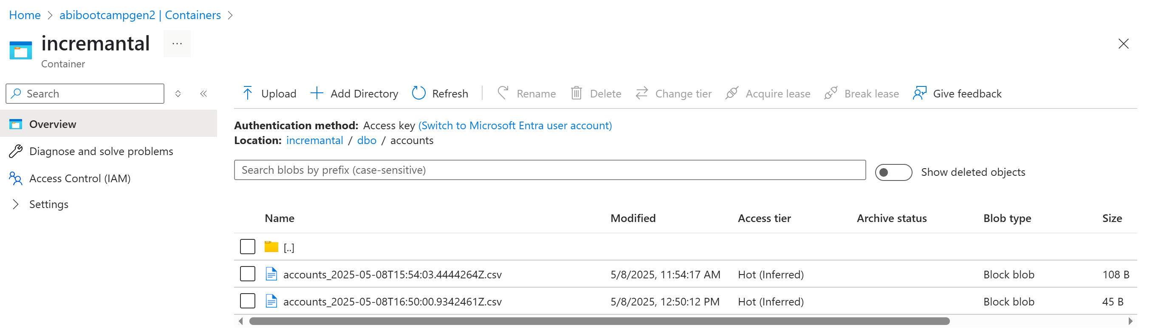

MIGRATE AZURE DATABRICKS INTO AZURE FABRIC
Method 1 :
Create the notebook in databricks
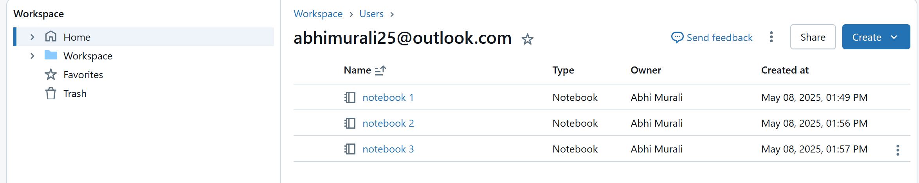
Download into ipython
Go to gabric workspace import
