Project Documentation: Incremental Data Loading and Automated Notifications using Microsoft Fabric
Project Overview
This project demonstrates an end-to-end data pipeline solution built on Microsoft Fabric, designed to efficiently ingest, transform, and load structured data from an on-premises source into a Fabric Lakehouse and Warehouse. The solution incorporates incremental data loading, data cleansing, Slowly Changing Dimension (SCD) Type 1 implementation, and automated email notifications upon pipeline success.
Key Technologies Used
- Microsoft Fabric (Lakehouse, Warehouse, Data Pipelines, Notebooks)
- On-Premises Data Gateway (for secure data transfer)
- Delta Lake (for SCD Type 1 implementation)
- Power Automate / Office 365 Outlook (for automated notifications)
- PySpark & SQL (for data transformations and merges)
Problem Statement Organizations often struggle with :
- Efficiently moving on-premises data to the cloud without manual intervention.
- Handling incremental updates while maintaining historical data integrity.
- Ensuring data quality through deduplication, null handling, and type standardization.
- Monitoring pipeline executions and receiving real-time success/failure alerts. This project addresses these challenges by automating data ingestion, transformation, and notification workflows in Microsoft Fabric.
Project Objectives 1.
- On-Premises Data Ingestion Configure the On-Premises Data Gateway to securely connect and transfer data from an on-premises SQL database to Fabric Lakehouse.
- Use Copy Data activities in Fabric Pipelines to dynamically process files.
- Data Transformation & Cleansing Implement Bronze-to-Silver-to-Gold architecture:
- Bronze Layer: Raw data ingestion.
- Silver Layer: Data cleansing (removing duplicates, handling nulls, standardizing data types).
- Gold Layer: Business-ready datasets with SCD Type 1 logic. 3. SCD Type 1 Implementation
Use Delta Lake and PySpark to:
- Generate hash keys for detecting changes.
- Apply merge operations (upsert logic) to update existing records or insert new ones.
- Implement SCD Type 1 for tables: Accounts, Customers, Loans, Loan Payments, Transactions.
- Automated Notifications
- Integrate Office 365 Outlook Activity to send email alerts upon pipeline success.
- Data Ingestion: On-premises data → On-Premises Gateway → Fabric Lakehouse (Bronze Layer). Dynamic file processing using @copy activity Processing
- Silver Layer (Dataflow Gen 1): Remove duplicates, replace nulls, detect data types.
- Gold Layer (Warehouse + Delta Tables): Apply SCD Type 1 logic via PySpark Notebooks
- SCD Type 1 Logic: Hash Key Generation: CRC32 hash on key columns to detect changes.
- Merge Operations: When Matched: Update records with new values.
- When Not Matched: Insert new records.
- Automation & Monitoring: Pipeline Scheduling: Daily incremental loads. Success Notification: Outlook email trigger on pipeline completion. Key Achievements ✔ Seamless On-Premises to Cloud Integration – Eliminated manual data transfers using On-Premises Gateway. ✔ Incremental Data Loading – Optimized performance by processing only new/modified files. ✔ Data Quality Enforcement – Automated deduplication, null handling, and type conversion. ✔ SCD Type 1 Implementation – Ensured historical tracking of changes in key tables. ✔ End-to-End Automation – Reduced manual intervention with scheduled pipelines and notifications

Medallion Architecture
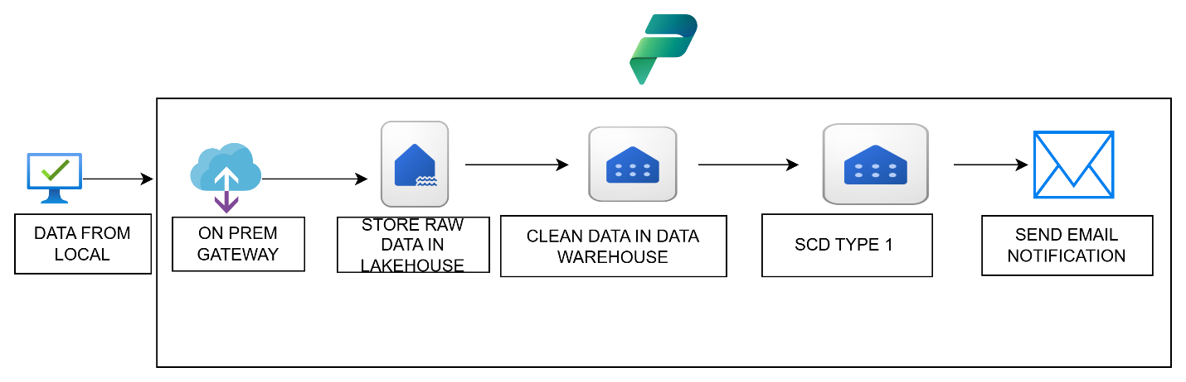
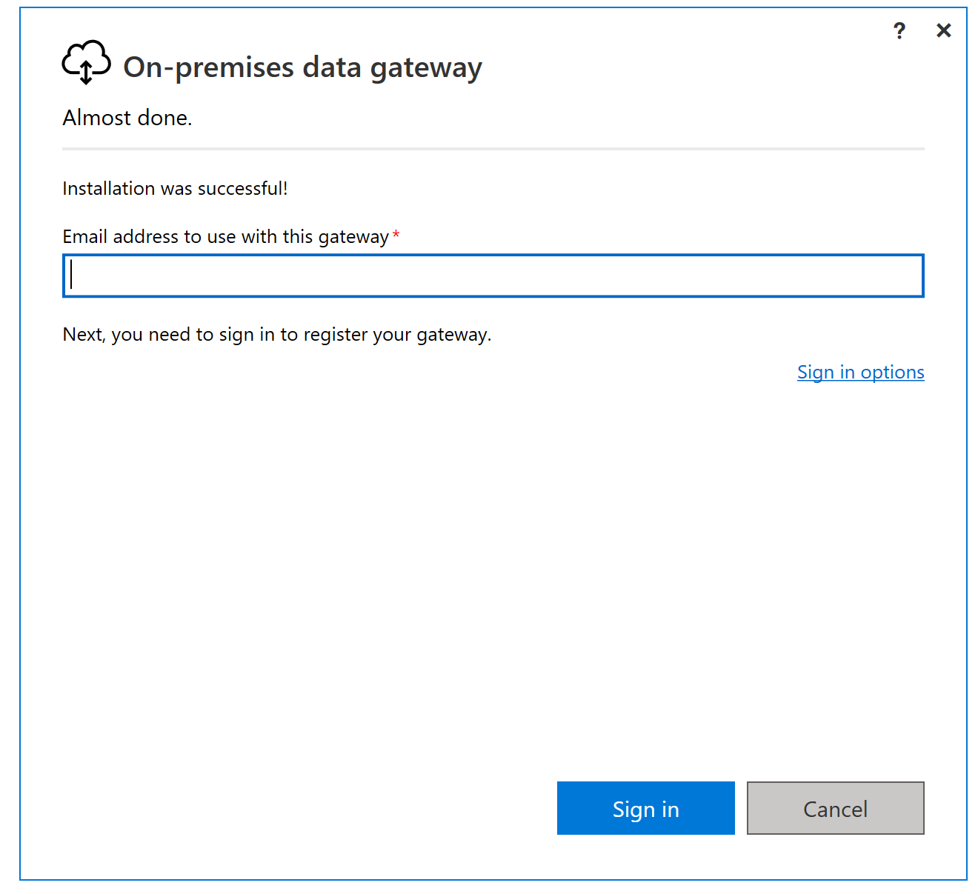
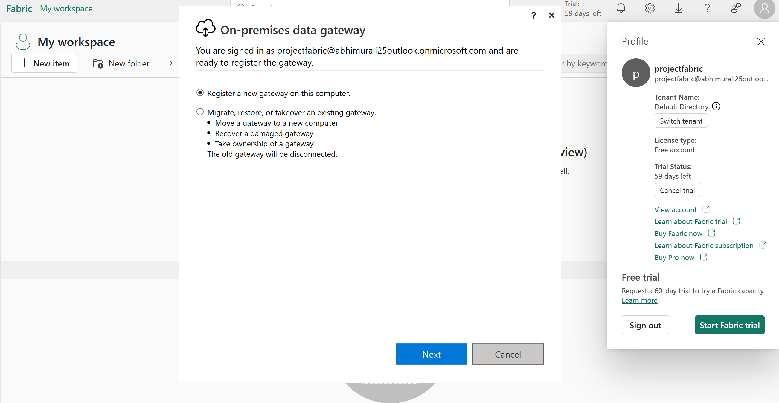
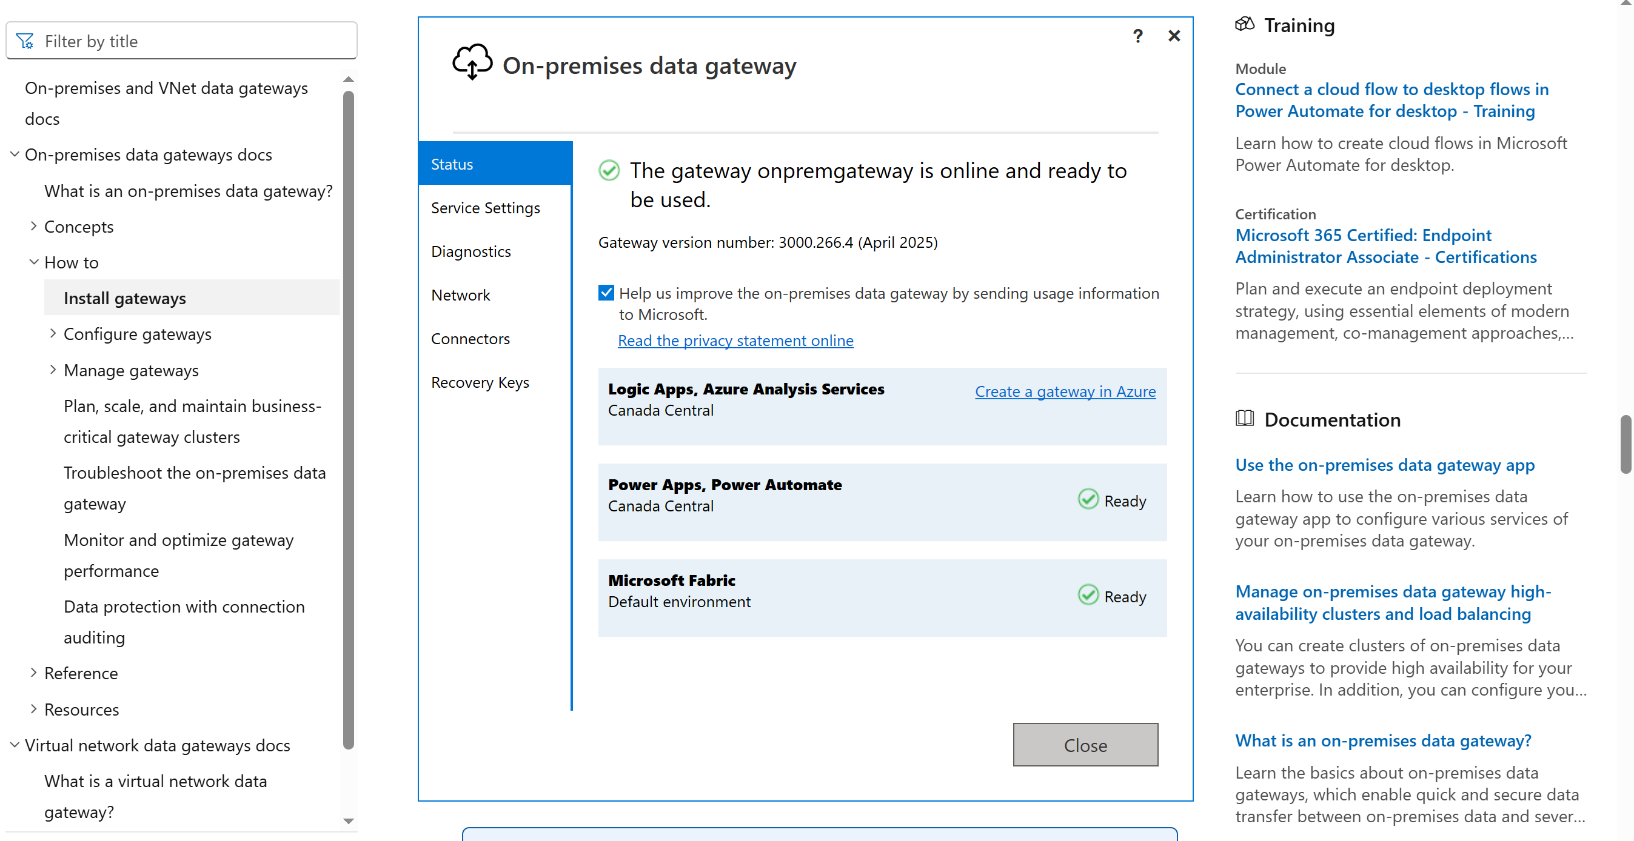
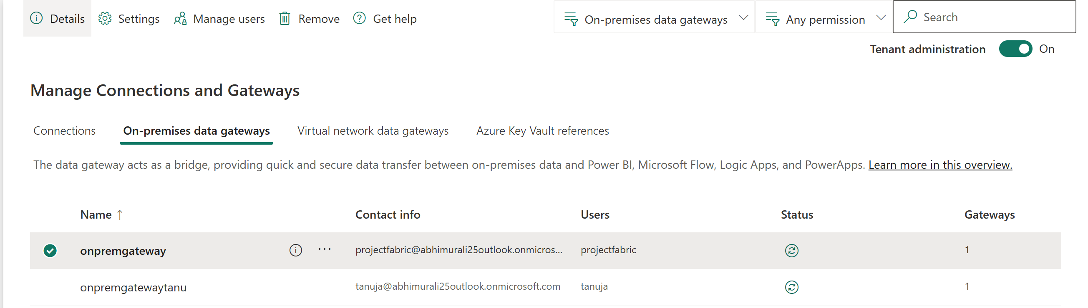
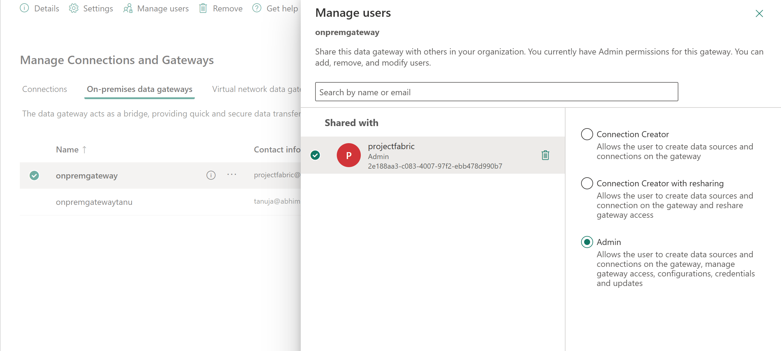
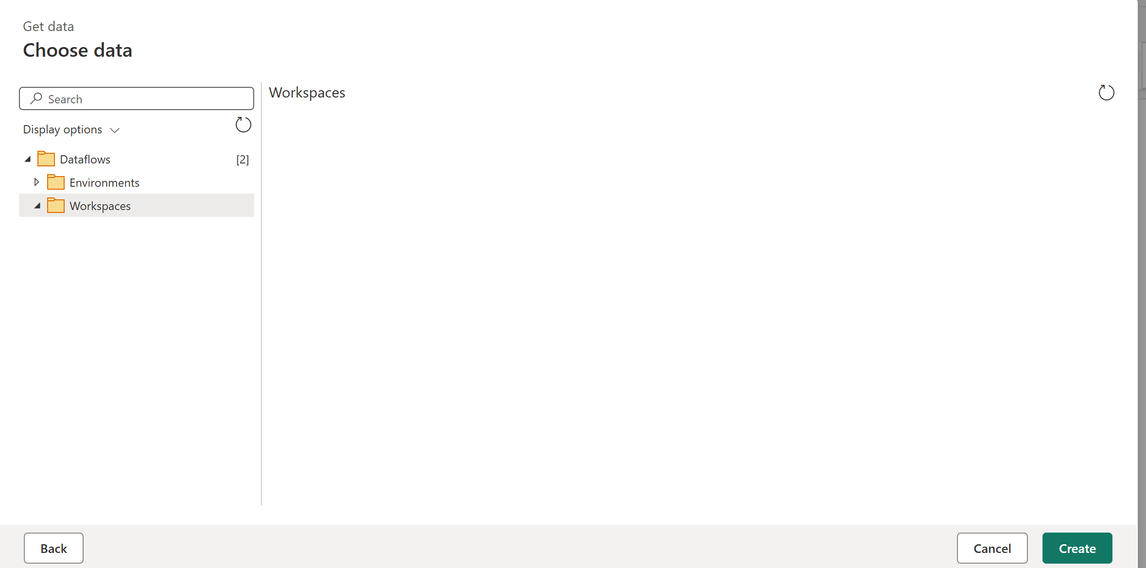
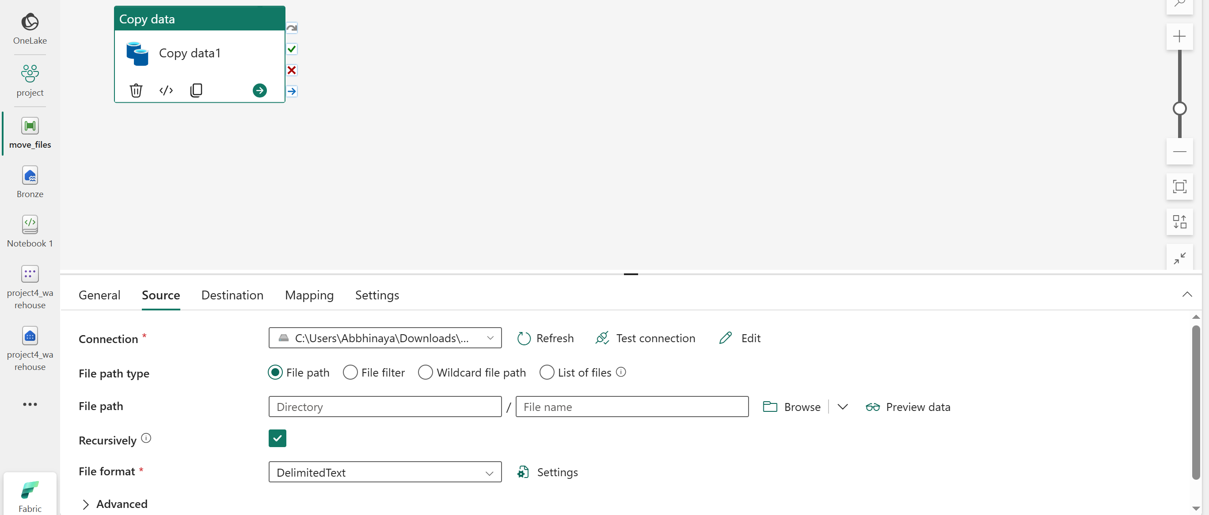
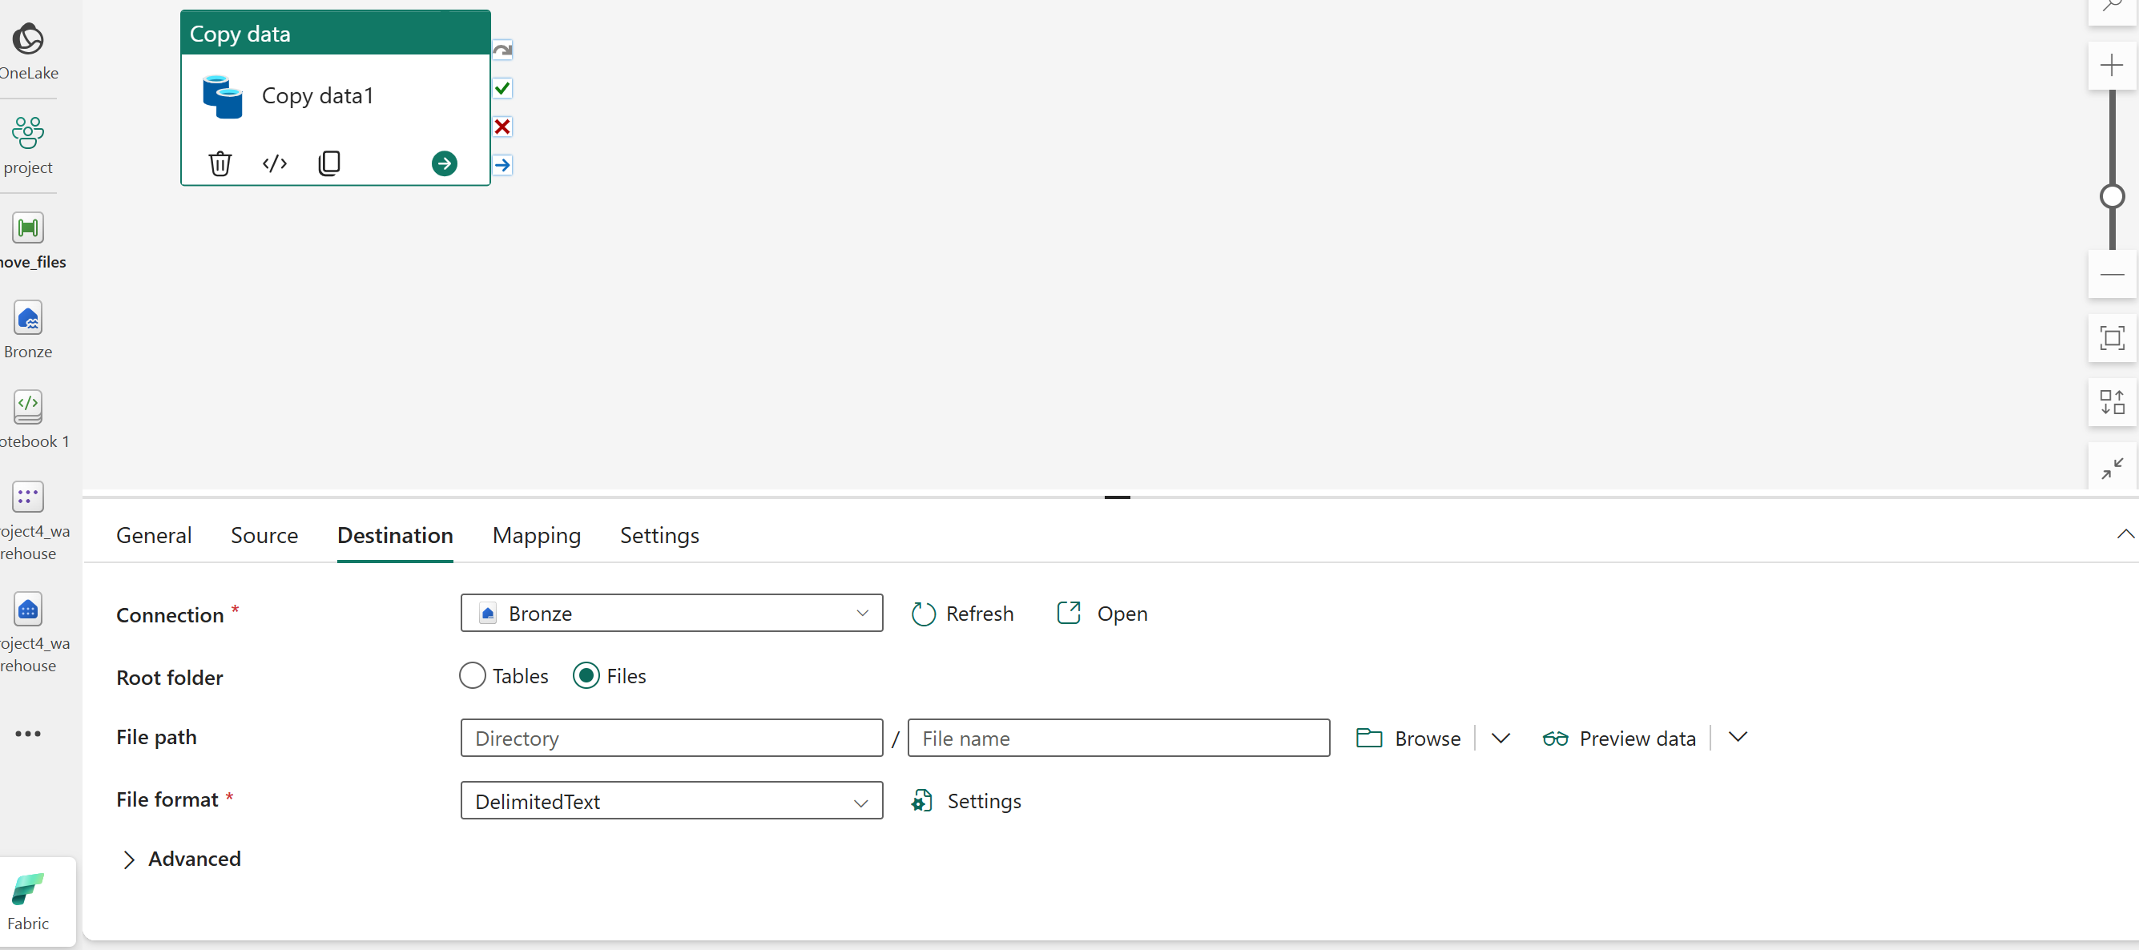

LOADED ALL FILES IN LAKEHOUSE
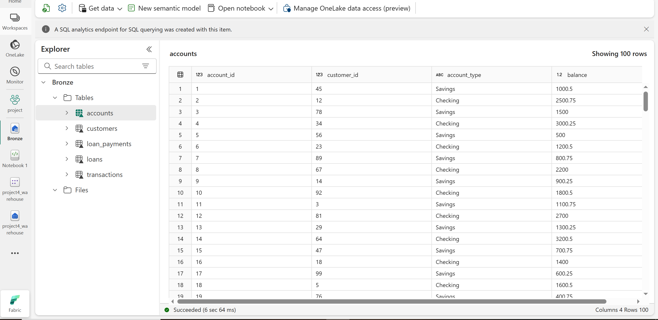
CLEANE THE DATA USING DATA FLOW GEN 2
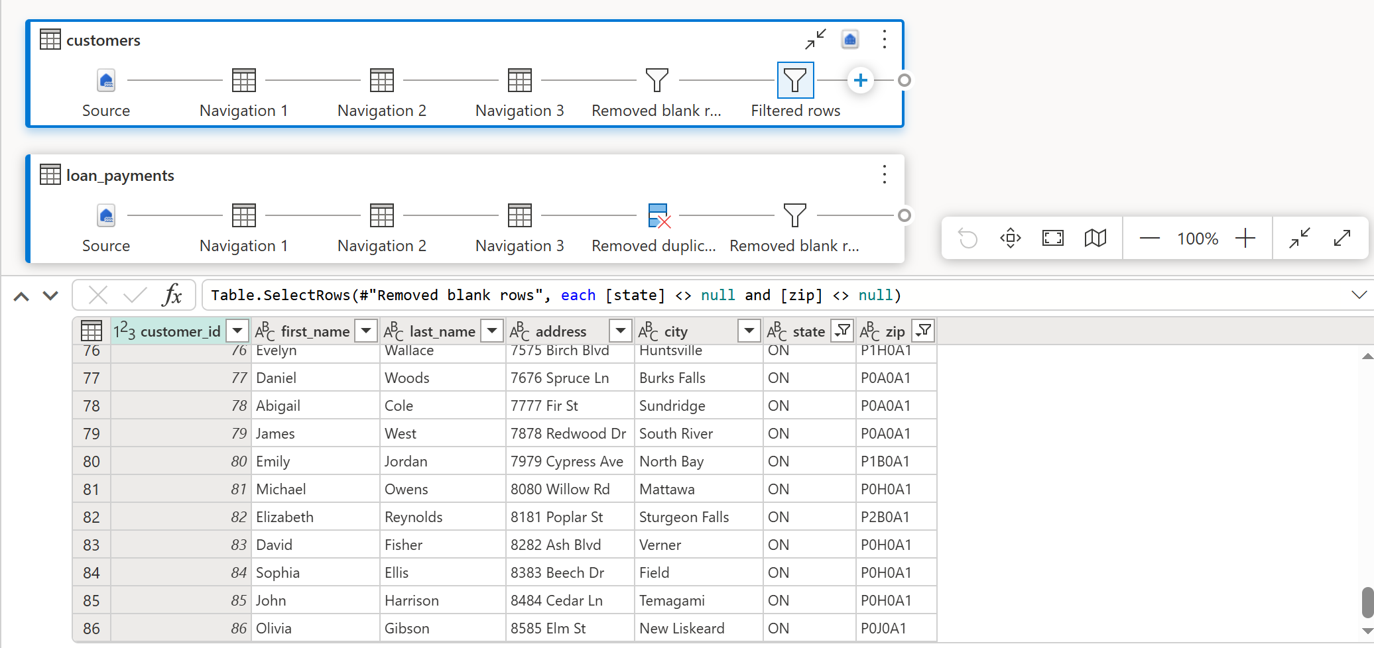
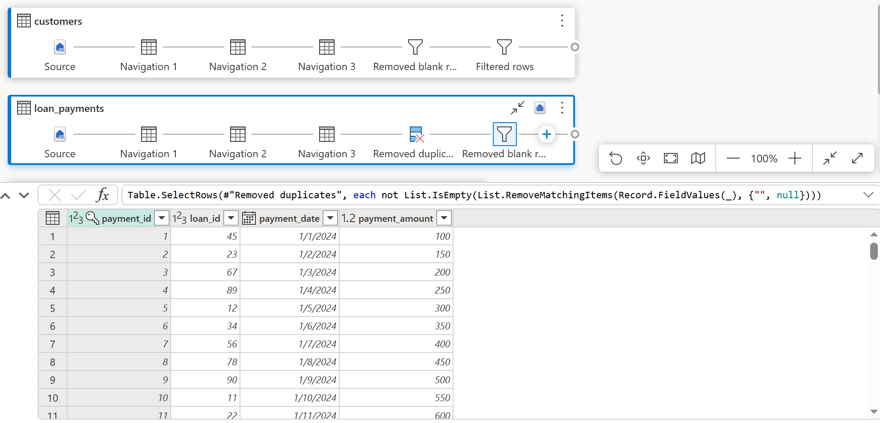
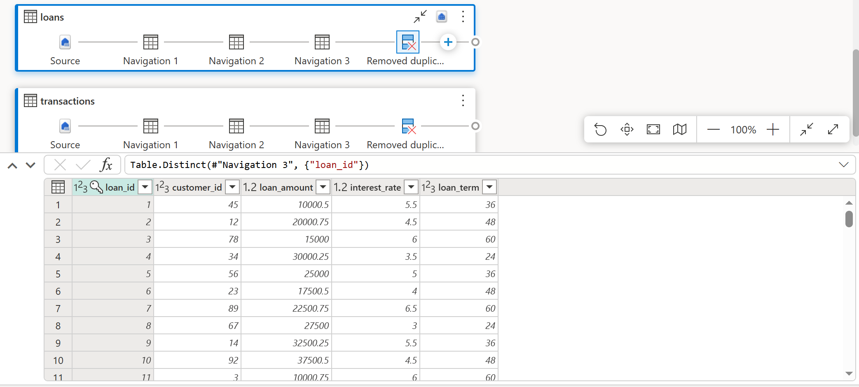
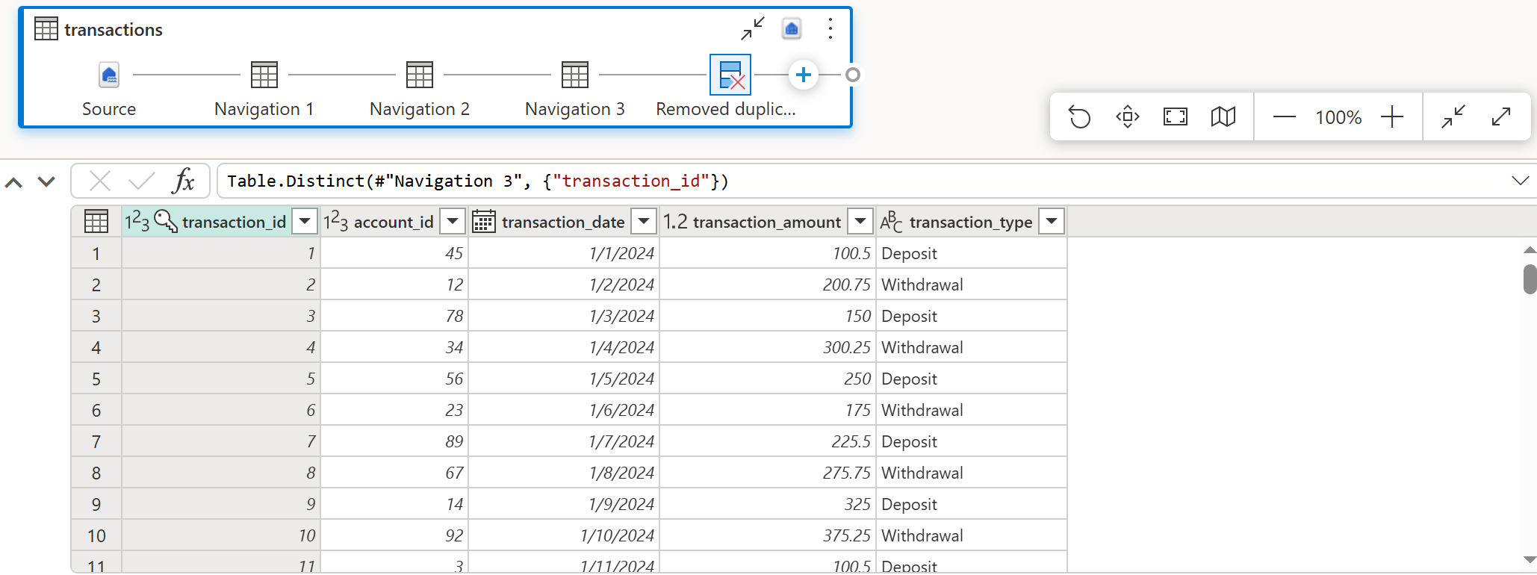
USED SCDTYPE 1 FOR ALL THE FILES
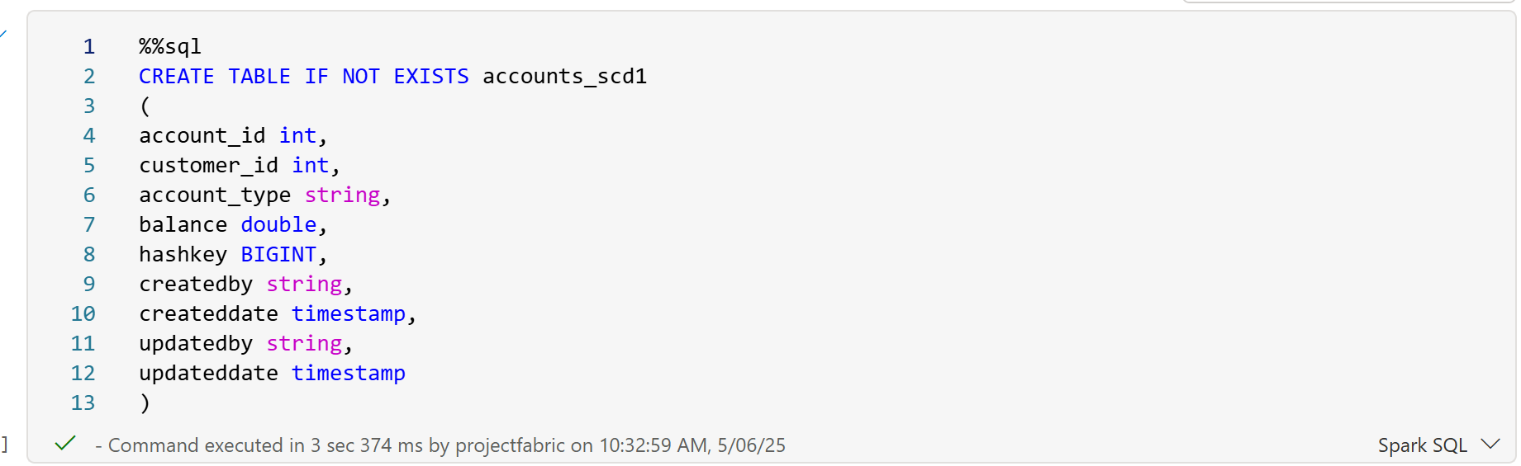
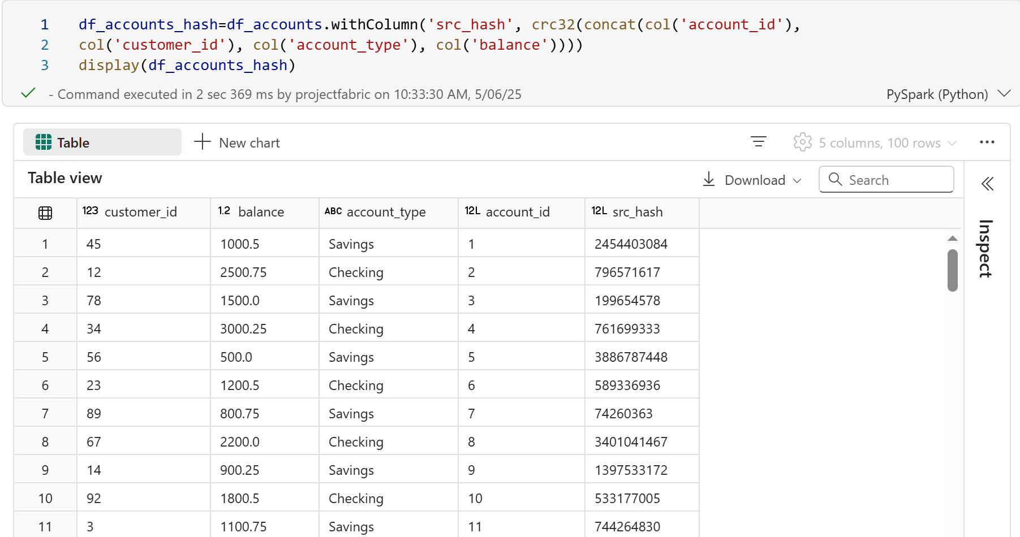
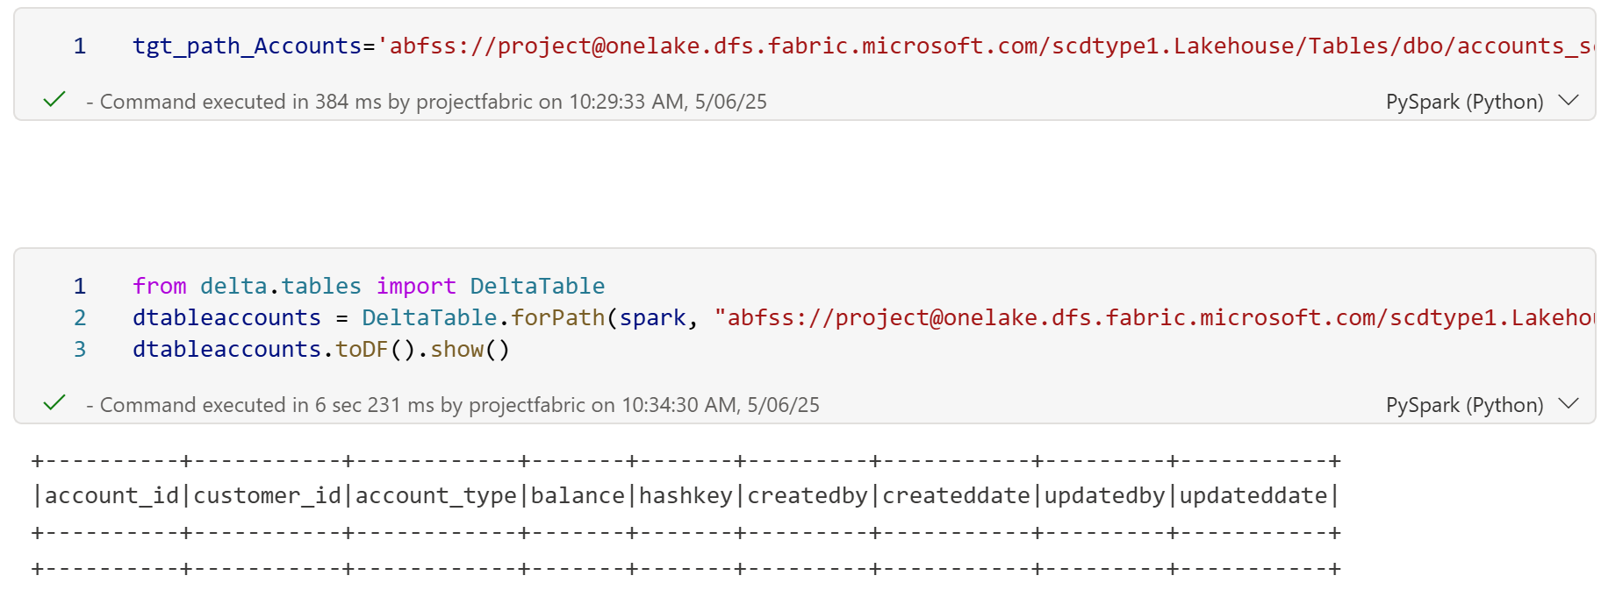
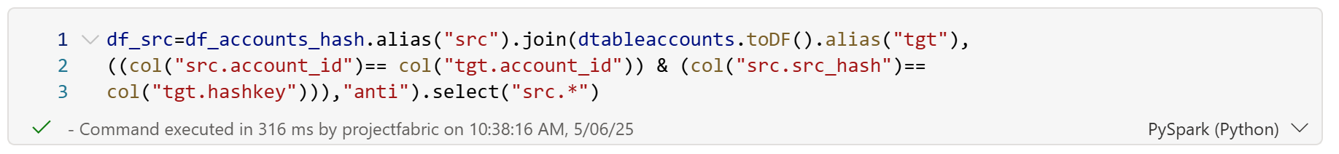
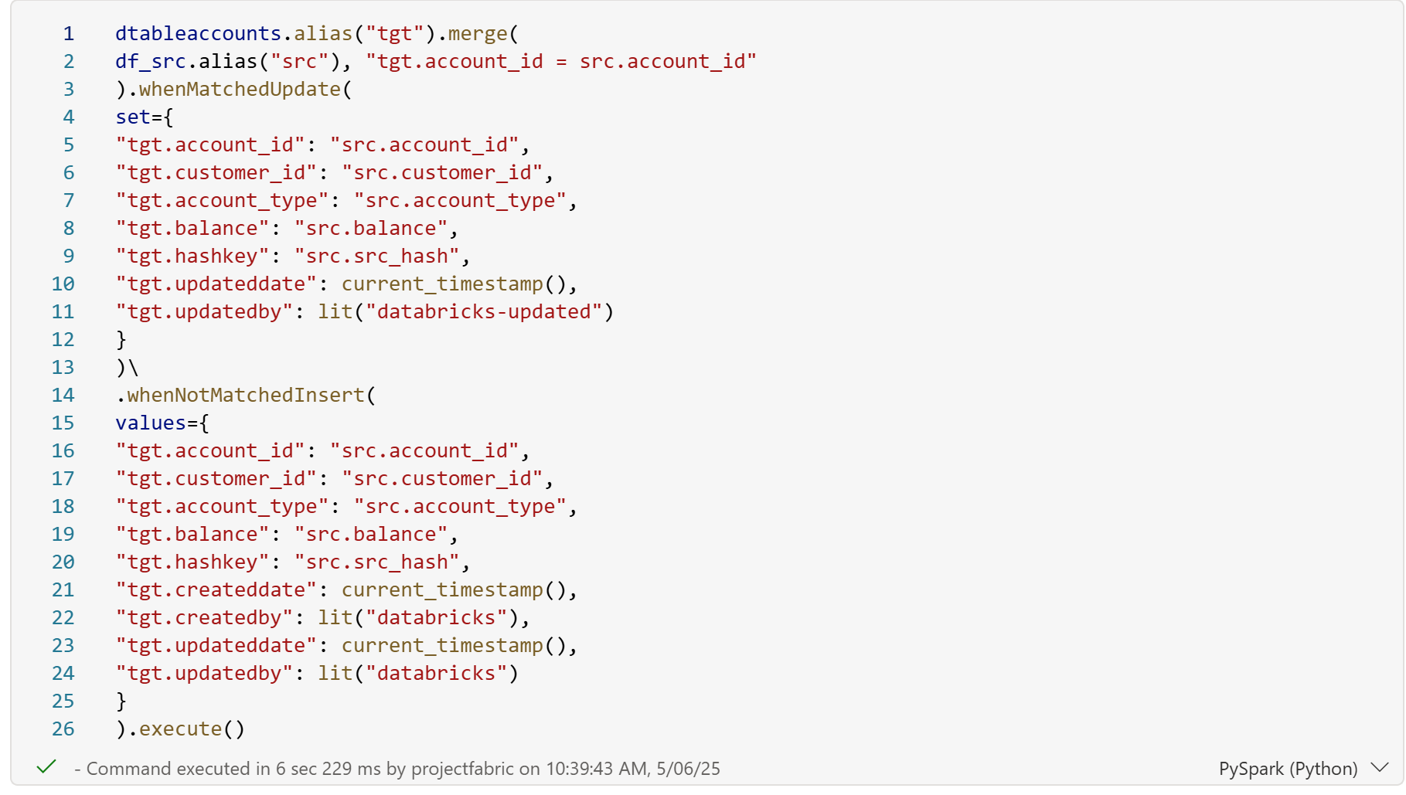

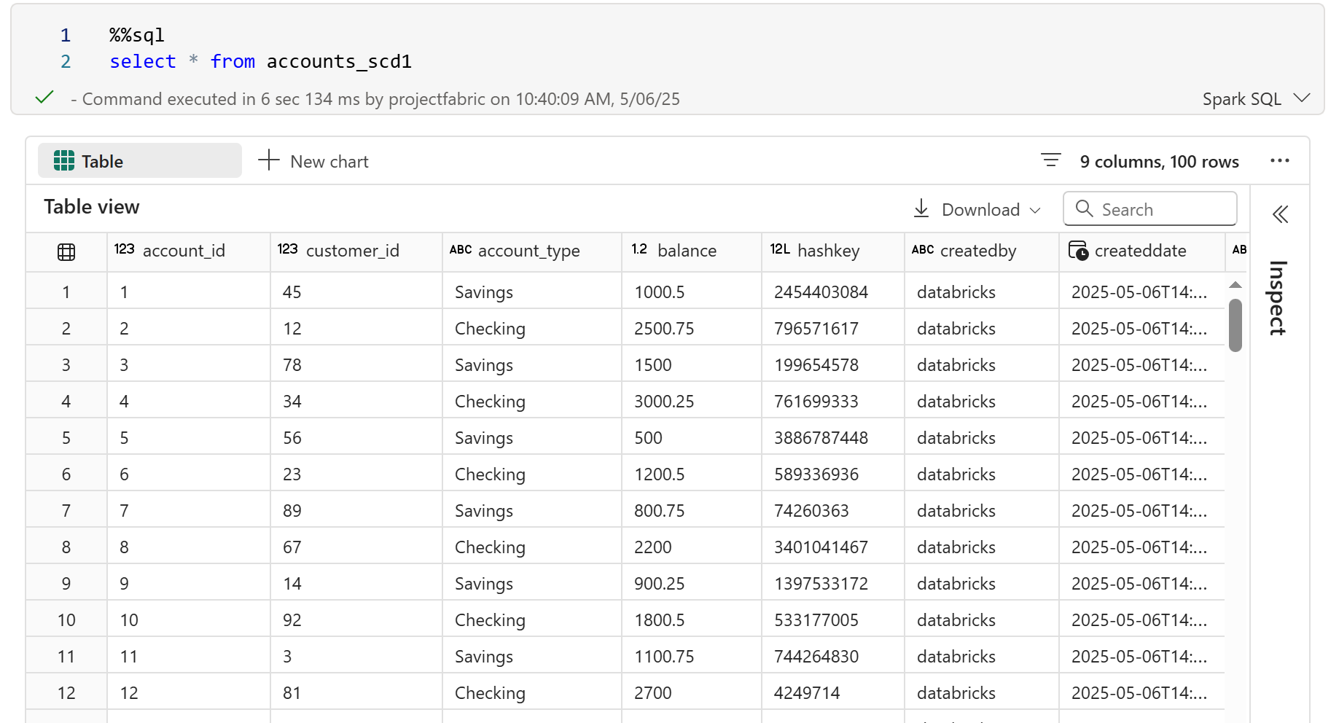
FOR CUSTOMER TABLE
%%sql
CREATE TABLE IF NOT EXISTS customers_scd1
(
customer_id int,
first_name string,
last_name string,
address string,
city string,
state string,
zip string,
hashkey BIGINT,
createdby string,
createddate timestamp,
updatedby strin
g,
updateddate timestamp
)

df_customers=spark.read.synapsesql('project4_warehouse.dbo.customers')

df_customers_hash=df_customers.withColumn('src_hash',
crc32(concat(col('customer_id'), col('first_name'), col('last_name'),col('address'),
col('city'), col('state'), col('zip'))))
display(df_customers_hash)

from delta.tables import DeltaTable
dtablecustomers = DeltaTable.forPath(spark, 'abfss://project@onelake.dfs.fabric.microsoft.com/scdtype1.Lakehouse/Tables/dbo/customers_scd1')
dtablecustomers.toDF().show()

df_src_customers=df_customers_hash.alias("src").join(dtablecustomers.toDF().alias("tgt"), ((col("src.customer_id")== col("tgt.customer_id")) & (col("src.src_hash")==
col("tgt.hashkey"))),"anti").select("src.*")

dtablecustomers.alias("tgt").merge(
df_src_customers.alias("src"), "tgt.customer_id = src.customer_id"
).whenMatchedUpdate(
set={
"tgt.customer_id": "src.customer_id",
"tgt.first_name": "src.first_name",
"tgt.last_name": "src.last_name",
"tgt.address": "src.address",
"tgt.city": "src.city",
"tgt.state": "src.state",
"tgt.zip": "src.zip",
"tgt.hashkey": "src.src_hash",
"tgt.updateddate": current_timestamp(),
"tgt.updatedby": lit("databricks-updated")
}
).whenNotMatchedInsert(
values={
"tgt.customer_id": "src.customer_id",
"tgt.first_name": "src.first_name",
"tgt.last_name": "src.last_name",
"tgt.address": "src.address",
"tgt.city": "src.city",
"tgt.state": "src.state",
"tgt.zip": "src.zip",
"tgt.hashkey": "src.src_hash",
"tgt.createddate": current_timestamp(),
"tgt.createdby": lit("databricks"),
"tgt.updateddate": current_timestamp(),
"tgt.updatedby": lit("databricks")
}
).execute()

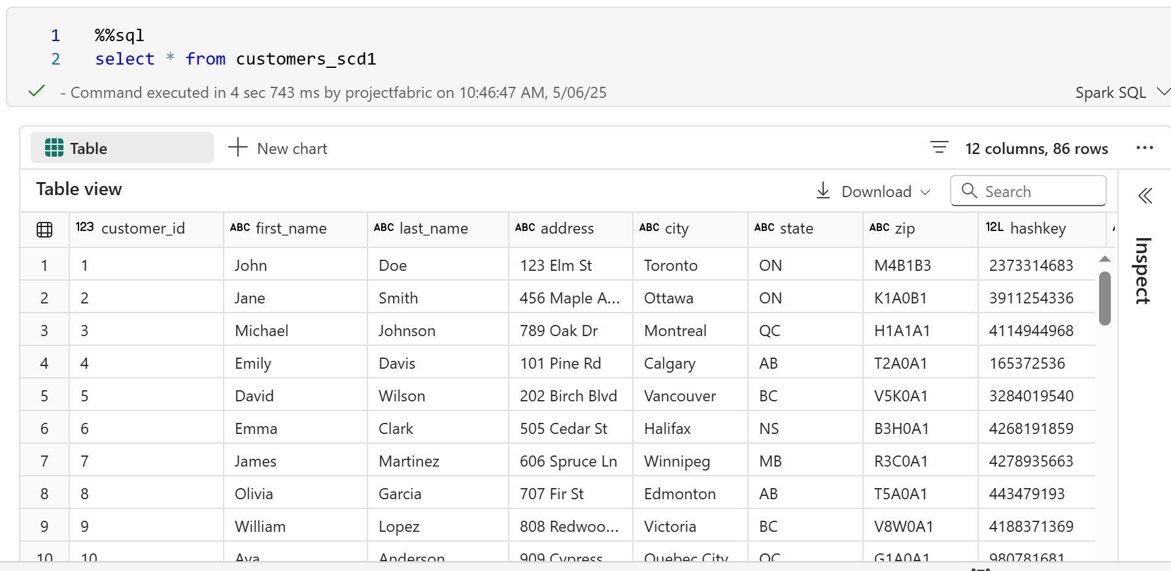FOR LOAN_PAYMENTS TABLE
%%sql
CREATE TABLE IF NOT EXISTS loanpayments_scd1
(
payment_id int,
loan_id int,
payment_date timestamp,
payment_amount double,
hashkey BIGINT,
createdby string,
createddate timestamp,
updatedby string,
updateddate timestamp
)

df_loanPayments=spark.read.synapsesql('project4_warehouse.dbo.loan_payments')
display(df_loanPayments)

df_hashloanPayments=df_loanPayments.withColumn('src_hash',
crc32(concat(col('payment_id'), col('loan_id'), col('payment_date'),
col('payment_amount'))))
display(df_hashloanPayments)

tgt_path_LoanPayments='abfss://project@onelake.dfs.fabric.microsoft.com/scdtype1.Lakehouse/Tables/dbo/loanpayments_scd1'

from delta.tables import DeltaTable
dtableloanPayments = DeltaTable.forPath(spark, tgt_path_LoanPayments)
dtableloanPayments.toDF().show()

df_src_loanPayments=df_hashloanPayments.alias("src").join(dtableloanPayments.toDF().alias("tgt"), ((col("src.payment_id")== col("tgt.payment_id")) &
(col("src.src_hash")== col("tgt.hashkey"))),"anti").select("src.*")
display(df_src_loanPayments)

dtableloanPayments.alias("tgt").merge(
df_src_loanPayments.alias("src"), "tgt.payment_id = src.payment_id"
).whenMatchedUpdate(
set={
"tgt.payment_id": "src.payment_id",
"tgt.loan_id": "src.loan_id",
"tgt.payment_date": "src.payment_date",
"tgt.payment_amount": "src.payment_amount",
"tgt.hashkey": "src.src_hash",
"tgt.updateddate": current_timestamp(),
"tgt.updatedby": lit("databricks-updated")
}
).whenNotMatchedInsert(
values={
"tgt.payment_id": "src.payment_id",
"tgt.loan_id": "src.loan_id",
"tgt.payment_date": "src.payment_date",
"tgt.payment_amount": "src.payment_amount",
"tgt.hashkey": "src.src_hash",
"tgt.createddate": current_timestamp(),
"tgt.createdby": lit("databricks"),
"tgt.updateddate": current_timestamp(),
"tgt.updatedby": lit("databricks")
}
).execute()

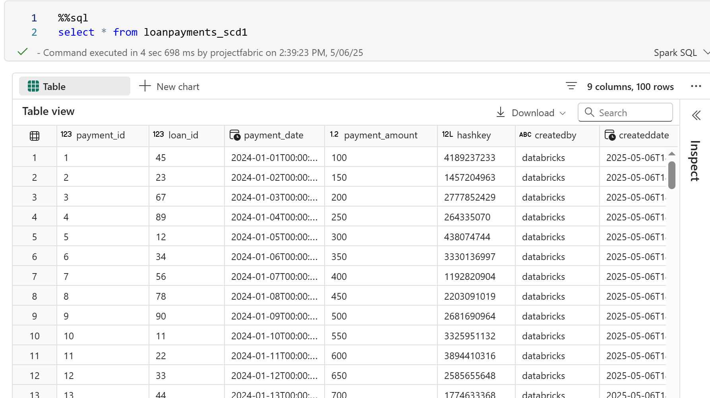
FOR LOANS TABLE
%%sql
CREATE TABLE IF NOT EXISTS loans_scd1
(
loan_id int,
customer_id int,
loan_amount double,
interest_rate double,
loan_term int,
hashkey BIGINT,
createdby string,
createddate timestamp,
updatedby string,
updateddate timestamp
)

df_loans=spark.read.synapsesql('project4_warehouse.dbo.loans')
display(df_loans)

df_hashloans=df_loans.withColumn('src_hash',
crc32(concat(col('customer_id'), col('loan_id'), col('interest_rate'), col('loan_term'),
col('loan_amount'))))
display(df_hashloans)

tgt_path_loans='abfss://project@onelake.dfs.fabric.microsoft.com/scdtype1.Lakehouse/Tables/dbo/loans_scd1'

from delta.tables import DeltaTable
dtableloans = DeltaTable.forPath(spark, tgt_path_loans)
dtableloans.toDF().show()

df_src_loans=df_hashloans.alias("src").join(dtableloans.toDF().alias("tgt"), ((col("src.loan_id")== col("tgt.loan_id")) &
(col("src.src_hash")== col("tgt.hashkey"))),"anti").select("src.*")
display(df_src_loans)

dtableloans.alias("tgt").merge(
df_src_loans.alias("src"), "tgt.loan_id = src.loan_id"
).whenMatchedUpdate(
set={
"tgt.customer_id": "src.customer_id",
"tgt.loan_id": "src.loan_id",
"tgt.interest_rate": "src.interest_rate",
"tgt.loan_amount": "src.loan_amount",
"tgt.loan_term": "src.loan_term",
"tgt.hashkey": "src.src_hash",
"tgt.updateddate": current_timestamp(),
"tgt.updatedby": lit("databricks-updated")
}
).whenNotMatchedInsert(
values={
"tgt.customer_id": "src.customer_id",
"tgt.loan_id": "src.loan_id",
"tgt.interest_rate": "src.interest_rate",
"tgt.loan_amount": "src.loan_amount",
"tgt.loan_term": "src.loan_term",
"tgt.hashkey": "src.src_hash",
"tgt.createddate": current_timestamp(),
"tgt.createdby": lit("databricks"),
"tgt.updateddate": current_timestamp(),
"tgt.updatedby": lit("databricks")
}
).execute()

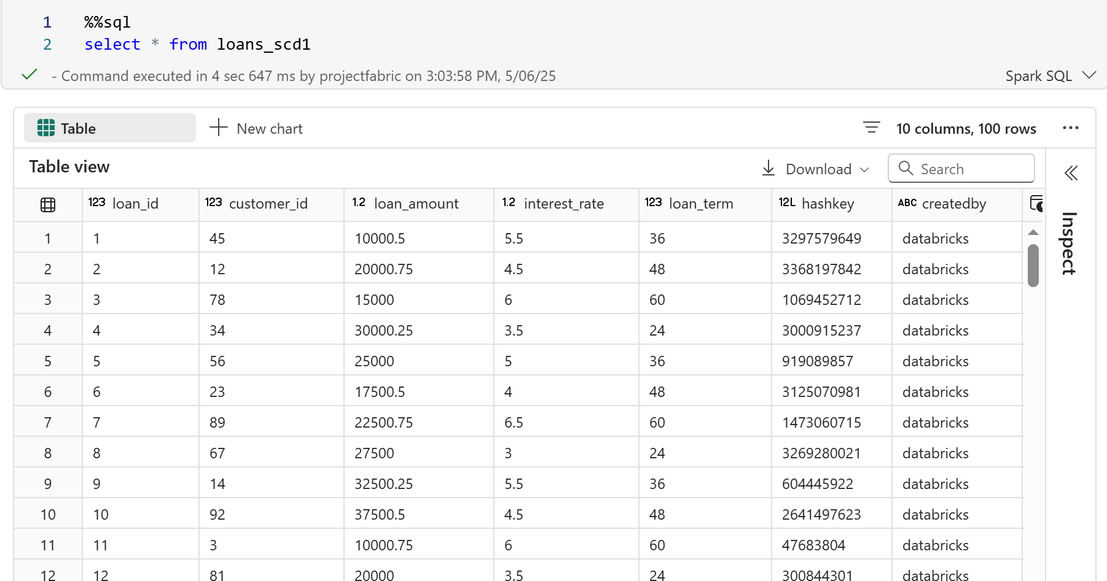
FOR TRANSACTION TABLE
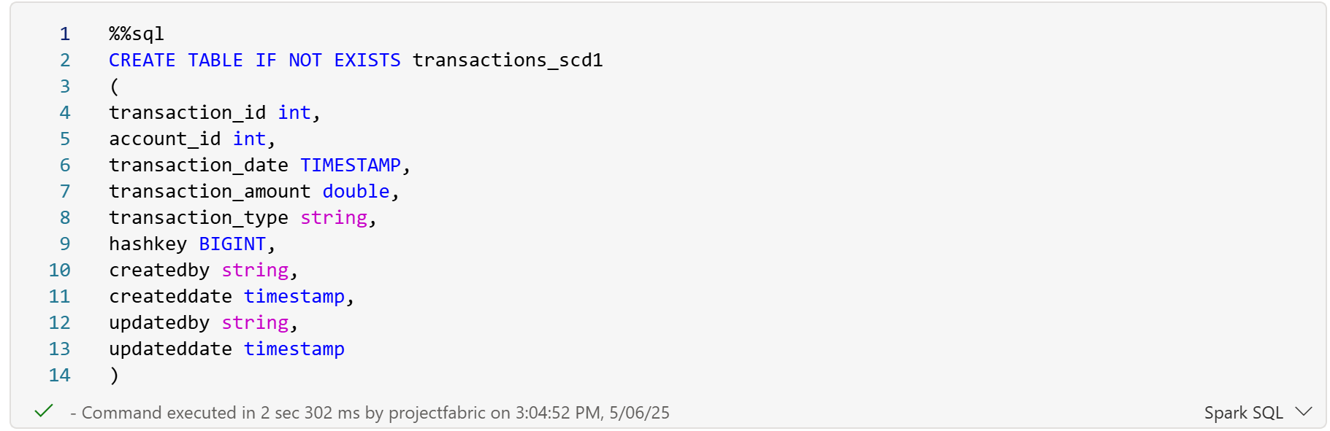
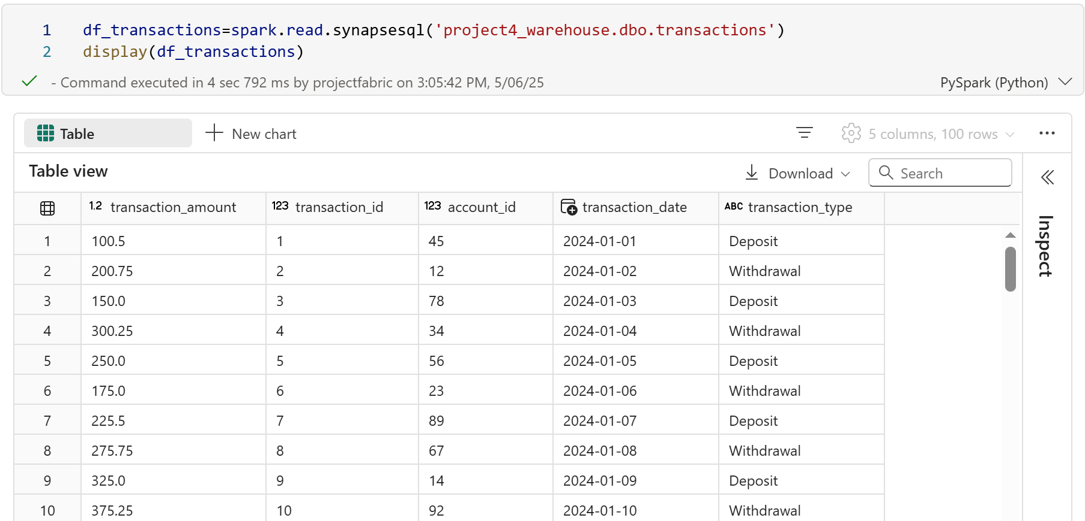
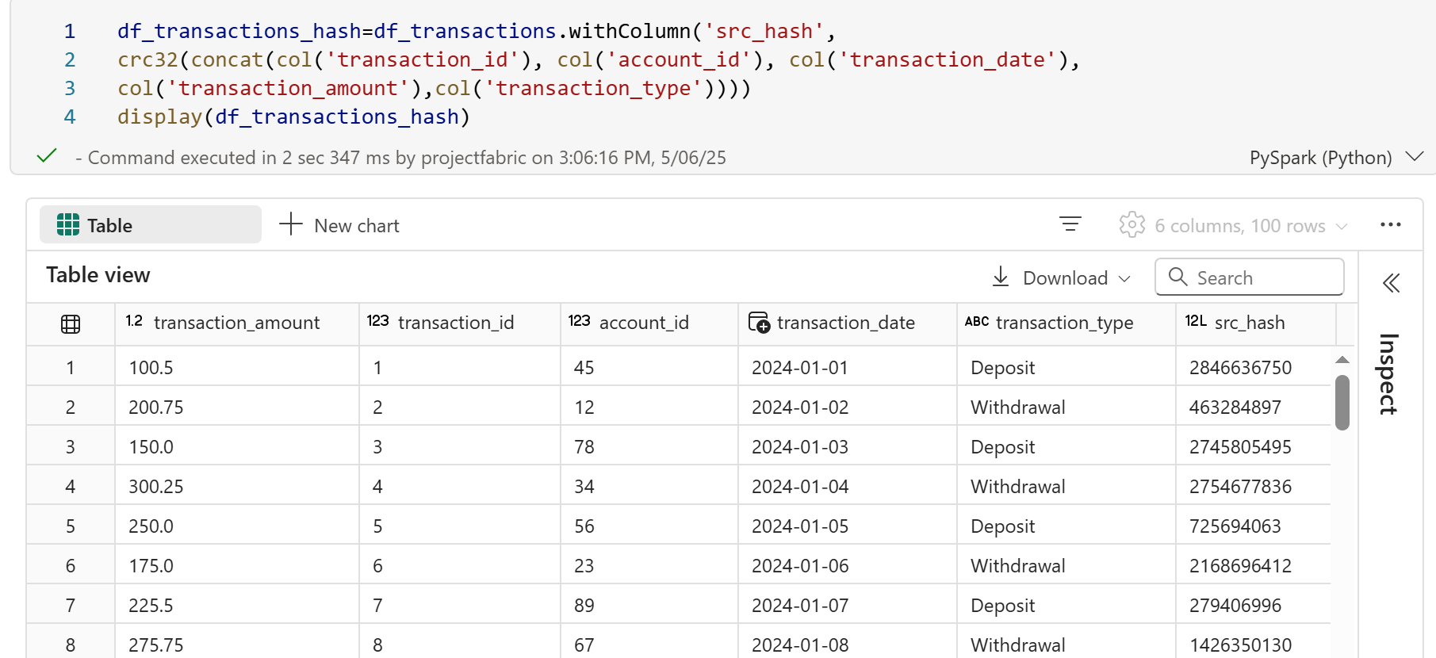
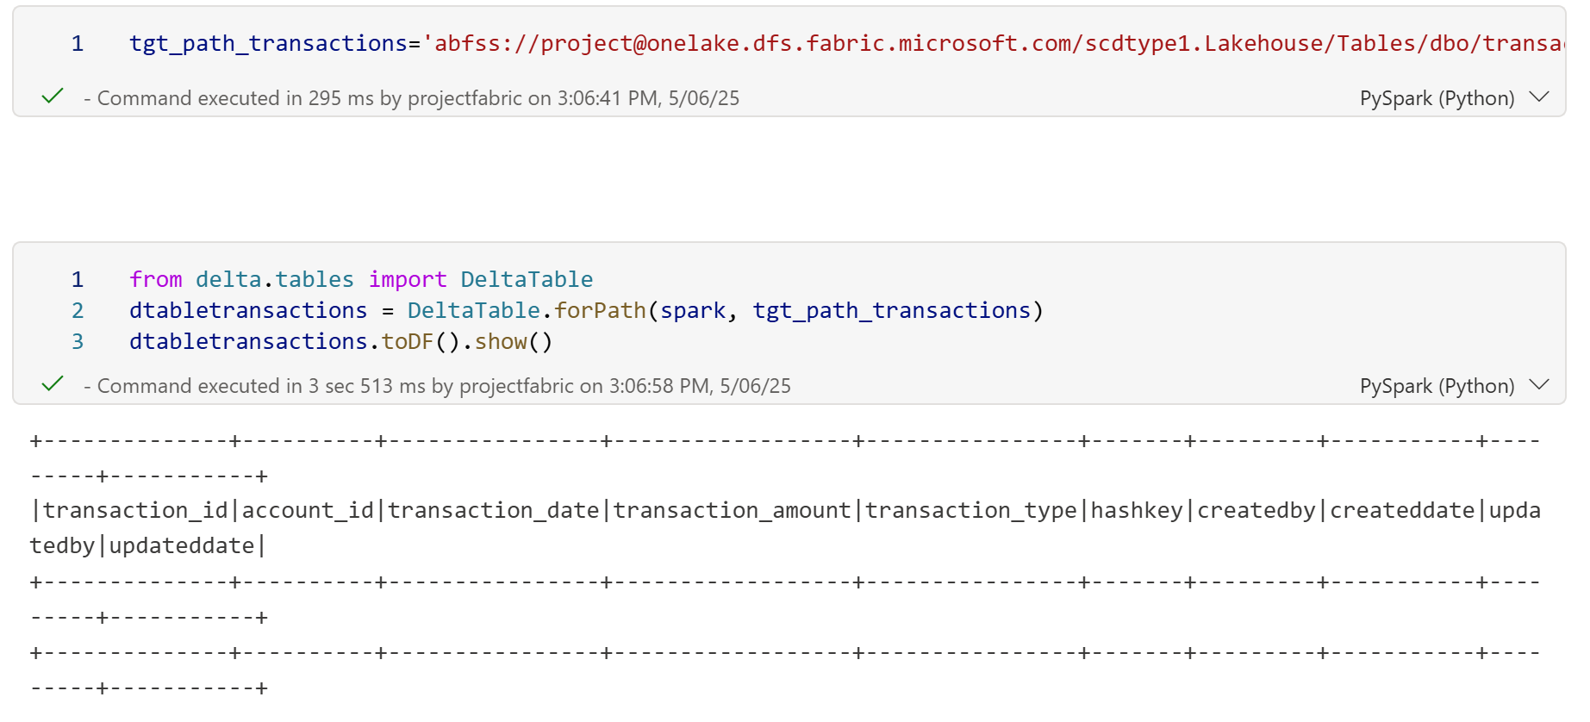
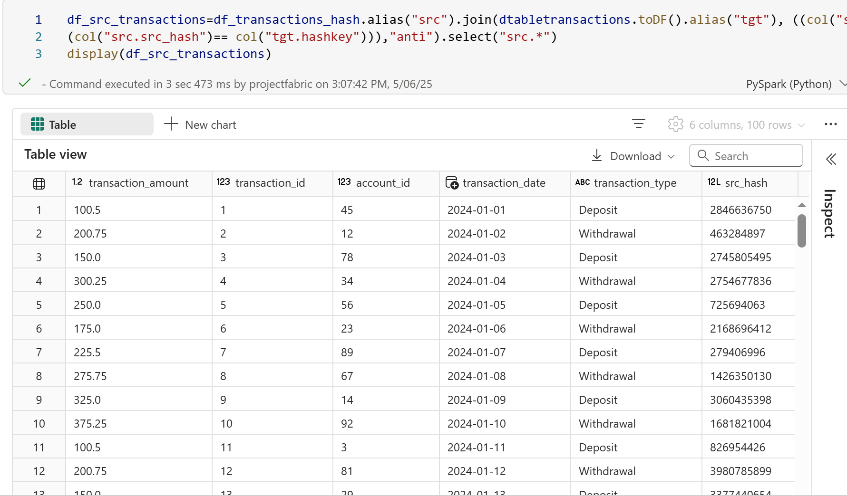
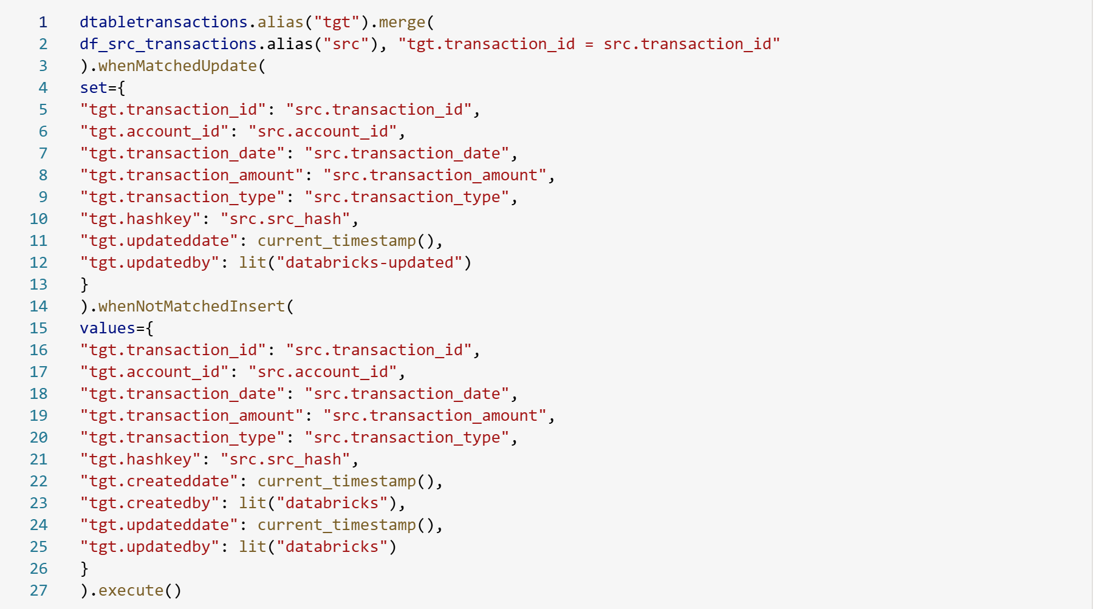
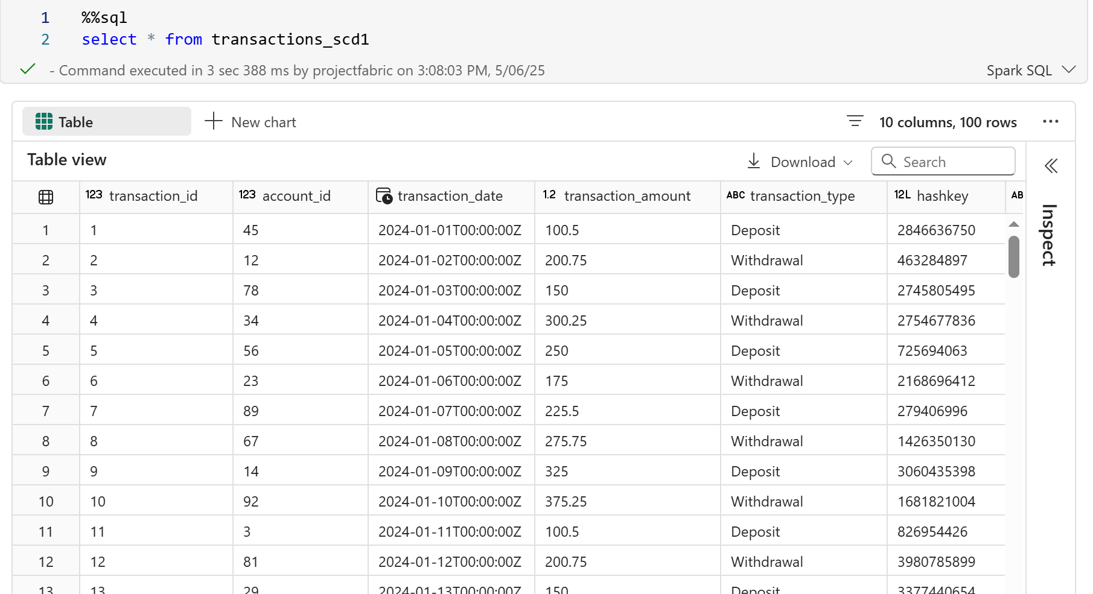
HERE IS THE FINAL PIPEPLINE
