Read me before running the code, unzip the project file:

Before, open the web application project in NetBeans IDE

* First, Apache NetBeans IDE is required to perform the web application in java using html and jsp. (assume Apache NetBeans IDE is being installed)
* You have to download the apache tomcat server zip files <https://tomcat.apache.org/download-10.cgi> as default server connected with jsp files
* Download Mysql community server( depends on your computer version) and sql connector(.jar) in miscrosoft.com to perform mysql database.

<https://dev.mysql.com/downloads/mysql/>

<https://dev.mysql.com/downloads/connector/j/5.1.html>

* After successful download, you have to initialize the mysql as below:

*1. Start MySQL server*

*-* *Open a command prompt*

*-* *Go to the “bin” directory within the extracted root folder of the MySQL server with command “cd”*

*o* *E.g., “cd C:\Users\student\Desktop\mysql-8.0.18-winx64\bin”*

*.* *Initialization of the data directory with command*

| *mysqld --initialize-insecure* |
| --- |

*-* *Start the MySQL server with command*

| *mysqld* |
| --- |

*2. Execute SQL command to create user*

*-* *Open another command prompt*

*.* *Again, change to the “bin” directory of the extracted root folder of the MySQL server with command “cd”*

*-* *a. Start the MySQL client as the “root”*

| *mysql -u root* |
| --- |

*-* *b. Create a new user called “mysqluser” with password “mypass”*

| *create user 'user1'@'localhost' identified by '12345678';* |
| --- |

*-* *c. Grant all privileges to the user for allowing the user to work on all databases*

| *grant all privileges on *.* to 'user1'@'localhost' with grant option;* |
| --- |

*-* *d. Logoff mysql with command*

| *quit* |
| --- |

| *mysql -u mysqluser -p* |
| --- |

*o Note*

*§ The system will ask you for the password (i.e., “12345678”)*

*- b. Create a database called “user” with command*

| *create database user;* |
| --- |

*- c. Use the database*

| *use user;* |
| --- |

*Insert mysql commands from projectjsp.txt to create tables*

*1.login*

*2.student*

*3.studentcourse*

*4.teacher*

*5.admin*

*6.personal*

*7.Quit mysql*

| *quit* |
| --- |

Then, open the web application project in NetBeans IDE

Make sure the web application is runnable on your localhost server:

1. Select Apache Tomcat or TomEE and add your downloaded apache tomcat files which are stored in your computer.
2. Then click next…
3. It will require you to set the username and password in everytime you re-opened and run the project files.

example:

username: admin

password: admin

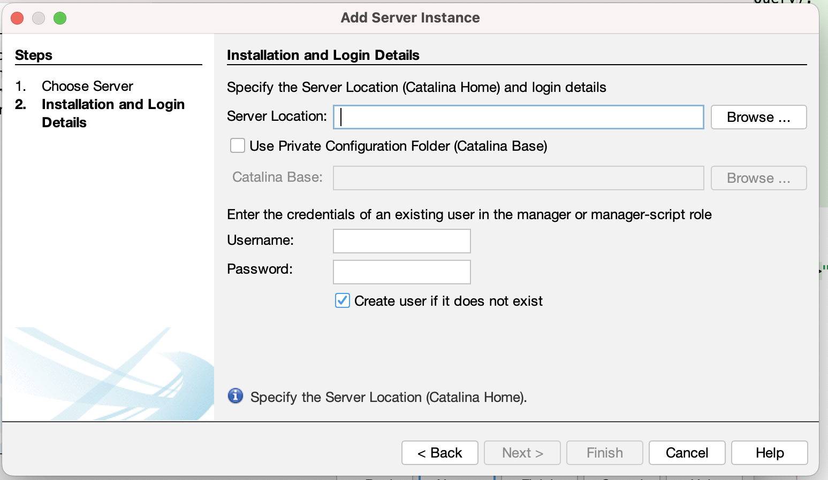

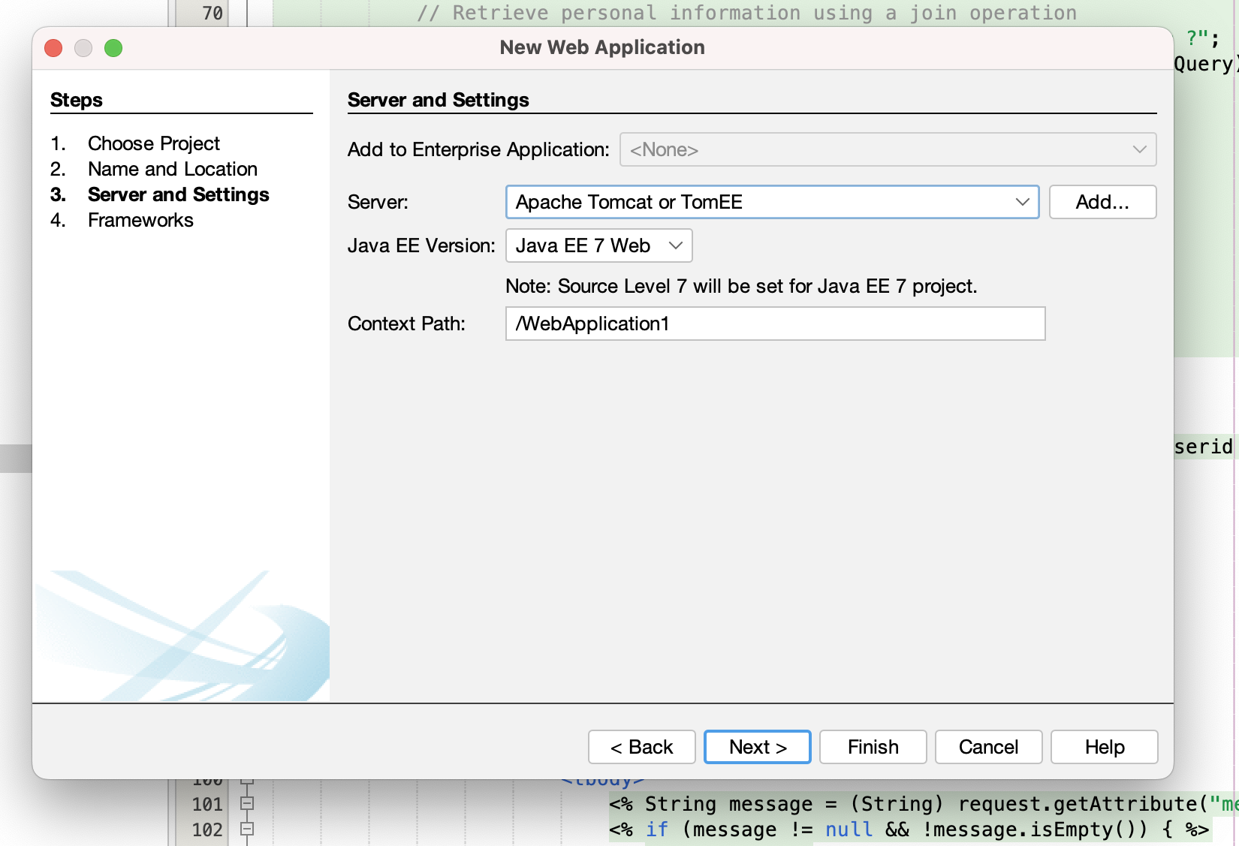

Make sure click on the properties of project ( we named ProjectJSP)

to select libraries to add jar/folder that your download mysql connector jar with mysql

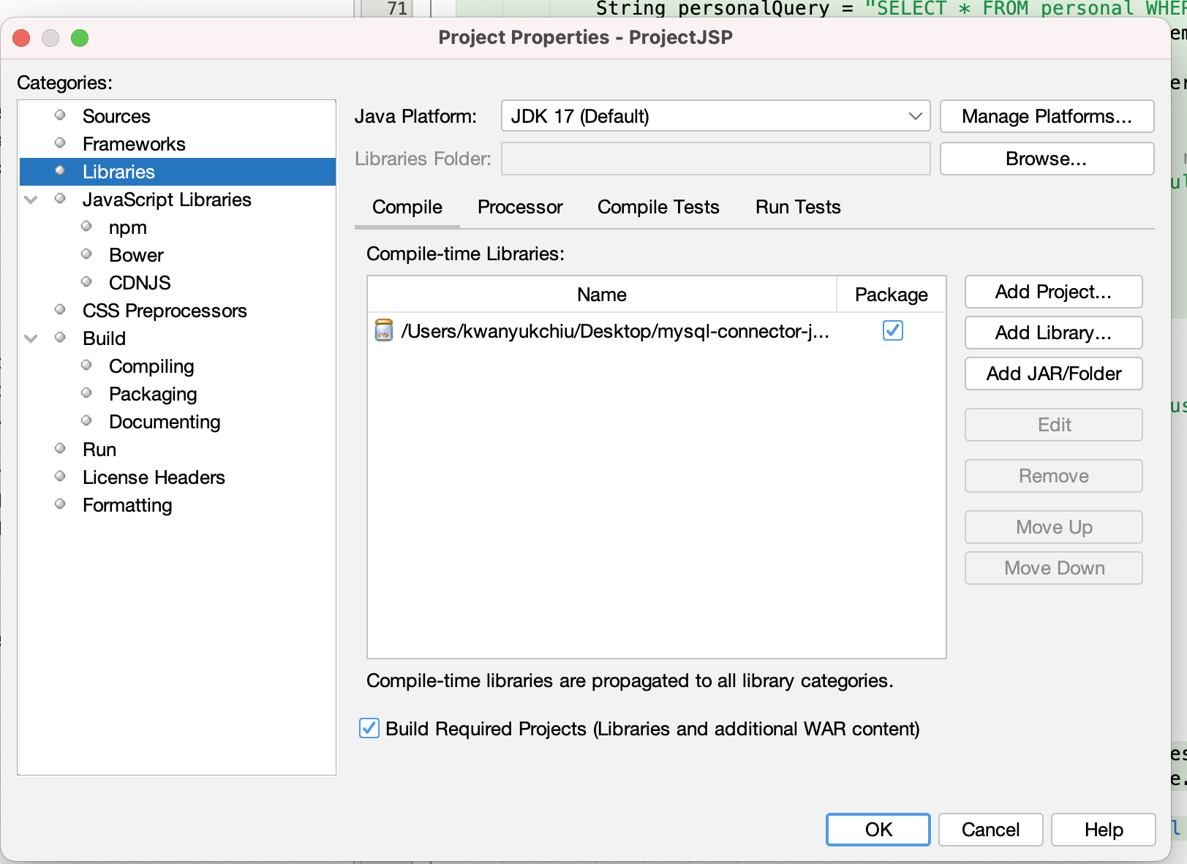

Select RUN in the below, to check your server information is matched, and choose a suitable default browser.

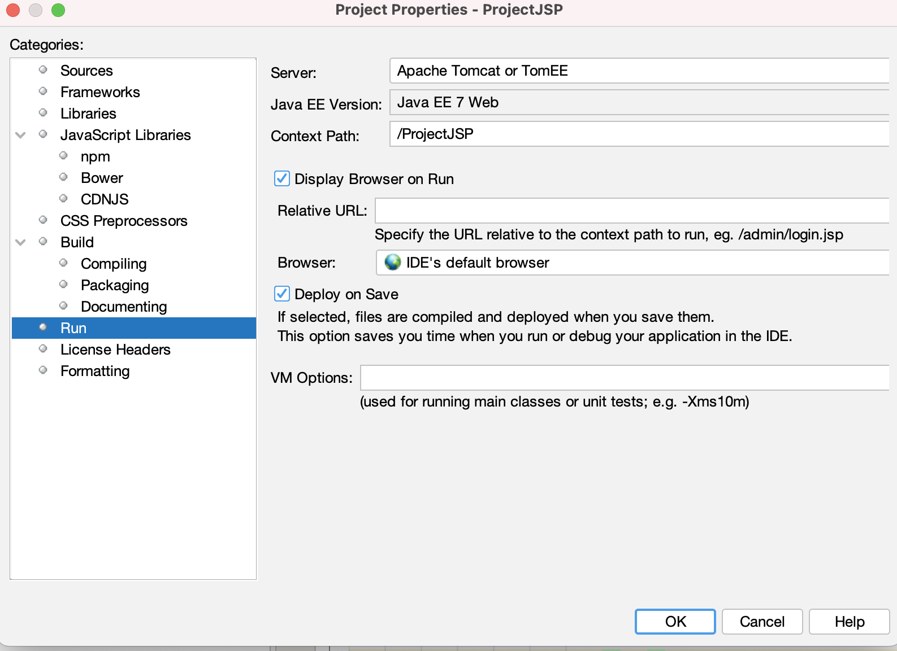

Then, run the codes in the project files.

Ensure you type in the url that is matched with the name of jsp files

for example, localhost:8080/ProjectJSP/login.jsp

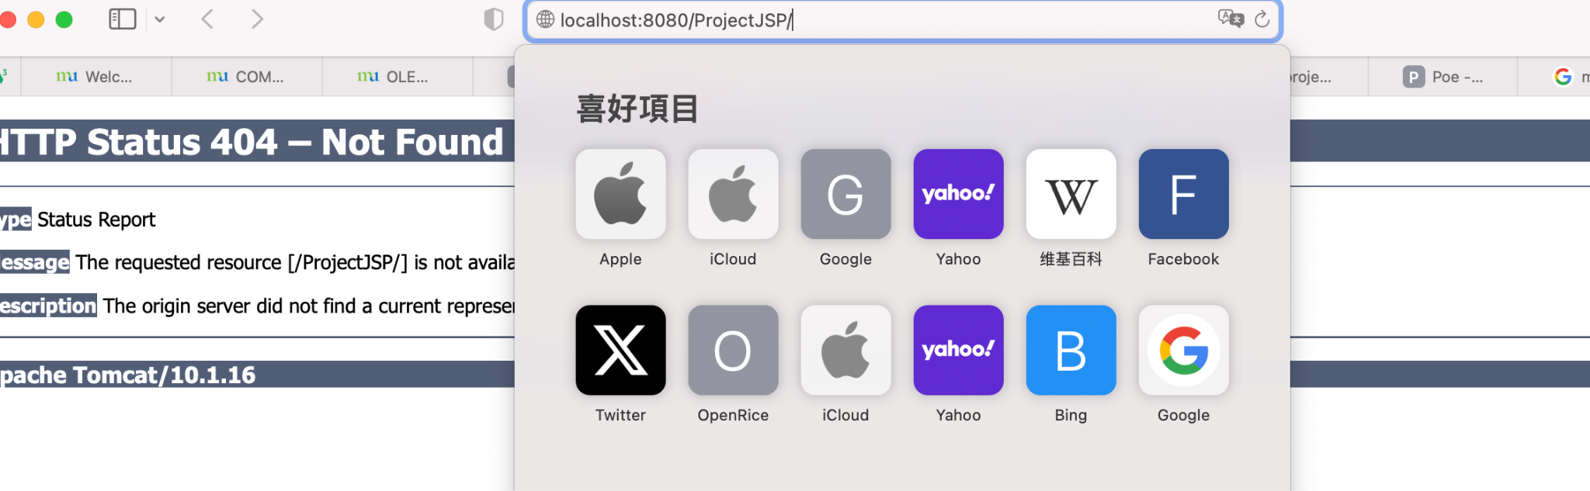

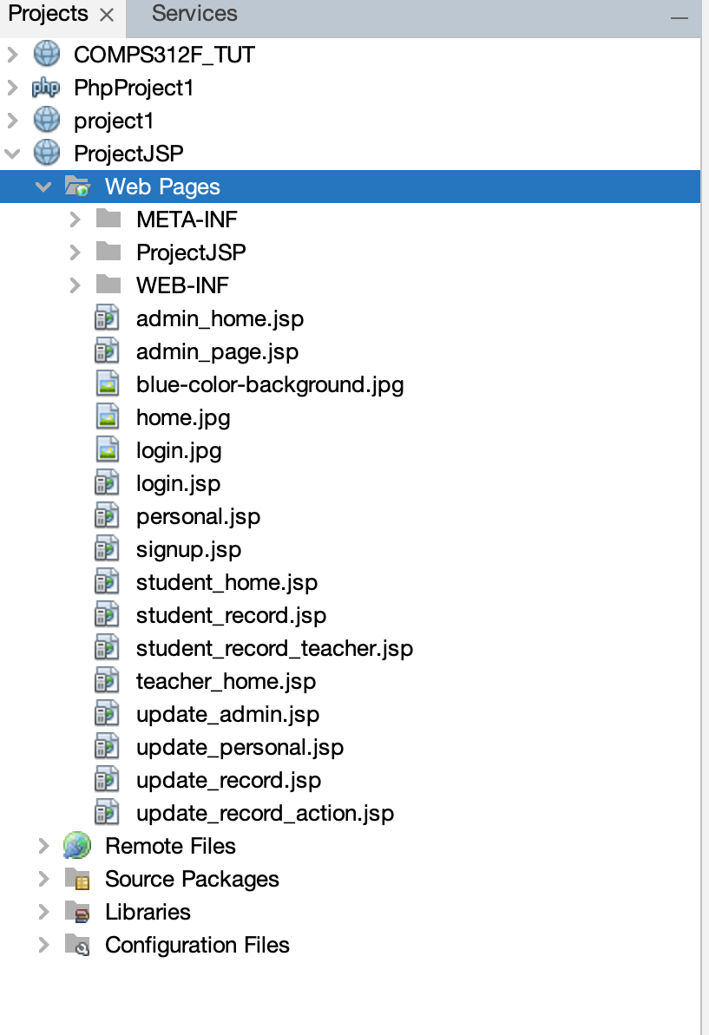

REMARKS:

1. The main code is located in the web page in the ProjectJSP
2. The user interface shown above is using macOS/iOS platform