TASK 5

**Step 1: Clone the Git Repository** # Clone the repository

git clone https://github.com/original-repo/spring-framework.git

# Change to the project directory cd spring-framework

# Add your GitHub repository as the remote

git remote set-url origin <https://github.com/Abbinayasri>

spring-framework.git

# Push the project to your own repo git push origin main

**Step 2: Install Maven**

# Update package lists sudo apt update

# Install Maven

sudo apt install maven -y mvn -version

# Remove existing Maven sudo apt remove maven -y

# Download the latest Maven version cd /opt

sudo wget <https://downloads.apache.org/maven/maven-> 3/3.9.6/binaries/apache-maven-3.9.6-bin.tar.gz

# Extract and move Maven

sudo tar -xvzf apache-maven-3.9.6-bin.tar.gz sudo mv apache-maven-3.9.6 /opt/maven

# Set up environment variables

echo 'export M2_HOME=/opt/maven' | sudo tee -a /etc/profile.d/maven.sh echo 'export PATH=$M2_HOME/bin:$PATH' | sudo tee -a

/etc/profile.d/maven.sh source /etc/profile.d/maven.sh

**Verify installation:**

mvn -version which mvn

If necessary, create a symbolic link:

sudo ln -s /opt/maven/bin/mvn /usr/bin/mvn **Step 3: Build the Project with Maven**

Navigate to the Jenkins workspace and build the project: cd /var/lib/jenkins/workspace/Spring-framework

# Clean and package the project (skipping tests) mvn clean package -DskipTests

**Step 4:** **Set Up Jenkins Pipeline**

1. Open **Jenkins Dashboard** → Click **New Item** → Select **Pipeline**.
2. Go to **Pipeline** section and add the following script:

pipeline { agent any

environment {

IMAGE_NAME = "docker-user-name/my-app" REGISTRY = "docker.io"

DOCKER_USER = "docker-user-name" DOCKER_PASS = "your-docker-password"

}

stages {

stage('Checkout Code') { steps {

git url: 'https://github.com/git-user-name/git-repo-name.git', branch: 'main'

}

}

stage('Build Docker Image') { steps {

script {

sh "docker build -t $IMAGE_NAME:latest ."

}

}

}

stage('Login to Docker Registry') {

steps {

script {

sh 'echo $DOCKER_PASS | docker login -u $DOCKER_USER --password-stdin'

}

}

}

stage('Push Image to Docker Registry') { steps {

script {

sh "docker push $IMAGE_NAME:latest"

}

}

}

}

post {

success {

echo 'Pipeline executed successfully!'

}

failure {

echo 'Pipeline failed! Check the logs for errors.'

}

}

}

**Step 5: Fix Permissions for Jenkins**

Ensure Jenkins has the correct permissions:

sudo chown -R jenkins:jenkins /var/lib/jenkins/workspace/Spring- framework

sudo chmod -R 775 /var/lib/jenkins/workspace/Spring-framework Restart Jenkins to apply changes:

sudo systemctl restart jenkins

**Step 6 : Run and Debug the Pipeline**

After setting up everything, go to Jenkins and **trigger the build**. If there are any errors:

docker images # Check if the image exists docker ps -a # Check running containers

docker logs <container_id> # View container logs

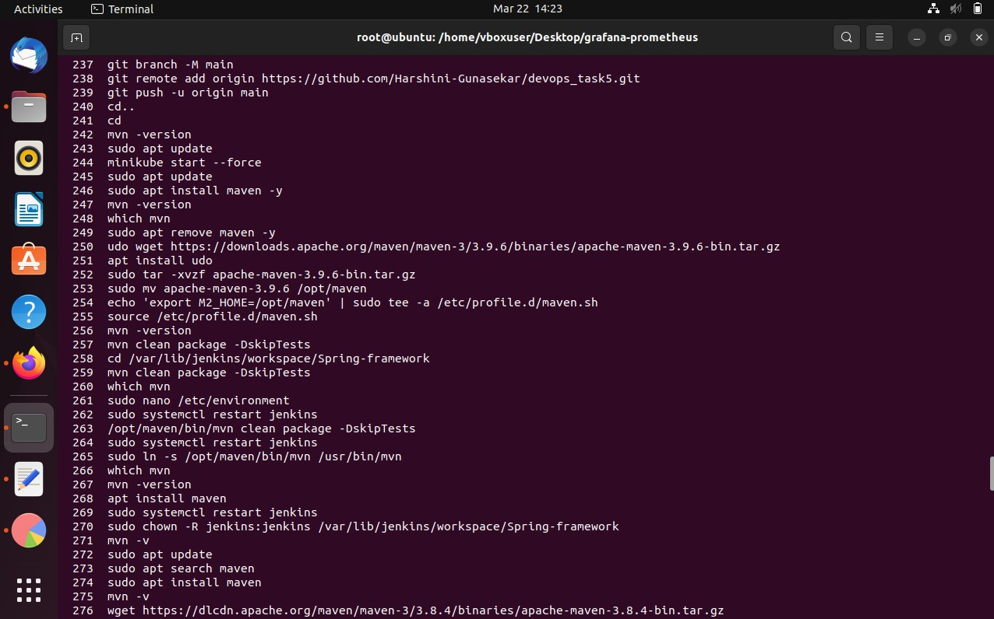

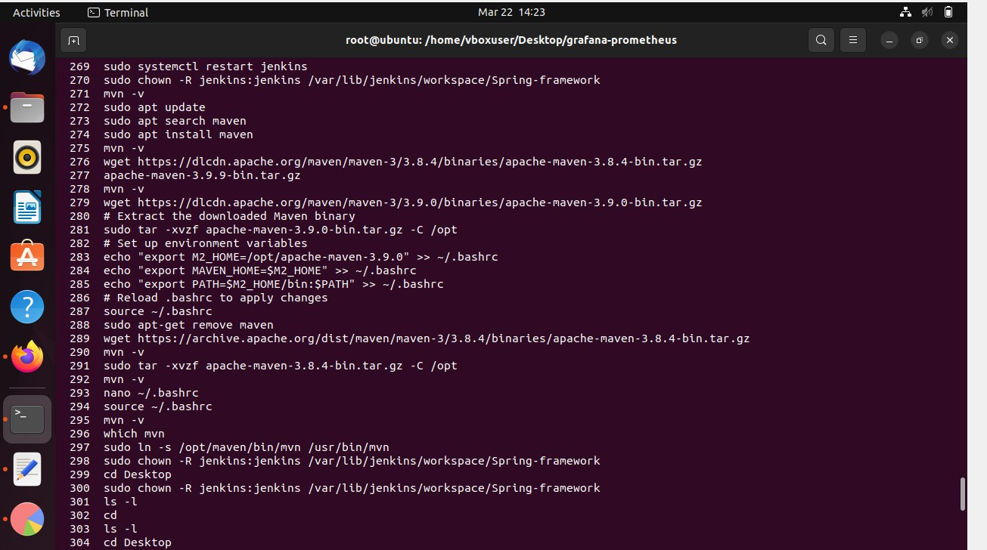

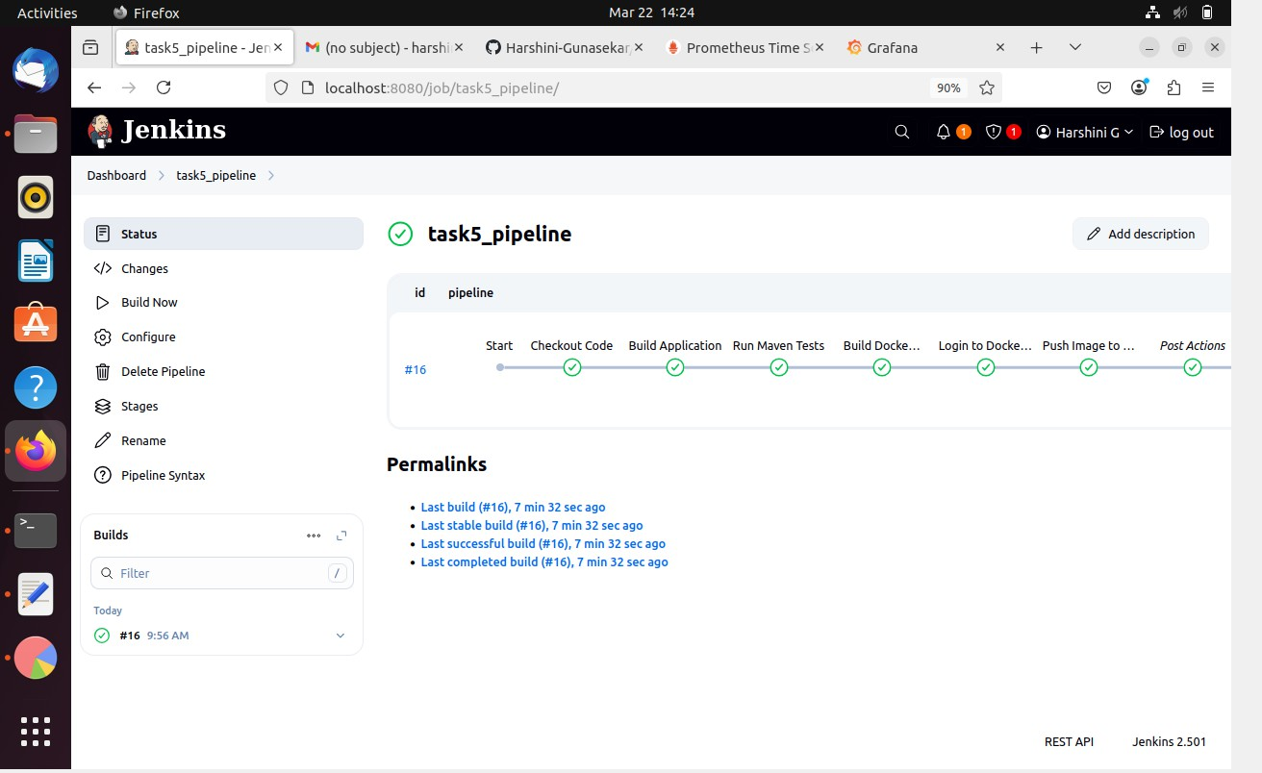

Abbinaya

Abbinay

Abbinaya