# Exercise 03 — Concept of Decomposition

## 1. Demographic Pyramid of the Russian Federation

The demographic pyramid represents the population distribution by age and gender in the Russian Federation. The image of the demographic pyramid has been added as requested.

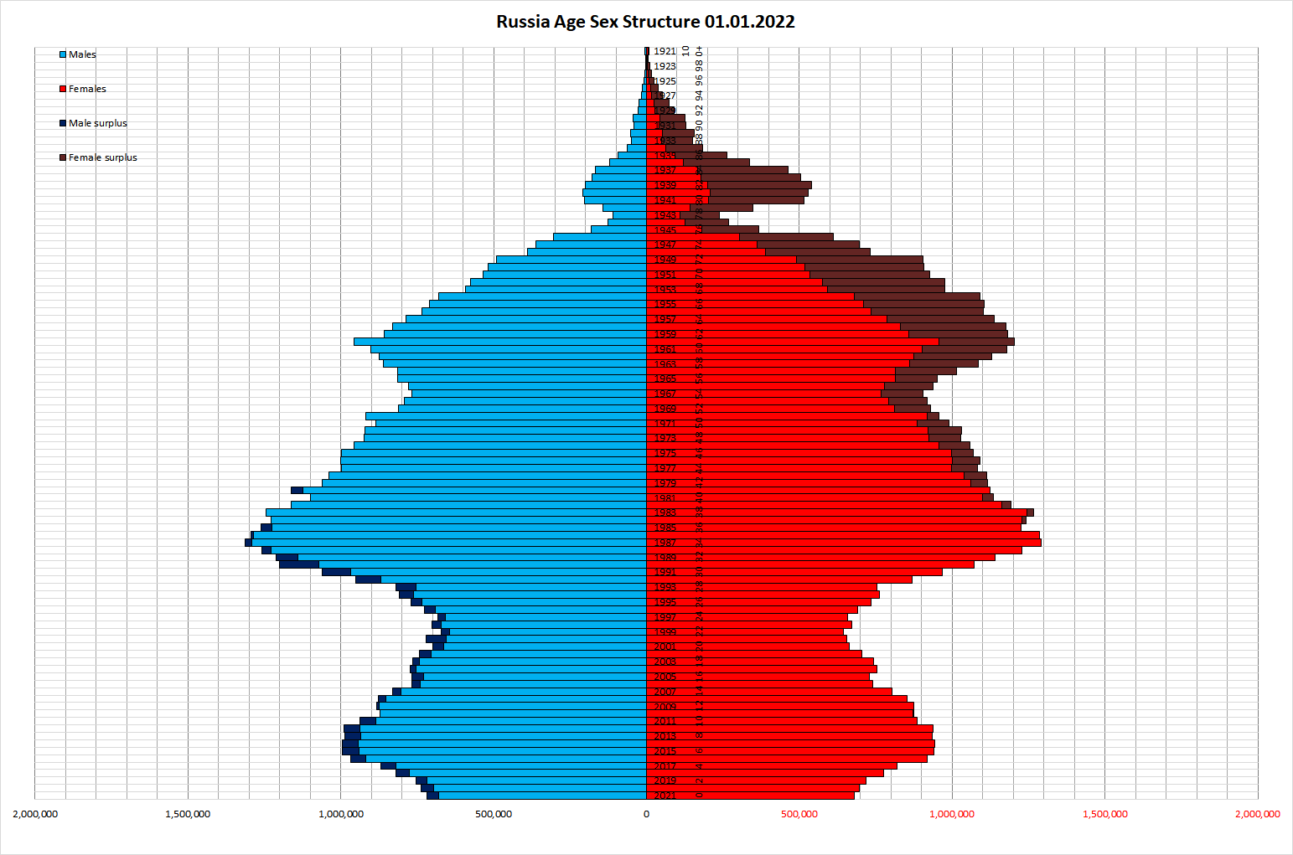

Image of Russian Demographic Pyramid

## 2. Breakdown Indicator

The breakdown indicator for the demographic pyramid is age and gender. This categorization provides a clear visualization of the population structure.

## 3. Purpose of the Demographic Pyramid

The purpose of the demographic pyramid is to illustrate the age and gender composition of a population, helping policymakers, researchers, and planners understand demographic trends, forecast population changes, and plan for future needs such as healthcare, education, and employment.

## 4. Type of Decomposition

The demographic pyramid uses a component (object) decomposition. It categorizes the population into distinct groups based on two attributes: age and gender.

## 5. Levels of Decomposition

The demographic pyramid has three levels of decomposition:  
- Level 0: The total population.  
- Level 1: Population by gender (male and female).  
- Level 2: Population by age groups within each gender (e.g., 0-4 years, 5-9 years, etc.).

## 6. Criteria for Categorization

The criteria used for categorization at each level are:  
- Level 1: Gender (male and female).  
- Level 2: Age groups (e.g., 0-4, 5-9, 10-14, etc.).

## 7. Order of Construction

The demographic pyramid is constructed in the following order:  
1. Total population is determined (Level 0).  
2. Population is divided by gender into male and female groups (Level 1).  
3. Each gender group is further divided into age groups (Level 2).  
This sequential approach ensures clarity and completeness in representing the population structure.