**Lesson 3 - The Box Model**

**Lecture Notes**

**Activity 1: Keyboard Efficiency**

Notepad++

* Must be text Editor Context
  + Save = Ctrl + S
  + Find = Ctrl + F
  + Find In Files = Ctrl + Shift + F
    - Think of this as an upgraded version of Ctrl + F
  + Find Next = F3
  + Replace = Ctrl + H
* Must be in replace window context
  + Replace All = Alt + A
  + Tab = go to next field
  + Space = toggle a checkbox

**Useful Combos**

* View page updates
  + Make a change in code
  + Save (Ctrl + S)
  + Switch windows from notepad++ to google chrome (alt+tab)
  + Refresh google chrome (F5)
  + Switch back to notepad++ (alt+tab)
* Find occurrences in a file
  + Double click a word in notepad
  + ctrl + f
  + Click back in the text editor
  + F3 through all of the occurrences
* Replace in selection
  + Highlight selection with mouse (or with ctrl + shift + up/left/right/down)
  + Ctrl + h brings up replace window
  + Type out the search term (<h2)
  + Tab to the next field, type the next term (<h3
  + (optionally tab to the “In Selection” checkbox and then hit space to turn it on)
  + Alt + A will replace all.

**Lecture**

1. **Styling HTML with CSS**
   1. CSS = Cascading Style Sheets
   2. Inline styles
      1. My last job, these were not allowed
      2. From here on out, you will not be allowed to write any more inline styles.
   3. Internal styles
      1. Can be useful while you’re building a webpage, then later on, pull it out into an external style sheet
      2. “Separation of concerns”

A design principle for separating a computer program into distinct sections such that each section addresses a separate concern. A concern is a set of information that affects the code of a computer program. A concern can be as general about the details of the hardware the website is being run on , or as specific as the tags and attributes in an html file. A program that embodies Separation of Concerns well is call a “modular” program.

* 1. External styles
     1. Absolutely the most common - many companies will have a folder with a bunch of these
        1. That way all of their web pages will look and feel the same
        2. One repository of css files means that all webpages (and website could have the same look and feel
     2. Also plenty of css files are available for download on the internet to help get your web-page looking great.

1. **The CSS Box Model**
   1. Visual example below
   2. Padding = packing peanuts
   3. Margin = outside the box
   4. Border = the box itself
   5. Content = the text, or content, or the item being shipped
2. **The element selector**
   1. p, h1, body, etc..
3. **The ID attribute**
   1. #idSelectorGoesHere
   2. IDs must be unique to the whole page
4. **The class attribute**
   1. .classSelectorGoesHere
   2. classes can show up on any number of elements

**Margin: 0px**



**Margin: 5px**

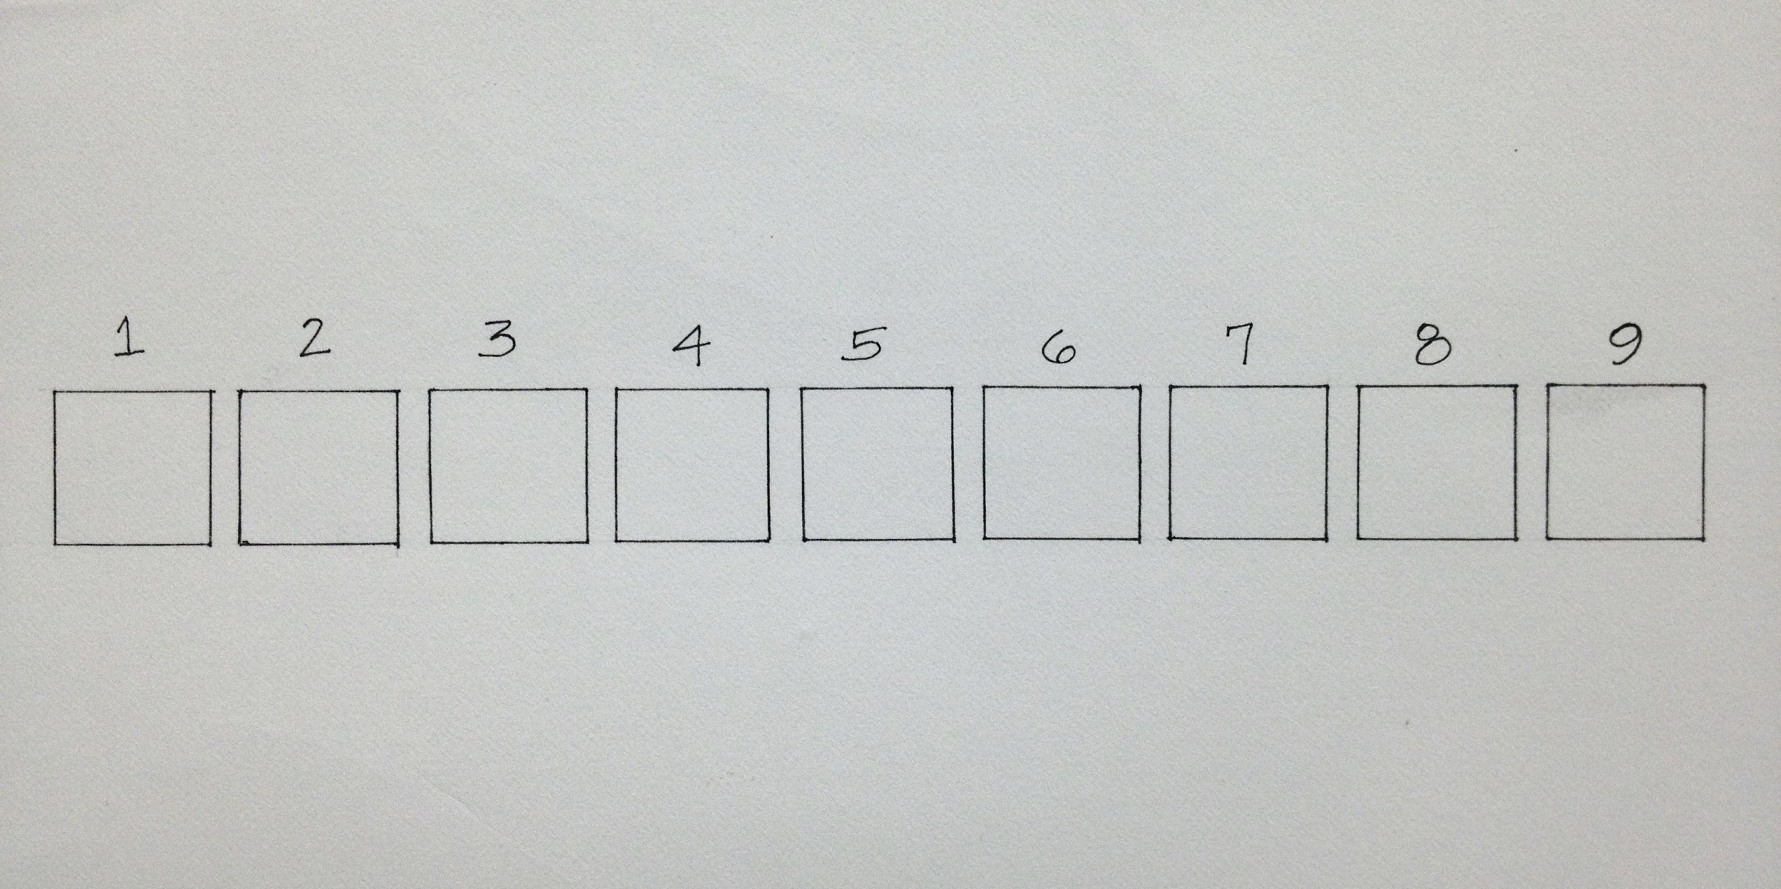

**Padding: 20px**



**Padding: 0px**



**Activity 2: Google Chrome Inspection**

<https://en.wikipedia.org/wiki/Main_Page>

* Right click anywhere on the page
* Inspect Element
* Click on html element tags to see which styles are being applied
* Click on “Computed” to see the css box model breakdown
* Hover over various html elements tags to see which is which on the webpage