**Lesson 6 - CSS: CSS: Float, Inline-block, Selectors, Align**

**Lecture Notes**

**Lecture Notes**

**Float**

<http://learnlayout.com/float.html>

<http://learnlayout.com/clear.html>

<http://learnlayout.com/clearfix.html>

<http://learnlayout.com/float-layout.html>

<http://stackoverflow.com/questions/9189810/css-display-inline-vs-inline-block>

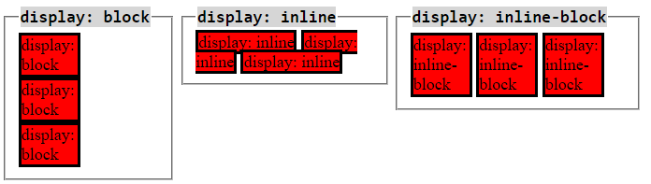

**Inline elements:**

1. respect left & right margins and padding, but **not** top & bottom
2. **cannot** have a width and height set
3. allow other elements to sit to their left and right.

**Block elements:**

1. Respects margin & padding in all directions
2. forces a line break after the block element

**Inline-block elements:**

1. allow other elements to sit to their left and right
2. respect top & bottom margins and padding
3. respect height and width

**CSS Combinators**

<http://www.w3schools.com/cssref/css_selectors.asp>

* Descendant selectors
  + Uses a space
  + div p { background-color:red; }
    - finds all p tags that are within a <div> on some level
    - Would work on <div> <ul> <li> <p> text goes here </p> </li> </ul> </div>
    - <p> is an **eventual** ancestor of <div>
* Child selector
  + Uses a greater than sign >
  + A bit more specific
  + ul > li
    - Find all li tags that are direct child of ul tags
    - html should be formed this way anyway - it certainly can’t hurt to be explicit here
* Adjacent sibling selector
  + Not very common, uses a plus sign.
  + Can get a little confusing using these
  + Although, they can be nice when used with a class selector
    - li.emphasized { box-shadow:5px; }
    - li.emphasized + li { margin: 5px 0px; }
    - (bump the next li down a bit, because this one is emphasized.
* General sibling selector
  + A little bit more common. Much more useful
  + Uses a tilde ~
  + Find all siblings on the same level
  + Eventually we can use these when building an expand/collapse tree.

**CSS Psuedo-classes:**

* Order can be important!
* <http://www.w3schools.com/css/tryit.asp?filename=trycss_pseudo-class_hover_div>
* :first-child
  + really just first
* :hover
  + Incredibly useful
  + Can be used on all elements!
  + Can be used in a chain
* :active
  + Very useful for form controls
  + If you have an active checkbox, textbox, or button, how should it look?
* :nth-of-type(n)
  + <http://www.w3schools.com/cssref/sel_nth-of-type.asp>
  + Accepts “odd” or “even” as input!
  + an+b (allows you to select # of things!)
  + Very useful for doing “alt-rows” in a table

**CSS attribute selectors**

<http://www.w3schools.com/css/css_attribute_selectors.asp>

* We will focus on these once we have learned a bit of javascript.
* For now, they’re just good to know about.
* Sometimes people put data on html elements

**Activity**

* Selectors work in google chrome search!
* Google chrome inspect element, you can change the pseudo-class state of the element!
* <http://flukeout.github.io/>