CYBR 320

Abby Gopal

M8 simulation

In a hospital, hiring cybersecurity professionals is essential because they safeguard sensitive patient data, ensure regulatory compliance, prevent data breaches, secure critical medical devices and infrastructure, defend against ransomware and malware, educate staff, respond to security incidents, and assess and recommend security technologies. This proactive approach is crucial for patient privacy and the uninterrupted delivery of healthcare services. Hiring cybersecurity professionals is preferred over immediate pen testing or accelerated spending because it ensures continuous protection, compliance, vulnerability mitigation, staff education, incident response, and appropriate technology selection. It offers long-term cost-effectiveness, safeguards patient trust, and protects critical infrastructure, making it a comprehensive and proactive approach to healthcare security.

This option is the best choice because it offers comprehensive protection for your network, servers, and VDI with minimal impact on performance, especially in the healthcare sector. It provides continuous and proactive defense, ensures user and data protection, maintains regulatory compliance, enhances user awareness, and can be scaled and customized to the organization's needs. While external audits and open-source solutions have their merits, they are typically more limited in their scope and effectiveness in ensuring ongoing, robust security in a healthcare environment.

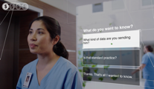

The lack of security awareness and practices among staff can lead to severe breaches and compliance issues. Sending patient records over personal email poses significant risks, including data privacy violations, regulatory non-compliance, data leakage, and the potential for data breaches. It also lacks the control, security, and audit trail required for sensitive healthcare data. This practice can lead to legal and reputation issues for healthcare organizations.

Receiving a call from Logan regarding a compliance breach and investigations indicates that there has been a data breach. The leakage of patient clinical data and a patient complaint about unsolicited medical treatment advertisements indicate a critical breach of patient data privacy and possible regulatory non-compliance. So, handling the breach is more important than worrying about compliance.

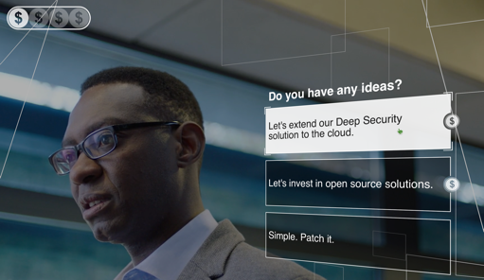While open-source solutions and patching are valuable components of a cybersecurity strategy, Deep Security offers the advantages of a commercial, all-in-one solution with centralized management, active threat detection, customization, regular updates, and expert support. This makes it a preferred choice for organizations seeking robust and proactive cybersecurity protection.

In this scenario, organizing security training and enabling anti-ransomware functionality is worthwhile because it enhances data protection, reduces risks, improves compliance, prepares the organization for potential incidents, and ultimately contributes to maintaining patient trust and the hospital's reputation. The organization faces compliance and data breach concerns in the scenario described. While board training is valuable for long-term security awareness, it may not directly address the immediate risks posed by potential breaches. Enabling anti-ransomware functionality, security training, and incident response preparations are more pressing priorities. Shutting down email and network entirely is a drastic measure that would severely disrupt daily operations. It should only be considered in extreme circumstances, such as an active and widespread security threat, like a massive malware outbreak or a critical breach. It would be a last resort. It's generally advisable to take a balanced approach. Address immediate security concerns with the mentioned measures and schedule board training for the next month or a suitable timeframe. Shutting down the email and network completely should be reserved for severe, imminent threats that require such a response.

What have I learned?

Adequate IT security and data protection are crucial in business and healthcare organizations. The lack of security awareness and practices among staff can lead to serious breaches and compliance issues in both settings. This underscores the importance of a well-integrated security solution to protect sensitive data and critical information, whether business-related or patient data. Collaboration between IT security teams and other operational departments is essential in both scenarios. In a business firm, this might involve working closely with finance, human resources, and legal departments to address security challenges effectively. Collaboration with operational teams like the OPS team is vital in a hospital to ensure a secure healthcare environment.

Responding to threats like phishing emails and quickly detecting and preventing breaches are proactive security measures in both contexts. However, the emotional impact may differ. A business firm's focus might be safeguarding sensitive business data and maintaining operational continuity. In a hospital, the stakes are incredibly high, and every second counts for saving lives. This emotional aspect, coupled with the pressure to make quick decisions, is particularly intense for a security analyst in a healthcare setting. The critical role of IT security is evident in both business firms and healthcare organizations. It's a reminder that remaining proactive and prepared to defend against threats is necessary to ensure data privacy, safety, and compliance with regulations, whether you are safeguarding business or patient data.

References:

<https://resources.trendmicro.com/datacenter-attack.html>