**Eclipse 4 RCP - Tutorial**

***Building Eclipse RCP applications based on Eclipse 4***

**Lars Vogel**

Version 6.7

Copyright © 2009 , 2010 , 2011 , 2012 Lars Vogel

05.11.2012

|  |  |  |  |
| --- | --- | --- | --- |
| **Revision History** | | | |
| Revision 0.1 | 14.02.2009 | Lars Vogel | created |
| Revision 0.2 - 6.7 | 16.02.2009 - 05.11.2012 | Lars Vogel | bug fixes and enhancements |

**Eclipse e4**

This tutorial gives an overview about the Eclipse 4 application platform.

This tutorial describes the creation of Eclipse 4 based applications, e.g. Eclipse RCP applications. It describes the modeled application concept and the new programming model which is based on annotations and dependency injection.

**Table of Contents**

**[1. Eclipse 4](http://www.vogella.com/articles/EclipseRCP/article.html" \l "e4overview)**

**[1.1. What is Eclipse 4?](http://www.vogella.com/articles/EclipseRCP/article.html" \l "e4overview_eclipse4)**

**[1.2. The Eclipse Platform project](http://www.vogella.com/articles/EclipseRCP/article.html" \l "e4overview_platform)**

**[1.3. What is the Eclipse e4 project?](http://www.vogella.com/articles/EclipseRCP/article.html" \l "e4overview_what)**

**[1.4. Provisional API](http://www.vogella.com/articles/EclipseRCP/article.html" \l "e4overview_api)**

**[2. The Architecture of Eclipse](http://www.vogella.com/articles/EclipseRCP/article.html" \l "architecture)**

**[2.1. Eclipse based applications](http://www.vogella.com/articles/EclipseRCP/article.html" \l "architecture_overview)**

**[2.2. Terminology](http://www.vogella.com/articles/EclipseRCP/article.html" \l "e4terminology)**

**[2.3. Important configuration files](http://www.vogella.com/articles/EclipseRCP/article.html" \l "architecture_configurationfiles)**

**[3. Tutorial: Install Eclipse 4.2 for RCP development](http://www.vogella.com/articles/EclipseRCP/article.html" \l "tutorial_installation)**

**[3.1. Prerequisites](http://www.vogella.com/articles/EclipseRCP/article.html" \l "tutorial_prerequisites)**

**[3.2. Download and Install Eclipse 4.2](http://www.vogella.com/articles/EclipseRCP/article.html" \l "tutorial_installationrelease)**

**[3.3. Install the Eclipse 4 tooling](http://www.vogella.com/articles/EclipseRCP/article.html" \l "tutorial_installation2)**

**[4. Tutorial: Eclipse 4 application using the wizard](http://www.vogella.com/articles/EclipseRCP/article.html" \l "tutorial_e4wizard)**

**[4.1. Overview](http://www.vogella.com/articles/EclipseRCP/article.html" \l "tutorial_e4wizard_tools)**

**[4.2. Create project](http://www.vogella.com/articles/EclipseRCP/article.html" \l "tutorial_e4wizard_project)**

**[4.3. Launch](http://www.vogella.com/articles/EclipseRCP/article.html" \l "wizward_launch)**

**[5. Eclipse 4 application model](http://www.vogella.com/articles/EclipseRCP/article.html" \l "applicationmodel)**

**[5.1. What is the application model?](http://www.vogella.com/articles/EclipseRCP/article.html" \l "applicationmodel_overview)**

**[5.2. Where is the application model defined?](http://www.vogella.com/articles/EclipseRCP/article.html" \l "applicationmodel_runtime)**

**[5.3. How is the model connected to my Java classes?](http://www.vogella.com/articles/EclipseRCP/article.html" \l "applicationmodel_java)**

**[5.4. URI in the model](http://www.vogella.com/articles/EclipseRCP/article.html" \l "runtime_uri)**

**[5.5. Application model editor](http://www.vogella.com/articles/EclipseRCP/article.html" \l "plugin_creatinge4_editor)**

**[5.6. Supplementary](http://www.vogella.com/articles/EclipseRCP/article.html" \l "model_supplementary)**

**[5.7. Model access at runtime](http://www.vogella.com/articles/EclipseRCP/article.html" \l "modelruntime)**

**[5.8. Meta-model of the application model](http://www.vogella.com/articles/EclipseRCP/article.html" \l "model_structure)**

**[5.9. Creation of the runtime application model](http://www.vogella.com/articles/EclipseRCP/article.html" \l "appmodel_runtime)**

**[6. Supplementary model attributes](http://www.vogella.com/articles/EclipseRCP/article.html" \l "supplementary)**

**[6.1. Tags](http://www.vogella.com/articles/EclipseRCP/article.html" \l "supplementary_tags)**

**[6.2. Persisted State](http://www.vogella.com/articles/EclipseRCP/article.html" \l "supplementary_persistence)**

**[7. Overview of available model elements](http://www.vogella.com/articles/EclipseRCP/article.html" \l "importantmodelelement_element)**

**[8. Identifiers for model elements](http://www.vogella.com/articles/EclipseRCP/article.html" \l "e4modelids)**

**[8.1. Identifiers for model elements](http://www.vogella.com/articles/EclipseRCP/article.html" \l "e4modelids_requirements)**

**[8.2. Best practices for naming conventions](http://www.vogella.com/articles/EclipseRCP/article.html" \l "e4modelids__nc)**

**[9. Tutorial: Create an Eclipse plug-in](http://www.vogella.com/articles/EclipseRCP/article.html" \l "e4_plugin)**

**[9.1. Create a plug-in project](http://www.vogella.com/articles/EclipseRCP/article.html" \l "e4_plugin_create)**

**[9.2. Validate the result](http://www.vogella.com/articles/EclipseRCP/article.html" \l "e4_plugin_validate)**

**[10. Feature project](http://www.vogella.com/articles/EclipseRCP/article.html" \l "eclipsefeatureproject_overview)**

**[11. Tutorial: From Plug-in to Eclipse 4 application](http://www.vogella.com/articles/EclipseRCP/article.html" \l "plugin_creatinge4)**

**[11.1. Create product configuration](http://www.vogella.com/articles/EclipseRCP/article.html" \l "plugin_creatinge4_product)**

**[11.2. Create a feature project](http://www.vogella.com/articles/EclipseRCP/article.html" \l "plugin_feature)**

**[11.3. Enter feature dependencies in product](http://www.vogella.com/articles/EclipseRCP/article.html" \l "plugin_dependencies)**

**[11.4. Create Application model](http://www.vogella.com/articles/EclipseRCP/article.html" \l "plugin_creatinge4_e4xmi)**

**[11.5. Add model elements to the application model](http://www.vogella.com/articles/EclipseRCP/article.html" \l "plugin_creatinge4_modelelements)**

**[11.6. Start application](http://www.vogella.com/articles/EclipseRCP/article.html" \l "plugin_creatinge4_start)**

**[11.7. Add plug-in dependencies](http://www.vogella.com/articles/EclipseRCP/article.html" \l "plugin_creatinge4_dependencies)**

**[12. Important user interface model elements](http://www.vogella.com/articles/EclipseRCP/article.html" \l "e4uiconcept)**

**[12.1. Windows](http://www.vogella.com/articles/EclipseRCP/article.html" \l "e4uiconcept_window)**

**[12.2. Parts](http://www.vogella.com/articles/EclipseRCP/article.html" \l "parts)**

**[12.3. Perspective](http://www.vogella.com/articles/EclipseRCP/article.html" \l "e4uiconcept_perspective)**

**[12.4. PartStacks and PartSashContainers](http://www.vogella.com/articles/EclipseRCP/article.html" \l "e4uiconcept_container)**

**[13. Configure the deletion of persisted model data](http://www.vogella.com/articles/EclipseRCP/article.html" \l "tutorial_clearpesistence)**

**[14. Tutorial: Modeling a User Interface](http://www.vogella.com/articles/EclipseRCP/article.html" \l "tutorial_modelelements)**

**[14.1. Create modeled user interface](http://www.vogella.com/articles/EclipseRCP/article.html" \l "tutorial_modelelements1)**

**[14.2. Adding model elements](http://www.vogella.com/articles/EclipseRCP/article.html" \l "tutorial_modelelements1a)**

**[14.3. Create Java classes and connect to the model](http://www.vogella.com/articles/EclipseRCP/article.html" \l "tutorial_modelelements2)**

**[14.4. Test](http://www.vogella.com/articles/EclipseRCP/article.html" \l "tutorial_modelelements3)**

**[14.5. Layout](http://www.vogella.com/articles/EclipseRCP/article.html" \l "tutorial_modelelementslayout)**

**[15. Dependency Injection and Annotations](http://www.vogella.com/articles/EclipseRCP/article.html" \l "dependencyinjectione4)**

**[15.1. What is Dependency Injection?](http://www.vogella.com/articles/EclipseRCP/article.html" \l "dependencyinjection)**

**[15.2. Define dependencies in Eclipse](http://www.vogella.com/articles/EclipseRCP/article.html" \l "dependencyinjection_eclipse)**

**[15.3. Dependency injection in Eclipse 4](http://www.vogella.com/articles/EclipseRCP/article.html" \l "dependencyinjection_container)**

**[16. Scope of injection](http://www.vogella.com/articles/EclipseRCP/article.html" \l "context)**

**[16.1. What can be injected?](http://www.vogella.com/articles/EclipseRCP/article.html" \l "context_what)**

**[16.2. Key/values pairs and Context Variables](http://www.vogella.com/articles/EclipseRCP/article.html" \l "context_keyscontext)**

**[16.3. How are objects searched?](http://www.vogella.com/articles/EclipseRCP/article.html" \l "context_ieclipsecontext)**

**[16.4. What are the relevant classes and interfaces](http://www.vogella.com/articles/EclipseRCP/article.html" \l "context_classes)**

**[16.5. Who creates the context for model elements?](http://www.vogella.com/articles/EclipseRCP/article.html" \l "context_who)**

**[17. Behavior Annotations](http://www.vogella.com/articles/EclipseRCP/article.html" \l "programmingmodel)**

**[17.1. API definition via inheritance](http://www.vogella.com/articles/EclipseRCP/article.html" \l "programmingmodel_inheritance)**

**[17.2. API definition via annotations](http://www.vogella.com/articles/EclipseRCP/article.html" \l "programmingmodel_annotation)**

**[17.3. Lifecycle Hooks](http://www.vogella.com/articles/EclipseRCP/article.html" \l "lifecycle)**

**[18. Tutorial: Using dependency injection](http://www.vogella.com/articles/EclipseRCP/article.html" \l "tutorial_di)**

**[18.1. Getting a Composite](http://www.vogella.com/articles/EclipseRCP/article.html" \l "tutorial_di1)**

**[18.2. Validation](http://www.vogella.com/articles/EclipseRCP/article.html" \l "tutorial_di2)**

**[19. Exercise: Define Part Lifecycle](http://www.vogella.com/articles/EclipseRCP/article.html" \l "tutorial_api)**

**[19.1. Overview](http://www.vogella.com/articles/EclipseRCP/article.html" \l "tutorial_api0)**

**[19.2. Using @PostConstruct and @PreDestroy](http://www.vogella.com/articles/EclipseRCP/article.html" \l "tutorial_api1)**

**[19.3. @Focus](http://www.vogella.com/articles/EclipseRCP/article.html" \l "tutorial_focus)**

**[19.4. Validate](http://www.vogella.com/articles/EclipseRCP/article.html" \l "tutorial_api2)**

**[20. Commands, Handlers, Menus, Toolbars and Popups](http://www.vogella.com/articles/EclipseRCP/article.html" \l "commands)**

**[20.1. Overview](http://www.vogella.com/articles/EclipseRCP/article.html" \l "commands_overview)**

**[20.2. Default commands](http://www.vogella.com/articles/EclipseRCP/article.html" \l "commands_defaults)**

**[20.3. Menus and Toolbar](http://www.vogella.com/articles/EclipseRCP/article.html" \l "commands_menu)**

**[20.4. View Menus](http://www.vogella.com/articles/EclipseRCP/article.html" \l "commands_views)**

**[20.5. Popup Menu - Context Menu](http://www.vogella.com/articles/EclipseRCP/article.html" \l "commands_popup)**

**[20.6. Scope of handlers](http://www.vogella.com/articles/EclipseRCP/article.html" \l "commands_valid)**

**[20.7. Several methods with @Execute](http://www.vogella.com/articles/EclipseRCP/article.html" \l "commands_several)**

**[20.8. Passing parameters to commands](http://www.vogella.com/articles/EclipseRCP/article.html" \l "commands_parameter)**

**[20.9. Core expressions](http://www.vogella.com/articles/EclipseRCP/article.html" \l "commands_coreexpressions)**

**[20.10. Evaluate your own values in Core expressions](http://www.vogella.com/articles/EclipseRCP/article.html" \l "commands_coreexpressionsown)**

**[20.11. Naming schema for command and handler IDs](http://www.vogella.com/articles/EclipseRCP/article.html" \l "commands_ids)**

**[21. Tutorial: Defining and using Commands and Handlers](http://www.vogella.com/articles/EclipseRCP/article.html" \l "tutorial_uicomponents)**

**[21.1. Overview](http://www.vogella.com/articles/EclipseRCP/article.html" \l "uicomponents_overview)**

**[21.2. Defining Commands](http://www.vogella.com/articles/EclipseRCP/article.html" \l "uicomponents_command)**

**[21.3. Defining Handler classes](http://www.vogella.com/articles/EclipseRCP/article.html" \l "uicomponents_handlerclasses)**

**[21.4. Defining Handlers in your model](http://www.vogella.com/articles/EclipseRCP/article.html" \l "uicomponents_handlers)**

**[21.5. Adding a Menu](http://www.vogella.com/articles/EclipseRCP/article.html" \l "uicomponents_menu)**

**[21.6. Adding a Toolbar](http://www.vogella.com/articles/EclipseRCP/article.html" \l "uicomponents_toolbar)**

**[21.7. Closing the application](http://www.vogella.com/articles/EclipseRCP/article.html" \l "uicomponents_close)**

**[21.8. Simulate save](http://www.vogella.com/articles/EclipseRCP/article.html" \l "uicomponents_save)**

**[22. Key bindings](http://www.vogella.com/articles/EclipseRCP/article.html" \l "keybindings)**

**[22.1. Overview](http://www.vogella.com/articles/EclipseRCP/article.html" \l "keybindings_overview)**

**[22.2. BindingContext entries using by JFace](http://www.vogella.com/articles/EclipseRCP/article.html" \l "keybindings_bindingcontext)**

**[22.3. Define Shortcuts](http://www.vogella.com/articles/EclipseRCP/article.html" \l "keybindings_entries)**

**[22.4. Key Bindings for a Part](http://www.vogella.com/articles/EclipseRCP/article.html" \l "keybindings_partbindings)**

**[22.5. Activating Bindings](http://www.vogella.com/articles/EclipseRCP/article.html" \l "keybindings_validbindings)**

**[22.6. Issues with Keybinding](http://www.vogella.com/articles/EclipseRCP/article.html" \l "keybindings_issues)**

**[23. Application model modifications at runtime](http://www.vogella.com/articles/EclipseRCP/article.html" \l "modeldynamics)**

**[23.1. Creating model elements](http://www.vogella.com/articles/EclipseRCP/article.html" \l "modeldynamics_creating)**

**[23.2. Modifying existing model elements](http://www.vogella.com/articles/EclipseRCP/article.html" \l "modeldynamics_modification)**

**[24. Example for changing the application model](http://www.vogella.com/articles/EclipseRCP/article.html" \l "modeldynamics)**

**[24.1. Example: Dynamically create a new Window](http://www.vogella.com/articles/EclipseRCP/article.html" \l "modeldynamics_example1)**

**[24.2. Example: Dynamically create a new Part](http://www.vogella.com/articles/EclipseRCP/article.html" \l "modeldynamics_example2)**

**[25. Model Addons](http://www.vogella.com/articles/EclipseRCP/article.html" \l "modeladdons)**

**[25.1. Overview](http://www.vogella.com/articles/EclipseRCP/article.html" \l "modeladdons_overview)**

**[25.2. Framework Addons](http://www.vogella.com/articles/EclipseRCP/article.html" \l "modeladdons_standard)**

**[25.3. Additional SWT addons](http://www.vogella.com/articles/EclipseRCP/article.html" \l "modeladdons_swtaddons)**

**[25.4. Relationship to other services](http://www.vogella.com/articles/EclipseRCP/article.html" \l "modeladdons_lifecycle)**

**[26. Accessing and extending the Eclipse Context](http://www.vogella.com/articles/EclipseRCP/article.html" \l "extentcontext)**

**[26.1. Accessing the context](http://www.vogella.com/articles/EclipseRCP/article.html" \l "extentcontext_access)**

**[26.2. OSGi services](http://www.vogella.com/articles/EclipseRCP/article.html" \l "extentcontext_adding)**

**[26.3. Objects and Context Variables](http://www.vogella.com/articles/EclipseRCP/article.html" \l "icontextvariables)**

**[26.4. Model Addons](http://www.vogella.com/articles/EclipseRCP/article.html" \l "extentcontext_modeladdons)**

**[26.5. RunAndTrack](http://www.vogella.com/articles/EclipseRCP/article.html" \l "extentcontext_turnandtrack)**

**[26.6. Context Functions](http://www.vogella.com/articles/EclipseRCP/article.html" \l "icontextfunction)**

**[27. Using dependency injection for your own Java objects](http://www.vogella.com/articles/EclipseRCP/article.html" \l "ownobjects)**

**[27.1. Overview](http://www.vogella.com/articles/EclipseRCP/article.html" \l "ownobjects_overview)**

**[27.2. Using dependency injection to get your own objects](http://www.vogella.com/articles/EclipseRCP/article.html" \l "ownobjects_difrom)**

**[27.3. Using dependency injection to create objects](http://www.vogella.com/articles/EclipseRCP/article.html" \l "ownobjects_diinto)**

**[28. Relevant tags in the application model](http://www.vogella.com/articles/EclipseRCP/article.html" \l "recipes_tags)**

**[29. Eclipse 4 Best Practice](http://www.vogella.com/articles/EclipseRCP/article.html" \l "bestpractice)**

**[29.1. Extending the Eclipse Context](http://www.vogella.com/articles/EclipseRCP/article.html" \l "bestpractices_osig)**

**[29.2. Application communication](http://www.vogella.com/articles/EclipseRCP/article.html" \l "bestpractise_eventadmin)**

**[29.3. Static vs. dynamic application model](http://www.vogella.com/articles/EclipseRCP/article.html" \l "bestpracticese_dynamics)**

**[29.4. Component based development](http://www.vogella.com/articles/EclipseRCP/article.html" \l "bestpractices_components)**

**[29.5. Usage of your own extension points](http://www.vogella.com/articles/EclipseRCP/article.html" \l "bestpracticese_extensionpoints)**

**[29.6. API definition](http://www.vogella.com/articles/EclipseRCP/article.html" \l "bestpractices_minimizeapi)**

**[29.7. Packages vs. Plug-in dependencies](http://www.vogella.com/articles/EclipseRCP/article.html" \l "bestpractices_dependencies)**

**[30. Closing words](http://www.vogella.com/articles/EclipseRCP/article.html" \l "closingwords)**

**[31. Thank you](http://www.vogella.com/articles/EclipseRCP/article.html" \l "thankyou)**

**[32. Questions and Discussion](http://www.vogella.com/articles/EclipseRCP/article.html" \l "questions)**

**[33. Links and Literature](http://www.vogella.com/articles/EclipseRCP/article.html" \l "resources)**

**[33.1. Source Code](http://www.vogella.com/articles/EclipseRCP/article.html" \l "sourcecode)**

**[33.2. Eclipse 4](http://www.vogella.com/articles/EclipseRCP/article.html" \l "webresrouces_eclipse4)**

**1. Eclipse 4**

**1.1. What is Eclipse 4?**

Eclipse 4 introduces a new set of technologies which increase the flexibility of Eclipse plug-in development. The simultaneous release of Eclipse named *Juno* in June 2012 was based on Eclipse 4.2.

Eclipse 3.8 was released in parallel to Eclipse 4.2 but the Eclipse 3.x series will be discontinued after the Eclipse 3.8 release, i.e. there will not be an Eclipse 3.9 release. Eclipse 3.8 receives bug fixes for a year via service releases.

Eclipse 4 was an opportunity to rationalize the best parts of the Eclipse 3.x APIs and to fix pain points of Eclipse 3.x development. Eclipse 3.x changed from 3.0 to 3.8, and tough lessons were learned about the difficulties and flexibility of the APIs.

Eclipse 3.x developers will find that many of the concepts that know are carried across and found in Eclipse 4.

The major enhancements in Eclipse 4 compared to Eclipse 3.x are the following.

* The Eclipse application is described via a defined structure called the application model
* This application model can be modified at development and runtime
* This application model can be extended
* Eclipse 4 supports dependency injection
* Eclipse widgets can be styled via external CSS files, similar to webpages
* The application model is decoupled from its presentation, e.g. different user interface toolkits such as SWT or JavaFX, can be used to render the model

Eclipse 4 provides a compatibility layer which allows Eclipse 3.x plug-ins to run unmodified.

Eclipse 4 primarily contains enhancements for Eclipse based development. The user of the Eclipse IDE, e.g. a web developer or a Swing developer, will only indirectly benefit because tool development of Eclipse becomes easier. This allows Eclipse developers to create better tools for Eclipse users.

**1.2. The Eclipse Platform project**

The *Eclipse Platform* project provides the core frameworks and services upon which all Eclipse based applications are created. It also provides the runtime in which Eclipse components are loaded, integrated, and executed. The primary purpose of the Platform project is to enable other developers to easily build and deliver integrated tools and applications.

**1.3. What is the Eclipse e4 project?**

*Eclipse e4* is the name used for the *Eclipse Platform's* incubator project. This incubator is used for exploratory projects relating to improving the Eclipse Platform. The new Eclipse 4 platform was originally developed within the incubator and the incubator name became synonymous with the new Eclipse Platform. Today the term *e4* it is only the name of the project.

The e4 project includes several technology evaluations. Some of these evaluations have been ported back to the core Eclipse framework. All functionality described in this document are part of the official Eclipse 4 release, except the *Eclipse e4 tooling* project.

The subproject *Eclipse e4 tooling* provides tools to develop Eclipse 4 applications. They are very useful, but have not been added to the Eclipse core because they are not as mature as the other components.

Projects such as XWT, TM or OpenSocial Gadgets, which are also part of the Eclipse e4 project, are not included in the standard Eclipse 4.2 core platform and are not described in this document.

**1.4. Provisional API**

Currently the Application Programming Interface (API) for Eclipse 4 is still marked as provisional, i.e. this means that the API might be changed in the future.

Eclipse 4.2 already runs the complete Eclipse IDE therefore it is unlikely that dramatic changes will occur in the future.

It is therefore relatively safe to start using the API now, but nevertheless you must be prepared that you might have to make some adjustments to your application.

**2. The Architecture of Eclipse**

**2.1. Eclipse based applications**

An Eclipse application consists of individual software components. The Eclipse IDE can be viewed as a special Eclipse application with the focus supporting software development.

The components of the Eclipse IDE are primarily the following. Please note that the graph should display the concept, the displayed relationship is not 100 % accurate.

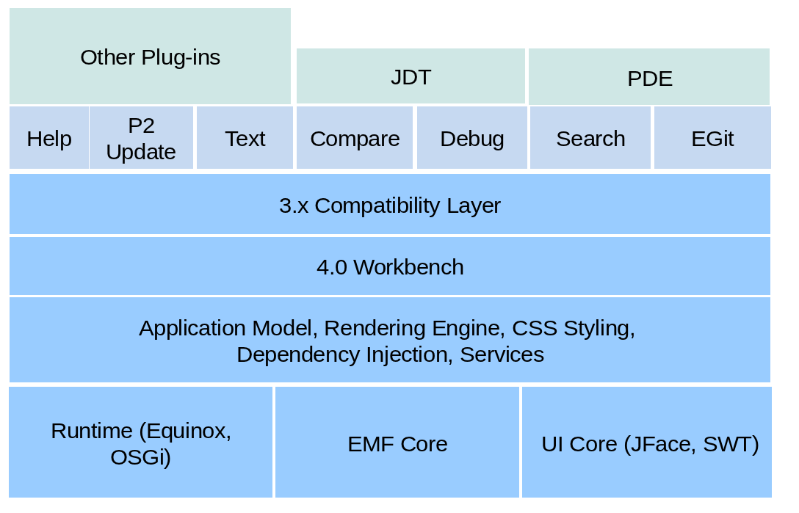

OSGi is a specification which describes a modular approach for Java application. Equinox is one implementation of OSGi and is used by the Eclipse platform. The Equinox runtime provides the necessary framework to run a modular Eclipse application.

SWT is the standard user interface component library used by Eclipse. JFace provides some convenient APIs on top of SWT. The workbench provides the framework for the application. The workbench is responsible for displaying all other UI components.

On top of these base components, the Eclipse IDE adds components which are important for an IDE application, for example the Java Development Tools (JDT) or version control support (EGit).

Eclipse 4 has a different programming model then Eclipse 3.x. Eclipse 4 provides the *3.x Compatibility Layer* component which maps the 3.x API to the 4.0 API. This allows Eclipse 3.x based components to run unmodified on Eclipse 4.

Eclipse based applications which are not primarily used as software development tools are called Eclipse RCP applications. An Eclipse 4 RCP application typically uses the base components of the Eclipse platform and adds additional application specific components.

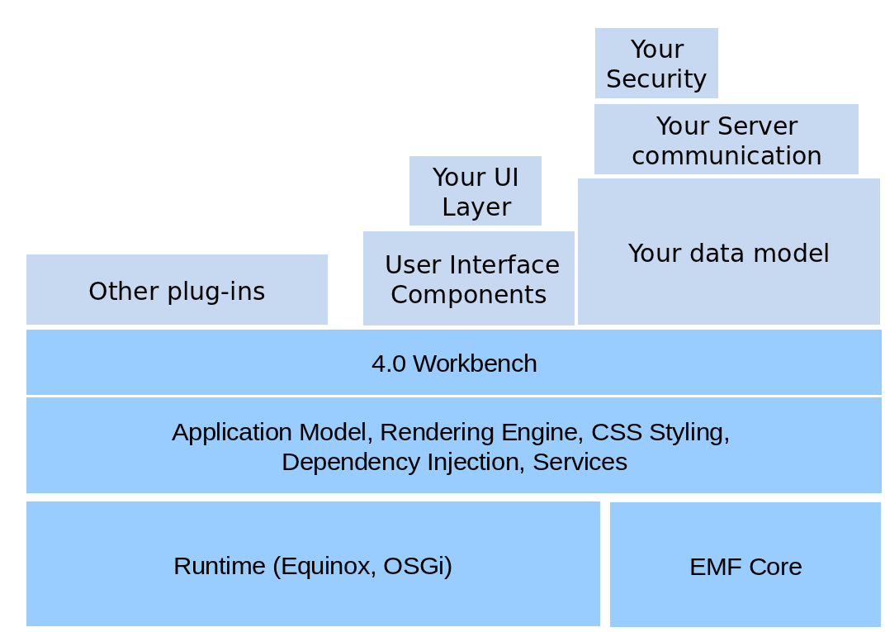

The programming model of OSGi (Equinox) allows you to define dynamic software components, i.e. OSGi services, which can also be part of an Eclipse based application.

**2.2. Terminology**

An Eclipse application consists of several Eclipse components. A software component in Eclipse is called a *plug-in*. A software component in OSGi is called a *bundle*. Both terms can be used interchangeably.

This tutorial uses the terms *Eclipse based applications* , *Eclipse application*, *Eclipse 4 application* and *Eclipse RCP application* interchangeably for referring to an application which is based on the Eclipse 4 framework.

If a certain concept refers to Eclipse 3.x, then it is explicitly stated.

**2.3. Important configuration files**

An Eclipse plug-in has the following main configuration files.

* MANIFEST.MF - Contains the OSGi configuration information.
* plugin.xml - Contains information about Eclipse specific extension mechanisms

An Eclipse plug-in defines its API via the *MANIFEST.MF* file, e.g. the Java packages which can be used by other plug-ins and its dependencies, e.g. the packages or plug-ins which are required by the plug-in.

The *plugin.xml* file provides the possibility to define *extension points* and *extensions*. *Extension-points* define interfaces for other plug-ins to contribute functionality. *Extensions* contribute functionality to these interfaces. Functionality can be code and non-code based.

In Eclipse 4 the usage of extension points and extensions is very limited. They are mostly used to define pointers to other Eclipse 4 configuration files.

**3. Tutorial: Install Eclipse 4.2 for RCP development**

**3.1. Prerequisites**

The following assumes that you have Java installed in at least version 1.6.

**3.2. Download and Install Eclipse 4.2**

This tutorial is based on the Eclipse 4.2 release. Download the *Eclipse for RCP and RAP Developers* package from the following URL.

http://www.eclipse.org/downloads/

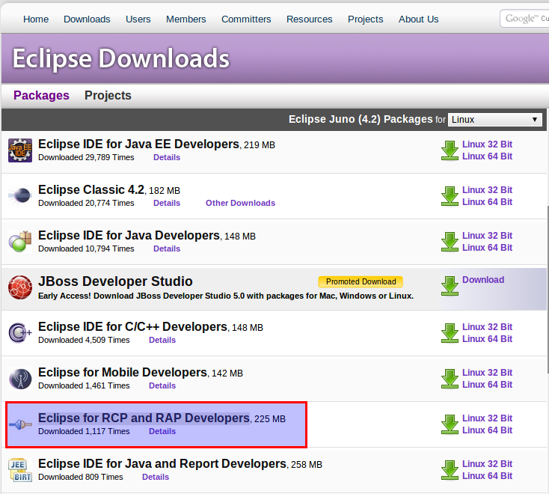

The download is a zip file, which is a compressed archive of multiple files. Most operating systems can extract zip files in their file browser. For example if you are using Windows7 as the operating system, right mouse click on the file in the explorer and select the *Extract all...* menu entry. If in doubt about how to unzip, search via Google for *How to unzip a file on ...* , replacing "..." with your operating system.

Do not extract Eclipse to a directory with a path which contains spaces as this might lead to problems in the usage of Eclipse.

After you extracted the zip file, double-click the *eclipse.exe* (Windows) or the *eclipse* file (Linux) (or the launcher icon specific to your platform) to start Eclipse.

To avoid any collision with existing work select an empty directory as the workspace for this tutorial.

**3.3. Install the Eclipse 4 tooling**

The Eclipse SDK download does not include the Eclipse e4 tooling, which makes creating Eclipse 4 applications easier. These tools provide wizards to create Eclipse 4 artifacts and the specialized model editor for the application model.

The update site of the *Eclipse e4 tooling* for the Eclipse 4.2 release is the following.

http://download.eclipse.org/e4/updates/0.12

From this update site, install only the *E4 CSS Spy* and the *Eclipse e4 Tools*.

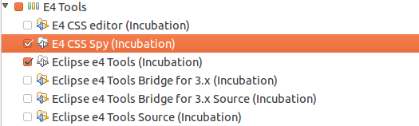

**4. Tutorial: Eclipse 4 application using the wizard**

**4.1. Overview**

The Eclipse 4 tooling project provides a project generation wizard which allows you to create a working Eclipse 4 based RCP application.

**4.2. Create project**

Select *File* → *New* → *Others* → *Eclipse 4* → *Eclipse 4 Application Project* .

Create a project called com.example.e4.rcp.wizard using the default settings. This should be similar to the following screenshots.

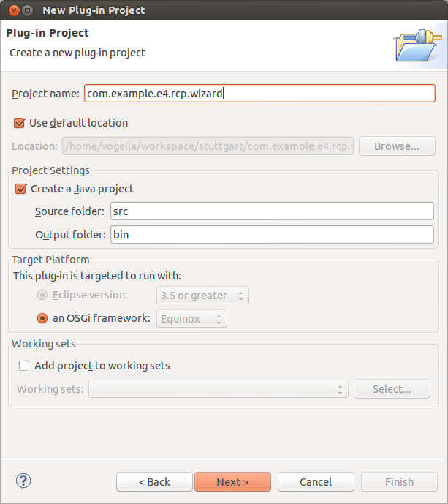

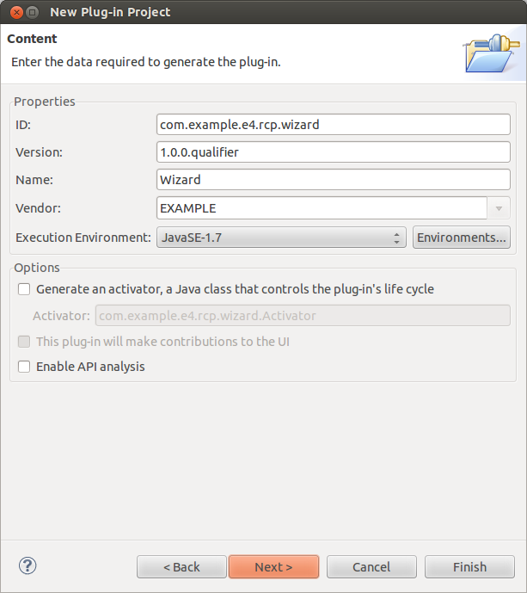

Select the development mode and the creation of sample context checkbox on the last page.

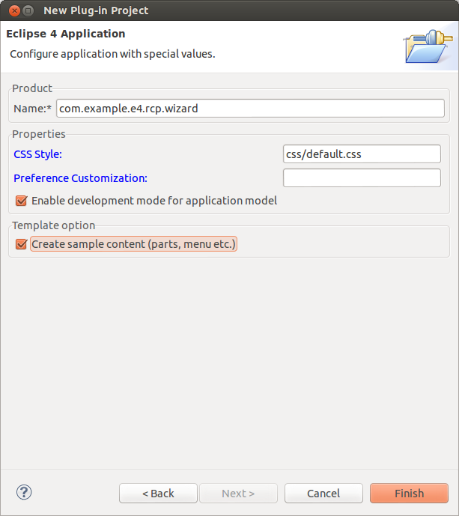

This wizard creates all the necessary files to start your application. The central file for starting your application is the *.product* file, created in your project folder.

**4.3. Launch**

Open your *com.example.e4.rcp.wizard.product* product configuration file by double-clicking on the file in package explorer.

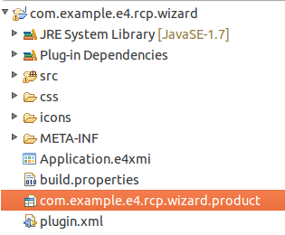

Switch to the *Overview* tab and launch your product by pressing the *Launch an Eclipse application* hyperlink. This should start the generated Eclipse application.

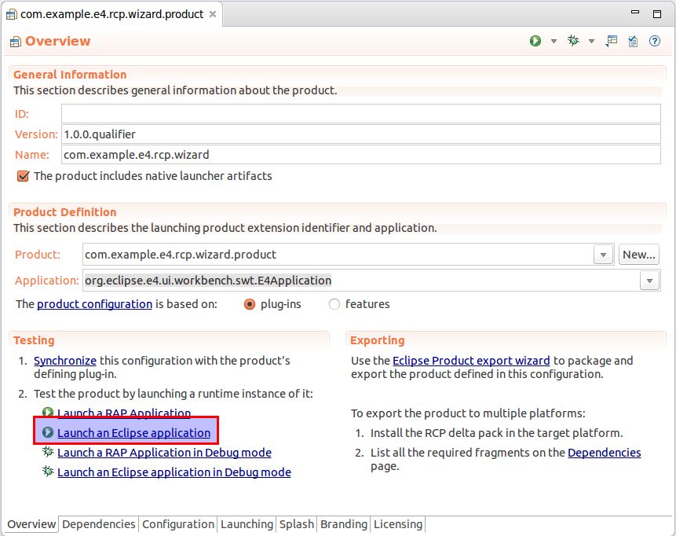

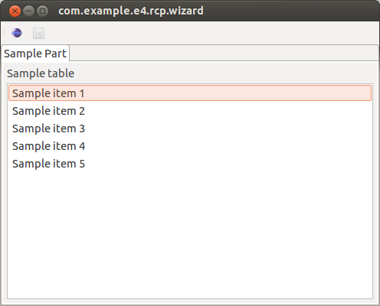

**5. Eclipse 4 application model**

**5.1. What is the application model?**

The visual part of an Eclipse application consists of *Perspectives*, *Parts* (Views and Editors), Menus, Toolbars, etc. An Eclipse application also includes non-visual components, e.g. *Handlers*, *Commands* and *Key bindings* .

Eclipse 4 uses an abstract description, called the *application model*, to describe the structure of an application. This application model contains the visual elements as well as some non-visual elements of the Eclipse 4 application.

Each model element has attributes which describe its current state, e.g. the size and the position for a *Window*. Model elements might be in a hierarchical order, for example *Parts* might be grouped below a *Perspective*.

The application model defines the structure of the application; it does not describe the content of the individual user interface components.

For example the application model describes which *Parts* are available. It also describes the *Parts* properties, e.g. if a *Part* is closable, its label, ID, etc.

But it does not describe the content of the *Part*, e.g. the labels, text fields and button it consists of. The content of the *Part* is still defined by your source code.

If the application model was a house, it would describe the available rooms (*Parts*) and their arrangement (*Perspectives*, *PastStacks*, *PartSashContainer*) but not the furniture of the rooms. This is illustrated by the following image.

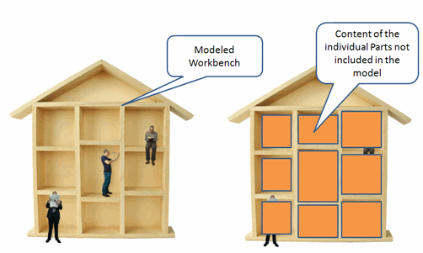

**5.2. Where is the application model defined?**

The application model is extensible. The basis of this model is typically defined as a static file. The default name for this file is Application.e4xmi and the default location is the main directory of your application plug-in.

You can change the default name and location via the org.eclipse.core.runtime.products extension point. Via the applicationXMI parameter you specify the local and name of the model file. See the appendix for a detailed description of this procedure.

The XMI file is read at application startup and the initial application model is constructed from this file.

**5.3. How is the model connected to my Java classes?**

Application model elements can contain references to Java classes via an Uniform Resource Identifier (URI).

The URI describes the location of the Java class. The first part of this URI is the plug-in, the second one the package and the last one the class.

For example a model description for a *Part* contains attributes such as labels, tooltips and icon URIs. It also contains a class URI which points to a Java class for this element. This class provides the behavior of the *Part* — using the house/rooms metaphor from earlier, the class is responsible for defining the furnishings and the layout of the room, and how the interactive objects behave.

If the model elements get activated this class will get instantiated.

The objects created based on the application model are called *model objects*.

**5.4. URI in the model**

URIs follow one of two patterns, one for identifying *resources* and another one for identifying *classes*. The following table describes these two patterns. The example assumes that the bundle is called *test*.

**Table 1. URI pattern**

| **Pattern** | **Description** |
| --- | --- |
| bundleclass://Bundle-SymbolicName/ package.classname  Example:  bundleclass://test/test.parts.MySavePart | Used to identify Java classes. It consists of the following parts: "bundleclass://" is a fixed schema, Bundle-SymbolicName as defined in the *MANIFEST.MF* file, and the fully qualified classname. |
| platform:/plugin/Bundle-SymbolicName/ path/filename.extension  Example:  platform:/plugin/test/icons/save\_edit.gif | Identifier for a resource in the plug-in. "platform:/plugin/" is a fixed schema, followed by the Bundle-SymbolicName of the *MANIFEST.MF* file, followed by the path to the file and the filename. |

**5.5. Application model editor**

The Eclipse tooling project provides an editor which makes it easier to work on an application model.

To open the model editor double-click on your *Application.e4xmi* file (or right click on it and select *Open With* → *Eclipse 4 model editor* .

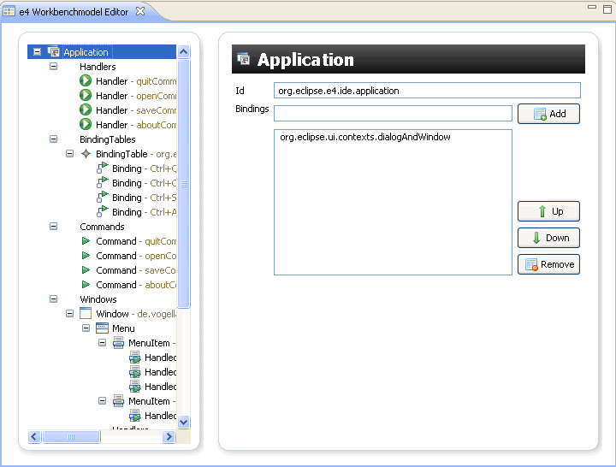

The model editor has several preference settings which can be reached via *Window* → *Preferences* → *Model Editor*. The following screenshot shows the preference page.

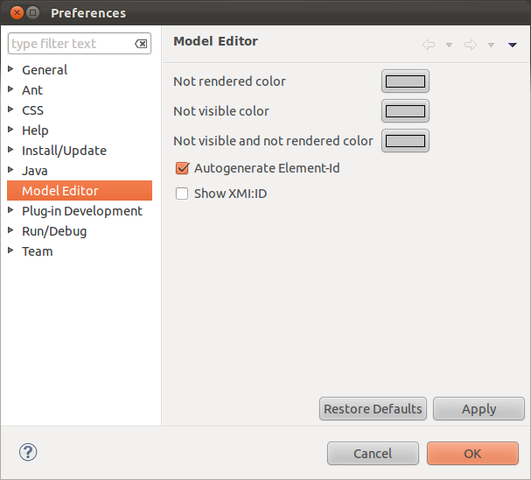

**5.6. Supplementary**

The *Supplementary* tab in the model editor allows to enter additional information about a model element.

All model elements allow to enter *Tags*. These *Tags* can be used by the Eclipse platform to select the related model elements via the *ModelService*. By default Eclipse uses some predefined *Tags* to determine the state of certain model elements. For example the *shellMaximized* and *shellMinimized* tag on a *Window* is used by Eclipse to determine if the *Window* should be maximized or minimized.

The following screenshot shows how to define the maximization of a *Window*.

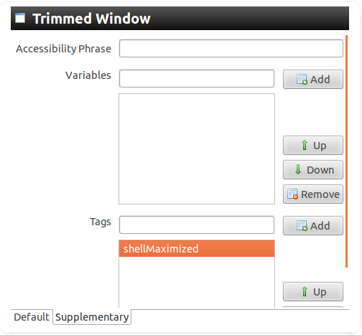

Model elements allow also to have persisted state. If you retrieve the model element you can get and set this persisted state.

*// modelObject is the model object*

*// retrieved via dependency injection*

*// Get the state by the "yourKey" key*

String state = addon.getPersistedState().get(yourKey);

*// Store the state*

modelObject.getPersistedState().put(yourKey, state)

**5.7. Model access at runtime**

The application model is also available at runtime. The application can access the model and change it via a defined API.

Add the org.eclipse.e4.tools.emf.liveeditor plug-in and its dependencies to your launch configuration to make the model editor available in your application.

Afterwards you can open the model editor for your running application via the **Alt**+**Shift**+**F9** shortcut. This also works for the Eclipse 4 IDE itself.

Opening the live editor in your Eclipse 4 application requires that your application has keybindings configured.

You can change your application model directly at runtime by using the model editor. Most changes are directly applied, e.g. if you change the orientation of a PartSashContainer your user interface will update itself automatically. If you modifying the Eclipse IDE model you should be careful as this might put the running Eclipse IDE into a bad state.

In the live model editor, you can select the *Part* element, right click on it and select *Show Control* to get the *Part* highlighted.

**5.8. Meta-model of the application model**

The possible structure of the application model is defined by an meta-model created with the Eclipse Modeling Framework (EMF). A meta-model describes the structure of a data model, e.g. it defines which properties a Part has.

EMF is a popular general purpose modeling framework and is the basis for lots of Eclipse based projects. EMF allows to generate Java classes from a meta-model.

Eclipse EMF uses an *.ecore* file to define the meta-model.

The meta-model of the Eclipse 4 applications is stored in the org.eclipse.e4.ui.model.workbench plug-in in *model* folder. The base model definition can be found in the *UIElements.ecore* file. The Eclipse 4 model classes have been generated based on this model.

If you want to investigate this model, you could install the EMF tooling via the Eclipse update manager and import the defining plug-in into your workspace. To import a plug-in from your current Target Platform (default is the Eclipse IDE) into your workspace, use the *Plug-ins* *View*, right click on a plug-in and select *Import As* → *Source Project*.

The *Application.e4xmi* file, which describes the Eclipse application model, is a persisted version of an EMF model.

**5.9. Creation of the runtime application model**

During startup the Eclipse runtime creates the application model based on the *Application.e4xmi* and instantiates the referred classes in the model if required.

The life cycle of every model object is therefore controlled by the Eclipse runtime. The Eclipse runtime instantiates and destroys the model objects.

**6. Supplementary model attributes**

**6.1. Tags**

The *Supplementary* tab in the model editor allows to enter additional information about a model element.

All model elements allow to enter *Tags*. These *Tags* can be used by the Eclipse platform to select the related model elements via the *ModelService*. By default Eclipse uses some predefined *Tags* to determine the state of certain model elements. For example the *shellMaximized* and *shellMinimized* tag on a *Window* is used by Eclipse to determine if the *Window* should be maximized or minimized.

The following screenshot shows how to define the maximization of a *Window*.



Another tag which is used frequently is the *NoAutoCollapse* tag which you can add to a *PartStack* container. With this flag the *PartStack* will not collapse even if you remove all parts from it.

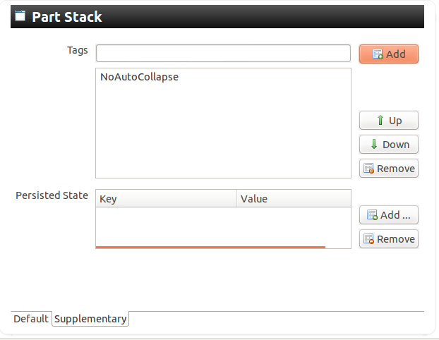

Check the appendix of this {tutorial} for more tags.

**6.2. Persisted State**

Model elements allow also to have persisted state. If you retrieve the model element you can get and set this persisted state.

*// modelObject is the model object*

*// retrieved via dependency injection*

*// Get the state by the "yourKey" key*

String state = addon.getPersistedState().get(yourKey);

*// Store the state*

modelObject.getPersistedState().put(yourKey, state)

**7. Overview of available model elements**

Model elements have Java classes associated with them. As the model is interactive you can use these model elements to change its attributes or children.

The following is a table of important model elements based on their Java classes. These model elements can also get injected.

**Table 2. Eclipse 4 model element**

| **Model element** | **Description** |
| --- | --- |
| MApplication | Describes the application object. Can be used for example to add new windows to your application |
| MWindow | Represents a Window in your application. |
| MTrimmedWindow | Represents a Window in your application. The underlying SWT shell has been created with the SWT.SHELL\_TRIM attribute which means, it has a tile, a minimize, maximize and resize button. |
| MPerspective | Object for the perspective model element. |
| MPart | Represents the model element part, e.g. a View or a Editor. |
| MDirtyable | Property of MPart which can be injected. If set to true, this property informs the Eclipse platform that this Part contains unsaved data (is dirty). In a Handler you can query this property to trigger a save. |
| MPartDescriptor | MPartDescriptor is a template for new Parts. You define in your application model a PartDescriptor. A new Part based on this PartDescriptor can be created via the EPartService and shown its showPart() method. |
| Snippets | Snippets can be used to pre-configure model parts which you want to create via your program. You can use EcoreUtil.copy to copy a Snippet and assign it to another model element, e.g. on a MSash you can add a newly copied MStack called *copy*, via getChildren().add(copy). Also the model service has some methods to create and clone a snippet. |

**8. Identifiers for model elements**

**8.1. Identifiers for model elements**

Every model element allows you to define an ID. This ID is used by the Eclipse framework to identify this model element. Make sure you always maintain an ID for every model elements and ensure that these IDs are unique.

Therefore make sure that all your model elements have an ID assigned to them.

**8.2. Best practices for naming conventions**

The following suggest best practice for naming conventions, which are also used in this tutorial.

**Table 3. Naming conventions**

| **Object** | **Description** |
| --- | --- |
| Project Names | The plug-in project name is the same as the top-level package name. |
| Packages | For plug-in containing lots of user interface components use sub-packages based on the primary purpose of the components. For example the com.example package may have the com.example.parts and com.example.handler sub-package. |
| Class names for model elements | Use the primary purpose of the model element as a suffix in the class name. For example a class which represents a Part which displays Todo objects, might be called TodoOverviewPart. |
| IDs | Define clear rules for naming IDs in plugin.xml.  IDs should always start with the top-level package. If appropriate use the sub-package of the implementing class also. The remainder of the ID should be descriptive for the purpose of the component. For example: "com.example.parts.todolist".  ID should be only lower cases (some Eclipse projects also use camelCase for the last part of the ID). |

**9. Tutorial: Create an Eclipse plug-in**

**9.1. Create a plug-in project**

In Eclipse select *File* → *New Project* → *Plug-in Development* → *Plug-in Project*.

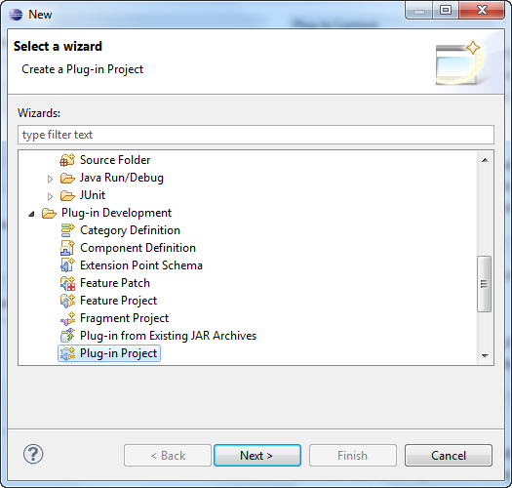

Give your plug-in the name *com.example.e4.rcp.todo*.

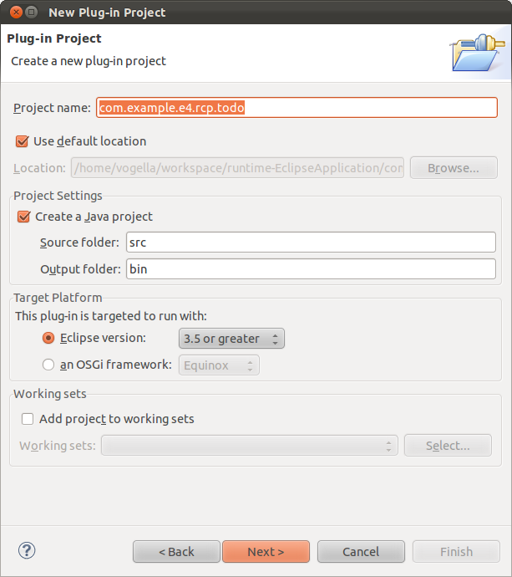

Press *Next* and make the following settings. Select *No* at the question *Would you like to create a rich client application* and uncheck *This plug-in will make contributions to the UI* . Uncheck the *Generate an activator, a Java class that controls the plug-ins life-cycle* option.

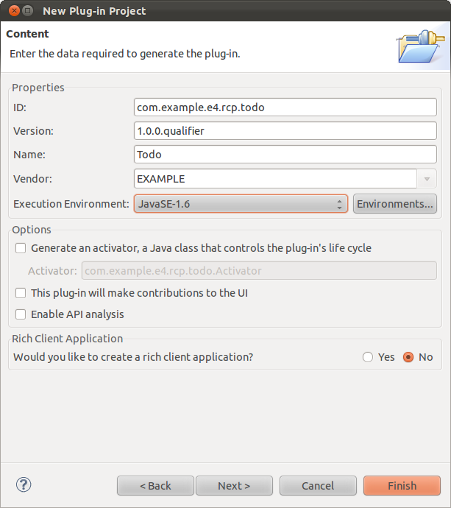

Press the *Finish* button; we will not use a template.

**9.2. Validate the result**

Open the project and check if any Java classes were created. You should have no classes in the source folder.

Open the *MANIFEST.MF* file and switch to the *Extensions* tab. Validate that the list of Extensions is currently empty.

**10. Feature project**

An Eclipse feature project contains *features*. A feature has a name, version number, a software license and contains a list of plug-ins and other features which can be understood as a logical unit.

A feature is described via a *feature.xml* file in the Eclipse feature project.

Features are used by the Eclipse update manager, the build process and optionally for the definition of Eclipse products. Features can also be used as the basis for a launch configuration.

Eclipse provides several predefined features, e.g. org.eclipse.rcp for Eclipse 3.x based RCP applications or org.eclipse.e4.rcp for Eclipse 4 based RCP applications.

You can create a new feature project via the following menu path: *File* → *New* → *Other* → *Plug-in Development* → *Feature Project*.

If you open the *feature.xml* file you can change the feature properties via a special editor.

The *Plug-ins* tab allows you to change the included plug-ins in the feature.

The *feature.xml* file is a simple text file. For example the file might look like the following in a text editor.

<?xml version="1.0" encoding="UTF-8"?>

<feature

id="de.vogella.featuretest.feature"

label="Feature"

version="1.0.0.qualifier">

<description url="http://www.example.com/description">

[Enter Feature Description here.]

</description>

<copyright url="http://www.example.com/copyright">

[Enter Copyright Description here.]

</copyright>

<license url="http://www.example.com/license">

[Enter License Description here.]

</license>

<plugin

id="de.vogella.featuretest.testplugin"

download-size="0"

install-size="0"

version="0.0.0"

unpack="false"/>

</feature>

**11. Tutorial: From Plug-in to Eclipse 4 application**

In this chapter we convert the Eclipse plug-in into an Eclipse 4 application.

**11.1. Create product configuration**

Create a new project called *com.example.e4.rcp.todo.product* of type *General* → *Project*.

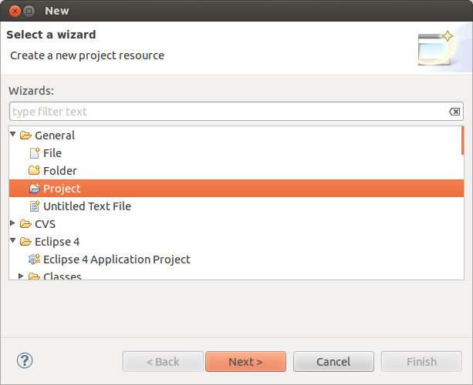

Right click on this project and select *New* → *Product Configuration*. Create a *todo.product* product configuration file.

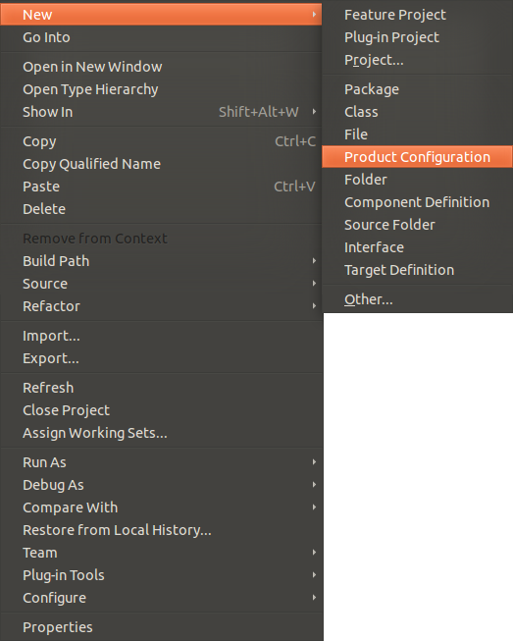

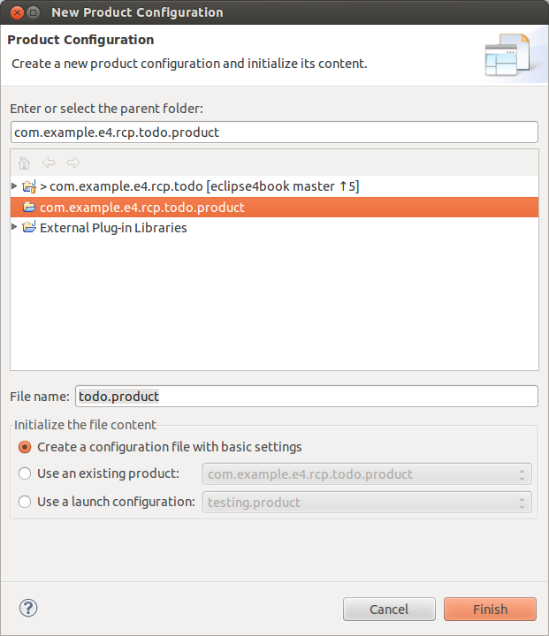

Press the *New* button on the *Overview* tab of the product editor.

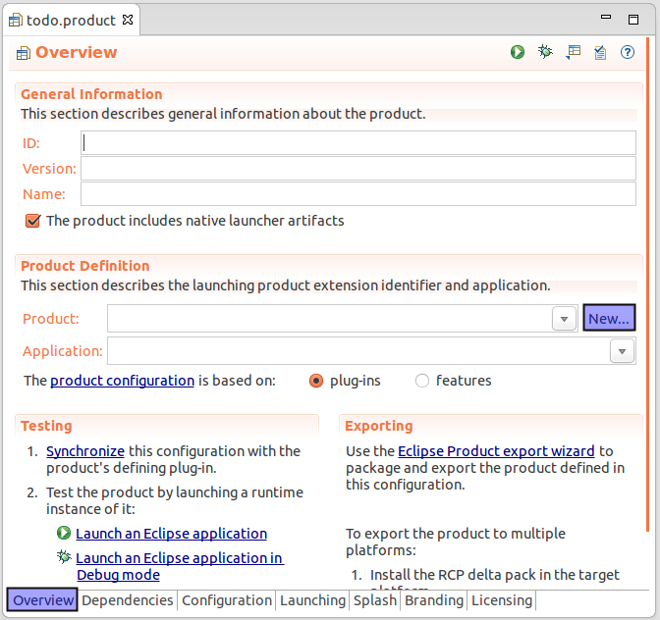

Enter *to-do* as the name, the defining plug-in is your plug-in and use the name *product* as the ID. Select as *Application* the E4Application application class.

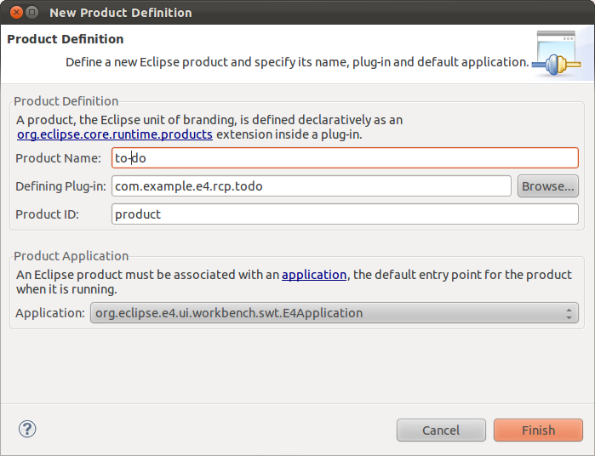

**11.2. Create a feature project**

Create a new feature project called *com.example.e4.rcp.todo.feature*.

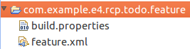

Include the com.example.e4.rcp.todo plug-in into this feature.

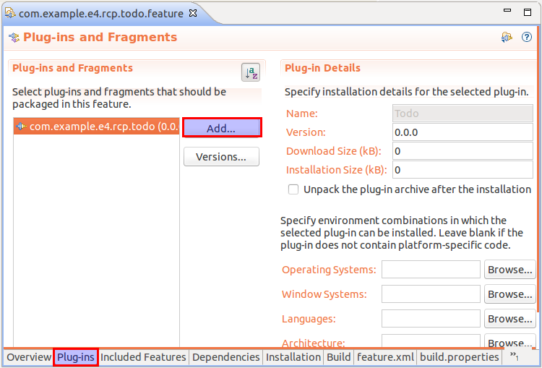

**11.3. Enter feature dependencies in product**

Change your product configuration file to use features. To do this open your product configuration file and select the *Feature* option on the *Overview* tab of the product editor.

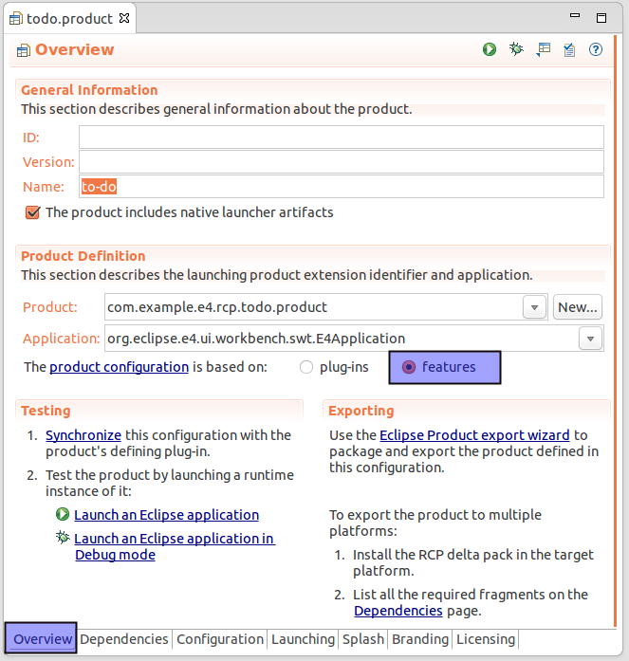

Select the *Dependencies* tab and add the org.eclipse.e4.rcp and the com.example.e4.rcp.todo.feature features as dependencies via the *Add* button.

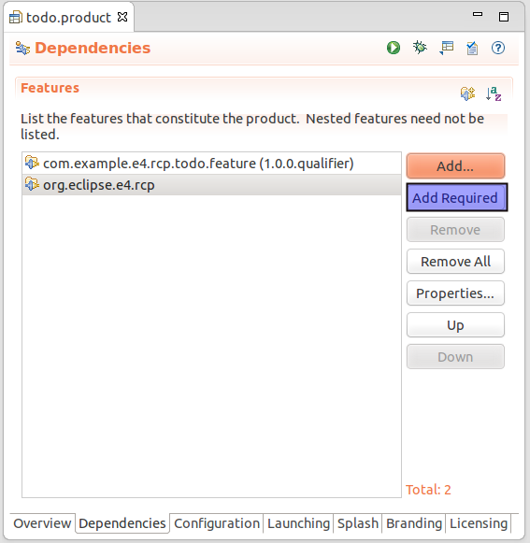

Press the *Add Required* button. This will add the org.eclipse.emf.common and org.eclipse.emf.ecore features to the dependencies.

**11.4. Create Application model**

Select *File* → *New* → *Other* → *Eclipse 4* → *Model* → *New Application Model* to open a wizard. Use the project as the container and the filename suggested by the wizard.

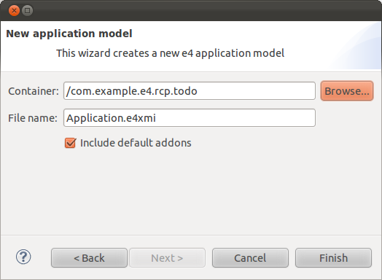

This will create the *Application.e4xmi* file and open this file with the application model editor.

**11.5. Add model elements to the application model**

Add one Window to your application model so you have a visual component.

Select the *Windows* node and press the *Add* Button for a TrimmedWindow.

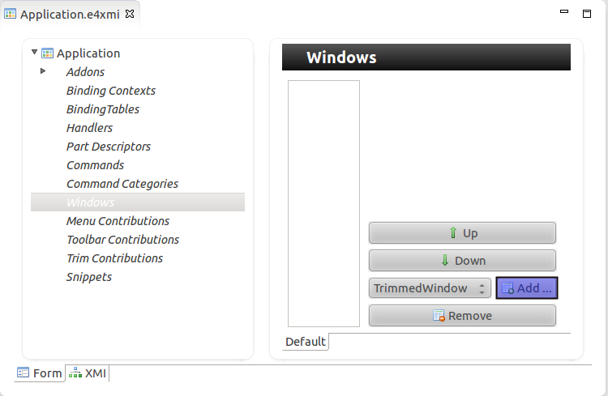

Enter an ID, the position and size of the window and a label as shown in the screenshot below.

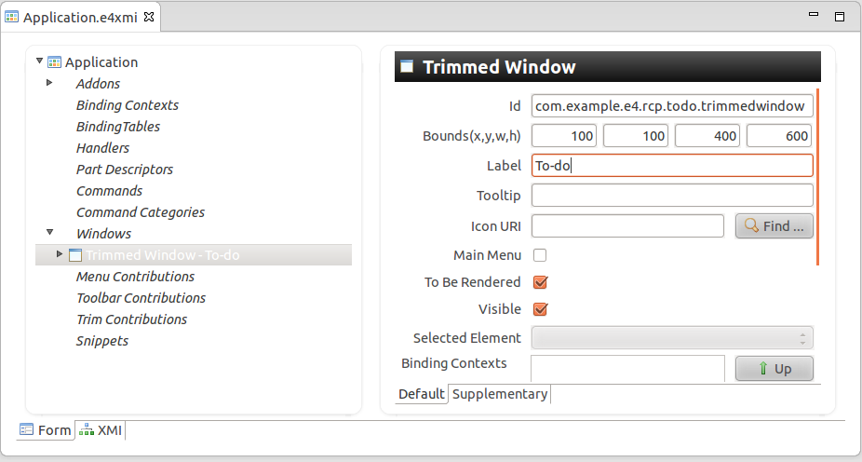

**11.6. Start application**

Open the product file and select the *Overview* tab. Press the *Launch an Eclipse application* hyperlink in the *Testing Section*.

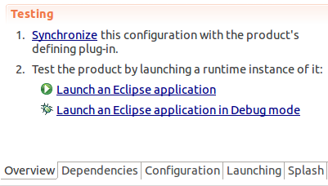

Validate that your application starts. It should be an empty application, which can be moved and closed.

**11.7. Add plug-in dependencies**

In the upcoming exercises you will use the functionality from other Eclipse plug-ins. This requires that you define a dependency to these plug-ins in your application. The exact details of applying this modular approach will be covered in a later chapter.

Open your *META-INF/MANIFEST.MF* file and select the *Dependencies* tab. Use the *Add* button in the *Required Plug-ins* section to add the following plug-ins as dependency.

* org.eclipse.core.runtime
* org.eclipse.swt
* javax.inject
* org.eclipse.e4.core.di
* org.eclipse.e4.ui.workbench
* org.eclipse.e4.ui.di
* org.eclipse.e4.ui.services
* org.eclipse.e4.core.di.extensions

Also add the javax.annotation package as package dependency.

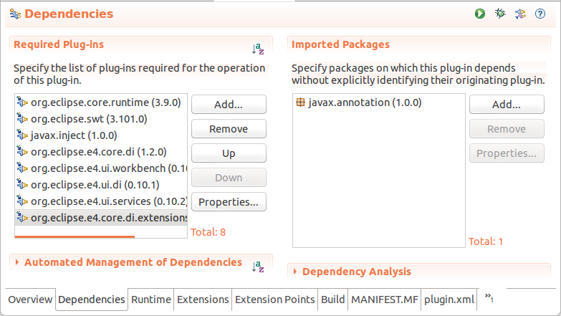

**12. Important user interface model elements**

The following model elements represents the basic elements which you use to create the user interface of your application.

**12.1. Windows**

Eclipse applications consist of one or more *Windows*. Typically an application has only one *Window* but you are not limited to that, e.g. if you want to support multiple displays for two connected monitors.

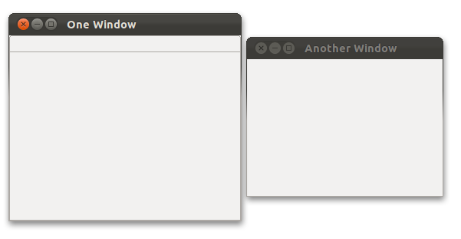

**12.2. Parts**

*Parts* are user interface components which allow you to navigate and modify data. *Parts* are typically divided into *Views* and *Editors*.

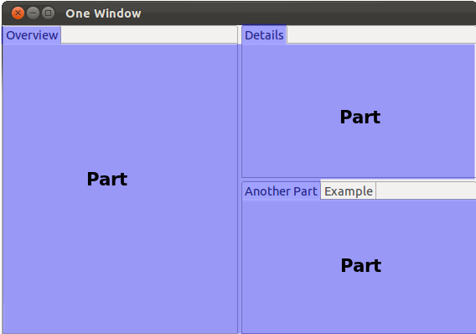

The distinction into *Views* and *Editors* is primarily not based on technical differences, but on a different concept of using and arranging these *Parts*.

A *View* is typically used to work on a set of data, which might be a hierarchical structure. If data is changed via the *View*, this change is typically directly applied to the underlying data structure. A *View* sometimes allows us to open an *Editor* for a selected set of data.

An example for a *View* is the *Java Package Explorer*, which allows you to browse the files of Eclipse projects. If you change data in the Package Explorer, e.g. bz renaming a file, the file name is directly changed on the file system.

*Editors* are typically used to modify a single data element, e.g. a file or a data object. To apply the changes made in an editor to the data structure, the user has to explicitly save the editor content.

*Editors* were traditionally placed in a certain area, called the *editor area*. Until Eclipse 4 this was a hard limitation. Eclipse 4 applies no technical restrictions on *Editors*, they can be freely positioned.

For example the *Java* *Editor* is used to modify Java source files. Changes to the source file are applied once the user selects the *Save* command.

**12.3. Perspective**

A *Perspective* is a visual container for a set of *Parts*. You can switch *Perspectives* in your Eclipse RCP application via the the *EPartService* service.

**12.4. PartStacks and PartSashContainers**

*Parts* can be directly assigned to a *Window* or a *Perspective*. If you want to group and arrange *Parts* you can use *PartStacks* and *PartSashContainers*.

*PartStacks* contain a stack of *Parts* of which only one is visible at the same time and can be selected via tabs. A *PartSashContainer* displays all its children at the same time either horizontally or vertically.

The following shows a simple Eclipse application layout using two *PartSashContainers* and a few *PartStacks*.

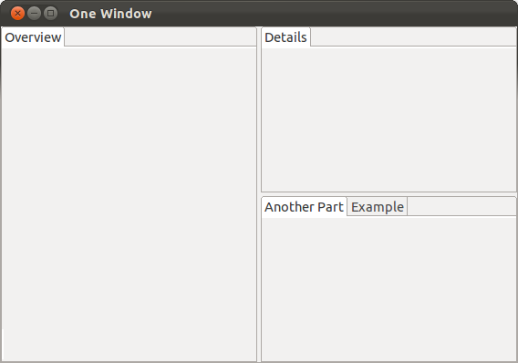

On the top of this layout there is a horizontal *PartSashContainer* which contains another *PartSashContainer* and some *PartStacks*. The hierarchy is depicted in the following graphic.

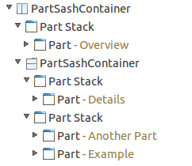

**13. Configure the deletion of persisted model data**

Eclipse 4 persists certain user changes in your application. During development this might lead to situations where changes are not correctly applied and displayed, e.g. you define a new menu entry and this entry is not displayed in your application.

Either set the *Clear* flag on the *Main* tab in your Run configuration or add the *clearPersistedState* parameter for your product configuration file or Run configuration.

The following screenshot shows this setting in the product configuration file.

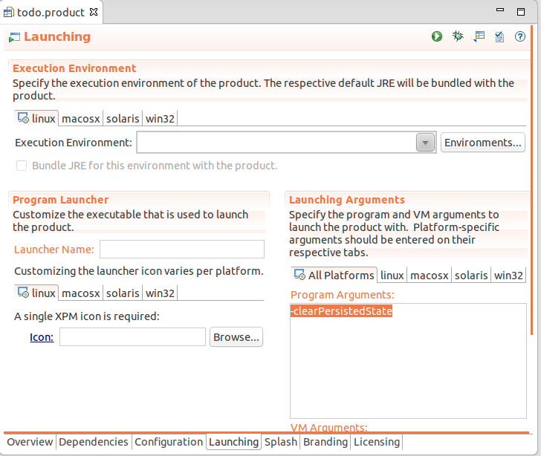

It is recommended that you set this during your development phase to avoid unexpected behavior. Please note that parameters must be specified via the *-* sign, e.g. *-clearPersistedState*.

**14. Tutorial: Modeling a User Interface**

**14.1. Create modeled user interface**

You will extend the modeled user interface of your Eclipse 4 application.

You will add a *Perspective* to the Window. This *Perspective* will contain a *PartSashContainer*. This container will divide its children horizontally.

The *PartSashContainer* will contain a *PartStack* and another *PartSashContainer*. This second *PartSashContainer* will contain two *PartStacks* and divide them vertically.

Each *PartStacks* will contain one *Part*.

After these changes, your user interface should look like the following screenshot.

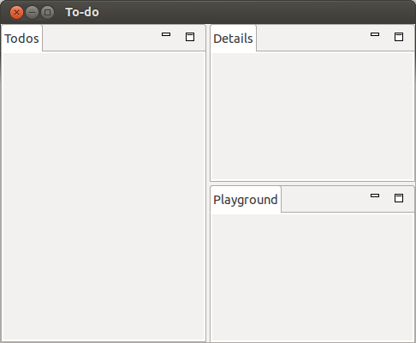

**14.2. Adding model elements**

Open the *Application.e4xmi* file. Go to your *To-do* Window and select the *Controls* node. Add a *PerspectiveStack*. Press the *Add* button to create a *Perspective* entry.

Enter the value *To-Do* in the *Label* field and the value *com.example.e4.rcp.todo.perspective* in the *Id* field.

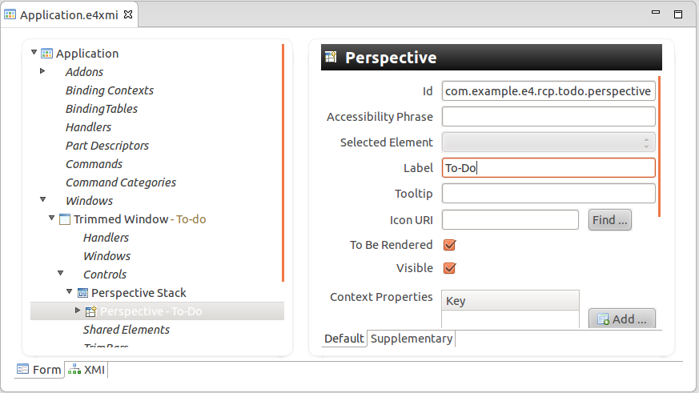

Select *Controls* below the newly created *Perspective* and add a *PartSashContainer*. Change its *Orientation* attribute to *Horizontal*.

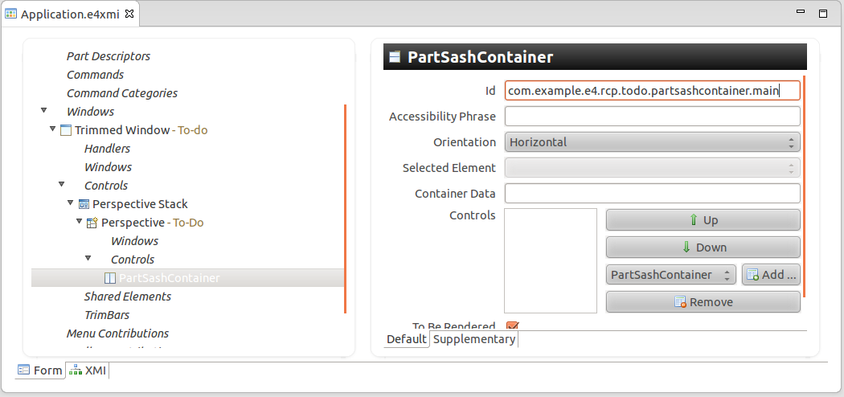

In the drop-down list of the *PartSashContainer* select *PartStack* and press the *Add* button.

Re-select the parent *PartSashContainer* and add another *PartSashContainer*. Now add two *PartStacks* to the second *PartSashContainer*. This should result in a tree in your application model similar to the following screenshot.

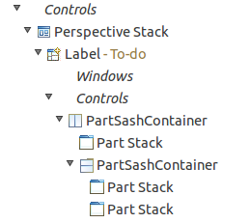

Add a *Part* to each *PartStack*. As ID for the *Parts* use the prefix com.example.e4.rcp.todo.part and the suffix from the following table.

**Table 4. Label and ID from the Parts**

| **ID Suffix** | **Label** |
| --- | --- |
| \*.todooverview | To-Dos |
| \*.tododetails | Details |
| \*.playground | Playground |

The following screenshot shows the data for one *Part*.

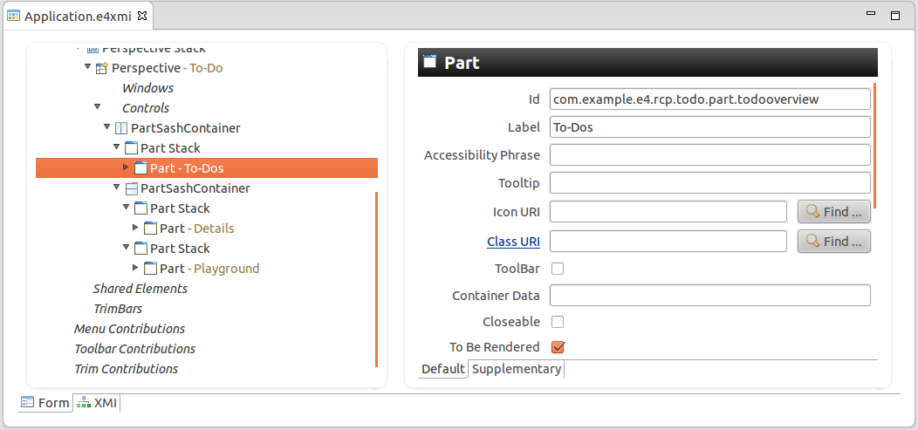

Start your product and validate that the user interface looks as planned. Reassign your *Parts* to other *PartStacks*, if required. The model editor supports drag-and drop for reassignment.

Please note that you have not yet created a Java class for your application.

**14.3. Create Java classes and connect to the model**

You will now create Java objects and connect them to the application model.

Create the com.example.e4.rcp.todo.parts package.

Create three Java classes called *TodoOverviewPart*, *TodoDetailsPart* and *PlaygroundPart* in this package. These classes do not extend another class, nor do they implement any interface.

The following code shows the TodoDetailsPart class.

**package** com.example.e4.rcp.todo.parts;

**public** **class** TodoDetailsPart {

}

Open the *Application.e4xmi* file and connect the class with the correct model object. You can do this via the *Class URI* property of the *Part* model element.

The following table gives an overview of which elements should be connected.

**Table 5. Connecting Java classes with Model Element**

| **Class** | **Part ID suffix** |
| --- | --- |
| TodoOverviewPart | \*.todooverview |
| TodoDetailsPart | \*.tododetail |
| PlaygroundPart | \*.playground |

The Eclipse 4 model editor allows you to search for an existing class via the *Find...* button. The initial list is empty, start typing the class name to see the results.

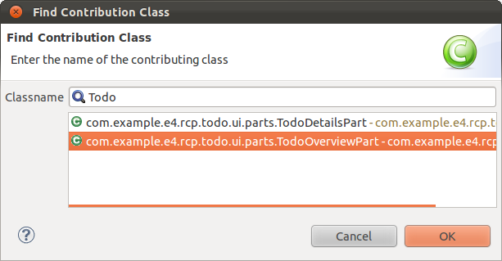

**14.4. Test**

Run your application. It should start, but you should see no difference in your user interface.

To validate that the model objects are created by the Eclipse runtime, create a no-argument constructor, e.g. with no parameters, for one of the classes and add a System.out.println() statement. Afterwards verify that the constructor is called, once you start your application.

**14.5. Layout**

Use the model *Container Data* attribute to assign a layout weight of 40 to the left container and 60 to the right container.

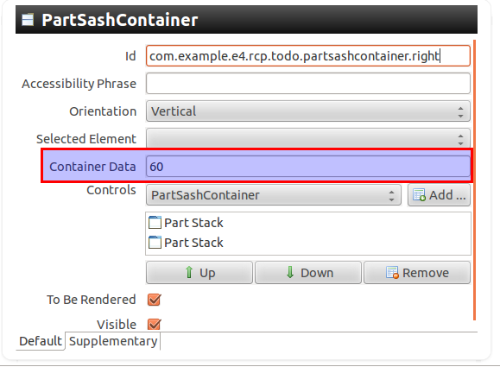

As a result the left container should use 40 % of the avaialable space.

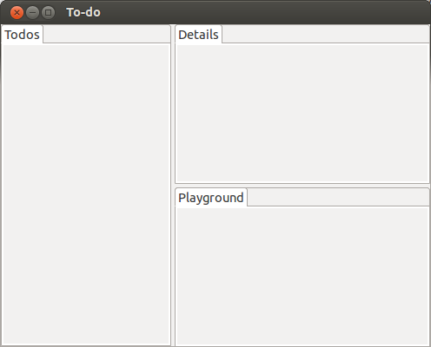

**15. Dependency Injection and Annotations**

**15.1.  What is Dependency Injection?**

The general concept behind dependency injection is called *Inversion of Control* . A class should not configure its dependencies but should be configured from outside.

Dependency injection is a concept which is not limited to Java. But we will look at dependency injection from a Java point of view.

A Java class has a dependency on another class if it uses an instance of this class, e.g. via calling the constructor or via a static method call. For example a class which accesses a logger service has a dependency on this service class.

Ideally Java classes should be as independent as possible from other Java classes. This increases the possibility of reusing these classes and to be able to test them independently from other classes, for example for unit testing.

If the Java class directly creates an instance of another class via the new operator, it cannot be used and tested independently from this class.

To decouple Java classes its dependencies should be fulfilled from the outside. A Java class would simply define its requirements like in the following example:

**public** **class** MyPart {

*@Inject* **private** Logger logger;

*// DatabaseAccessClass would talk to the DB*

*@Inject* **private** DatabaseAccessClass dao;

*@Inject*

**public** **void** init(Composite parent) {

logger.info("UI will start to build");

Label label = **new** Label(parent, SWT.NONE);

label.setText("Eclipse 4");

Text text = **new** Text(parent, SWT.NONE);

text.setText(dao.getNumber());

}

}

Another class could read these dependencies and create an instance of the class, injecting objects into the defined dependency. This can be done via the Java reflection functionality. This class is usually called the dependency container and is a framework class.

This way the Java class has no hard dependencies, i.e. it does not rely on an instance of a certain class. For example if you want to test a class which uses another object which directly uses a database, you could inject a *mock* object.

Mock objects are objects which act as if they are the real object but only simulate their behavior. Mock is an old English word meaning to mimic or imitate.

If dependency injection is used, a Java class can be tested in isolation, which is good.

Dependency injection can happen on:

* the constructor of the class (construction injection)
* a method (method injection)
* a field (field injection)

Dependency injection can happen on static as well as on non-static fields and methods.

**15.2. Define dependencies in Eclipse**

Eclipse 4 supports constructor, method and field injection. It uses the standard Java @Inject and @Named annotations, which were defined in the Java Specification Request 330 (JSR330). In addition to these standard annotations, it declares the @Optional and @Preference annotations.

The following table gives an overview of the dependency injection (DI) annotations.

**Table 6. Annotations for Dependency Injection**

| **Annotation** | **Description** |
| --- | --- |
| @javax.inject.Inject | Marks a field, a constructor or a method. The Eclipse framework tries to inject the parameter. |
| @javax.inject.Named | Defines the name of the key for the value which should be injected. By default the fully qualified class name is used as key. Several default values are defined as constants in the IServiceConstants interface. |
| @Optional | Marks an injected value to be optional. If it can not be resolved, null is injected. Without @Optional the framework would throw an Exception.  The specific behavior depends where @Optional is used:   * for parameters: a null value will be injected; * for methods: the method calls will be skipped * for fields: the values will not be injected. |
| @Preference | Eclipse can store key/values pairs as so-called preferences. The @Preference annotation defines that the annotated value should be filled from the preference store. |

The org.eclipse.e4.core.di.annotations package contains the @Optional annotation and the @Preference annotation is included in the org.eclipse.e4.core.di.extensions package. Both are part of the org.eclipse.e4.core.di plug-in.

**15.3. Dependency injection in Eclipse 4**

The Eclipse 4 runtime creates objects for the Java classes referred by the application model. During this instantiation the Eclipse runtime scans the class definition for annotations.

Based on these annotations the Eclipse framework performs the injection. First the constructor injection is performed and afterwards the field and method injections.

Constructors are called before the fields are injected. Accessing an injected field in the constructor will result in an Exception thrown by the Framework.

The Eclipse framework also tracks the injected values and if they change, it can re-inject the new values. This means applications can be freed from having to install (and remove) listeners.

For example you can define that you want to get the current selection injected. If the selection changes, the Eclipse framework will inject the new value.

**16. Scope of injection**

**16.1. What can be injected?**

We covered how dependency injection works and which annotations can be used to define the behavior of the Java classes. But we have not yet covered what the scope of injection is, i.e. what you can inject into your model classes.

The Eclipse runtime creates a context in which the possible values for injection can be stored. This context can be modified, e.g. the application and the framework can add elements to the context.

The Eclipse context contains:

* all objects associated with the application model
* all other objects which have explicitly been added to the context
* all Preferences - key/value pairs which typically used to configure the application
* OSGi services - software components which can be dynamically consumed

Applications can define their own injection suppliers too.

For the purpose of this tutorial, all elements of the context will be called *context elements*.

**16.2. Key/values pairs and Context Variables**

Objects can be places in the context via the Class name or via a String. If the key is a String, this key/value pair is called a *Context variable*.

Key/value pairs or *Context variables* can be present at different levels in the context hierarchy.

*Context variables* and key/value pairs in the context allow to separate the interesting state from the source of the state. For example in the Eclipse IDE a lot of components use the active editor to drive their views, but it means their views are coupled to the active editor; the editor could instead set a context variable to their state and the views react to that variable change instead.

The Eclipse platform places several key/value pairs and *Context variables* into the context. Several *Context variables* keys are defined in the IServiceConstants interface.

**16.3. How are objects searched?**

All possible values for dependency injection can be accessed via the context.

The context contains Java objects which can be accessed by keys. Keys can manifest themselves in two forms: Strings and Class objects.

If a String is used as a key, the corresponding key/value pair is called a *Context Variable*.

Access to the context works in a similar way to accessing a Java Map data structure.

The context is not a flat structure like a Map. It is hierarchical and can also dynamically compute values for requested keys.

A context can be local to an object and can have a parent context.

Model elements which implements the MContext interface have a local context. These are currently MApplication, MWindow, MPerspective, MPart and MPopupMenu.

The main context is created by the Eclipse Framework and all context objects of the model elements are hierarchically connected to the main context object.

Model objects that implement the MContext interface have their own local context. This is for example the case for MWindow and MPart. Each context for a model element contains a reference to the Model object itself.

If for example a *Part* requests an object by a certain key from the context, Eclipse will first search for this object in the local context of the part. If it does not find the key in the local context it will search the parent context. This process continues until the main context has been reached. At this point the framework would check for fitting OSGi services in the OSGi registry.

The following picture visualizes this context hierarchy.

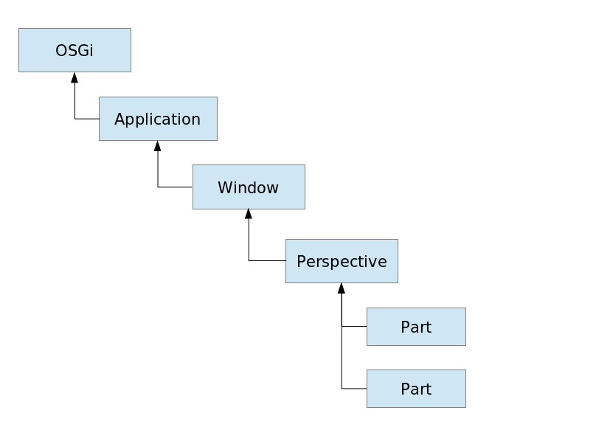

The context is hierarchical to avoid collisions in injected values and to increase the isolation of the classes in terms of what they need. For example a *Part* needs a unique Composite objects to create its user interfaces. Since *Parts* have different local contexts, their @Inject gets the needed implementation from the actual context.

The search happens transparently for the caller of the injection.

**16.4. What are the relevant classes and interfaces**

The interface for the context object is the IEclipseContext interface.

The Eclipse platform uses the OSGiContextStrategy class to search for OSGi services if the Eclipse framework does not find the requested key in the hierarchy of IEclipseContext objects.

**16.5. Who creates the context for model elements?**

Eclipse 4 has a flexible renderer framework. For each model element the framework determines a renderer class which is responsible for creating the Java object associated with the model element. This renderer class creates, if required, the local context for the model element via the EclipseContextFactory class and connects this local context to the context hierarchy.

For example the ContributedPartRenderer class is responsible for creating the Java objects for *Parts* in the model. The interface for *Parts* is MPart.

ContributedPartRenderer creates a Composite for every *Part* and injects this Composite into the local context of the *Part*.

Another example is the WBWRenderer class which is responsible for creating a *Window*. This class puts an instance of the IWindowCloseHandler and the ISaveHandler interface into the context of the *Window*. The first is responsible for the behavior of a *Window* during close, the other one for saving. For example the default IWindowCloseHandler would prompt you if you want to save *Parts* which indicate that they have saveable content via the MDirtyable model attribute. You can change this default IWindowCloseHandler implementation via the MWindow model object. The following example shows this.

*@Execute*

**public** **void** execute(**final** Shell shell, EModelService service,

MWindow window) {

IWindowCloseHandler handler = **new** IWindowCloseHandler() {

*@Override*

**public** **boolean** close(MWindow window) {

**return** MessageDialog.openConfirm(shell,

"Close",

"You will loose data. Really close?");

}

};

window.getContext().set(IWindowCloseHandler.**class**, handler);

}

**17. Behavior Annotations**

**17.1. API definition via inheritance**

In general, every framework defines an application programming interface (API).

If you use a framework you need to have a convention for which methods are called at which point of the execution of your program. For example if a Java class is responsible for handling a toolbar button click, the framework needs to know which method of this class it should call.

The "traditional" way of defining an API is via inheritance. This approach requires that your classes extend or implement framework classes and interfaces. This is how Eclipse 3.x defined its API.

The framework defines via an abstract class which methods must be implemented. In this example the method might be called execute() and the framework knows that this method must be called once the toolbar button is clicked.

For example in Eclipse 3.x a *View* class would extend the abstract ViewPart class. This class defines the createPartControl() method.

The Eclipse 3.x framework knows that createPartControl() is responsible for creating the user interface and calls this method once the *View* becomes visible.

API definition via inheritance is a simple way to define an API, but it also couples the classes tightly to the framework. For example testing the class without the framework is difficult. It also makes extending or updating the framework difficult.

**17.2. API definition via annotations**

Eclipse 4 does not require that classes extend framework classes. To be precise Eclipse 4 does not provide any such classes.

Eclipse 4 uses annotations to indicate that a certain behavior is expected from the framework.

I will call these annotations *behavior annotations*.

Behavior annotations are used to indicate that certain methods should be called at certain events. The following tables list the available behavior annotations.

**Table 7. Eclipse lifecycle annotations for Parts**

| **Annotation** | **Description** |
| --- | --- |
| @PostConstruct | Is called after the class is constructed and the field and method injection has been performed. |
| @PreDestroy | Is called before the class is destroyed. Can be used to clean up resources. |
| @Focus | Indicates that this method should be called, once the Part gets the focus. It is ***required*** to set the focus on one user interface control otherwise certain workbench functionality does not work. |
| @Persist | Is called if a save request on the Part is triggered. Can be used to save the data of the Part. |
| @PersistState | Is called before the model object is disposed, so that the Part can save its state. |

**Table 8. Other Eclipse Behavior Annotations**

| **Annotation** | **Description** |
| --- | --- |
| @Execute | Marks a method in a handler class to be executed. Only one method in a handler should be annotated with @Execute. |
| @CanExecute | Marks a method to be visited by the Command- Framework to check if a handler is enabled |
| @GroupUpdates | Indicates that updates for this @Inject should be batched. If you change such objects in the IEclipseContext the update will be triggered by the processWaiting() method on IEclipseContext. |
| @EventTopic and @UIEventTopic | Allows you to subscribe to events send by the EventAdmin service. |

All these annotations will also trigger dependency injections. Therefore you do not need to add the @Inject annotation if you use these annotations.

The @PostConstruct, @PreDestroy annotations are included in the javax.inject package.

The org.eclipse.e4.core.di.annotations package contains the @Execute, @CanExecute annotations.

@Persists, @PersistState and @Focus are part of the org.eclipse.e4.ui.di package.

**17.3. Lifecycle Hooks**

Typically some functionality should be triggered if an application is started or stopped. Eclipse 4 allows you to register a class to predefined events of this lifecycle. For example you can use these lifecycle hooks to create a login screen before the actual application is started.

The org.eclipse.core.runtime.product extension point allows you to define this lifecycle class with a property with the lifeCycleURI key.

This property points to a class via the bundleclass:// schema.

In the lifecycle class you can use the following annotations. The annotated methods will be called by the framework depending on the life cycle of your application.

**Table 9. Life Cycle Annotations**

| **Annotation** | **Description** |
| --- | --- |
| @PostContextCreate | Is called after the Application’s IEclipseContext is created, can be used to add objects, services, etc. to the context. This context is created for the MApplication class. |
| @ProcessAdditions | Is called directly before the model is passed to the renderer, can be used to add additional elements to the model. |
| @ProcessRemovals | Same as @ProcessAdditions but for removals. |
| @PreSave | Is called before the application model is saved. You can modify the model before it is persisted. |

The following example shows how to register a lifecycle class in your *plugin.xml* file.

<?xml version="1.0" encoding="UTF-8"?>

<plugin>

<extension

id="product"

point="org.eclipse.core.runtime.products">

<product

name="testing"

application="org.eclipse.e4.ui.workbench.swt.E4Application">

<property

name="appName"

value="testing">

</property>

<property

name="applicationXMI"

value="testing/Application.e4xmi">

</property>

<property

name="applicationCSS"

value="platform:/plugin/testing/css/default.css">

</property>

<property

name="lifeCycleURI"

value="bundleclass://testing/testing.LifeCycleManager">

</property>

</product>

</extension>

</plugin>

The following coding for the lifecycle class will display a shell.

**package** testing;

**import** org.eclipse.e4.core.services.events.IEventBroker;

**import** org.eclipse.e4.ui.workbench.UIEvents;

**import** org.eclipse.e4.ui.workbench.lifecycle.PostContextCreate;

**import** org.eclipse.swt.SWT;

**import** org.eclipse.swt.widgets.Shell;

**import** org.osgi.service.event.Event;

**import** org.osgi.service.event.EventHandler;

**public** **class** LifeCycleManager {

*@PostContextCreate*

**void** postContextCreate() {

**final** Shell shell = **new** Shell(SWT.TOOL | SWT.NO\_TRIM);

shell.open();

}

}

**18. Tutorial: Using dependency injection**

**18.1. Getting a Composite**

In the following tutorial we extend our classes to use dependency injection.

Change the TodoOverviewPart class to the following:

**package** com.example.e4.rcp.todo.parts;

**import** javax.inject.Inject;

**import** org.eclipse.swt.widgets.Composite;

**public** **class** TodoOverviewPart {

*@Inject*

**public** TodoOverviewPart(Composite parent) {

*// Assuming that dependency injection works*

*// parent will never be null*

System.out.println("Woh! Got Composite via DI.");

*// Does it have a layou manager?*

System.out.println("Layout: " + parent.getLayout().getClass());

}

}

**18.2. Validation**

Run your application and check in the *Console* *View* of your Eclipse IDE to see if the *Composite* parameter was injected. Note down the layout class which the Composite has assigned to, if it is not null.

**19. Exercise: Define Part Lifecycle**

**19.1. Overview**

Although the user interface of a *Part* can be created in the constructor, it is recommended that the user interface should instead be created in a @PostConstruct method. When the constructor is fired, no marked fields or methods will have been injected, which can lead to subtle errors.

Realizing the user interface of a *Part* in a @PostConstruct requires that @Inject methods be aware that the user interface might not yet be created.

In the following tutorial we use the @PostConstruct and @PreDestroy annotations in our *Parts*.

**19.2. Using @PostConstruct and @PreDestroy**

Add the following method to your TodoOverviewPart, TodoDetailsPart and PlaygroundPart classes.

*// Declare a field label, required for @Focus*

Label label;

**public** **void** createControls(Composite parent) {

label = **new** Label(parent,SWT.NONE);

label.setText("A text....");

}

Annotate the method with @PostContruct.

Create an empty public void dispose() method and annotate it with @PreDestroy.

Remove all constructors from your classes.

**19.3. @Focus**

Implement a @Focus method in each *Part*. Setting the focus to one of SWT controls is mandatory otherwise the Eclipse services do not work reliably.

*@Focus*

**private** **void** setFocus() {

label.setFocus();

}

**19.4. Validate**

Run your application and validate that the @PostContruct method is called. Use either debugging or a System.out.println() statement. Every Part needs to assign focus to one of its controls, otherwise certain services will not work. Therefore we added a SWT label to be the focus control. Even though a label cannot take focus, it triggers the SWT.ACTIVATE event, which is sufficient for the Eclipse services to work correctly.

If you are familiar with SWT, add a few more controls to your user interface.

**20. Commands, Handlers, Menus, Toolbars and Popups**

**20.1. Overview**

The Eclipse application model can contain commands and handlers.

A command in Eclipse is a declarative description of an abstract action which can be performed, for example *save*, *edit* or *copy*. A command is independent from its implementation details.

The behavior of a command is defined via a handler. A handler defines a class via the contributionURI attribute of the handler. This attribute is displayed as "Class URI" in the model editor. The handler can be global to the application, or scoped to a window or even a part.

This class uses the @Execute annotation to define which method is called once the handler is executed. The @CanExecute annotation defines the method which evaluates if the handler is currently active. If the handler can always execute, it does not need to supply a @CanExecute method.

@CanExecute is called by the framework if the SWT.SHOW event happens. This event is for example triggered if a new Part is displayed. Also if you add items to the toolbar, a timer is automatically registered by the Eclipse framework which, as of the time of this writing, executes every 400 Milliseconds. This timer will check the @CanExecute to enable or disable the related toolbar entry.

In the handler class you can determine the command ID if the command was triggered via the user interface. Determining the ID is not possible, if it was triggered via the command service (limitation). The following code snippet shows how to get the command ID.

*@Execute*

**public** **void** execute(MHandledItem item) {

MCommand command = item.getCommand();

*// Prints out the commmand ID*

System.out.println(command.getElementId());

}

**20.2. Default commands**

If you know Eclipse 3.x you are probably searching for the predefined commands which you can re-use. The Eclipse 4 platform tries to be as lean as possible.

Eclipse 4 does not include standard commands anymore. You have to define all your commands.

**20.3. Menus and Toolbar**

You can add menus and toolbars to the application model for the Window and for Parts. Menu and toolbars items contain references to commands. If a command is selected, the runtime will determine the relevant handlers for the command.

For simple cases you can also use the "Direct MenuItem" or a "Direct ToolItem", which allows you to define a class to be executed directly. This is useful if you just want to respond to the user clicking on a menu item or tool item.

Using commands together with handlers gives you more flexibility, for example you can have different Handlers for different scopes (Applications or Views) and you can define key bindings for the handler's associated commands.

Toolbars in the application are encapsulated in the application model via the *trimbar* model element. A trimbar can be defined for Windows. Via its attribute you define if the trimbar should be placed on the top, left, right or bottom corner of the Window.

The related command is assigned to the menu and toolbar entry. Menus and toolbars support separators. Menus can have submenus.

**20.4. View Menus**

To show a menu for a *View* you have to add a tag to the corresponding entry in the *Application.e4xmi* file. This tag must be defined before the menu children are defined and looks like the following.

<tags>ViewMenu</tags>

Only one Menu in a Part should contain this tag.

To add such a View menu entry, select the entry *Menu* under our Part, select *ViewMenu* and press the *Add* button.

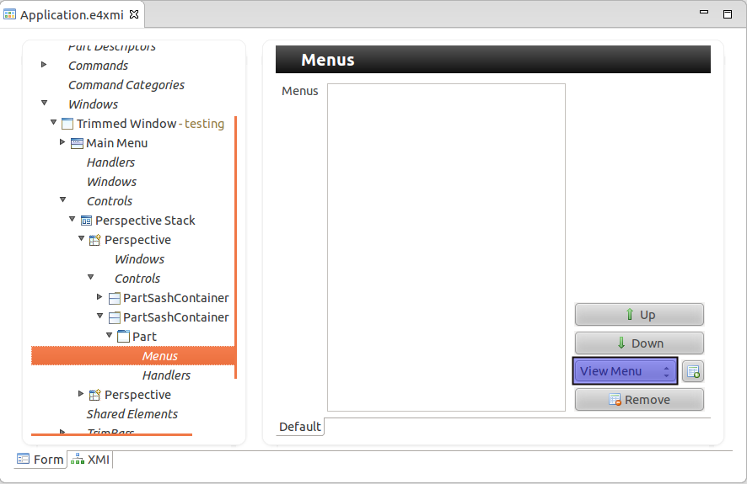

**20.5. Popup Menu - Context Menu**

You can also define a popup menu for *SWT* controls. For this you define a *Popup Menu* for your *Part* in the application model.

You can then assign it via the EMenuService class to a *SWT* control. The *ID* parameter must be the *elementId* of your *Popup Menu* model element.

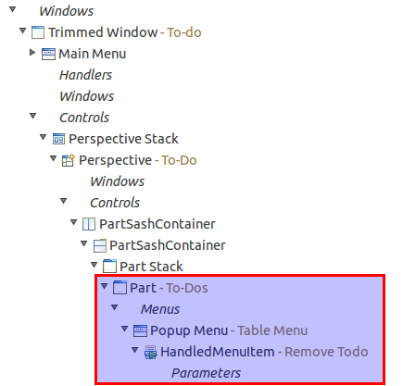

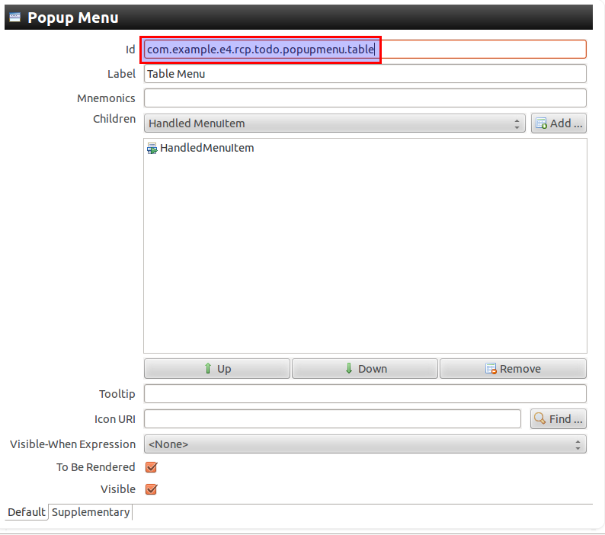

The following code shows an example for the registration.

**package** com.example.e4.rcp.todo.parts;

**import** javax.annotation.PostConstruct;

**import** org.eclipse.e4.ui.workbench.swt.modeling.EMenuService;

**import** org.eclipse.swt.SWT;

**import** org.eclipse.swt.widgets.Composite;

**import** org.eclipse.swt.widgets.Text;

**public** **class** TodoDetailsPart {

*@PostConstruct*

**public** **void** createUi(Composite parent, EMenuService service) {

**final** Text text = **new** Text(parent, SWT.BORDER);

text.setText("Hello");

*// Make use to use the correct ID*

*// from the application model*

menuService.registerContextMenu(text,

"com.example.e4.rcp.todo.popupmenu.table");

}

}

If you want to implement this example you also need to add a dependency to the org.eclipse.e4.ui.workbench.swt plug-in in your application.

**20.6. Scope of handlers**

Each command can have only one valid handler for a given scope. The application model allows you to define a handler for the application, for a *Window* and for a *Part*.

If more than one handler is defined for a command, Eclipse will select the handler most specific to the model element.

For example if you define a handler for the "Copy" command for your Window and if you define another "Copy" handler for your Part, the runtime will select the handlers closest to model element.

Once the handler is selected, @CanExecute is called so the handler can determine if it is able to execute in the given context. If it returns false it will disable any menu and tool items that point to that command.

**20.7. Several methods with @Execute**

You should only annotate one methods of a handler with @Execute. If you annotate several methods the the Eclipse runtime picks one of them.

**20.8. Passing parameters to commands**

You can also pass parameters to commands.

To define that a command accepts a parameter, select your command and press the *Add* button in the *Parameter* section.

The ID is the identifier which you can use to get the parameter via the @Named annotation.

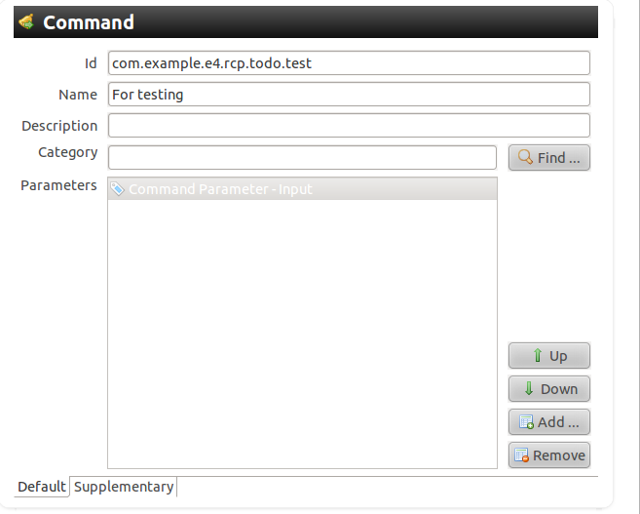

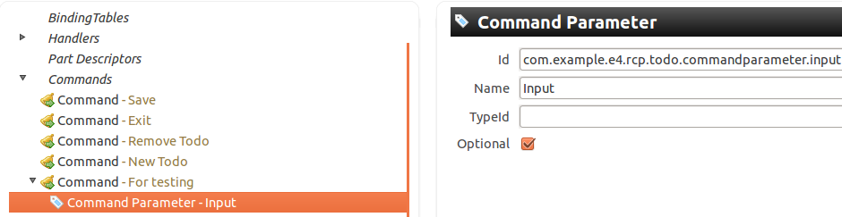

Getting the parameter via @Named annotation in your handler is demonstrated in the following code example.

**package** com.example.e4.rcp.todo.handlers;

**import** javax.inject.Named;

**import** org.eclipse.e4.core.di.annotations.CanExecute;

**import** org.eclipse.e4.core.di.annotations.Execute;

**public** **class** TestHandler {

*@Execute*

**public** **void** execute(*@Named("com.example.e4.rcp.todo" +*

*".commandparameter.input")* String param) {

System.out.println(param);

}

}

In your menu or toolbar entries you use the ID of the command in the *Name* field. The entry in the *Value* field is passed to the command.

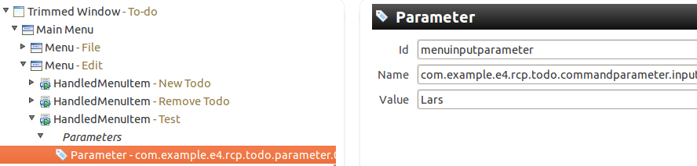

**20.9. Core expressions**

The visibility of menus, toolbars and their entries can be restricted via the *core expressions*. You add the corresponding attribute in the application model to the ID defined by the org.eclipse.core.expressions.definitions extension point in the *plugin.xml* file.

To add this extension point to your application, open the *plugin.xml* file and select the *Dependencies* tab in the editor. Add the org.eclipse.core.expressions plug-in in the *Required Plug-ins* section.

Afterwards select the *Extensions* tab, press the *Add* button and add the org.eclipse.core.expressions.definitions extension. You define an ID under which the core expression can be referred to in the application model.

Via right mouse click on the extension you can start building your expression.

You can assign this core expression to your menu entry in the application model. The following screenshot shows this for the *Test* menu entry.

The following example can be used to restrict the visibility of a menu entry based on the type of the current selection. You will later learn how to set the current selection. Please note that the variable for the selection is currently called org.eclipse.ui.selection. In Eclipse 3.x this variable is called selection.

<extension

point="org.eclipse.core.expressions.definitions">

<definition

id="com.example.e4.rcp.todo.selectionset">

<with variable="org.eclipse.ui.selection">

<iterate ifEmpty="false" operator="or">

<**instanceof** value="com.example.e4.rcp.todo.model.Todo">

</**instanceof**>

</iterate>

</with>

</definition>

</extension>

This expression can be used to restrict the visibility of model elements.

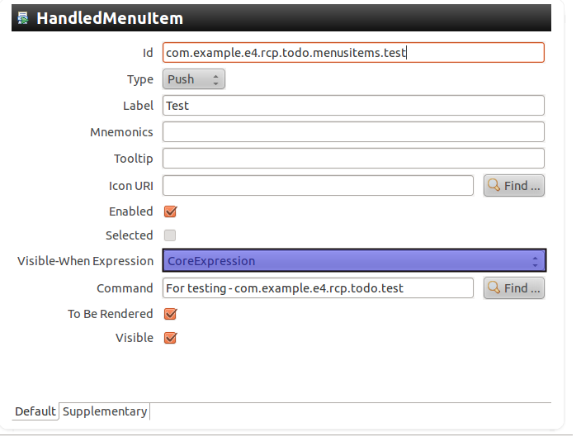

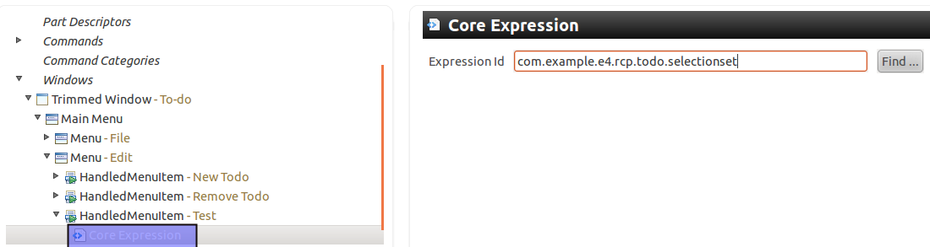

This approach is similar to the definition of core expressions in Eclipse 3.x.

The values available for Eclipse 3.x are documented in the Eclipse Wiki under the following link: **[Core Expressions](http://wiki.eclipse.org/Command_Core_Expressions" \t "_top)** and contained in the ISources interface. Eclipse 4 does not always support the same variables, but the wiki might still be helpful.

**20.10. Evaluate your own values in Core expressions**

You can also place values in the IEclipseContext of your application and use these for your visible-when evaluation.

Later you will learn more about modifying the IEclipseContext but the following codes is an example Handler which places a value for the *myactivePartId* key in the context.

*@Execute*

**public** **void** execute(IEclipseContext context) {

*// put an example value in the context*

context.set("myactivePartId",

"com.example.e4.rcp.ui.parts.todooverview");

}

The following shows an example core expression which evaluates to true if an *myactivePartId* key with the value com.example.e4.rcp.ui.parts.todooverview is found in the context.

This core expression can get assigned to a menu entry and control the visibility.

<extension

point="org.eclipse.core.expressions.definitions">

<definition

id="com.example.e4.rcp.todo.todooverviewselected">

<with

variable="myactivePartId">

<equals

value="com.example.e4.rcp.ui.parts.todooverview">

</equals>

</with>

</definition>

</extension>

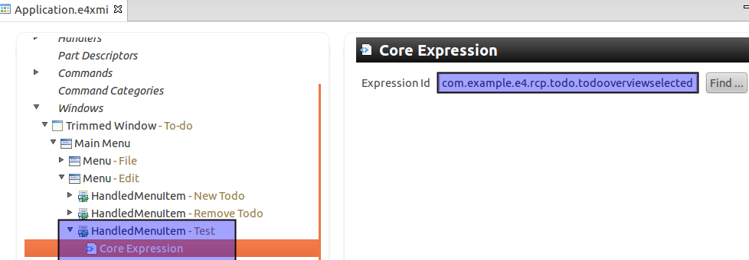

**20.11. Naming schema for command and handler IDs**

A good convention is to start IDs with the *top level package name* of your project and to use only lower case.

The IDs of commands and handler should reflect their relationship. For example if you implement a command with the com.example.contacts.commands.show ID, you should use com.example.contacts.handler.show as the ID for the handler. If you have more than one handler defined, add another suffix to it, describing its purpose, e.g. *com.example.contacts.handler.show.details*.

In case you implement commonly used functions, e.g. save, copy, you should use the existing platform IDs, as some Eclipse contributions expect these IDs. A more complete list of command IDs is available in org.eclipse.ui.IWorkbenchCommandConstants.

**Table 10. Default IDs for commonly used commands**

| **Command** | **ID** |
| --- | --- |
| Save | org.eclipse.ui.file.save |
| Save All | org.eclipse.ui.file.saveAll |
| Undo | org.eclipse.ui.edit.undo |
| Redo | org.eclipse.ui.edit.redo |
| Cut | org.eclipse.ui.edit.cut |
| Copy | org.eclipse.ui.edit.copy |
| Paste | org.eclipse.ui.edit.paste |
| Delete | org.eclipse.ui.edit.delete |
| Import | org.eclipse.ui.file.import |
| Export | org.eclipse.ui.file.export |
| Select All | org.eclipse.ui.edit.selectAll |
| About | org.eclipse.ui.help.aboutAction |
| Preferences | org.eclipse.ui.window.preferences |
| Exit | org.eclipse.ui.file.exit |

**21. Tutorial: Defining and using Commands and Handlers**

**21.1. Overview**

You will now define commands and handlers for your application. We will define our handlers for the whole application.

**21.2. Defining Commands**

Open the *Application.e4xmi* file and select *Commands*.

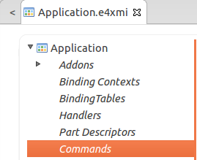

Via the *Add* button you can create new commands. The name and the ID are the important fields. Create the following commands.

**Table 11. Commands**

| **ID** | **Name** |
| --- | --- |
| org.eclipse.ui.file.saveAll | Save |
| org.eclipse.ui.file.exit | Exit |
| com.example.e4.rcp.todo.new | New Todo |
| com.example.e4.rcp.todo.remove | Remove Todo |
| com.example.e4.rcp.todo.test | For testing |

**21.3. Defining Handler classes**

Create the com.example.e4.rcp.todo.handlers package for your handler classes.

All handler classes will implement the execute() method.

**package** com.example.e4.rcp.todo.handlers;

**import** org.eclipse.e4.core.di.annotations.CanExecute;

**import** org.eclipse.e4.core.di.annotations.Execute;

**public** **class** SaveAllHandler {

*@Execute*

**public** **void** execute() {

System.out.println("Called");

}

*// Technically not needed*

*// will default to true*

*@CanExecute*

**public** **boolean** canExecute() {

**return** true;

}

}

Using this template for all classes, implement the following classes.

* SaveAllHandler
* ExitHandler
* NewTodoHandler
* RemoveTodoHandler
* TestHandler

**21.4. Defining Handlers in your model**

Select the entry *Handlers* in your application model and create the handlers from the following table for your commands. For the definition of handlers the ID, the command and the class is relevant information.

Use the *com.example.e4.rcp.todo.handlers* prefix for all handlers IDs.

**Table 12. Handlers**

| **Handler ID** | **Command - Class** |
| --- | --- |
| \*.save | Save - SaveAllHandler |
| \*.exit | Exit - ExitHandler |
| \*.new | New Todo - NewTodoHandler |
| \*.remove | Remove Todo - RemoveTodoHandler |
| \*.test | For testing - TestHandler |

The application model editor shows both the name and the ID of the command. The class URI follows the bundleclass:// schema, the table only defines the class name to make the table more readable. For example for the save handler this looks like the following:

bundleclass:*//com.example.e4.rcp.todo/[CONTINUE...]*

com.example.e4.rcp.todo.handlers.SaveAllHandler

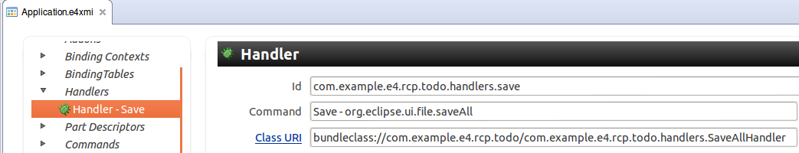

**21.5. Adding a Menu**

You will now add a Menu to your application model.

Select the *Application.e4xmi* file. To add a menu to a *Window* select your *TrimmedWindow* entry in the model and flag the *Main Menu* attribute.

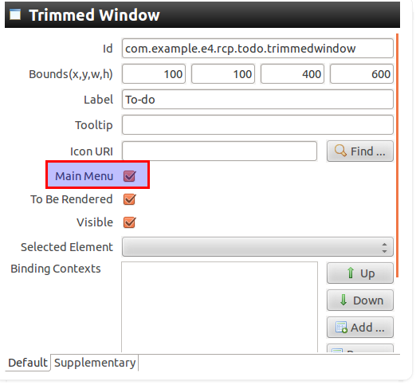

Assign the *org.eclipse.ui.main.menu* ID to your main menu.

Add two menus, one with the name *File* and the other one with the name *Edit* in the *Label* attribute.

Also set the *org.eclipse.ui.file.menu* ID for the *File* menu. Use *com.example.e4.rcp.todo.menu.edit* as ID for the *Edit* menu.

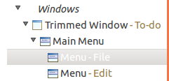

Add a *HandledMenuItem* to the *File* menu. This item should point to the *Save* command via the *Command* attribute.

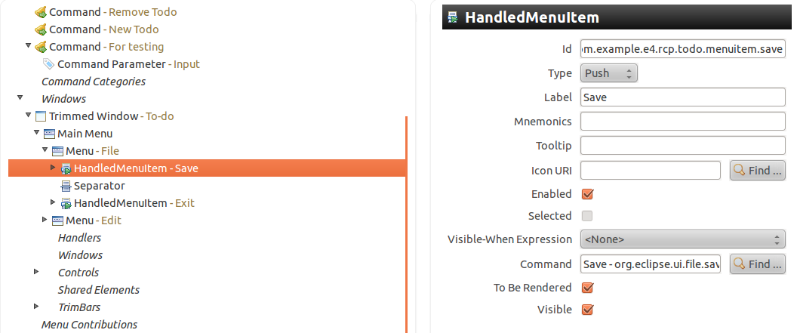

Add a *Separator* after the save menu item and add after that an entry for the exit command.

Add all other commmands to the *Edit* menu.

**21.6. Adding a Toolbar**

Select the *TrimBars* node under your *Window* entry and press the *Add* button. The *Side* attribute should be set to *Top*, so that all toolbars assigned to that *TrimBar* appear on the top of the application.

Add a *ToolBar* to your TrimBar. Add a *Handled ToolItem* to this ToolBar, which points to the org.eclipse.ui.file.saveAll command.

Set the label for this entry to *Save*.

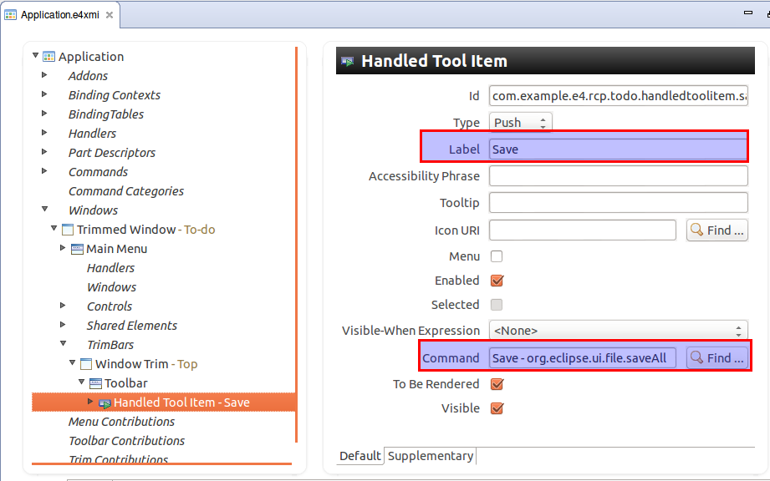

**21.7. Closing the application**

To test if your handler is working, change your ExitHandler class, so that it will close your application.

**package** com.example.e4.rcp.todo.handler;

**import** org.eclipse.e4.core.di.annotations.Execute;

**import** org.eclipse.e4.ui.workbench.IWorkbench;

**public** **class** ExitHandler {

*@Execute*

**public** **void** execute(IWorkbench workbench) {

workbench.close();

}

}

**21.8. Simulate save**

Change your SaveAllHandler class, so that System.out.println writes the following message to the console: *SaveAllHandler called.*.

**22. Key bindings**

**22.1. Overview**

It is also possible to define key bindings (shortcuts) for your Eclipse application. This requires two steps, first you need to enter values for the *BindingContext* node of your application model.

Afterwards you need to enter the keybindings for the relevant *BindingContext* in the *BindingTable* node of your application model. A *BindingTable* is always assigned to a specific *BindingContext*. A *BindingContext* can have several *BindingTables* assigned to it.

*BindingContexts* are defined in a hierarchical fashion, so that keybindings in child *BindingContexts* override the matching keybinding in the parent *BindingContext*.

**22.2. BindingContext entries using by JFace**

The *BindingContext* is defined via its ID. A *BindingContext* can get assigned to a *Window* or a *Part* in the application model. This would define which keyboard shortcuts are are valid for the Window *Window* or the *Part*.

Eclipse JFace uses predefined *BindingContext* identifier which are based on the org.eclipse.jface.contexts.IContextIds class. JFace distinguishes between shortcuts for dialogs, windows or both.

The following gives an overview of the supported ID and the validity of keybindings defined with reference to this Context ID.

**Table 13. Default BindingContext values**

| **Context ID** | **Description** |
| --- | --- |
| org.eclipse.ui.contexts.dialogAndWindow | Key bindings valid for Dialogs and Windows |
| org.eclipse.ui.contexts.dialog | Key bindings valid in Dialogs |
| org.eclipse.ui.contexts.window | Key bindings valid for Windows |

As an example, **Ctrl**+**C** (Copy) would be defined in *dialogAndWindows* as it is valid everywhere, but **F5** (Refresh) might only be defined for a Window and not for a Dialog.

**22.3. Define Shortcuts**

The *BindingTable* node in the application model allows you to define shortcuts for a specific *BindingContext*.

To define a shortcut you create a new node for *BindingTable* and define a reference for the Context ID.

In your keybinding you define the key *Sequence* and the command associated with this shortcut.

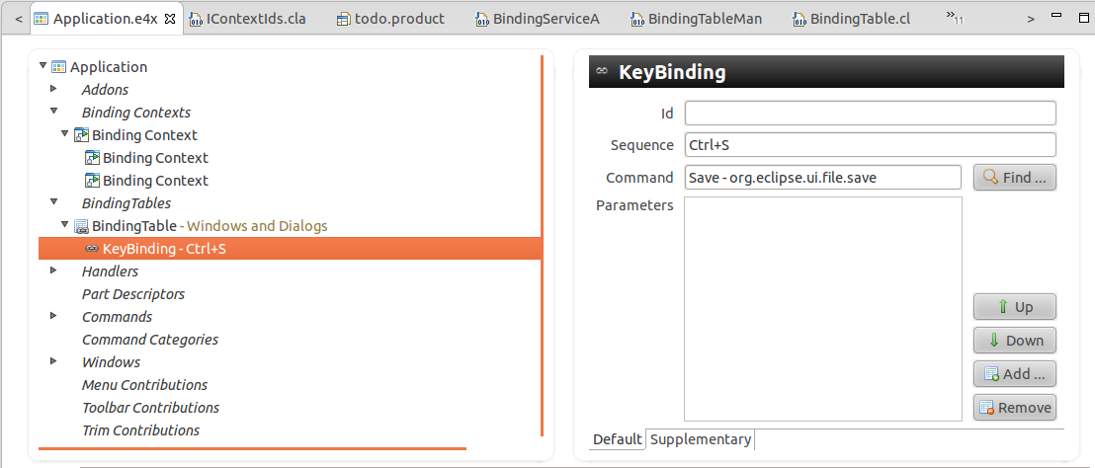

The control keys are different for the different platforms, e.g. on the Mac vs. a Linux system. For example you can use Ctrl but this would be hardcoded. It is better to use the M1 - M4 metakeys .

**Table 14. Key Mapping**

| **Control Key** | **Mapping for Windows and Linux** | **Mapping for Mac** |
| --- | --- | --- |
| M1 | Ctrl | Command |
| M2 | Shift | Shift |
| M3 | Alt | Alt |
| M4 | Undefined | Ctrl |

These values are defined in the SWTKeyLookup class

**22.4. Key Bindings for a Part**

You can assign a specific *BindingContext* to be active while a Part is active.

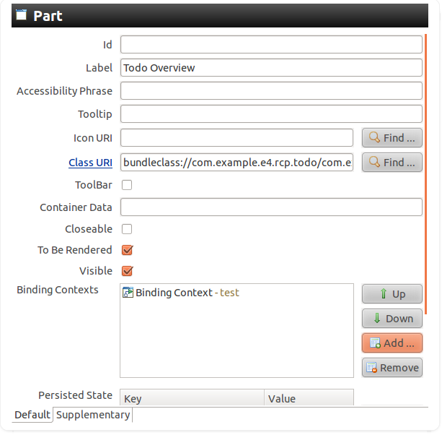

**22.5. Activating Bindings**

If there are several valid key bindings defined the ContextSet class is responsible for selecting the default one. ContextSet uses the BindingContext hierarchy to determine the lookup order. A BindingContext is more specific depending on how many ancestors are between it and a root BindingContext (the number of levels it has). The most specific BindingContext are considered first, the root BindingContext are considered last.

You can also use the EContextService service which allows you to explicitly activate and deactivate a BindingContext via the activateContext() and deactivateContext() methods.

**22.6. Issues with Keybinding**

The keybinding implementation requires that all *Parts* correctly implement @Focus. Eclipse requires that one control get the focus assigned.

**23. Application model modifications at runtime**

**23.1. Creating model elements**

As the model is interactive, you can change it at runtime, for example you can change the size of the current window, add Parts to your application or remove menu entries.

To add your new model elements to the application you can use the modelservice or get existing elements injected.

**23.2. Modifying existing model elements**

You can also get the model elements injected and change their attribute.

**24. Example for changing the application model**

**24.1. Example: Dynamically create a new Window**

To create new model objects you can use the MBasicFactory.INSTANCE class. This is a factory used to create new model objects via typed create\*() methods. For example you can create a new Window at runtime as shown in the following snippet.

*// Create a new window and set its size*

MWindow window = MBasicFactory.INSTANCE.createTrimmedWindow();

window.setWidth(200);

window.setHeight(300);

*// Add new Window to the application*

application.getChildren().add(window);

**24.2. Example: Dynamically create a new Part**

For example the following adds a new part to the currently active window.

**package** testing.handlers;

**import** org.eclipse.e4.core.di.annotations.Execute;

**import** org.eclipse.e4.ui.model.[CONTINUE...]

.application.descriptor.basic.MPartDescriptor;

**import** org.eclipse.e4.ui.model.application.ui.basic.MBasicFactory;

**import** org.eclipse.e4.ui.model.application.ui.basic.MPart;

**import** org.eclipse.e4.ui.model.application.ui.basic.MWindow;

**public** **class** AddPartHandler {

*@Execute*

**public** **void** execute(MWindow window) {

MPart part = MBasicFactory.INSTANCE.createPart();

part.setElementId("mynewid");

part.setLabel("A new Part");

part.setContributionURI("bundleclass://com.example." +

"e4.rcp.todo/com.example.e4.rcp.todo.parts.TodoOverviewPart");

window.getChildren().add(part);

}

}

**25. Model Addons**

**25.1. Overview**

Eclipse 4 tries to keep the core framework as minimal as possible. Addons model object can be registered globally on the application model and can enhance the application with additional functionality. Addons are normal Java objects.

Addons use the bundleclass:// URI convention in the application model to refer to the Java objects.

Having these Addons registered allows them to be enhanced or replaced by the Eclipse platform team or by a customer specific implementation in case the need arises.

**25.2. Framework Addons**

Currently the following standard Addons are useful for Eclipse applications. Their class names give an indication of their provided functionality. Check their Javadoc to get a short description of their purpose.

* CommandServiceAddon
* ContextServiceAddon
* BindingServiceAddon
* CommandProcessingAddon
* ContextProcessingAddon
* BindingProcessingAddon

**25.3. Additional SWT addons**

Additional Addons are available, e.g. to support drag-and-drop of *Parts* in your application.

To support drag-and-drop for *Parts* you need to add the org.eclipse.e4.ui.workbench.addons.swt plug-in to your product configuration file. Then you can use the DnDAddon and the CleanupAddon from this bundle as Addons in your application model. This plug-in contains also the MinMax add-on which adds the minimize and maximize functionality to your applicatoion.

The org.eclipse.e4.ui.workbench.addons.swt plug-in contributes these plug-ins to your application model via a processors, e.g. a Java class which changes the application model. If you remove the plug-in from your product the these Add-ons are not available.

**25.4. Relationship to other services**

Addons are created before the rendering engine renders the model and after the EventAdmin Service has been created.

This allows Addons to alter the user interface that is produced by the rendering engine. For example, the min/max Addon changes the tab folders created for MPartStacks to have min/max buttons in the corner.

The EventAdmin services provides the notifications about Eclipse events, e.g. if a *Part* is activated. As the EventAdmin services is created before Addons are created , the Addons can to subscribe to events from the Eclipse platform.

**26. Accessing and extending the Eclipse Context**

**26.1. Accessing the context**

To access an existing context you can use dependency injection, if the relevant object is managed by the Eclipse runtime, i.e. if you are using a model object.

**package** com.example.e4.rcp.todo.handlers;

**import** org.eclipse.e4.core.contexts.IEclipseContext;

**import** org.eclipse.e4.core.di.annotations.Execute;

**public** **class** ShowMapHandler {

*@Execute*

**public** **void** execute(IEclipseContext context) {

*// Add objects to this local context of this handler*

*// ...*

}

}

Alternatively if your model object extends MContext you can use DI to get the model object injected and use the getContext() method to access its context. For example MPart, MWindow, MApplication and MPerspective extend MContext.

**package** com.example.e4.rcp.todo.parts;

**import** javax.annotation.PostConstruct;

**import** javax.annotation.PreDestroy;

**import** org.eclipse.e4.core.contexts.IEclipseContext;

**import** org.eclipse.e4.ui.model.application.ui.basic.MPart;

**import** org.eclipse.swt.widgets.Composite;

*// Getting the application context*

*// via the MApplication object*

**public** **class** TodoDetailsPart {

*@PostConstruct*

**public** **void** createControls(Composite parent,

MApplication application) {

IEclipseContext context = application.getContext();

*// Add or access objects to and from the application context*

*// ...*

}

}

If you are outside of a model object, you still can access the OSGi context via the following:

**public** Object start() {

*// Get Bundle Information*

Bundle bundle = FrameworkUtil.getBundle(getClass());

BundleContext bundleContext = bundle.getBundleContext();

IEclipseContext eclipseCtx =

EclipseContextFactory.getServiceContext(bundleContext);

*// Fill Context with information using set(String,Object)*

*// ....*

*// Create instance of class*

ContextInjectionFactory.make(MyPart.**class**, eclipseCtx);

}

**26.2. OSGi services**

You can add objects to the context via OSGi services. OSGi services are automatically available in the context. But OSGi services are global to the framework runtime — they can not access the workbench model or its context.

**26.3. Objects and Context Variables**

You can add key / value pairs directly to the IEclipseContext, for example a todo object under the *active* key. Adding objects to a Context can be done via the set() method on IEclipseContext. The following example creates a new context via the EclipseContextFactory.create() factory method call and adds some objects to it.

*@Inject*

**public** **void** addingContext(IEclipseContext context) {

*// We want to add objects to context*

*// Create instance of class*

IEclipseContext myContext = EclipseContextFactory.create();

*// Putting in some values*

myContext.set("mykey1", "Hello1");

myContext.set("mykey2", "Hello2");

*// Adding a parent relationship*

myContext.setParent(context);

*// Alternatively you can also*

*// establish a parent/child*

*// relationship via the*

*// context.createChild() method call*

}

A *Context variable* can be declared as *modifiable* via the declareModifiable(key) method call.

*@Inject*

**public** **void** addingContext(IEclipseContext context) {

*// Putting in some values*

context.set("mykey1", "Hello1");

context.set("mykey2", "Hello2");

*// Declares the named value as modifiable*

*// by descendants of this context. If the value does not*

*// exist in this context, a null value is added for the name.*

context.declareModifiable("mykey1");

}

Modifiable *Context variables* are added to particular levels of the IEclipseContext hierarchy and can also be modified using the modify() method rather than set() method of the IEclipseContext.

The modify() methods searches up the chain to find the Context defining the variable. If none of the Context on the parent chain have a value set for the name, the value will be set in this Context. If the key already exists in the context, then modify() requires that the key has been set to modifiable with the declareModifiable() method, if not, the method throws an exception.

You can add key/values pairs and *Context variables* at different levels of the context hierarchy so supply your application with different objects.

**26.4. Model Addons**

You can add *Addons* to the application model. These *Addons* contain a reference to Java classes, which can extend the context or interact with other Eclipse platform services, e.g. the EventAdmin.

For example you could register a model *Addon* to put some values into the context.

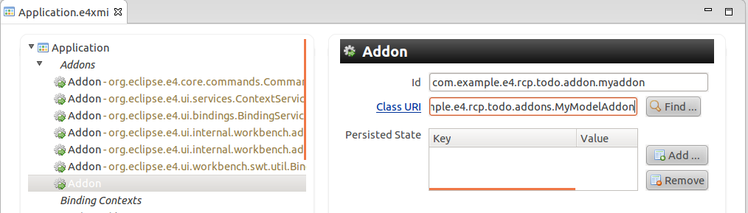

The following code shows an example implementation for the *Addon*.

**package** com.example.e4.rcp.todo.addons;

**import** javax.annotation.PostConstruct;

**import** org.eclipse.e4.core.contexts.IEclipseContext;

**public** **class** MyModelAddon {

*@PostConstruct*

**public** **void** init(IEclipseContext context) {

context.set("test1", "Hello");

}

}

**26.5. RunAndTrack**

The IEclipseContext allows you via the runAndTrack() method to register a Java object of type RunAndTrack.

A RunAndTrack is basically a Runnable which has access to the context. If the runnable accesses any values in this context during its execution, the runnable will be executed again after any of those values change.

The runAndTrack() method allows a client to keep some external state synchronized with one or more values in this context.

The runnable does not need to be explicitly unregistered from this context when it is no longer interested in tracking changes. If a subsequent invocation of this runnable does not access any values in this context, it is automatically unregistered from change tracking on this context.

**26.6. Context Functions**

*Context Functions* implement the IContextFunction interface and allow you to lazily create an object.

In Eclipse 4 you would extend the ContextFunction class to receive an IEclipseContext in the compute() method as input.

*Context Functions* are contributed as OSGi Services. They implement the IContextFunction interface from the org.eclipse.e4.core.contexts package. The Eclipse 4 runtime adds them by default to the application context but you could add *Context Functions* to any context in the context hierarchy.

Via the *service.context.key* property, they define their key under which they are added to the context.

The following example shows the declaration of a *Context Function*. This function is available in the application context under the com.example.e4.rcp.todo.contextservice.test key and can be injected via the @Inject @Named annotation.

<?xml version="1.0" encoding="UTF-8"?>

<scr:component xmlns:scr="http://www.osgi.org/xmlns/scr/v1.1.0"

name="com.example.e4.rcp.todo.contextservice.translate">

<implementation **class**="com.example.e4.rcp.todo.contextservice.Test"/>

<service>

<provide **interface**="org.eclipse.e4.core.contexts.IContextFunction"/>

</service>

<property name="service.context.key" type="String"

value="com.example.e4.rcp.todo.contextservice.test"/>

</scr:component>

Using *Context Functions* instead of plain OSGi services have the advantage that these functions has access to the application context, that they can be lazily created and that they are available in the application context. OSGi services are singletons and could not be used in a multi user environment.

**27. Using dependency injection for your own Java objects**

**27.1. Overview**

Using dependency injection for your own Java objects has two flavors. First you want the Eclipse dependency container to create your own objects and then get them injected into your model objects. Secondly you want to create objects which declare their dependencies with @Inject and want to create it via dependency injection.

Both approaches are described here.

**27.2. Using dependency injection to get your own objects**

If you want the Eclipse framework to create your objects for you, annotate them with @Creatable. This way you are telling the Eclipse DI container that it should create a new instance of this object if it does not find an instance in the context.

The Eclipse DI container will use the constructor with the highest number of parameters of this class for which the Eclipse DI container can find values in the Eclipse context. You can also use @Inject on the constructor to indicate that Eclipse should try to run dependency injection also for this constructor.

For example, assume that you have the following domain model.

*@Creatable*

**class** Todo {

*@Inject*

**public** Todo(Dependent depend, YourOSGiService service) {

*// placeholder*

}

}

*@Creatable*

**class** Dependent {

**public** Dependent() {

*// placeholder*

}

}

If no fitting constructor is found, the Eclipse framework will throw an exception.

Assuming that you have defined the YourOSGiService service in your application, you can get an instance of your Todo data model injected in a Part.

*// Field Injection*

*@Inject* Todo todo

**27.3. Using dependency injection to create objects**

Using dependency injection is not limited to the objects created by the Eclipse runtime. You can use @Inject in a Java class and use the dependency injection framework to create your class.

*// Create instance of class*

ContextInjectionFactory.make(MyJavaObject.**class**, context);

The ContextInjectionFactory.make() method creates the object. You can also put it into the context. If you want to retrieve the object from the Context, you can use the key you specified.

For this you can either use an existing context as described in the last section or a new context. Using a new context is preferred to avoid collision of keys and to isolate your changes in a local context.

IEclipseContext context = EclipseContextFactory.create();

*// Add your Java objects to the context*

context.set(MyDataObject.**class**.getName(), data);

context.set(MoreStuff.**class**, moreData);

**28. Relevant tags in the application model**

The following table lists the most important tags for model elements of Eclipse 4 applications.

Additional tags are defined in the IPresentationEngine class. It is up to the renderer implementation and model AddOns to interpret these tags. Renderer might also define additional tags. You also find more information about the available tags in the Eclipse 4 Wiki (see resources for link).

**Table 15. Relevant tags of application model elements**

| **Tag** | **Model element** | **Description** |
| --- | --- | --- |
| shellMaximized | Window or Trimmed Window | Window is maximized at start of the application. |
| shellMinimized | Window or Trimmed Window | Window is minimized at start of the application. |
| NoAutoCollapse | PartStack | Avoids that the MinMax Addon minimizes this PartStack if all Parts have been removed from it. |
| FORCE\_TEXT | ToolItem | Enforces that text and icon is shown for a toolbar item. |
| NoMove | Part | Prevents the user from moving the part (based on the DndAddON). |

**29. Eclipse 4 Best Practice**

Best practices tend to be subjective. If you disagree with certain suggestions, feel free to use your own approach.

**29.1. Extending the Eclipse Context**

The application can use the Eclipse Context for providing functionality, communication and for changing Eclipse behavior. You have several options to contribute to the context: OSGi services, context functions, context elements, context variables and ModelAddons.

The programming model of Eclipse 4 makes it relatively easy to use OSGi services, compared to Eclipse 3.x. OSGi services are effectively Singletons and do not have access to the Eclipse application context. OSGi services are a good approach for infrastructure services which are Singletons.

*Context functions* are OSGi services which are typically stored on the application level and have access to the Eclipse application context. If this is required, they can be used instead of pure OSGi services.

*Context elements* are useful, if values should be stored on certain places in the Eclipse context hierarchy. Also replacing Eclipse platform implementations is a valid use case to use context elements, e.g. to change the default window close handler.

*Context functions* and *context variables* are useful in situations where the variables need to change, and are different for different levels in the Eclipse context hierarchy.

*Model AddOns* allow you to contribute Java objects to the application context. The advantages of *Model AddOns* are that they are part of the application model, hence they are very visible components. A *Model AddOn* can register itself to events or contribute again to the Eclipse context.

**29.2. Application communication**

For user interface scoped communication it is recommended to use *Context variables* or the EventAdmin service for communicating the state.

The EventAdmin service is a good choice, if there is no scope involved in the communication. The strengths of EventAdmin is that arbitrary listeners can listen to events and that the publish / subscribe mechanism is relatively simple.

**29.3. Static vs. dynamic application model**

If your application model is primarily static, you should define it statically, as this static model provides a good visibility of your application at development time.

If required, add dynamic behavior. These dynamic parts can be evaluated at runtime via the live model editor.

**29.4. Component based development**

Eclipse and OSGi support component based development.

User interface related and core functionalities should be separated into different plug-ins.

The data model of the application should be kept in its own plug-in. Almost all plug-ins will depend on this plug-in, therefore keep it as small as possible.

**29.5. Usage of your own extension points**

The programming model of Eclipse 4 has reduced the need for using *Extension points* but Extension points still have valid use cases.

If you have multiple plug-ins which should contribute to a defined API, you can still define and use your own extension points.

**29.6. API definition**

Eclipse plug-ins explicitly declare their API via their exported packages. Publish only the packages which other plug-ins should use. This way you can later on change your internal API without affecting other plug-ins. Avoid exporting packages just for testing.

**29.7. Packages vs. Plug-in dependencies**

OSGi allows you to define dependencies via plug-ins or via packages.

Dependencies based on packages express an API dependency as they allow you to exchange the implementing plug-in. Dependencies based on plug-ins imply a dependency on an implementation.

Use package dependencies whenever you intent to exchange the implementing plug-in.

Package dependencies add complexity to the setup as you usually have more packages than plug-ins.

Therefore use plug-in dependencies, if there is only one implementing plug-in and an exchange of this plug-in in the near future is unlikely.

**30. Closing words**

I hope you enjoyed this introduction into the Eclipse 4 framework. Of course there is much more, check out the "Eclipse 4 development" section under my lists of **[Eclipse Plug-in and Eclipse RCP Tutorials](http://www.vogella.com/eclipse.html" \t "_top)** section.

**31. Thank you**

Please help me to support this article:

|  |  |
| --- | --- |
| **[Flattr this](http://flattr.com/thing/49772/Tutorials-for-Eclipse-Java-Android-and-Webprogramming)** | 窗体顶端  https://www.paypal.com/en_US/i/scr/pixel.gif  窗体底端 |

**32. Questions and Discussion**

Before posting questions, please see the **[vogella FAQ](http://www.vogella.com/faq.html" \t "_top)**. If you have questions or find an error in this article please use the **[www.vogella.com Google Group](http://groups.google.com/group/vogella" \t "_top)**. I have created a short list **[how to create good questions](http://www.vogella.com/blog/2010/03/09/asking-community-questions/" \t "_top)** which might also help you.

**33. Links and Literature**

**33.1. Source Code**

**[Source Code of Examples](http://www.vogella.com/code/index.html" \t "_top)**

**33.2. Eclipse 4**

**[Eclipse 4 RCP Wiki](http://wiki.eclipse.org/Eclipse4/RCP" \t "_top)**

**[Eclipse 4 RCP FAQ](http://wiki.eclipse.org/Eclipse4/RCP/FAQ" \t "_top)**

**[vogella Eclipse Tutorials](http://www.vogella.com/eclipse.html" \t "_top)**

**[Eclipse wiki with Eclipse 4 tutorials](http://wiki.eclipse.org/Eclipse4/Tutorials" \t "_top)**

**[Eclipse 4 Dependency Injection Wiki](http://wiki.eclipse.org/Eclipse4/RCP/Dependency_Injection" \t "_top)**

**[Eclipse 4 RCP Wiki for tags for the Application model](http://wiki.eclipse.org/Eclipse4/RCP/Modeled_UI/Tags" \t "_top)**

**[Eclipse 4 Build Schedule](http://www.eclipse.org/eclipse/platform-releng/buildSchedule.html" \t "_top)**