dubbo结合nacos实现分布式负载均衡的案例
参考dubbo JavaSDK手册 基于 Spring Boot Starter 开发微服务应用，创建项目。
参考dubbo JavaSDK手册 注册中心Nacos，将nacos配置为注册中心。
完整代码参见 http://code.streamcomputing.com/testing/stc-ai-platform/-/tree/dubbo-nacos-demo

1. 初始化项目

1.1 创建父项目dubbo-nacos-demo
对应的pom.xml如下
XML
<?xml version="1.0" encoding="UTF-8"?>
<project xmlns="http://maven.apache.org/POM/4.0.0"
xmlns:xsi="http://www.w3.org/2001/XMLSchema-instance"
xsi:schemaLocation="http://maven.apache.org/POM/4.0.0 http://maven.apache.org/xsd/maven-4.0.0.xsd">
<modelVersion>4.0.0</modelVersion>
<groupId>com.streamcomputing.ai</groupId>
<artifactId>dubbo-nacos-demo</artifactId>
<version>1.0-SNAPSHOT</version>
<packaging>pom</packaging>
<modules>
<module>interface</module>
<module>provider</module>
<module>consumer</module>
</modules>
<properties>
<dubbo.version>3.2.15</dubbo.version>
<spring-boot.version>3.2.0</spring-boot.version>
<nacos-client.version>2.1.0</nacos-client.version>
<maven.compiler.source>21</maven.compiler.source>
<maven.compiler.target>21</maven.compiler.target>
<project.build.sourceEncoding>UTF-8</project.build.sourceEncoding>
</properties>
<dependencyManagement>
<dependencies>
<!-- Spring Boot -->
<dependency>
<groupId>org.springframework.boot</groupId>
<artifactId>spring-boot-dependencies</artifactId>
<version>${spring-boot.version}</version>
<type>pom</type>
<scope>import</scope>
</dependency>
<!-- Dubbo -->
<dependency>
<groupId>org.apache.dubbo</groupId>
<artifactId>dubbo-bom</artifactId>
<version>${dubbo.version}</version>
<type>pom</type>
<scope>import</scope>
</dependency>
<dependency>
<groupId>com.alibaba.nacos</groupId>
<artifactId>nacos-client</artifactId>
<version>${nacos-client.version}</version>
<type>pom</type>
<scope>import</scope>
</dependency>
</dependencies>
</dependencyManagement>
<build>
<pluginManagement>
<plugins>
<plugin>
<groupId>org.springframework.boot</groupId>
<artifactId>spring-boot-maven-plugin</artifactId>
<version>${spring-boot.version}</version>
</plugin>
</plugins>
</pluginManagement>
</build>
</project>

1.2 创建子项目interface
对应的pom如下
XML
<?xml version="1.0" encoding="UTF-8"?>
<project xmlns="http://maven.apache.org/POM/4.0.0"
xmlns:xsi="http://www.w3.org/2001/XMLSchema-instance"
xsi:schemaLocation="http://maven.apache.org/POM/4.0.0 http://maven.apache.org/xsd/maven-4.0.0.xsd">
<modelVersion>4.0.0</modelVersion>
<parent>
<groupId>com.streamcomputing.ai</groupId>
<artifactId>dubbo-nacos-demo</artifactId>
<version>1.0-SNAPSHOT</version>
</parent>
<artifactId>interface</artifactId>
<properties>
<maven.compiler.source>21</maven.compiler.source>
<maven.compiler.target>21</maven.compiler.target>
<project.build.sourceEncoding>UTF-8</project.build.sourceEncoding>
</properties>
</project>

1.3 创建子项目consumer和provider
对应的pom.xml如下，将其中的artifactId修改为对应的模块名
XML
<?xml version="1.0" encoding="UTF-8"?>
<project xmlns="http://maven.apache.org/POM/4.0.0"
xmlns:xsi="http://www.w3.org/2001/XMLSchema-instance"
xsi:schemaLocation="http://maven.apache.org/POM/4.0.0 http://maven.apache.org/xsd/maven-4.0.0.xsd">
<modelVersion>4.0.0</modelVersion>
<parent>
<groupId>com.streamcomputing.ai</groupId>
<artifactId>dubbo-nacos-demo</artifactId>
<version>1.0-SNAPSHOT</version>
</parent>
<artifactId>provider</artifactId>
<properties>
<maven.compiler.source>21</maven.compiler.source>
<maven.compiler.target>21</maven.compiler.target>
<project.build.sourceEncoding>UTF-8</project.build.sourceEncoding>
</properties>
<dependencies>
<dependency>
<groupId>com.streamcomputing.ai</groupId>
<artifactId>interface</artifactId>
<version>1.0-SNAPSHOT</version>
</dependency>
<dependency>
<groupId>org.springframework.boot</groupId>
<artifactId>spring-boot-starter</artifactId>
</dependency>
<dependency>
<groupId>com.alibaba.cloud</groupId>
<artifactId>spring-cloud-starter-alibaba-nacos-discovery</artifactId>
</dependency>
<dependency>
<groupId>org.apache.dubbo</groupId>
<artifactId>dubbo</artifactId>
<version>${dubbo.version}</version>
</dependency>
<dependency>
<groupId>org.apache.dubbo</groupId>
<artifactId>dubbo-spring-boot-autoconfigure</artifactId>
<version>${dubbo.version}</version>
</dependency>
</dependencies>
</project>

2. 定义服务接口和实现及调用类及启动类

2.1 interface模块
在interface模块中创建DemoService.java
Java
package org.apache.dubbo.springboot.demo;
public interface DemoService {
String sayHello(String name);
}

2.2 provider模块
在provider模块中创建DemoServiceImpl
Java
package org.apache.dubbo.springboot.demo.provider;
import org.apache.dubbo.config.annotation.DubboService;
import org.apache.dubbo.springboot.demo.DemoService;
import org.springframework.beans.factory.annotation.Value;
@DubboService
public class DemoServiceImpl implements DemoService {
@Override
public String sayHello(String name) {
return "Hello " + name;
}
}
创建启动类
EnableDubbo注解表示开启dubbo。
Java
package org.apache.dubbo.springboot.demo.provider;
import org.apache.dubbo.config.spring.context.annotation.EnableDubbo;
import org.springframework.boot.SpringApplication;
import org.springframework.boot.autoconfigure.SpringBootApplication;
@SpringBootApplication
@EnableDubbo
public class ProviderApplication {
public static void main(String[] args) {
SpringApplication.run(ProviderApplication.class, args);
}
}

2.3 consumer模块
在consumer中创建Task.java
Java
package org.apache.dubbo.springboot.demo.consumer;
import java.util.Date;
import org.apache.dubbo.config.annotation.DubboReference;
import org.apache.dubbo.springboot.demo.DemoService;
import org.springframework.boot.CommandLineRunner;
import org.springframework.stereotype.Component;
@Component
public class Task implements CommandLineRunner {
@DubboReference
private DemoService demoService;
@Override
public void run(String... args) throws Exception {
new Thread(()-> {
while (true) {
try {
Thread.sleep(1000);
System.out.println(new Date() + " Receive result ======> " + demoService.sayHello("world"));
} catch (InterruptedException e) {
e.printStackTrace();
Thread.currentThread().interrupt();
}
}
}).start();
}
}
创建启动类
Java
package org.apache.dubbo.springboot.demo.consumer;
import org.apache.dubbo.config.spring.context.annotation.EnableDubbo;
import org.springframework.boot.SpringApplication;
import org.springframework.boot.autoconfigure.SpringBootApplication;
@SpringBootApplication
@EnableDubbo
public class ConsumerApplication {
public static void main(String[] args) {
SpringApplication.run(ConsumerApplication.class, args);
}
}

3. 配置yaml
dubbo.application.name定义了 Dubbo 的应用名
dubbo.protocol.name定义了Dubbo 协议信息
dubbo.registry定义了Dubbo 使用的注册中心

3.1 provider端yaml
YAML
spring:
application:
name: dubbo-nacos-demo-provider
dubbo:
protocol:
name: dubbo
port: -1
registry:
address: nacos://172.16.31.80:8848
group: dubbo-nacos-demo
username: nacos
password: nacos

3.2 consumer端yaml
parameters.register-consumer-url表示注册接口级消费者，参考nacos注册中心更多配置
YAML
spring:
application:
name: dubbo-nacos-demo-consumer
dubbo:
protocol:
name: dubbo
port: -1
registry:
address: nacos://172.16.31.80:8848
group: dubbo-nacos-demo
username: nacos
password: nacos
parameters.register-consumer-url: true

4. 初步实现dubbo分布式调用

4.1 分别启动provider和consumer

4.2 打开nacos后台
可以在nacos看到已经注册到了nacos的服务列表
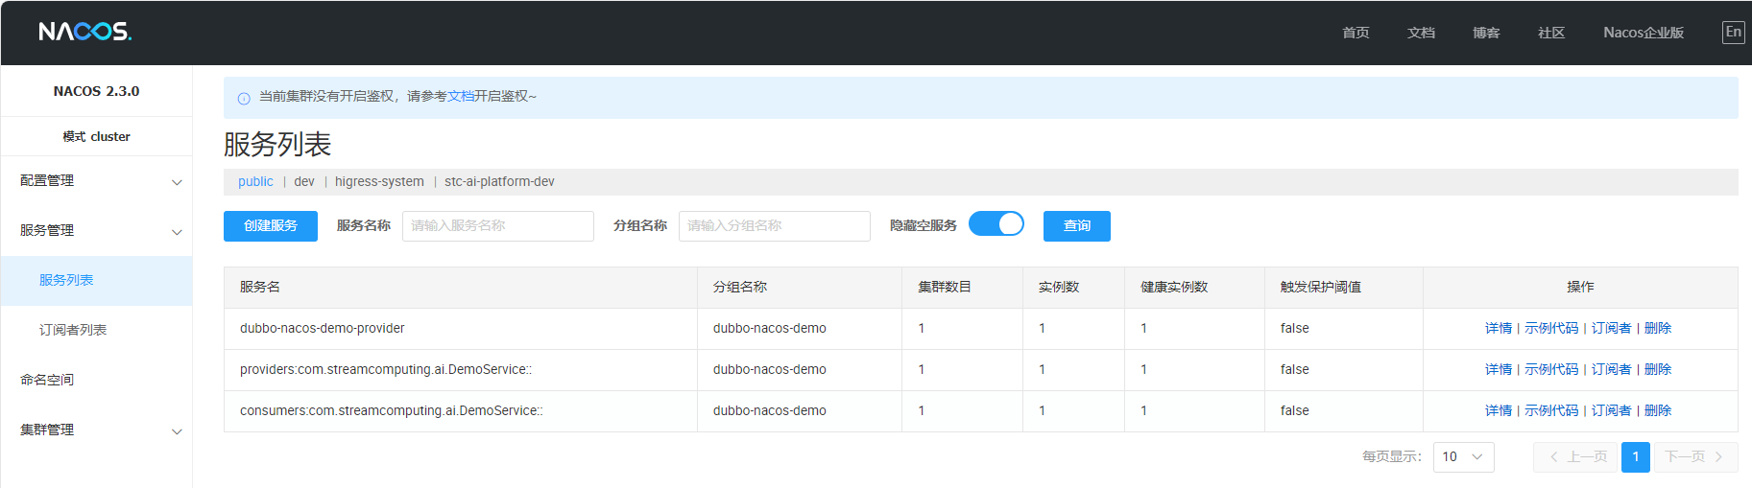

4.3 观察consumer的控制台
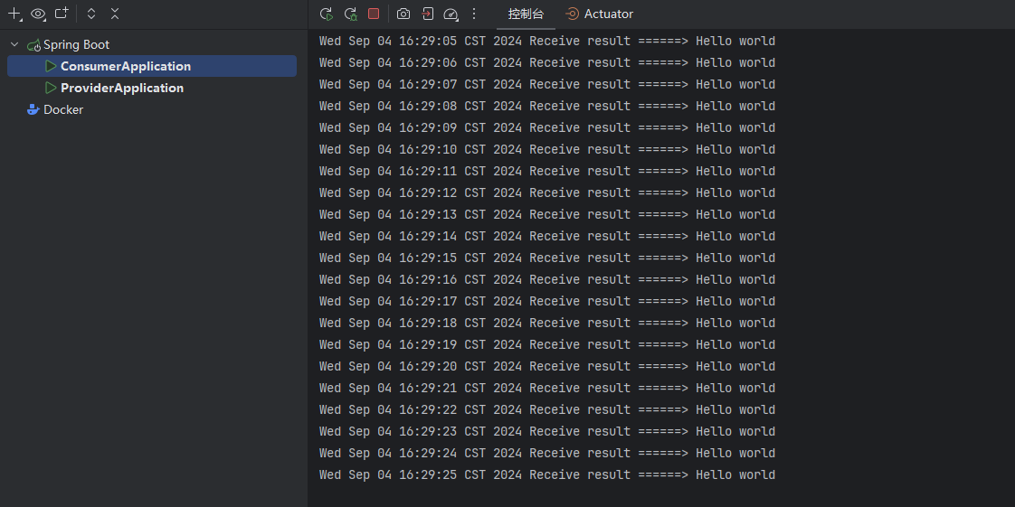

5. 报错解决：qos端口占用
启动consumer，可以看到有如下报错
org.apache.dubbo.qos.server.QosBindException: qos-server can not bind localhost:22222
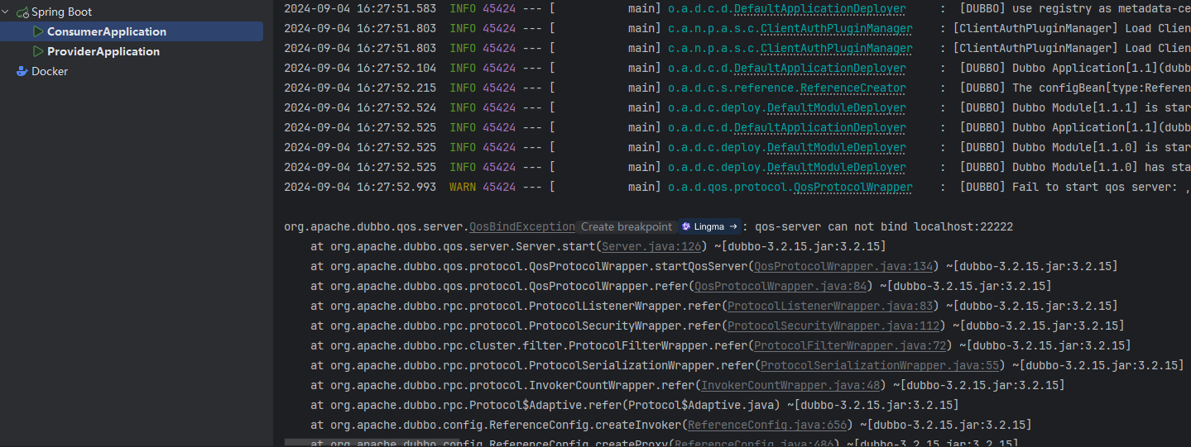
Qos=Quality of Service，qos是Dubbo的在线运维命令，可以对服务进行动态的配置、控制及查询。本案例用不上。因此可以将其关闭
修改consumer和provider端的application.yml，增加如下配置
YAML
dubbo.application.qos-enable: false

6. 实现服务降级
假如provider端出现问题，无法调用，因此需要实现服务降级

6.1 在consumer端新建DemoServiceMock类
Java
public class DemoServiceMock implements DemoService {
@Override
public String sayHello(String name) {
return "this is mock data of DemoService";
}
}

6.2 修改Task类的DubboReference注解
将DemoServiceMock 的完整包名.类名添加到DubboReference的mock配置
Java
@DubboReference(mock = "org.apache.dubbo.springboot.demo.consumer.DemoServiceMock")
private DemoService demoService;

6.3 测试
先启动provider，再启动consumer，可以看到consumer正常调用到了provider。
停止provider，再观察consumer端的控制台。
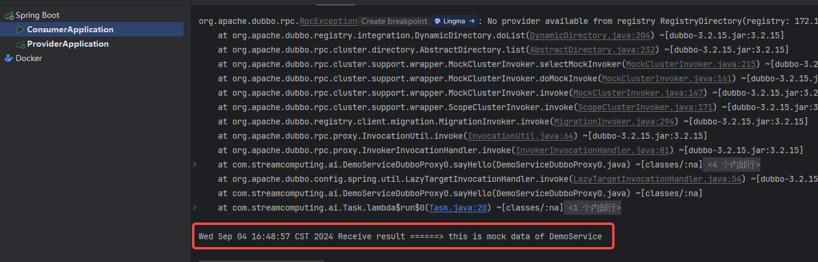
可以看到DemoServiceMock.sayHello被调用了，说明当provider无法调通时，DemoService实现了服务降级。

7. 实现分布式负载均衡

7.1 报错解决: dubbo.cache 文件夹重复占用
在本地启动多个provider实例，
启动时发现出现如下报错
org.apache.dubbo.common.cache.FileCacheStoreFactory$PathNotExclusiveException: xxx\.dubbo\.mapping.dubbo-nacos-demo-provider.dubbo.cache is not exclusive. Maybe multiple Dubbo instances are using the same folder.
修改provider端的application.yml，关闭file-cache即可
YAML
dubbo.application.enable-file-cache: false
再次启动，可以发现无报错

7.2 修改DemoServiceImpl
为了区分不同的provider实例，需要修改DemoServiceImpl，获取当前实例的端口号，并返回
Java
@DubboService
public class DemoServiceImpl implements DemoService {
@Value("${server.port}")
private String port;
@Override
public String sayHello(String name) {
return port + "\t" + "Hello " + name;
}
}

7.3 为provider配置loadbalance
修改provider的application.yaml，dubbo.provider.loadbalance: roundrobin，表示，使用轮询的方式为provider端实现负载均衡
YAML
dubbo:
provider:
loadbalance: roundrobin

7.4 创建多个启动配置，为不同的实例配置不同的port
为provider创建两个yaml，application-dev1.yaml
YAML
server:
port: 8081
application-dev2.yaml
YAML
server:
port: 8082
在idea创建两个启动配置，分别使用dev1和dev2为profile
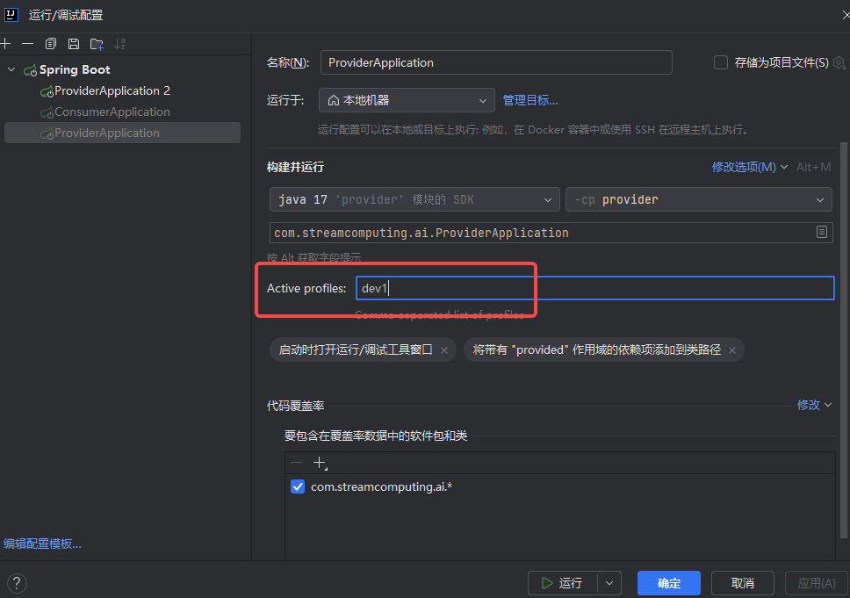

7.5 启动两个provider实例
分别启动ProviderApplication和ProviderApplication 2两个启动配置，可以在nacos后台看到有两个健康的实例，说明启动成功
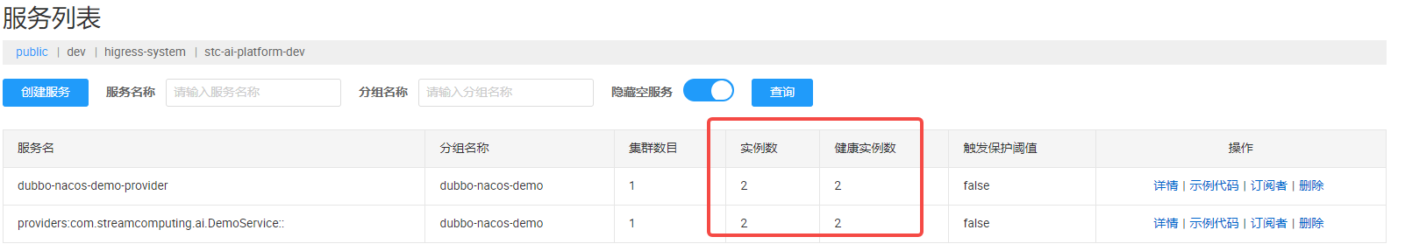

7.6 启动consumer，测试负载均衡
可以看到DemoService分别在8081和8082两个实例中轮询调用
