Ward_Abigail_HW2

Abigail Ward

6/29/2021

### Question 1

random sample of 100,000 values from the Poisson distribution and a histogram of the results on a density scale

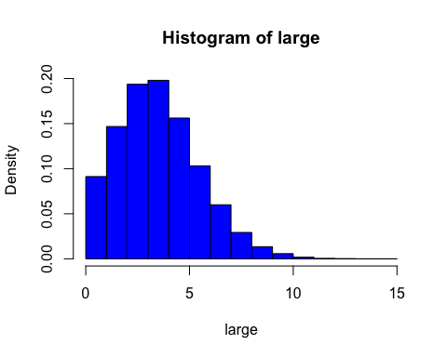

random sample of 100 values from the Poisson distribution and a histogram of the results on a density scale

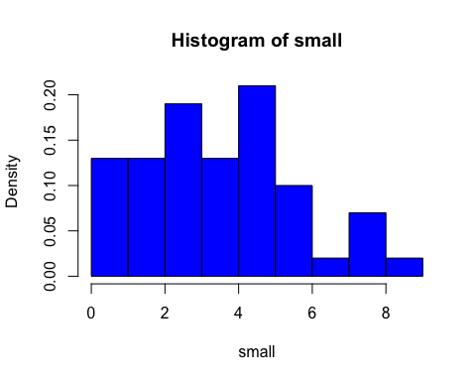

### Question 2

visualization that compares the proportions each of the possible outcomes in the sample of size 100,000 to the theoretical probabilities of each of the outcomes for the Poisson distribution

For which sample size are the proportions of each outcome more similar to the probabilities given by the density function of the Poisson distribution?

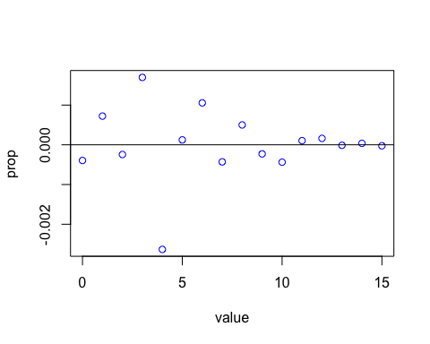

## Warning: Ignoring unknown parameters: binwidth, bins, pad

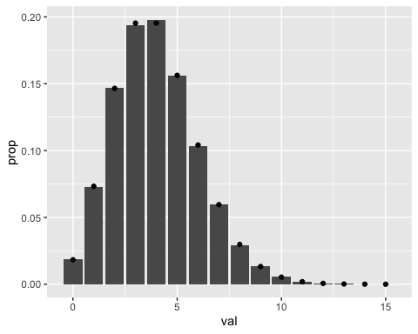 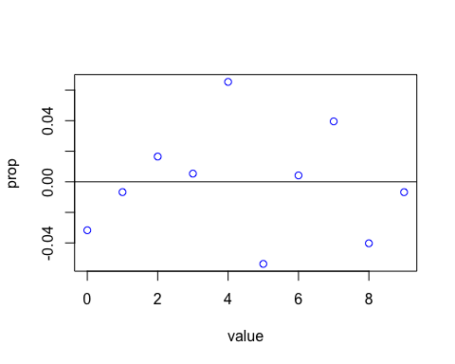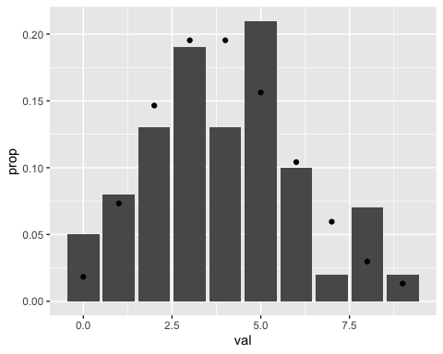

The larger sample size resulted in proportions of each outcome more similar to the probabilities given by the density function of the Poisson distribution.

#### Question 3.a

values of $x_{0.75}$ for the Normal distributions with mean 0 and sd in $1,2,3,...10$ and plot the points consisting of the value of the sd and the corresponding $x_{0.75}$. This should give an indication of a simple function relating sd and $x_{0.75}$.

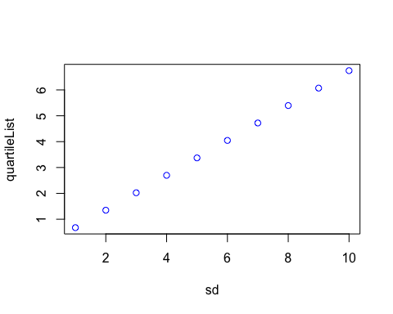

#### Question 3.b

$z_{p}=\frac{w_{p}−μ}{σ}$

#### Question 3.c

$w_{0.25}=z_{0.25}σ+μ$ $w_{0.75}=z_{0.75}σ+μ$ $w_{0.5}=μ$ $w_{0.75}−w_{0.25}=2σz_{0.75}$

#### Question 3.d

$m=μ$ $q=2σz_{0.75}$ $σ=\frac{q}{2z_{0.75}}$

### Question 4

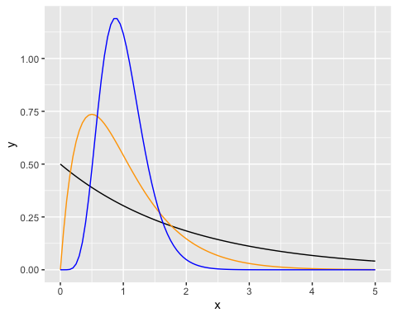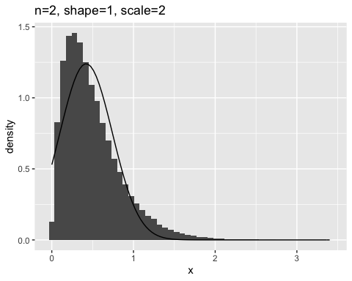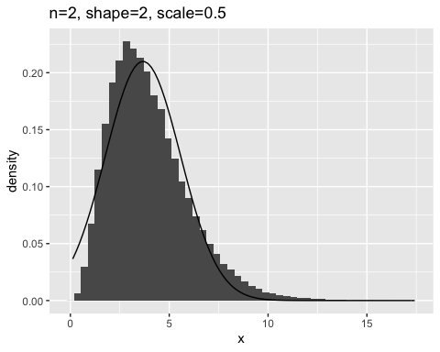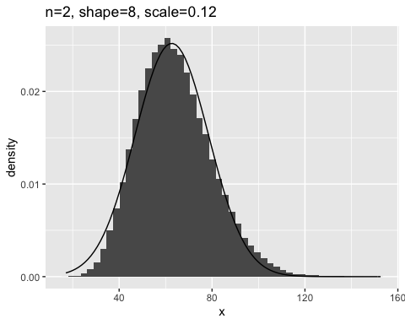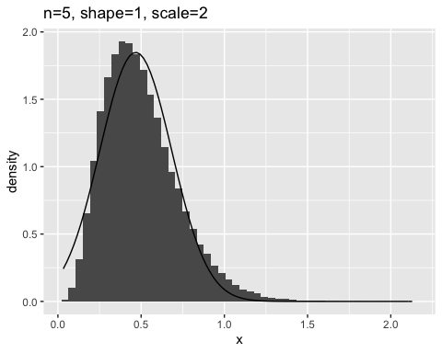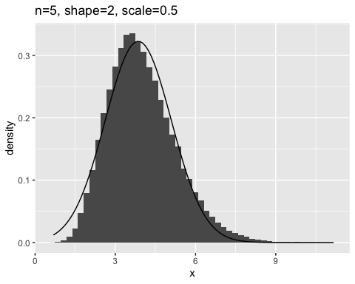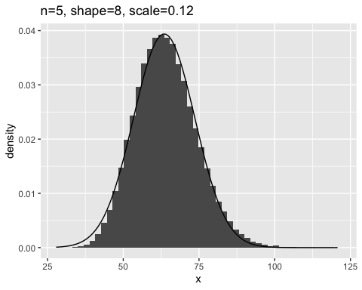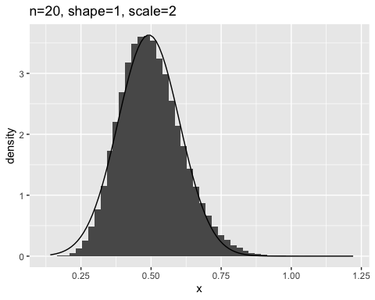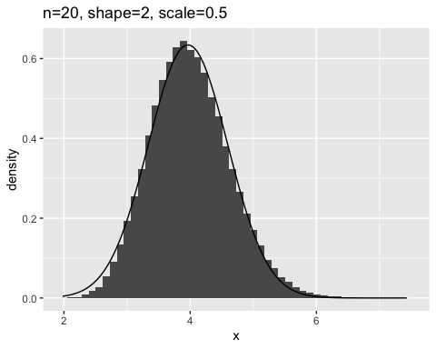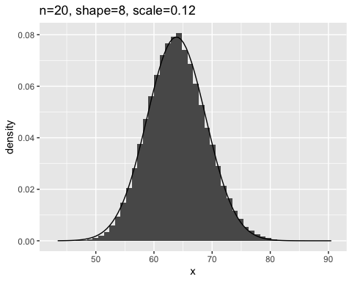

An increase in the number of terms in the sample results in a histogram that more closely resembles the normal distribution. A decrease in the scale and an increase in the shape appears to have am positive impact in the degree of resemblance between the histogram and the normal distribution.

### Question 5

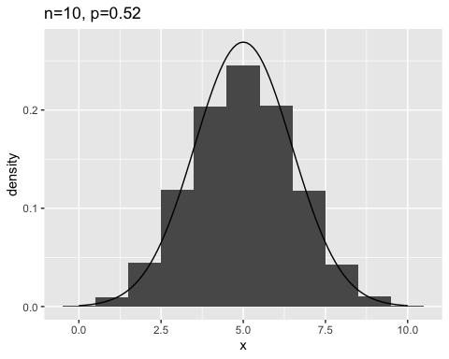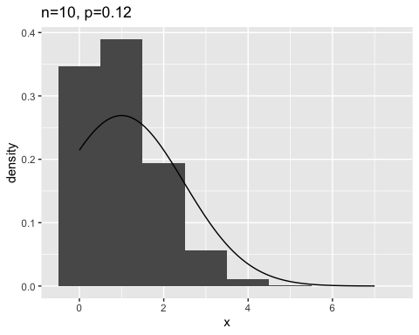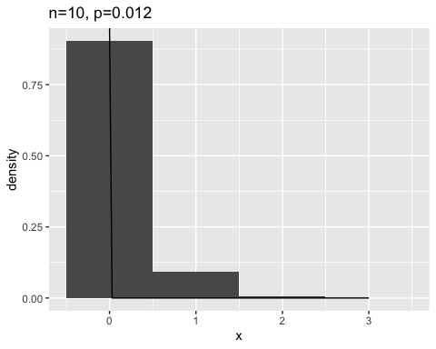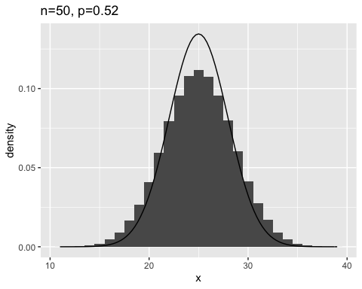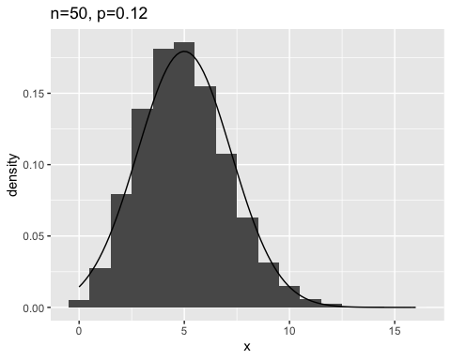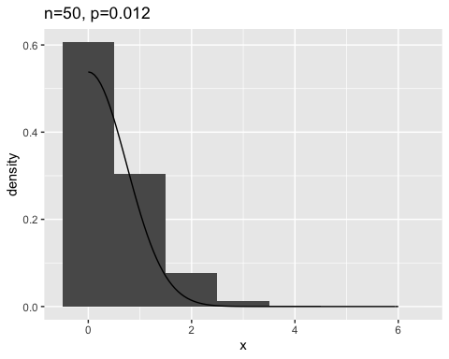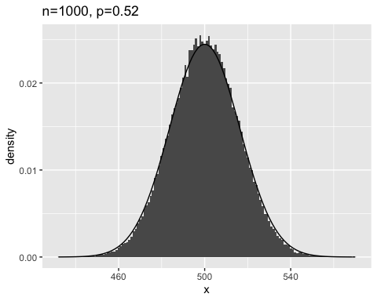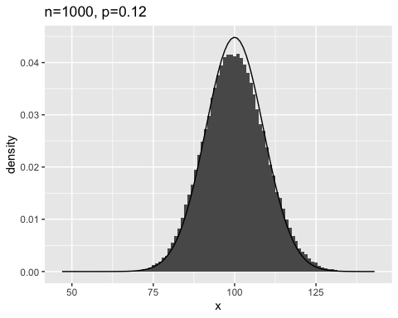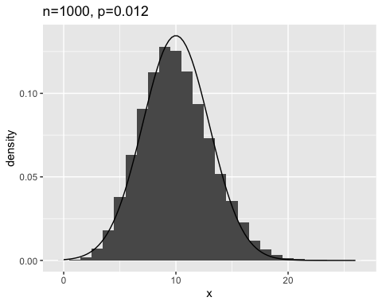

#### Question 5.b

The degree of resemblance increases with the increase in the number of terms n in the sample. Additionally, the closer p is to 0.5, the more closely the histogram resembles the normal distribution.