Ward_Abigail_HW3

Abigail Ward

7/06/2021

### Question 1.a

In the plots below, you can see that the maximum likelihood estimates of $μ$ and $σ^{2}$ are consistent and approach $μ=0$ and $σ^{2}=1$ as $n$ increases toward infinity.

set.seed(12345)  
N<-10000  
samp<-rnorm(N)  
theta.est<-function(n,s=samp){  
 m<-mean(s[1:n])  
 s2<-sum((s[1:n]-m)^2)/n  
 return(c(m,s2))  
}  
dat.consist<-t(sapply(1:N,theta.est))  
dat.consist<-data.frame(dat.consist)  
dat.consist$n<-1:N  
names(dat.consist)<-c("mu.hat","sigma.sq.hat","n")  
  
maxlikelihoodplot<-ggplot(dat.consist,aes(x=dat.consist$n)) + geom_point(data=dat.consist,aes(x=dat.consist$n, y=dat.consist$mu.hat))  
maxlikelihoodplot

## Warning: Use of `dat.consist$n` is discouraged. Use `n` instead.

## Warning: Use of `dat.consist$mu.hat` is discouraged. Use `mu.hat` instead.

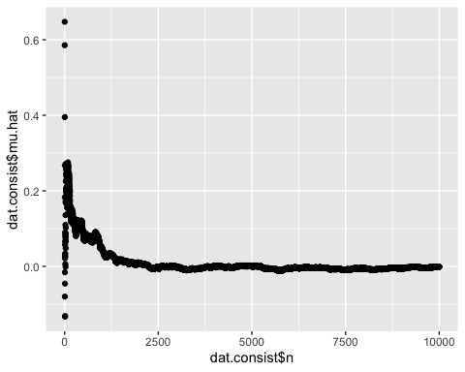

varianceplot<-ggplot(dat.consist,aes(x=dat.consist$n)) + geom_point(data=dat.consist,aes(x=dat.consist$n, y=dat.consist$sigma.sq.hat))  
varianceplot

## Warning: Use of `dat.consist$n` is discouraged. Use `n` instead.

## Warning: Use of `dat.consist$sigma.sq.hat` is discouraged. Use `sigma.sq.hat`  
## instead.

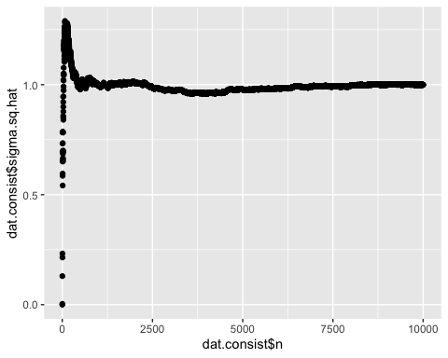

### Question 1.b

The maximum likelihood estimate of $μ$ does seem to be unbiased since the average of 10000 small samples is still very close to $0$. The maximum likelihood estimate of $σ$ seems to be biased since the expected value was $1$, but the calculated value was $0.805$. This bias was corrected by dividing the sum of the squared differences by 4 instead of 5.

set.seed(45678)  
mat<-matrix(rnorm(10000*5),ncol=5)  
means<-c()  
sd<-c()  
newSD<-c()  
for (x in 1:10000){  
 m<-mean(mat[x,])  
 means[x] <-m  
 s<-sum((mat[x,]-m)^2)/5  
 sd[x]<-s  
 s2<-sum((mat[x,]-m)^2)/4  
 newSD[x]<-s2  
}  
  
avgMean<-mean(means)  
avgSD<-mean(sd)  
avgNewSD<-mean(newSD)  
avgMean

## [1] 0.008816334

avgSD

## [1] 0.8049875

avgNewSD

## [1] 1.006234

## Question 2

$f(λ)=\prod_{i=1}^{n}{λ}\text{exp}(−λx_{i})$

$\text{ln}f(λ)=\text{ln}(\prod_{i=1}^{n}{λ}\text{exp}(−λx_{i}))$

$\text{ln}f(λ)=\sum_{i=1}^{n}{\text{ln}}(λ\text{exp}(−λx_{i}))$

$\text{ln}f(λ)=\sum_{i=1}^{n}{ }[lnλ+\text{ln}(\text{exp}(−λx_{i}))]$

$\text{ln}f(λ)=\sum_{i=1}^{n}{ }\text{ln}λ−\sum_{i=1}^{n}{ }λx_{i}$

$g(λ)=\text{ln}f(λ)=nλ−λ\sum_{i=1}^{n}{ }x_{i}$

$\frac{dg}{dλ}=n\frac{1}{λ}−\sum_{i=1}^{n}{ }x_{i}=0$

$\frac{1}{λ}=\frac{1}{n}\sum_{i=1}^{n}{ }x_{i}=\overset{‾}{x}$

$λ=\frac{1}{\overset{‾}{x}}$

## Question 3.a

The maximum likelihood estimate of both $μ$ and $σ^{2}$ are equal to the given $λ$

lambdas<-c(4,25,100)  
set.seed(345678)  
mat.sim<-matrix(rep(NA,100000*3),ncol=3)  
for(i in 1:3){  
 mat.sim[,i]<-rpois(100000,lambdas[i])  
}  
apply(mat.sim,2,mean)

## [1] 3.99768 25.00485 99.98159

apply(mat.sim,2,var)

## [1] 3.997375 25.111318 99.068502

## Question 3.b

The proposed Normal approximation to the $Poisson(λ)$ improves as $λ$ increases as shown in the histograms better matching the normal distribution dots as well as the smaller sum of the absolute differences of the two probabilities.

lambdas<-c(4,25,100)  
lim.max<-c(qpois(.99995,4), qpois(.99995,25), qpois(.99995,100))  
  
for(i in 1:length(lambdas)){  
 x<-0:lim.max[i]  
 lower<-pnorm(x-.5,mean=lambdas[i],sd=sqrt(lambdas[i]))  
 upper<-pnorm(x+.5,mean=lambdas[i],sd=sqrt(lambdas[i]))  
 p.norm<-upper-lower  
 instance<-data.frame(x=0:lim.max[i],  
 d=dpois(0:lim.max[i],lambda=lambdas[i]),  
 d.approx=p.norm)  
 g<-ggplot(data=instance,aes(x=x))+geom_col(aes(y=d),color="blue",fill="blue")+  
 geom_point(aes(y=d.approx))  
 print(g)  
}

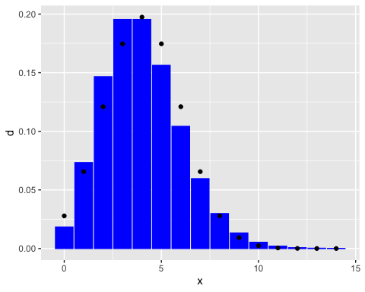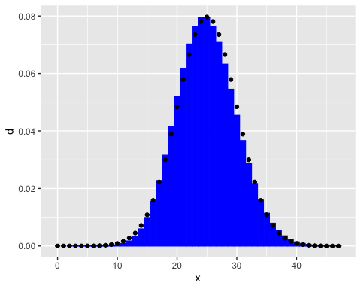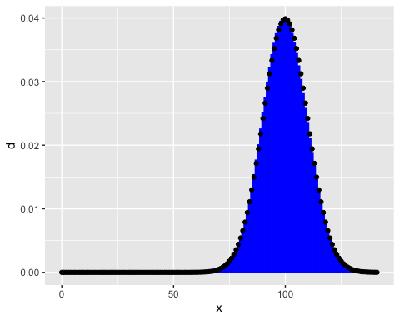

for(i in 1:length(lambdas)){  
 x<-0:lim.max[i]  
 lower<-pnorm(x-.5,mean=lambdas[i],sd=sqrt(lambdas[i]))  
 upper<-pnorm(x+.5,mean=lambdas[i],sd=sqrt(lambdas[i]))  
 p.pois<-dpois(x,lambda=lambdas[i])  
 p.norm<-upper-lower  
 approx.error<-sum(abs(p.pois-p.norm))  
 print(approx.error)  
}

## [1] 0.1177445  
## [1] 0.05049299  
## [1] 0.02515794

## Question 4

dat.pop<-read.csv("population.csv",stringsAsFactors = FALSE)  
dat.den<-  
 read.csv("population-density.csv",stringsAsFactors = FALSE)  
names(dat.den)[4]<-"density"  
  
#4a answer  
dat.pop<-filter(dat.pop,Year==2000,!Code %in% c("","OWID_WRL"))  
dat.den<-filter(dat.den,Year==2000,!Code %in% c("","OWID_WRL"))  
  
  
dat.both<-inner_join(dat.den,dat.pop,by="Code")  
mean(dat.both$Entity.x==dat.both$Entity.y)

## [1] 1

#this is equal to 1

inds<-c(  
 which(dat.both$density %in%  
 c(max(dat.both$density),min(dat.both$density))),  
 which(dat.both$Population %in%  
 c(max(dat.both$Population),min(dat.both$Population)))  
)

dat.both<-transmute(dat.both,den.log=log(density),  
 pop.log=log(Population),entity=Entity.x)  
  
  
dat.text<-dat.both[inds,]

g<-ggplot(dat.both,aes(x=pop.log,y=den.log))+geom_point()  
g

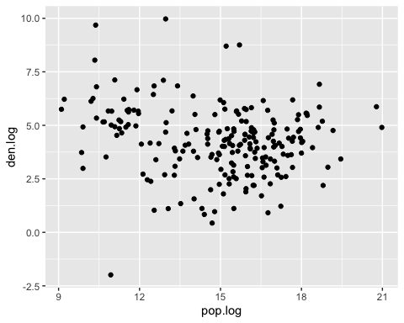

g<-g+  
 geom_text(data=dat.text,aes(x=pop.log,y=den.log,label=entity))  
g

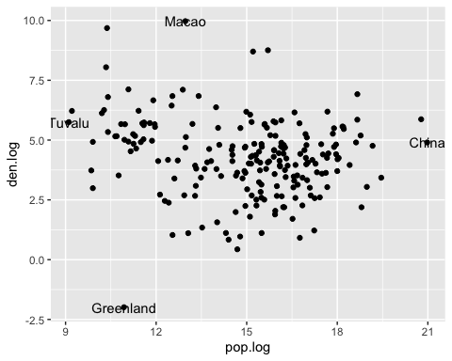

lin.model<-lm(den.log~pop.log, data=dat.both)  
  
coef<-lm(den.log~pop.log,data=dat.both)$coefficients  
coef

## (Intercept) pop.log   
## 6.0776440 -0.1214985

coefRev<-lm(pop.log~den.log,data=dat.both)$coefficients  
slopeRev<-1/coefRev[2]  
interceptRev<- (-coefRev[1])/coefRev[2]  
  
g<-g+  
 geom_abline(slope=coef[2],intercept=coef[1],color="red") +  
 geom_abline(slope=slopeRev,intercept=interceptRev,  
 color="blue")  
g

