**ENGR 102**

**Lab # 5B *[100 Points]***

This individual assignment should follow a similar strategy to the one pursued for your team program, in putting together this program. Note: in comparison to the team program, there will be far fewer conditions (but will be some) and far fewer necessary test cases. However, there will be more computation, including practice interpolating data.

You may wish to review the process for interpolating (e.g. interpolating between distances traveled, or between 3D points) if you don’t remember this.

Your task is to create a program that will report what the stress is for a given strain, for structural steel. We will be creating a simplified model for the relationship between stress and strain, and asking you to compute with it.

*Background:*

Stress-strain relationships are important in several engineering disciplines. In very rough terms, the strain of an object tells how much it has deformed, and the stress on an object tells how much force the material is exerting in response. Different materials have different stress-strain relationships. These relationships are often displayed graphically as a stress-strain curve, plotting strain on the x-axis and stress on the y-axis. An example curve is the curve below. The image was taken from <http://www.ce.memphis.edu/1101/notes/concrete/section_1_strength_of_materials.html>, which includes a more complete description. If you perform a web search on “Stress-strain curve for steel”, and look at images, you will see several other examples, both idealized and measured. Different materials will have differently-shaped stress-strain curves.

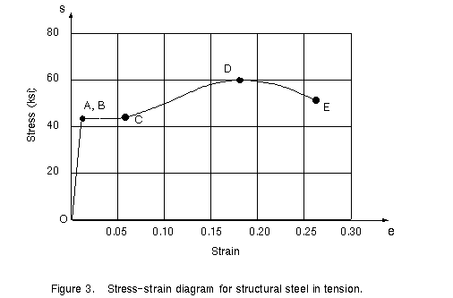

*Activity 1: Preparation [40 Points]*

For this part of the project, put together a document (e.g. Microsoft Word file) you will use to plan your program. You will turn in a PDF of this document.

First, examine the stress-strain curve. The curve has an increasing linear elastic region (from O to A) in which the stress is directly proportional to the strain. The slope of this region is called Young’s Modulus. After this (from point A to point B), there continues to be increasing stress per strain, but not at a constant rate. From the upper yield point (B) to the lower yield point (C) is a “plastic” region that is not linear (although it appears so in the figure above). This is followed by a “strain hardening” region (C to D) up to the point of “maximum strength (D), a “necking” region (D to E) and finally a fracture point (E). Points A and B are actually distinct, and the plastic region is not purely linear, but in this idealized model, we will not worry about that.

You are to come up with a simplified **purely linear model** of the stress-strain curve. That is, you are to approximate the curve by a series of line segments. You should approximate the graph by at least 4 linear segments. The lines should begin at 0,0, and end at the fracture point. Using more lines will give a more accurate representation, but will be more work in coding; for this assignment, you do not need to be precise, and can use just 4 segments.

* For the linear elastic portion, state what Young’s Modulus is
* Record the endpoints (as strain and stress “coordinates”) for each of the linear segments. You will need to estimate these from the graph.

You’ll now work on taking that linear approximation of the stress-strain curve, and creating a program that can evaluate it for you. (i.e. given a strain, report the stress).

Next, consider what values you need to store, and the general steps you will need to follow in your program.

* Make a list of the variables you believe you are likely to need, and the names you will use.
* Create a sequence of steps that you will follow
  + If you have a conditional statement (and you should…), you might want to indicate each part of the condition as a separate action.
  + The computation here will involve a few stages. Please separate the stages into different parts; do not just say “compute stress”.

Next, create a list of test cases that you will use in your program. Be sure to handle both “typical” and “edge” cases. Do this before writing the program itself!

* Similar to the group activity, for each test case state what it is you are trying to test (e.g. a typical case, an edge case, which region(s) you are testing, etc.), the value you want as input and the value as output.
* Note that you should try to come up with a complete set of test cases that thoroughly test the idea.

When you have done this, save the document in PDF format.

*Part 2: Constructing your program [60 Points]*

AFTER doing the above, construct your program. Your program should ask users for a strain, and report the stress. As you write your program, please be sure to do the following:

* Include comments for your program. You should probably begin by converting your list of steps into comments.
* Develop incrementally. That is, write some code, and test it before writing the next section of code.
* Be sure your program runs on all test cases.
* Be sure to include specific instructions to the user for getting input, and writing a descriptive output.