**ENGR 102**

**Lab #11B [100 Points]**

***Activity: An Interpolation Function – to be done individually.***

*We have encountered the process of interpolation a few times in this course – most recently in Lab 9. You may wish to refer back to your work on prior assignments when doing this one and may reuse code from them if you wish. You will create 2 versions of an interpolation program, and should save these as 2 different files, labeled* **Lab_11b_*Activity_1a*** *and* **Lab_11b_*Activity_1b****.*

1. **[50 Points]***You should create a function that will perform linear interpolation from a set of measured data from a file shown below. File “TestDataSpace.dat” provided.*

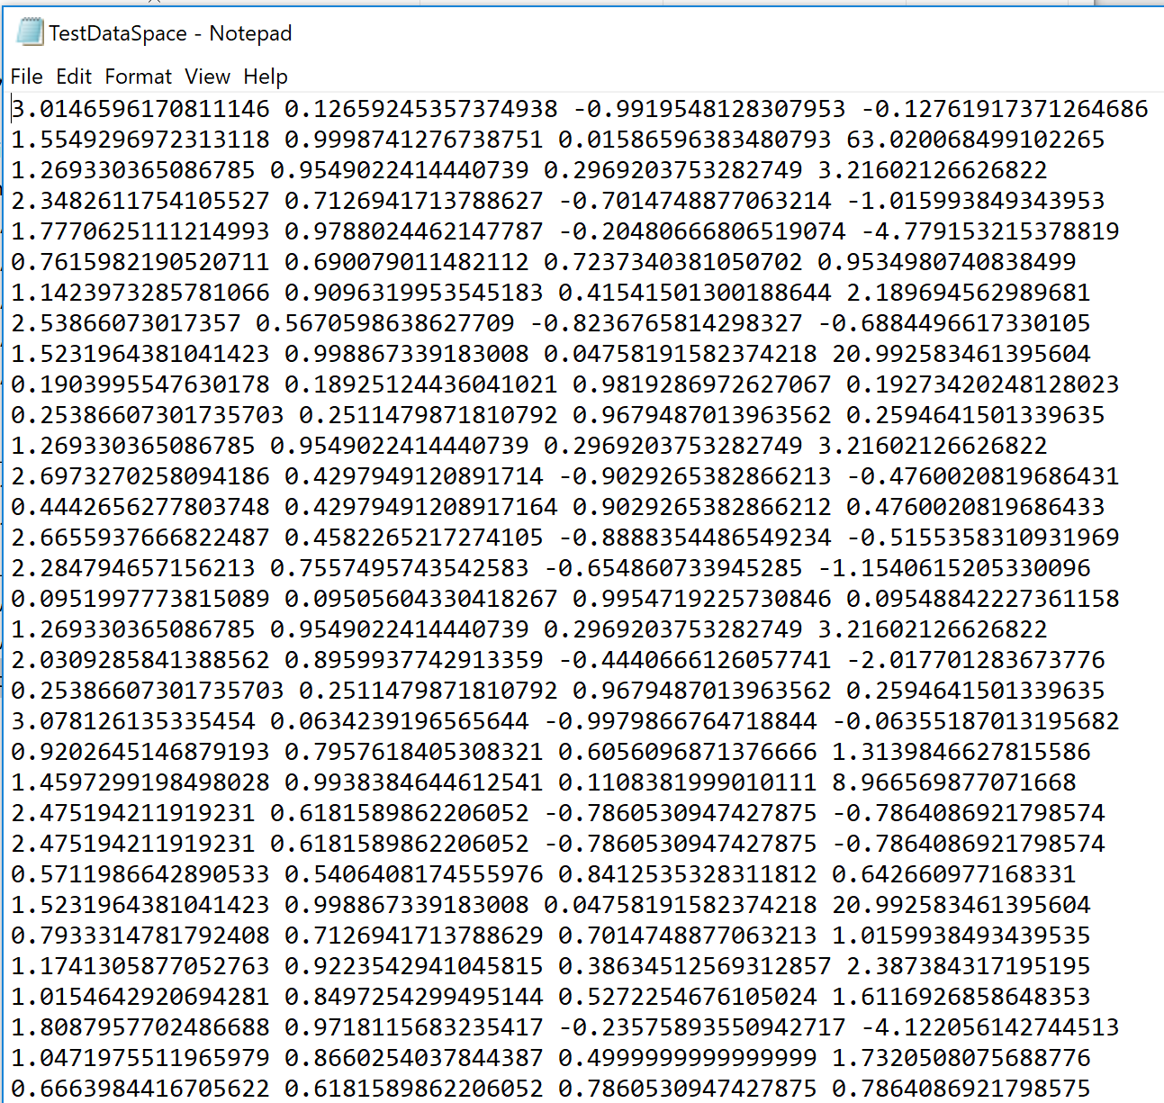

*Your function can read this file using numpy loadtxt function. Research and figure this out. The file has a pair of numbers separated by spaces.*

*The function should take as input a list of values at which samples were taken, and then another list giving the measurements (you can assume each measurement is a single value) at those values. It should also take in a query value, and should give the best estimate it can of the value at that query.* ***Be sure to handle values that are outside of the range, by extrapolating.***

*You should write a program that allows you to test your function by reading the lists from a file where each line of the file is a pair of numbers separated by spaces: the value where the sample was taken, and the measurement at that value.*

*Important: The two lists will correspond to each other: i.e. for the i-th value in the first list, the measurement will be the i-th element of the second list (these are called parallel lists or arrays). But, you should* ***not*** *assume that the input values are in increasing/decreasing order. That is, the values in the first list can be in any random ordering, not necessarily from smallest to largest or largest to smallest. You will have to account for this in your program, and there is more than one way to do so. You should discuss what options you can think of to handle the data arriving in any order like that and decide what you think the best option for handling it is.*

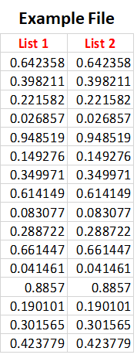

*Your program should ask the user for the name of the file and should also take in additionally a query value (corresponding to Col1), and should interpolate the best estimate (corresponding to Col2) for that query value. Challenge: Handle values that are outside of the range, by extrapolating.*

1. **[50 Points] Extend your program from part (a) so that it will handle not just single measurement values (Column 2) but vector data. Use Column 3 and Column 4 in File “TestDataSpace.dat” and in general your program should handle up to n Columns.**

Your program should ask a user for a file name, and the number of dimensions, n, of the vector data. It should then read from the file, assuming the values at which measurements are taken are the first column, and then there will be n entries, all space-separated. You may find it easier to store your vector data in numpy arrays.

Your interpolation function should return the vector data either using tuples or using arrays

from the numpy module.