**ENGR 102**

**Lab #12B**

**Activity: Creating tally marks – to be done individually (100 Points)**

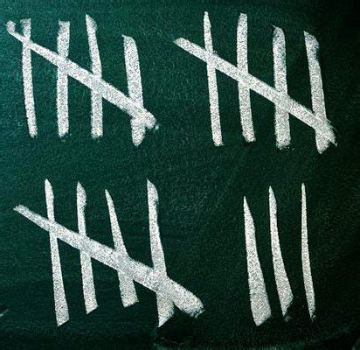

You are to create a program that uses the turtle graphics routines to draw tally marks representing numbers. Briefly, a user should be asked for a number, and then tally marks should be drawn equivalent to the number.

* Tally marks are used to aid counting. As numbers are counted, each number encountered is represented by a short vertical line, except that every fifth number will instead be represented by a diagonal line passing through the previous four vertical lines.
* Your program should be able to draw tallies for numbers up to at least 100.
* Each group of 5 tallies should be clearly separated from other groups.
* When you have to draw tallies, each “row” of the drawing should be able to hold at least 10 (i.e. 2 sets of 5) and at most 25 (i.e. 5 sets of 5) tally marks. You may choose how many a row should hold (anywhere from 2 to 5 sets of 5), but should make sure that a window easily displays up to 100 tallies.
* You may find the Python documentation of the turtle module helpful to refer to: <https://docs.python.org/3.3/library/turtle.html>

You may use a top-down, a bottom-up, or some hybrid approach to designing your program. But, you should go through a design process, first.

1. Before writing any code, you should go through a design process. Try to do so carefully – either follow a top-down approach, a full bottom-up approach, or some combination. But, in any case, you should come up with a list of functions you plan to implement, each with its own clear purpose.
   1. Create a document that outlines all the functions you will create, including a purpose for each, stating what the function does, and any parameters it has. The purpose for each function can become its docstring (40 Points)
2. After you have written a description of your program, including the planned functions, go ahead and write code for each function. Be sure to create a docstring for each function. Turn in your program and the design document you created earlier, zipped into one file. (60 Points)

Challenge: See if you can create a program so that the lines are drawn with some irregularities, so that each is not perfectly vertical, or not perfectly straight, etc.